

Johnson Production Group

Press Kit

# One-Liner

# As Miya and her fiancé plan their dream wedding they are stalked by an eerie and dangerous veiled bride who is determined that Miya will never walk down the aisle.

# Synopsis

Owning a successful hair salon and about to be married to the man of her dreams, MIYA doesn’t think things can get any better. But things quickly begin to fall apart when she receives a wedding invitation – to the wedding of her fiancé Ian and his *ex-fiancée Lily*.

It’s been no family secret that Lily was unstable and when Ian broke off their engagement last year, it sent her over the edge. But Miya discovers just how crazy Lily really is when she suddenly finds herself being stalked by an eerie bride dressed in a wedding gown and veil. At first Ian is supportive and believes that it’s Lily. But with Lily having an iron- clad alibi every time Miya claims to see the bride, Ian begins to doubt that Lily really is the one harassing her... in fact, he begins to suspect Miya might be making the whole thing all up!

Miya tries everything she can to prove Lily is the one behind the horrifying series of events that begin to tear her and Ian apart. From the death of his beloved dog to accidents that befall his mother, Deb, and his brother, Mark, Miya is convinced Lily is carrying out a twisted and deadly plan of revenge. To make matters worse, police Detective Watts, who is investigating the case, begins to suspect Miya might be the one responsible for the mayhem, since she seems to be becoming emotionally unglued.

Determined to prove she’s not the one going crazy, Miya digs deep into Lily’s past - uncovering a family secret that causes her to question if Lily is working alone – or if she has a secret accomplice. With her wedding to Ian on hold, Miya desperately tries to reveal the true identity of the bride before the mysterious veiled woman completely destroys her life – and robs her of Ian’s love forever...

# Producers

Executive Producer

TIMOTHY O. JOHNSON

Producer

KEN SANDERS

Associate Producer

KATIE LECLERC

Co-Producer

SHERI REEVES

Key Cast

|  |  |  |
| --- | --- | --- |
| CHARACTER  Miya  Ian  Lori  Mark  Caroline  Sandra |  | ACTOR  KATIE LECLERC  JEFF SCHINE  HANNAH BAREFOOT  BEN GAVIN  KENDRA CARELLI  AMANDA MADDOX |

# Key Cast Biographies

KATIE LECLERC

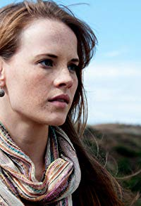 Katie Leclerc's career began in 2005, when she made her first appearance on Veronica Mars. This jump-started a series of minor roles and small appearances in movies and TV shows. She got her breakout role starring as a deaf teenager, Daphne Vasquez, who finds out she was taken home by the wrong family in ABC Family's Switched at Birth.

## JEFF SCHINE

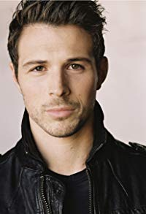Jeff Schine is known for Without a Clue (2005), The Walking Dead: A New Frontier (2016), Division III: Football's Finest (2011), Mafia III (2016)

## HANNAH BAREFOOT

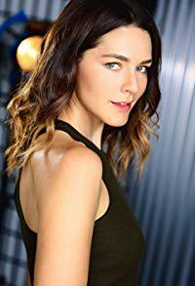 Hannah Barefoot is a theatrically trained actress, singer, dancer, writer, and producer. She was born and raised in Cody, Wyoming to a teacher mother and an engineer father. Always encouraged to perform from a young age, Hannah grew up dancing, singing alongside her talented father, and creating backyard plays with her sisters and neighborhood friends. She pursued a BFA in Theatre and Dance with a minor in Vocal Performance at the University of Wyoming, then finished her education with a degree in Drawing and Painting at Portland State University. Hannah has always been an athlete, both a competitive swimmer and an accomplished dancer for all of her childhood and well into college. Hannah continues to dance and sing, both professionally and for the love of it. She is also a kick boxer and has begun incorporating this into her films.

She landed her first leading film role in the LGBT cult favorite, 'The Falls: Testament of Love', as the jilted Mormon housewife of a man learning to own his sexuality. Her performance earned excellent reviews for it's grounded nature and raw emotional power. She has since continued to make a name for herself as a leading lady in the indie film world, with psychological thrillers like 'Off the Rails', and has appeared in numerous television shows ranging from a recurring role on Amazon's 'Good Girls Revolt' to TNT's 'The Librarians'. In her writing and producing, she gravitates toward creating complex female characters who are basically good but who do bad things. She wrote, produced, and starred in the dark action comedy, 'Incendio', which screened in 17 festivals internationally and won 'Best Short', 'Best Stunt Choreography', and was nominated for many others. She is in development of her own series, a feature, and several shorts.

Hannah is the Development Associate of two-time Emmy winning director/producer, Scott Winant, and together they are creating projects that promote a complex feminist world-view.

# Production Credits

### Full Cast

|  |  |
| --- | --- |
| [Actors](http://www.imdb.com/name/nm7589451/?ref_=ttfc_fc_cl_t1)  KATIE LECLERC  JEFF SCHINE  HANNAH BAREFOOT  BEN GAVIN  KENDRA CARELLI  AMANDA MADDOX  KENT FAULCON  JAN DALEY  CHARLES CHRISTOPHER  GREG COLLINS  NICK BALLARD  MONICA YOUNG  JEANETTE O’CONNOR  HEATHER HORTON  LESLIE SIMMS  DENNIS W. HALL  DENNY DORMODY  NICK PLANTICO  TAMMIE BAIRD | Role  Miya  Ian  Lori  Mark  Caroline  Sandra  Detective Watts  Deb  Ryan Candler  Detective Young  Derek  Dr. Wilkens  Mrs. Parke  Ellen  Woman Driver  Process Server  Reverend Connelly  Stunt Coordinator  Lori Stunt Double |

### Produced by

|  |  |  |
| --- | --- | --- |
| TIMOTHY O. JOHNSON |  | executive producer |
| KEN SANDERS |  | producer |
| KATIE LECLERC |  | associate producer |
| SHERI REEVES |  | co-producer |

### Directed by

ROB MALENFANT

### Written by

BARBARA KYMLICKA

### Cinematography by

ERIC ROY ANDERSON

### Film Editing by

KEVIN LAVELLE

### Casting By

JEFF HARDWICK, CSA

### Production Design by

CHANTAL MASSUH

### Costume Design by

JOHN C. HOUSTON IV

### Full Crew

Line Producer HANK GROVER

First Assistant Director JOHN ALEXANDER STERN

Additional First Assistant Director JOSHUA LOU FRIEDMAN

Second Assistant Directors JOSH LARSEN

REBEKAH SHRIVER

2nd Second Assistant Director PHINEAS PALMER

Production Secretary GABBI LATADE

Script Supervisor KATYA LOBAN

Additional Script Supervisor ANN M. DORIA

A Camera Operator ERIC ROY ANDERSON

B Camera Operator FERGUSON SAUVÉ-ROGAN

Steadicam Operator THEO PINGARELLI

A Camera First Assistant ALAN KOPLIN

B Camera First Assistant ROSE OXNARD

Additional B Camera 1st Assistant CARSON REAVES

BEN BRADY

LAWRENCE MONTEMAYOR

Second Assistant Camera TYLER M. MANZO

Camera P.A JOSHUA MATTHEW THOMAS

D.I.T. KYRAN DUNN

Still Photographers CHARLES CHRISTOPHER

MIKE TAING

Production Sound Mixer JASON AARON MORAN

Gaffer ANDREW MESSERSMITH

Best Boy Electric NATHAN HANSEN

Key Grip BRIAN PATIERNO

Additional Key Grips JOSH ANDERSEN

ALEX W. EVANS

CHRIS HARTSELL

Best Boy Grip JOHN ELKIN

Additional Best Boy Grips MAZEN BAYOUMY

ROBERT BENNETT

CHARLES M. CARTWRIGHT

FAISAL SHAH

Grip & Electric Swing REYNALDO FORTANEL

CHRIS GINNAVEN JR.

JUSTIN KNODEL

RYAN LOPEZ

ALEXANDER TOBIAS

Art Director CAMERON BARRETT

Prop Master KEARNEY THOMPSON

Set Dressers DAVID S. FIELD

PAUL MARTIN

Costume Supervisor MORGAN DIXON

CHRISTY L. MELE

Makeup Department Head STACIE GRACIE

Hair Stylist Department Head ERICA MEDINA

Hair Stylists JENNIFER BUCHALLA

MELANIE CRISTESCU

PRISCILLA NGUYEN

Makeup Artist NINA BRACKETT

FX Makeup Artist ERICA MEDINA

Location Manager SEAN B. HERNANDEZ

Key Assistant Location Manager REMY ELLES

Assistant Location Manager SHEILA RYAN

Key Set Production Assistant MICHAEL TODD WYNN

Production Assistants HANNAH DURAN

MBELA N. ENDELEY

KELSIE INSERRA

MICHAEL OATES KEALEY

JOEY MARTIN

MITCHELL PETERSON

PATRICK REAVES

VICTOR REDMAN

DOMENICO RISO

MEGAN SCHNEIDER

MAGGIE SOTTER

Extras Casting Director PETE SUTTON

Fire Safety Advisors LAURANCE A. EDWARDS

TIMOTHY C. STILSON

ROD WASHINGTON

Craft Service LUKE LAKIN

### Second Unit

Directors CHRISTIAN ACKERMAN

MARCO BARGELLINI

DAVID BENULLO

First Assistant Director JOSH LARSEN

Director of Photography FERGUSON SAUVÉ-ROGAN

Production Sound Mixer GERALD WOLFE

### Post Production

Post Production Services BLUEPRINT POST PRODUCTION

JON KELBLE, V. P. OF POST PRODUCTION

Colorist RANDY COONFIELD

Stock Footage SHADOWLAND, LLC

Camera Equipment HOLLYWOOD CAMERA AND SETELEVISION

Grip and Lighting Equipment BRILLIANT SCREEN STUDIOS

Script Clearance HOLLYWOOD SCRIPT RESEARCH

DENNIS WHITCOMB

ERIN MANACKER

Production Insurance GIOVANNI CUAREZ

AMERICAN ENTERTAINMENT INSURANCE SERVICES

Payroll Services ERIN RAY,  
SENIOR ACCOUNT MANAGER/CLIENT SERVICES

NPI ENTERTAINMENT PAYROLL, INC.

Extras Payroll MACCPRO

# Producer Biographies

TIM JOHNSON – Executive Producer

Tim Johnson is among the most active and reliable producers in the business thanks to top rate productions and an 'on time, on budget' reputation. Previously, he managed the production of ABC's THE DAYS (MINDSHARE/TOUCHTONE.) Prior to forming Johnson Production Group and Ignite Entertainment, Tim served as Head of West Coast Programming Executive and launched the successful series DOC (88 episodes,) SUE THOMAS, FBI, MYSTERIOUS WAYS, JUST CAUSE, PONDEROSA, CHRISTY, ITS A MIRACLE AND MIRACLE PETS.

Johnson is also responsible for producing the international hit series, DR. QUINN, MEDICINE WOMAN for CBS PRODS/SULLIVAN COMPANY for over 5 seasons. During his 100-episode tenure, he also launched LIVE FROM THE RANCH with Orson Bean - a nationally syndicated talk show focusing on family values in America. He also developed and produced the original docu-drama COLD CASE for CBS network, which was the very first program to integrate television with the Internet.

Recent Projects:

Eat, Play, Love – Executive Producer

Sleepwalking in Suburbia – Executive Producer

The Stalker Club – Executive Producer

Infidelity in Suburbia – Executive Producer

Hunter's Cove – Executive Producer

Double Mommy – Executive Producer

Hearts of Christmas – Executive Producer

The Rooftop Christmas Tree – Executive Producer

A Snow Capped Christmas – Executive Producer

A December Bride – Executive Producer

The Mistletoe Promise – Executive Producer

Stalked by My Mother – Executive Producer

Stalked by My Doctor: The Return – Executive Producer

Backstabbed – Executive Producer

The Convenient Groom – Executive Producer

Killer Coach – Executive Producer

Tulips in Spring – Executive Producer

Hearts of Spring – Executive Producer

Stalked by My Doctor – Executive Producer

Becoming Santa – Executive Producer

Magic Stocking – Executive Producer

Just in Time for Christmas – Executive Producer

A Gift Wrapped Christmas – Executive Producer

A Mother's Instinct – Executive Producer

Ice Sculpture Christmas – Executive Producer

The Reckoning – Executive Producer

Bad Sister – Executive Producer

Family for Christmas – Executive Producer

Double Daddy – Executive Producer

Her Infidelity – Executive Producer

Stalked by My Neighbor – Executive Producer

Babysitter's Black Book – Executive Producer

A Gift of Miracles – Executive Producer

Strange Empire – Executive Producer

Sugar Daddies – Executive Producer

Paper Angels – Executive Producer

A Cookie Cutter Christmas – Executive Producer

Stranded in ParadiseFor Better or For Worse – Executive Producer

Baby Bootcamp – Executive Producer

Ring By Spring – Executive Producer

Sole Custody – Executive Producer

The Cheating Pact – Executive Producer

Deadly Spa – Executive Producer

Walking the Halls – Executive Producer

June In January – Executive Producer

Christmas in the City – Executive Producer

Snow Bride – Executive Producer

Dirty Teacher – Executive Producer

The Surrogate – Executive Producer

Merry In-Laws – Executive Producer

A Bride for Christmas – Executive Producer

Naughty or Nice – Executive Producer

Christmas Crush– Executive Producer

Teenage Bank Heist– Executive Producer

How to Fall in Love – Executive Producer

Home Invasion – Executive Producer

Final Sale – Executive Producer

Confined – Executive Producer

Tornado Valley– Executive Producer

The Wedding Dance– Executive Producer

Trust – executive producer

Toxic Skies– executive producer

Storm seekers – executive producer

Making Mr. Right – executive producer

Love Sick – executive producer

Just Breathe – executive producer

Devils Diary – executive producer

Swarm – executive producer

## JOHNSON PRODUCTION GROUP

The Johnson Production Group contracts globally to produce television and motion picture content for international networks, studios and distributors. Based in Los Angeles and Vancouver, British Columbia, the company manages production, facilitates development and financing, procures distribution and guarantees quality and timely execution of its programs. While costs have gone up, so has the demand for quality. No longer is good enough, good enough. Johnson Production Group serves that segment when a show needs to be "A" quality, but produced efficiently enough to meet a locked budget. JPG specializes in value, protection of creative elements, and delivery of a quality finished product.

## KEN SANDERS - Producer

Over the past decade and a half, Ken Sanders has written and/or produced over forty feature-length motion pictures. Since starting his film production company, Shadowland, LLC, with partner Robert Ballo in 2009, Sanders has also produced THE CHEATING PACT, MISSING AT 17, THE PERFECT BOYFRIEND, DIRTY TEACHER, THE SURROGATE, STALKED AT 17, TEENAGE BANK HEIST, WALKING THE HALLS, BETRAYED AT 17, HOME INVASION, MATERNAL OBSESSION, and ACCUSED AT 17, all of which received big ratings when they premiered on Lifetime Television.

From 2001 to 2008, Sanders partnered with prolific Hollywood producer Pierre David and produced eight made-for-TV movies in Canada. Sanders co-wrote many of the films, including ‘TIL LIES DO US PART, MAID OF HONOR, STRANGER AT THE DOOR, THE PERFECT HUSBAND, SAVING EMILY, and A KILLER UPSTAIRS.

Prior to partnering with David, Sanders served as Vice President of Production at WIN Ventures, a division of World International Network, a leading supplier of independent feature films and made-for-TV movies. During his tenure at WIN Ventures Sanders oversaw the development, production, and post-production of roughly twenty films a year, including LIVING IN FEAR, FACING THE ENEMY, and SHE’S NO ANGEL, and many more which aired on the USA Network, Court TV, HBO, Showtime, Cinemax, and The Movie Channel.

In the mid-1990s, Sanders worked as the Vice President of Creative Affairs at Image Organization, helping to develop and oversee such theatrical projects as LITTLE MEN (released by Warner Brothers) and WISHMASTER (released by Artisan), the latter of which went on to become the highest-grossing independent feature film of 1997.

At the beginning of his career, Sanders worked as the Director of Development at High Five Productions, helping to prepare such television specials as THE JUDDS FAREWELL CONCERT and THE WOMEN OF COUNTRY. He also worked for media mogul Ted Turner, doing a stint as a promotions producer for CNN and SuperStation WTBS.

In addition to his film and television work, Sanders has served as an adjunct professor at Biola University, where he taught classes on producing and screenwriting. He is also a frequent guest lecturer at Los Angeles Valley College and the Los Angeles Film School, where he speaks on topics ranging from the business of film to post-production to pitching and script development. Sanders received his degree in Filmic Writing from the University of Southern California, School of Cinematic Arts.

## Billing Block

Johnson Production Group in Association with Harbor Light Studios Presents   
“A BRIDE’S REVENGE”  
Starring KATIE LECLERC JEFF SCHINE HANNAH BAREFOOT BEN GAVIN KENDRA CARELLI AMANDA MADDOX Casting by JEFF HARDWICK, CSA   
Production Designer CHANTAL MASSUH Costume Designer JOHN C. HOUSTON IV   
Edited by KEVIN LAVELLE Director of Photography ERIC ROY ANDERSON Executive Producer TIMOTHY O. JOHNSON Co-Producer SHERI REEVES   
Associate Producer KATIE LECLERC Produced by KEN SANDERS   
Written by BARBARA KYMLICKA Directed by ROB MALENFANT

Special Thanks to



Christian Ackerman

College of the Canyons Cooperative Work Experience Education Program

Columbia College Hollywood

Columbia College Chicago

Richard Brandes

California Lutheran University

Claremont McKenna College

Santa Clarita Film Office

FILM LA

Jill’s Cake Creations

© MMXVIII Harbor Light Studios, LLC All Rights Reserved

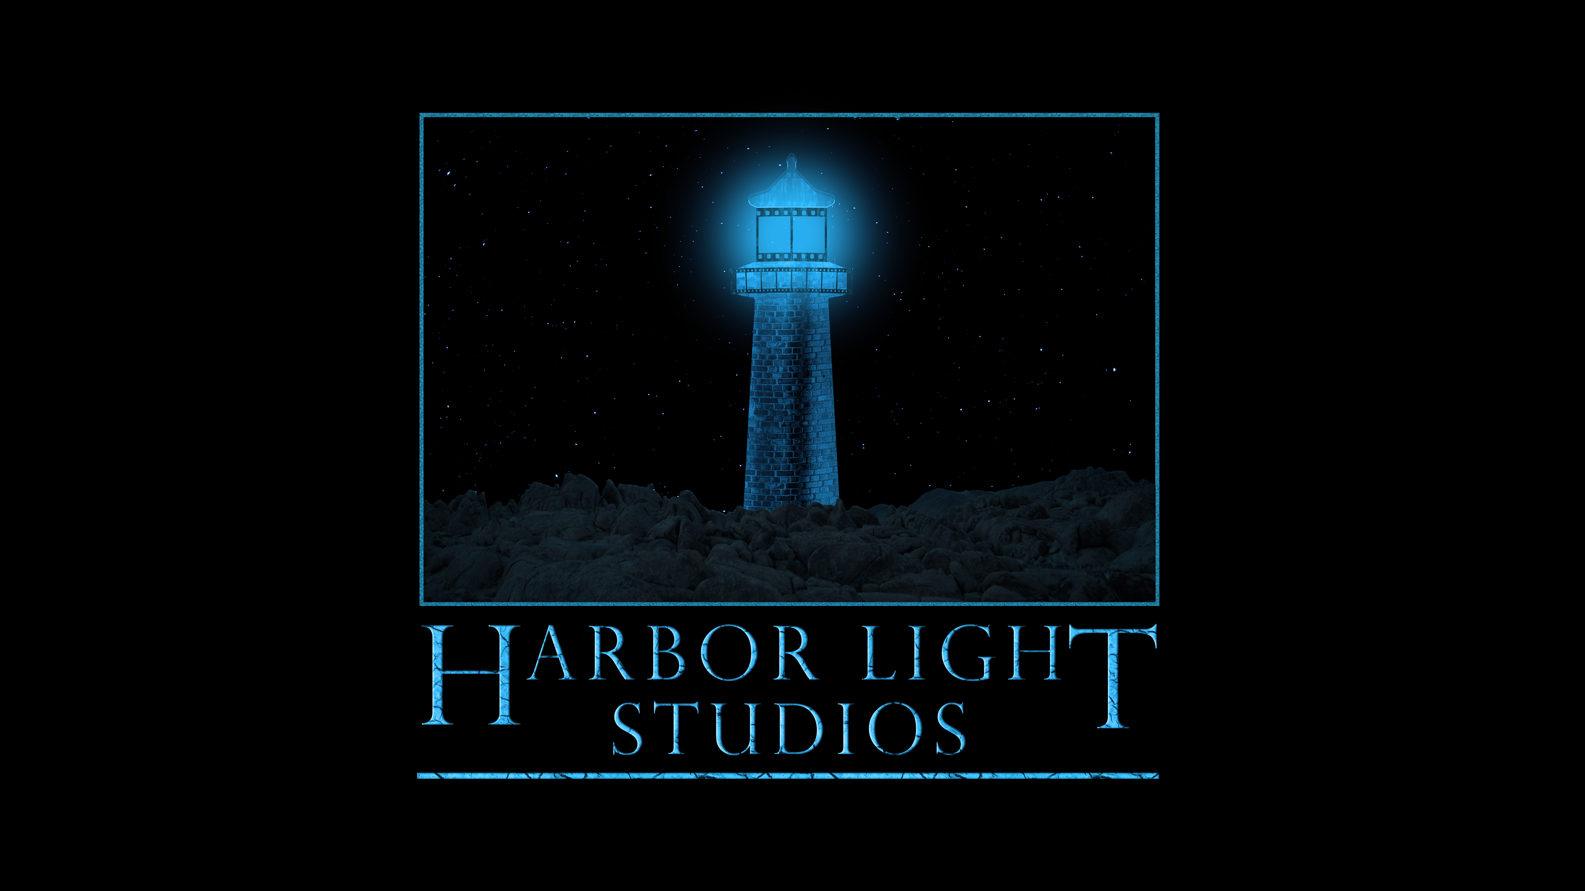



Meta Data

LONG (max 540 characters) synopsis

Owning a successful hair salon and about to be married to the man of her dreams, MIYA doesn’t think things can get any better. Things quickly begin to fall apart when she receives a wedding invitation – to the wedding of her fiancé Ian and his *ex-fiancée Lily*. Soon Miya is being stalked by an eerie bride dressed in a wedding gown and veil and Ian begins to suspect Miya might be making it all up! When a series of horrifying events start to occur, Miya is convinced that Lily is carrying out a twisted and deadly plan of revenge. (531)

MEDIUM (max 180) synopsis

# As Miya and her fiancé plan their dream wedding they are stalked by an eerie and dangerous veiled bride who is determined that Miya will never walk down the aisle. (162)

SHORT (max 54 characters) synopsis

Miya is stalked by an eerie bride before her wedding (52)

5 KEY WORDS

Wedding, stalker, revenge, fiancé, mystery