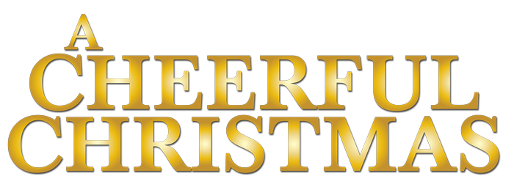

Johnson Production Group

Press Kit

One-Liner
While doing her job to deliver the most magical Christmas ever to a royal client, Lauren finds herself falling for their son who soon shares her love of everything Christmas.

Synopsis

Lauren and her best friend Colleen think they have landed the dream job… giving people the best and most magical Christmas ever as their personal "Christmas Coaches". This holiday season promises to be their biggest ever when they land a royal client, The Anderson family, who have moved from England. When Lauren meets the eldest son, James, he wants nothing to do with planning Christmas as he's busy negotiating a big acquisition for his father's company. Lauren, however, won't be thwarted in helping this royal family embrace the true spirit of Christmas and the more she prods James on their family holiday traditions, the more he opens up about himself. Soon sparks start to fly between Lauren and the handsome Prince, but competition arrives in the form of an old childhood friend and business colleague of James, Maryam. Now Lauren must win James' heart while also giving the Andersons the best Christmas they've ever had.

Producers
Executive Producer
TIMOTHY O. JOHNSON
Executive Producer
ANDREW C. ERIN
Producer
HAYDEN BAPTISTE
Producer
BONNIE ZIPURSKY

Key Cast
CHARACTER  Lauren  Colleen  James  Joyce  Maryam |  | ACTOR  ERICA DEUTSCHMAN  TIANNA NORI  CHAD CONNELL  JENNIFER VALLANCE  SAMANTHA MADELY

Key Cast Biographies

ERICA DEUTSCHMAN
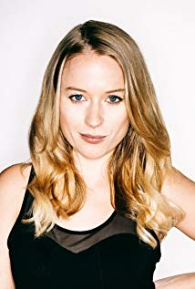
Today audiences around the world will probably recognize actress Erica Deutschman best from her role as Beth in the dramatic fantasy series Being Human, where she transforms from the innocent girl next door to an eerie hauntress who makes the main character’s life unbearable. Never failing to captivate her audience, Deutschman’s impressive range coupled with her drop dead gorgeous looks have made her a leading lady for a long list of film and television productions across genres including The Howling Reborn, Hidden, Reign, Fatal Vows, Blue Mountain State, Sex Addict/Love Addict and others.
Earlier in her career Deutschman starred in Christos Sourligas dramatic feature film Happy Slapping, which premiered at the Montreal International Film Festival in 2011.
Shortly after Deutschman went on to guest star on the hit television show Lost Girl, as well as A Stranger in My Home, before landing the recurring role of Beth on SyFy’s multi-award winning series Being Human. Deutschman also appeared in multi-award winning director Deepa Mehta’s film Beeba Boys, which was chosen as an Official Selection of the prestigious 2015 Toronto International Film Festival in 2015.
While Deutschman has undoubtedly made her name known as an actress in hit film and television productions, she has also proven her capacity to command the stage through her roles in high-profile theatre productions including “Nutcracker,” “Sleeping Beauty,” “Coppelia,” and “The Comedy of Love and War.”
With a collective body of work that spans the gamut, Deutschman has displayed herself as the kind of actress who can take on virtually any role with ease and natural finesse. She went on to appear in American Gothic (2016) and Ransom (2017).

TIANNA NORI
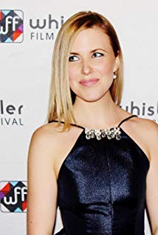
Tianna Nori is an actress and producer, known for The Sublet, The Demolisher, Bite, Save Yourself, the TV Series Untouchable, Inspiration, Therapy and Northern Lights of Christmas

CHAD CONNELL

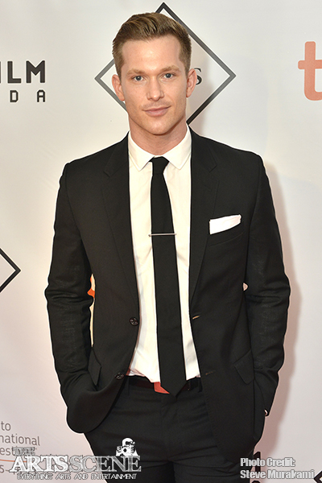
Born in Ottawa, Ontario, Canada, Chad started performing in local productions at a young age. He landed a few roles in Montreal; just enough to keep him busy in High School. He then took time off to attend the Ryerson University Theatre School Drama Programme, from which he graduated in 2006.

JENNIFER VALLANCE
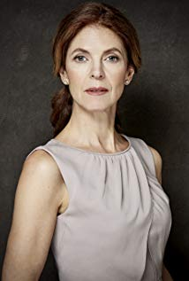
Jennifer (Reid) was born and educated in the south of England and traveled the world as a photographer before becoming a business owner in London. She emigrated to Canada is 1989 and became a singer, dancer, composer and actor in plays, musical theatre, and was the co-founder and co-songwriter in the rock band Rules of Seven. She raised 2 children as a single parent and owns her film company Girl On A Wire Productions. Now living in Toronto.

SAMANTHA MADELY
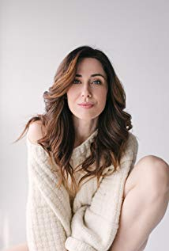
Samantha Madely is an actress and assistant director, known for The Art of More, Heroes Reborn, Gunshot, Ransom, Gutshot, the TV Series' In Contempt, No Easy Days and Murdoch Mysteries.

Production Credits

Full Cast
Actors  ERICA DEUTSCHMAN  TIANNA NORI  CHAD CONNELL  JENNIFER VALLANCE  SAMANTHA MADELY  KAREN WADDELL  JUSTINEEYRE  RON KOLOGIE  RICHARD NASH  BRITTANY ADAMS  CHRIS VIOLETTE | Role  Lauren  Colleen  James  Joyce  Maryam  Helen  Gineen  Ian  David  Kelly  Cousin Peter

Produced by
TIMOTHY O. JOHNSON |  | executive producer
ANDREW C. ERIN |  | executive producer
HAYDEN BAPTISTE |  | producer
BONNIE ZIPURSKY |  | producer

Directed by
M.J. GRABIAK

Written by
BARBARA KYMLICKA

Director of Photography
MARTIN BUZORA

Film Editing by
BRIAN NOON

Casting By
RON LEACH, C.D.C.

Production Design by
DANIEL MARKWORTH

Costume Design By
SARAH A. CARROLL

Full Crew
AINSLIE S. WIGGS  MARIO SCENNA  BEN HRKACH  JOHNNY ROSS  MACRAE MARTIN  NICOLE VIENS-BRENNAN  NIAMH O’KELLY  MARTIN BUZORA  CHRISTOPHER BERTI  CAMERON PREYDE  JULIEN MAMAZZA  JONAH HART  ASHRAF ASFOUR  JEFF BRAY  PETR MAUR  DANIEL MARKWORTH  ANDY DEUTSCHLANDER  ELIZABETH ROSS  LUNDEY LAYNE  KIRK KNAPP  ERIKA HILLE  MICHAEL WILLIAMS  SARAH A. CARROLL  ELLA JAMES-BESWICK  DEBORAH RING  STEVEN BRUNI  JESSICA DOUCET  NICK CROSSE  JADE BACON  HUNTER BREEN  MADISON MOORE  SAMNANG TEP  NINA BAINS  PHIL PINEAU  JONATHAN LAWLESS  FRANCESCO FALSETTO  MARCUS LAUTENBACH  KIRK KNAPP  SONIC LIGHTNING ENTERTAINMENT  BRIAN NOON  MICHAEL PEMBROKE  STEPHANE GREGOIRE  DREW EDWARD BULMER  ROBERT SWAITA  KS ON THE KEYS  YOUSEF GHADBAN  (TWO FRIENDS CATERING)  ARIAN-ALEX ASANJARANI  SHANNON ASANJARANI  MADISON BARR  KARA FRAWLY  AINSLIE S. WIGGS  AINSLIE CASTING  NICOLE VIENS-BRENNAN | Production Manager  First Assistant Director  Second Assistant Director  Third Assistant Director  Production Accountant  Office Production Assistant  Director of Photography  First Assistant Camera  Second Assistant Camera  Camera Operator  B Camera First Assistant Camera  Data Management Technician  Stills Photographer  Production Designer  Art Director  Set Dressers  Graphic Designer  Script Supervisor  Costume Designer  Set Costumer  Daily Wardrobe  Gaffer  Best Boy Electric  Key Grip  Best Boy Grip  Key Make-up  Key Hair  Location Manager  Assistant Location Manager  Location Production Assistants  Sound Mixer  Boom Operator  Sound Company  Picture Editor  Transport Coordinator  Drivers  Catering  Craft Service  Security  Extras Casting  Post Production Accountant

Producer Biographies

TIM JOHNSON – Executive Producer
Tim Johnson is among the most active and reliable producers in the business thanks to top rate productions and global distribution appeal.
Johnson is also responsible for producing the international hit series, DR. QUINN, MEDICINE WOMAN for CBS for over 5 seasons. During his 100-episode tenure, he also developed and produced the original docu-drama COLD CASE for CBS network, which was the very first program to integrate television with the Internet.
Johnson has produced over 150 movies, 15 globally released series for every major US network - including ABC, Disney, CBS, NBC, Netfly, FOX and Sony.

JOHNSON PRODUCTION GROUP
The Johnson Production Group contracts globally to produce television and motion picture content for international networks, studios and distributors. Based in Los Angeles and Vancouver, British Columbia, the company manages production, facilitates development and financing, procures distribution and guarantees quality and timely execution of its programs. While costs have gone up, so has the demand for quality. No longer is good enough, good enough. Johnson Production Group serves that segment when a show needs to be "A" quality, but produced efficiently enough to meet a locked budget. JPG specializes in value, protection of creative elements, and delivery of a quality finished product.

ANDREW C. ERIN – Producer
Andrew Erin is a Canadian Writer/Director making a big splash in the US, and has produced, written and directed numerous commercially successful films.
His directorial debut, SAM’S LAKE, was an official selection at the Tribeca Film Festival and did an excellent theatrical run in select theaters around the country; distributed by Lionsgate Films. Andrew also wrote the script for the film.
Andrew’s directorial credits include, SIMPLE THINGS, produced for Screen Media Ventures and Universal Studios. Besides winning The Bob Clark Award for Best Director at the California Independent Film Festival, the film was commercially received.
Andrew has worked continuously as a writer/director, building a strong library of films in the Thriller/Horror genres with: Embrace of The Vampire, The Clinic, Final Sale, Confined and Toxic Skies.
His most recent project, HAVENHURST was recently acquired by Lionsgate, set for release 2016. It was written, directed and produced under his own banner, along with Twisted Pictures.

HAYDEN BAPTISTE - Producer
Hayden Baptiste is a Producer and Development Executive with The Mob Entertainment, an LA Based production company with a Canadian office in Ontario. After spending nearly 15 years working as an Associate Producer for The Johnson Production Group and working as an Independent Producer in Toronto and Vancouver, Hayden has evolved into a well rounded producer who understands all aspects of production from development to delivery.
Hayden has produced films for various networks including CBC, Bravo, The Hallmark Network, UP TV and Lifetime Network. His films have been selected for film festivals around the world including the Montreal World Film Festival, Atlantic Film Festival, Screamfest, Catalina Film Festival, National Screen Institute and Chicago International. In addition to his extensive production experience, Hayden is a screenwriter and composer.
Hayden has studied at the Canadian Screen Training Centre, and completed the summer intensive screenwriting program at UBC.
Selected Credits
2017 Sweetheart (Producer)
2017 Christmas Festival Of Ice (Producer) Hallmark Network
2017 Precious Things (Co-Executive Producer)
2016 Eyewitness (TV Movie) (Co-Executive Producer)
2016 The Rooftop Christmas Tree (TV Movie) (Co-executive Producer) UP TV
2013 Leave Us Alone (Short) (Executive Producer) / (Producer) *Winner Catalina Film Festival
2011 From Darkness (Short) (Executive Producer)
2011 Three Weeks, Three Kids (TV Movie) (Associate Producer) Hallmark Network
2010 Confined (Associate Producer) The Movie Network
2009 Kick Me Down (Producer)

M. J. GRABIAK - Director
Marita is veteran Television Director/Writer, with 40 credits in episodic television in a wide range of genres, having directed repeatedly for the top producers in the USA; Joss Whedon, J.J. Abrams, and John Wells. Was hired by Ryan Murphy to be one of the first female directors on American Horror Story. Her TV Movies, both Thrillers and Romantic Comedies, have been highly rated on Lifetime and Hallmark Channels.
In addition to averaging at least 3 TV movies per year, in 2018, she directed V Wars for Netflix. A versatile director, as strong with obtaining great performances, as she is technically with camera, she is very adept with the design of action and CGI sequences.
Marita had thousands of hours of film production experience, before she made the move into Television Directing on the long running series ER in 2001. She has worked successfully with acclaimed actors such as; Lady Gaga, Cuba Gooding Jr.,Emma Stone, Kathy Bates,Sarah Paulson, George Clooney, Sally Fields, and is known for elevating performances of young and lesser experienced actors.
A talented global filmmaker, with cameras and drone in hand, she has explored some of the most remote places on earth. Her journeys provide her with rich and fascinating life experiences, which resonate profoundly in her work. In 2017, she undertook an expedition through the jungles and mountains of Papua New Guinea and the Solomon Islands, where she photographed tribal peoples, wildlife, and explored many WWII sites such as Guadalcanal. In 2018 she continued in the Lower Solomon Islands and the countries of Vanautu and New Caledonia, where she interviewed indigenous peoples on small islands, who have never encountered outsiders.
Past adventures include; filming Victoria Falls from every angle, (including White Water Rafting down the Zambezi River), covering Normandy during the 70th Anniversary of D Day, and Road Trips spanning from Europe, Central Asia, to Japan. Her poetical documentary "The Silk Road in Central Asia", (as a one person crew in Uzbekistan & Turkmenistan) is a one of her best writing examples.
Raised in a small town near Pittsburgh, Pennsylvania, she attended Carnegie Mellon University for theater, and graduated from UCLA with a B.A. Major in Motion Picture/Television, and a Minor in Art History. Her experiences includes working in NYC Off Broadway Theater, and as a Story Analyst for Independent Feature companies. For a decade, she was one of Hollywood’s top Script Supervisors on high budget features, filmed everywhere in the USA, and as far away as Malaysia.
Marita's inspirations comes from the study of theater and film history, art, architecture, ancient civilizations, current cultural anthropology, and classic literature.

Billing Block

Johnson Production Group Presents “A CHEERFUL CHRISTMAS”
ERICA DEUTSCHMAN TIANNA NORI CHAD CONNELL JENNIFER VALLANCE and SAMANTHA MADELY Casting by RON LEACH, CDC Production Designer DANIEL MARKWORTH Edited by BRIAN NOON Director of Photography MARTIN BUZORA COSTUME DESIGN BY SARAH A. CARROLL Executive Producer TIMOTHY O. JOHNSON ANDREW C. ERIN Produced by HAYDEN BAPTISTE BONNIE ZIPURSKY
Written by BARBARA KYMLICKA Directed by M.J. GRABIAK

With the participation of

The Canadian Film or Video Production Tax Credit
THE PRODUCERS WISH TO THANK THE CITY OF OTTAWA
© MMXVIII Christmas Coach Productions Inc. All Rights Reserved
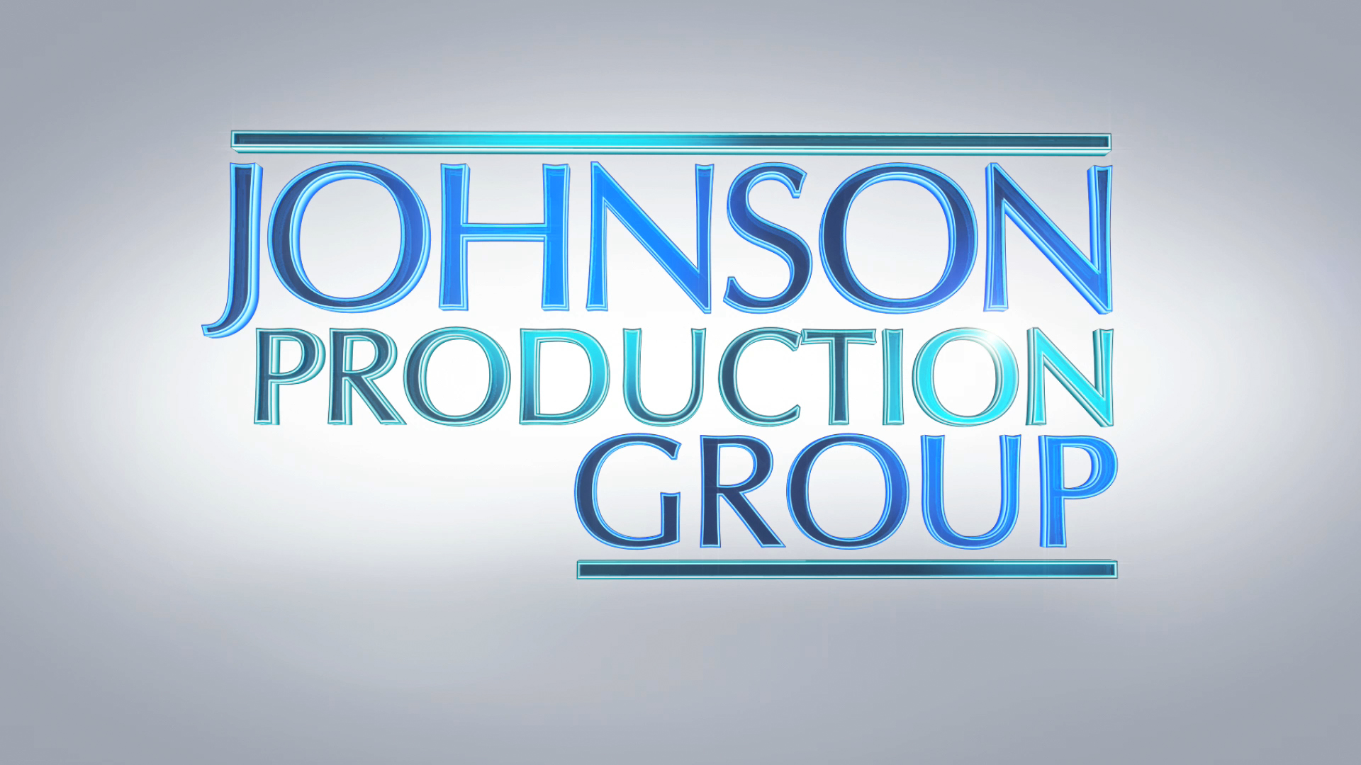
Meta Data
LONG (max 3000 characters) synopsis

Lauren and her best friend Colleen think they have landed the dream job… giving people the best and most magical Christmas ever as their personal "Christmas Coaches". This holiday season promises to be their biggest ever when they land a royal client, The Anderson family, who have moved from England. When Lauren meets the eldest son, James, he wants nothing to do with planning Christmas as he's busy negotiating a big acquisition for his father's company. Lauren, however, won't be thwarted in helping this royal family embrace the true spirit of Christmas and the more she prods James on their family holiday traditions, the more he opens up about himself. Soon sparks start to fly between Lauren and the handsome Prince, but competition arrives in the form of an old childhood friend and business colleague of James, Maryam. Now Lauren must win James' heart while also giving the Andersons the best Christmas they've ever had. (931)

MEDIUM (max 500) synopsis
Lauren and Colleen have the dream job as personal "Christmas Coaches". When Lauren meets the son of their new royal clients who have moved from England, James wants nothing to do with planning Christmas. Lauren prods him on their family holiday traditions and he finally opens up about himself. Soon sparks fly between between them, but competition arrives in the form of his old friend and colleague, Maryam. Lauren must win James' heart while also giving his family their best Christmas ever. (495)
SHORT (max 100 characters) synopsis
Lauren falls for the son of a royal client while trying to deliver the most magical Christmas ever (99)
5 KEY WORDS
royal, romance, party planner, friends

