Johnson Production Group

Press Kit

One-Liner

When a struggling housewife poses as a potential buyer to help her boss close real estate transactions, she discovers her boss will do anything to close a deal - even murder.

Synopsis
Shelby Adams and her husband, Grant, struggled to get by. They had a hard time paying the rent on their house and keeping up with the bills in today’s economy. Something had to be done and Shelby was the one that took the initiative.
Getting her real estate license, Shelby wanted to make money while Grant’s indecisions and insecurities caused friction between them. He had a low paying job and was resigned that it would be his lot in life. They were feeling the strain on their relationship.
However, everything changed when Paulette entered their lives.
Paulette was a successful realtor that claimed she saw something in Shelby that she admired. She offered Shelby a job to assist Paulette with her real estate ventures. It would be the opportunity Shelby had been waiting for.
Yet Paulette’s business practices seemed unconventional. She had Shelby pretend to be potential buyer to pressure sales. She also had Shelby pretend to be expert on mold in order to claim there were no problems with a property. Shelby was wary but Paulette always had an answer. There was always an excuse. Paulette was good at manipulating people - including Shelby. After all, Paulette had a dream project she wanted to do and wanted Shelby to be part of it. Paulette had a financial backer and all she needed was time to put the deal together. Shelby was all ears. Paulette had Shelby under her thumb.
In the end Shelby saw through Paulette’s nefarious schemes. Shelby couldn’t be a corrupt salesperson. Shelby decided to quit and make her own dream project with Paulette’s money guy. She had learned enough and was ready to go on her own. It was a bad move.
What Shelby didn’t know, was no one ever crossed Paulette. When you did, people tended to die.

Producers
Executive Producer
TIMOTHY O. JOHNSON
Producer
KEN SANDERS
Producer
ROBERT BALLO

Key Cast
CHARACTER  Paulette Bolton  Shelby Wilson  Grant Wilson  Max Rhaymer  Walter  Charlotte |  | ACTOR  JOSIE DAVIS  BRITTANY UNDERWOOD  MICAH ALBERTI  KEVIN SPIRTAS  BRAD LEE WIND  AMANDA MUSSO

Key Cast Biographies

JOSIE DAVIS
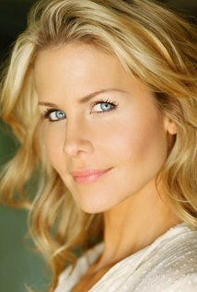
Josie Davis began her career acting in commercials at the age of three years. She played Sarah Powell, a quiet, bookish character, on Charles in Charge for four seasons.
Beginning as a teenager, Davis began studying acting with the Brooklyn-born Paul E. Richards—Lee Strasberg's "right-hand man" at the Actors Studio in the 1950s. At 24, she auditioned and became a member of Actors Studio. At the time, the judges were Martin Landau, Mark Rydell, and Shelley Winters. Josie was one of only two performers selected to join that year.
Davis was cast as Camille Desmond on Beverly Hills, 90210 in 2000. She then was cast in the other Aaron Spelling show, Titans opposite Victoria Principal and Yasmine Bleeth.
Her other television credits include working opposite Clifton Collins Jr. on Fear Itself, with David Spade on Rules of Engagement, with James Woods on Shark, Ghost Whisperer, a Christmas episode of Two and a Half Men, NCIS, CSI: Miami, Burn Notice, Chuck, Bones, and a recurring role opposite Skeet Ulrich and Gary Sinise on CSI: NY.
After Titans came to an end, Davis left TV to pursue film work. She acted in a number of films, including the Nicolas Cage-directed Sonny, opposite James Franco and Scott Caan, The Trouble with Romance with Kip Pardue, and Kalamazoo? with Mayim Bialik, among many other indies.
She was also the lead actress in the television movie The Perfect Assistant, which premiered on Lifetime on January 2, 2008.
Josie's many film rolls included thrillers The Perfect Student with Natasha Henstridge, Seduced by Lies with Lochlyn Munro and Marc Menard, Past Obsession with Lochlyn Munro and comedy Stealing Roses with John Heard and Cindy Williams. Davis not only is an actress, but has ventured into producing and is also a screenwriter.

BRITTANY UNDERWOOD
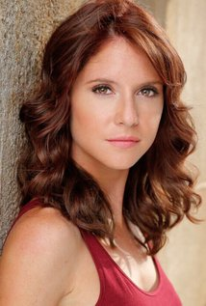
Brittany Underwood was born on July 6, 1988 in Newark, New Jersey, USA. She is an actress and producer, known for One Life to Live (1968), Game Change (2012) and Margaret (2011).

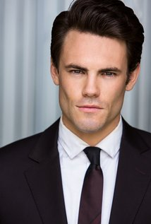
MICAH ALBERTI
Micah Alberti, born on August 19, 1984 in Oregon, Wisconsin, USA, is an American model and actor. Alberti began modeling as an adolescent and snagged his first acting gig playing James Edward Martin on All My Children. After his one-year stint on the soap opera ended, Alberti popped up in prime-time guest spots (8 Simple Rules, Smallville) until he landed his breakthrough role on the ABC Family drama Wildfire as troubled teen Matt Ritter. In 2009 he starred in the cable thriller Xtra Credit as a convicted teen attending a prison-reform school who is seduced by a teacher desperate to get out of her abusive marriage.

KEVIN SPIRTAS
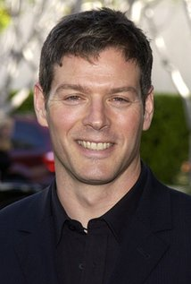
Kevin Spirtas is perhaps best known for his roles as Dr. Craig Wesley on the soap opera Days of Our Lives, Jonas Chamberlain on the ABC soap opera One Life to Live, and as Nick in the slasher film Friday the 13th Part VII: The New Blood (1988). Spirtas has worked on Broadway, with roles including Hugh Jackman's understudy in The Boy from Oz, and has also worked as a stunt performer. He began using the name "Kevin Spirtas" professionally in 1995, having been previously credited as "Kevin Blair".
In 2015, Spirtas portrayed Dominic Delacort on the soap opera web series Winterthorne. In 2016, he was nominated for an Indie Series Award for Best Guest Actor in a Drama, and a Daytime Emmy Award for Outstanding Actor in a Digital Daytime Drama Series for the role.

BRAD LEE WIND
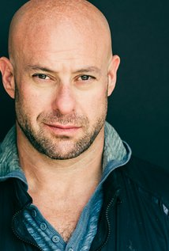
Brad Lee Wind was born in Brooklyn, New York City, USA. He is an actor, known for NCIS (2016), The Odd Couple (2016), It's Always Sunny in Philadelphia (2016), Stolen from the Suburbs (2015), Baby Daddy (2015), Jane the Virgin (2015), Mi America (2015), Castle (2015) Ridiculousness (2014), The Taking of Pelham 1 2 3 (2009), White Collar (2009), Ugly Betty (2008). Brad loves performing live on stage, large and small and can usually be seen in a play somewhere around town. On weekends he can be found at the beach playing volleyball or riding his Harley.

AMANDA MUSSO
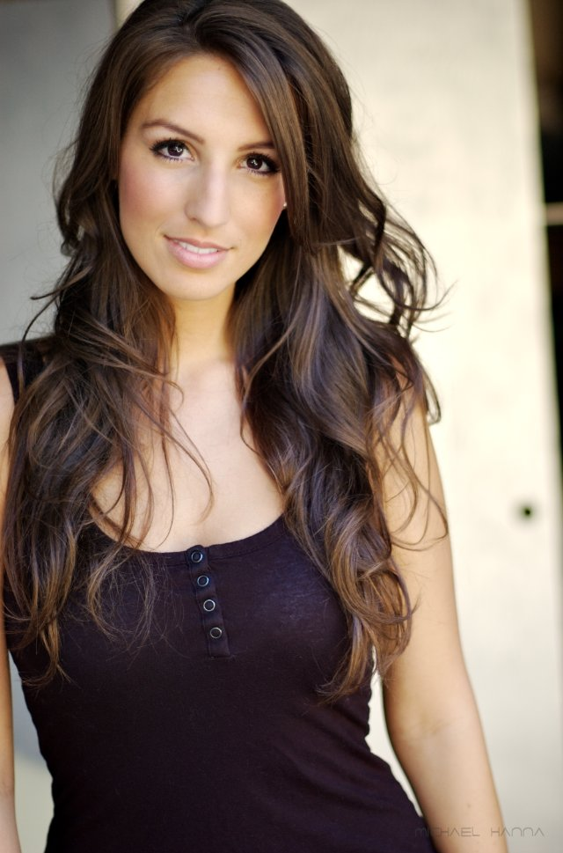
Born in Long Beach, California the only girl of three kids, Amanda Musso came to Los Angeles in 2004 to pursue an acting career. Prior to moving, Amanda graduated from Capistrano Valley High School in 2003 where she made her footprint in the theater world. After graduating she was accepted into the American Musical and Dramatic Academy of Los Angeles. Once in L.A., Amanda worked diligently, training and preparing for her performances at the Academy, before landing a co-star/stunt role on the highly successful sit-com "Two and a Half Men" (2005). In that same year, Amanda graduated from AMDA, and booked her first commercial for The World Poker Tournament along side Phil Hellmuth, World Poker Champion. Soon after her first television and commercial bookings, she was one of the stars in the online and YouTube sensation, "Lindsay Fully Loaded" (2007) and quickly booked another co-star role in the new NBC detective series "Life" (2007). Her first feature films came in 2008 with the role of Candice in the romantic comedy "Screw Cupid", following with the role of Eddie Murphies receptionist in "A Thousand Words" (2009) and a co-starring role in NBC's remake of "Knight Rider" (2009). Since then she has appeared on stage in Durango, CO in George M. Cohens, "The Tavern" and as Magenta in "The Rocky Horror Picture Show". She also co-stars in numerous short films, including "Thanks for Dying", "The Newest Pledge", and "Alter Ego ". She is excited about the completion of her most recent work on the Emmy Award Winning show "Modern Family" co-starring in the new 2011 season and guest starring in Cedric The Entertainers new Pilot, "All Rise".

Production Credits

Full Cast
GRANT WILSON  MAX RHAYMER  WALTER  FELICIA  CHARLOTTE  JERRY SYMERTON  TYSON  AMANDA  LAWRENCE  BOBBY NELSON  BETH  COP  SEAN  DAVID | Micah Alberti  Kevin Spirtas  Brad Lee Wind  Taji Coleman  Amanda Musso  Charles Christopher  Justin Arnold  Janna VanHeertum  Dan Louis  Josh Fingerhut  René Ashton  Ace Underhill  Leif Carlgren  Henry Bonilla

Produced by
Timothy O. Johnson |  | executive producer
Ken Sanders |  | producer
Robert Ballo |  | producer
Marianne C. Wunch |  | line producer

Directed by
Doug Campbell

Screenplay Written by
Raul Inglis
J. Bryan Dick

Music by
Kevin Blumenfeld

Film Editing by
Gregory Hobson

Casting By
Jeff Hardwick, C.S.A.

Production Design by
Rebecca Balzano

Director of Photography
Eric Roy Anderson

Costume Design by
Anna Lloyd-Jones

Makeup Department
Lauren Nicole Guzman |  | key makeup & hair stylist
Patrick Anthony Lising |  | makeup & hair swing
Cecilia Quezada |  | makeup & hair assistant

Assistant Directors
Daniel Ringey |  | first assistant director
Laila Petrone |  | first assistant director
Tina Martin |  | second assistant director
Deborah Schlaff |  | 2nd second assistant director

Art Department
Ben Brecher |  | prop master
Sasha Wulf |  | assistant prop master
John Paul Acosta |  | set dresser
Lauren Miller |  | art department swing
Jay Valine |  | art department swing

Sound Department
Darryl Williams |  | production sound mixer

Camera and Electrical Department
Isaac Han |  | best boy electrics
Theodore Hyppolite |  | best boy electrics
Nash Dutton |  | electrician
Silas Robinson |  | key grip
Dennis Pires |  | key grip
Benjamin Cumming |  | gaffer
Ben Goldberg |  | gaffer
Walter Orsini |  | best boy grip
Gavin Davenport |  | best boy grip
Brayton Austin |  | company grip
John Fisher |  | company grip
Joseph M. Setele |  | camera operator
Megan Johnson |  | a camera first assistant
Chris Galano |  | a camera first assistant
Lauren Peele |  | b camera first assistant
Eric Kim |  | second assistant camera
Kevin Hahn |  | second assistant camera
Jeremy Peele |  | second assistant camera
Brandon Keith Osborn |  | second assistant camera

Casting Department
Morgue N. Marcus  Little Bird Casting |  | extras casting director

Costume and Wardrobe Department
John C. Houston IV |  | wardrobe supervisor
Tiffany Maxwell |  | wardrobe assistant
Nikki Esquibel |  | wardrobe assistant

Transportation Department
James Quattrochi |  | transportation captain
Chase Parsons |  | Transportation production assistant
Will Lee |  | Transportation production assistant

Other crew
Thijs Bazelmans |  | media manager
Skylar V. Smith |  | media manager
Charles Christopher |  | still photographer
April McQuarrie |  | script supervisor
Sheila Ryan |  | location manager
Sean B. Hernandez |  | assistant location manager
Val Blakely |  | location scout
Jason Albanese |  | medic
Denise Bennett |  | production accountant
Michael Dumin |  | key set production assistant
Eric Wiseman |  | production assistant
Jordan Roman |  | production assistant
Joe Boi |  | production assistant
Chris Matosian |  | production assistant
Sean Patterson |  | production assistant
Joel Halstead |  | craft service
CF Food Kitchen |  | caterer
Edward Flores

Second Unit
Buzz Hughes |  | first assistant director
Joseph M. Setele |  | director of photography
Lauren Peele |  | camera first assistant
Roland Quiambao |  | production sound mixer

Post Production
Thijs Bazelmans |  | assistant editor
Griff Partington |  | post production supervisor
Shadowland, LLC |  | stock footage
GOAL Productions, Inc |  | camera equipment
Cinestache |  | grip and lighting equipment
Wilcox Sound & Communications |  | production sound equipment
Dennis Whitcomb  Hollywood Script Research |  | script clearance
Giovanni Cuarez  American Entertainment Insurance Services |  | production insurance
Shadowland, LLC |  | los angeles production services

Producer Biographies

TIM JOHNSON – Executive Producer
Tim Johnson is among the most active and reliable producers in the business thanks to top rate productions and an 'on time, on budget' reputation. Previously, he managed the production of ABC's THE DAYS (MINDSHARE/TOUCHTONE.) Prior to forming Johnson Production Group and Ignite Entertainment, Tim served as Head of West Coast Programming Executive and launched the successful series DOC (88 episodes,) SUE THOMAS, FBI, MYSTERIOUS WAYS, JUST CAUSE, PONDEROSA, CHRISTY, ITS A MIRACLE AND MIRACLE PETS.

Johnson is also responsible for producing the international hit series, DR. QUINN, MEDICINE WOMAN for CBS PRODS/SULLIVAN COMPANY for over 5 seasons. During his 100-episode tenure, he also launched LIVE FROM THE RANCH with Orson Bean - a nationally syndicated talk show focusing on family values in America. He also developed and produced the original docu-drama COLD CASE for CBS network, which was the very first program to integrate television with the Internet.

Recent Projects:
For Better or For Worse – Executive Producer
Baby Bootcamp – Executive Producer
Ring By Spring – Executive Producer
Sole Custody – Executive Producer
The Cheating Pact – Executive Producer
Deadly Spa – Executive Producer
Walking the Halls – Executive Producer
June In January – Executive Producer
Christmas in the City – Executive Producer
Snow Bride – Executive Producer
Dirty Teacher – Executive Producer
The Surrogate – Executive Producer
Merry In-Laws – Executive Producer
A Bride for Christmas – Executive Producer
Naughty or Nice – Executive Producer
Christmas Crush– Executive Producer
Teenage Bank Heist– Executive Producer
How to Fall in Love – Executive Producer
Home Invasion (2011) – Executive Producer
Final Sale (2011) – Executive Producer
Confined (2010) – Executive Producer
Tornado Valley (2009) – Executive Producer
The Wedding Dance (2009) – Executive Producer
Trust (2009) – executive producer
Toxic Skies (2008) – executive producer
Storm seekers (2008) – executive producer
Making Mr. Right (2008) – executive producer
Love Sick (2008) – executive producer
Just Breathe (2008) – executive producer
Devils Diary (2007) – executive producer
Swarm (2007) – executive producer

JOHNSON PRODUCTION GROUP
The Johnson Production Group contracts globally to produce television and motion picture content for international networks, studios and distributors. Based in Los Angeles and Vancouver, British Columbia, the company manages production, facilitates development and financing, procures distribution and guarantees quality and timely execution of its programs. While costs have gone up, so has the demand for quality. No longer is good enough, good enough. Johnson Production Group serves that segment when a show needs to be "A" quality, but produced efficiently enough to meet a locked budget. JPG specializes in value, protection of creative elements, and delivery of a quality finished product.

KEN SANDERS – Producer
Over the past decade and a half, Ken Sanders has written and/or produced over forty feature-length motion pictures. Since starting his film production company, Shadowland, LLC, with partner Robert Ballo in 2009, Sanders has also produced THE CHEATING PACT, MISSING AT 17, THE PERFECT BOYFRIEND, DIRTY TEACHER, THE SURROGATE, STALKED AT 17, TEENAGE BANK HEIST, WALKING THE HALLS, BETRAYED AT 17, HOME INVASION, MATERNAL OBSESSION, and ACCUSED AT 17, all of which received big ratings when they premiered on Lifetime Television.
From 2001 to 2008, Sanders partnered with prolific Hollywood producer Pierre David and produced eight made-for-TV movies in Canada. Sanders co-wrote many of the films, including ‘TIL LIES DO US PART, MAID OF HONOR, STRANGER AT THE DOOR, THE PERFECT HUSBAND, SAVING EMILY, and A KILLER UPSTAIRS.
Prior to partnering with David, Sanders served as Vice President of Production at WIN Ventures, a division of World International Network, a leading supplier of independent feature films and made-for-TV movies. During his tenure at WIN Ventures Sanders oversaw the development, production, and post-production of roughly twenty films a year, including LIVING IN FEAR, FACING THE ENEMY, and SHE’S NO ANGEL, and many more which aired on the USA Network, Court TV, HBO, Showtime, Cinemax, and The Movie Channel.
In the mid-1990s, Sanders worked as the Vice President of Creative Affairs at Image Organization, helping to develop and oversee such theatrical projects as LITTLE MEN (released by Warner Brothers) and WISHMASTER (released by Artisan), the latter of which went on to become the highest-grossing independent feature film of 1997.
At the beginning of his career, Sanders worked as the Director of Development at High Five Productions, helping to prepare such television specials as THE JUDDS FAREWELL CONCERT and THE WOMEN OF COUNTRY. He also worked for media mogul Ted Turner, doing a stint as a promotions producer for CNN and SuperStation WTBS.
In addition to his film and television work, Sanders has served as an adjunct professor at Biola University, where he taught classes on producing and screenwriting. He is also a frequent guest lecturer at Los Angeles Valley College and the Los Angeles Film School, where he speaks on topics ranging from the business of film to post-production to pitching and script development. Sanders received his degree in Filmic Writing from the University of Southern California, School of Cinematic Arts.
ROBERT BALLO –Producer
With over 34 years of industry experience, Robert Ballo has created award-winning productions for clients that include ABC, TBS, PBS, Discovery Channel, and Lifetime, and that have aired on national network television, cable networks, and internationally in Asia and Europe. As Director of Photography and Producer at Shadowland, Ballo has created over a dozen feature films seen on the Lifetime Network and distributed internationally. As Director of Photography, his Shadowland films include MISSING AT 17, THE SURROGATE, STALKED AT 17, TEENAGE BANK HEIST, WALKING THE HALLS, BETRAYED AT 17, HOME INVASION, MATERNAL OBSESSION, ACCUSED AT 17 and SPECTRES. Other feature film credits include RUNNIN' AT MIDNITE, THE AFFAIR and STARVING ARTISTS. Ballo has also traveled the world on many documentary productions.
His television credits for national broadcast and cable networks include COLLEGE SPORTS IN AMERICA, GREAT EUROPEAN BALLOON ADVENTURE, DIRTY HARRY THE ORIGINAL, THE GREAT YEAR, and THE ROSE PARADE - PAGEANT FOR THE AGES. Through his other digital motion picture company, GOAL Productions, Ballo works with Fortune 500 companies, non-profit organizations and government agencies to produce sales and marketing videos as promotional communications.
After a twenty-year tenure teaching film and video imaging, Ballo recently retired from his position as an Associate Professor of Practice at USC’s School of Cinematic Arts. A graduate of the USC film production program himself, Ballo is a member of the Academy of Television Arts and Sciences.

DOUG CAMPBELL – Director
Lately Doug has been directing feature films with his friends Producer Ken Sanders and Producer/DP Robert Ballo. Since 2009 they have completed multiple features which have all been acquired by Lifetime. Doug has directed 21 feature films (twelve of which he wrote or co-wrote), 18 hours of network TV, four commercials and 20 short subjects. His projects have appeared in theaters and on TV across the world. Domestically, CBS, HBO, Lifetime, Showtime, Fox, PAX-TV, The Family Channel and other networks have broadcast my work. A film he financed, wrote and directed, THE TOMORROW MAN, was nominated for Best New Live Action Feature, Best Director and Best Screenplay in the 2001 DVD Premiere Awards sponsored by Daily Variety Magazine. Doug took home the Best Director Award.
Growing up in the San Fernando Valley north of Los Angeles, Doug made his first Super-8 when he was fourteen. After studying under Sandy Mackendrick at California Institute of the Arts, he directed his first feature film at age 24. Since then, shooting low budget films and TV has taught him to work fast, get the good performance and keep it fun. Having directed different genres (action, family adventure, children's television, documentary, sci-fi and teen comedy), his favorites are thriller and drama. In 2003 Jikei schools asked Doug to design the curriculum and launch a new film school, Tokyo Film Center School of Arts. Currently he teaches at Academy of Art University in San Francisco under Executive Director Diane Baker. “Filmmaking is something knew I wanted to do as a kid, and I can't imagine doing anything else.”

Billing Block

Johnson Production Group Presents “BACKSTABBED”
Josie Davis Brittany Underwood Micah Alberti
Kevin Spirtas Brad Lee Wind Amanda Musso
Edited by Gregory Hobson Music by Kevin Blumenfeld
Director of Photography Jeff Hardwick, csa
Executive Producer Timothy O. Johnson Produced by Ken Sanders Robert Ballo
Written by Raul Inglis J. Bryan Dick Directed by Doug Campbell
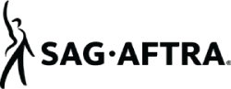

FilmLA

Paula Loos

© MMXVI Johnson Management Group. All Rights Reserved

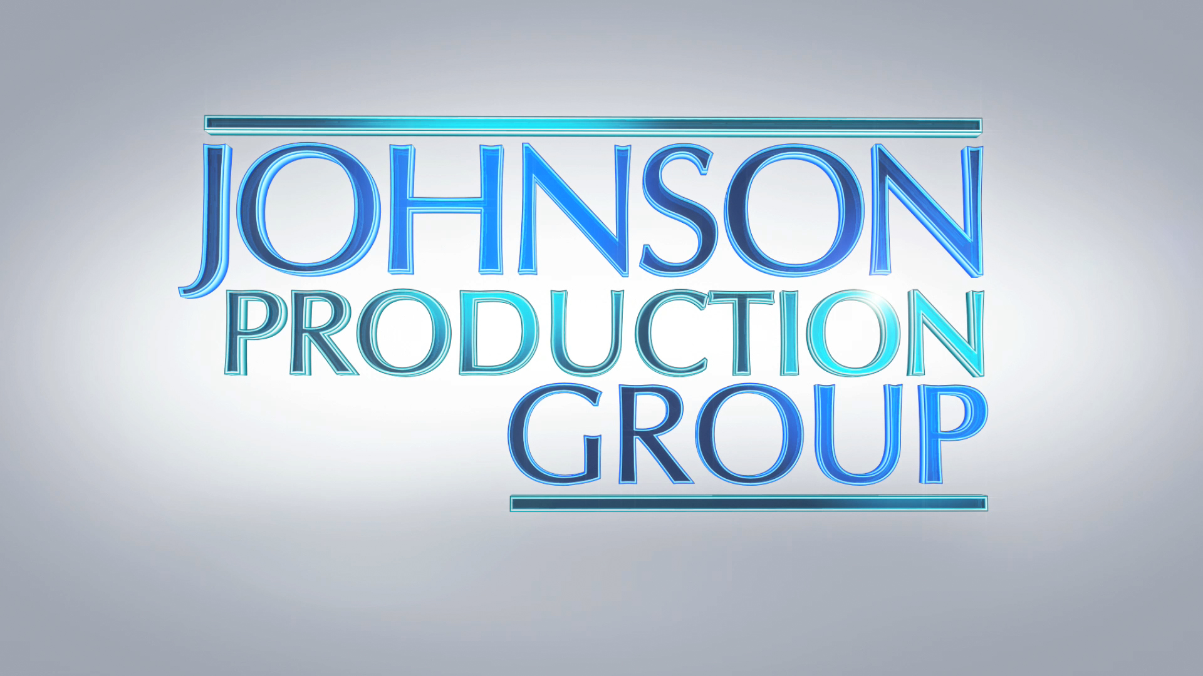

META DATA

LONG (max 540 characters) synopsis
Shelby Adams and her husband struggled to get by so Shelby took the initiative by getting her real estate license. Paulette was a successful realtor that claimed she saw something in Shelby she admired and offered her a job as an assistant with her real estate ventures. Paulette’s business practices seemed unconventional. Shelby was wary but Paulette always had an answer. When Shelby thought she had learned enough and was ready to go on her own, things took a very dark turn. What Shelby didn’t know was no one ever crossed Paulette.
(537)

MEDIUM (max 180) synopsis
When a struggling housewife poses as a potential buyer to help her boss close real estate transactions, she discovers her boss will do anything to close a deal - even murder. (174)

SHORT (max 54 characters) synopsis
Paulette will do anything to close deal, even murder (53)

5 KEY WORDS
Thriller, Murder, Backstabbed, real estate

