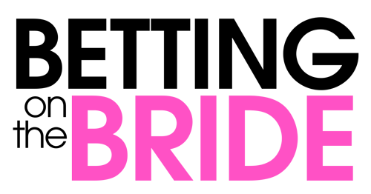
Johnson Production Group

Press Kit

One-Liner
Take a chance on love

Synopsis
Mel had always hoped that by thirty she’d be married to the perfect husband. And she’s come close, three times to be exact. But every time she became engaged her newly minted fiancé would reveal his true colors. There was Darren - the cheater, Trent - who revealed he didn’t want children, and lastly Will - the momma’s boy. Disillusioned, Mel has decided to focus on her career as an event planner and has sworn off marriage for good. Enter Damon, an average guy and local weather man. He’s the “nice” guy, the one girls call “a friend”. Unbeknownst to Mel, Damon has just placed a bet with his friends to prove that he’s not just the shoulder girls use to cry on, betting he could get a girl to say yes to his marriage proposal in just thirty days. When Damon picks Mel as the woman to place his bet on he promptly hires her to oversee his parent’s 25th wedding anniversary party as a way to get to know her. At first Damon tries to win her over by shedding his nice guy ways and be “cool”. But all his efforts at not being himself fall comically flat. It’s his sincerity and kindness that has Mel intrigued…and suspicious; after all her last three boyfriends were also too good to be true. But time and again Damon proves to Mel that he is genuine, from the sweet stories his parents share with her about Damon to the time Damon stands up to her beloved niece’s bully. So despite herself - and to her mother’s joy - Mel finds herself falling in love with Damon. Even though it wasn’t part of the bet, Damon finds he’s also falling for Mel and her infectiously impulsive ways. But their love story is overshadowed by Damon’s knowledge of the bet and the antics of Mel’s last fiancé Will - a handsome hunk who tries to win Mel back. When Damon realizes he has truly fallen in love with Mel he calls off the bet and proposes to her with a clean conscious. Mel - who has been reassured that Damon is the real deal - says “yes”! But her joy is short lived when Will learns of the bet Damon placed on her and spills the beans. Mel is devastated and so yet again breaks off the engagement. It is now up to Damon to prove that despite the bet he is still the same “nice” guy Mel fell in love with and the man Mel should marry.

Producers
Executive Producer
TIMOTHY O. JOHNSON
Producer
OLIVER DE CAIGNY
Supervising Producer
NAVID SOOFI

Key Cast
CHARACTER  Melanie Banning  Damon Hadley  Joanna Banning  Anna Banning |  | ACTOR  KARISSA LEE STAPLES  PETER MOONEY  CINDY BUSBY  KIM DELANEY

Key Cast Biographies

KARISSA LEE STAPLES
Karissa Lee Staples was born in Portland, Maine. At 19, after years of performing in community and professional theater productions, she moved to New York City to study at an acting conservatory before ultimately landing in Los Angeles. Staples is best known for her series regular roles as Victoria Jagger in the Gemini-nominated sitcom, "What's Up, Warthogs!" ('11) and Paloma Madsen in USA Network's, "Necessary Roughness" ('13).

PETER MOONEY
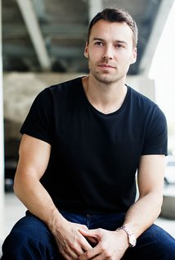
Peter Mooney was born on August 19, 1983 in Winnipeg, Manitoba, Canada. He is an actor and writer, known for Rookie Blue (2010), Camelot (2011) and Heroes Reborn (2015).

CINDY BUSBY
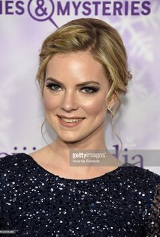
Cindy Busby was born in Montreal, Quebec, Canada. She is an actress, known for Heartland (2007), The Big Year (2011) and Unleashing Mr. Darcy (2016).

KIM DELANEY
Kim Delaney was born on November 29, 1961, in Philadelphia, Pennsylvania, and was raised in Roxborough. She is the daughter of Joan and Jack Delaney, who retired from Delphi Automotive, where he served as a committeeman for the United Auto Workers. She has four brothers: Ed Delaney and John Delaney, who are older than her, and Keith and Patrick Delaney, who are younger. As a cheerleader at John W. Hallahan Catholic Girls High School in Philadelphia, she dreamed of being a court reporter and settling close to home. Kim began her modeling career working for the Elite agency while still in high school. After graduation, Kim continued to model in Philadelphia and then headed for New York City, quickly winning commercials. She studied acting in New York with William Esper. She auditioned for Dynasty (1981) and Dallas (1978) , but lost out. When she auditioned for All My Children (1970), however, she got the part of Jenny Gardner, and in August 1981 her acting career took off. In the spring of 1983, she made her busy schedule even busier by performing in an off-Broadway play directed by Dorothy Lyman. She has been nominated for many acting awards, winning an Emmy Award for Outstanding Supporting Actress in a Drama Series for playing Diane Russell on NYPD Blue (1993). She has continued to star in both television and theater, as well as in films such as Rules of Engagement (1995) and Mission to Mars (2000). Kim Delaney lives in Los Angeles, California.

Production Credits

Full Cast
Actors  KARISSA LEE STAPLES  PETER MOONEY  CINDY BUSBY  WOODY JEFFREYS  KIM DELANEY  RON KOLOGIE  STEVE BARAN  ANDY THOMPSON  JESSE REID  LIA FRANKLAND  LAURA K. MACDONALD  CHRIS SHIELDS  CHRIS COPE  JEFF GLADSTONE | Role  Melanie Banning  Damon Hadley  Joanna Banning  Will Peters  Anna Banning  Gord Banning  Robert  Fred  Vince  Avery  Emma  Reverend Macey  Justin  Darren

Produced by
Timothy O. Johnson |  | executive producer
Oliver de Caigny |  | producer
Navid Soofi |  | supervising producer

Directed by
Marita Grabiak

Written by
Barbara Kymlicka

Music by
Russ Howard III

Cinematography by
Anthony Metchie, csc

Film Editing by
Jason Nielsen

Casting By
Judy Lee

Production Design by
Heather Coutts

Navid Soofi |  | production manager
Troy Scott |  | first assistant director
Jeff Croft |  | second assistant director
Tim Lanham |  | set decorator
Laura Maier |  | assistant set decorator
Rob Van Poelgeest |  | lead dresser
Sarah Stapleton |  | art director
Charlene Irani |  | on set dresser
Lauren Sominczuk |  | dressers
Cooper Debeck
David Olsen
Brittney Towson |  | property master
Sarah Stapleton |  | property assistants
Heidi Bazuta
Elizabeth Mcleod |  | make-up artist
Katelyn Abbott |  | hair stylist
Taylor Barron |  | swing
Stacey Bradder |  | costume designer
Miles Roberts |  | assistant costume designer
Linden Watt |  | set supervisor
Melissa David |  | truck costumer
Megan G.  Cindy J. |  | background costumers
Michael Krizaj |  | camera operator
Laurent Danis  Jerry Wang |  | first assistants camera
Maude Ducre |  | second assistants camera
Lena Ying
Daniel Leon Pitts |  | gaffer
Evan Kehoe |  | best boy
Sarah Kliewer |  | electric
Daniel Howard
Steve M.
Galan W.
Tyler Mcbean |  | generator operator
Oliver Rice |  | key grip
Slatie Chu |  | dolly grip
Danny Wattey |  | grip
Peter Gibson |  | transport coordinator
Chris Wild |  | transport captain
Pete Fiddler  Tracy Murray |  | drivers
Jeff Charlton
Doug Halvorson
Barry Hunt |  | security coordinator
Brendon Olsen |  | location manager
Jerome Turner |  | assistant location manager
Graham Bannerman |  | key location assistants
Tabitha Worby
Geoff Frostad
Christopher O’brien |  | production sound mixer
Heraldo Abreu |  | boom operator
Hanna Van Dijk |  | script supervisor
Matthew Santoro |  | script coordinator
Megan Turnbull |  | payroll accountant
Matthew Santoro |  | production coordinator
Damion Harper |  | third assistant director
Quinn Bresch |  | craft service/first aid
Chelsea Bresch
Austin Gourmet |  | catering
Brandon Crewe
Nabil Minnikh
Konstantin Minnikh
Ciarra Cook |  | casting assistant
La Hilts |  | extras casting
Jennifer Roberts |  | background coordinator
Andrea Whitburn |  | stand in
Coastal Clearances |  | script clearances by
Chandler Fogden Aldous  Law Corporation |  | legal services by
Front Row Insurance  Brokers |  | insurance by
Leah Myers |  | post production supervisor
Jeff Stojak |  | assistant editor
Devin Taylor |  | second assistant editors
Ron Penchalaiya
Evan Graves |  | visual effects
Seán Travers |  | colourist
Annuit Coeptis  Entertainment |  | picture post production  provided by
Finalé Post |  | additional post services  provided by
Cinescope Sound |  | audio post production
Gregor Phillips |  | supervising sound editor
 |  | re-recording mixers
 |  | dialogue editor
 |  | sfx editor
 |  | foley artists

Producer Biographies

TIM JOHNSON – Executive Producer
Tim Johnson is among the most active and reliable producers in the business thanks to top rate productions and an 'on time, on budget' reputation. Previously, he managed the production of ABC's THE DAYS (MINDSHARE/TOUCHTONE.) Prior to forming Johnson Production Group and Ignite Entertainment, Tim served as Head of West Coast Programming Executive and launched the successful series DOC (88 episodes,) SUE THOMAS, FBI, MYSTERIOUS WAYS, JUST CAUSE, PONDEROSA, CHRISTY, ITS A MIRACLE AND MIRACLE PETS.

Johnson is also responsible for producing the international hit series, DR. QUINN, MEDICINE WOMAN for CBS PRODS/SULLIVAN COMPANY for over 5 seasons. During his 100-episode tenure, he also launched LIVE FROM THE RANCH with Orson Bean - a nationally syndicated talk show focusing on family values in America. He also developed and produced the original docu-drama COLD CASE for CBS network, which was the very first program to integrate television with the Internet.

Recent Projects:
For Better or For Worse – Executive Producer
Baby Bootcamp – Executive Producer
Ring By Spring – Executive Producer
Sole Custody – Executive Producer
The Cheating Pact – Executive Producer
Deadly Spa – Executive Producer
Walking the Halls – Executive Producer
June In January – Executive Producer
Christmas in the City – Executive Producer
Snow Bride – Executive Producer
Dirty Teacher – Executive Producer
The Surrogate – Executive Producer
Merry In-Laws – Executive Producer
A Bride for Christmas – Executive Producer
Naughty or Nice – Executive Producer
Christmas Crush– Executive Producer
Teenage Bank Heist– Executive Producer
How to Fall in Love – Executive Producer
Home Invasion (2011) – Executive Producer
Final Sale (2011) – Executive Producer
Confined (2010) – Executive Producer
Tornado Valley (2009) – Executive Producer
The Wedding Dance (2009) – Executive Producer
Trust (2009) – executive producer
Toxic Skies (2008) – executive producer
Storm seekers (2008) – executive producer
Making Mr. Right (2008) – executive producer
Love Sick (2008) – executive producer
Just Breathe (2008) – executive producer
Devils Diary (2007) – executive producer
Swarm (2007) – executive producer

JOHNSON PRODUCTION GROUP
The Johnson Production Group contracts globally to produce television and motion picture content for international networks, studios and distributors. Based in Los Angeles and Vancouver, British Columbia, the company manages production, facilitates development and financing, procures distribution and guarantees quality and timely execution of its programs. While costs have gone up, so has the demand for quality. No longer is good enough, good enough. Johnson Production Group serves that segment when a show needs to be "A" quality, but produced efficiently enough to meet a locked budget. JPG specializes in value, protection of creative elements, and delivery of a quality finished product.

OLIVER DE CAIGNY - Producer
Oliver De Caigny is a Canadian producer originally from Belgium, his background in financing, production, and post production makes his a well-rounded producer for any type of production. His experience in financing and production agreements (film and TV series and movies-of-the week), distribution agreements (both domestic and foreign) as well as international co-productions, Canadian tax credit, Telefilm Canada and Canada Media Fund incentives provides him with a well-rounded background in development, production and distribution for motion pictures, television series and productions.
Recent Projects
Strange Empire (2014, 13 episodes) – Producer
Her Infidelity (2014) - Producer
Paper Angels (2014) - Producer
A Cookie Cutter Christmas (2014) - Producer
For Better or For Worse (2014) – Producer
A Ring By Spring (2014) – Producer
June In January (2014) – Producer
Baby Bootcamp (2013) – Producer
A Badge Of Betrayal (aka Sole Custody) (2013) – Producer
R.L. Stine’s: The Haunting Hour (53 Episodes) – Associate Producer
A Bride For Christmas (2013) – Producer
The Dating Coach (2012) – Producer
Radio Rebel (2012) – Executive Producer
Seattle Superstorm (2012) – Producer

Billing Block

Johnson Production Group Presents “BETTING ON THE BRIDE”
Karissa Lee Staples Peter Mooney Cindy Busby & Kim Delaney
Edited by Jason Nielsen Music by Russ Howard III
Director of Photography Anthony Metchie, csc
Executive Producer Timothy O. Johnson Produced by Oliver De Caigny
Supervising Producer Navid Soofi Casting Judy Lee Production Designer Heather Coutts Written by Barbara Kymlicka Directed by Marita Grabiak
With the participation of the Province of British Columbia
Film Incentive BC
The Canadian Film or Video Production Tax Credit
© MMXVII Bride Productions Inc. All Rights Reserved

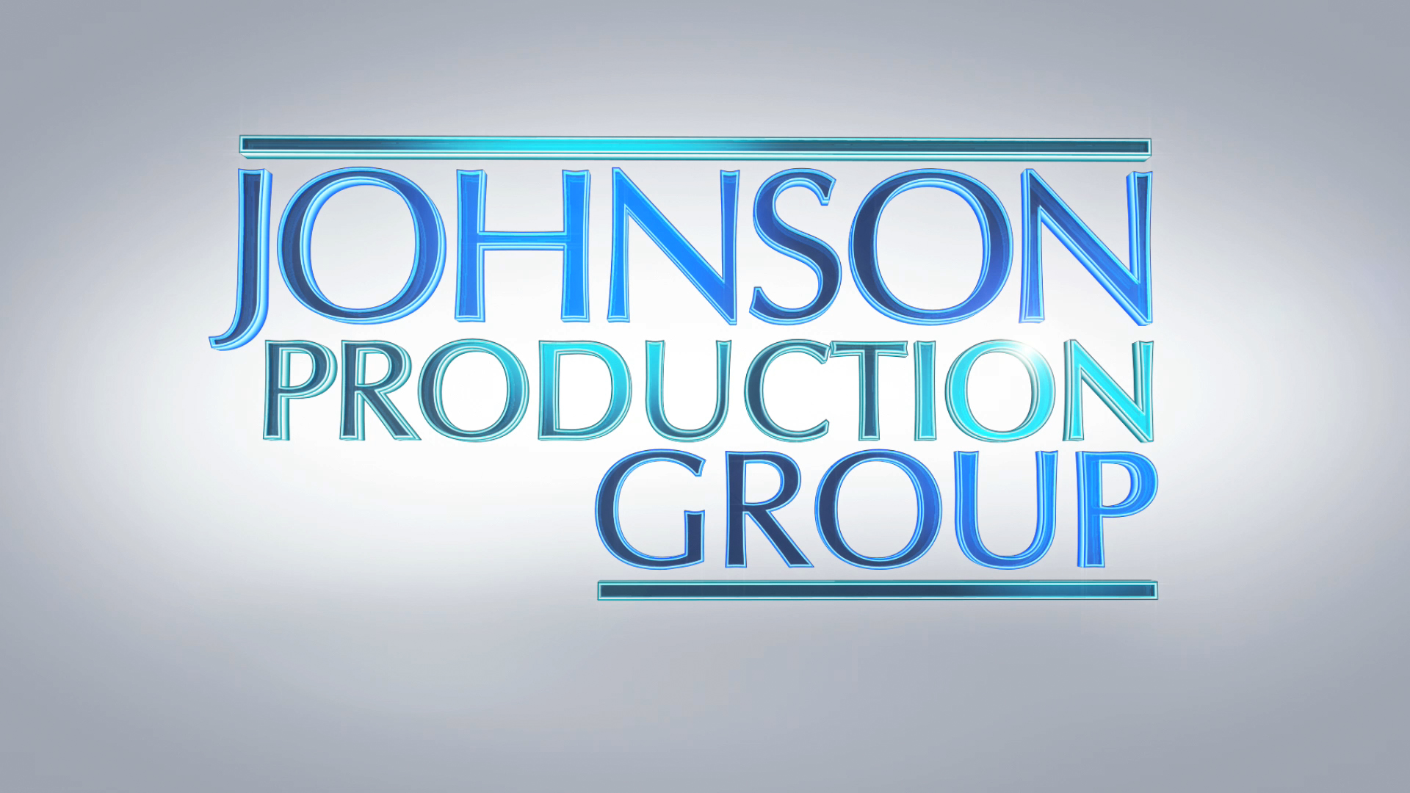

Meta Data

LONG (max 540 characters) synopsis
After breaking off three wedding engagements, Melanie has sworn off saying “yes” for good, until she meets Damon and truly falls in love, unaware she’s been handpicked to help Damon win a bet to prove he can get a woman to say “yes” to his marriage proposal in thirty days. As he tries to win her over, it’s his sincerity and kindness that has Mel intrigued…and suspicious but she soon finds herself falling in love with him. Even though it wasn’t part of the bet, Damon finds he’s also falling for Mel and her infectiously impulsive ways. (536)

MEDIUM (max 180) synopsis
After breaking off 3 engagements, Melanie has sworn off marriage until she meets Damon, unaware that Damon has bet he can get a woman to say “yes” to his marriage proposal in 30 days (180)

SHORT (max 54 characters) synopsis
Melanie is unaware that she is part of a proposal bet (53)

5 KEY WORDS
Bride 30 days wedding betting

