
Johnson Production Group
Press Kit

One-Liner
Would a career in law take a back seat to love…and an ice sculpting festival?

Synopsis
Emma Parker, returns from university to her small town home while awaiting the results of her recent bar exam. She is about to become an attorney in her mother's successful practice, but quickly sets the law (and her responsibilities to her mother’s firm) aside in order to save the town's beloved ice-sculpting competition.
As she rediscovers the town where she grew up, Emma meets Nick Claiborne, a local tree farmer, and their initial attraction turns sour when he doesn’t support her desire to save the ice sculpture competition. What Emma doesn’t know is Nick is an ice sculptor who has suppressed his love of the art due to a broken heart.
After raising a small fortune in just a few days, Emma revives the competition; finds a new ice-sculpting partner in Nick Claiborne; a new love of art and ice sculpting to replace the law in her future; and the love of her life.

Producers
Executive Producer
TIMOTHY O. JOHNSON

Executive Producer
ANDREW C. ERIN

Producer
HAYDEN BAPTISTE

Key Cast
ACTOR  TAYLOR COLE  DAMON RUNYAN  GIANPAOLO VENUTA  JONATHAN WHITTAKER  TEAGAN VINCZE  WENDY CREWSON |  | CHARACTER  Emma Parkers  Nick  Lonny  Dan Parkers  Sarah  Carol Parkers

Key Cast Biographies

TAYLOR COLE
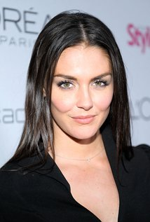
Born and raised in Arlington, Texas, Taylor Cole had a fulfilling high school experience. Proving to be a gifted athlete, she played on her high school's volleyball team and traveled around the country with the Junior Olympics squad.
Her stunning good looks also allowed her to travel around the world as a professional model doing photo shoots in Italy, France, Germany, Australia among many other countries.
Taylor had recently relocated to New York City to pursue her modeling career further when the opportunity to guest-star in the pilot of Summerland (2004) arose.
She was visiting her mother and step-dad (Shawn Christian) in Los Angeles when she landed an audition with the Summerland (2004) producers. She won them over and the recurring part became a regular role.

DAMON RUNYAN
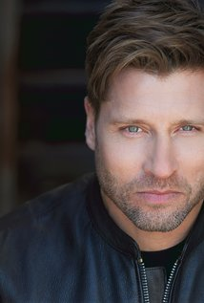
Damon Runyan is an actor and director, known for Gangland Undercover (2015), Degrassi: The Next Generation (2001) and One Starry Christmas (2014). He is married to Jodie Dowdall.

WENDY CREWSON
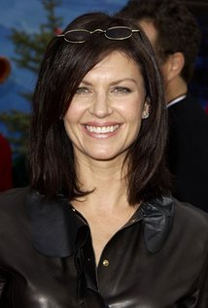
Wendy Crewson was raised in Winnipeg, Manitoba, Canada. She attended Westwood Collegiate and was first exposed to acting when she performed in The Boy Friend in grade 10.

GIANPAOLO VENUTA
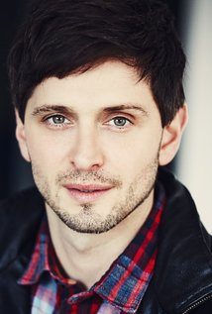
Gianpaolo Venuta was born on August 30, 1978 in Montréal, Québec, Canada. He is an actor and director, known for The Words (2012), Far Cry 3 (2012) and Time of Death (2013).

JONATHAN WHITTAKER
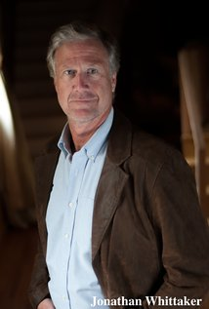
Appears as Dr. Edward Blake in the YTV/Nickelodeon hit Open Heart. Past credits include Robert McNamara, U.S. Secretary of State in the Kennedys. Appearances in Chicago, Land of the Dead, The X-Files, Transporter the Series, The Outer Limits amongst others. Numerous stage credits include but are not limited to - Arcadia, Les Miserables, Dirty Dancing, Man of La Mancha.

TEAGAN VINCZE
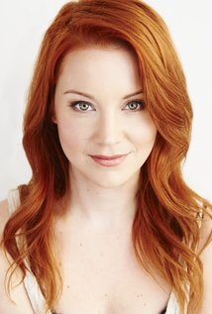
Teagan Vincze was born on March 23, 1984 in Vancouver, British Columbia, Canada. She is an actress and producer, known for Motive (2013), The Scarehouse (2014) and The Unauthorized Melrose Place Story (2015).

Production Credits

Full Cast
Actor | Role
TAYLOR COLE | Emma
DAMON RUNYAN | Nick Claiborne
WENDY CREWSON | Carol Parkers
JONATHAN WHITTAKER | Dan Parkers
TEAGAN VINCZE | Sarah Morton
GIANPAULO VENUTA | Lonny Barnes
TONI ELLWAND | Vera Baxter
PAULA MacPHERSON | Nancy O'Neil
RODRIGUES WILLIAMS | Paul Andrews
MEGHAN HOOPLE | Kendra
RANDY THOMAS | Frank Duvall
WERONIKA SOKALSKA | Tara Carlin
JOEY BELFIORE | Jason

Produced by
Timothy O. Johnson |  | executive producer
Andrew C. Erin |  | executive producer
Hayden Baptiste |  | producer

Directed by
Bradley Walsh
Written by
David Golden

Cinematography by
Russ Goozee, CSC

Film Editing by
Bruce Lange

Casting By
Ron Leach, CDC
Mike Migliara, CDC

Production Design by
Lisa Soper

Costume Design by
Jenn Stroud

CREW
Hayden Baptiste | Line Producer
Michel Poirier | First Assistant Director
Joseph J. Gillanders | Second Assistant Director
Lisa Soper | Production Designer
Shane Boucher | Art Director
Damien McPhillips | Set Decorator
Paul Pellerine | Set Dresser
Jodie Rice
Pascale Arpin
Matthew Mander
Ted Kennedy | On-Set Dresser
Kat Baldassari | Daily On-Set Dresser
Tara Burr | Buyer
Balint Kertesz | Property Master
Lonnie Lapierre | Graphic Designer
William Mood | Carpenter
Michael Steele
Tonie St-Onge
Kevin Ashe | Ice Sculptors
Kenny Hayden
Ryan Hill
Nathan McKeough
Mowafek Nemaand
Jennifer Stroud | Costume Designer
Jasmine Murray-Bergquist | Assistant Costume Designer
Tara Burr | Wardrobe Assistant
Markie Conners-Magill
Deborah Ring
Anna Della Zazzera | Key Makeup Artist
Samnang 'Sammie' Tep | Key Hairstylist
Marissa Clemence | Swing
Shannon Doyle
Marieve Guilbault
Russ Goozee, Csc | A Camera Operator
Jesse Clark | A Camera First Assistant
Greg Drizhachenko | A Camera Second Assistant
Adrian Langley | B Camera Operator
Diego Dias | B Camera First Assistant
Stephanie Toonders | B Camera Second Assistant
Cameron Preyde | DMT
Petr Maur | Stills Photographer
Dylan Argument | Production Sound Mixer
Matt Farrier | Boom Operator
Jon Olts | Gaffer
Rene Cotton | Best Boy Electric
Sheena Johnson | Electric
Andreas Borrel
Tony Plebon | Generator Operator
Peter Chartier | Key Grip
Mackenzie Fraser | Best Boy
ADAM Mclaren | Dolly Grip
Ethan Edwards | Grip
Stephanie Beaune | Third Assistant Director
KRISTEN Mcnaule | Production Coordinator
Scott Coulthart | Office PA
Brian Griffin | Production Accountant
Margaret Gagnon | First Assistant Accountant
Nicole Viens | Post-Production Accountant
Ainslie S. Wiggs | Location Manager
Sean Parker | Assistant Location Manager
Matthew Joyce | Production Assistants
Macrae Martin
Adrian Matthews
John E. Riley
Alanna Sherman
Michael Williams | Script Supervisor
Jessica Laight | Transportation Coordinator
Randy Lepage
Jeff Bray | Transportation Captain
IAN Mckay
Dylan St. Amand | Drivers
SANDY Mcdermid
Markie Conners-Magill
Johnny Ross
Ks On The Keys | Caterer
Kevin Preece | Craft Service
Ike Murphy | Project Manager
Colin Campbell | Online Editor
Richard Doman | Assistant Online Editor
Lorraine Grant | Colourist
Arthur J. Gallagher Canada Limited | Insurance Services By
Municipality Of Mississippi Mills | Special Thanks
Community Of Almonte
Mississippi River Power Plant
Textile Museum
Carleton Place Nursery
Monkey & Me Creations
Superior Restaurant
Baker Bob's
Heirloom Café & Bistro
Café Postino
L. G. Lee & Sons
Xquisit Communications Inc.
Don & Ruth Stewart
Nathan Rudyk
Matt & Katie Tiffany
Capital Temporary Lodging
Turris Communications
John Petti
Megan Inwood
Post Production Services Provided By | Cameras Provided by
Urban Post Production | 2D HOUSE
 | Lighting and Grip Equipment Provided by
Actra | AFFINITY PRODUCTION GROUP

Producer Biographies

TIM JOHNSON – Executive Producer
Tim Johnson is among the most active and reliable producers in the business thanks to top rate productions and an 'on time, on budget' reputation. Previously, he managed the production of ABC's THE DAYS (MINDSHARE/TOUCHTONE.) Prior to forming Johnson Production Group and Ignite Entertainment, Tim served as Head of West Coast Programming Executive and launched the successful series DOC (88 episodes,) SUE THOMAS, FBI, MYSTERIOUS WAYS, JUST CAUSE, PONDEROSA, CHRISTY, ITS A MIRACLE AND MIRACLE PETS.

Johnson is also responsible for producing the international hit series, DR. QUINN, MEDICINE WOMAN for CBS PRODS/SULLIVAN COMPANY for over 5 seasons. During his 100-episode tenure, he also launched LIVE FROM THE RANCH with Orson Bean - a nationally syndicated talk show focusing on family values in America. He also developed and produced the original docu-drama COLD CASE for CBS network, which was the very first program to integrate television with the Internet.

Recent Projects:
For Better or For Worse – Executive Producer
Baby Bootcamp – Executive Producer
Ring By Spring – Executive Producer
Sole Custody – Executive Producer
The Cheating Pact – Executive Producer
Deadly Spa – Executive Producer
Walking the Halls – Executive Producer
June In January – Executive Producer
Christmas in the City – Executive Producer
Snow Bride – Executive Producer
Dirty Teacher – Executive Producer
The Surrogate – Executive Producer
Merry In-Laws – Executive Producer
A Bride for Christmas – Executive Producer
Naughty or Nice – Executive Producer
Christmas Crush– Executive Producer
Teenage Bank Heist– Executive Producer
How to Fall in Love – Executive Producer
Home Invasion (2011) – Executive Producer
Final Sale (2011) – Executive Producer
Confined (2010) – Executive Producer
Tornado Valley (2009) – Executive Producer
The Wedding Dance (2009) – Executive Producer
Trust (2009) – executive producer
Toxic Skies (2008) – executive producer
Storm seekers (2008) – executive producer
Making Mr. Right (2008) – executive producer
Love Sick (2008) – executive producer
Just Breathe (2008) – executive producer
Devils Diary (2007) – executive producer
Swarm (2007) – executive producer

JOHNSON PRODUCTION GROUP
The Johnson Production Group contracts globally to produce television and motion picture content for international networks, studios and distributors. Based in Los Angeles and Vancouver, British Columbia, the company manages production, facilitates development and financing, procures distribution and guarantees quality and timely execution of its programs. While costs have gone up, so has the demand for quality. No longer is good enough, good enough. Johnson Production Group serves that segment when a show needs to be "A" quality, but produced efficiently enough to meet a locked budget. JPG specializes in value, protection of creative elements, and delivery of a quality finished product.

ANDREW C. ERIN – Producer
Andrew Erin is a Canadian Writer/Director making a big splash in the US, and has produced, written and directed numerous commercially successful films.
His directorial debut, SAM’S LAKE, was an official selection at the Tribeca Film Festival and did an excellent theatrical run in select theaters around the country; distributed by Lionsgate Films. Andrew also wrote the script for the film.
Andrew’s directorial credits include, SIMPLE THINGS, produced for Screen Media Ventures and Universal Studios. Besides winning The Bob Clark Award for Best Director at the California Independent Film Festival, the film was commercially received.
Andrew has worked continuously as a writer/director, building a strong library of films in the Thriller/Horror genres with: Embrace of The Vampire, The Clinic, Final Sale, Confined and Toxic Skies.
His most recent project, HAVENHURST was recently acquired by Lionsgate, set for release 2016. It was written, directed and produced under his own banner, along with Twisted Pictures.

HAYDEN BAPTISTE – Producer
Hayden Baptiste is a Producer and Development Executive with The Mob Entertainment, an LA Based production company with a Canadian office in Ontario. After spending nearly 15 years working as an Associate Producer for The Johnson Production Group and working as an Independent Producer in Toronto and Vancouver, Hayden has evolved into a well rounded producer who understands all aspects of production from development to delivery.
Hayden has produced films for various networks including CBC, Bravo, The Hallmark Network, UP TV and Lifetime Network. His films have been selected for film festivals around the world including the Montreal World Film Festival, Atlantic Film Festival, Screamfest, Catalina Film Festival, National Screen Institute and Chicago International. In addition to his extensive production experience, Hayden is a screenwriter and composer.
Hayden has studied at the Canadian Screen Training Centre, and completed the summer intensive screenwriting program at UBC.

Selected Credits
2017 Sweetheart (Producer)
2017 Christmas Festival Of Ice (Producer) Hallmark Network
2017 Precious Things (Co-Executive Producer)
2016 Eyewitness (TV Movie) (Co-Executive Producer)
2016 The Rooftop Christmas Tree (TV Movie) (Co-executive Producer) UP TV
2013 Leave Us Alone (Short) (Executive Producer) / (Producer) *Winner Catalina Film Festival
2011 From Darkness (Short) (Executive Producer)
2011 Three Weeks, Three Kids (TV Movie) (Associate Producer) Hallmark Network
2010 Confined (Associate Producer) The Movie Network
2009 Kick Me Down (Producer)

Billing Block

Johnson Production Group with Crown Media Productions Presents
“CHRISTMAS FESTIVAL OF ICE”
Taylor Cole Damon Runyan Gianpaolo Venuta Jonathan Whittaker Teagan Vincze and Wendy Crewson Edited by Tyler MacIntyre Casting by RON LEACH, C.D.C.
MIKE MIGLIARA, C.D.C. Production Designer LISA SOPER Costume Designer JENNIFER STROUDDirector of Photography RUSS GOOZE, C.S.C. Editor BRUCE LANGE
Executive Producers Timothy O. Johnson Andrew C. Erin Produced by Hayden Baptiste Written by David Golden Directed by Bradley Walsh
© 2017 Crown Media Productions, LLC All Rights Reserved
With the participation The Canadian Film or Video Production Tax Credit

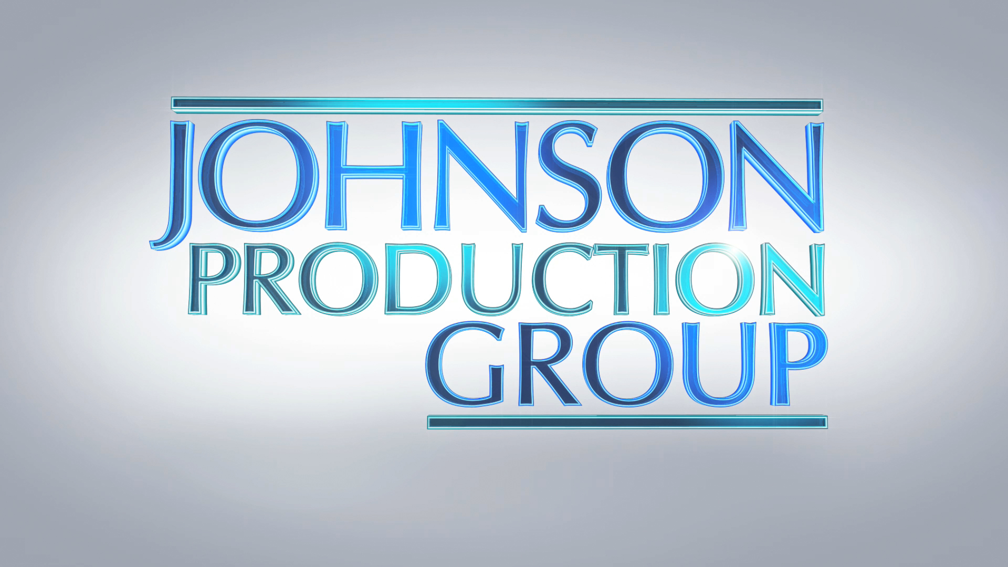


Meta Data

LONG (max 540 characters) synopsis
Emma Parker is about to move back home and become an attorney in her mother's successful practice, but quickly sets the law (and her responsibilities to her mother’s firm) aside in order to save the town's beloved ice-sculpting competition. There she meets Nick Claiborne, a local tree farmer, and their initial attraction turns sour when he doesn’t support her desire to save the ice sculpture competition. What Emma doesn’t know is Nick is an ice sculptor who has suppressed his love of the art due to a broken heart. (519)
MEDIUM (max 180) synopsis
Emma Parker moves back home and become an attorney in her mother's successful practice, but quickly sets the law aside in order to save the town's beloved ice-sculpting competition (180)
SHORT (max 54 characters) synopsis
Emma works to save the local ice-sculpting competition (54)
5 KEY WORDS
Christmas Ice sculpture festival romance

