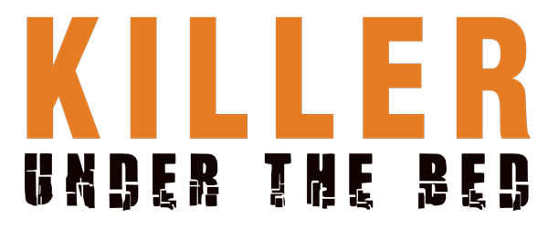
Johnson Production Group

Press Kit

One-Liner
After moving into a new home, a teenage girl discovers a cursed doll that puts the lives of her family in jeopardy.

Synopsis
Recovering from the loss of her husband, Sarah moves her daughters Chrissy and Kilee to a new city where Sarah joins a new dental practice and Chrissy has been recruited to play on the local school’s lacrosse team.
Kilee hates the move, feeling that they’re running away from her dad’s memory. It only gets worse when she’s bullied at school by Tina and is endlessly fighting with her sister. It feels like the world is against her, until she discovers a doll, riddled with pins, hanging in her backyard shed. She soon comes to believe that the doll holds supernatural powers.
As a test, she wishes for her sister to get a pain in her leg. To her astonishment, it works. Soon, she’s using the doll for all types of wishes: revenge on the bully Tina, an attitude adjustment for Sarah’s manipulative co-worker Dr. Ryder, and love from her handsome English teacher, Mr. McCabe.
Suddenly, with this power at her disposal, the future doesn’t seem so bleak. Tina is put in her place, McCabe is crushing on her, and Dr. Ryder is no longer a threat to her mom.
All seems well…until Chrissy discovers the doll. Not liking that Kilee is messing around with the “occult”, Chrissy throws the doll away in their trash bins. However, the next morning, the doll is back in Kilee’s bed and Chrissy’s leg pain is acting up again, even though Kilee removed the wish days before. For the first time, Kilee becomes concerned about what she might have unleashed on the people in her life.
It only gets worse from there. McCabe begins obsessively stalking Kilee. Tina steals the doll and is viciously attacked. Dr. Ryder becomes overly paranoid and threatens Sarah’s life. With every passing hour, the doll’s powers and abilities grow and grow.
In an attempt to stop the doll from hurting anyone else, Kilee references a book on the occult and buries the doll deep in a forest. When that doesn’t work, she realizes that not only has her betrayal angered it, but has made it even more dangerous.
Now bent on vengeance, the doll traps Kilee, Chrissy, and Sarah in their new home for an epic battle for their lives.

Producers
Executive Producer
TIMOTHY O. JOHNSON
Executive Producer
REGINA LEE
Producer
KEN SANDERS
Co Producer
SHERI REEVES
Key Cast
CHARACTER  Sarah  Kilee  Chrissy  Mr. McCabe  Tina  Dr. Ryder |  | ACTOR  KRISTY SWANSON  BREC BASSINGER  MADISON LAWLOR  CHRIS PRASCUS  ASHLEE FUSS  KRISTIN CAREY

Key Cast Biographies
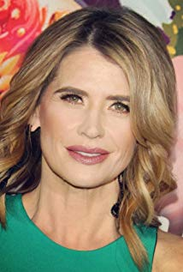
KRISTY SWANSON
Kristy Swanson was born on December 19, 1969 in Mission Viejo, California, USA as Kristen Noel Swanson. She is an actress and producer with an extensive filmography, known for Buffy the Vampire Slayer (1992), Ferris Bueller's Day Off (1986) and Flowers in the Attic (1987).

BREC BASSINGER
Brec Bassinger was born on May 25, 1999 in Saginaw, Texas, USA as Brec Marie Bassinger. She is an actress, known for The Goldbergs (2013), School of Rock (2016) and Bella and the Bulldogs (2015).

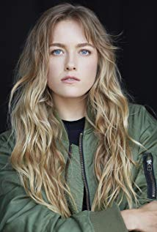
MADISON LAWLOR
Madison is the daughter of Brett, a physician and Patricia a teacher and the sister to Skye. She grew up in Rapid City loving outdoor sports and is an avid snowboarder, snow skier, soccer player and hiker. Madison first experienced her love of acting when she was cast in the lead of the musical a Secret Garden. This was such a positive experience that she went to Los Angeles for a summer and tested the waters of professional acting. She returned to Rapid City at the end of the summer with a mission to graduate early from High School and move to Los Angeles. Just before moving to Los Angeles Madison anchored two state AA champion relay teams in track and placed second in the 800 meter run.
At age 16 Madison moved to Los Angeles secured theatrical and commercial representation and began working as a guest star on Disney, Nickelodeon and TNT television shows, on numerous national commercials. Madison has enjoyed working with such Directors as Tony Valenzuela and Isaac Florentine.
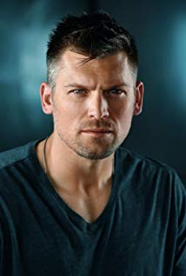
CHRIS PRASCUS
Chris Prascus is known for his work on Shameless (2011) and Revenge (2011).

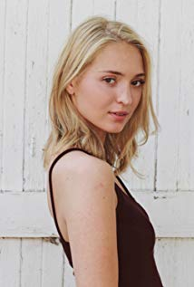
ASHLEE FUSS
Ashlee Füss was born on September 6, 1994 in St. Paul, Minnesota, USA as Ashlee Armella Füss. She is an actress, known for The Fosters (2013), Grey's Anatomy (2005) and CSI: Crime Scene Investigation (2000).

KRISTIN CAREY
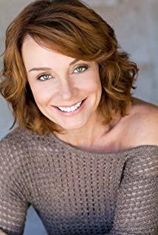
Kristin Carey grew up in Santa Rosa, California with aspirations of working in the movie and television business. At a young age Kristin demonstrated a propensity for acting on the stage. She quickly became involved in her school productions. After graduating from the B.F.A Theatre Program at The University of Southern California, she has appeared in numerous national commercials, films and television shows such as "The West Wing," "Without A Trace" and "Bones." She had a 'recurring role' as Dr. Dottie Prewitt on the soap opera "Passions."
Kristin was chosen by the Farrelly Brothers to play a supporting role in their New Line Cinema produced film "Hall Pass." She has played the lead role in a number of independent feature films. Her Sprint commercial, where she plays a studio executive, was produced and directed by the Farrelly Brothers. It has appeared in film theatres across the country.
Kristin has earned rave reviews performing on stage in the plays "It's Just Sex," "Embraceable You," "Agency," "Evita" and the highly acclaimed original play "The War Room" which honored and raised money for the VFW. She gave a stunning portrayal of the complex personality traits associated with criminal behavior for the Los Angeles Police department. She has trained with acting teachers Ivana Chubbuck, Harvey Lembeck, Stephen Book and H. Richard Greene to name a few. She possesses an excellent singing voice developed through her musical theatre work on stage.

Production Credits

Full Cast
Actors  KRISTY SWANSON  BREC BASSINGER  MADISON LAWLOR  CHRIS PRASCUS  ASHLEE FUSS  KRISTIN CAREY  FREDRICK DAWSON  TUNISHA HUBBARD  VICTORIA SCOTT  CHARLES CHRISTOPHER  GAR-YE LEE  BUDDY SOSTHAND  PETER CHEVAKO | Role  Sarah  Kilee  Chrissy  Mr. McCabe  Tina  Dr. Ryder  Dr. Abbot  Barbie  Mandy  Mr. Lipchitz  Allison  Stunt Coordinator  Voodoo Babydoll Puppeter

Produced by
TIMOTHY O. JOHNSON |  | executive producer
REGINA LEE |  | executive producer
KEN SANDERS |  | producer
SHERI REEVES |  | co producer

Directed by
JEFF HARE

Written by
J. BRYAN DICK

Music by
KEVIN BLUMENFELD

Sound Design by
ANDRES BOULTON

Cinematography by
BRAD RUSHING C.S.C.

Film Editing by
JASON NIELSEN

Casting By
JEFF HARDWICK, CSA

Production Design by
CHASE WRIGHT

Doll Design by
BILL JOHNSON

Costume Design by
JOHN C. HOUSTON IV

Full Crew

Line Producer
CHRISTIAN ACKERMAN

First Assistant Director
JOSHUA LOU FRIEDMAN

Second Assistant Director
ANTHONY ARRIGO

Production Secretary
GABBI LATADE

Script Supervisor
KATYA LOBAN

A Camera Operator
HARRIS KHAN

B Camera Operator
JAMES MARKHAM HALL, JR.

A Camera First Assistant
HARRIS KHAN

B Camera First Assistant
WOODY RAY

Additional B Camera 1st Assistant
ILIJA GAVRAN
KATE KETCHAM
TIFFANY MURRAY
DAVID M. PARKS
YVGENIY ZHUK

Second Assistant Camera
GREG UNGER

Steadicam Operators
JAY RUGGIERI
SAM WILKERSON

Camera P.A
JOSHUA MATTHEW THOMAS

D.I.T
KYRAN DUNN

Still Photographer
CHARLES CHRISTOPHER
MIKE TAING

Production Sound Recordist
JASON AARON MORAN

Gaffer
Alexander L. Gracie

Additional Gaffer
BRENT BAILEY
ANDREW MESSERSMITH
JOEL REAVES

Best Boy Electrics
NATHAN HANSEN
ANDREW MESSERSMITH

Key Grip
BRAIN PATIERNO
KYLE SORVIG

Additional Key Grip
CHRIS HARTSELL

Best Boy Grips
ALEX EMMONS
CRISTINA GUZMAN
ISAIAH REZA-SOTO
ERIC M. VELASQUEZ

Grip & Electric Swing
SYDNEY BENNETT
REYNALDO FORTANEL
LOGAN JUSTICE
TANNER LYON

Art Director
ALLISON MARRAMA

Prop Master
MICHAEL O’CONNOR

Set Dresser
LANE YOUNG

Costume Supervisor
KRISTI STARK

Costume Assistant
MARIEL GONZALEZ
SUSANNA SONG

Makeup Special Effects
JULIA HAPNEY

Makeup Department Head
ERICA MEDINA

Hairstylist Department Head
JULIA HAPNEY

Hair Stylists
MELANIE CRISTESCU
RUTH AGUILERA
PRISCILLA NGUYEN
AMANDA NILO
STACIE GRACIE

Location Manager
SEAN B. HERNANDEZ

Key Assistant Location Manager
REMY ELLES

Extras Casting Director
PETE SUTTON

Key Set Production Assistant
DOMENICO RISO

Production Assistants
JEDD GABRIEL CABALLERO
HANNAH DURAN
BREANNA FINCH
TONY HOLT
KELSIE INSERRA
KRISTA KARKAR
CLAS LINDGREN
JOSEPH MARTIN
MITCHELL PETERSON
SELVIN RAMIREZ
JESSICA RAMOS
VICTOR REDMAN
MEGAN SCHNEIDER
MAGGIE SOTTER

Craft Service
LUKE LAKIN

Set Medic
DAN ROGERS

Caterer
FOOD FETISH

Second Unit

Director
DAVID BENULLO

First Assistant Director
BUZ WALLICE

Director of Photography
JAMES MARKHAM HALL, JR.

Production Sound Mixer
JERRY WOLFE

Post Production

Sound Designer
ANDRES BOULTON

Re-Recording Mixer
ANDRES BOULTON

Sound Effects Editor
CHRISTIAN ZERPA

Foley Artist
STEVE WALTER

Foley Editors
RYAN VILLARREAL

Post Production Services Provided By
BLUEPRINT POST PRODUCTION
JON KELBLE, V. P. OF POST PRODUCTION

Colorist
RANDY COONFIELD

Music Editor
KEVINE BLUMENFELD

Lone Wolf Effects Doll Crew
WILL ZUIDEMA
TOOD WATSON

Visual FX
DAN WALKER

Stock media provided by
RICKRAY/POND5
ZENSTRATUS/POND5

Camera Equipment Supplied by
HOLLYWOOD CAMERA
SETELEVISION

Grip and Lighting Equipment Provided by
BRILLIANT SCREEN STUDIOS

Trailers Provided by
EASY RIDER PRODUCTIONS
REEL WASTE AND RECYCLING

Police Equipment and Vehicles Provided By
BRILLIANT SCREEN STUDIOS

Script Clearance
DENNIS WHITCOMB
ERIN MANACKER
HOLLYWOOD SCRIPT RESEARCH

Production Insurance
GIOVANNI CUAREZ
AMERICAN ENTERTAINMENT INSURANCE SERVICES

Payroll Services
ERIN RAY, SENIOR ACCOUNT MANAGER/CLIENT SERVICES
NPI ENTERTAINMENT PAYROLL, INC.

Extras Payroll
MACCPRO

Special Thanks
THE SANTANA FAMILY OF RANCHO SANTANA
BLAKE REIGLE
HANK GROVER

Producer Biographies

TIM JOHNSON – Executive Producer
Tim Johnson is among the most active and reliable producers in the business thanks to top rate productions and an 'on time, on budget' reputation. Previously, he managed the production of ABC's THE DAYS (MINDSHARE/TOUCHTONE.) Prior to forming Johnson Production Group and Ignite Entertainment, Tim served as Head of West Coast Programming Executive and launched the successful series DOC (88 episodes,) SUE THOMAS, FBI, MYSTERIOUS WAYS, JUST CAUSE, PONDEROSA, CHRISTY, ITS A MIRACLE AND MIRACLE PETS.
Johnson is also responsible for producing the international hit series, DR. QUINN, MEDICINE WOMAN for CBS PRODS/SULLIVAN COMPANY for over 5 seasons. During his 100-episode tenure, he also launched LIVE FROM THE RANCH with Orson Bean - a nationally syndicated talk show focusing on family values in America. He also developed and produced the original docu-drama COLD CASE for CBS network, which was the very first program to integrate television with the Internet.

Recent Projects:
Eat, Play, Love – Executive Producer
Sleepwalking in Suburbia – Executive Producer
The Stalker Club – Executive Producer
Infidelity in Suburbia – Executive Producer
Hunter's Cove – Executive Producer
Double Mommy – Executive Producer
Hearts of Christmas – Executive Producer
The Rooftop Christmas Tree – Executive Producer
A Snow Capped Christmas – Executive Producer
A December Bride – Executive Producer
The Mistletoe Promise – Executive Producer
Stalked by My Mother – Executive Producer
Stalked by My Doctor: The Return – Executive Producer
Backstabbed – Executive Producer
The Convenient Groom – Executive Producer
Killer Coach – Executive Producer
Tulips in Spring – Executive Producer
Hearts of Spring – Executive Producer
Stalked by My Doctor – Executive Producer
Becoming Santa – Executive Producer
Magic Stocking – Executive Producer
Just in Time for Christmas – Executive Producer
A Gift Wrapped Christmas – Executive Producer
A Mother's Instinct – Executive Producer
Ice Sculpture Christmas – Executive Producer
The Reckoning – Executive Producer
Bad Sister – Executive Producer
Family for Christmas – Executive Producer
Double Daddy – Executive Producer
Her Infidelity – Executive Producer
Stalked by My Neighbor – Executive Producer
Babysitter's Black Book – Executive Producer
A Gift of Miracles – Executive Producer
Strange Empire – Executive Producer
Sugar Daddies – Executive Producer
Paper Angels – Executive Producer
A Cookie Cutter Christmas – Executive Producer
Stranded in ParadiseFor Better or For Worse – Executive Producer
Baby Bootcamp – Executive Producer
Ring By Spring – Executive Producer
Sole Custody – Executive Producer
The Cheating Pact – Executive Producer
Deadly Spa – Executive Producer
Walking the Halls – Executive Producer
June In January – Executive Producer
Christmas in the City – Executive Producer
Snow Bride – Executive Producer
Dirty Teacher – Executive Producer
The Surrogate – Executive Producer
Merry In-Laws – Executive Producer
A Bride for Christmas – Executive Producer
Naughty or Nice – Executive Producer
Christmas Crush– Executive Producer
Teenage Bank Heist– Executive Producer
How to Fall in Love – Executive Producer
Home Invasion – Executive Producer
Final Sale – Executive Producer
Confined – Executive Producer
Tornado Valley– Executive Producer
The Wedding Dance– Executive Producer
Trust – executive producer
Toxic Skies– executive producer
Storm seekers – executive producer
Making Mr. Right – executive producer
Love Sick – executive producer
Just Breathe – executive producer
Devils Diary – executive producer
Swarm – executive producer

JOHNSON PRODUCTION GROUP
The Johnson Production Group contracts globally to produce television and motion picture content for international networks, studios and distributors. Based in Los Angeles and Vancouver, British Columbia, the company manages production, facilitates development and financing, procures distribution and guarantees quality and timely execution of its programs. While costs have gone up, so has the demand for quality. No longer is good enough, good enough. Johnson Production Group serves that segment when a show needs to be "A" quality, but produced efficiently enough to meet a locked budget. JPG specializes in value, protection of creative elements, and delivery of a quality finished product.

KEN SANDERS - Producer
Over the past decade and a half, Ken Sanders has written and/or produced over forty feature-length motion pictures. Since starting his film production company, Shadowland, LLC, with partner Robert Ballo in 2009, Sanders has also produced THE CHEATING PACT, MISSING AT 17, THE PERFECT BOYFRIEND, DIRTY TEACHER, THE SURROGATE, STALKED AT 17, TEENAGE BANK HEIST, WALKING THE HALLS, BETRAYED AT 17, HOME INVASION, MATERNAL OBSESSION, and ACCUSED AT 17, all of which received big ratings when they premiered on Lifetime Television.
From 2001 to 2008, Sanders partnered with prolific Hollywood producer Pierre David and produced eight made-for-TV movies in Canada. Sanders co-wrote many of the films, including ‘TIL LIES DO US PART, MAID OF HONOR, STRANGER AT THE DOOR, THE PERFECT HUSBAND, SAVING EMILY, and A KILLER UPSTAIRS.
Prior to partnering with David, Sanders served as Vice President of Production at WIN Ventures, a division of World International Network, a leading supplier of independent feature films and made-for-TV movies. During his tenure at WIN Ventures Sanders oversaw the development, production, and post-production of roughly twenty films a year, including LIVING IN FEAR, FACING THE ENEMY, and SHE’S NO ANGEL, and many more which aired on the USA Network, Court TV, HBO, Showtime, Cinemax, and The Movie Channel.
In the mid-1990s, Sanders worked as the Vice President of Creative Affairs at Image Organization, helping to develop and oversee such theatrical projects as LITTLE MEN (released by Warner Brothers) and WISHMASTER (released by Artisan), the latter of which went on to become the highest-grossing independent feature film of 1997.
At the beginning of his career, Sanders worked as the Director of Development at High Five Productions, helping to prepare such television specials as THE JUDDS FAREWELL CONCERT and THE WOMEN OF COUNTRY. He also worked for media mogul Ted Turner, doing a stint as a promotions producer for CNN and SuperStation WTBS.
In addition to his film and television work, Sanders has served as an adjunct professor at Biola University, where he taught classes on producing and screenwriting. He is also a frequent guest lecturer at Los Angeles Valley College and the Los Angeles Film School, where he speaks on topics ranging from the business of film to post-production to pitching and script development. Sanders received his degree in Filmic Writing from the University of Southern California, School of Cinematic Arts.

SHERI REEVES – Co-Producer

Sheri Reeves is known for her work on Hush (1998), Gone Fishin' (1997) and First Kid (1996).
Her recent work includes:
Web Cam Girls (co-producer)
2016 Red Skies at Night: The Story of Flower (Short) (producer)
My Cousin's Ghetto Wedding (producer)
Save the Date (producer)
2017 Fleur (Short) (producer)
2017 Vitals (producer)
2013 Canyon Road (producer)
2012 A Night at the Silent Movie Theater (producer)
2011 Jack the Reaper (producer)

Billing Block

Johnson Production Group in Association with Harbor Light Studios Presents
“KILLER UNDER THE BED”
Starring KRISTY SWANSON BREC BASSINGER MADISON LAWLOR CHRIS PRASCUS ASHLEE FUSS and KRISTIN CAREY Music KEVIN BLUMENFELD
Sound Design ANDRES BOULTON Cinematography BRAD RUSHING C.S.C.
Film Editing JASON NIELSEN Casting By JEFF HARDWICK, CSA
Production Design CHASE WRIGHT Doll Design BILL JOHNSON
Costume Design JOHN C. HOUSTON IV Executive Producers TIMOTHY O. JOHNSON REGINA LEE Producer KEN SANDERS Co Producer SHERI REEVES
Written by J. BRYAN DICK Directed by JEFF HARE

The Producers Wish To Thank

SAG-AFTRA One Union FilmLA

Santa Clarita Film Office

Columbia College Chicago

Columbia College Hollywood

College of the Canyons Cooperative Work Experience Education Program

© MMXVIII Johnson Production Group, Inc. All Rights Reserved
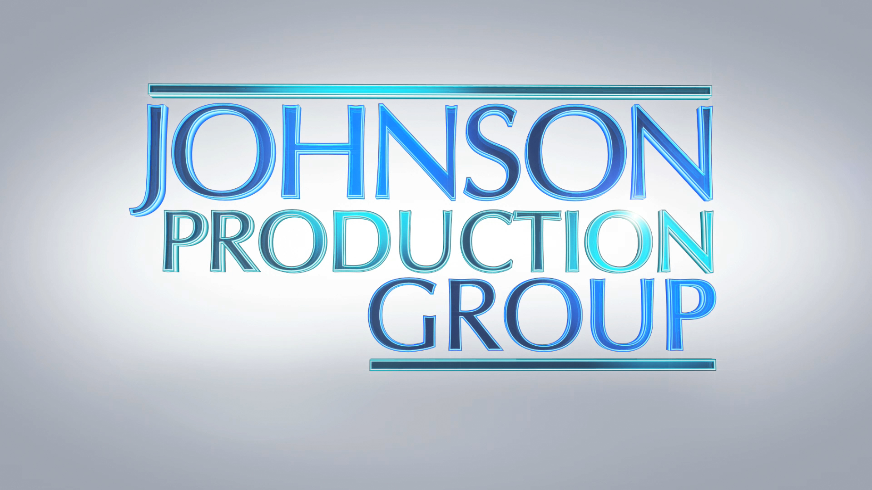
Meta Data

LONG (max 540 characters) synopsis
After her husband dies, Sarah moves her daughters Chrissy and Kilee to a new city. Kilee hates the move, feeling that they’re running away from her dad’s memory. When she’s bullied at school and is endlessly fighting with her sister, it feels like the world is against her, until she discovers a doll, riddled with pins, in her backyard shed. She soon comes to believe that the doll holds supernatural powers but when it starts acting on its own, Kilee becomes concerned about what she might have unleashed on the people in her life. (533)

MEDIUM (max 180) synopsis
After moving into a new home, a teenage girl discovers a cursed doll that puts the lives of her family in jeopardy. (115)

SHORT (max 54 characters) synopsis
A cursed doll puts a teen’s family in jeopardy. (47)

5 KEY WORDS
Teens, family, voodoo, doll, Thriller

