Johnson Production Group

Press Kit

One-Liner
Alex Burns takes exciting risks to fulfill her dream of being a travel writer…and finds love as well!

Synopsis

Copyeditor for Around the World Travel, Alex Burns (Katrina Bowden) has always wanted to see her own words in print. Now she has a chance to realize her dream as the magazine is holding a contest. The one who writes the best travel article will make the cover story, land a writing position, and win a first class ticket to anywhere in the world! Alex can’t wait to tell her boyfriend, investment banker Barton Kane (Anthony Konechny), but he’s got a surprise too. Thinking he might propose, Alex is relieved when Barton’s big announcement is that he’s made partner and though he’s supportive of her news, he’s also taken aback. She wants to be a travel writer? That doesn’t sound like the Alex he knows. She’s never been one to take risks.
In fact, Alex was almost too timid to approach her boss, Peter McHugh (Chris Shields) with her story idea – a profile of Cole Taylor (Thomas Beaudoin), the elusive nature and extreme sports photographer who lives at the Ridgeline Resort in the Colorado Rockies. Encouraged by her coworker and best friend Kate (Elysia Rotaru), Alex finally makes her pitch and McHugh loves it. The only catch is he wants her to write from the angle of a non-adventurer trying every extreme sport she can. A bit of a klutz and afraid of heights, Alex has always been more of a worrier than a warrior, but with just seven days to write the story of her life, she boards a plane from New York to Denver, determined to leave her comfort zone and her fears behind.
The challenges begin when the shuttle to the resort breaks down and a handsome stranger offers her a ride. Not knowing it’s Cole Taylor and afraid to get in his Jeep, Alex refuses and trudges off alone. Exhausted but eager to begin right away, she signs up for a biking excursion. But when she learns it’s on a mountain, she jumps off the chairlift and nearly causes a pile-up. Luckily, the same cute guy offers a hand, and she accepts. Heading back, someone calls out to Cole and Alex realizes who he is! Later, she musters the courage to go to his gallery where his manager Max (Doron Bell) is trying to convince him to engage more with patrons. Seeing his reluctance, Alex offers to help Cole with his art exhibit, if he’ll be her extreme sports guide. It’s a deal!
Cole starts Alex out easy at a climbing gym but soon she’s doing an obstacle course, skiing and ziplining. Photographing her exhilaration, Cole feels inspiration he hasn’t felt in years and Alex feels more alive than ever. As the two get to know each other they find they share a common desire to see Africa’s Victoria Falls and also begin to fall in love. Too bad Barton arrives and lets it slip that Cole is part of her article. Upset his privacy was breached and believing she’s marrying Barton anyway, Cole storms off. But later when he reads Alex’s piece, Cole realizes she hasn't betrayed him at all, especially when she flies back to Colorado with her winning plane ticket. Now there might just be an African adventure in store for both of them.

Producers
Executive Producer
BARB HARWOOD
Executive Producer
LES ALEXANDER
Executive Producer
TIM GAMBLE
Executive Producer
BRUCE D. JOHNSON
Producer
OLIVER DE CAIGNY
Key Cast
CHARACTER  Alex  Cole  Kate  Barton  Sarah |  | ACTOR  KATRINA BOWDEN  THOMAS BEAUDOIN  ELYSIA ROTARU  ANTHONY KONECHNY  COREY WOODS

Key Cast Biographies

KATRINA BOWDEN
Katrina Bowden recently wrapped the indie feature Divorce Party and will next be seen as the lead in two indie features Hard Sell, opposite Kristen Chenoweth, and Monolith. Bowden also starred in the TNT series “Public Morals,” opposite Michael Rappaport and Ed Burns for DreamWorks Television, and prior to that was most well known for playing the drop dead gorgeous receptionist Cerie in the mega hit NBC series “30 Rock.” Her additional big screen credits include American Reunion for Universal and Nurse 3D for Lionsgate, among others. She recently graced the covers of Maxim and FHM and was once named “Sexiest Woman Alive” by Esquire. Recently, Bowden started her own successful health and fitness blog dubbed Fit Kat, which can be found at http://fitkatbykatrinabowden.com.

THOMAS BEAUDOIN
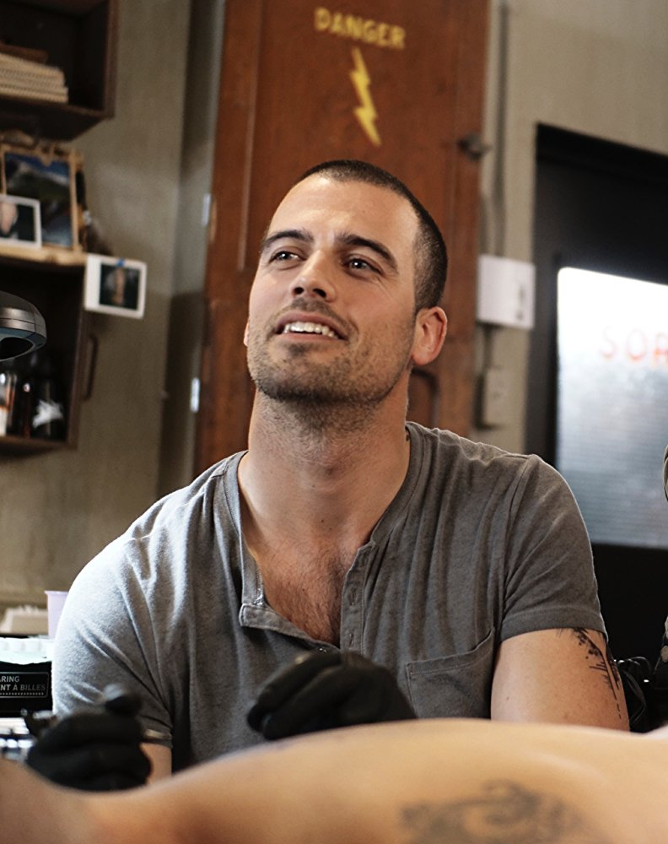
Born in Thetford Mines, Quebec, Canada, Thomas Beaudoin spent the first half of his life in Drummondville, Quebec. After a year studying psychology and exercise science at Concordia University in Montreal, he moved to New York City to study English and acting. It was not long before he was cast in leading roles in world-renowned plays such as Tennessee Williams’ Orpheus Descending, Agnès Jaoui and Jean-Pierre Barci’s Cuisine et Dépendances, and Alexandre Dumas’ La Dame Aux Camélias.
On the big screen, Beaudoin starred in the feature film Derailed for MarVista Entertainment and soon he will be seen staring in the Canadian miniseries “Herbert et Fanny” for Sphère Média. His other television credits include recurring roles on NBC’s hit series “The Blacklist,” opposite David Strathairn, on Club Illico’s French series “Victor Lessard” and Aetios Productions’ Canadian series “Blue Moon.”
In addition to his numerous supporting roles and guest star television credits, Beaudoin is known for his breakout role as Daniel on Lifetime’s “The Spirit of Christmas” and MarVista Entertainment’s Love’s Last Resort directed by Brian Herzlinger.
A jack-of-all-trades, Beaudoin is a skilled photographer and cinematographer, with work that can be seen at www.ernestmarius.com. He also enjoys traveling, playing ice hockey, rock climbing, boxing, and studying Krav Maga, an Israeli martial art.

ELYSIA ROTARU
Elysia Rotaru was born on November 9, 1984 in Vancouver, British Columbia, Canada as Crystal Elysia Lorraine Rotaru. She is an actress and producer, known for Arrow (2012), Dead Again in Tombstone (2017) and Diary of a Wimpy Kid: Rodrick Rules (2011).

ANTHONY KONECHNY
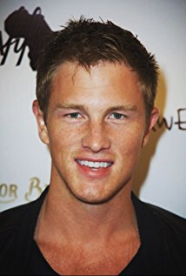
Anthony Konechny is an actor and producer, known for Fifty Shades of Grey (2015), X-Men: Apocalypse (2016) and Godzilla (2014).

COREY WOODS
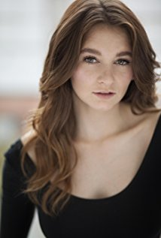
Corey Woods was born in the small village of Fruitvale, BC. After graduating she decided to move out to Vancouver to pursue her passion in acting.
Soon after moving she booked her first role in "The Unauthorized Saved by the Bell Story" and since then had opportunities to work on Lifetime’s "The Unauthorized Melrose Place Story", Universals "R.L. Stine's Monsterville: The Cabinet of Souls", and also CW's "Supernatural".

Production Credits

Full Cast
Actor | Role
KATRINA BOWDEN | Alex
THOMAS BEAUDOIN | Cole
ELYSIA ROTARU | Kate
ANTHONY KONECHNY | Barton
COREY WOODS | Sarah
CHRIS SHIELDS | Peter
TONY GIROUX | Max
TREVOR SHANE LERNER | Shuttle Driver
BEVERLEY BREUER | Norah
MARION EISMAN | Barbara
TOM TASSE | Charles
MICHELE DE BROEL | Front Desk Clerk
GABRIEL CARTER | Announcer
ZACHARY COLE GULKA | Staffer Steve
CHAD SAYN | Stunt Coordinators
DOUG CHAPMAN
MAJA ARO | Alex Stunt Doubles
LANA LONERGAN
WYATT CAMERON | Cole Stunt Doubles
DAR HICKS
OLEKSII KYSHLOVYCH
RYAN SCHROEDER

Produced by
BARB HARWOOD |  | executive producer
LES ALEXANDER |  | executive producer
TIM GAMBLE |  | executive producer
BRUCE D. JOHNSON |  | executive producer
OLIVER DE CAIGNY |  | producer
NAVID SOOFI |  | supervising producer

Directed by
PAUL ZILLER

Story by
BRUCE D. JOHNSON

Teleplay by
KIRSTEN HANSEN

Music by
LAWRENCE SHRAGGE

Director of Photography
MIKE KAM

Film Editing by
JASON NIELSEN

Casting By
JUDY LEE

Production Design by
LLOYD STONE

Full Crew
 | TROY SCOTT | first assistant directors
 | MIchele E. Dutka
 | JEFF CROFT | second assistant director
 | Tim Lanham | set decorators
 | Ruby SOTELO
 | NATALIA PEIXOTO | assistant set decorator
 | rob van poelgeest | lead dresser
 | CHARLENE IRANI | on set dresser
 | RYAN GOBERT | dressers
 | TOBY ESLAKE
 | EVAN KEHOE
 | CHRIS GAUTHIER
 | COURTNEY VERWOLD
 | LAUREN DOMINCZUK | property masters
 | TIM JOHNSON
 | Aaron WHITEHEAD | assistant property masters
 | Daniel CIPILINSKY
 | CATHERINE LONG | make-up artist
 | KATRINA GLUBRECHT | hair stylist
 | Jessica hawkins  ISABELLE FALLU | swings
 | Stacey bradder | costume designer
 | MYRA GONZALEZ | set supervisors
 | Linden Watt
 | CECILIA IGNACIO | truck costumer
 | Grace NG | background costumer
 | Kenneth Lau | camera operators
 | Peter PLANTA
 | Mark Miller
 | Gregory Brown
 | KYLE VOLLSTAEDT  CHRISTIAN LAI | first assistants camera
 | Andy AlVAREZ | second assistants camera
 | Diana PARRY
PIERRE CRUZ |  | gaffer
GARETH JONES |  | best boy electric
WEST VANDENBERG |  | electric
LIVIO SANTAROSSA |  | generator operator
MICHAEL JOHNSTON |  | key grip
Mark kent |  | dolly grip
MITChell rowland |  | best boy grip
CAMERON WATTS |  | grips
MARTIN Calvo
MATThew carson
Peter Gibson |  | transport coordinator
Tracy Murray |  | transport captain
sam sodeyf |  | drivers
Jeff charlton
Doug HALVORSON
Gord MACKAY
Barry Hunt |  | security coordinator
Steve Woodley |  | animal wranglers
Dacrcy woodley
garrett vandusen |  | location manager
ANDREW ARMOUR |  | assistant location manager
ABDULLA DAIANI |  | key location assistants
JAMES BURKE
STUART BROWNE
MARTYNA CZAPLAK
ALEXIS GOLAT
TREVOR KYLE
REBECCA MATZOV
Christopher O’Brien |  | production sound mixer
Heraldo ABREU |  | boom operator
ANITA MCGEE |  | script supervisors
Robyn Ludwig
paralee cook |  | payroll accountant
JEFF DESMARAIS |  | production coordinator
Alex Zahara |  | production assistant
Darren devlin |  | third assistant director
Quinn LEWIS-bresch |  | craft service/first aid
CHELSEA BRESCH
Austin Gourmet |  | catering
Brandon crewe |  | caterers
nabil minnikh
Konstantin minnikh
ciarra cook |  | casting assistant
LA Hilts |  | extras casting
Diane Chester  jennifer roberts |  | extras casting assistants
Matt TINGEY |  | background wrangler
ANDREA WHITBURN |  | stand in
Coastal ClearanceS |  | script clearances
Chandler Fogden Aldous  Law Corporation |  | legal services
Front Row Insurance  Brokers |  | insurance
Leah Myers |  | post production supervisor
devin taylor |  | assistant editor
Ron Penchalaiya |  | second assistant editor
Evan Graves |  | visual effects
SeÁN TRAVERS |  | colourist
Annuit coeptis  Entertainment |  | picture post production
Finalé POST |  | additional post services
Cinescope Sound |  | audio post production
Gregor Phillips |  | supervising sound editor
Gregor Phillips |  | re-recording mixers
AARON OLSON |  | dialogue editor
Gregorio gomez |  | sfx editor
ALEX MACIA |  | foley artists
DEVON QUELCH

Producer Biographies

JOHNSON PRODUCTION GROUP
The Johnson Production Group contracts globally to produce television and motion picture content for international networks, studios and distributors. Based in Los Angeles and Vancouver, British Columbia, the company manages production, facilitates development and financing, procures distribution and guarantees quality and timely execution of its programs. While costs have gone up, so has the demand for quality. No longer is good enough, good enough. Johnson Production Group serves that segment when a show needs to be "A" quality, but produced efficiently enough to meet a locked budget. JPG specializes in value, protection of creative elements, and delivery of a quality finished product.
OLIVER DE CAIGNY - Producer
Oliver De Caigny is a Canadian producer originally from Belgium, his background in financing, production, and post production makes his a well-rounded producer for any type of production. His experience in financing and production agreements (film and TV series and movies-of-the week), distribution agreements (both domestic and foreign) as well as international co-productions, Canadian tax credit, Telefilm Canada and Canada Media Fund incentives provides him with a well-rounded background in development, production and distribution for motion pictures, television series and productions.
Recent Projects
Eat, Play, Love –Producer
Sleepwalking in Suburbia –Producer
Woman on the Run
Infidelity in Suburbia –Producer
Sleigh Bells Ring – Producer
The Rooftop Christmas Tree – Producer
A Snow Capped Christmas – Producer
A December Bride – Producer
The Mistletoe Promise – Producer
The Convenient Groom – Producer
Tulips in Spring – Producer
Hearts of Spring – Producer
Becoming Santa – Producer
Magic Stocking – Producer
Just in Time for Christmas – Producer
A Gift Wrapped Christmas – Producer
A Mother's Instinct – Producer
Ice Sculpture Christmas – Producer
The Reckoning – Producer
Family for Christmas – Producer
Her Infidelity – Producer
A Gift of Miracles – Producer
Strange Empire (13 episodes) – Producer
Her Infidelity - Producer
Paper Angels - Producer
A Cookie Cutter Christmas) - Producer
For Better or For Worse – Producer
A Ring By Spring – Producer
June In January – Producer
Baby Bootcamp – Producer
A Badge Of Betrayal (aka Sole Custody) – Producer
R.L. Stine’s: The Haunting Hour (53 Episodes) – Associate Producer
A Bride For Christmas – Producer
The Dating Coach – Producer
Radio Rebel – Executive Producer
Seattle Superstorm – Producer

NAVID SOOFI – Supervising Producer

Recent projects:
Sleepwalking in Suburbia (TV Movie) (supervising producer) (post-production)
2016 A Snow Capped Christmas (line producer)
2016 The Mistletoe Promise (TV Movie) (supervising producer)
2016 Lord Jones Is Dead (producer)
2016 Tulips in Spring (TV Movie) (supervising producer)
2016 Hearts of Spring (TV Movie) (supervising producer)
2015 Becoming Santa (TV Movie) (line producer)
2015 A Gift Wrapped Christmas (TV Movie) (supervising producer)
2015 A Mother's Instinct (TV Movie) (supervising producer)
2015 Ice Sculpture Christmas (TV Movie) (supervising producer)
2015 Family for Christmas (TV Movie) (supervising producer)
2015 Her Infidelity (TV Movie) (supervising producer)
2015 A Gift of Miracles (TV Movie) (supervising producer)
2014 Paper Angels (TV Movie) (supervising producer)
2014 A Cookie Cutter Christmas (TV Movie) (supervising producer)
2014 For Better or for Worse (TV Movie) (line producer)
2014 Skye & Chang (TV Movie) (line producer)
2014 Baby Boot Camp (TV Movie) (line producer)
2014 Ring by Spring (TV Movie) (line producer)
2014 The Town That Came A-Courtin' (line producer)
2014 June in January (TV Movie) (line producer)
2013 One Foot in Hell (TV Movie) (line producer) / (producer)
2011 The 13th Annual Leo Awards (TV Special) (red carpet producer)
2011 Real Estate 101 (TV Series) (collaborating producer)
2011 Pressed (line producer) / (producer)
2010/I Transparency (executive producer)
FMA Entertainement Weekly (TV Series) (line producer - 13 episodes, 2010) (producer - 13 episodes, 2010)
2009 Inscribed (Short) (producer)
2009 Me and Myself (Short) (producer)
2009 Bad Girls (Short) (executive producer)
2009 Together We're Heavy (co-producer)
2009 Last Flowers (Short) (executive producer)

Billing Block

Johnson Production Group Presents “LOVE ON THE SLOPES”
Katrina Bowden and Thomas Beaudoin
Casting by Judy Lee Production Designer Lloyd Stone Edited by Jason Nielsen
Music by Lawrence Shragge Director of Photography Mike Kam
Executive Producers Barb Harwood Les Alexander Tim Gamble Bruce D. Johnson Produced by Oliver De Caigny Supervising Producer Navid Soofi Story by Bruce D. Johnson Teleplay by Kirsten Hansen Directed by Paul Ziller
With the participation of the Province of British Columbia
Film Incentive BC
The Canadian Film or Video Production Tax Credit
© MMXVIII Winter Productions Inc. All Rights Reserved

Meta Data

LONG (max 540 characters) synopsis
Copyeditor for Around the World Travel, Alex Burns has always wanted to see her own words in print. Now she has a chance to realize her dream as the magazine is holding a contest. Whoever writes the best travel article will make the cover story, land a writing position and win a first class ticket to anywhere in the world! Her pitch to do a story on the elusive nature and extreme sports photographer Cole Tayor wins but the catch is her editor wants her to write from the angle of a non-adventurer trying every extreme sport she can. (537)
MEDIUM (max 180) synopsis
Alex wins a contest to write a travel article on the elusive nature and extreme sports photographer Cole Tayor from the angle of a non-adventurer trying every extreme sport she can (180)
SHORT (max 54 characters) synopsis
Alex takes risks to be a travel writer…and finds love. (54)
5 KEY WORDS
Romance Skiing Ziplining Writer Photographer

