Johnson Production Group

Press Kit

One-Liner
A young widow finds a tattered old Christmas stocking at a Holiday craft sale, but is skeptical of its magic when it seems to create small trinkets on its own.

Synopsis
This holiday tale surrounds Lindsey Monroe – a widow still mourning her husband’s death – and daughter Hannah. When Hannah buys a stocking at their town’s Christmas craft fair, Lindsey suddenly starts to magically find things inside it that begin holding importance in her everyday life. The stocking holds a power and energy that quickly becomes clear, restoring Lindsey’s faith in life and love – and leading her to open up her heart after meeting a handsome artist.

Producers
Executive Producer
TIMOTHY O. JOHNSON
Producer
OLIVER DE CAIGNY
Producer
MAURA DUNBAR

Key Cast
CHARACTER  Lindsey Monroe  Scott Terrell  Donna |  | ACTOR  BRIDGET REGAN  VICTOR WEBSTER  IRIS QUINN

Key Cast Biographies

BRIDGET REGAN
Bridget Regan is currently in production on the third season of TNT’s hit series “The Last Ship” in addition to the second season of The CW’s critically acclaimed series “Jane The Virgin” as well as ABC’s “Agent Carter.” These roles made E! Online declare her “The Ultimate Kick-Butt TV Villain.”
A native of Carlsbad, California, Regan relocated to New York City to pursue her acting career upon graduating North Carolina School of the Arts. In 2010, she completed her run playing Kahlen on “Legend of the Seeker,” produced for ABC Studios by Sam Raimi and Rob Tapert. Other television credits include recurring roles on USA’s “White Collar,” “Beauty and the Beast,” “Perception,” and “The Black Donnellys,” as well as TNT’s adaptation of Lisa Gardner’s bestselling mystery thriller “Hide” alongside Carla Gugino,”The Good Wife,” “Person of Interest,” “Sons of Anarchy,” “NCIS: Los Angeles,” “Six Degrees,” and “Law & Order: Criminal Intent.” Film credits include “The Leisure Class,” “Devil’s Gate,” “John Wick,” “The Best and the Brightest” with Neal Patrick Harris and Amy Sedaris, “Sex and the City,” “The Babysitters” and “Binders.”
In December 2007, Regan originated the role of Cecile Leroux in the Broadway comedy “Is He Dead?,” written by Mark Twain, adapted by David Ives with Michael Blackmore directing, and continued in the role through March 2008.

VICTOR WEBSTER
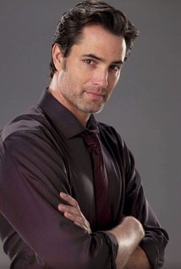
Victor Webster was born in Calgary, Alberta, Canada. In the summer of 1986 Victor and his family moved to San Clemente, CA where he attended high school. Webster was interested in acting from a very early age and participating in many school plays and theater classes helped him to realize his love of the art. As a teenager, Webster searched for a productive outlet in order to avoid getting into too much trouble. He began to study, and later teach, martial arts, which proved to be a perfect fit for him.
After graduation he attended Saddleback College and then chose to go into the world of business in an effort to carve out a life for himself. He became a stockbroker and later owned and operated an import/export company. Unfortunately, his work wasn’t fulfilling but a chance encounter provided him an opportunity to pursue his true dream of acting.
Webster was approached for an acting gig and landed the job starring on an NBC daytime series. He immediately followed that with a starring role on the Emmy® Award winning AMC Network series “The Lot” and then the number one nationally syndicated action series “Mutant X.” With this, Webster caught the attention of People magazine and was named one of their 50 Most Eligible Bachelors. He began doing guest roles on other series while working on “Mutant X,” which included a notable role in 2003 as a boyfriend of Samantha’s on HBO’s “Sex and the City.”
Webster’s film career began with the the box office smash “Bringing Down the House.” During this time he alternated between television and film roles. His guest star credits include roles on shows such as “Bones,” “CSI,” “NCIS,” “Criminal Minds,” “Necessary Roughness” and “Single Ladies.” He has also had recurring roles on a variety of series including “Related,” “Charmed,” Lincoln Heights,” Harper’s Island,” “Melrose Place” and “Castle.”
On the big screen, Webster has had roles in movies such as “Must Love Dogs,” “Surrogates” and “Why Did I Get Married Too?” Since 2011 he has starred as the Scorpion King in the third and fourth installments of the franchise; “The Scorpion King 3: Battle for Redemption” and “The Scorpion King 4: Quest for Power.” His most recent film project was alongside Steven Seagal in the action film “A Good Man.”
Though he has kept busy with his acting career he has never given up his love, and great talent, for martial arts. Webster holds a black belt in Tae Kwon Do and has taught and competed in many forms of martial arts. He holds an undefeated record as a heavyweight in both Tae Kwon Do competition and amateur kick boxing and is also a multiple medal winner in the no gi jiu jitsu world championships.
Currently, Victor stars in the television show “Continuum,” which has recently begun its fourth season.
IRIS QUINN
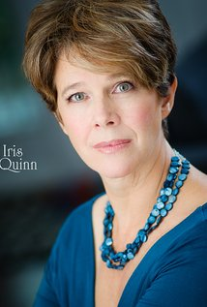
Iris Quinn's acting career includes a variety of roles in television and film as well as stage productions and voice-over work. She also runs an actors' studio in Vancouver; coaching and mentoring young actors. In 2002 she was appointed to the faculty of University of British Columbia. She resides in Vancouver, British Columbia with her husband, actor, Fred Henderson.

Cast
Bridget Regan |  | Lindsey Monroe
Victor Webster |  | Scott Terrell
Iris Quinn |  | Donna
Imogen Tear |  | Hannah Monroe
Fred Henderson |  | Mayor Fred
Nhi Do |  | Jenny
Kelli Ogmundson |  | Employee
Ellen Kennedy |  | Ruth
Maxine Miller |  | Christmas Lady
Danny Wattley |  | Reverand Blair
Daniel Martin |  | Frank
Dolores Drake |  | Debbie O'Neal
Pearce Visser |  | Santa
Jilena Cori |  | Sarah
Emily Wheeler |  | Poster girl
Beckham Crawford |  | Jake
Cassandra Summers |  | Town person

Production Credits

Directed by
David Winning

Written by
Buddy Baron

Produced by
Timothy O. Johnson |  | executive producer
Oliver De Caigny |  | producer
Maura Dunbar |  | producer

Music by
Russ Howard III

Cinematography by
Anthony Metchie

Film Editing by
Fabiola Caraza

Production Design by
Harry Brar

Makeup Department
Marecel Daniel |  | assistant makeup artist

Production Management
Navid Soofi |  | production manager

Second Unit Director or Assistant Director
Troy Scott |  | second assistant director
Patrick Weir |  | first assistant director

Art Department
Ryan MacInnes |  | carpenter / on set dresser
Ali Tavasoli |  | construction coordinator

Sound Department
Craig George |  | sound effects editor
Alex Macia |  | foley artist
Tony McVann |  | a.d.r. recorded by
Karla Melendez |  | dialogue editor
Gregor Phillips |  | sound re-recording mixer / supervising sound editor
Tony Poulsen |  | boom operator
Devon Quelch |  | foley artist
Taymaz Saba |  | sound assistant
James Schoening |  | sound mixer

Camera and Electrical Department
Jenna Fuoco |  | second assistant camera: a camera
Jackson Harper |  | assistant camera
Clyde Harrelson |  | gaffer
Justin Kamal |  | 1st assistant camera
Gabriel Medina |  | director of photography: second unit
Collin Morrison |  | steadicam
Vincent Oosterhof |  | lamp op

Casting Department
Judy Lee |  | casting
Edward D. Rea |  | casting associate

Other crew
Sean Cummings |  | location manager
Brian McWha |  | production assistant
Taliesin Sanford |  | script supervisor

Producer Biographies

TIM JOHNSON – Executive Producer
Tim Johnson is among the most active and reliable producers in the business thanks to top rate productions and an 'on time, on budget' reputation. Previously, he managed the production of ABC's THE DAYS (MINDSHARE/TOUCHTONE.) Prior to forming Johnson Production Group and Ignite Entertainment, Tim served as Head of West Coast Programming Executive and launched the successful series DOC (88 episodes,) SUE THOMAS, FBI, MYSTERIOUS WAYS, JUST CAUSE, PONDEROSA, CHRISTY, ITS A MIRACLE AND MIRACLE PETS.

Johnson is also responsible for producing the international hit series, DR. QUINN, MEDICINE WOMAN for CBS PRODS/SULLIVAN COMPANY for over 5 seasons. During his 100-episode tenure, he also launched LIVE FROM THE RANCH with Orson Bean - a nationally syndicated talk show focusing on family values in America. He also developed and produced the original docu-drama COLD CASE for CBS network, which was the very first program to integrate television with the Internet.

Recent Projects:
For Better or For Worse – Executive Producer
Baby Bootcamp – Executive Producer
Ring By Spring – Executive Producer
Sole Custody – Executive Producer
The Cheating Pact – Executive Producer
Deadly Spa – Executive Producer
Walking the Halls – Executive Producer
June In January – Executive Producer
Christmas in the City – Executive Producer
Snow Bride – Executive Producer
Dirty Teacher – Executive Producer
The Surrogate – Executive Producer
Merry In-Laws – Executive Producer
A Bride for Christmas – Executive Producer
Naughty or Nice – Executive Producer
Christmas Crush– Executive Producer
Teenage Bank Heist– Executive Producer
How to Fall in Love – Executive Producer
Home Invasion (2011) – Executive Producer
Final Sale (2011) – Executive Producer
Confined (2010) – Executive Producer
Tornado Valley (2009) – Executive Producer
The Wedding Dance (2009) – Executive Producer
Trust (2009) – executive producer
Toxic Skies (2008) – executive producer
Storm seekers (2008) – executive producer
Making Mr. Right (2008) – executive producer
Love Sick (2008) – executive producer
Just Breathe (2008) – executive producer
Devils Diary (2007) – executive producer
Swarm (2007) – executive producer

JOHNSON PRODUCTION GROUP
The Johnson Production Group contracts globally to produce television and motion picture content for international networks, studios and distributors. Based in Los Angeles and Vancouver, British Columbia, the company manages production, facilitates development and financing, procures distribution and guarantees quality and timely execution of its programs. While costs have gone up, so has the demand for quality. No longer is good enough, good enough. Johnson Production Group serves that segment when a show needs to be "A" quality, but produced efficiently enough to meet a locked budget. JPG specializes in value, protection of creative elements, and delivery of a quality finished product.
OLIVER DE CAIGNY - Producer
Oliver De Caigny is a Canadian producer originally from Belgium, his background in financing, production, and post production makes his a well-rounded producer for any type of production. His experience in financing and production agreements (film and TV series and movies-of-the week), distribution agreements (both domestic and foreign) as well as international co-productions, Canadian tax credit, Telefilm Canada and Canada Media Fund incentives provides him with a well-rounded background in development, production and distribution for motion pictures, television series and productions.
Recent Projects
Strange Empire (2014, 13 episodes) – Producer
Her Infidelity (2014) - Producer
Paper Angels (2014) - Producer
A Cookie Cutter Christmas (2014) - Producer
For Better or For Worse (2014) – Producer
A Ring By Spring (2014) – Producer
June In January (2014) – Producer
Baby Bootcamp (2013) – Producer
A Badge Of Betrayal (aka Sole Custody) (2013) – Producer
R.L. Stine’s: The Haunting Hour (53 Episodes) – Associate Producer
A Bride For Christmas (2013) – Producer
The Dating Coach (2012) – Producer
Radio Rebel (2012) – Executive Producer
Seattle Superstorm (2012) – Producer

Maura Dunbar Producer
Maura Dunbar is a producer and production manager, known for The Shunning (2011),The American Bible Challenge (2012) and The Confession (2013).

Billing Block

Johnson Production Group Presents “THE MAGIC STOCKING”
Bridget Regan Victor Webster and Iris Quinn Edited by Fabiola Caraza
Music by Russ Howard III Director of Photography Gabriel Medina
Executive Producers Timothy O. Johnson Produced by Oliver De Caigny Maura Dunbar Written by Buddy Baron Directed by David Winning
With the participation of the Province of British Columbia
Film Incentive BC
The Canadian Film or Video Production Tax Credit
© MMXV Johnson Production Group All Rights Reserved
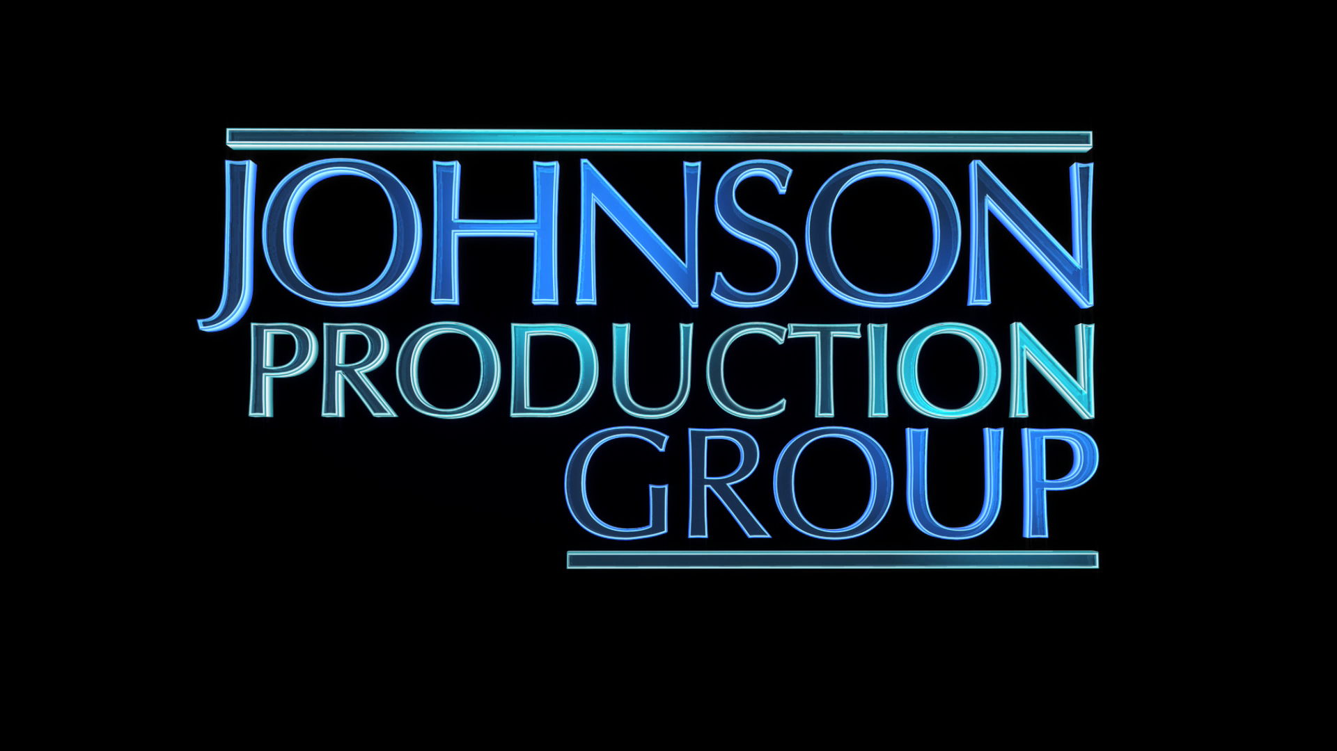

Meta Data

LONG (max 540 characters) synopsis
This holiday tale surrounds Lindsey Monroe – a widow still mourning her husband’s death – and daughter Hannah. When Hannah buys a stocking at their town’s Christmas craft fair, Lindsey suddenly starts to magically find things inside it that begin holding importance in her everyday life. The stocking holds a power and energy that quickly becomes clear, restoring Lindsey’s faith in life and love – and leading her to open up her heart after meeting a handsome artist. (468)

MEDIUM (max 180) synopsis
A young widow finds a tattered old Christmas stocking at a Holiday craft sale, but is skeptical of its magic when it seems to create small trinkets on its own. (160)

SHORT (max 54 characters) synopsis
Widow is skeptical of magic in a Christmas stocking (51)

5 KEY WORDS
Christmas, widow, single mother, romance

