

Johnson Production Group

Press Kit

One-Liner
When a teenage girl unwittingly gets involved in an illegal smuggling operation, she is arrested and her mother must work with the FBI to get her free.

Synopsis
At 18, a terribly shy Joanie gets recruited to do an amazing job: along with the cutest girls in school, she travels to exciting cities delivering camera lenses to photographers. New York! Chicago! Miami! Joanie begs her younger brother Peter, 15, to keep it a secret from their mom. During one of her trips, Joanie falls in love with the handsome Tucker -- a partner in the courier business.
When Joanie's mom Georgia (Darlene Vogel, Pacific Blue) finds out, Georgia is livid -- and suspicious of this strange courier business. But Joanie defies her mom and continues making deliveries.
On Joanie's next trip, she searches the camera case she's carrying and discovers diamonds hidden inside a lens. Joanie realizes she is part of an illegal smuggling ring! She quits, which angers her boss, the paranoid Danny (Bret Green, The Inspectors).
To Joanie's surprise, she learns her brother Peter has been diagnosed with intestinal cancer, which will bankrupt the family. Joanie begs Danny to be re-hired. At first, it's a challenge to regain Danny's trust, but the hard-working Joanie proves to be the most reliable "mule" of the group. Joanie makes several trips, earning big cash each time out.
Just when Joanie has earned enough money to pay for her brother's surgery, Federal Agents swoop in to arrest her. Joanie and her mom Georgia learn that the diamonds she delivers are illegal "blood diamonds" from Africa, and Joanie is part of a smuggling ring which helps finance the terrorists who attacked the USA on September 11. In the eyes of the Department of Homeland Security, Joanie is a terrorist.
Joanie is coerced into signing a deal with the DHS: in exchange for incriminating her friends, Joanie will get a very light sentence. But Joanie has grown to love Tucker, the handsome partner to Danny. Joanie is terribly torn. Will she double-cross the man she loves to keep herself out of jail? Or will she warn Tucker and run off with him?
Unbeknownst to Joanie, the paranoid Danny has discovered she is talking to the Feds. In a thrilling climax, Danny sets out to kill Joanie -- and anybody else on the smuggling team who conspires against him.

Producers
Executive Producer
TIMOTHY O. JOHNSON

Producer
ROBERT BALLO

Key Cast
CHARACTER  Georgia  Joanie  Alison  Sharnae  Danny  Tucker  Peter |  | ACTOR  DARLENE VOGEL  MONROE CLINE  SHELBY YARDLEY  JULIANA DESTEFANO  BRET GREEN  COLE REINHARDT  ZANDER GRABLE

Key Cast Biographies

DARLENE VOGEL

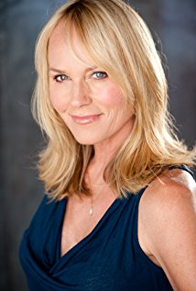
Darlene Vogel was born on October 25, 1962 in Modesto, California, USA as Darlene K. Vogel. She is an actress, known for Back to the Future Part II (1989), Pacific Blue (1996) and A Tiger's Tail (2014). She is married to Mark Howard. They have two children.

MONROE CLINE


Monroe Cline is an American actress and dancer. Monroe trained in theatre and dance from an early age, and was born and raised in Austin, Texas. She moved to Los Angeles in 2017 to pursue her professional career as both an actress and dancer, and has since worked on a number of commercials, music videos, and films.

SHELBY YARDLEY
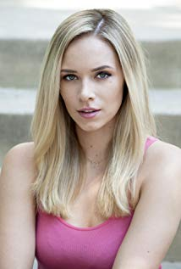
Shelby began her career in the entertainment industry as a television personality. Prior to starting a career in the entertainment industry, Shelby grew up as an athlete in Wichita, KS and attended Wichita State University. Although always having an interest in acting and modeling it wasn't until January of 2014 that she started taking acting lessons and found it was something she wanted to continue as a career. In May of 2015 she relocated to Los Angeles to pursue a career in acting.

JULIANA DESTEFANO

Juliana Destefano is an actress, known for Small Things, The Summoning (2019) and Helen Alone (2014).

BRET GREEN
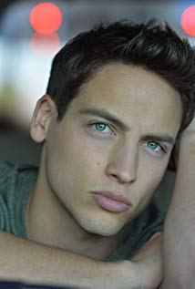
Bret Green is known for his work on the CBS crime series The Inspectors. He's appeared on Jane the Virgin, How to Get Away With Murder, Bones, and The Goldbergs. Bret graduated from Western Michigan University before moving to Los Angeles to pursue an acting career. He is the youngest of three boys.

COLE REINHARDT
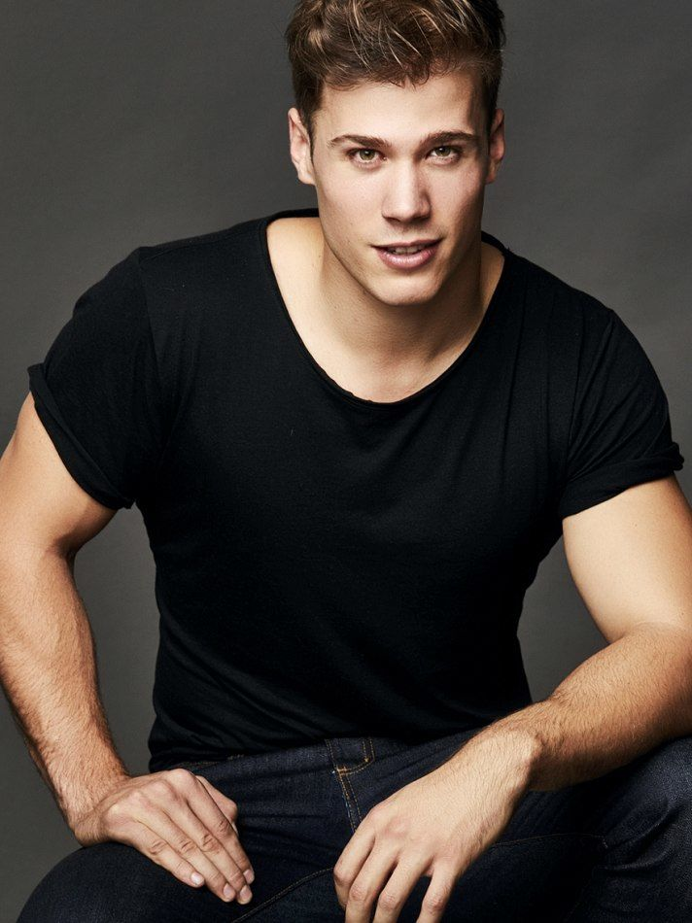
Cole Reinhardt is an American actor born with a love and fascination for story telling in all its forms. Sometimes it involved solving a Hardy Boys mystery, writing a short story, or just re-watching The Goonies for the hundredth time. By 5th grade he had learned (from a family friend) how to correctly use a camcorder and edit inside of Adobe Premiere. With these newfound skills he began to write and produce short films starring friends, family and himself on occasion. At 16 he began working as an intern for Fox Sports West's Prep Zone division and by 18 he was working as a Director. He was also an avid athlete often competing in Football, Baseball, Basketball, Wrestling, and Judo to name a few. It was in Wrestling where he learned about weight manipulation. About quickly dropping 10-15 pounds to reach a lower weight class along with how to gain weight rapidly when needed. Both of which he is now proficient in. After a few years directing, he decided to focus his efforts into developing his skills in front of the camera. He started attending local acting classes and joining local performances. Now, he continues his pursuits as an actor with various roles in both Film and Television.

ZANDER GRABLE
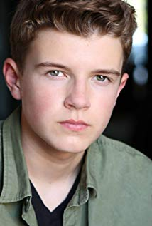
Zander Grable is from Edmond, Oklahoma, but lives in LA. He has been acting since he was 5 years old and is best known for the role of Logan in Find. Believe. Shine.

Production Credits

Full Cast
Actors  DARLENE VOGEL  MONROE CLINE  SHELBY YARDLEY  BRET GREEN  COLE REINHARDT  JULIANA DESTEFANO  ZANDER GRABLE  JEREMIAH MCQUEEN  LEANN VAN MOL  JANET LYNN FEMIANO  KIMBERLY ARLAND  AL MARCHESI | Role  Georgia  Joanie  Alison  Danny  Tucker  Sharnae  Peter  Agent Hope  Detective Espinoza  Olivia  Kendra  Mike

Produced by
TIMOTHY O. JOHNSON |  | executive producer
ROBERT BALLO |  | producer
DAN GOLDEN |  | line producer

Directed by
DOUG CAMPBELL

Written by
BOB INGRAHAM

Sound Design by
ANDRES BOULTON

Music by
MARC JOVANNI

Director of Photography
DAVID DOLNIK

Film Editing by
JONATHANN LAUNER

Casting By
JEFF HARDWICK, C.S.A.

Production Design by
PAUL DEDOES

Costume Design by
BOB MILLER
STEVE TREVOR

Crew
JOE MESIANO | production manager
TED CAMPBELL | first assistant director
JT TIERNEY | second assistant director
DOERTE LINDNER | production accountant
LUCAS PEDERSON | key set pa
SEAN STRUBLE | production assistant - prod. van driver
DEVON FOX | production intern
JERRY SHERMAN | studio teacher
AMY STANOSZEK | studio teacher
MORGUE N MARCUS | extras casting director
PAUL DEDOES | production designer
BRENDAN STEWART | art director
GAITHER NARRON | art swing
YOANN CIFUENTES | key grip
ANDREW DORWARD | best boy grip
CLIFF HORN | best boy grip
BOB MILLER | costume designer
STEVE HOWARD | costume designer
SHANNON TRIGGER | key makeup
RAMONA COLLAZO | key hair
TORYN REED | makeup artist
LEESA SIMONE | makeup artist
ANDY CARAZO | gaffer
DEREK MATARANGAS | gaffer
JAMES GILLIAM | best boy electric
BYONG HOON JO | best boy electric
DAVID DOLNIK | dop/cam op
CHRISTOPHER JORDAN | b camera op
NICK BIANCHI | b camera op
JAMES NAGEL | 1st assistant camera- a cam
ADAM BRANT | 1st assistant camera- a cam
DARRELL NASH | 1st assistant camera- a cam
DEON GIBSON | 1st assistant camera- b cam
JUSTIN CROWE | 2nd assistant camera
RICHARD DURYEA | 2nd assistant camera
ALEXANDER VAN HEISCH | media manager
IAN WELLS | ronin tech
DEON GIBSON | ronin tech
CAMERON SELAN | production sound mixer
ASH SUTTON | production sound mixer
JONATHON FREEMAN-ANDERSON | boom operator
LYSA CARLSON-OLDHAMS | craft service
JONATHANN LAUNER | editor
JESSICA PEREZ | still photographer
GRIFF PARTINGTON | post production supervisor

Producer Biographies

TIM JOHNSON – Executive Producer
Tim Johnson is among the most active and reliable producers in the business thanks to top rate productions and global distribution appeal.

Johnson is also responsible for producing the international hit series, DR. QUINN, MEDICINE WOMAN for CBS for over 5 seasons. During his 100-episode tenure, he also developed and produced the original docu-drama COLD CASE for CBS network, which was the very first program to integrate television with the Internet.

Johnson has produced over 150 movies, 15 globally released series for every major US network - including ABC, Disney, CBS, NBC, Netfly, FOX and Sony.

JOHNSON PRODUCTION GROUP
The Johnson Production Group contracts globally to produce television and motion picture content for international networks, studios and distributors. Based in Los Angeles and Vancouver, British Columbia, the company manages production, facilitates development and financing, procures distribution and guarantees quality and timely execution of its programs. While costs have gone up, so has the demand for quality. No longer is good enough, good enough. Johnson Production Group serves that segment when a show needs to be "A" quality, but produced efficiently enough to meet a locked budget. JPG specializes in value, protection of creative elements, and delivery of a quality finished product.

Billing Block
Johnson Production Group Presents “SMUGGLING IN SUBURBIA”
DARLENE VOGEL MONROE CLINE SHELBY YARDLEY JULIANA DESTEFANO BRET GREEN
COLE REINHARDT and ZANDER GRABLE Sound Design by ANDRES BOULTON
Music by MARC JOVANNI Director of Photography DAVID DOLNIK
Film Editing by JONATHANN LAUNER Casting By JEFF HARDWICK, C.S.A.
Production Design by PAUL DEDOES Costume Design by BOB MILLER and STEVE TREVOR
Executive Producer TIMOTHY O. JOHNSON Producer ROBERT BALLO
Line Producer DAN GOLDEN Written by BOB INGRAHAM Directed by DOUG CAMPBELL
With the participation of the Province of British Columbia
Film Incentive BC
The Canadian Film or Video Production Tax Credit

© MMXVIII Johnson Production Group Inc. All Rights Reserved



Meta Data

LONG (max 540 characters) synopsis
Joanie gets recruited to travel with other girls to exciting cities delivering camera lenses to photographers - and falls in love with Tucker, a partner in the courier business. When she searches the camera case she's carrying and finds diamonds hidden inside a lens, Joanie realizes she is part of an illegal smuggling ring! She just needs to pay for her brother's cancer surgery that would otherwise bankrupt the family. Just when Joanie has earned enough , Federal Agents arrest her. Will her mother be able to step in to get her free? (538)

MEDIUM (max 180) synopsis
When a teenage girl unwittingly gets involved in an illegal diamond smuggling operation, she is arrested and her mother must work with the FBI to get her free. (160)

SHORT (max 54 characters) synopsis
Teenage girl gets caught up with illegal smuggling (51)

5 KEY WORDS
Diamonds, Mules, Illegal, Teens, FBI

