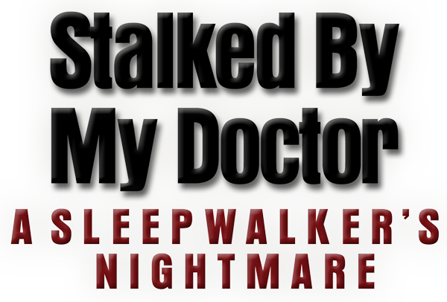

Johnson Production Group

Press Kit

One-Liner
Dr. Albert Beck finds his way into a sleep clinic only to fall for his first patient, Michelle, who suffers from sexsomnia

Synopsis
Wanted for multiple crimes, Dr. Albert Beck (Academy Award nominee Eric Roberts) hides out as a lowly waiter at a roadside diner in the New Mexico desert. But Beck escapes his dead-end life when he assumes the identity of another doctor en route to a new job at a nearby sleep clinic.
After charming his way past the clinic’s director, Pamela (Felissa Rose), Beck falls for his first patient: Michelle (Emilie Ullerup; Sleepwalking in Suburbia), who suffers from sexsomnia - a rare condition that causes her to sleepwalk into sexual relations with strangers. Beck dedicates himself to Michelle’s treatment, using it as an excuse to get close to her and try to win her affections.
But Beck’s romantic interest in Michelle is derailed by the arrival of her beautiful niece, Katie (Angeline Appel), who suffers from a similar nocturnal condition. Beck turns his romantic attentions to the younger woman, causing Michelle to grow suspicious and alert Pamela, who also begins to question Beck’s erratic behavior…
Needing to clear the path for his relationship with Katie, Beck frames Michelle for Pamela’s murder and has her institutionalized for the crime - giving him total access to a distraught Katie. Michelle, realizing Beck’s true intentions, escapes from the asylum and races to save her niece from the murderous doctor - leading to a dangerous showdown between Michelle, her sleepwalking niece, and the lovelorn Dr. Beck!

Producers
Executive Producer
TIMOTHY O. JOHNSON
Producer
KEN SANDERS
Co-Producers
SHERI REEVES
JOSEPH WILKA
Associate Producer
CHRISTIAN ACKERMAN
Key Cast
CHARACTER  Albert Beck  Michelle  Katie  Pamela  Nicky Bismar  Leo |  | ACTOR  ERIC ROBERTS  EMILIE ULLERUP  ANGELINE APPEL  FELISSA ROSE  MICHAEL PERL  MATT RIFE

Key Cast Biographies

ERIC ROBERTS

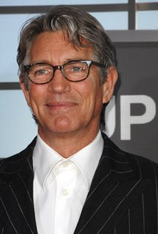
Eric Roberts is an Academy Awards nominee for his role in Runaway Train and a three-time Golden Globes nominee for Runaway Train, Star 80 and King of the Gypsies . He also won a Golden Satellite Award for the 2002 season of Less Than Perfect .

He also made a profound impact in the Emmy nominated television adaptation of Truman Capote’s In Cold Blood , directed by Jonathan Kaplan and co-starring Anthony Edwards and starred in La Cucaracha , which won Best Film at the Austin Film Festival in 1998, and for which Eric won Best Actor in the New York Independent Film Festival that same year. Eric’s starring role in the film, It’s My Party , received critical acclaim at the 1996 Sundance Film Festival .

Eric has diversified very recently, appearing in Sophie Muller’s Mr. Brightside video for The Killers, Brett Ratner’s video for Mariah Carey’s Emancipation of Mimi – Both award winners, and the Akon and Eminem video for Smack That .

Other notable performances include his roles in Final Analysis, The Pope of GreenwichVillage, Raggedy Man, Babyfever, Heaven’s Prisoners, The Specialist and The Grave.

Eric Roberts was recently seen in Christopher Nolan’s Batman – The Dark Knight , along with one of the most incredible casts ever assembled. This follows a stint on Heroes – A job that ranks as one of Eric’s favorites. Eric strives to be associated with more comedy, hence will be appearing in a Larry The Cable Guy movie, Witless Protection.

Eric Roberts was born in Biloxi, Mississippi and grew up in and around Atlanta, Georgia area. He began his career as an actor in his late teens in New York City. In 1989 Eric won the Theatre World Award for his role on Broadway in Burn This . He returned to the New York stage in 2003 in The Exonerated , which he appeared in as part of their touring company as well.

EMILY ULLERUP
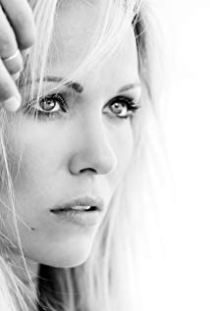
Ullerup-Petersen was born in Denmark, where her father Ove Ullerup-Petersen, a Jurist and Diplomat and a decorated Ambassador of Denmark in Vietnam, held the title of Lord Chamberlain for the Danish Royal Family.
It was always been her ambition to become an actress. When she graduated from high school in Copenhagen in 2003, she moved to Vancouver to pursue acting as a career. She studied at the Vancouver Film School and graduated in 2005.
Her first role was that of Julia Prynne in the hit sci-fi TV show Battlestar Galactica (2004). She also played the part of Sandra in the first episode of Blood Ties (2006). She was one of the main characters in the ground breaking series Sanctuary (2008) where she starred alongside Amanda Tapping. Emilie continued her journey and enjoyed versatility in her work bouncing between genres of Drama, Horror, Action and Comedy. She spent three seasons on the hit show Arctic Air as the lovably temperamental Swedish pilot, Astrid. She was continuously nominated for Leo Awards and UBCP Awards over several seasons of the series.
Recently Emily has starred in a variety of movies, particularly the popular Sleepwalking In Suburbia.

ANGELINE APPEL
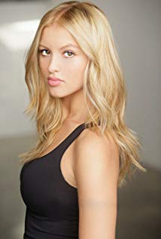
Angeline Appel was born as Angeline Fioridella Appel. She is an actress, known for Step Up Revolution (2012), Shameless (2011) and The Fosters (2013).

FELISSA ROSE

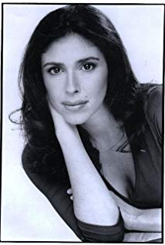
Felissa Rose Esposito grew up in New York always wanting to perform. At the age of 13, she landed the role of Angela in the cult film Sleepaway Camp (1983). At the age of 17, she applied for early admission to New York University's Tisch School of the Arts and was admitted that fall. Attending The Lee Strasberg institute, she began formal training as a serious actress.

Performing in plays around Manhattan put her hard work to the test. Felissa played Denise Savage in Savage in "Limbo," Karen in "Phone Sex," Renée in David Henry Hwang's "M.Butterfly," Willie in "This Property is Condemned," Desdemona in William Shakespeare's "Othello," and many more. Film work includes Woody Allen's Another Woman (1988), Pain and Suffering, The Night We Never Met (1993), and MTV's The Party Phone Series opposite Adam Sandler. She is currently working with NY Dinner Theater and plays Louise in Disorganized Crime as well as pursuing TV and film work.

MICHAEL PERL
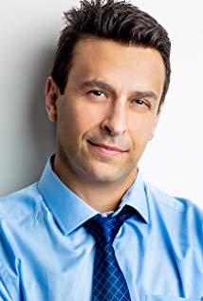
Michael, a native Angeleno, got his first role as Danny Zuko in his 5th grade production of "Grease" Two things he didn't realize when rehearsals started: one, this would become a lifelong thing and two, that he was going to be in big trouble for nicking his dad's cigarettes and rolling them up in the arm of his tiny white t-shirt for the first performance. He played Winston in the TV series based on the popular Francine Pascal novels, "Sweet Valley High" When the show ended, he went to get his BFA in Theatre from UCLA's school of Theatre, Film and Television. Since graduating, Michael has been working consistently in film, television and Los Angeles theatre.
Michael started a production company, Burton Street Productions, with his wife Melissa Lugo. They have produced award-winning short films and web series under that banner.

MATT RIFE
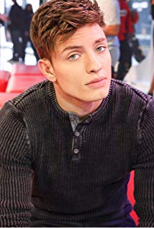
Matt Rife is an American standup comedian & actor originally from Ohio. Matt first started standup comedy at the age of 15 and has since toured around the world performing with some of the biggest names in comedy; Dane Cook, Ralphie May, Finesse Mitchell, Mike Epps, Deray Davis, Erik Griffin, etc... Now living in Los Angeles, Matt has become a popular regular in the comedy scene, including being the youngest male regular performer at the World Famous Laugh Factory. Comedy in his roots, Matt has easily transitioned into his much larger passion, acting. Getting his start on a couple of Disney shows until his break came when he was added as a leading cast member on MTV's hit show Wild N Out back in season 7.

Production Credits

Full Cast
Actors  ERIC ROBERTS  EMILIE ULLERUP  ANGELINE APPEL  FELISSA ROSE  MICHAEL PERL  MATT RIFE  STEVEN CHAN  CLAYTON ROHNER  MICHAEL C. ALEXANDER  RICKY DEAN LOGAN  MATTHEW GILMORE  BOB BANCROFT  NICOLE DUBOIS  XIAN MIKOL  MARISA ECHEVERRIA  JACOB FIGUEROA | Role  Albert Beck  Michelle  Katie  Pamela  Nicky Bismar  Leo  Tyler  Dr. Tanner  Detective  Sal  Rick  Dr. Trotter  Bobby Jo  Carrie  Bride  Dan

Casting by
JEFF HARDWICK, CSA

Costume Designer
MEARYGRACE GATO

Sound Design by
ANDRES BOULTON

Music by
STEVE GUREVITCH

Edited by
GREGORY HOBSON

Production Designer
CHASE WRIGHT

Director of Photography
FERGUSON SAUVÈ-ROGAN

Associate Producer
CHRISTIAN ACKERMAN

Co-Producer
SHERI REEVES
JOSEPH WILKA

Executive Producer
TIMOTHY O. JOHNSON

Story by
KEN SANDERS
ALEX WRIGHT

Based on Characters Created by
DOUG CAMPBELL
BRYCE DOERSAM

Screenplay by
JEFF HARE
DANIEL WEST

Produced by
KEN SANDERS

Directed by
JEFF HARE

Full Crew
JOSHUA LOU FRIEDMAN  JOSH BROWN  JOHN J. TIERNEY  JAVIER GALAVIZ  AUSTIN J. BRUCKS  GABBI LATADE  KENNEDY DEL TORO  KATYA LOBAN  KATE KETCHAM  JAY RUGGIERI  DAVID SPECK  CARSON REAVES  ROSE N. OXNARD  ALAN KOPLIN  JUSTIN R. SCHULTZ  LAMONT J. REEVES  TYLER M. MANZO  JAY RUGGIERI  NEIL BACHAND  KYRA DUNN  CHARLES CHRISTOPHER  JASON AARON MORAN  DANIEL KAUTZ  NATHAN HANSEN  MONICA MEJIA  ANDREW DORWARD  JENS ERICSON  BRIAN PATIERNO  ISAIAH REZA-SOTO  FAISAL SHAH  FAISAL SHAH  JUSTIN KNODEL  COLVIN ANG WEI SONG  ROB E. BENNETT  KEVIN MANNING  MICHAEL SURACI  ROBERT PAGE-ROBERTS  LANE YOUNG  MICHAEL O’CONNOR  KRISTA KARKAR  DOMENICO RISO  MICHAEL KNUDSEN  JENNIFER PATTERSON  ERICA MEDINA  JENNIFER PATTERSON  CRYSTAL LOZADA  TIFFANY ROYDSEN  DEAN GALANIS  LUKE LAKIN  PETE SUTTON  CHRISTOPHER M. MILLER  RICHARD ANDAL  TANNER CONANT  SHANIA GEZ  MIRNA HMAYDANI  NICOLETTE HOGAN  HALEY MEYERS  MICHELLE NASSIF  DARBY NEVEU  RYAN KELLY  ADAM RODRIGUEZ  PHILLIP RODRIGUEZ  JOHNNY ROMER  DAX RUBISH  MORGAINE RUNIONS  JILL SMITH  ELIZABETH WHITFIELD  MICHAEL TODD WYNN  ERIN TAYLOR  CHRISTOPHER M. JIMENEZ  HAYLEY HONEYCUTT  BAILEY WEIR  B & G THAI FOOD CATERING  GROUPZEE J. DEVLIN  Second Unit  TED CAMPBELL  MARCO BARGELLINI  DAVID BENULLO  CHRISTIAN ACKERMAN  CHUCK PARELLO  JOSH BROWN  KATE KETCHAM  MICHAEL SURACI  GREG UNGER  GERALD WOLFE  MAYRA RODRIGUEZ  LELLAN THOMAS | first assistant director  second assistant directors  second second assistant director  production coordinator  script supervisors  camera operators  a camera first assistant  additional a camera first assistants  b camera first assistant  second assistant camera  steadicam operators  d.i.t  still photographer  production sound mixer  gaffer  best boy electrics  key grip  additional key grip  best boy grip  grip & electric swing  prop master  art director  set dresser  art swing  costume supervisor  makeup department heads  hair department head  makeup artist  hair stylist  location manager  key assistant location manager  extras casting director  assistant to eric roberts  production assistants  craft service  caterer  directors  first assistant director  director of photography  gaffer  production sound mixers

Producer Biographies

TIM JOHNSON – Executive Producer
Tim Johnson is among the most active and reliable producers in the business thanks to top rate productions and global distribution appeal.
Johnson is also responsible for producing the international hit series, DR. QUINN, MEDICINE WOMAN for CBS for over 5 seasons. During his 100-episode tenure, he also developed and produced the original docu-drama COLD CASE for CBS network, which was the very first program to integrate television with the Internet.
Johnson has produced over 150 movies, 15 globally released series for every major US network - including ABC, Disney, CBS, NBC, Netfly, FOX and Sony.

JOHNSON PRODUCTION GROUP
The Johnson Production Group contracts globally to produce television and motion picture content for international networks, studios and distributors. Based in Los Angeles and Vancouver, British Columbia, the company manages production, facilitates development and financing, procures distribution and guarantees quality and timely execution of its programs. While costs have gone up, so has the demand for quality. No longer is good enough, good enough. Johnson Production Group serves that segment when a show needs to be "A" quality, but produced efficiently enough to meet a locked budget. JPG specializes in value, protection of creative elements, and delivery of a quality finished product.

KEN SANDERS - Producer
Over the past decade and a half, Ken Sanders has written and/or produced over forty feature-length motion pictures. Since starting his film production company, Shadowland, LLC, with partner Robert Ballo in 2009, Sanders has also produced THE CHEATING PACT, MISSING AT 17, THE PERFECT BOYFRIEND, DIRTY TEACHER, THE SURROGATE, STALKED AT 17, TEENAGE BANK HEIST, WALKING THE HALLS, BETRAYED AT 17, HOME INVASION, MATERNAL OBSESSION, and ACCUSED AT 17, all of which received big ratings when they premiered on Lifetime Television.

JEFF HARE – Director
Jeff Hare has been writing and directing movies, television, television commercials and infomercials, corporate films and videos and documentaries for over twenty years. His work is extremely diverse, and has been seen on movie screens worldwide, and on TV networks like Fox, American Movie Classics, Lifetime, LMN, MY NETWORK, Discovery, SPEED-TV, Cartoon Network and BET, to name just a few.

Billing Block

JOHNSON PRODUCTION GROUP in association with HARBOR LIGHT STUDIOS Presents “STALKED BY MY DOCTOR: A SLEEPWALKER'S NIGHTMARE”
Starring ERIC ROBERTS ANGELINE APPEL FELISSA ROSE MICHAEL PERL MATT RIFE AND EMILIE ULLERUP Casting by JEFF HARDWICK, CSA
Costume Designer MEARYGRACE GATO Sound Design by ANDRES BOULTON
Music by STEVE GUREVITCH Edited by GREGORY HOBSON
Production Designer CHASE WRIGHT Director of Photography
FERGUSON SAUVÈ-ROGAN Associate Producer CHRISTIAN ACKERMAN
Co-Producers SHERI REEVES JOSEPH WILKA Executive Producer TIMOTHY O. JOHNSON Story by KEN SANDERS & ALEX WRIGHT Based on Characters Created by DOUG CAMPBELL & BRYCE DOERSAM Screenplay by JEFF HARE & DANIEL WEST
Directed by JEFF HARE
Meta Data

LONG (max 3000 characters) synopsis
Wanted for multiple crimes, Dr. Albert Beck (Academy Award nominee Eric Roberts) hides out as a lowly waiter at a roadside diner in the New Mexico desert. But Beck escapes his dead-end life when he assumes the identity of another doctor en route to a new job at a nearby sleep clinic.
After charming his way past the clinic’s director, Pamela (Felissa Rose), Beck falls for his first patient: Michelle (Emilie Ullerup; Sleepwalking in Suburbia), who suffers from sexsomnia - a rare condition that causes her to sleepwalk into sexual relations with strangers. Beck dedicates himself to Michelle’s treatment, using it as an excuse to get close to her and try to win her affections.
But Beck’s romantic interest in Michelle is derailed by the arrival of her beautiful niece, Katie (Angeline Appel), who suffers from a similar nocturnal condition. Beck turns his romantic attentions to the younger woman, causing Michelle to grow suspicious and alert Pamela, who also begins to question Beck’s erratic behavior…
Needing to clear the path for his relationship with Katie, Beck frames Michelle for Pamela’s murder and has her institutionalized for the crime - giving him total access to a distraught Katie. Michelle, realizing Beck’s true intentions, escapes from the asylum and races to save her niece from the murderous doctor - leading to a dangerous showdown between Michelle, her sleepwalking niece, and the lovelorn Dr. Beck! (1425)

MEDIUM (max 500) synopsis
Wanted for multiple crimes, Dr. Albert Beck assumes the identity of another doctor enroute to a new job at a sleep clinic. He falls for his first patient: Michelle, who suffers from nocturnal sexsomnia - until his interest is derailed by the arrival of her beautiful niece who suffers from a similar condition. Beck turns his romantic attentions to the younger woman, causing Michelle to grow suspicious and alerting clinic director, Pamela, who also begins to question Beck’s erratic behavior... (497)

SHORT (max 100 characters) synopsis
Dr. Albert Beck is back in action treating sexsomnia patient, Michelle, and her beautiful niece (96)

5 KEY WORDS
sexsomnia, murder, Beck, sleepwalking, thriller

