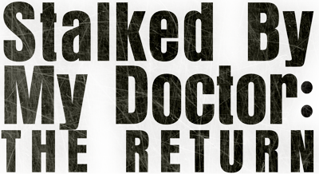
Johnson Production Group
Press Kit

One-Liner

After Dr. Albert Beck miraculously saves a teenage girl from drowning during Spring break in Mexico, he shows up at her school back home to check on her - and pursue his obsession.

Synopsis
While hiding from Federales under a false identity, Dr. Albert Beck ogles the gorgeous young women, struggling to control his urges. Suddenly an unconscious teenage girl is brought ashore, the victim of a surfing accident. Dr. Beck has no choice but to perform emergency CPR and save her life. As she coughs up salt water, Dr. Beck looks into the beautiful eyes of -- MELISSA, a stunning American girl on vacation with her mother. Dr. Beck is smitten. He immediately becomes friends with Melissa and her attractive mother, LINDA an emotionally troubled, yet wealthy widow who suffers from several mysterious ailments, mostly in her mind.
Dr. Beck wrestles with a dilemma: should he pursue Melissa? Or should he do what he knows is best and date women closer to his own age?
Unable to get Melissa out of his mind, Dr. Beck follows Melissa and Linda home to San Diego. He arrives at Melissa's school, pretending to check on her health. Melissa, charmed by the man who saved her life, arranges for her mother and Dr. Beck to meet. Soon, Dr. Beck begins to date Linda, pretending he is interested in romance.
He offers his services as Linda's personal doctor. Linda is elated! Finally she has found somebody who can take care of her... and Dr. Beck has found a way to get closer to Melissa.
But Melissa soon becomes suspicious of Dr. Beck, who can't help but glance at her suggestively, or occasionally touch her arm for a moment too long. Creeped out, Melissa tells Linda that Dr. Beck is crossing the line; however Linda -- who has agreed to marry Dr. Beck -- refuses to believe the man she loves is capable of such perverted behavior.
Desperate to stop the marriage from happening, Melissa reaches out to her mother's brother, Roger (30's). When Roger starts asking Beck too many questions and digs into his past, Dr. Beck murders Roger, making the problem disappear.
Now, with nobody in position to stop him, Dr. Beck marries Linda, planning to kill her on their honeymoon and become Melissa's legal guardian... and keep the teen girl for himself, forever. When a last minute clue informs Melissa of Dr. Beck's evil plan, it's up to Melissa to rescue her oblivious mother before she is murdered.
Will Melissa rescue her mother in time? Or will an enraged Dr. Beck -- his dream of a perfect love shattered once again -- kill them both?

Producers
Executive Producer
TIMOTHY O. JOHNSON
Producer
Ken Sanders
Producer
Robert Ballo
Executive Producer
SCOTT ANDERSON
Producer
OLIVER DE CAIGNY
Key Cast
CHARACTER  Dr. Beck  Amy Watkins  Linda Watkins |  | ACTOR  Eric Roberts  Claire Blackwelder  Hilary Greer

Key Cast Biographies

Eric Roberts
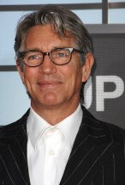
One of Hollywood's edgier, more intriguing characters running around and about for decades, Eric Anthony Roberts started life in Biloxi, Mississippi. He is the son of Betty Lou (Bredemus) and Walter Grady Roberts, one-time actors and playwrights. His siblings are actors Lisa Roberts Gillian and Julia Roberts, and he grew up in Atlanta, Georgia. He began his acting career at age 5 in a local theater company called the "Actors and Writers Workshop", founded by his late father. After his schooling at Grady High, he studied drama at age 17 in London for two years at the Royal Academy of Dramatic Arts, then returned to the States and continued his studies at the American Academy in New York. He made his NY stage debut in "Rebel Women" in 1976 at age 20 and appeared in regional productions, once playing the newspaper boy in a production of "A Streetcar Named Desire" starring Shirley Knight and Glenn Close.
After appearing in such daytime soaps as Another World (1964) and How to Survive a Marriage (1974), his career began to shift fast forward when he copped a leading role in a major film. In King of the Gypsies (1978), based on Peter Maas' best-seller about a fracturing dynasty of New York City gypsies, he made his debut alongside an intimidating roster of stars including Judd Hirsch, Susan Sarandon, Shelley Winters and Sterling Hayden. Young Eric held his own expertly (winning a Golden Globe nomination) while his burning intensity and brooding charm marked sure signs of star potential. After this, he won the lead opposite Milo O'Shea in the 1980 stage production of "Mass Appeal". He suffered serious injuries in a car accident during his nascent film career but lost no fans by the time he returned to co-star with Sissy Spacek as a small-town stranger in Raggedy Man (1981). It was, however, his stark and frightening portrayal of two-bit hustler Paul Snider, the cast-off boyfriend who slays Playmate-turned-movie starlet Dorothy Stratten (played by Mariel Hemingway) in Star 80 (1983) that really put him on the movie map and earned him a second Golden Globe nomination. A wide range of fascinating, whacked-out roles were immediately offered to him on a silver plate. He played another dangerous streetwise hustler type in The Pope of Greenwich Village (1984) opposite fellow rebel Mickey Rourke; a cocky soda pop sales exec in the Australian comedy The Coca-Cola Kid (1985); appeared with more charm and restraint opposite Rosanna Arquette in the offbeat romantic comedy Nobody's Fool (1986) and topped his prolific period off with an Academy Award nomination as a young prison escapee hiding out with Jon Voight aboard an out-of-control train in the ultra-violent, character-driven action adventure Runaway Train (1985). Good things continued to happen when he was a replacement lead in the original run of "Burn This" and won a Theatre World Award for his 1988 Broadway debut.
He soon began appearing as flashy secondary villains and creepies that showcased other stars instead, such as Final Analysis (1992) starring Richard Gere, Heaven's Prisoners (1996) top lining Alec Baldwin, and The Dark Knight (2008), part of the "Batman" series with Christian Bale and the late Heath Ledger.
Eric's undeniable, unconventional talent would occasionally mesh with the perfect role. At the Sundance Film Festival in 1996, he received critical applause for his starring role as a man dying of AIDS in the uplifting and emotional film It's My Party (1996) and earned more honors as a writer marked for murder in the mob-themed story La Cucaracha (1998). He was also perfectly cast as one of the cold-blooded killers in the Emmy-nominated TV adaptation of Truman Capote's chiller In Cold Blood (1996). Eric continued to appear sporadically on TV in such dramatic series as Law & Order: Criminal Intent (2001), while sometimes showing a fun side as well in comedy (The King of Queens (1998)). His own series work included Less Than Perfect (2002) and, more recently, and in the cult program Heroes (2006) where promise for a longer participation ended with his character's death.

HILARY GREER
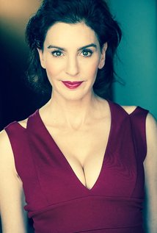
An actress, comedienne, and feisty writer born in NYC. Currently (Dec 2015) shooting the lead in a thriller opposite Eric Roberts. So young when she was called back for Annie on Broadway that she didn't know what an area code was. Hilary is also adept with her beloved SYFY genre. She had 2 seasons on Alien Dawn, in which she played Series Regular Ruby Turner a scientist and mother out to protect her son and save the world. It was the Best New Show in 2013 for Nickelodeon! Coming up next is Montauk Boys, a SYFY thriller pilot in which she has a Series Regular role again the lead's mom.

CLAIRE BLACKWELDER
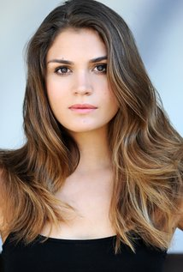
Claire Blackwelder was born on August 26, 1993 in Boise, Idaho, USA as Claire Elizabeth Blackwelder. She is an actress, known for Power Rangers Dino Charge (2015), 101 Ways to Get Rejected (2013) and Teens Wanna Know (2012).

Production Credits

Full Cast
Eric Roberts  Hilary Greer  Claire Blackwelder  Christopher Crabb  Mark Grossman  Sarah L. Kraft  Lance Holt  Tiffany Adams  Clint Jung  Alix Foedisch  Kimberly Spak  Luis Mercado  Lisa Marie  Manuel Cruz  Lesli Kay  Brianna Chomer  Zoë Grossfeld | DR. BECK  LINDA WATKINS  AMY WATKINS  UNCLE ROGER  GARTH  NURSE PETERS  DR. OSWALD  DR. CLARK  FBI AGENT CHUNG  KATRINA  OFFICIANT  JAVIER  HALEY  AGENT D'ANGELO  RACHEL  SOPHIE GREEN  STUNT PLAYER

Produced by
Timothy O. Johnson |  | executive producer
Ken Sanders |  | producer
Robert Ballo |  | producer
Marianne C. Wunch |  | line producer

Written & Directed by
Doug Campbell

Music by
Steve Gurevitch

Film Editing
Clayton Woodhull

Casting
Jeff Hardwick, C.S.A.

Production Design
Mason Reynolds

Director of Photography
Robert Ballo

Costume Design by
Christy Mele

Makeup Department
Patrick Anthony Lising |  | key hair stylist
Lauren Nicole Guzman |  | key makeup artist
LaQuanna Chong |  | makeup artist/hair stylists
Cecilia Quezada
Vanessa Gonzalez

Directors
Allan Aguilar |  | first assistant director
Paul O'Hannigan |  | second assistant director
Tina Martin  Teresa Cordts |  | 2nd second assistant directors

Art Department
Anthony Pausic |  | art director
Patrick Mitchell |  | set dresser
Jamie Oakes |  | art department assistant
Chase Kuker |  | property master

Second Unit
Daniel Ringey |  | directors
John Rhode
Sasha Wulf |  | first assistant director
Andrew Park, S.O.C. |  | director of photography
Lauren Peele |  | camera first assistant
Peter Mares

Camera and Electrical Department
Joseph M. Setele |  | a camera operators
Eric Roy Anderson
Liz Ehlers |  | a camera first assistants
Christine Adams
Jeremy Asuncion
John Rhode |  | b camera operators
Andrew Parke, S.O.C.
Lauren Peele  Jeremy Peele  Arturo Ochoa |  | b camera first assistants
Michael Dumin |  | camera second assistant
Chase Parsons |  | media manager
Charles Christopher |  | still photograper
Darryl Williams |  | production sound mixer
Andres Boulton |  | supervising sound editor
Silas Robinson |  | gaffers
Jesse G. Sperling
Walter Orsini |  | best boy electrics
Joshua Levy
Nicholas Favorite
Nick Street |  | electrician
Brad Carr |  | key grip
Dwight Lay |  | best boy grips
Nickolas W. Redfud
Josh Andersen |  | company grip

Costume and Wardrobe Department
John C. Houston IV |  | key costumer
Lindsey DeMay |  | set costumer

Other crew
Sheila Ryan |  | location manager
Sean B. Hernandez |  | assistant location manager
April McQuarrie |  | script supervisor
Sasha Wulf |  | production coordinator
Tina Martin |  | production accountant
Denise Bennett |  | production accountant
Jason Albanese |  | medic
Igor Konyashin |  | lifeguard
Morgue N. Marcus  Little Bird Casting |  | extras casting director
Derek Van Valkenburg |  | key set production assistants
Milton Kingsley Cheng
Patrick Reaves |  | transportation production assistants
Josh Paris
Rodion Borisov |  | production assistants
Ian Kronenberg
Joseph Wirth
Joel Halstead |  | craft service
Eric Wiseman
Ian Kronenberg
CF Food Kitchen |  | caterer
Edwing Flores

Post Productions
Griff Partington |  | post production supervisor
Shadowland, LLC  dubassy/ Pond5.com  jamesbenet/ Pond5.com  BenLynn/ Pond5.com  lprecise/ Pond5.com  RickRay/ Pond5.com  bspcinema/ Pond5.com  egdigital/ Pond5.com  Peshkov_Danil/ Pond5.com  Mclein/ Shutterstock  Shawn Riley/ Shutterstock  Francois Arseneault/ Shutterstock |  | stock footage
meunierd/ Shutterstock  Paul Vinten/ Shutterstock |  | stock image
Jonathan Morgan |  | foley editor
Bobb Barito |  | ADR Recording Engineer
Beatstreet NYC |  | ADR Facility
Tom Firestone |  | visual effects artist
GOAL Productions, Inc. |  | camera equipment
Shapeshifter |  | post production services
Randy Coonfield |  | colourist
David Berlinsky |  | online editor
Cineworks |  | grip and lighting equipment
Wilcox Sound & Communications |  | production sound equipment
Dennis Whitcomb |  | script clearance
Hollywood Script Research
Giovanni Cuarez |  | production insurance
American Entertainment Insurance Services
Shadowland, LLC |  | los angeles production services

Producer Biographies

TIM JOHNSON – Executive Producer
Tim Johnson is among the most active and reliable producers in the business thanks to top rate productions and an 'on time, on budget' reputation. Previously, he managed the production of ABC's THE DAYS (MINDSHARE/TOUCHTONE.) Prior to forming Johnson Production Group and Ignite Entertainment, Tim served as Head of West Coast Programming Executive and launched the successful series DOC (88 episodes,) SUE THOMAS, FBI, MYSTERIOUS WAYS, JUST CAUSE, PONDEROSA, CHRISTY, ITS A MIRACLE AND MIRACLE PETS.

Johnson is also responsible for producing the international hit series, DR. QUINN, MEDICINE WOMAN for CBS PRODS/SULLIVAN COMPANY for over 5 seasons. During his 100-episode tenure, he also launched LIVE FROM THE RANCH with Orson Bean - a nationally syndicated talk show focusing on family values in America. He also developed and produced the original docu-drama COLD CASE for CBS network, which was the very first program to integrate television with the Internet.

Recent Projects:
For Better or For Worse – Executive Producer
Baby Bootcamp – Executive Producer
Ring By Spring – Executive Producer
Sole Custody – Executive Producer
The Cheating Pact – Executive Producer
Deadly Spa – Executive Producer
Walking the Halls – Executive Producer
June In January – Executive Producer
Christmas in the City – Executive Producer
Snow Bride – Executive Producer
Dirty Teacher – Executive Producer
The Surrogate – Executive Producer
Merry In-Laws – Executive Producer
A Bride for Christmas – Executive Producer
Naughty or Nice – Executive Producer
Christmas Crush– Executive Producer
Teenage Bank Heist– Executive Producer
How to Fall in Love – Executive Producer
Home Invasion (2011) – Executive Producer
Final Sale (2011) – Executive Producer
Confined (2010) – Executive Producer
Tornado Valley (2009) – Executive Producer
The Wedding Dance (2009) – Executive Producer
Trust (2009) – executive producer
Toxic Skies (2008) – executive producer
Storm seekers (2008) – executive producer
Making Mr. Right (2008) – executive producer
Love Sick (2008) – executive producer
Just Breathe (2008) – executive producer
Devils Diary (2007) – executive producer
Swarm (2007) – executive producer

JOHNSON PRODUCTION GROUP
The Johnson Production Group contracts globally to produce television and motion picture content for international networks, studios and distributors. Based in Los Angeles and Vancouver, British Columbia, the company manages production, facilitates development and financing, procures distribution and guarantees quality and timely execution of its programs. While costs have gone up, so has the demand for quality. No longer is good enough, good enough. Johnson Production Group serves that segment when a show needs to be "A" quality, but produced efficiently enough to meet a locked budget. JPG specializes in value, protection of creative elements, and delivery of a quality finished product.

ROBERT BALLO –Producer
Mr. Ballo is an image-maker and storyteller. He has established an environment at Shadowland where interesting scripts can be developed and made into even more interesting movies. Mr. Ballo’s experience includes co-producing and shooting the feature film Runnin’ at Midnite and serving as cinematographer on the feature comedy Starving Artists. As president of Shadowland’s parent company, GOAL Productions, he serves variously as producer, director and cinematographer. His credits include numerous broadcast and corporate programs for the Tournament of Roses including the recent The Rose Parade: A Pageant for the Ages, a series of specials for Discovery Channel, and The Great Year, an independent television documentary examining the connection between astronomy and the history of civilization. As cinematographer, Mr. Ballo shot Dirty Harry: The Original, a 30th anniversary retrospective television special for the Encore cable network, and DVD featurettes for Clint Eastwood’s Space Cowboys and Unforgiven’s10th anniversary release. Mr. Ballo is currently producing a series of
DVD behind-the-scenes documentaries for independent film studio Nu Image.
Mr. Ballo is also a member of the professional faculty at USC’s School of CinemaTelevision, serving as both a cinematography and documentary instructor. He is an active contributor in the movie industry through his memberships in the International Cinematographers Guild and the Academy of Television Arts & Sciences

KEN SANDERS – Producer
Ken Sanders is a producer and director, known for A Killer Upstairs (2005), Maid of Honor (2006) and Dirty Teacher (2013).

Billing Block

Johnson Production Group in association with Shadowland Presents
“STALKED BY MY DOCTOR: THE RETURN”
Starring Eric Roberts Claire Blackwelder and Hilary Greer
Executive Producer Timothy O. Johnson Produced by Robert Ballo Ken Sanders
Written and Directed by Doug Campbell
With the participation of the Province of British Columbia
Film Incentive BC
The Canadian Film or Video Production Tax Credit
[Logo] Canada
© MMXV Ice Sculpture Productions Inc. All Rights Reserved

Johnson Production Group
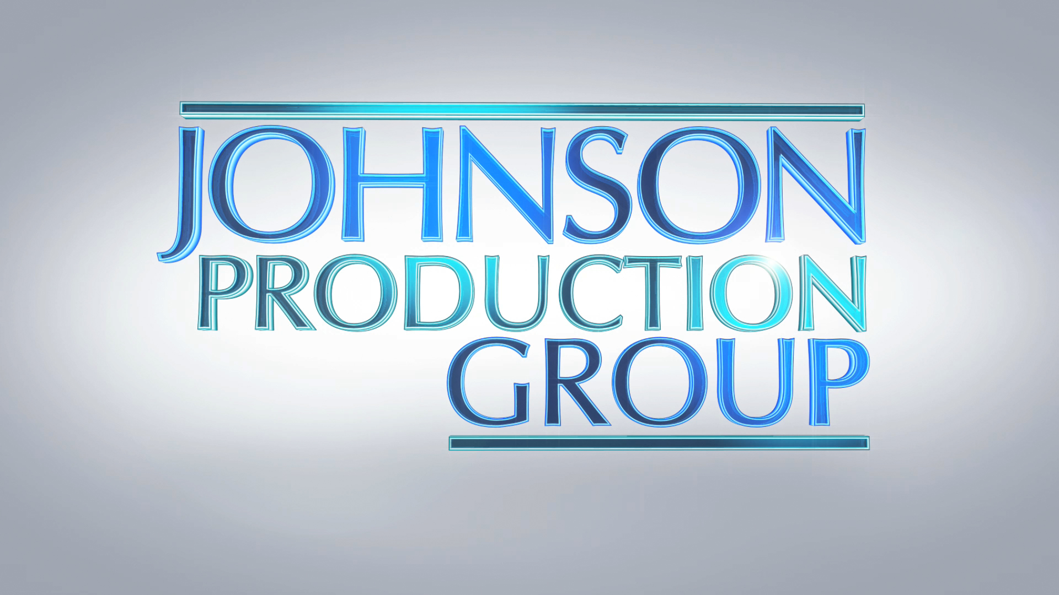

Meta Data

LONG (max 540 characters) synopsis
Dr. Beck is on the lamb for not being able to resist his urges for teenage girls. He is at a beach leering when Melissa is dragged onto shore, the victim of a surfing accident. Dr. Beck performs CPR and saves her life, then becomes smitten. He forms a relationship with Melissa’s mother, so he can be close to the young girl. Melissa is creeped out by Dr. Beck. She confides in her mother’s brother Roger who questions Dr. Beck. When the situation gets deadly, it is up to Melissa alone to stop the upcoming marriage. (516)

MEDIUM (max 180) synopsis
After Dr. Albert Beck miraculously saves a teenage girl from drowning during Spring break in Mexico, he shows up at her school back home to check on her and pursue his obsession. (178)

SHORT (max 54 characters) synopsis
Doctor pursues a women to get to her daughter (45)

5 KEY WORDS
Stalked by My Doctor Thriller

