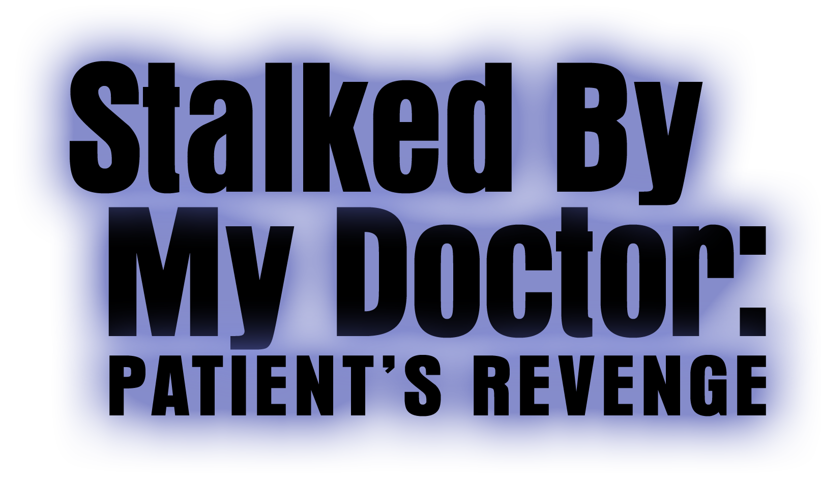

Johnson Production Group

Press Kit

One-Liner
Dr. Albert Beck is back -- will the madness start all over again?

Synopsis

After a jury finds him not guilty of the kidnapping and attempted murder of a former patient, the mentally disturbed Dr. Albert Beck (Eric Roberts) vows to rehabilitate himself. When he lands a teaching job at a prestigious Arizona medical school, he immediately develops a crush on a new student, Melissa (Anna Marie Dobbins), and struggles to keep his growing obsession from taking control of his life. Meanwhile, Dr. Beck’s former patient, and victim, Sophie Green (Brianna Chomer) is still furious at losing her court case against him and decides to enroll in the medical school where he is teaching -- so she can mete out her own form of personal justice.

Producers
Executive Producer
TIMOTHY O. JOHNSON
Co-Producer
SHERI REEVES
Producer
KEN SANDERS

Key Cast
CHARACTER  Dr. Albert Beck  Melissa  Sophie  Adrienne Green  Dean Sanchez  Jim Green  Detective Young  Detective Sandler |  | ACTOR  ERIC ROBERTS  ANNA MARIE DOBBINS  BRIANNA CHOMER  DEBORAH ZOE  RICO SIMONINI  JON BRIDDELL  TONY WINTERS  ERIC BURKE

Key Cast Biographies

ERIC ROBERTS

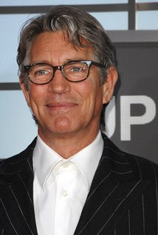
Eric Roberts is an Academy Awards nominee for his role in Runaway Train and a three-time Golden Globes nominee for Runaway Train, Star 80 and King of the Gypsies . He also won a Golden Satellite Award for the 2002 season of Less Than Perfect .

He also made a profound impact in the Emmy nominated television adaptation of Truman Capote’s In Cold Blood , directed by Jonathan Kaplan and co-starring Anthony Edwards and starred in La Cucaracha , which won Best Film at the Austin Film Festival in 1998, and for which Eric won Best Actor in the New York Independent Film Festival that same year. Eric’s starring role in the film, It’s My Party , received critical acclaim at the 1996 Sundance Film Festival .

Eric has diversified very recently, appearing in Sophie Muller’s Mr. Brightside video for The Killers, Brett Ratner’s video for Mariah Carey’s Emancipation of Mimi – Both award winners, and the Akon and Eminem video for Smack That .

Other notable performances include his roles in Final Analysis, The Pope of GreenwichVillage, Raggedy Man, Babyfever, Heaven’s Prisoners, The Specialist and The Grave.

Eric Roberts was recently seen in Christopher Nolan’s Batman – The Dark Knight , along with one of the most incredible casts ever assembled. This follows a stint on Heroes – A job that ranks as one of Eric’s favorites. Eric strives to be associated with more comedy, hence will be appearing in a Larry The Cable Guy movie, Witless Protection.

Eric Roberts was born in Biloxi, Mississippi and grew up in and around Atlanta, Georgia area. He began his career as an actor in his late teens in New York City. In 1989 Eric won the Theatre World Award for his role on Broadway in Burn This . He returned to the New York stage in 2003 in The Exonerated , which he appeared in as part of their touring company as well.

ANNA MARIE DOBBINS

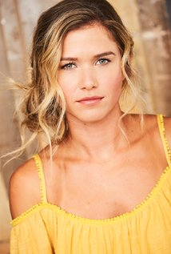
Anna Marie Dobbins was born on January 29th, 1991 in Birmingham, Al. She is the daughter of Barry and Linda Dobbins and has an older brother, Michael, and sister- in-law Brooke.

Anna Marie started her career as a dancer at the young age of 3. Her mother, Linda, opened the Linda Dobbins Dance studio when Anna Marie was 4 years old and initiated her training in all genres of dance. At the age of 8, Anna Marie found an interest in competitive cheer leading as well. Growing up she split her time between dance and cheer leading.

When Anna Marie turned 13 she developed an interest in acting and print modeling. She was represented locally by Real People Birmingham Talent Agency. Soon Anna Marie had the opportunity to expand her career by signing with Jpervis Talent Agency, an agency representing talent across the Southeastern U.S. She worked in this market for multiple years and received movie roles in films such as Footloose and Lifted, as well as roles on television shows such as Being Mary Jane and the Vampire Diaries.

Anna Marie attended Birmingham Southern College on a dance scholarship and graduated in 3.5 years with many academic accomplishments and a Bachelors Degree in Dance and Choreography.

After graduation, Anna Marie was encouraged to move to Los Angeles to pursue a professional acting career. In LA, Anna Marie signed contracts with Beal Talent and Associates and Snow Entertainment. She also signed a contract with one of the most prestigious dance agencies, MSA . Anna Marie has since been featured in multiple feature films such as: Dropped, Holding Patterns and in many National Commercials such as :American Career College, Ford Fusion, and more.

Make A Wish Foundation of Alabama is an organization that Anna Marie commits her time and energy to supporting. It is her desire to help children that are struggling with illness not only in Alabama, but around the world, having their wishes fulfilled.

BRIANNA CHOMER
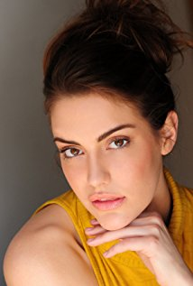
Brianna Chomer starred in her first feature film, Chatterbox, when she was 13 years old. Now over 18, Brianna has starred in five back-to-back films in 2015. Brianna was the "hero" girl for Verizon, and shot commercials and music videos for major directors, such as Jasper Forks, for the European release of J'aime Le Diable. She is a recent graduate from the Joanne Baron/D.W. Brown studio of Meisner technique and is actively working and auditioning. She is represented by Sovereign Talent Group, with Peter Young as point agent, and managed by Michelle Zeitlin, with More Zap Productions & Management. In addition, Brianna is developing her own eye for photography and directing by working with top industry pros, who are happy to mentor and guide her with a generous spirit. This young lady is going places....

Production Credits

Full Cast
Actors  ERIC ROBERTS  ANNA MARIE DOBBINS  BRIANNA CHOMER  DEBORAH ZOE  RICO SIMONINI  JON BRIDDELL  TONY WINTERS  ERIC BURKE  CARRIE SCHROEDER  ZEPHANIE IDOKO  CHRISTIAN VILINA  STEVEN KUZJ  CHELSEA BLECHMAN  KEREN COGHILL  GALINA SLAVOVA  LISA STARRETT  MORGAN TRISCH  ALEXANNE WAGNER | Role  Dr. Albert Beck  Melissa  Sophie Green  Adrienne Green  Dean Sanchez  Jim Green  Det. Young  Det. Sandler  Kendra  Victoria  Wes  News Reporter  Teacher/Dancer  Student/Dancer  Teacher/Dancer  Student/Dancer  Student/Dancer  Student/ Dancer

Casting by
Jeff Hardwick, CSA

Choreography by
Carson Dean

Original Song “Fall In Love” written by
Michael James Burns and Steve Gurevitch

Music by
Sandro Morales-Santoro

Edited by
Cody Miller

Costume Designer
Judi Bell

Production Designer
Chase Wright

Director of Photography
Eric Roy Anderson

Co-Producer
Sheri Reeves

Executive Producer
Timothy O. Johnson

Produced by
Ken Sanders

Written and Directed by
Doug Campbell

Additional Scenes Directed By
Jeff Hare

Line Producer
Christian Ackerman

First Assistant Director
John Alexander Stern

Additional First Assistant Directors
Marco Bargellini
Joshua Lou Friedman

Second Assistant Director
Josh Brown

2nd Second Assistant Directors
Ryan Gangl
Tyler McGraw
Fernanda Leon Irastorza
Hunter Johnson

Production Secretary
Gabbi Latade

Script Supervisors
April McQuarrie
Kennedy Del Toro

A Camera Operator
Eric Roy Anderson

B Camera Operators
Joseph M. Setele
John Rhode
James Markham Hall, Jr.

A Camera First Assistants
Ferguson Sauve-Rogan
Joe Gunawan
Sashie Rodriguez
B Camera First Assistants
Bernie Smith
Ryan Schultz
Ilija Gavran

Gimbal Operator
Misha Zvagilskiy

Second Assistant Camera
Tyler M. Manzo
Sammy Avgi

D.I.T
Skylar V. Smith

Still Photographer
Charles Christopher

Production Sound Recordists
Jason Aaron Moran
Maksim Osadchenko

Gaffers
Eric Fickenwirth
Alexander L. Gracie
Joshua Benson

Best Boy Electrics
Jesus Yanez
Alex W. Evans
Chris Hartsell

Key Grips
John Elkin
Alex F. Harris
Mason Malone
Brian Patierno

Best Boy Grips
Alex F. Harris
David Damiata
Trevor Doyle
Charley Kassabian
Joseph Hartzler
Anthony De Phillippi

Grip & Electric Swing
Faisal Shah
Josh Andersen
Austin Nelson
Joseph Augustine Tan
Eric Truglia

Art Director
Allison Marrama

Additional Art Director
Chantal Massuh

Assistant Art Director
Cameron Barrett

Set Decorator
Lane Young

On Set Dresser
Jazmin Lopez

Consultant
Cameron Diskin

Art Assistants
Nikki Rarick
Haley Santamaria

Costume Supervisor
Crystal Miel Cossey

Costume Assistants
Renee Johnson
Paula Flores

Additional Costume Design
Ranjinder Hans
Angela M. Eads

Makeup Department Head
Erica Medina

Hairstylist Department Head
Erica Medina

Hair Stylists
Priscilla Nguyen
Stacie Dwyer

Makeup Artists
Priscilla Nguyen
Julia Hapney
Judith Raquel Alcaraz
Arlene Medina

Location Manager
Sean B. Hernandez

Key Assistant Location Manager
Sheila Ryan

Assistant Location Manager
Remy Elles

Location Assistant
Tyler McGraw

Extras Casting Director
Pete Sutton

Music Editor
Ian Silver

Key Set Production Assistant
Troy Whitake

Production Assistants
Ronni Choi
Nathan Crookston
Madison Daniels
Marco Marzola
Ivan Provencio
Deborah Schlaff
Domenico Riso
Joshua Thomas
Madison Daniels
Linda Wong
Austin J. Brucks

Truck PAs
Frank Bifulco
Michael Angelo Talignani

Shuttle Driver
Jesus Perez

Transportation Captain
Patrick Reaves

Craft Service
Luke Lakin

Caterer
C F Food Kitchen
Edwing Flores

SECOND UNIT

Director
Ted Campbell

First Assistant Director
Tyler McGraw

Directors of Photography
Joseph M. Setele
John Rhode

First Assistant Camera
Bernie Smith

Production Sound Mixer
Mayra Rodriguez

POST PRODUCTION

Audio Post Services Provided by
Juniper Post, Inc.

Sound Supervisor
David Kitchens, MPSE

Supervising Sound Editor
Michael Kreple

Dialogue Editor
Ryan Cota

Sound Effects Editors
Sean Gray
Michael Lanoue

Foley
Gonzalo “Bino” Espinoza

Re-recording Mixer
Michael Kreple

Sound Coordinator
Jas Pennington

Audio Post Accountant
Stacy Kitchens

Post Production Services by
Blueprint Post Production

Colorist
Randy Coonfield

Online Editor
Jon Kelble

Visual FX
Dan Walker
Tammy Sutton

Music Editor
Ian Silver

Studio Manager
Claudia Serven

Score Recorded and Mixed at
La Maida Studios

Additional Music by
Steve Gurevitch and Michael James Burns

Original Song “Fall In Love”
Written by Michael James Burns and Steve Gurevitch
Performed by Eric Roberts and Mairead MacMullan

Additional Editing by
Itai Levin

Camera Equipment Supplied by
Hollywood Camera
Setelevision

Grip and Lighting Equipment Provided by
Brilliant Screen Studios

Trailers Provided by
Easy Rider Productions

Police Equipment and Vehicles Provided By
Brilliant Screen Studios

Script Clearance
Hollywood Script Research
Dennis Whitcomb
Erin Manacker

Production Insurance
Giovanni Cuarez
American Entertainment Insurance Services

Special Thanks
Anthony Clementi
Hank Grover
Sasha Urbina
Arielle Brachfeld

The Producers Wish To Thank
FilmLA
College of the Canyons Cooperative Work Experience Education Program

Stock media provided by
LBLSIBERIA/ Pond5
SpotmatikBlueSkyAerials/Pond5
jn14productions/Pond5
hooligantv/Pond5

Footage used under license from
Shutterstock.com

Producer Biographies

TIM JOHNSON – Executive Producer
Tim Johnson is among the most active and reliable producers in the business thanks to top rate productions and an 'on time, on budget' reputation. Previously, he managed the production of ABC's THE DAYS (MINDSHARE/TOUCHTONE.) Prior to forming Johnson Production Group and Ignite Entertainment, Tim served as Head of West Coast Programming Executive and launched the successful series DOC (88 episodes,) SUE THOMAS, FBI, MYSTERIOUS WAYS, JUST CAUSE, PONDEROSA, CHRISTY, ITS A MIRACLE AND MIRACLE PETS.

Johnson is also responsible for producing the international hit series, DR. QUINN, MEDICINE WOMAN for CBS PRODS/SULLIVAN COMPANY for over 5 seasons. During his 100-episode tenure, he also launched LIVE FROM THE RANCH with Orson Bean - a nationally syndicated talk show focusing on family values in America. He also developed and produced the original docu-drama COLD CASE for CBS network, which was the very first program to integrate television with the Internet.

Recent Projects:
Eat, Play, Love – Executive Producer
Sleepwalking in Suburbia – Executive Producer
The Stalker Club – Executive Producer
Infidelity in Suburbia – Executive Producer
Hunter's Cove – Executive Producer
Double Mommy – Executive Producer
Hearts of Christmas – Executive Producer
The Rooftop Christmas Tree – Executive Producer
A Snow Capped Christmas – Executive Producer
A December Bride – Executive Producer
The Mistletoe Promise – Executive Producer
Stalked by My Mother – Executive Producer
Stalked by My Doctor: The Return – Executive Producer
Backstabbed – Executive Producer
The Convenient Groom – Executive Producer
Killer Coach – Executive Producer
Tulips in Spring – Executive Producer
Hearts of Spring – Executive Producer
Stalked by My Doctor – Executive Producer
Becoming Santa – Executive Producer
Magic Stocking – Executive Producer
Just in Time for Christmas – Executive Producer
A Gift Wrapped Christmas – Executive Producer
A Mother's Instinct – Executive Producer
Ice Sculpture Christmas – Executive Producer
The Reckoning – Executive Producer
Bad Sister – Executive Producer
Family for Christmas – Executive Producer
Double Daddy – Executive Producer
Her Infidelity – Executive Producer
Stalked by My Neighbor – Executive Producer
Babysitter's Black Book – Executive Producer
A Gift of Miracles – Executive Producer
Strange Empire – Executive Producer
Sugar Daddies – Executive Producer
Paper Angels – Executive Producer
A Cookie Cutter Christmas – Executive Producer
Stranded in ParadiseFor Better or For Worse – Executive Producer
Baby Bootcamp – Executive Producer
Ring By Spring – Executive Producer
Sole Custody – Executive Producer
The Cheating Pact – Executive Producer
Deadly Spa – Executive Producer
Walking the Halls – Executive Producer
June In January – Executive Producer
Christmas in the City – Executive Producer
Snow Bride – Executive Producer
Dirty Teacher – Executive Producer
The Surrogate – Executive Producer
Merry In-Laws – Executive Producer
A Bride for Christmas – Executive Producer
Naughty or Nice – Executive Producer
Christmas Crush– Executive Producer
Teenage Bank Heist– Executive Producer
How to Fall in Love – Executive Producer
Home Invasion – Executive Producer
Final Sale – Executive Producer
Confined – Executive Producer
Tornado Valley– Executive Producer
The Wedding Dance– Executive Producer
Trust – executive producer
Toxic Skies– executive producer
Storm seekers – executive producer
Making Mr. Right – executive producer
Love Sick – executive producer
Just Breathe – executive producer
Devils Diary – executive producer
Swarm – executive producer

JOHNSON PRODUCTION GROUP
The Johnson Production Group contracts globally to produce television and motion picture content for international networks, studios and distributors. Based in Los Angeles and Vancouver, British Columbia, the company manages production, facilitates development and financing, procures distribution and guarantees quality and timely execution of its programs. While costs have gone up, so has the demand for quality. No longer is good enough, good enough. Johnson Production Group serves that segment when a show needs to be "A" quality, but produced efficiently enough to meet a locked budget. JPG specializes in value, protection of creative elements, and delivery of a quality finished product.

SHERI REEVES – Co-Producer
Sheri Reeves is known for her work on Hush (1998), Gone Fishin' (1997) and First Kid (1996).
Her recent work includes:
Web Cam Girls (co-producer)
2016 Red Skies at Night: The Story of Flower (Short) (producer)
My Cousin's Ghetto Wedding (producer)
Save the Date (producer)
2017 Fleur (Short) (producer)
2017 Vitals (producer)
2013 Canyon Road (producer)
2012 A Night at the Silent Movie Theater (producer)
2011 Jack the Reaper (producer)

KEN SANDERS - Producer
Over the past decade and a half, Ken Sanders has written and/or produced over forty feature-length motion pictures. Since starting his film production company, Shadowland, LLC, with partner Robert Ballo in 2009, Sanders has also produced THE CHEATING PACT, MISSING AT 17, THE PERFECT BOYFRIEND, DIRTY TEACHER, THE SURROGATE, STALKED AT 17, TEENAGE BANK HEIST, WALKING THE HALLS, BETRAYED AT 17, HOME INVASION, MATERNAL OBSESSION, and ACCUSED AT 17, all of which received big ratings when they premiered on Lifetime Television.
From 2001 to 2008, Sanders partnered with prolific Hollywood producer Pierre David and produced eight made-for-TV movies in Canada. Sanders co-wrote many of the films, including ‘TIL LIES DO US PART, MAID OF HONOR, STRANGER AT THE DOOR, THE PERFECT HUSBAND, SAVING EMILY, and A KILLER UPSTAIRS.
Prior to partnering with David, Sanders served as Vice President of Production at WIN Ventures, a division of World International Network, a leading supplier of independent feature films and made-for-TV movies. During his tenure at WIN Ventures Sanders oversaw the development, production, and post-production of roughly twenty films a year, including LIVING IN FEAR, FACING THE ENEMY, and SHE’S NO ANGEL, and many more which aired on the USA Network, Court TV, HBO, Showtime, Cinemax, and The Movie Channel.
In the mid-1990s, Sanders worked as the Vice President of Creative Affairs at Image Organization, helping to develop and oversee such theatrical projects as LITTLE MEN (released by Warner Brothers) and WISHMASTER (released by Artisan), the latter of which went on to become the highest-grossing independent feature film of 1997.
At the beginning of his career, Sanders worked as the Director of Development at High Five Productions, helping to prepare such television specials as THE JUDDS FAREWELL CONCERT and THE WOMEN OF COUNTRY. He also worked for media mogul Ted Turner, doing a stint as a promotions producer for CNN and SuperStation WTBS.
In addition to his film and television work, Sanders has served as an adjunct professor at Biola University, where he taught classes on producing and screenwriting. He is also a frequent guest lecturer at Los Angeles Valley College and the Los Angeles Film School, where he speaks on topics ranging from the business of film to post-production to pitching and script development. Sanders received his degree in Filmic Writing from the University of Southern California, School of Cinematic Arts.

Billing Block

Johnson Production Group in association with Stonecrest Entertainment Presents
“STALKED BY MY DOCTOR: PATIENT’S REVENGE” Starring Eric Roberts
Anna Marie Dobbins and Brianna Chomer Casting Jeff Hardwick, CSA
Choreography Carson Dean Original Song “Fall In Love” written by Michael James Burns and Steve Gurevitch Music Sandro Morales-Santoro Editing Cody Miller
Costume Design Judi Bell Production Design Chase Wright
Director of Photography Eric Roy Anderson
Executive Producer Timothy O. Johnson Co-Producer Sheri Reeves
Produced by Ken Sanders Written and Directed by Doug Campbell
© Copyright MMXVIII – Johnson Production Group, Inc. All Rights Reserved

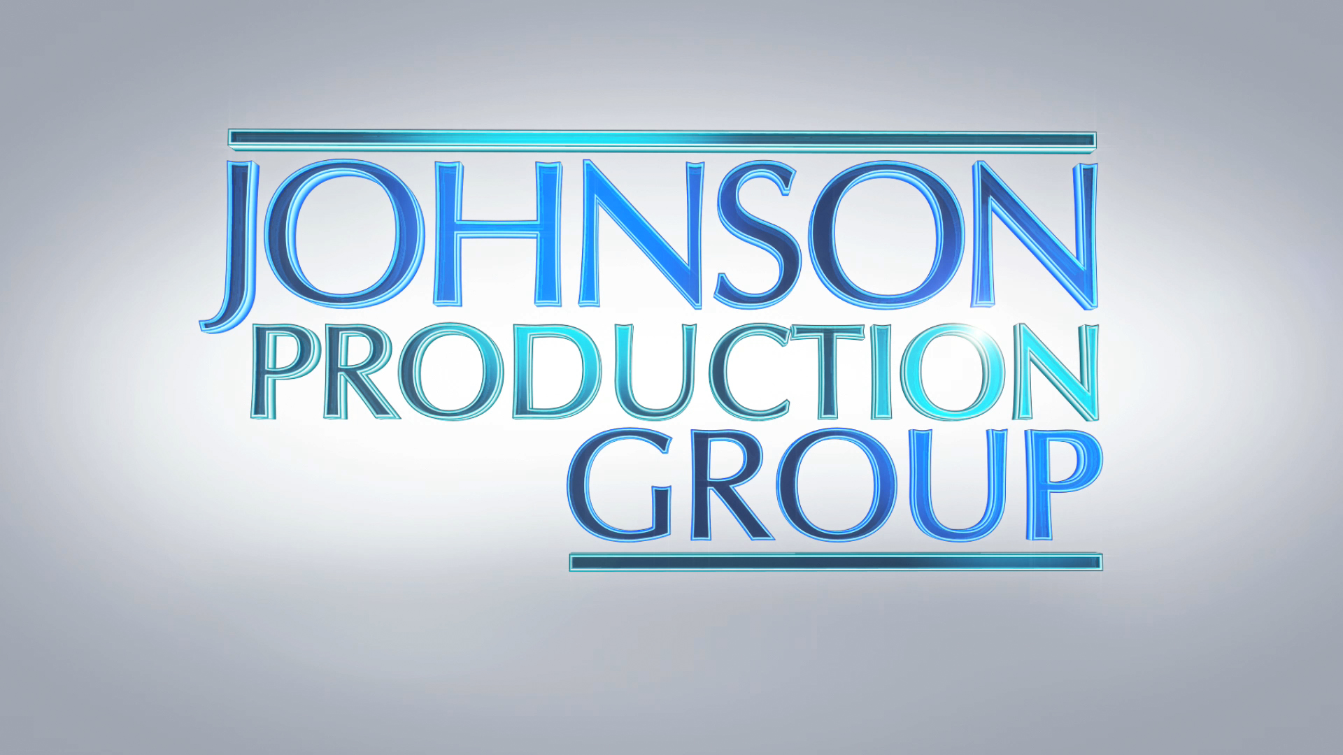

Meta Data

LONG (max 540 characters) synopsis
After he’s found not guilty of the kidnapping and attempted murder of a former patient, the mentally disturbed Dr. Beck vows to rehabilitate himself. When he lands a teaching job at a prestigious Arizona medical school, he immediately develops a crush on a new student, Melissa, and struggles to control his growing obsession. Meanwhile, his former patient and victim, Sophie, is still furious at losing her court case against him and enrolls in the school where he is teaching -- so she can mete out her own form of personal justice. (534)

MEDIUM (max 180) synopsis
After being acquitted of the kidnapping and attempted murder of a female patient, Dr. Beck joins the faculty of a university and becomes obsessed with one of his female students. (178)

SHORT (max 54 characters) synopsis
Dr. Beck is back - will the madness start again? (48)

5 KEY WORDS
Kidnapping, thriller, Albert Beck, revenge

