Johnson Production Group

Press Kit

One-Liner

Synopsis
When high school senior Maddy Beauregard falls in love with a college frat guy, Maddy's over-protective mom Claire strongly disapproves. Followed everywhere, Maddy realizes her own mother is a deranged stalker with a twisted desire to kill her new boyfriend.

After a fierce argument, Maddy's new boyfriend is found murdered. Police suspect Maddy is the killer -- but Maddy is certain her mother did it! Facing the gas chamber, Maddy flees from the cops, embarking on a secret mission to prove her mother's guilt. Will the police believe her? Or will Maddy go to her death, knowing her own mother slaughtered the boy she loved?

Producers
Executive Producer
TIMOTHY O. JOHNSON
Producer
ROBERT BALLO
Producer
KEN SANDERS

Key Cast
CHARACTER  Claire Beauregard  Gina West / Lucy Underhill  Maddy Beauregard  Tucker  Detective Kelly |  | ACTOR  Jennifer Taylor  Danielle Chuchran  Mia Topalian  Spencer Neville  Leith Burke

Key Cast Biographies

JENNIFER TAYLOR
Jennifer Taylor was born on April 19, 1972 in New Jersey, USA as Jennifer Bini. She is an actress, known for Two and a Half Men (2003). She has been married to Paul Taylor since 1997. They have two children.

Danielle Chuchran
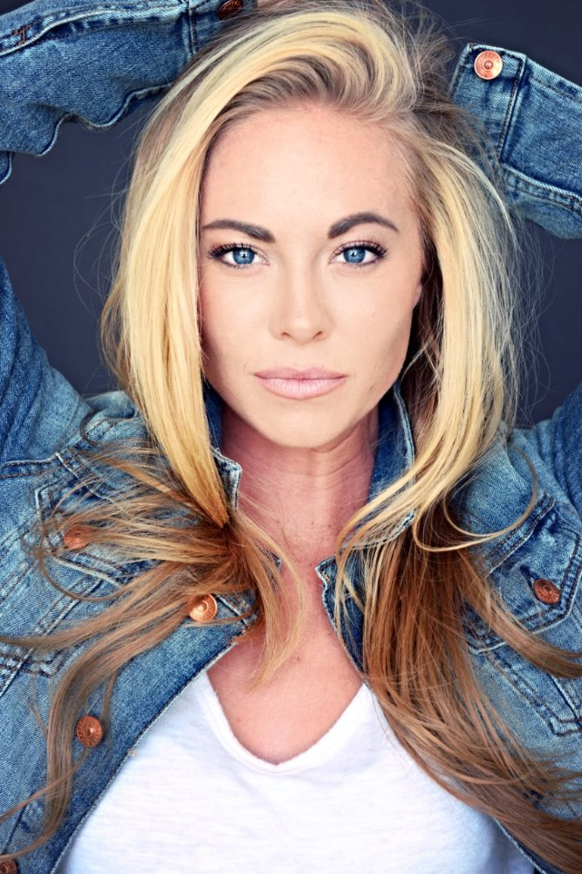
Danielle Ryan Chuchran was born in Upland, California but moved to Utah shortly after. She started her career with some ads, before she had her first role at the age of seven in "Little Secrets". With her part as Thing One in "The Cat in the hat" she consolidated her position as child-actress and did several films and series afterwards. Since "Minor Details" she is frequently working with John Lyde and Mainstay Productions and appeared in most of their projects. Danielle is quite sporty. She is an accomplished rider, and besides several other hobbies she loves to go shooting, both guns and archery. She likes to perform stunts and fighting scenes for her roles on her own. That passion started already with her role as Thing One and includes today also some serious rock climbing in her newer movie "Survivor". She is also very animal-loving, especially she likes spending time with her horses and her dog.

MIA TOPALIAN
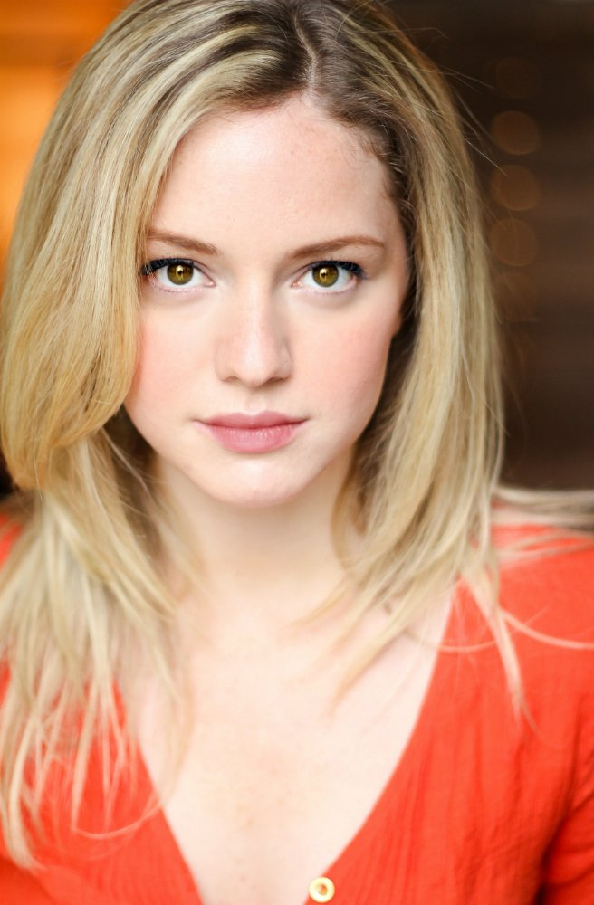
Mia Topalian is an actress, known for Hibiscus (2015), All My Children (2013) and Project October (2012).

Spencer Neville
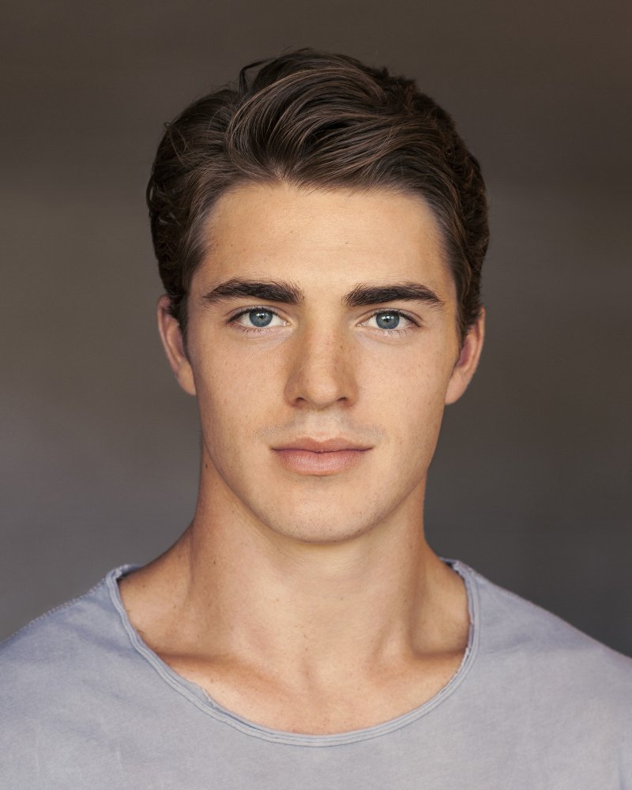
Spencer Neville is an actor and producer, known for AmeriGeddon (2016), Days of Our Lives (1965) and Hashtaggers (2016).

LEITH BURKE
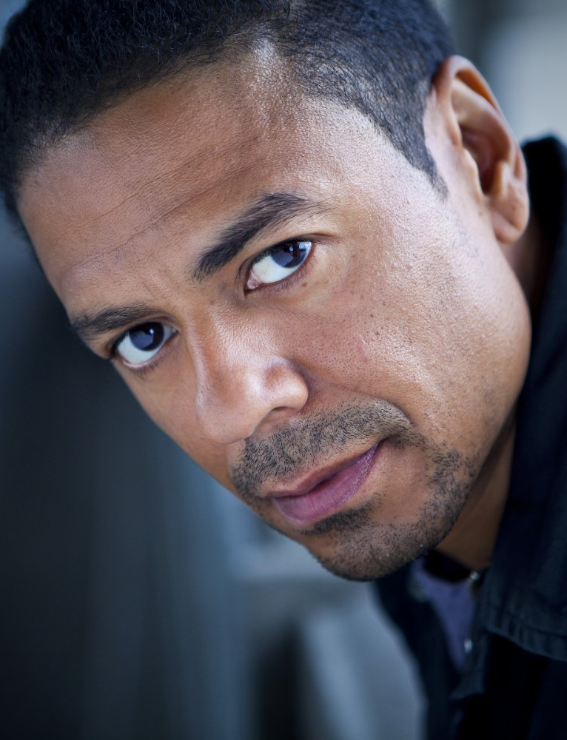
Leith M. Burke is an actor, known for The Haves and the Have Nots (2013), Parenthood (2010) and Eastsiders (2012).

Production Credits

Full Cast
Jennifer Taylor  Danielle Chuchran  Mia Topalian  Spencer Neville  Leith Burke  Brian McGovern  Kevin Scott Allen  Mim Drew  Ted Jonas  Devante Winfrey  Skye McDonald  Joe Hackett  Susan Beaubian  Thomas Silcott  Tina Martin  Juliana Destefano  Shae Smolik  Amelia Fischer | Claire Beauregard  Gina West / Lucy Underhill  Maddy Beauregard  Tucker  Detective Kelly  Sean Beauregard  Nick Fox  Vanessa Underhill  David Underhill  Oliver  Abigail  Parker  Dr. Lewis  Sydney  Rachel  Yolanda  Young Gina  Young Maddy

Casting by
Jeff Hardwick, C.S.A.

Sound Design by
Andres Boulton

Music by
Steve Gurevitch

Edited by
Thijs Bazelmans

Costume Designer
Christy L. Mele

Production Designer
Mason Reynolds

Director of Photography
Joseph M. Setele

Executive Producer
Timothy O. Johnson

Produced by
Ken Sanders
Robert Ballo

Written and Directed by
Doug Campbell

Line Producer Marianne C. Wunch

First Assistant Director Daniel Aspromonte

Second Assistant Director Stuart Davis
2nd Second Assistant Directors Jason Greaney
Lizzy Walker

Production Coordinator Rukmani Jones

Camera Operators John Rhode
David Speck

A Camera First Assistants Yvgeniy Zhuk
Arturo Ochoa

B Camera First Assistants Lauren Peele
Megan Johnson

Camera Second Assistant Michael Dumin

Media Managers Chase Parsons
Natalie Phillips

Still Photographers Charles Christopher
Derek Van Oss

Production Sound Mixers Darryl Williams
Matt McGowin

Gaffers Kevin Hahn
Kunlé Bagot-Simmons
Best Boy Electrics Andrew Frick
Nathan Robinson

Electrician Jamey Srock

Key Grips John Elkin
Nickolas Redfud
Best Boy Grips Nick DeRuve
Josh Maas
Company Grip Mitch Elliott
Art Director Anthony E. Pausic
Set Dresser James P. Mooney
Graphic Designer Linda Dahlem
Art Department Assistants Forbes Martin
Guojiang Deng

Wardrobe Supervisor John C. Houston IV
Wardrobe Assistant Beth Hebert

Key Makeup Artist Lauren Nicole
Key Hairstylist Patrick Anthony Lising
Makeup & Hair Assistant Forum J. Gotecha

Location Manager Sean B. Hernandez
Location Assistants Jeremiah Sayys
Tyler McGraw

Studio Teachers L. Jean Erikson
Jerry Sherman

Lifeguard Jovon Ching

Production Accountant Denise Bennett

Extras Casting Director Morgue N. Marcus
Little Bird Casting

Key Set Production Assistant Derek Van Valkenburg
Transportation Production Assistants Sasha Wulf
Ian Kronenberg
Production Assistants Eric Wiseman
Sourabh Chouhan
John Yun
Jiayi Sun
Morgan Dingle
Michael Chism
Madison Daniels
Sean M. Patterson
Eric Koester-Karsch
Craft Service Dave Harder
Thaddius Raymond

Caterer CF Food Kitchen
Edwing Flores

Second Unit

Directors David Benullo
Thijs Bazelmans
Jacob Michael Keller
John Rhode

First Assistant Directors Josh Larsen
Eric Wiseman

Directors of Photography John Rhode
David Speck

Camera First Assistant Lauren Peele

Production Sound Mixer Cameron Selan

Post Production

Supervising Sound Editor/ Andres Boulton
Re-recording Mixer

Foley Editor Jonathan Morgan
Foley Mixer Jason Coleman
Foley Artist Vincent Guisetti

Post Production Supervisor Griff Partington

Visual Effects Artist Tom Firestone

Post Production Services Shapeshifter

Colorist Randy Coonfield

Online Editor David Berlinsky

Stock Footage Shadowland
Rick Ray/ Shutterstock
WHstock/ Shutterstock
logoboom/ Shutterstock
VIA films/ Shutterstock
Airstock/ Pond5
The Clay Machine Gun/ Shutterstock
Spotmatik Ltd/ Shutterstock
246DRONES and MEDIA/ Shutterstock
SkyHighStudio/ Pond5
Laurin Rinder/ Shutterstock

Script Clearance Dennis Whitcomb
Hollywood Script Research

Production Insurance Giovanni Cuarez
American Entertainment Insurance Services

Los Angeles Production Services Shadowland

Grip and Lighting Equipment Brilliant Screen Studios

Camera Equipment GOAL Productions, Inc.

Production Sound Equipment Wilcox Sound & Communications

Police Vehicles and Equipment Screen Cops

Producer Biographies

TIM JOHNSON – Executive Producer
Tim Johnson is among the most active and reliable producers in the business thanks to top rate productions and an 'on time, on budget' reputation. Previously, he managed the production of ABC's THE DAYS (MINDSHARE/TOUCHTONE.) Prior to forming Johnson Production Group and Ignite Entertainment, Tim served as Head of West Coast Programming Executive and launched the successful series DOC (88 episodes,) SUE THOMAS, FBI, MYSTERIOUS WAYS, JUST CAUSE, PONDEROSA, CHRISTY, ITS A MIRACLE AND MIRACLE PETS.

Johnson is also responsible for producing the international hit series, DR. QUINN, MEDICINE WOMAN for CBS PRODS/SULLIVAN COMPANY for over 5 seasons. During his 100-episode tenure, he also launched LIVE FROM THE RANCH with Orson Bean - a nationally syndicated talk show focusing on family values in America. He also developed and produced the original docu-drama COLD CASE for CBS network, which was the very first program to integrate television with the Internet.

Recent Projects:
For Better or For Worse – Executive Producer
Baby Bootcamp – Executive Producer
Ring By Spring – Executive Producer
Sole Custody – Executive Producer
The Cheating Pact – Executive Producer
Deadly Spa – Executive Producer
Walking the Halls – Executive Producer
June In January – Executive Producer
Christmas in the City – Executive Producer
Snow Bride – Executive Producer
Dirty Teacher – Executive Producer
The Surrogate – Executive Producer
Merry In-Laws – Executive Producer
A Bride for Christmas – Executive Producer
Naughty or Nice – Executive Producer
Christmas Crush– Executive Producer
Teenage Bank Heist– Executive Producer
How to Fall in Love – Executive Producer
Home Invasion (2011) – Executive Producer
Final Sale (2011) – Executive Producer
Confined (2010) – Executive Producer
Tornado Valley (2009) – Executive Producer
The Wedding Dance (2009) – Executive Producer
Trust (2009) – executive producer
Toxic Skies (2008) – executive producer
Storm seekers (2008) – executive producer
Making Mr. Right (2008) – executive producer
Love Sick (2008) – executive producer
Just Breathe (2008) – executive producer
Devils Diary (2007) – executive producer
Swarm (2007) – executive producer

JOHNSON PRODUCTION GROUP
The Johnson Production Group contracts globally to produce television and motion picture content for international networks, studios and distributors. Based in Los Angeles and Vancouver, British Columbia, the company manages production, facilitates development and financing, procures distribution and guarantees quality and timely execution of its programs. While costs have gone up, so has the demand for quality. No longer is good enough, good enough. Johnson Production Group serves that segment when a show needs to be "A" quality, but produced efficiently enough to meet a locked budget. JPG specializes in value, protection of creative elements, and delivery of a quality finished product.

ROBERT BALLO –Producer
Mr. Ballo is an image-maker and storyteller. He has established an environment at Shadowland where interesting scripts can be developed and made into even more interesting movies. Mr. Ballo’s experience includes co-producing and shooting the feature film Runnin’ at Midnite and serving as cinematographer on the feature comedy Starving Artists. As president of Shadowland’s parent company, GOAL Productions, he serves variously as producer, director and cinematographer. His credits include numerous broadcast and corporate programs for the Tournament of Roses including the recent The Rose Parade: A Pageant for the Ages, a series of specials for Discovery Channel, and The Great Year, an independent television documentary examining the connection between astronomy and the history of civilization. As cinematographer, Mr. Ballo shot Dirty Harry: The Original, a 30th anniversary retrospective television special for the Encore cable network, and DVD featurettes for Clint Eastwood’s Space Cowboys and Unforgiven’s10th anniversary release. Mr. Ballo is currently producing a series of DVD behind-the-scenes documentaries for independent film studio Nu Image.
Mr. Ballo is also a member of the professional faculty at USC’s School of CinemaTelevision, serving as both a cinematography and documentary instructor. He is an active contributor in the movie industry through his memberships in the International Cinematographers Guild and the Academy of Television Arts & Sciences

KEN SANDERS – Producer
Ken Sanders is a producer and director, known for A Killer Upstairs (2005), Maid of Honor (2006) and Dirty Teacher (2013).

Billing Block

Johnson Production Group Presents “STALKED BY MY MOM”
Jennifer Taylor Danielle Chuchran Mia Topalian Spencer Neville Leith Burke
Edited by Thijs Bazelmans Music by Steve Gurevitch
Director of Photography Joseph M. Setele
Executive Producer Timothy O. Johnson Produced by Robert Ballo Ken Sanders
Written by Doug Campbell Directed by Doug Campbell

With the participation of the Province of British Columbia
Film Incentive BC
The Canadian Film or Video Production Tax Credit
[Logo] Canada
© All Rights Reserved

Johnson Production Group
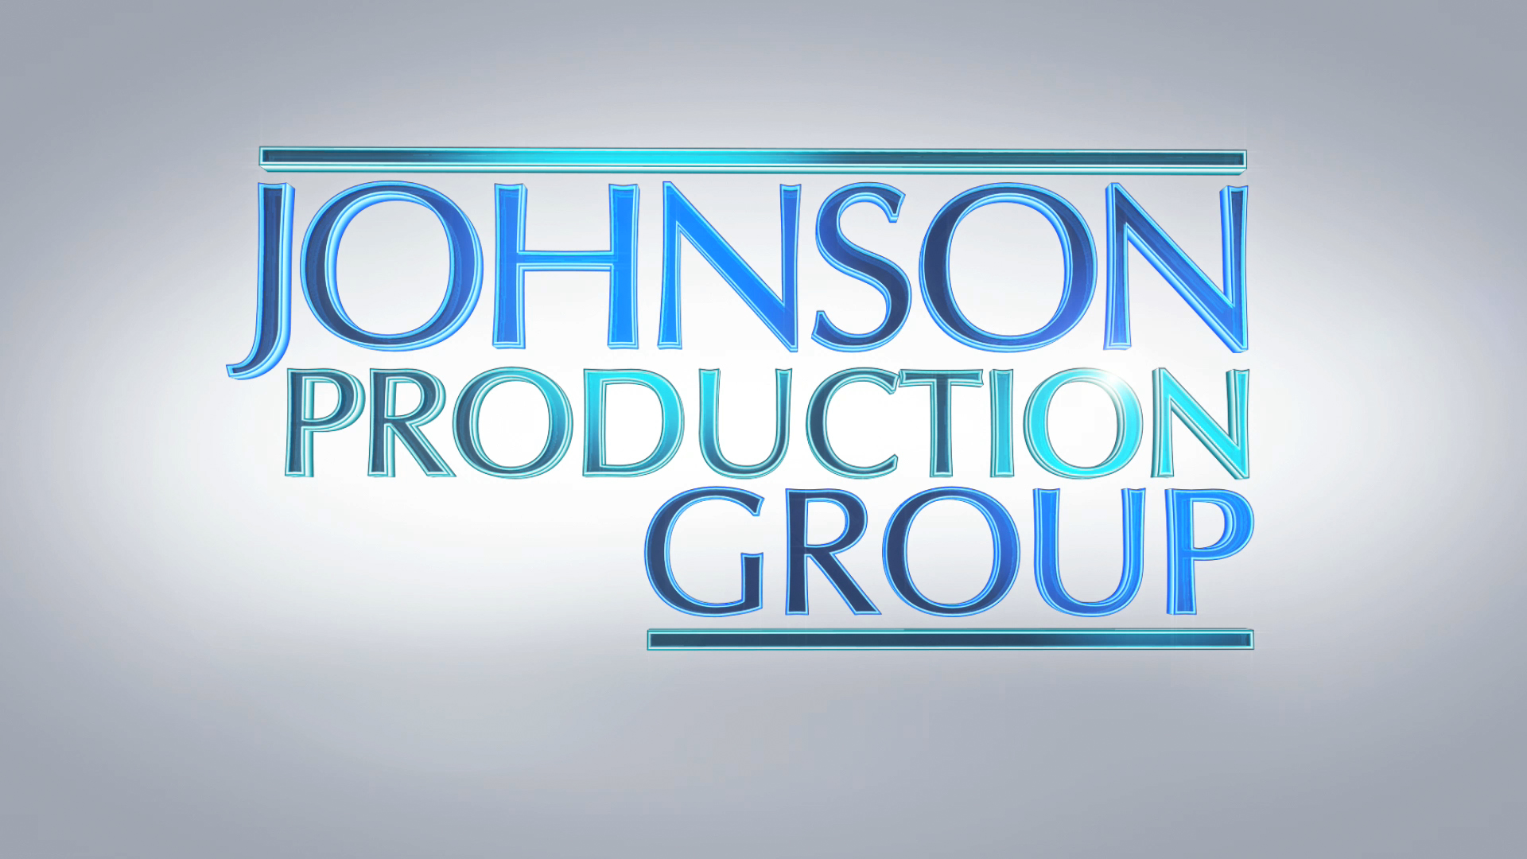

Meta Data

LONG (max 540 characters) synopsis
When high school senior Maddy Beauregard falls in love with a college frat guy, Maddy's over-protective mom Claire strongly disapproves. Followed everywhere, Maddy realizes her own mother is a deranged stalker with a twisted desire to kill her new boyfriend.
When Maddy's boyfriend is found murdered, police suspect Maddy is the killer -- but she is certain her mother did it! Facing the gas chamber, Maddy flees from the cops, embarking on a secret mission to prove her mother's guilt. (485)

MEDIUM (max 180) synopsis
When Maddy falls in love with a college guy, her over-protective mom disapproves. Maddy realizes her own mother is a deranged stalker with a twisted desire to kill her boyfriend. (177)

SHORT (max 54 characters) synopsis
Maddy's stalker mom tries to kill her new boyfriend (52)

5 KEY WORDS
Stalked by My Mom Thriller

