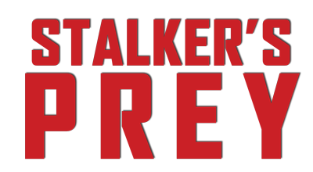

Johnson Production Group

Press Kit

One-Liner
Not all blood-thirsty predators are in the deep; some can be your hero.

Synopsis
Laura’s life is turned upside down when she is attacked by a shark while celebrating her 18th birthday. She’s rescued by Bruce, a handsome young man, who becomes the town’s local hero. As she recovers, Bruce becomes smitten with his damsel in distress, but Laura is not ready to move past the boyfriend she lost in the attack. Bruce infiltrates every aspect of Laura’s life, but her friends and family can’t see through his dangerous obsession. When Laura turns down Bruce’s advances, she finds herself being stalked by the local hero who believes that she owes him more than her life.

Producers
Executive Producer
TIMOTHY O. JOHNSON
Executive Producer
BONNIE FARLEY-LUCAS
Executive Producer
RICHARD J. LUCAS
Producer
ANDREW GERNHARD
Producer
SHANE O'BRIEN
Producer
ZACH O'BRIEN

Key Cast
CHARACTER  Laura  Bruce  Sandy |  | ACTOR  SAXON SHARBINO  MASON DYE  CYNTHIA GIBB

Key Cast Biographies

SAXON SHARBINO
Saxon Sharbino is an American actress. She is best known for portraying Amelia Robbins in the FOX series Touch opposite Kiefer Sutherland and Maria Bello. In 2015, she starred opposite Sam Rockwell in the hit horror classic Poltergeist. She also starred alongside William H. Macy and Amanda Peet in the critically acclaimed indie film Trust Me. Other TV credits include Friday Night Lights and Netflix series Love.

MASON DYE
Mason Dye is an American actor known for his role on MTV’s Teen Wolf and the top-rated Lifetime thriller, Flowers in the Attic, opposite Heather Graham and Ellen Burstyn. Other TV recurring credits include MTV’s Finding Carter and TNT’s Major Crimes. Most recently, he starred in two theatrical movies, Left Behind: Vanished: Next Generation with Teen Wolf co-star Dylan Sprayberry and Chad Scheifele’s critically acclaimed indie thriller, Natural Selection, opposite Kat McNamara and Anthony Michael Hall.

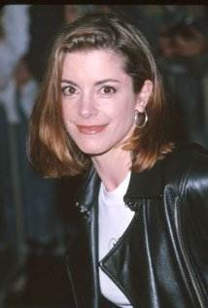
CYNTHIA GIBB
Cynthia Gibb is a veteran American actress who has had a successful film and television career. The New Englander made her film debut in Woody Allen's Stardust Memories. Upon graduation, Gibb landed a role as a scatter-brained teen in CBS’s Search for Tomorrow, which led directly to another teen role, an ambitious wasp in Fame (syndicated, 1983-86). Gibb entered films in 1986, playing three roles that year: in the Rob Lowe starrer Youngblood, a Catholic woman raped and murdered by the death squads in Oliver Stone's Salvador and in the teen comedy Modern Girls. Her sharp comedic timing led to Steven Soderbergh’s romantic comedy Full Frontal in 2002. She has exhibited intelligence and ability in several action films, including Malone (1987), Jack's Back (1988), Short Circuit 2 (1988) and Death Warrant (1990).

Production Credits

Full Cast
Actors  SAXON SHARBINO  MASON DYE  CYNTHIA GIBB  LUKE SLATTERY  CAMRUS JOHNSON  ARABELLA OZ  JESSICA ALEXANDRA GREEN  EDDIE RESENDES  MARKLEY RIZZI  KEVIN SHEA  GILLIAN ROSE  KALI MONEY  ALEXIS LARIVIER  BILL SALVATORE  J.H. TORRANCE DOWNES  CHRISTINA SCIONGAY | Role  Laura  Bruce  Sandy  Nick  Parker  Liz  Casey Jean Hempel  Station Detective  Mrs. Kane  Mr. Alves  Bre  Ashley  Chloe  Political Fundraiser Guest / Reporter  Richard Kane  Alison (voice)

Produced by
Bonnie Farley-Lucas |  | executive producer
Erica Joseph Hunter |  | line producer
Richard J. Lucas |  | executive producer
Paul Melluzzo |  | associate producer
Shane O'Brien |  | producer
Zach O'Brien |  | producer
Kevin Shea |  | co-producer
Greg White |  | associate producer

Directed by
Colin Theys

Writing credits
John Doolan |  | screenwriter

Cinematography by
Branden James Maxham

Film Editing by
Bryan Capri

Casting by
Shane O'Brien

Production Design by
Caley Bisson

Art Direction by
Kaitlyn Murphy

Costume Design by
Annie Simon

Makeup Department
Kevin Anton |  | makeup artist
Jennifer Hauck |  | makeup artist
Jackie Zbuska |  | makeup department head

Second Unit Director or Assistant Director
Jamal Lee Turner |  | first assistant director
Katharine McManus |  | second assistant director

Art Department
Layla Calo-Baird |  | property master

Sound Department
Bumi Hidaka |  | re-recording mixer
Bumi Hidaka |  | sound designer
Michael Infante |  | sound mixer (as Mike Infante)
Brian Quill |  | re-recording mixer
Brian Quill |  | supervising sound editor
Jose Ramirez |  | sound mixer

Stunts
Sean Gallimore |  |  |  | safety coordinator
Shane Gallimore |  |  |  | safety coordinator

Camera and Electrical Department
Robert Clark |  |  | still photographer
Rodrigo Fernandez |  |  | first assistant camera
Steve Levin |  |  | second assistant camera
Dan Peck |  |  | best boy electric
Brad Piche |  |  | best boy grip
Sam Robinson |  |  | gaffer
Jason Rodriguez |  |  | digital imaging technician
Evan Wood |  |  | key grip

Costume and Wardrobe Department
Sarah Bieber |  | assistant costume designer

Editorial Department
Talia Lidia |  | supervising editor

Location Management
Kevin Shea |  | location manager

Transportation Department
William Battle |  | transportation

Other crew
Torrey Benane |  | production assistant
Katherine Eckerson |  | intern
Peter Misluk |  | assistant to the producers
Grace Otte-Cheney |  | intern
Brien Slate |  | key production assistant
Paul Stenko |  | intern
James Summerville |  | intern
Spencer Swindon |  | first team production assistant

Producer Biographies

TIM JOHNSON – Executive Producer
Tim Johnson is among the most active and reliable producers in the business thanks to top rate productions and an 'on time, on budget' reputation. Previously, he managed the production of ABC's THE DAYS (MINDSHARE/TOUCHTONE.) Prior to forming Johnson Production Group and Ignite Entertainment, Tim served as Head of West Coast Programming Executive and launched the successful series DOC (88 episodes,) SUE THOMAS, FBI, MYSTERIOUS WAYS, JUST CAUSE, PONDEROSA, CHRISTY, ITS A MIRACLE AND MIRACLE PETS.

Johnson is also responsible for producing the international hit series, DR. QUINN, MEDICINE WOMAN for CBS PRODS/SULLIVAN COMPANY for over 5 seasons. During his 100-episode tenure, he also launched LIVE FROM THE RANCH with Orson Bean - a nationally syndicated talk show focusing on family values in America. He also developed and produced the original docu-drama COLD CASE for CBS network, which was the very first program to integrate television with the Internet.

Recent Projects:
For Better or For Worse – Executive Producer
Baby Bootcamp – Executive Producer
Ring By Spring – Executive Producer
Sole Custody – Executive Producer
The Cheating Pact – Executive Producer
Deadly Spa – Executive Producer
Walking the Halls – Executive Producer
June In January – Executive Producer
Christmas in the City – Executive Producer
Snow Bride – Executive Producer
Dirty Teacher – Executive Producer
The Surrogate – Executive Producer
Merry In-Laws – Executive Producer
A Bride for Christmas – Executive Producer
Naughty or Nice – Executive Producer
Christmas Crush– Executive Producer
Teenage Bank Heist– Executive Producer
How to Fall in Love – Executive Producer
Home Invasion (2011) – Executive Producer
Final Sale (2011) – Executive Producer
Confined (2010) – Executive Producer
Tornado Valley (2009) – Executive Producer
The Wedding Dance (2009) – Executive Producer
Trust (2009) – executive producer
Toxic Skies (2008) – executive producer
Storm seekers (2008) – executive producer
Making Mr. Right (2008) – executive producer
Love Sick (2008) – executive producer
Just Breathe (2008) – executive producer
Devils Diary (2007) – executive producer
Swarm (2007) – executive producer

JOHNSON PRODUCTION GROUP
The Johnson Production Group contracts globally to produce television and motion picture content for international networks, studios and distributors. Based in Los Angeles and Vancouver, British Columbia, the company manages production, facilitates development and financing, procures distribution and guarantees quality and timely execution of its programs. While costs have gone up, so has the demand for quality. No longer is good enough, good enough. Johnson Production Group serves that segment when a show needs to be "A" quality, but produced efficiently enough to meet a locked budget. JPG specializes in value, protection of creative elements, and delivery of a quality finished product.

BONNIE FARLEY-LUCAS – Executive Producer
RICHARD J. LUCAS – Executive Producer
ANDREW GERNHARD – Producer
SHANE O’BRIEN – Producer
ZACH O’BRIEN - Producer

Billing Block

Johnson Production Group Presents “A STALKER’S PREY”
Saxon Sharbino Mason Dye Cynthia Gibb
Edited by Bryan Capri Cinematography Branden James Maxham
Executive Producers Bonnie Farley-Lucas Richard J. Lucas Timothy O. Johnson
Produced by Andrew Gernhard Shane O’Brien Zach O’Brien Written by John Doolan Directed by Colin Theys
© MMXVII Productions Inc. All Rights Reserved
Johnson Production Group
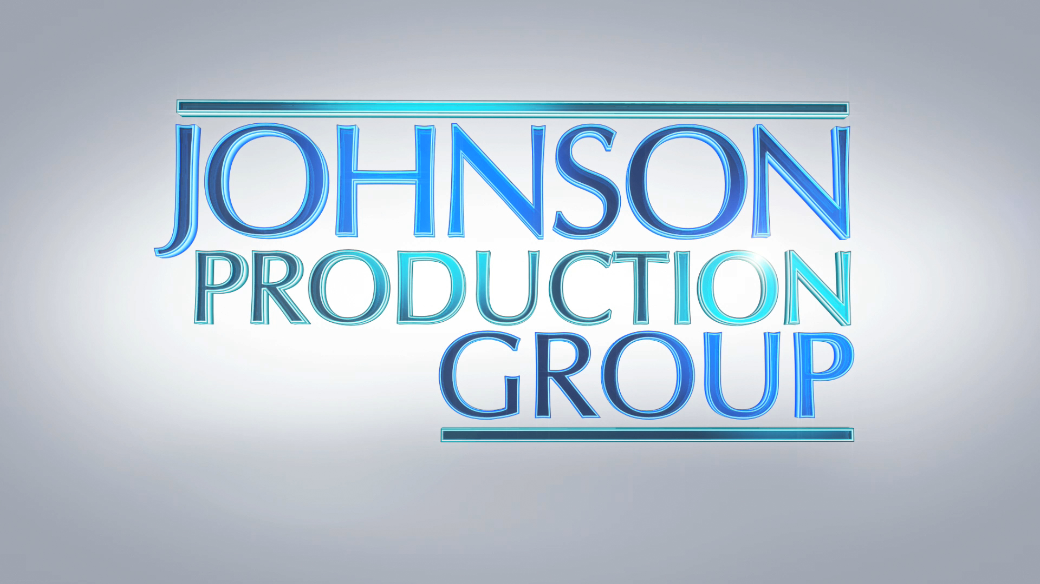

Meta Data

LONG (max 540 characters) synopsis
Laura’s life is turned upside down when she is attacked by a shark while celebrating her 18th birthday. She’s rescued by Bruce, a handsome young man who becomes a local hero for his bravery and become smitten with his damsel in distress. Bruce shows up in more and more places in her life, but her friends and family can’t see the hints of obsession that she starts picking up from her dreamy rescuer. When she tries to tell him no, she winds up being stalked by a local hero who believes that she owes him her life (514)

MEDIUM (max 180) synopsis
Laura is attacked by a shark and rescued by a smitten Bruce. When she tries to tell him no, she winds up being stalked by a local hero who believes that she owes him her life (173)

SHORT (max 54 characters) synopsis
Laura is stalked by her rescuer from a shark attack (51)

5 KEY WORDS
Stalked Shark Prey Hero Thriller

