The Mistletoe Secret

Johnson Production Group

Press Kit

One-Liner
Based on the New York Times best seller, Mistletoe Secret by Richard Paul Evans. A small town diner owner is falling in love with a travel article writer...or is it his ghost writer she's in love with?

Synopsis

“The Mistletoe Secret” follows Aria Eubanks, owner of the Mistletoe Diner and huge fan of adventure and travel star Sterling Masters. She and her father Mack, find out that Sterling Masters is going to write about all the festive Christmas celebrations in their hometown of Midway, Utah. Little does she know that her favorite writer is not who she thinks he is. Alex Bartlett arrives in town on assignment as Sterling’s ghostwriter and is the author of all Sterling’s travel articles. At first, Alex clashes with Aria but slowly finds himself falling for her. Complications arise when the real Sterling Masters shows up and charms Aria. When Aria discovers their Christmas secret, she must decide if she really fell in love with Sterling, the star, or Alex, the man who wrote all the articles that captured her heart.

Producers
Executive Producer
TIMOTHY O. JOHNSON
Co-Executive Producer
JOSEPH WILKA
Producer
NAVID SOOFI
Supervising Producer
OLIVER DE CAIGNY

Key Cast
CHARACTER  Aria  Alex  Mack  Sterling  Catherine  Leslie |  | ACTOR  KELLIE PICKLER  TYLER HYNES  PATRICK DUFFY  CHRISTOPHER RUSSELL  BEVERLY ELLIOT  KAZUMI EVANS

Key Cast Biographies
KELLIE PICKLER
Kellie Pickler was born in Albemarle, North Carolina to Cynthia Morton and Clyde "Bo" Raymond Pickler, Jr. Cynthia left when Kellie was 2 but was then granted custody for two years. Kellie was returned to her grandparents at age 12. Her father was in and out of jail throughout her childhood and she was raised in Albemarle, North Carolina by her grandparents, who were big influences in her life. She has a half-sister named Courtney and two half-brothers, Eric and Michael; she has never met Michael. Kellie and Eric continued to live with their grandfather after their grandmother died of lung cancer in 2002. At North Stanly High School in New London, North Carolina, from which she graduated in 2004, she was a cheerleader and a beauty queen. In 2005 she tried out for American Idol (2002) and was sent to Hollywood. She sang many famous songs, including "Since U Been Gone" by Kelly Clarkson, "A Broken Wing" by Martina McBride, and "Blame it on the Sun" by Stevie Wonder. She was one of Simon's favorites, but was eliminated in the Final 6. Back in North Carolina she was given a key to the city on "Kellie Pickler Day", May 6, 2006. She then headed to Nashville, Tennessee to pursue her dreams. She was signed to 19 Recordings/BNA Records and wrote and sang many chart-toppers, including "Red High Heels", "I Wonder", "Things That Never Cross a Man's Mind", "Don't You Know You're Beautiful", "You Didn't Know How Much I Loved You", and "The Best Days of Your Life".

TYLER HYNES
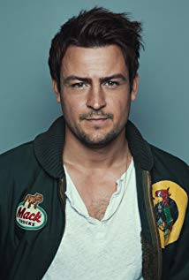
Tyler Hynes was born in Toronto and raised in Ottawa Ontario with the artist gene in his veins. He is an accomplished actor, director, producer, editor, writer and musician, and he is constantly striving to create and star in new and innovative projects. Hynes got his professional start at the age of eight performing on stage, touring Canada in the role of young Tommy in the rock musical The Who’s Tommy. From there he went on to television and films. By age 13, Hynes was on television screens everywhere starring as a main character in “Amazon” and he hasn't stopped since. Some of his greatest accolades and achievements include a Best Actor Gemini nomination for “Tagged: The Jonathan Wamback Story,” which told the real life tragedy about a Canadian high school student who was beaten and left for dead.
At age 18, Hynes landed in movie theaters everywhere starring alongside Andie MacDowell and Tim Roth in “The Last Sign.” He then transitioned from teen actor to adult actor flawlessly, and in his 20s he found himself working alongside James Franco and Sienna Miller in “Camille.” Shortly thereafter, Hynes captivated audiences everywhere in NBC’s “The Firm” based on John Grisham’s novel, in which he portrayed the smug and overly intelligent Ivy Leaguer Patrick Walker, who was about to stand trial for first degree murder. He also appeared in “Betty and Coretta” opposite Mary J. Blige.
Most recently, Hynes can be seen in a recurring role this season of “UnREAL,” as well as a lead in the upcoming feature, “Peace,” starring opposite Alexander Ludwig. He also cultivated a huge following as a series regular on “Saving Hope,” for his portrayal of Luke Reid, the paramedic brother of the main character. His other notable recurring guest starring roles include “Transporter: The Series,” and the critically acclaimed Canadian series, “19-2.”
While his acting portfolio continues to prosper, Hynes keeps adding his name to grassroots indie projects where he has written, directed and starred in his own short films. A talented musician with a knack for the unknown, Hynes enjoys reading and traveling in his down time.

CHRISTOPHER RUSSELL
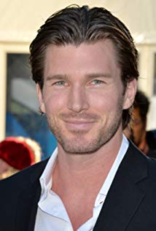
Christopher Russell is a first generation Canadian born to British parents. From a very young age, he was drawn to the arts and began performing. His first role as an actor was portraying Mary and Joseph's donkey in his pre-school production of “The Nativity Story,” for which he received rave reviews. In high school, Russell performed in many productions, most notably as Magnus Muldoon in a rendition of Tom Stoppard’s “The Real Inspector Hound,” which earned him the Sears Drama Festival Award of Excellence.
Russell recently filmed the lead role of Madison in ABC Family’s pilot “Gorgeous Morons.” His numerous television credits prior to that include guest star and recurring appearances on “Girlfriends’ Guide to Divorce,” “Men in Trees” with Anne Heche, “Flashpoint,” “The Listener,” “Murdoch Mysteries,” The CW’s “iZombie,” “Nikita,” “Supernatural” and “Beauty and the Beast,” as well as the TV movies “Love, Again,” “Midnight Masquerade,” “The Boy Next Door,” “Seduced By Lies” and “Catch A Christmas Star.”
Russell’s film credits include “Gone Tomorrow,” “Gangster Exchange,” George Romero’s “Land of the Dead,” “Center Stage: Turn It Up” and “The Right Kind Of Wrong,” which was an official selection for TIFF 2013, starring “True Blood’s” Ryan Kwanten and Catherine O'Hara.
Russell currently lives in Vancouver with his wife and his two children.

PATRICK DUFFY
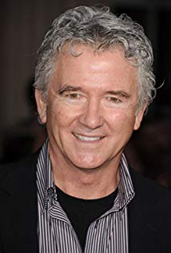
Youngest of 2 children, and only son born to Terrence and Marie Duffy. Patrick was born in Montana, where his parents owned local taverns, and raised in Everett, Washington, since age 12. He wanted to become a professional athlete, and became a certified scuba diver while in his teens. However, his involvement in his high school's drama department led him to apply to the Professional Actors Training Program at the University of Washington, Seattle. He was one of 12 people accepted, from over 1,200 applicants. He ruptured both of his vocal cords during his senior year of college, but he created the position of actor-in-residence, where he worked as an interpreter for ballet, opera, and orchestra companies in Washington. He also taught mime and movement classes. Around this time, he met his wife, Carlyn, a ballet dancer with the First Chamber Dance Company of New York. Carlyn introduced Patrick to Buddhism, which he has practiced for the past 30 years. The couple married in a Buddhist temple in 1974. They then moved to New York, where Patrick appeared in Off-Broadway plays, and supported himself and his wife by working as a carpenter. The couple then moved to Hollywood, where he drove a florist's delivery truck, and landed small roles in film and television. His son, Padraic Duffy, was born in 1974/5. In 1976, Patrick was working as a house painter when he landed the role of "Mark Harris" in the TV series Man from Atlantis (1977). Two years later, he won the role of "Bobby Ewing" on Dallas (1978). His second son, Conor Duffy, was born in 1979/80. In 1986, his parents were murdered by 2 teenagers who raided their tavern in Montana. Patrick has continued to work, however, starring in a variety of TV movies, and as "Frank Lambert" on his third TV series, Step by Step (1991). Since SBS was canceled in 1997, Patrick has continued to pursue his TV career, which includes 2 Dallas reunion movies and the revival series Dallas (2012). Widowed in 2017, he splits his time between Los Angeles and southern Oregon.

BEVERLEY ELLIOT

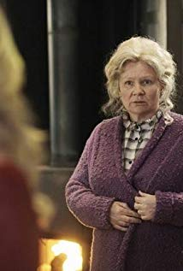
Beverley Elliott is a Canadian actress and singer-songwriter. She is best known for playing the role of Granny in Once Upon a Time,[2] Maggie Krell in Harper's Island, Brick Bannerman in Kingdom Hospital and Sally Duffield in Bordertown.

KAZUMI EVANS
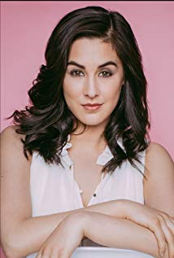
Kazumi Evans (born September 14, 1989) is a Canadian voice actress and singer who participates in a number of dubs for cartoon shows, including the singing voice for Rarity and Princess Luna in My Little Pony: Friendship is Magic, Adagio Dazzle in My Little Pony: Equestria Girls - Rainbow Rocks, Mad Madeline on The Deep, and Skipper in the Barbie films. One of her biggest roles to date is Iris the lead character in the French animated show LoliRock which was released in English by Netflix in May 2016.

Production Credits

Casting by
LINDSAY CHAG and
JUDY LEE

Production Designer
HEATHER COUTTS

Director of Photography
MIKE KAM

Edited By
JASON NIELSEN

Music by
RUSS HOWARD III

Supervising Producer
OLIVER DE CAIGNY

Co-Executive Producer
JOSEPH WILKA

Executive Producer
TIMOTHY O. JOHNSON

Produced By
NAVID SOOFI

Written By
RICKIE CASTANEDA and
MEGAN HOCKING

Based on the Novel By
RICHARD PAUL EVANS

Directed By
TERRY INGRAM

Producer Biographies

TIM JOHNSON – Executive Producer
Tim Johnson is among the most active and reliable producers in the business thanks to top rate productions and global distribution appeal.
Johnson is also responsible for producing the international hit series, DR. QUINN, MEDICINE WOMAN for CBS for over 5 seasons. During his 100-episode tenure, he also developed and produced the original docu-drama COLD CASE for CBS network, which was the very first program to integrate television with the Internet.
Johnson has produced over 150 movies, 15 globally released series for every major US network - including ABC, Disney, CBS, NBC, Netfly, FOX and Sony.

JOHNSON PRODUCTION GROUP
The Johnson Production Group contracts globally to produce television content for international networks, studios and distributors. Based in Los Angeles and Vancouver, British Columbia, the company manages production, facilitates development and financing, procures distribution and guarantees quality and timely execution of its programs. While costs have gone up, so has the demand for quality. No longer is good enough, good enough. Johnson Production Group serves that segment when a show needs to be "A" quality, but produced efficiently enough to meet a locked budget. JPG specializes in value, protection of creative elements, and delivery of a quality finished product.
JOSEPH WILKA – Producer
Joseph Wilka is the Head of Production for Johnson Production Group. Los Angeles-based, Joseph had already produced and directed several feature films before serving as the senior marketing executive for Gravitas Ventures. While at Gravitas, Wilka helped pioneer new distribution models for independent films including day-and-date theatrical releases. It was also at Gravitas where Joseph first worked with Johnson Production Group to facilitate the release of their films to the worldwide Video On Demand audience. After serving as the Director of Distribution and Production for Viva Pictures, where he produced English-language versions of foreign animated titles for DirecTV, Wilka officially joined Johnson Production Group. As Head of Production, he oversees the development, production, and distribution of films from multiple production units for release on broadcast and streaming platforms.
NAVID SOOFI – Producer
Recent projects:
Sleepwalking in Suburbia (TV Movie) (supervising producer) (post-production)
2016 A Snow Capped Christmas (line producer)
2016 The Mistletoe Promise (TV Movie) (supervising producer)
2016 Lord Jones Is Dead (producer)
2016 Tulips in Spring (TV Movie) (supervising producer)
2016 Hearts of Spring (TV Movie) (supervising producer)
2015 Becoming Santa (TV Movie) (line producer)
2015 A Gift Wrapped Christmas (TV Movie) (supervising producer)
2015 A Mother's Instinct (TV Movie) (supervising producer)
2015 Ice Sculpture Christmas (TV Movie) (supervising producer)
2015 Family for Christmas (TV Movie) (supervising producer)
2015 Her Infidelity (TV Movie) (supervising producer)
2015 A Gift of Miracles (TV Movie) (supervising producer)
2014 Paper Angels (TV Movie) (supervising producer)
2014 A Cookie Cutter Christmas (TV Movie) (supervising producer)
2014 For Better or for Worse (TV Movie) (line producer)
2014 Skye & Chang (TV Movie) (line producer)
2014 Baby Boot Camp (TV Movie) (line producer)
2014 Ring by Spring (TV Movie) (line producer)
2014 The Town That Came A-Courtin' (line producer)
2014 June in January (TV Movie) (line producer)
2013 One Foot in Hell (TV Movie) (line producer) / (producer)
2011 The 13th Annual Leo Awards (TV Special) (red carpet producer)
2011 Real Estate 101 (TV Series) (collaborating producer)
2011 Pressed (line producer) / (producer)
2010/I Transparency (executive producer)
FMA Entertainement Weekly (TV Series) (line producer - 13 episodes, 2010) (producer - 13 episodes, 2010)
2009 Inscribed (Short) (producer)
2009 Me and Myself (Short) (producer)
2009 Bad Girls (Short) (executive producer)
2009 Together We're Heavy (co-producer)
2009 Last Flowers (Short) (executive producer)

OLIVER DE CAIGNY - Supervising Producer
Oliver De Caigny is a Canadian producer originally from Belgium, his background in financing, production, and post production makes his a well-rounded producer for any type of production. His experience in financing and production agreements (film and TV series and movies-of-the week), distribution agreements (both domestic and foreign) as well as international co-productions, Canadian tax credit, Telefilm Canada and Canada Media Fund incentives provides him with a well-rounded background in development, production and distribution for motion pictures, television series and productions.
Recent Projects
Eat, Play, Love –Producer
Sleepwalking in Suburbia –Producer
Woman on the Run
Infidelity in Suburbia –Producer
Sleigh Bells Ring – Producer
The Rooftop Christmas Tree – Producer
A Snow Capped Christmas – Producer
A December Bride – Producer
The Mistletoe Promise – Producer
The Convenient Groom – Producer
Tulips in Spring – Producer
Hearts of Spring – Producer
Becoming Santa – Producer
Magic Stocking – Producer
Just in Time for Christmas – Producer
A Gift Wrapped Christmas – Producer
A Mother's Instinct – Producer
Ice Sculpture Christmas – Producer
The Reckoning – Producer
Family for Christmas – Producer
Her Infidelity – Producer
A Gift of Miracles – Producer
Strange Empire (13 episodes) – Producer
Her Infidelity - Producer
Paper Angels - Producer
A Cookie Cutter Christmas) - Producer
For Better or For Worse – Producer
A Ring By Spring – Producer
June In January – Producer
Baby Bootcamp – Producer
A Badge Of Betrayal (aka Sole Custody) – Producer
R.L. Stine’s: The Haunting Hour (53 Episodes) – Associate Producer
A Bride For Christmas – Producer
The Dating Coach – Producer
Radio Rebel – Executive Producer
Seattle Superstorm – Producer

TERRY INGRAM- Director
Terry Ingram has over 25 years experience in the industry. He has directed over 50 episodes of series television for almost every network in the US and Canada as well as directed over 30 plus television movies. Terry has worked internationally: Canada, Spain, the US and South Africa.
His more recent projects include:
2017-2019 Chesapeake Shores (TV Series) (10 episodes)
2019 Just Add Romance (TV Movie)
2019 The Chronicle Mysteries: The Wrong Man (TV Movie)
2019 Valentine in the Vineyard (TV Movie)
2018 All of My Heart: The Wedding (TV Movie)
2018 Aurora Teagarden Mysteries: The Disappearing Game (TV Movie)
2018 Reap What You Sew: An Aurora Teagarden Mystery (TV Movie)
2018 Morning Show Mystery: Mortal Mishaps (TV Movie)
2017 The Sweetest Christmas (TV Movie)
2017 Marry Me at Christmas (TV Movie)
2017 All of My Heart: Inn Love (TV Movie)
2017 Hailey Dean Mystery: Deadly Estate (TV Movie)
2017 Dead Over Heels: An Aurora Teagarden Mystery (TV Movie)
2016 Looks Like Christmas (TV Movie)
2016 Finding Father Christmas (TV Movie)
2016 Hailey Dean Mystery: Murder, with Love (TV Movie)
2016 The Julius House: An Aurora Teagarden Mystery (TV Movie)
2016 Death Al Dente: A Gourmet Detective Mystery (TV Movie)
2016 Anything for Love (TV Movie)
2016 Love on the Sidelines (TV Movie)
2015 Wish Upon a Christmas (TV Movie)
2015 The Christmas Note (TV Movie)
2015 'Tis the Season for Love (TV Movie)
2015 Love Under the Stars (TV Movie)
2015 My New Best Friend (TV Movie)
2014 Vow of Violence (TV Movie)
2014 The Christmas Shepherd (TV Movie)
2014 My Boyfriends' Dogs (TV Movie)
2014 Stolen from the Womb (TV Movie)
2014 The Good Mistress (TV Movie)
2013 Hats Off to Christmas! (TV Movie)
2013 Profile for Murder (TV Movie)
2013 Chupacabra vs. the Alamo (TV Movie)

Billing Block

Johnson Production Group Presents “THE MISTLETOE SECRET”
Starring KELLIE PICKLER TYLER HYNES CHRISTOPHER RUSSELL BEVERLY ELLIOT
KAZUMI EVANS and PATRICK DUFFY
Casting by LINDSAY CHAG JUDY LEE Production Designer HEATHER COUTTS
Director of Photography MIKE KAM Edited By JASON NIELSEN
Music by RUSS HOWARD III Executive Producers TIMOTHY O. JOHNSON JOSEPH WILKA Producer NAVID SOOFI Supervising Producer OLIVER DE CAIGNY
Written By RICKIE CASTANEDA MEGAN HOCKING Based on the Novel By
RICHARD PAUL EVANS Directed By TERRY INGRAM
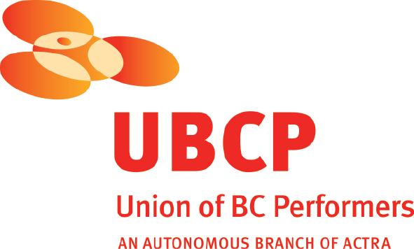
With the participation of the Province of British Columbia
Film Incentive BC
The Canadian Film or Video Production Tax Credit
© MMXIX Johnson Production Group Inc. All Rights Reserved

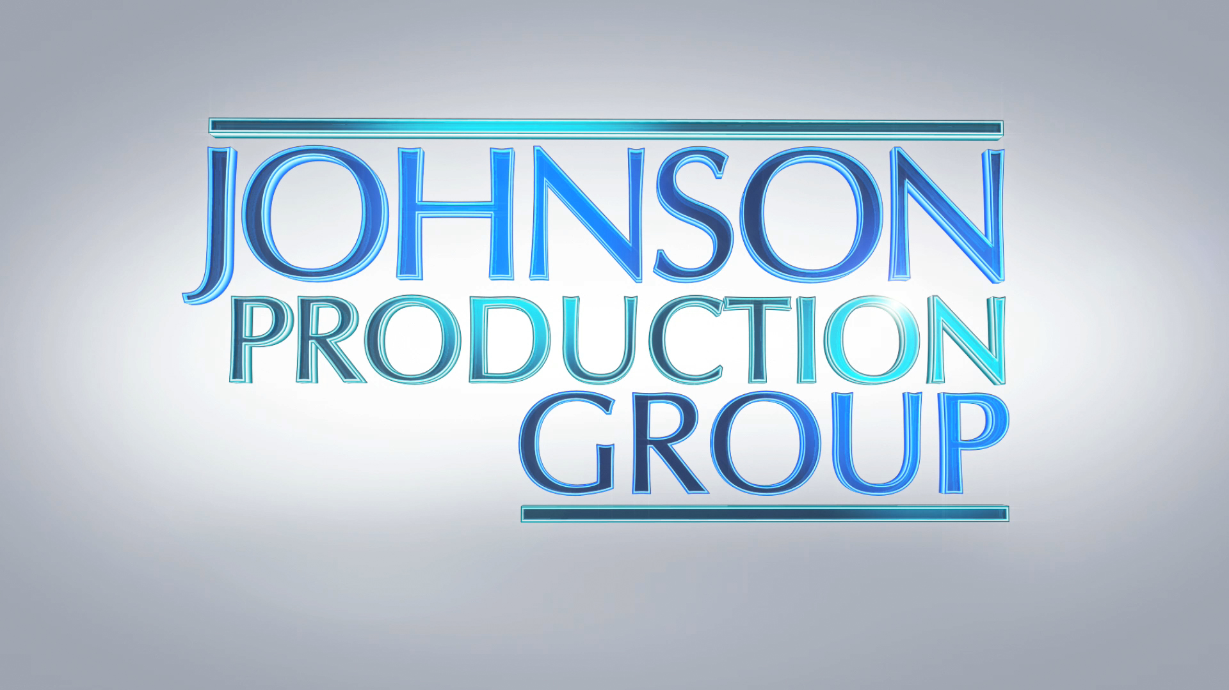

Meta Data

LONG (max 3000 characters) synopsis

“The Mistletoe Secret” follows Aria Eubanks, owner of the Mistletoe Diner and huge fan of adventure and travel star Sterling Masters. She and her father Mack, find out that Sterling Masters is going to write about all the festive Christmas celebrations in their hometown of Midway, Utah. Little does she know that her favorite writer is not who she thinks he is. Alex Bartlett arrives in town on assignment as Sterling’s ghostwriter and is the author of all Sterling’s travel articles. At first, Alex clashes with Aria but slowly finds himself falling for her. Complications arise when the real Sterling Masters shows up and charms Aria. When Aria discovers their Christmas secret, she must decide if she really fell in love with Sterling, the star, or Alex, the man who wrote all the articles that captured her heart. (819)

MEDIUM (max 500) synopsis

Aria Eubanks, owner of the Mistletoe Diner, and her father Mack are huge fans of travel writer Sterling Masters and are excited to find out that he is going to write about the festive Christmas celebrations in their hometown. When Alex Bartlett arrives on assignment as Sterling’s ghostwriter he initially clashes with Aria but slowly finds himself falling for her. Complications arise when the real Sterling Masters shows up and charms Aria. Is it a travel article writer...or is it his ghost writer she's in love with? (484)

SHORT (max 100 characters) synopsis
Aria is excited to meet travel writer, Sterling Masters, but not so much his ghost writer, Alex. (97)

5 KEY WORDS
Christmas, hometown, writer, romance, secret

