Johnson Production Group

Press Kit

One-Liner

When two weeks before Christmas, Emma returns to her hometown built around her family's pioneer Christmas Light factory, she finds the lights have gone dim in the once festive town prompting Emma to reconnect with her old flame as together they set their hearts and the town ablaze with light again.

Synopsis

Real estate broker Emma Simmons is on the rise with her career in Phoenix. She returns home to sell her family house in Cherry Creek and spend Christmas time there. Cherry Creek was always a town full of the Christmas spirit, in fact Emma’s family has lived there for generations and owns the Christmas lights factory which supplies much of that joy and wonder to surrounding towns. Over the last few years times have gotten tough with all the light competitors and Emma’s dad had to cut back at the factory. With the help of Simmons Lights engineer, Ben, Emma has a plan to light up the city once more, originally with hope of selling her house but perhaps there is more reason to stay in this small town than she thinks.

Producers
Executive Producers
TIMOTHY O. JOHNSON
KIM FIELDS
ART RUTTER
Producer
NAVID SOOFI
Supervising Producer
OLIVER DE CAIGNY

Key Cast
CHARACTER  Emma  Ben  Lily  Heather  Rose  Aurora |  | ACTOR  KIM FIELDS  ADRIAN HOLMES  CHRISTINA SICOLI  PARVEEN DOSANJH  MINDY COHN  LISA WHELCHEL

Key Cast Biographies

KIM FIELDS

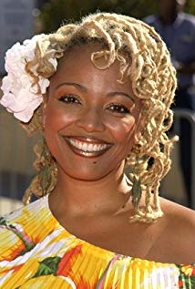
Kim Fields was born on May 12, 1969 in New York City, New York, USA as Kim Victoria Fields. Se is an American television actress, producer, and director. She entered the field of acting and television commercials, as a child artist. Though Kim bagged her first acting assignment at the age of 5, her appearance was largely unnoticed. When she was just 9 years old, she got her big break in acting career in a popular sitcom. The character, ‘Tootie Ramsey,’ which Kim played, made her a household name in United States. Kim continued with her acting career even after growing up. As a mature actress, she played prominent roles in many sitcoms. Kim is musically inclined and has released her albums in rap music and R&B. She has been a part of some popular reality television shows and dancing competitions. To this day, her name remains popular in entertainment industry. She is active in acting career with her captivating performances.She is also know for appearing in Living Single (1993), What to Expect When You're Expecting (2012) and For Better or for Worse (2012). Her most recent work includes A Question of Faith (2014), Merry Wish-Mas (2017), the TV Series Living the Dream and TV movie Wrapped Up In Christmas (2017).

ADRIAN HOLMES

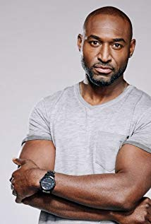
Born March 31st, in Wrexham, North Wales to Barbadian parents, Adrian Holmes grew up in Vancouver, British Columbia where he studied theatre and found his love for performing at a young age. He is an actor known for Red Riding Hood (2011) directed by Catherine Hardwick (Twilight), and Elysium (2013) directed by Neill Blomkamp (District 9). With over 100 television credits including Arrow and the comedy Impastor, one of his fan favorites was his recurring role of 'Basqat' on the long running CW series, Smallville. Holmes is most proud and honored to have helped produce along side Step by Step productions and play the lead role as Errol Barrow in the Docudrama, "Barrow: Freedom Fighter". Shot in his homeland of Barbados in 2016 it is an important story about the life and times of Errol Barrow, the first Prime Minister of Barbados in 1966, who fought for freedom, equality and the education of his people.

Leading the cast as 'Nick Barron' on Bravo's original series, 19-2 was also a major highlight in his career. He took home Canada's top honor in film and television in 2017 with the Canadian Screen Award, (CSA) for best lead male in a dramatic series. The show won Best Drama at the 2016 Canadian Screen Awards, and was also nominated for a 2016 International Emmy Award for Best Drama. It has been hailed by the press including the New York Times which stated, "The series is in the tradition of shows like "The Wire," portraying law enforcement less flashily and less noisily than others, and thus more accurately." He just completed filming the big action feature Skyscraper with Dwayne "The Rock" Johnson which is expected to be in theaters July 2018. Adrian now splits his time between Vancouver and Los Angeles.

CHRISTINA SICOLI
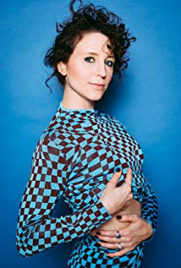
Christina was born and raised in Port Colborne, Ontario where at a young age spent most of her days playing dress up and pretending to be teen detective, Nancy Drew. A triple threat performer, she graduated at the top of her class from the Randolph Academy For The Performing Arts and The Second City (Toronto). A "tour de force", Sicoli is an award winning actress, character driven comedienne, writer and accomplished improvisor.

PARVEEN DOSANJH
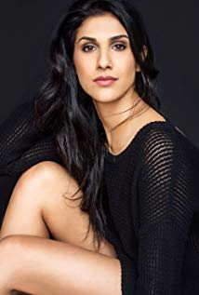
Actress Parveen Dosanjh is thrilled to be working at a time when television storytelling has become so sophisticated and character-driven, but a career in front of the camera was not always in focus. While being drawn to performance and storytelling from an early age, it wasn’t until she attended a motivational seminar that she chose to step away from her career and pursue acting full time. The gamble paid off, and after landing guest spots on series like “Supergirl” and “Arrow,” she was cast as Dr. Nani Singh in Season 1 of the science fiction series “Another Life,” currently streaming now on Netflix.

MINDY COHN
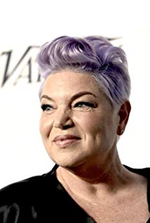
Mindy Cohn was born on May 20, 1966 in Los Angeles, California, USA as Melinda Heather Cohn. She is an actress, producer, voice actress and singer. She is known for her role as Natalie Green in the sitcom The Facts of Life and for being the voice of Velma Dinkley in the Scooby-Doo franchise from 2002 to 2015. She resides in Beverly Hills. Cohn has continued her acting career outside of The Facts of Life. In 1984 she had a leading role as the daughter alongside Stockard Channing in RKO's video production of "Table Settings". In 1986, she appeared in The Boy Who Could Fly as next-door neighbor Geneva. She also had guest appearances in other popular TV shows, including Charles in Charge (playing Buddy's sister Bunny, a young alcoholic, in the 1988 episode "Bottle Baby"), and two guest appearances in the second season of the cop drama 21 Jump Street (playing Rosa in the 1987 episode "Christmas In Saigon" and the 1988 episode "Chapel of Love"). In 2004 Cohn appeared in the WB comedy The Help. In 2010, Cohn played the role of Violet, the leading character in Casper Andreas's movie Violet Tendencies, and appeared on the Season 8 premiere of TLC's What Not to Wear on October 29, 2010. She appeared in an episode of Hot in Cleveland on July 13, 2011, on The Secret Life of the American Teenager on March 26, 2012, and in The Middle on May 21, 2014.
LISA WHELCHEL
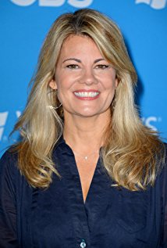
Lisa Whelchel was born in Littlefield, Texas, on, May 29, 1963. She is an American actress, singer-songwriter, author, and speaker. She discovered acting at age 8 and performed in musical theater for the next four years. At 10 she became a born-again Christian and devoted her life to her Christian faith. When she was 12 she wrote to the Disney Studios asking for an audition as a Mouseketeer on The New Mickey Mouse Club (1977). She moved to California the next year and appeared in syndication from 1977-1978. In 1979, she began her starring role as wealthy, preppy, private-school girl "Blair Warner" on The Facts of Life (1979). The show lasted nine years and she filmed the last regular episode, The Facts of Life: Big Apple Blues (1988) televised on Saturday, March 19th, 1988. 6 and 7 weeks later came two larger-cast specials, The Facts of Life: The Beginning of the End (1988), televised on Saturday, April 30, 1988, and the series finale, The Facts of Life: The Beginning of the Beginning (1988) televised on Saturday, May 7, 1988. On Saturday, July 9, 1988, she married Steven Cauble, who was an associate pastor at Whelchel's church, "The Church On the Way" in Van Nuys, California. On Saturday, January 17, 1990 she gave birth to son Tucker Stephenson Cauble. Her second child and first daughter, Haven Katherine Hill Cauble, was born on Thursday, September 26, followed by third child and second daughter Clancy Elizabeth Cauble (aka Clancy Cauble) on Thursday, November 12, 1992. She released a Christian pop album, "All Because of You," in 1984. The next year she was nominated for a Grammy Award for Best Inspirational Performance. She has written many books including "Creative Correction", "So You're Thinking About Homeschooling", "The Facts of Life (and Other Lessons My Father Taught Me)", "Friendships for Grown-Ups", "Taking Care of the Me in Mommy", and "Speaking Mom-Ese". In 2001, she reprized her role of "Blair Warner" for the made-for-television movie, The Wonderful World of Disney: The Facts of Life Reunion (2001), on the ABC Network. On Sunday, March 7, 2004, she and Charlotte Rae performed "The Facts of Life" theme song at the 2nd Annual TV Land Awards. On Thursday, April 10, 2011, Whelchel and the cast of The Facts of Life (1979), including Charlotte Rae, Nancy McKeon, Mindy Cohn, Kim Fields, Geri Jewell & Cloris Leachman were honored with the Pop Culture Award at the 9th Annual TV Land Awards at the Javits Center in New York City. She officially divorced her husband, Steven Cauble, on Thursday, March 1, 2012, after 23 years of marriage. She appeared on the 25th season of Survivor (2000), located in the Philippine Islands, as part of the Tandang tribe. She appeared on the CBS talk show, The Talk (2010) and "The Jeff Probst Show" to promote her appearance on "Survivor" in 2012. In 2012 she also appeared in "Teen Star Lisa Whelchel: Surviving 'Survivor' and Divorce". She also appeared on a second episode titled "Survivor Finalists". During the 25th Season Reunion Show on CBS, "America's Sweetheart" she won the fan-voted Sprint Player of the Season by 0.7% over Malcolm which is the closest margin of victory in Survivor history. The prize money that Lisa Whelchel won was $100,000 U.S. Lisa began to co-host on The Jeff Probst Show (2012) that started televising in January of 2013.
Production Credits

Full Cast
Actor | Role
KIM FIELDS | Emma
ADRIAN HOLMES | Ben
CHRISTINA SICOLI | Lily
PARVEEN DOSANJH | Heather
BRENDAN TAYLOR | Phil
LISA WHELCHEL | Aurora
MINDY COHN | Rose
MARLEE WALCHUK | Ms. Fisher
WILLIAM SAMPLES | Dusty
ASHLEY ALEXANDER | Katy Jenkins
SEBASTIAN BILLINGSLEY-RODRIGUEZ | Liam
BILL POZZOBON | Mr. Thompson
CORINA BIZIM | Mrs. Collins
JOE COSTA | Carl
BJ HARRISON | Leonna
BENJAMIN WILKINSON | Nate
ANDREW CREIGHTNEY | Grandpa Roy
DALE REYNOLDS | Mr. Brian
NANCY MCKEON | Kathy

Produced by
TIMOTHY O. JOHNSON |  | executive producer
KIM FIELDS |  | executive producer
ART RUTTER |  | executive producer
NAVID SOOFI |  | producer
OLIVER DE CAIGNY |  | supervising producer

Directed by
RHONDA F. BARAKA

Written by
BARBARA KYMLICKA

Original Score by
RED JANES

Cinematography by
MIKE KAM
SEAN COX

Film Editing by
JASON NIELSEN

Casting By
JUDY LEE

Production Design by
HEATHER COUTTS

Full Crew
TROY SCOTT | associate producers
HADRIAN RAJOTTE
NAVID SOOFI | production managers
DARREN ROBSON
TROY SCOTT | first assistant directors
JEFF CROFT
JEFF CROFT | second assistant director
CASSY HUNGERSON
KATIE GOOLD | set decorator
RUSTY ROSS | assistant set decorator
KSENIIA LIEONTIEVA | on set dresser
KATIE STEWART | buyer
TOM JOHNSON | set dressers
SKYE DYKEN
LOUIS LLARENA
RICHARD WITTING
JOELY OSIKA
LAUREN DOMINCZUK | property master
RONALD LIN | assistant property master
EMILY POIRIER | props
KATIE HILLIER | graphic designer
KATHLEEN FOWLSTONE | make-up artist
KEELY ANDERSON | hair stylist
SELENA TAYLOR | make-up swings
COURTNEY YELLOW-QUILL
STACEY BRADDER | costume designer
NAOMI LAZARUS | assistant costume designer
CALVIN JAY | truck costumer
LINDEN LIGERTWOOD | set supervisor
GELLERT HORVATH | background costumer
KEVIN MAYES | ms. fields tailor
CHRISTIAN LAI | camera operators
SEAN COX
GREGORY CZAPLAK
BRIAN CECI
THOMAS KELLY | first assistants camera
HYUNG JOO KIM
THOMAS WANG | second assistants camera
MARIA GARCIA
PIERRE CRUZ | gaffer
BRIN TAYLOR | best boy electric
CORY TYMOSCHUK | electric
SEBASTIAN SYROTA
TREVOR HATELT | generator operators
NAHUM ROBERTSON
MARTIN CALVO | key grip
ERIK MORTENSEN | best boy grip
ANDRIJ LYSKOV | dolly grip
DENNIS CHAPPELL | grips
KAID KRAWCHUK
PETER GIBSON | transport coordinator
DOUG HALVORSON | transport captain
JEFF CHARLTON | drivers
SAEED SODEYF
VIC PAULUS
HARLAN DAVIDSON
GORDON MACKAY
GARY WATSON
BRENT VINEY
SHANE CALADO | special effects coordinator
JOEL CLARK | special effects assistants
ARTUR GIMENES
BARRY HUNT | security coordinator
JOSEPH BUCCI | security
JASON HUNT
JEREMY HUNT
ONKAR S. NAGRA
PERRY PARSONS
RICHARD PLUHOWY
GARRETT VANDUSEN | location manager
ROBERT BRICKER | assistant location managers
ROBIN LAWRENCE
LINDA LIU | key location assistants
JAMES MCINTOSH
ROBIN LAWRENCE
CELESTE CROWE
WAYNE LAM
MICHELLE TOLOSA
RYAN TOUCHET
EMILIA SAINZ SOLER | production sound mixer
ELSY DAGDUG CHAMELIS | boom operator
SAMANTHA DUNBAR | script supervisor
PARALEE COOK | production accountant
LAURA GELUCH | production accountant assistant
HADRIAN RAJOTTE | business affairs
JEFF DESMARAIS | production coordinator
ROB GUTHRIE | third assistant directors
CASSY HUNGERSON
QUINN LEWIS-BRESCH | craft service/first aid
DARREN GORDA
TASTEBUDS MOBILE CATERING | catering
BILL SCHILDPATT | chefs
SHARON TOUCHET
CIARRA COOK | casting assistant
LA HILTS | extras casting
ELFIE PAVALOVIC | background coordinators
CHRIS BILLION
PRIYA MADHWAN | stand-ins
NICOLE BAPTISTE
COASTAL CLEARANCES | script clearances
CHANDLER FOGDEN ALDOUS LAW CORPORATION | legal services
FRONT ROW INSURANCE BROKERS | insurance
LEAH MYERS | post production supervisor
RON PENCHALAIYA | assistant editor
RAYNE MUIR | second assistant editor
EVAN GRAVES | visual effects
SEÁN TRAVERS | colourist
CINESCOPE SOUND | audio post production
GREGOR PHILLIPS | supervising sound editor
GREGOR PHILLIPS | re-recording mixer
AARON OLSON | dialogue editors
ELAN GABRIEL
CRAIG GEORGE | sfx editor
ALEX MACIA | foley artists
DEVON QUELCH
FINALÉ POST | additional post services  provided

Producer Biographies

TIM JOHNSON – Executive Producer
Tim Johnson is among the most active and reliable producers in the business thanks to top rate productions and global distribution appeal.
Johnson is also responsible for producing the international hit series, DR. QUINN, MEDICINE WOMAN for CBS for over 5 seasons. During his 100-episode tenure, he also developed and produced the original docu-drama COLD CASE for CBS network, which was the very first program to integrate television with the Internet.
Johnson has produced over 150 movies, 15 globally released series for every major US network - including ABC, Disney, CBS, NBC, Netfly, FOX and Sony.

JOHNSON PRODUCTION GROUP
The Johnson Production Group contracts globally to produce television content for international networks, studios and distributors. Based in Los Angeles and Vancouver, British Columbia, the company manages production, facilitates development and financing, procures distribution and guarantees quality and timely execution of its programs. While costs have gone up, so has the demand for quality. No longer is good enough, good enough. Johnson Production Group serves that segment when a show needs to be "A" quality, but produced efficiently enough to meet a locked budget. JPG specializes in value, protection of creative elements, and delivery of a quality finished product.
NAVID SOOFI – Producer
Recent projects:
Sleepwalking in Suburbia (TV Movie) (supervising producer) (post-production)
2016 A Snow Capped Christmas (line producer)
2016 The Mistletoe Promise (TV Movie) (supervising producer)
2016 Lord Jones Is Dead (producer)
2016 Tulips in Spring (TV Movie) (supervising producer)
2016 Hearts of Spring (TV Movie) (supervising producer)
2015 Becoming Santa (TV Movie) (line producer)
2015 A Gift Wrapped Christmas (TV Movie) (supervising producer)
2015 A Mother's Instinct (TV Movie) (supervising producer)
2015 Ice Sculpture Christmas (TV Movie) (supervising producer)
2015 Family for Christmas (TV Movie) (supervising producer)
2015 Her Infidelity (TV Movie) (supervising producer)
2015 A Gift of Miracles (TV Movie) (supervising producer)
2014 Paper Angels (TV Movie) (supervising producer)
2014 A Cookie Cutter Christmas (TV Movie) (supervising producer)
2014 For Better or for Worse (TV Movie) (line producer)
2014 Skye & Chang (TV Movie) (line producer)
2014 Baby Boot Camp (TV Movie) (line producer)
2014 Ring by Spring (TV Movie) (line producer)
2014 The Town That Came A-Courtin' (line producer)
2014 June in January (TV Movie) (line producer)
2013 One Foot in Hell (TV Movie) (line producer) / (producer)
2011 The 13th Annual Leo Awards (TV Special) (red carpet producer)
2011 Real Estate 101 (TV Series) (collaborating producer)
2011 Pressed (line producer) / (producer)
2010/I Transparency (executive producer)
FMA Entertainement Weekly (TV Series) (line producer - 13 episodes, 2010) (producer - 13 episodes, 2010)
2009 Inscribed (Short) (producer)
2009 Me and Myself (Short) (producer)
2009 Bad Girls (Short) (executive producer)
2009 Together We're Heavy (co-producer)
2009 Last Flowers (Short) (executive producer)

OLIVER DE CAIGNY – Supervising Producer
Oliver De Caigny is a Canadian producer originally from Belgium, his background in financing, production, and post production makes his a well-rounded producer for any type of production. His experience in financing and production agreements (film and TV series and movies-of-the week), distribution agreements (both domestic and foreign) as well as international co-productions, Canadian tax credit, Telefilm Canada and Canada Media Fund incentives provides him with a well-rounded background in development, production and distribution for motion pictures, television series and productions.

Recent Projects
Eat, Play, Love –Producer
Sleepwalking in Suburbia –Producer
Woman on the Run
Infidelity in Suburbia –Producer
Sleigh Bells Ring – Producer
The Rooftop Christmas Tree – Producer
A Snow Capped Christmas – Producer
A December Bride – Producer
The Mistletoe Promise – Producer
The Convenient Groom – Producer
Tulips in Spring – Producer
Hearts of Spring – Producer
Becoming Santa – Producer
Magic Stocking – Producer
Just in Time for Christmas – Producer
A Gift Wrapped Christmas – Producer
A Mother's Instinct – Producer
Ice Sculpture Christmas – Producer
The Reckoning – Producer
Family for Christmas – Producer
Her Infidelity – Producer
A Gift of Miracles – Producer
Strange Empire (13 episodes) – Producer
Her Infidelity - Producer
Paper Angels - Producer
A Cookie Cutter Christmas) - Producer
For Better or For Worse – Producer
A Ring By Spring – Producer
June In January – Producer
Baby Bootcamp – Producer
A Badge Of Betrayal (aka Sole Custody) – Producer
R.L. Stine’s: The Haunting Hour (53 Episodes) – Associate Producer
A Bride For Christmas – Producer
The Dating Coach – Producer
Radio Rebel – Executive Producer
Seattle Superstorm – Producer

RHONDA F. BARAKA - Director
Rhonda Freeman-Baraka is a multi-dimensional writer with vast experience in writing for television and film, newspapers and magazines and promotional, publicity and marketing outlets.
A graduate of Talladega College with a Bachelor of Arts degree in English, Ms. Freeman-Baraka discovered a passion for journalism when she began writing an article for the city’s local newspaper, The Daily Home, earning five dollars a week to pen a column about the goings on at her college campus. That position led her to a summer internship with the newspaper where she wrote feature stories about many of the notable and colorful residents of Talladega, Alabama. Those articles earned her a first place win in a national competition staged by the National Association of Black Journalists. Ms. Ms. Freeman-Baraka was chosen out of hundreds of applicants to become the organization’s first William Monroe Trotter intern, an honor that earned her a 10-week internship at the National Leader Newspaper in Philadelphia, PA.
Upon graduation from Talladega College, she landed a position at her hometown newspaper, The Tuskegee News, where she rapidly ascended the ranks to become Editor and Associate Publisher. With a keen eye towards politics and social issues, Ms. Freeman-Baraka won numerous awards from the Alabama Press Association for her investigative reports and biting editorials.
After six years at the paper, she left to join her then-husband in the launching of an entertainment magazine called TAFRIJA, marking her official entry into the realm of entertainment. For nine years, she served as editor of TAFRIJA Magazine where she was the first to interview many of the biggest artists to emerge from the southeast, including Usher, Toni Braxton, Pink! and Outkast. Her interviewing style led her to a second career as a media trainer for a wide array of entertainers, among them Usher, Kelly Rowland, Solange Knowles, Outkast, and LisaRaye.
After nine years of running TAFRIJA, Ms. Freeman-Baraka began to extend her brand as a freelance writer, contributing to an array of national, regional and local publications, among them Billboard Magazine, New York Daily News, Creative Loafing, Jezebel, Atlanta Magazine, Georgia Music Magazine, Upscale Magazine, the Atlanta Tribune, Request Magazine, VH1.com, and MTV.com. She has written bios for hundreds of new and established recording artists and producers from Chris Brown to T.I.
Rhonda Ms. Freeman-Baraka made her foray into the film industry with the 2008 production of her film “Pastor Brown,” a family drama that has been touted as a classic and uplifting take on the prodigal son story. Directed by Rockmond Dunbar, “Pastor Brown” features an all-star cast, including Dunbar, Salli Richardson-Whitfield, Nicole Ari Parker, Keith David, Ernie Hudson, Tasha Smith, Michael Beach, Tisha Campbell-Martin and Michael B. Jordan.
“Pastor Brown” won rave reviews and garnered wide viewership during its premiere on Lifetime TV in February 2013 and went on to garner six Black Reel nominations, including Outstanding Screenplay (Adapted or Original), TV Movie or Mini-series.
Ms. Ms. Freeman-Baraka followed up “Pastor Brown” with a series of releases for UP! TV including “Trinity Goodheart” (Eric Benet, James Hong and Erica Gluck), “Saving Westbrook High” (Salli Richardson-Whitfield, Loretta Devine, GregAlan Williams), “My Dad’s A Soccer Mom” (Lester Speight, Wendy Raquel-Robinson, Skai Jackson), “Marry Me For Christmas” and “Marry Us For Christmas” (both starring Malinda Williams, Victoria Rowell, Carl Payne, GregAlan Williams, and Kristoff St. John).
Ms. Ms. Freeman-Baraka’s first project for TV One was “To Hell And Back” (Ernie Hudson and Vanessa Bell Calloway) the 2015 drama based on the Book of Job, followed by “For the Love of Ruth” (Denise Boutte, Gary Dourdan, Loretta Devine and James Pickens Jr) inspired by the biblical story of Ruth, Naomi and Boaz.
Her most recent works for TV One include “Royal Family Thanksgiving,” “Royal Family Christmas,” and the highly-anticipated “Miki Howard Story.”
She recently wrote and directed “Merry Christmas Baby,” the fourth installment in her “Marry Me For Christmas” franchise.
Her most recent projects include “The Miki Howard Story,” which garnered the largest viewership in the history of TV One, “The Secret She Kept,” her adaption of Reshonda Tate Billingsley’s best-selling novel of the same title, and A DeBarge Family biopic.
In addition to being a working writer, director and producer, Ms. Freeman-Baraka has also spent considerable time teaching and speaking to aspiring writers and filmmakers.

Billing Block

Johnson Production Group Presents “YOU LIGHT UP MY CHRISTMAS”
KIM FIELDS ADRIAN HOLMES CHRISTINA SICOLI PARVEEN DOSANJH MINDY COHN and LISA WHELCHEL Casting by JUDY LEE Production Designer HEATHER COUTTS
Edited by JASON NIELSEN Original score by RED JANES Director of Photography
MIKE KAM SEAN COX Executive Producer TIMOTHY O. JOHNSON Produced by
NAVID SOOFI Supervising Producer OLIVER DE CAIGNY
Written by BARBARA KYMLICKA Directed by RHONDA F. BARAKA
With the participation of the Province of British Columbia
Film Incentive BC
The Canadian Film or Video Production Tax Credit
© MMXIX Light Up Productions Inc. All Rights Reserved

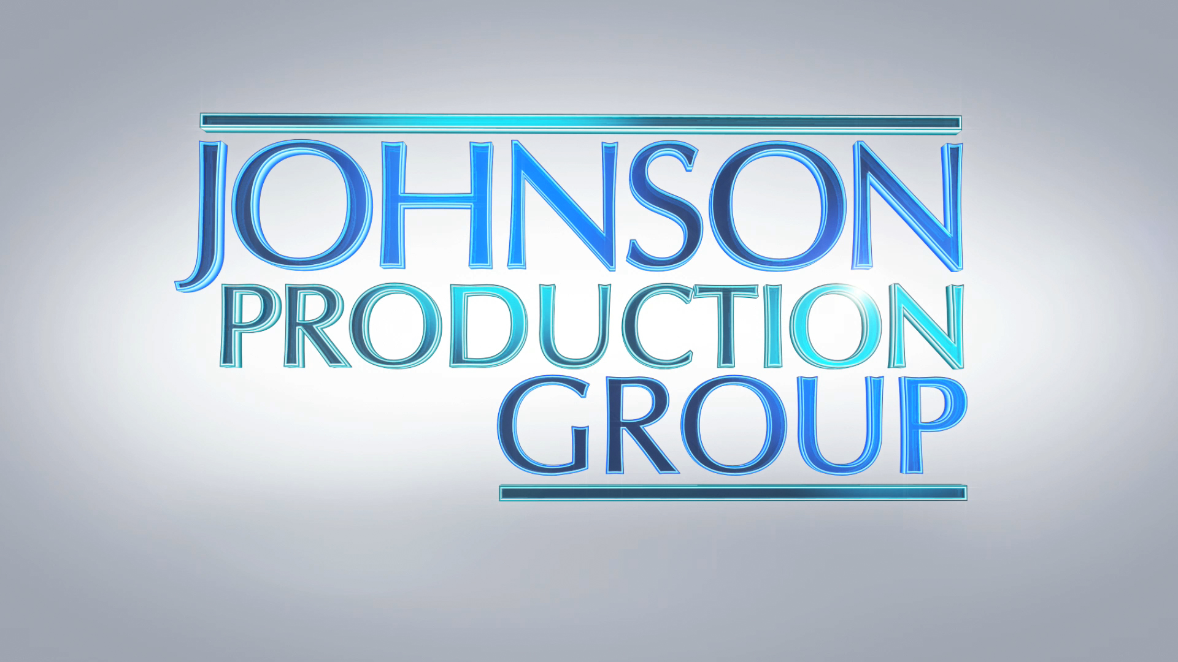

Meta Data

LONG (max 3000 characters) synopsis

Real estate broker Emma Simmons is on the rise with her career in Phoenix. She returns home to sell her family house in Cherry Creek and spend Christmas time there. Cherry Creek was always a town full of the Christmas spirit, in fact Emma’s family has lived there for generations and owns the Christmas lights factory which supplies much of that joy and wonder to surrounding towns. Over the last few years times have gotten tough with all the light competitors and Emma’s dad had to cut back at the factory. With the help of Simmons Lights engineer, Ben, Emma has a plan to light up the city once more, originally with hope of selling her house but perhaps there is more reason to stay in this small town than she thinks. (722)

MEDIUM (max 500) synopsis
When two weeks before Christmas, Emma returns to her hometown built around her family's pioneer Christmas Light factory, she finds the lights have gone dim in the once festive town prompting Emma to reconnect with her old flame as together they set their hearts and the town ablaze with light again. (299)

SHORT (max 100 characters) synopsis
Back in her once festive hometown with her old flame, Emma lights up their hearts and the town again (100)

5 KEY WORDS
Christmas, romance, hometown, friends, family

