

Johnson Production Group

Press Kit

# One-Liner

# Escaping an abusive relationship, a woman moves to a new town and opens her own restaurant but is harassed by a man whose family used to own it. When she turns the tables on him it evolves into a game of cat and mouse that has deadly consequences.

# Synopsis

# Lucy has just escaped an abusive relationship and moved to a new town where she's finally fulfilled her lifelong dream: opening her own gourmet restaurant where she's the head chef. When she encounters the jealous Frank, whose family used to own the restaurant that was in her new space, she becomes the target of constant harassment. Lucy, having had enough of abusive men in her life, turns the tables on Frank and inserts herself into his life. Now Lucy and Frank are engaged in a high stakes game of cat and mouse that has deadly consequences.

# Producers

Executive Producers

TIMOTHY O. JOHNSON

ANDREW C. ERIN

OLIVER DE CAIGNY

Co-Executive Producers

JOSEPH WILKA

LISA ALFORD

Producer

TARALEE GERHARD

# Key Cast

|  |  |  |
| --- | --- | --- |
| CHARACTER  Lucy Gerhard  Frank Clyborne  Megan  Emily Clyborne |  | ACTOR  KATHRYN KOHUT  TOMAS CHOVANEC  CHELSEA MUIRHEAD  BRIDGET WAREHAM |

# Key Cast Biographies

## KATHRYN KOHUT

****Kathryn Kohut is a Canadian actress, martial artist and model. She was born in Wetaskiwin, Alberta into a family of pipeline welders. Welding alongside her father in Fort McMurray, she was recruited by EllisDon and grew to have a successful career in the construction industry. Her career as an actress began only recently, as growing up she didn't have access to acting programs and didn't consider it a possibility until she decided to leave the construction industry and follow the pull she felt towards the arts.

Kohut began her training at the Lee Strasberg Theatre and Film Institute in New York, and has since continued her studies with a diverse number of teachers and coaches throughout Canada, USA and the UK. She hit the ground running, with her first role being a supporting lead in Spare Parts (RLJE Films, Amazon Prime) and has continued on an upward trajectory.

Apart from acting, Kohut is an avid horseback rider, and extreme sports enthusiast with a passion for dirt biking, wake boarding, skiing and Muay Thai. In 2014, she won Miss International Canada and placed second runner up out of 85 contestants in Bangkok, Thailand. In 2015, she won Miss International Canada and placed second runner up at Miss Universe Canada in 2017.

Kohut is passionate about supporting causes that are close to her heart which include the Malala Fund, the Canadian Centre to End Human Trafficking and Black Lives Matter. She is also an animal rights advocate and volunteered for animal shelters and organizations growing up.

## TOMAS CHOVANEC

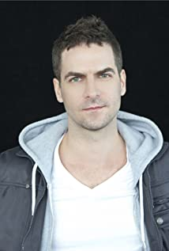Tomas Chovanec has been a professional actor for over twenty years, earning his ACTRA card while still in high school at Etobicoke School of Arts in Toronto.

“Moving to Ottawa from Toronto, I wasn’t sure what the tv/film scene was like here, but I quickly found out there’s loads of work happening here.”

Whether it’s an actor role, principal role, guest lead role, recurring role, lead role, he has the tools to be ready “on the day”.

With techniques learned from years of studying at Pro Actors Lab, Meisner technique with John Riven, audition technique with Ron Leach, voice work with Rae-Ellen Bodie, he knows how to work moment to moment.

“I’ll often be asked by curious people wanting to know what it’s like getting to pretend all the time when you’re acting, is it fun to pretend to be a cop/lawyer/doctor/criminal etc…, I will tell them my approach is more in line with; acting isn’t about pretending, it’s about revealing. Acting truthfully under imaginary circumstances. Bring your life experience, use your imagination, and learn how to make it read on camera.”

## CHELSEA MUIRHEAD

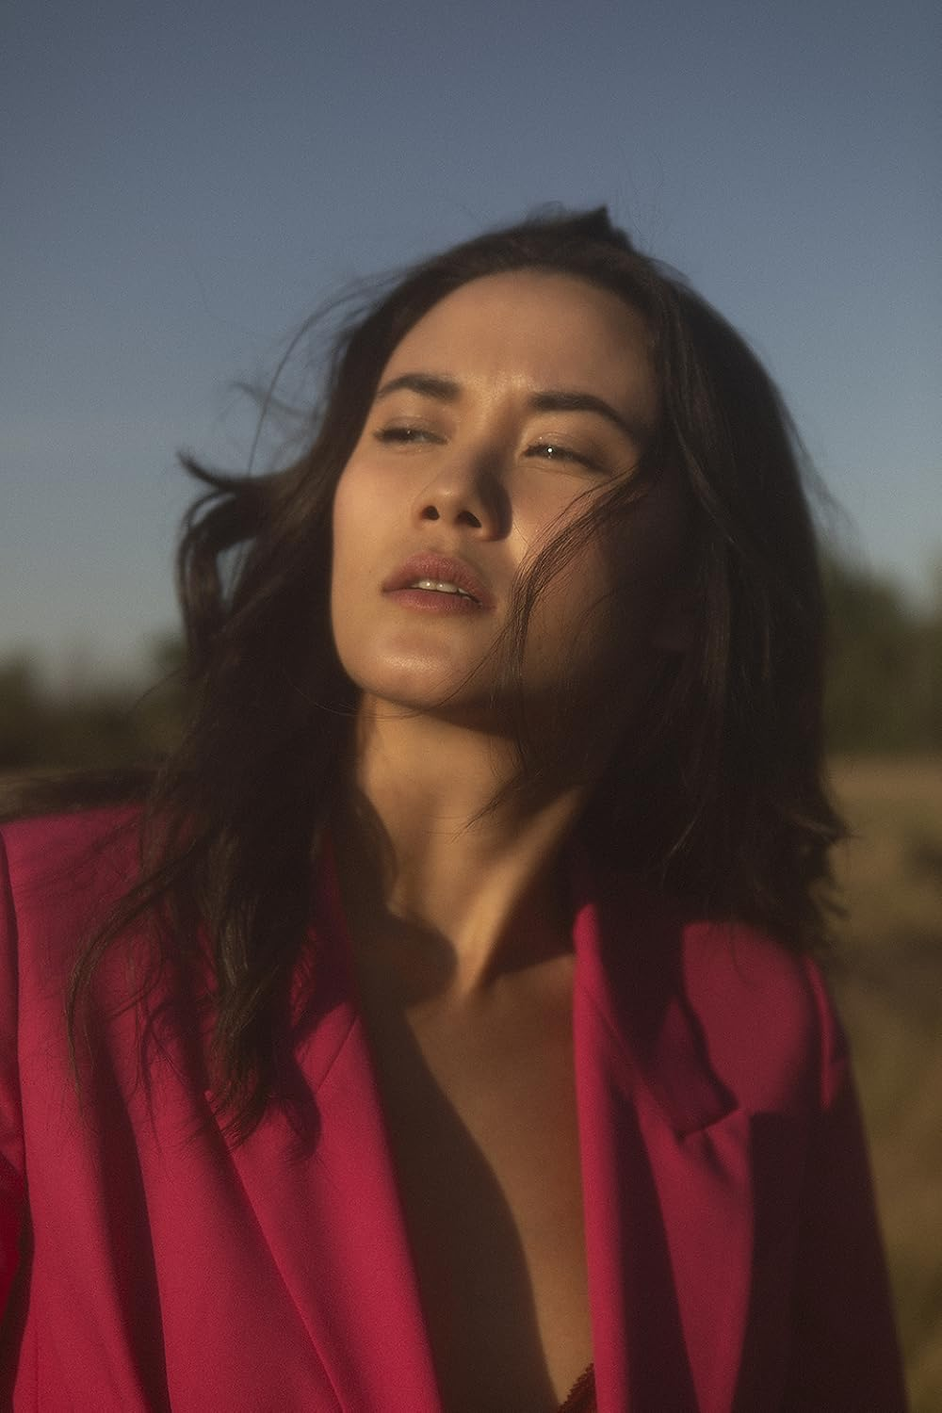Chelsea Muirhead is a Filipino-Scottish actor from Toronto. After discovering her love of acting in high school, performing as Columbia in "Rocky Horror picture show", Chelsea soon found herself diving into her passion and attending the Ryerson Theatre School (now known as the Ryerson School of Performance). It was here at Ryerson were Chelsea trained for 4 years studying acting for both film and theatre.

Whilst in her studies in theatre school Chelsea has starred in several plays such as Regan in Shakespeare's tragedy "King Lear", to more comedic contemporary rolls, such as Loretta in George F. Walker's "Featuring Loretta" to name a few. On top of being an accomplished theatre actress, Chelsea has broken into the film industry with gusto. Upon graduating the highly renowned school of performance in 2016 Chelsea has had tremendous commercial success on the circuit, including landing her first break out roll as Jill in the horror/ thriller "Spare parts" directed by Andrew Hunt.

## BRIDGET WAREHAM

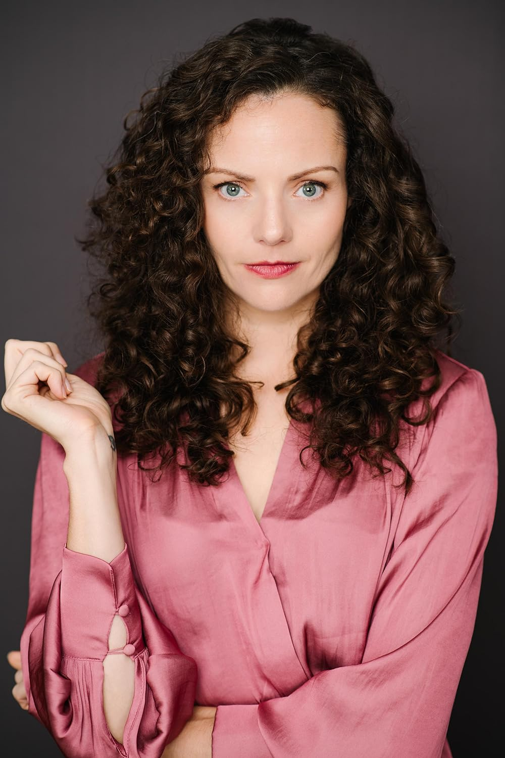After graduating from the Acting Program at the National Theatre School of Canada, Bridget Wareham has become a dedicated professional actor who takes risks and is willing to go to the deepest, darkest depths for the work. She strives to make her work truthful and compelling by allowing herself to be exposed and vulnerable on camera. She is known for her roles in My Christmas Guide, Hudson & Rex, The Uncanny Valley and George of the Jungle. Bridget received the Best Actress award at both the LA Live Film Festival and the Honor Film Festival in 2019 for her work in The Uncanny Valley.

# Production Credits

### Full Cast

|  |  |
| --- | --- |
| [Actors](http://www.imdb.com/name/nm7589451/?ref_=ttfc_fc_cl_t1)  KATHRYN KOHUT  TOMAS CHOVANEC  CHELSEA MUIRHEAD  BRIDGET WAREHAM  TIM MYLES  ANSHUMAN PANDEY  GEOFF ADAMS  JUSTIN NURSE | Role  Lucy Gerhard  Frank Clyborne  Megan  Emily Clyborne  Greg  Det. Sharma  Kevin Gerhard  Ayden Johnson |

### Casting

BRIAN LEVY, c.s.a.  
JASON STROUD, c.d.c  
MALLORY HORSMAN

### Composer

CATALIN MARIN

### Costume Designer

MORGAN LEIGH TODD

### Editor

ADAM VAN BOXMEER

### Production Designer

DEENA RIGGS

### Director of Photography

NATHAN "JONNA" BOULIANE

### Written by

ERICA LANE

### Directed by

ALEXANDRE CARRIÈRE

### Full Crew

|  |  |
| --- | --- |
| ALEXANDRA WARING | Associate Producer |
| BORYS SHAPOVALOV | First Assistant Director |
| SHARA DÉSIRÉE KING | Second Assistant Directors |
| RACHEL DEAL |  |
| DONNA CORCORAN | Third Assistant Director |
| MALLORY HORSMAN | Assistant Production Manager |
| MALLORY HORSMAN | Casting Director |
| MELANIE GIBBONS | Production Coordinator |
| LOGAN A. WAGNER | Head Production Accountant |
| LOU MARTIN | Production Accountant (NL) |
| MATTHEW CARVELL | Post Production Accountant |
| ALEXANDRA WARING | Post Production Supervisor |
| RICHARD FRAZIER | Post Production Coordinator |
| DEENA RIGGS | Production Designer |
| STEPHEN BUTLER | Set Dresser |
| KOBE DILLON | Props Master |
| MORGAN LEIGH TODD | Costume Designer |
| BAILEY REID-CULLETON | Set Costumer |
| NATHAN "JONNA" BOULIANE | Director of Photography |
| RODRIGO IÑIGUEZ BECERRIL | B Camera Operators |
| ADAM PENNEY |  |
| RILEY HARNETT | A Cam - First Assistant Camera |
| NICK JACKSON |  |
| MATTHEW FITZGERALD | A Cam - Second Assistant Camera |
| FATIMA SANTIN ZELAYA |  |
| JOSEF GERHARDS | B Cam - First Assistant Camera |
| JOSEF GERHARDS | Drone Camera Operators |
| NATHAN GATES |  |
| LIAN MORRISON | Lab Technicians |
| AARON ELLIOT |  |
| SARAH HOWSE | Stills Photographer |
| SEAN MURPHY | Gaffer |
| GRANT COURTNEY | Best Electrics |
| ROBERT ALEXANDER PIKE |  |
| ANDREW HAMMOND | Key Grip |
| JOSHUA CAINE | Best Grips |
| STEPHEN VATCHER |  |
| ORIGIN CAMERA RENTAL | EQUIPMENT |
| DIEGO MEDINA | Sound Mixer |
| ALEX TOPOLNISKI | Boom Operator |
| DAVE CONNORS | Script Supervisor |
| ALEXANDER PIERCE | Location Manager |
| CAMERON COURTNEY | Location PAs |
| MITCH "JOHNNY TRASH" HOBBS |  |
| MARK KEATS |  |
| MILES SHARP |  |
| MEGAN GREGORY | Key Hair & Makeup Artist |
| SAMANTHA KOSUB | Hair & Makeup Assistant |
| PAUL ELLIOTT | Transport Coordinator |
| JAMES WALL | Key Driver |
| ROLF MARTIN | Driver |
| JAMES MICHAEL WOOLRIDGE | Security |
| RANDY TAVERNOR | Caterer |
| THE NO CONFLICT CLEARANCE COMPANY | Script Clearance |
| HALL WEBBER LLP | Legal Services |
| DANNY WEBBER |  |
| ABOVE THE LINE MEDIA SERVICES | Business Affairs |
| BRENDAN MCNEILL |  |
| ARTHUR J. GALLAGHER CANADA LTD. | Insurance by |
| URBAN POST PRODUCTION | Post Production Services |
| JONAH GILLESPIE | Dialogue Editors |
| RODRIGO MURILLO |  |
| JONAH GILLESPIE | ADR Editor |
| EHREN PFEIFER | ADR Recordist |
| LUKA TOMA | Sound FX Editor |
| TESS MOIR | Foley Artist |
| DAVE MERCEL | Foley Recordist |
| TYLER HALL | SFX Mixer |
| EVAN GRAVES | VFX |
| WARREN CHINN | Colorist |
| KALI RAIGH | Online / Packaging Editor |
| COLIN MCLELLAN | Dialogue / Final Mix Editor |
| ASHLEY SAMPSON | Project Manager |
| BRUCE REES | Picture Operations Manager |
| ROBERTA BRATTI | V.P. of Operations |
| ARTGRID/PIOTREK_NAUMOWICZ | Stock Footage |
|  | |
| "La Luna" | |
| by Cyril Giroux, Alessandro Gambassi, Pablo Love and David Bossan | |
| courtesy of Audio Network Rights Limited | |
|  | |
| "Sing Me to Sleep" | |
| by Pete Masitti | |
| courtesy of Audio Network Rights Limited | |
|  | |
| "Too Much of a Good Thing" | |
| by Bruce Maginnis and Kate Henshaw | |
| courtesy of Audio Network Rights Limited | |
|  | |
| "Torna Il Sole" | |
| by Cyril Giroux, Alessandro Gambassi, Campbell E. Browning and David Bossan | |
| courtesy of Audio Network Rights Limited | |

# Producer Biographies

## TIMOTHY O. JOHNSON – Executive Producer

Timothy O. Johnson is among the most active and reliable producers in the business thanks to top rate productions and global distribution appeal. He is the managing partner of Johnson Production Group, a Canadian based operation that produces over 100 hours of dramatic television annually with hundreds of programs running internationally. The company is the leader supplier to Lifetime, Hallmark and other international outlets.

A graduate of the Marshall School of Business at the University of Southern California, he served as President of the USC Entertainment Management Association and a member of the Advisory Committee of the Center for Entrepreneurial Studies.

Johnson is also responsible for producing the international hit series, DR. QUINN, MEDICINE WOMAN for CBS for over 5 seasons. During his 100-episode tenure, he also developed and produced the original docu-drama COLD CASE for CBS network, which was the very first program to integrate television with the Internet.

Most recently, Johnson has produced the THE NOEL DIARY, being the #1 Film on Netflix’s Top 10 list in December of 2022. He was also at the helm of the successful GIRL IN THE SHED: THE KIDNAPPING OF ABBY HERNANDEZ, as well as the V.C. Andrews series of films, to date including TWILIGHT’S CHILD, MIDNIGHT WHISPERS, and DAWN, all produced for Lifetime..

Johnson has produced over 400 movies and 15 globally released series for every major US network - including Netflix, Lifetime, Hallmark, ABC, Disney, CBS, NBC, Netfly, FOX and Sony.

## JOHNSON PRODUCTION GROUP

The Johnson Production Group contracts globally to produce television content for international networks, studios and distributors. Based in Los Angeles and Vancouver, British Columbia, the company manages production, facilitates development and financing, procures distribution and guarantees quality and timely execution of its programs. While costs have gone up, so has the demand for quality. No longer is good enough, good enough. Johnson Production Group serves that segment when a show needs to be "A" quality, but produced efficiently enough to meet a locked budget. JPG specializes in value, protection of creative elements, and delivery of a quality finished product.

OLIVER DE CAIGNY – Executive Producer  
Oliver De Caigny is a Canadian producer originally from Belgium, his background in financing, production, and post production makes him a well-rounded producer for any type of production. His experience in financing and production agreements (film and TV series and movies-of-the week), distribution agreements (both domestic and foreign) as well as international co-productions, Canadian tax credit, Telefilm Canada and Canada Media Fund incentives provides him with a well-rounded background in development, production and distribution for motion pictures, television series and productions.

ANDREW C. ERIN – Executive Producer  
Andrew Erin is a Canadian Writer/Director making a big splash in the US, and has produced, written and directed numerous commercially successful films. His directorial debut, SAM’S LAKE, was an official selection at the Tribeca Film Festival and did an excellent theatrical run in select theaters around the country; distributed by Lionsgate Films.  Andrew also wrote the script for the film. Andrew’s directorial credits include, SIMPLE THINGS, produced for Screen Media Ventures and Universal Studios.  Besides winning The Bob Clark Award for Best Director at the California Independent Film Festival, the film was commercially received. Andrew has worked continuously as a writer/director, building a strong library of films in the Thriller/Horror genres with: Embrace of The Vampire, The Clinic, Final Sale, Confined and Toxic Skies.

## JOSEPH WILKA – Co-Executive Producer

Joseph Wilka is the Head of Production for Johnson Production Group. Los Angeles-based, Joseph had already produced and directed several feature films before serving as the senior marketing executive for Gravitas Ventures. While at Gravitas, Wilka helped pioneer new distribution models for independent films including day-and-date theatrical releases. It was also at Gravitas where Joseph first worked with Johnson Production Group to facilitate the release of their films to the worldwide Video On Demand audience. After serving as the Director of Distribution and Production for Viva Pictures, where he produced English-language versions of foreign animated titles for DirecTV, Wilka officially joined Johnson Production Group. As Head of Production, he oversees the development, production, and distribution of films from multiple production units for release on broadcast and streaming platforms.

## LISA ALFORD – Co-Executive Producer

Lisa Alford is a development executive at Johnson Production Group. A Massachusetts native, Lisa has lived and worked in Los Angeles for over a decade, always in support of excellent storytelling. Prior to joining Johnson Production Group, Lisa worked as an executive at TriStar television where she specialized in identifying IP that supported TriStar’s mission to feature diverse, authentic characters and champion underrepresented voices. Lisa came up at Sony Pictures Television where she worked as a production coordinator in the Television Movies and Miniseries department and in the writers room on the WGN hit series OUTSIDERS. In her current role, Lisa shepherds projects from the concept phase through story development, production, and post.

## TARALEE GERHARD– Producer

Taralee Gerhard committed to following her dream of making movies almost 20 years ago when the film industry was in its infancy in Ottawa. She spent several years with Fireside Pictures in Ottawa and truly cares about the family culture that Fireside has fostered amongst the crew, supporting each other's big sky dreams, making movies to be proud of. During the Covid-19 pandemic, the spirit of taking risks and following her heart lead Taralee to Newfoundland and she remains truly grateful to be able to continue working with Fireside Pictures as an in house Producer opening a new territory, expanding the Fireside Family and helping to foster the independent film industry in Newfoundland.

## Billing Block

LIFETIME Presents in association with JOHNSON PRODUCTION GROUP   
**A CHEF'S DEADLY REVENGE** starringKATHRYN KOHUT TOMAS CHOVANEC CHELSEA MUIRHEAD BRIDGET WAREHAM Casting BRIAN LEVY, c.s.a. JASON STROUD, c.d.c MALLORY HORSMAN Composer CATALIN MARIN Costume Designer MORGAN LEIGH TODD Editor ADAM VAN BOXMEER Production Designer DEENA RIGGS Director of Photography NATHAN "JONNA" BOULIANE Co-Executive Producers JOSEPH WILKA   
LISA ALFORD Executive Producers ANDREW C. ERIN OLIVER DE CAIGNY   
Executive Producer TIMOTHY O. JOHNSON Producer TARALEE GERHARD   
Written by ERICA LANE Directed by ALEXANDRE CARRIÈRE



The Canadian Film or Video Production Tax Credit  


© MMXXIV Fireside (WSW) NL Films Inc. & Fireside (WSW) ON Films Inc   
All Rights Reserved





Meta Data

LONG (max 3000 characters) synopsis

Lucy has just escaped an abusive relationship and moved to a new town where she's finally fulfilled her lifelong dream: opening her own gourmet restaurant where she's the head chef. When she encounters the jealous Frank, whose family used to own the restaurant that was in her new space, she becomes the target of constant harassment. Lucy, having had enough of abusive men in her life, turns the tables on Frank and inserts herself into his life. Now Lucy and Frank are engaged in a high stakes game of cat and mouse that has deadly consequences. (547)

MEDIUM (max 500) synopsis

Escaping an abusive relationship, Lucy moves to a new town and opens her own restaurant but is harassed by Frank, whose family used to own it. When she turns the tables on him it evolves into a game of cat and mouse that has deadly consequences. (245)

SHORT (max 100 characters) synopsis

Lucy opens her own restaurant but when she turns the tables on a harasser it has deadly consequences. (100)

5 KEY WORDS

Restaurant, abusive relationship, stalker, chef