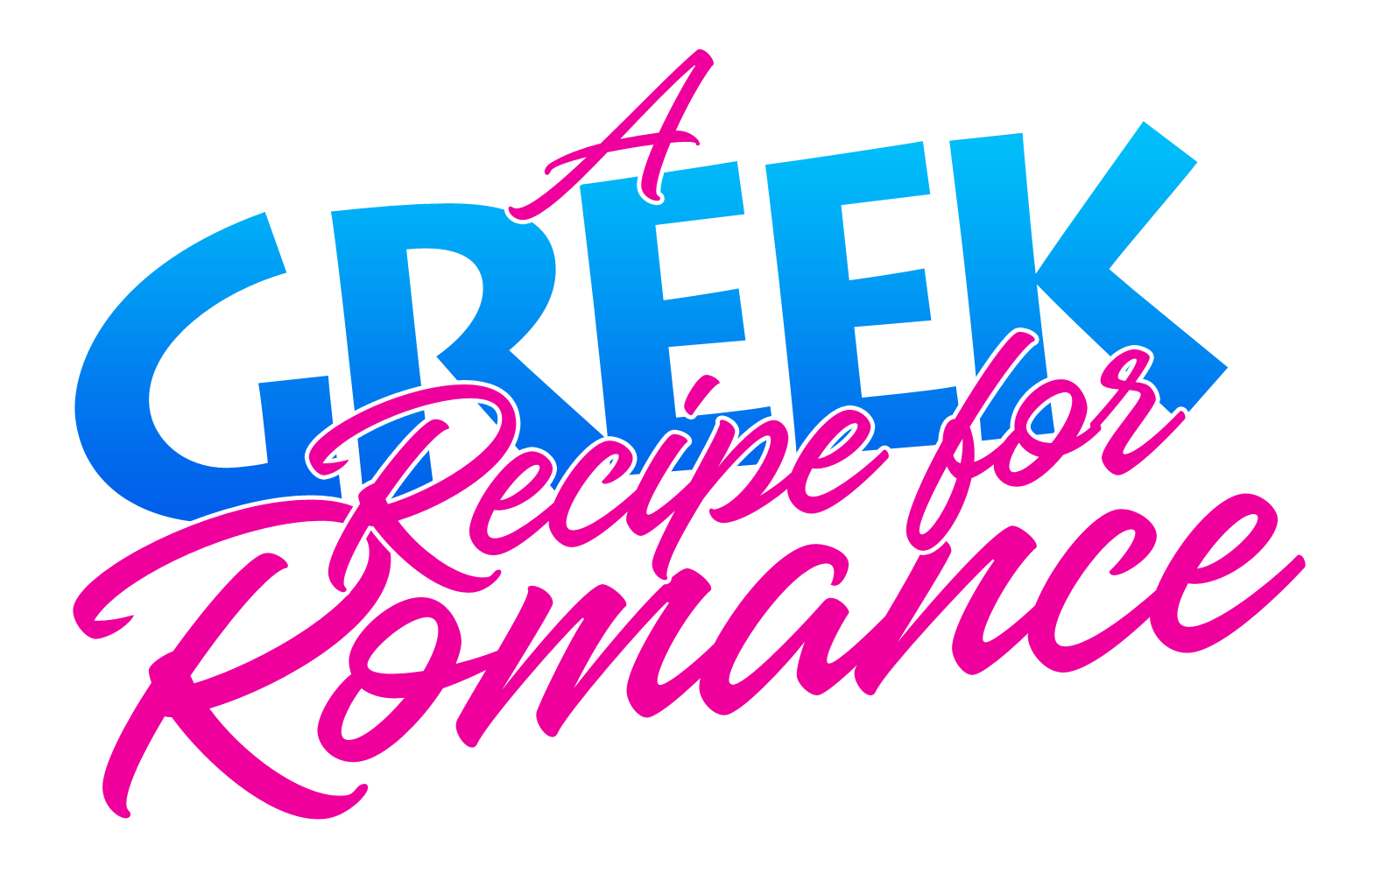

Johnson Production Group

Press Kit

# One-Liner

After losing her job, a young woman travels to Greece to lick her wounds and ends up partnering with a mysterious young chef to rebuild his mother’s old restaurant.

# Synopsis

# When Abby is unceremoniously laid off from her job running a New York City hotel, she heads to Greece where her mom recently moved to clear her head and figure out what’s next. There, she meets Theo, a mysterious young chef with an incredible passion for food. Theo is also grappling with the questions about his future. He dreams of opening his own restaurant while facing pressure from his father to give up cooking and take over the family business. In a bid to win her job back, Abby teams up with Theo to help reopen his mother’s old family restaurant. There Theo will showcase his talents and expertise in the kitchen, while Abby puts her hospitality skills to the test, putting together a charming culinary experience. Abby and Theo make an amazing team as they navigate the ups and downs of building a business, despite mounting pressure from Theo’s wealthy family to shut down and return home. Soon they realize they are falling in love. As the restaurant's grand opening approaches, they realize they’re cooking up more than just mouthwatering Greek delicacies, but also an epic romance for the ages.

# Producers

Executive Producers

TIMOTHY O. JOHNSON

JOSEPH WILKA

Co-Executive Producer

LISA ALFORD

Producer

DAVID BOYLES

# Key Cast

|  |  |  |
| --- | --- | --- |
| CHARACTER  Abby  Theo  Nikolas  Jackie  Dimitris |  | ACTOR  DANIELLE C. RYAN  RAFAEL KARIOTAKIS  ARGIRIS GKAGKANIS  PERU KAVALIERI  NIKOLAS MAKRIS |

# Key Cast Biographies

# Danielle C. Ryan - IMDbDANIELLE C. RYAN

Danielle Ryan Chuchran was born in Upland, California but moved to Utah shortly after. She started her career with some ads, before she had her first role at the age of seven in "Little Secrets." With her part as Thing One in "The Cat in the hat" she consolidated her position as child-actress and did several films and series afterwards. Since "Minor Details" she has frequently working with John Lyde and Mainstay Productions and appeared in most of their projects. Danielle is quite sporty. She is an accomplished rider, and besides several other hobbies she loves to go shooting, both guns and archery. She likes to perform stunts and fighting scenes for her roles on her own. That passion started already with her role as Thing One and includes today also some serious rock climbing in her newer movie Survivor. She also loves animals and especially likes spending time with her horses and her dog.

# RAFAEL KARIOTAKIS

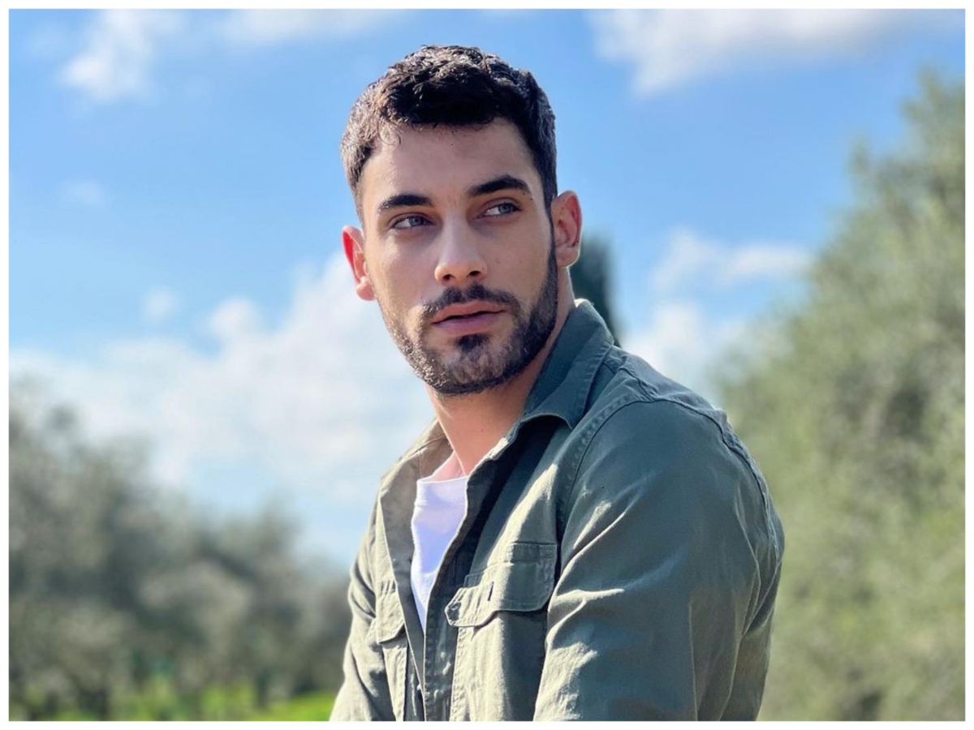Rafael was born in Athens, Greece. He rose to fame as a Lip sync performer and model on TikTok who is widely recognized for his self titled account. His performances have received more than 21 million likes on the platform. He is also an actor and has appeared in 238 episodes of the Greek TV series I gi tis elias.

# ARGIRIS GKAGKANIS

# Συνέντευξη του Αργύρη Γκαγκάνη στη Σοφία Τσέπα | Λόγια ΣταράταArgiris was born in Hannover in Germany,grew up in Thessaloniki in Greece and studied drama in London.

He is a stage and screen actor and a voice over artist. He has most recently appearing in several films including Saison Morte, The Meaning of August, and Rise. He has had roles in several TV series including IQ 160, Zoi, Save Me, O ordos, Agapi paranomi, as well as recurring roles in Ilios and Aggeliki.

# PERU KAVALIERI

Peru Kavalieri is a successful American actress who studied acting in Stella Adler in New York. She played in NBC series "Days of Our Lives'', in the film "American connection" next to Faye Dunaway, Daryl Hannah, Michael Madsen, in "God love's caviar" next to Catherine Deneuve & John Cleese ( Monty Python's ), in the Romanian film "Lubire Elena" with the great actress Maia Morgenstern. She had an establish career in USA and Greek tv and films , because she played in many famous tv series and films. Peru heritage is Greek, so she speaks fluent American and Greek language { without accent} ,and some Italian. She is a SAG member. Peru had already 12 Movies and 7 tv Series, both American and Greek. Her abilities in drama and comedy are incredible! The last years she works a lot in USA, and she appearance in many Film Festivals, like Cannes, Venice, Toronto, Berlin, Sundance etc.

**NIKOLAS MAKRIS**

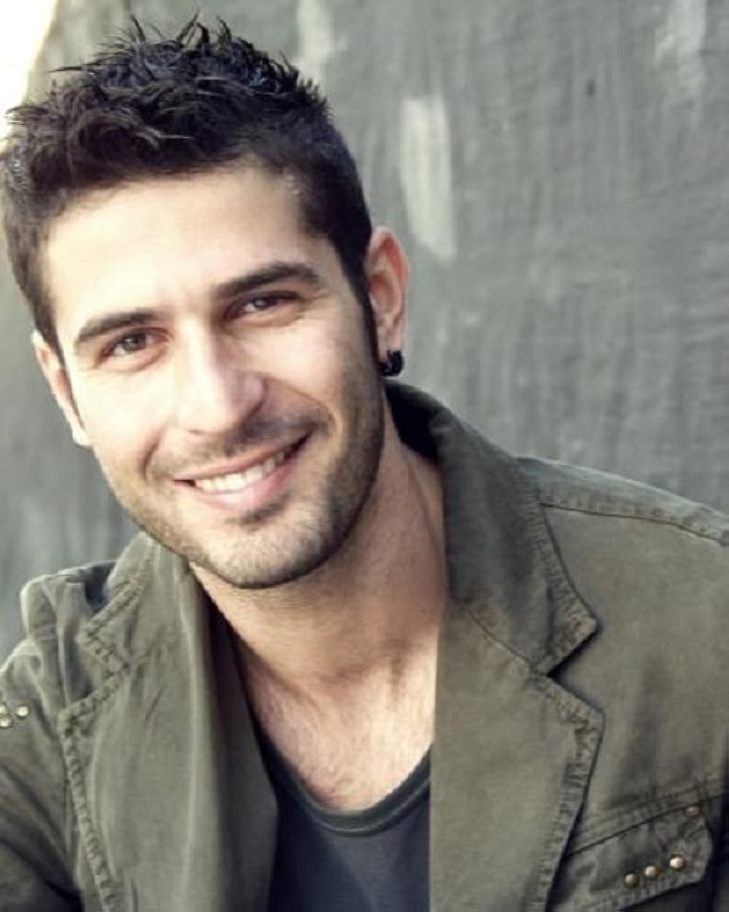Nikolas Makris is a greek actor and director, born in Athens. He studied Finance and Banking at the University of Piraeus. Graduated from the “Archi – Nelly Kara” drama school. While living in Los Angeles he studied acting at the “Beverly Hills Playhouse” and “New Collective LA” and took courses in Filmmaking at the “New York Film Academy LA”. He got his bachelor with distinction in Filmmaking from “Queen Margaret University” of Edinburgh. He has been working as an actor since 2006 in many theaters, including the National Theater of Greece and major tv shows. He is known for his roles in Alithini Erotes (as Antonis), Hara Agnoeitai (as Nikolas), Zoi Mou (as Kostas), I Tourta Tis Mamas (as Chester), Tria Milia (as Mihalis).

He has also written and directed theatrical plays and short films.

# Production Credits

### Full Cast

|  |  |
| --- | --- |
| [Actors](http://www.imdb.com/name/nm7589451/?ref_=ttfc_fc_cl_t1)  DANIELLE C. RYAN  RAFAEL KARIOTAKIS  ARGIRIS GKAGKANIS  PERU KAVALIERI  NIKOLAS MAKRIS  VANGELIS PAPADAKIS  CHRISTINA BARLOGIANNI | Role  Abby  Theo  Nikolas  Jackie  Dimitris  Yannis  Cassia |

### Casting

JEFF HARDWICK CASTING

### Composer

RUSS HOWARD III

### Costume Designer

PEGGY CHAIDEMENATOU

### Editor

ROB PALLATINA

### Production Designers

IOULIA KOTSIFAKI

### Co-Director of Photography

ALEXANDER YELLEN  
BRANDEN MAXHAM

### Written by

KEITH HEMSTREET  
KATIE KERR  
COLIN THEYS

### Directed by

COLIN THEYS

### Full Crew

|  |  |
| --- | --- |
| SARRI ELLI | First Assistant Director |
| CHRYSSA COSMIDOU |  |
| DOUNIAS EMMANOUIL | Greek Casting |
| DIMITRIS ZOGRAFAKIS | Producer |
| PETROS MANTOUVALOS | Line Producer |
| RITA PASCHALINOPOULOU | Production Coordinator |
| ELEFTHERIA PASXALINOPOULOU | Production Manager Assistant |
| MARIZA PSIXOGIOU | Production Manager Assistant #2 |
| ASIMINA CHAMPA | Production Accountant |
| ANNA KATI | Office PA |
| CRISTOS - SOTIRIS CHAMPAS | Key PA |
| GIANNIS MALLIS | PA |
| MARIZA PSICHOGIOU | PA |
| GEORGIOS TSIROGIANNIS | CAST PA |
| IOULIA KOTSIFAKI | Production Designer |
| MANINA TRIANTAFILOPOULOU | Set Dresser |
| MICHALIS KOTSIFAKIS | Props Master |
| MARIA-EIRINI TRIANTAFILLOPOULOU | Art Director Assist |
| MARGARITA CHALAKATEVAKI | Art Director Assist |
| PEGGY CHAIDEMENATOU | Costume Designer |
| RENA EPISKOPOY | Wardrobe Assistant |
| SAPFO VARIA | Wardrobe Assistant |
| ALEXANDER YELLEN | Director of Photography |
| BRANDEN MAXHAM |  |
| ALEXANDER YELLEN | A Camera Operator |
| BRANDEN MAXHAM |  |
| SOFIA GIVISI | Focus Puller |
| NIKOLAS NIKOLAIDIS | Camera OP |
| APOSTOLOS NALMPATIS | Camera OP |
| ELVIA MEGA | DIT and DAILY |
| ELVIA MEGA | Stills Photographer |
| IOANNIS KARAMITROS | Gaffer |
| NIKOS BOURBOS | Best Electric |
| NIKOLAS MOUSAFIRAKIS | Electrican |
| NIKOLAOS MPOURMPOS | Electrican |
| STELIOS PANAGIOTAKIS | Key Grip |
| DIMITRIOS KALOMOIRIS | Sound Engineer |
| MANOLIS MAKRIDAKIS | Sound Engineer |
| RAFAEL DARIO LE BARS | Boom Operator |
| PETROS THANOU | Boom Operator |
| TOMMY SKLAVOS | Location Manager |
| SPYROS DRAKOPOULOS | Location Manager |
| VICTORIA CHALIOTOU | Makeup-Special Effect |
| KONSTANTINA GALANOPOULOU | Key Hair Stylist |
| KONTINOS PANAGIOTIS | Drivers |
| GIANNIS TZITZIRAS | Drivers |
| VASSILIS NIKAS | Caterers |
| HOLLYWOOD SCRIPT RESEARCH | Script Clearances by |
| GREGORY K. BOONE | Legal Services |
| HOLLYWARE LLC | Business Affairs |
| MOMENTOUS INSURANCE BROKERAGE | Insurance |
| BRITTANY RUSSELL | Post Production Supervisor |
| BLUELINE FINISHING | Post Production Services |
| ANDRES BOULTON | Sound FX Editors |
| ANDRES BOULTON | Re-Recording Mixer |
| LUIS MIGUEL HENAO | VFX Artist |
| BRITTANY RUSSELL | Colorist |
| BRITTANY RUSSELL | Project Manager |
| PONDS5 | Stock Footage |

# Producer Biographies

## TIMOTHY O. JOHNSON – Executive Producer

Timothy O. Johnson is among the most active and reliable producers in the business thanks to top rate productions and global distribution appeal. He is the managing partner of Johnson Production Group, a Canadian based operation that produces over 100 hours of dramatic television annually with hundreds of programs running internationally. The company is the leader supplier to Lifetime, Hallmark and other international outlets.

A graduate of the Marshall School of Business at the University of Southern California, he served as President of the USC Entertainment Management Association and a member of the Advisory Committee of the Center for Entrepreneurial Studies.

Johnson is also responsible for producing the international hit series, DR. QUINN, MEDICINE WOMAN for CBS for over 5 seasons. During his 100-episode tenure, he also developed and produced the original docu-drama COLD CASE for CBS network, which was the very first program to integrate television with the Internet.

Most recently, Johnson has produced the THE NOEL DIARY, being the #1 Film on Netflix’s Top 10 list in December of 2022. He was also at the helm of the successful GIRL IN THE SHED: THE KIDNAPPING OF ABBY HERNANDEZ, as well as the V.C. Andrews series of films, to date including TWILIGHT’S CHILD, MIDNIGHT WHISPERS, and DAWN, all produced for Lifetime..

Johnson has produced over 400 movies and 15 globally released series for every major US network - including Netflix, Lifetime, Hallmark, ABC, Disney, CBS, NBC, Netfly, FOX and Sony.

## JOHNSON PRODUCTION GROUP

The Johnson Production Group contracts globally to produce television content for international networks, studios and distributors. Based in Los Angeles and Vancouver, British Columbia, the company manages production, facilitates development and financing, procures distribution and guarantees quality and timely execution of its programs. While costs have gone up, so has the demand for quality. No longer is good enough, good enough. Johnson Production Group serves that segment when a show needs to be "A" quality, but produced efficiently enough to meet a locked budget. JPG specializes in value, protection of creative elements, and delivery of a quality finished product.

## JOSEPH WILKA – Executive Producer

Joseph Wilka is the Head of Production for Johnson Production Group. Los Angeles-based, Joseph had already produced and directed several feature films before serving as the senior marketing executive for Gravitas Ventures. While at Gravitas, Wilka helped pioneer new distribution models for independent films including day-and-date theatrical releases. It was also at Gravitas where Joseph first worked with Johnson Production Group to facilitate the release of their films to the worldwide Video On Demand audience. After serving as the Director of Distribution and Production for Viva Pictures, where he produced English-language versions of foreign animated titles for DirecTV, Wilka officially joined Johnson Production Group. As Head of Production, he oversees the development, production, and distribution of films from multiple production units for release on broadcast and streaming platforms.

## LISA ALFORD – Co-Executive Producer

Lisa Alford is a development executive at Johnson Production Group. A Massachusetts native, Lisa has lived and worked in Los Angeles for over a decade, always in support of excellent storytelling. Prior to joining Johnson Production Group, Lisa worked as an executive at TriStar television where she specialized in identifying IP that supported TriStar’s mission to feature diverse, authentic characters and champion underrepresented voices. Lisa came up at Sony Pictures Television where she worked as a production coordinator in the Television Movies and Miniseries department and in the writers room on the WGN hit series OUTSIDERS. In her current role, Lisa shepherds projects from the concept phase through story development, production, and post.

## DAVID BOYLES – Producer

David is the primary producer for Hollyware LLC. He has over two decades of experience in developing, implementing and producing award winning projects in the entertainment industry. (Concept through Distribution) His extensive experience in international production of Film, Television, Commercials, Games, and mixed media enables him to deliver timely, on budget, and magical visuals mixed with compelling content.

## Billing Block

Hallmark Channel Presents in association with Johnson Production Group   
 “A GREEK RECIPE FOR ROMANCE”  
starring DANIELLE C. RYAN RAFAEL KARIOTAKIS ARGIRIS GKAGKANIS PERU KAVALIERI NIKOLAS MAKRIS Casting JEFF HARDWICK CASTING CSA Composer RUSS HOWARD III Costume Designer PEGGY CHAIDEMENATOU Editor ROB PALLATINA Production Designer IOULIA KOTSIFAKI Co-Directors of Photography ALEXANDER YELLEN BRANDEN MAXHAM Co-Executive Producer LISA ALFORD Executive Producers TIMOTHY O. JOHNSON JOSEPH WILKA Producer DAVID BOYLES Written by KEITH HEMSTREET KATIE KERR COLIN THEYS Directed by COLIN THEYS

© MMXXIII Johnson Production Group Inc. All Rights Reserved







Meta Data

LONG (max 3000 characters) synopsis

When Abby is unceremoniously laid off from her job running a New York City hotel, she heads to Greece where her mom recently moved to clear her head and figure out what’s next. There, she meets Theo, a mysterious young chef with an incredible passion for food. Theo is also grappling with the questions about his future. He dreams of opening his own restaurant while facing pressure from his father to give up cooking and take over the family business. In a bid to win her job back, Abby teams up with Theo to help reopen his mother’s old family restaurant. There Theo will showcase his talents and expertise in the kitchen, while Abby puts her hospitality skills to the test, putting together a charming culinary experience. Abby and Theo make an amazing team as they navigate the ups and downs of building a business, despite mounting pressure from Theo’s wealthy family to shut down and return home. Soon they realize they are falling in love. As the restaurant's grand opening approaches, they realize they’re cooking up more than just mouthwatering Greek delicacies, but also an epic romance for the ages. (1111)

MEDIUM (max 500) synopsis

When Abby is laid off from running a New York City hotel, she heads to Greece where she meets Theo, a mysterious young chef with an incredible passion for food. In a bid to win her job back, Abby teams up with Theo to help reopen his mother’s old restaurant. They make an amazing team, despite mounting pressure from Theo’s wealthy family to give it up. As their grand opening approaches, they realize they’re cooking up more than just mouthwatering Greek delicacies, but also an epic romance. (494)

SHORT (max 100 characters) synopsis

Abby travels to Greece and partners with a talented chef to rebuild his mother’s old restaurant.

(96)

5 KEY WORDS

Culinary experience, family restaurant, foodies