

Johnson Production Group

Press Kit

One-Liner

A klutzy Maid of Honor gets help from her handsome nemesis when things go awry at her best friend’s Costa Rican wedding.

Synopsis
Costa Rican surf swells and warm sand are just the distraction Emily needs from her ex boyfriend and his new, online relationship. Standing beside her best friend Phoebe as Maid of Honor is a dream come true, but it quickly turns into a nightmare when a group of rascally monkeys steal Emily’s bag— and the priceless, heirloom wedding rings she was holding onto! Desperate to forgo her klutzy reputation and not be responsible for ruining the wedding, Emily teams up with an unlikely aid; Ryan, the best man and her longtime rival. As a local tour guide, Ryan knows the incredible land of the tropical country; just not as well as he thought. Their hilarious misadventure takes them from stunning jungle volcanoes to surreal ancient archaeological sites and leads them somewhere neither of them saw coming; love. By helping each other, Emily and Ryan find a way to get past their old hangups and look forward to a future together— all the while saving the day, and the wedding.

Producers
Executive Producers
TIMOTHY O. JOHNSON
JOSEPH WILKA
Co-Executive Producers
LISA ALFORD
Producer
DAVID BOYLES

Key Cast
CHARACTER  Emily  Ryan  Phoebe  Jamal  Tyesha  Sue  Harold  Bruce |  | ACTOR  RHIANNON FISH  CHRISTOPHER RUSSELL  BRITTANY CAREL  CJ HAMMOND  KOURTNEY GEORGE  MAUREEN KEDES  GREGORY M. MITCHELL  JON BRIDDELL

Key Cast Biographies

RHIANNON FISH

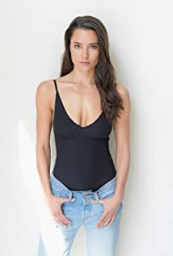
From Australian soap star to Hallmark sweetheart, Rhiannon Fish has range. Getting started on the small screen at the age of 11, the 32-year-old Canada-born Australia-raised actress made her television debut on the hit series Neighbours.

Roles that followed were in series such as As the Bell Rings and Satisfaction before her role of April Scott in Home and Away, an Australian soap opera, brought her recognition on a much greater scale from 2010 to 2013.

Later, Fish had a recurring role in the popular science-fiction series The 100 and appeared in films such as Occupation, You’re Bacon Me Crazy and A Love to Remember before making her debut on the Hallmark Channel in Aurora Teagarden Mysteries: How To Con a Con.

It wasn’t until 2021’s Journey of My Heart that she shined on the Hallmark screen as a leading lady opposite Darien Martin,, followed by A Splash of Love and then A Picture of Her.

CHRISTOPHER RUSSELL
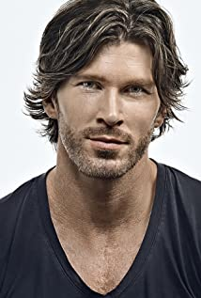
Christopher Russell is a first generation Canadian born to British parents. From a very young age, he was drawn to the arts and began performing. His first role as an actor was portraying Mary and Joseph's donkey in his pre-school production of “The Nativity Story,” for which he received rave reviews. In high school, Russell performed in many productions, most notably as Magnus Muldoon in a rendition of Tom Stoppard’s “The Real Inspector Hound,” which earned him the Sears Drama Festival Award of Excellence.
Russell recently filmed the lead role of Madison in ABC Family’s pilot “Gorgeous Morons.” His numerous television credits prior to that include guest star and recurring appearances on “Girlfriends’ Guide to Divorce,” “Men in Trees” with Anne Heche, “Flashpoint,” “The Listener,” “Murdoch Mysteries,” The CW’s “iZombie,” “Nikita,” “Supernatural” and “Beauty and the Beast,” as well as the TV movies “Love, Again,” “Midnight Masquerade,” “The Boy Next Door,” “Seduced By Lies” and “Catch A Christmas Star.”
Russell’s film credits include “Gone Tomorrow,” “Gangster Exchange,” George Romero’s “Land of the Dead,” “Center Stage: Turn It Up” and “The Right Kind Of Wrong,” which was an official selection for TIFF 2013, starring “True Blood’s” Ryan Kwanten and Catherine O'Hara.
Russell currently lives in Vancouver with his wife and his two children.

BRITTANY CAREL
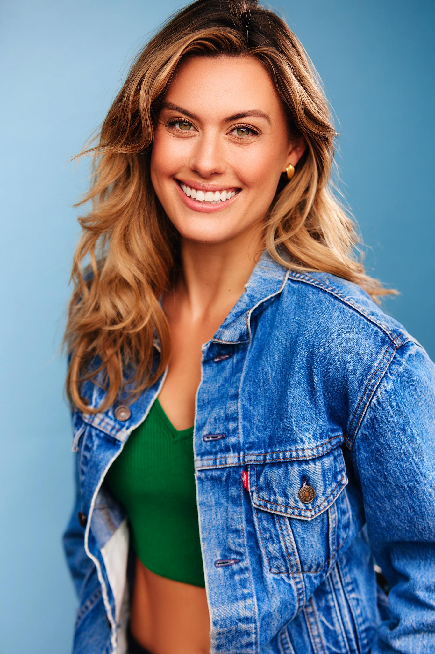
Brittany Carel-Breslauer is an accomplished American model and actress, hailing from South Florida and currently residing in Los Angeles.
With a passion for the entertainment industry from a young age, Brittany embarked on her career by appearing in commercials and print advertisements with her striking looks and natural charisma. Brittany quickly made a name for herself in the modeling world. Her unique ability to effortlessly embody different styles and capture the essence of a brand has led her to work with global brands such as Coca-Cola and Volkswagen.
Brittany expanded her horizons and ventured into acting in 2020. Her performance as "The Second" in sci-fi thriller "The Recruit" has been showcased in numerous film festivals. Her commitment to her craft is evident in her ability to bring authenticity and depth to every role she takes on.
Beyond her professional endeavors, Brittany is actively involved in philanthropic work. She has partnered with notable organizations such as the Alzheimer's Association, Autism Speaks, Alzheimer's LA, and ASPCA, demonstrating her commitment to making a positive impact in the community.
As she continues to evolve and take on new challenges, there is no doubt that Brittany's acting career will continue to flourish and leave a lasting impression on the industry.

CJ HAMMOND
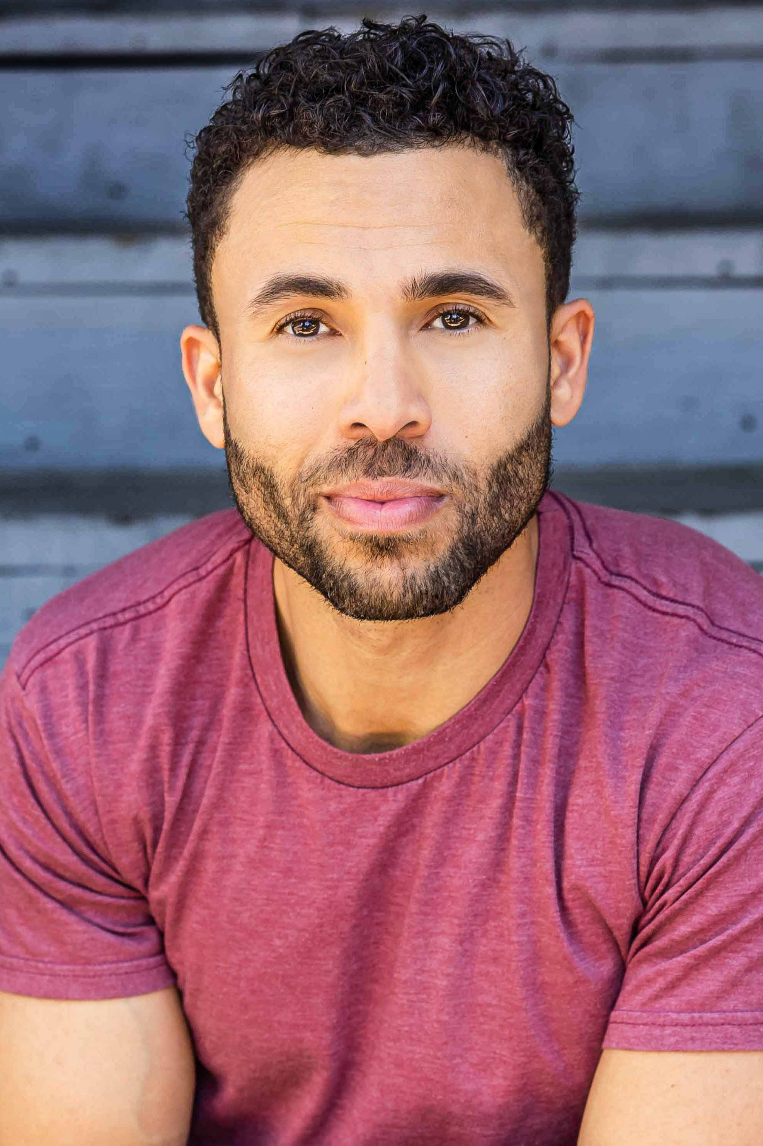
CJ Hammond is originally from Denver, CO and moved to Los Angeles to solidify his entertainment career. He began his career in modeling and has been in numerous print campaigns. Since then, CJ has expanded his talents into TV, film & music and has landed the role of Leading Man in several feature films. He has been busy as a commercial actor having appeared in multiple television commercials, including national spots for Volkswagon, IHOP and Coors Light.
As an artist, CJ's music has been mentioned in Rolling Stone.
He is passionate about community and fighting inequality. He is a board member for the South LA Cafe Foundation, which aims to break the shackles of oppression and inequality by creating, building and empowering the South Central community.

KOURTNEY GEORGE
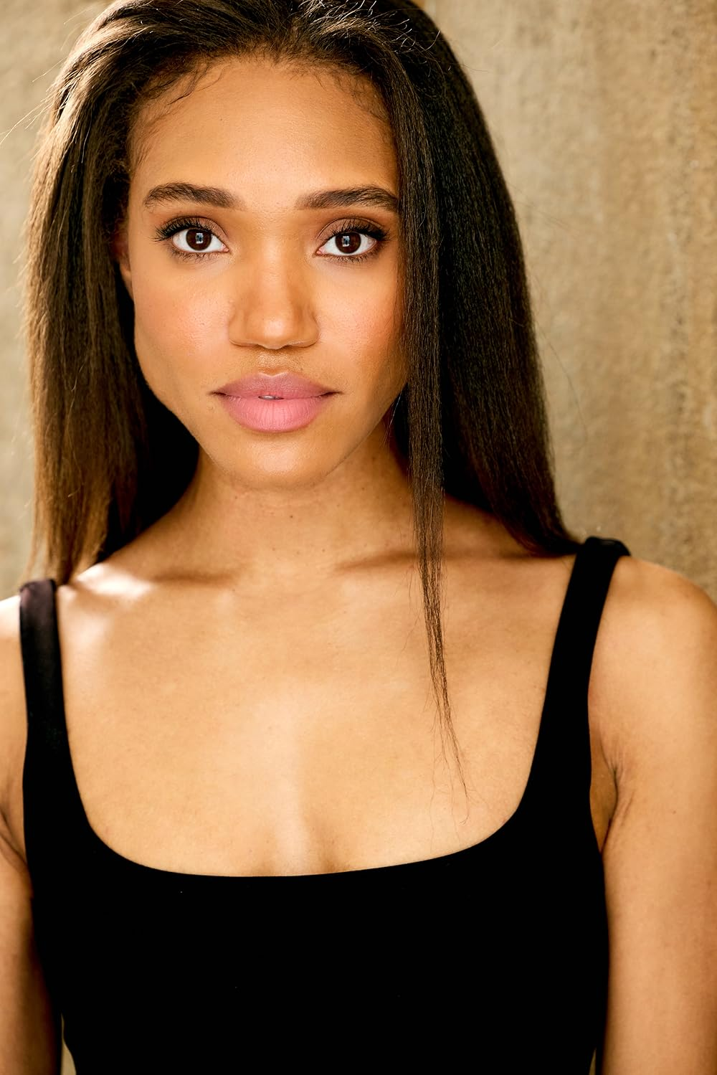
Kourtney George is an Atlanta, Ga native with roots in Louisiana. She is currently a Los Angeles based actor, and has been acting since she was 12 years old. After graduating from Spelman College with a minor in drama, she moved to New York City.
There she began making creative content and acting videos online as @CreoleKourt. After a couple years in NYC, she relocated to Los Angeles to pursue her acting career. One of her most outstanding credits is “Making Peace” - a film set in 1969. This film has been nominated for 27 film festival awards and won 21 awards. In 2021, Kourtney won “Best Lead Actress” at the Utah Film Festival, and she continues to be recognized for her work.
Kourtney has a passion for helping the less fortunate. Every year she gives back to the homeless community in Los Angeles. By preparing sandwiches and other lunch items, she contributes to the betterment of her community. “When you’re hungry you can’t make the best decisions; you’re in survival mode. No one should have to live like that” said Kourtney George.
In addition to Kourtney’s acting career, she continues her work as a digital creator partnering with global brands. Kourtney has worked with Sony Pictures, Warner Brothers, BET, Essence Magazine, FabFitFun, Mixed Chicks, Triller, and Pretty Little Thing.

MAUREEN KEDES
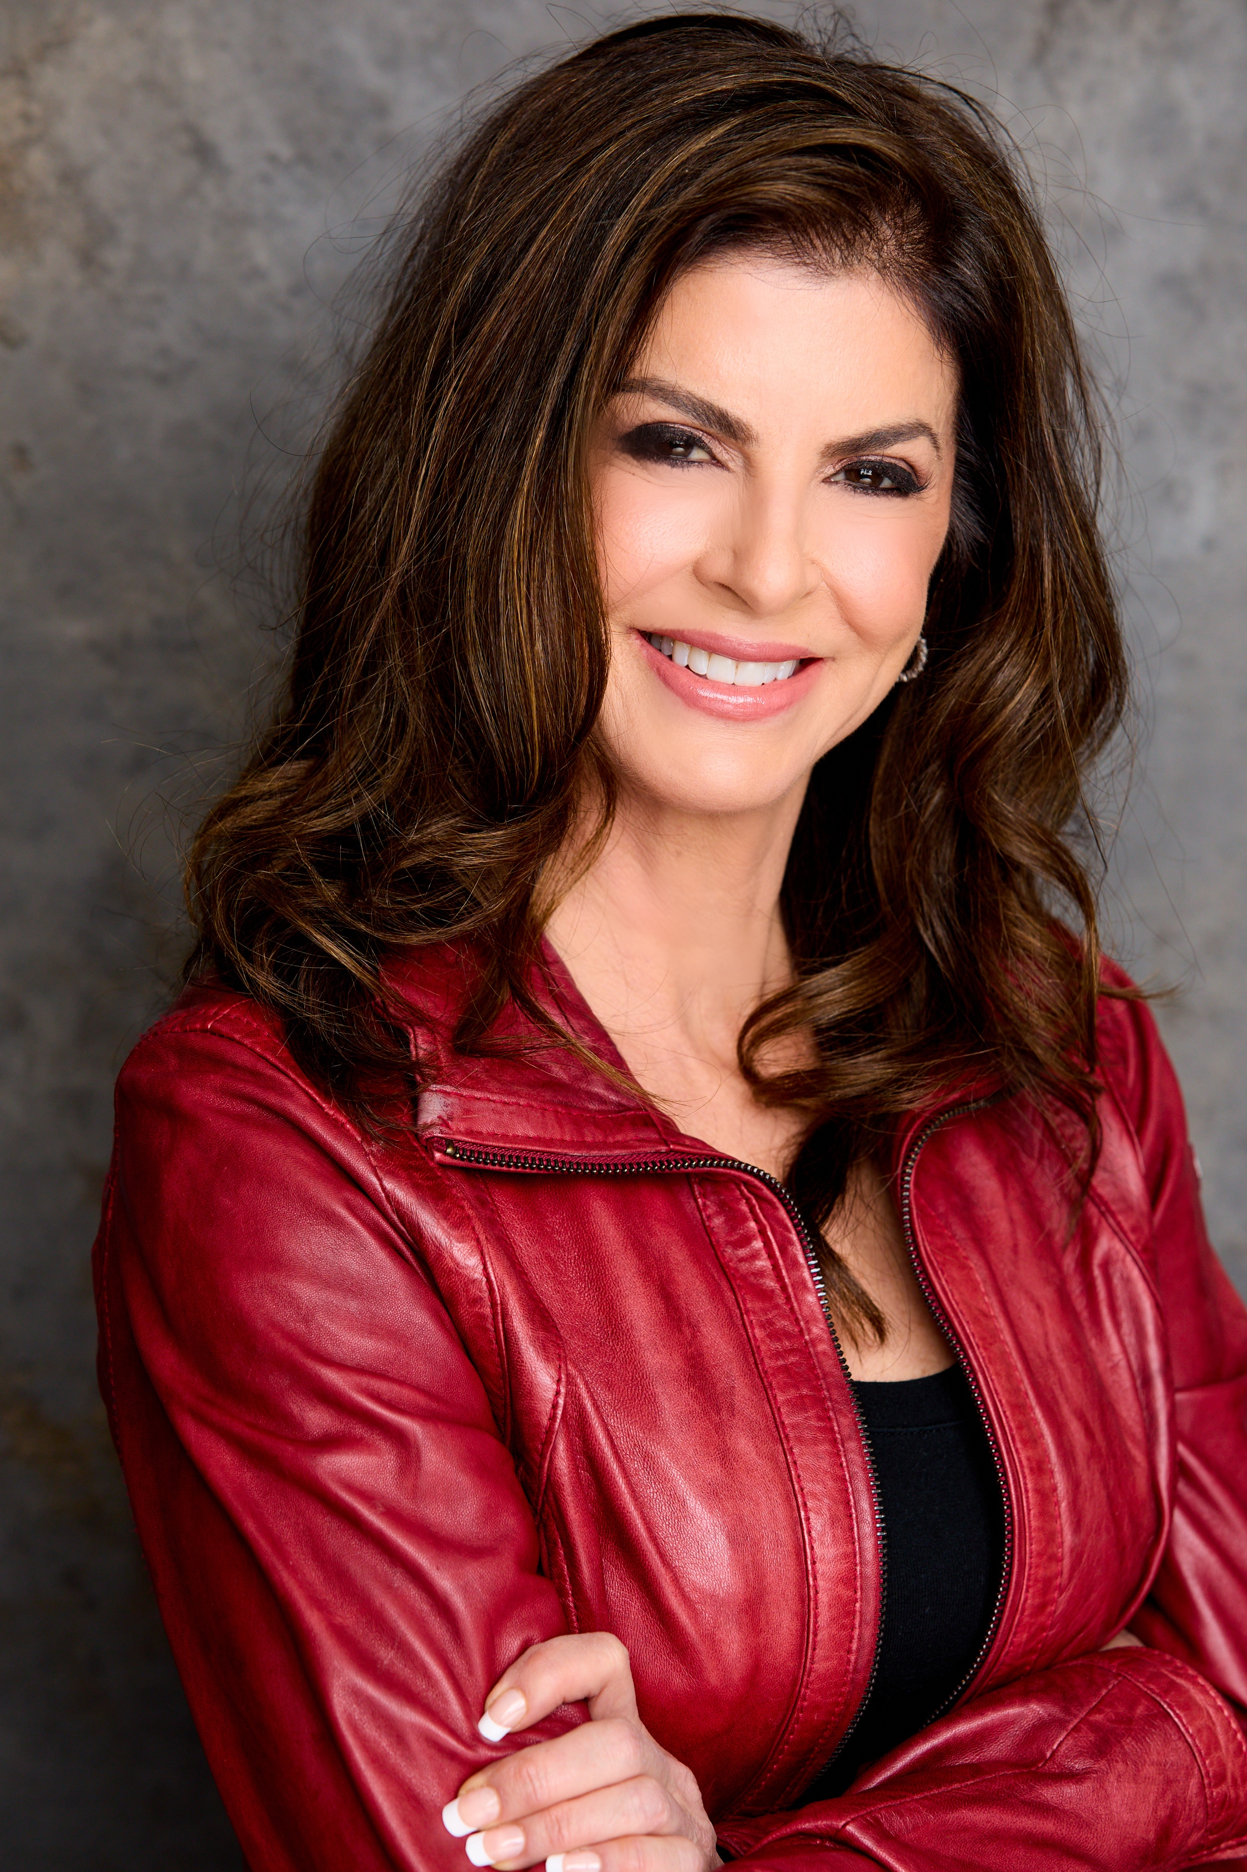
Maureen Kedes is a Los Angeles based actor and singer. Her proudest accomplishment was taking off from the entertainment business for over two decades to raise her two boys, both nationally ranked scholar-athletes at Stanford and UCLA.
Maureen Kedes relaunched her career in late 2018, and has logged more than 40 new film projects since.
She grew up internationally as the daughter of a renowned genetic scientist and a real estate investor. She got her Ivy League undergraduate degree from Barnard College of Columbia University and starred in Off-Off Broadway performances while attending University.
She studied acting at Lee Strasberg Theatre Institute in New York, the Beverly Hills Playhouse in Los Angeles and the American Conservatory Theatre in San Francisco. Currently, she is enrolled at The Actor’s Circle in Los Angeles. Ms. Kedes was also a well- known fixture in the comedy clubs with two Improv Comedy groups in the late 1990s: Instant Gratification and Uninvited Guests, appearing at the Ice House and various clubs around Los Angeles.
For voice, Maureen Kedes studied under legendary Andy Anselmo in New York at the Singer's Forum Foundation and in Los Angeles, with Steven Memel and with Elizabeth Howard at the Vocal Power Academy . With her big voice and range (mezzo-soprano to soprano) her favorite styles are: Opera, Broadway, Pop, Jazz.
She has been a freelance session singer, and toured for Yamaha Microphones. Kedes has been the lead singer and host of cabaret nights at various Los Angeles clubs.
In her time away from the entertainment business, Ms. Kedes ran a successful boutique PR firm, hosted over 200 episodes of her own business radio show on VoiceAmerica network, and made real estate investments.
Maureen Kedes is also a regular contributor to Patch.com, AOL’s micro-news source.
She speaks Italian and French well enough to handle a script and is a master at accents: French, Italian, British, Persian, Russian.
She is an advanced yoga practitioner, loves to travel, ski, cook, spend time with family, friends and her dog.

GREGORY M. MITCHELL
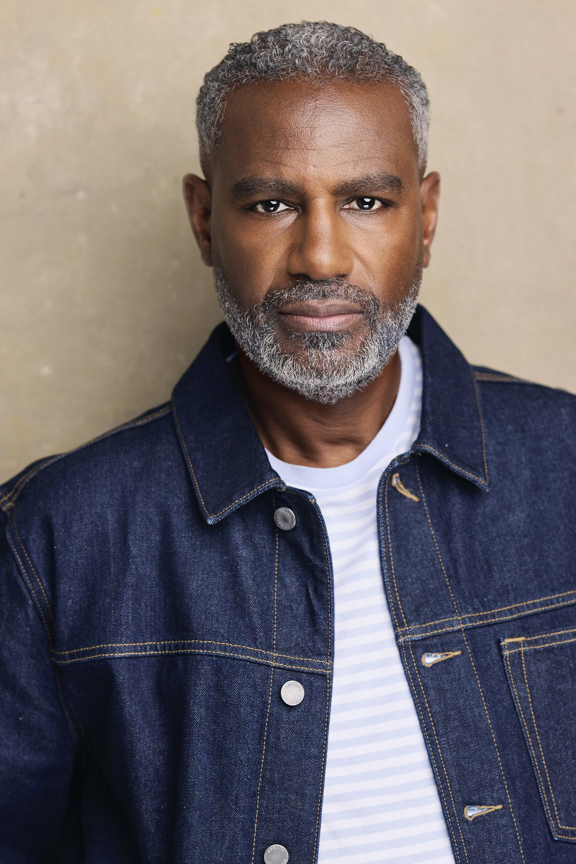
Gregory M. Mitchell, an American actor known for his roles in Greenleaf (OWN), Nightmare School Moms (LMN), The Kept Mistress Killer (Lifetime), and Bad Nanny (LMN), was born in Fort Pierce, Florida, to James and Ernestine Mitchell. Growing up in Detroit, he was exposed to violence and gang activity, but his dreams and aspirations remained strong. He credits Detroit with providing him with tough skin, fearlessness, strength, drive, and determination. After graduating high school, he moved to Atlanta to attend college and pursued entrepreneurship. He has owned and operated businesses since 2003 and sold his marketing agency in July 2016.
On November 12, 2016, he realized that his childhood dream of acting was attainable and accessible in Atlanta, the new Hollywood South. He launched a campaign to pursue his childhood dream and worked on the set of Greenleaf, a popular series on Oprah Winfrey Network (OWN). He expresses gratitude to Keith David, Lynn Whitfield, Lamman Rucker, Oprah Winfrey, Samuel L. Jackson, Clement Virgo, and other producers and directors for their guidance and support throughout his journey.

JON BRIDDELL
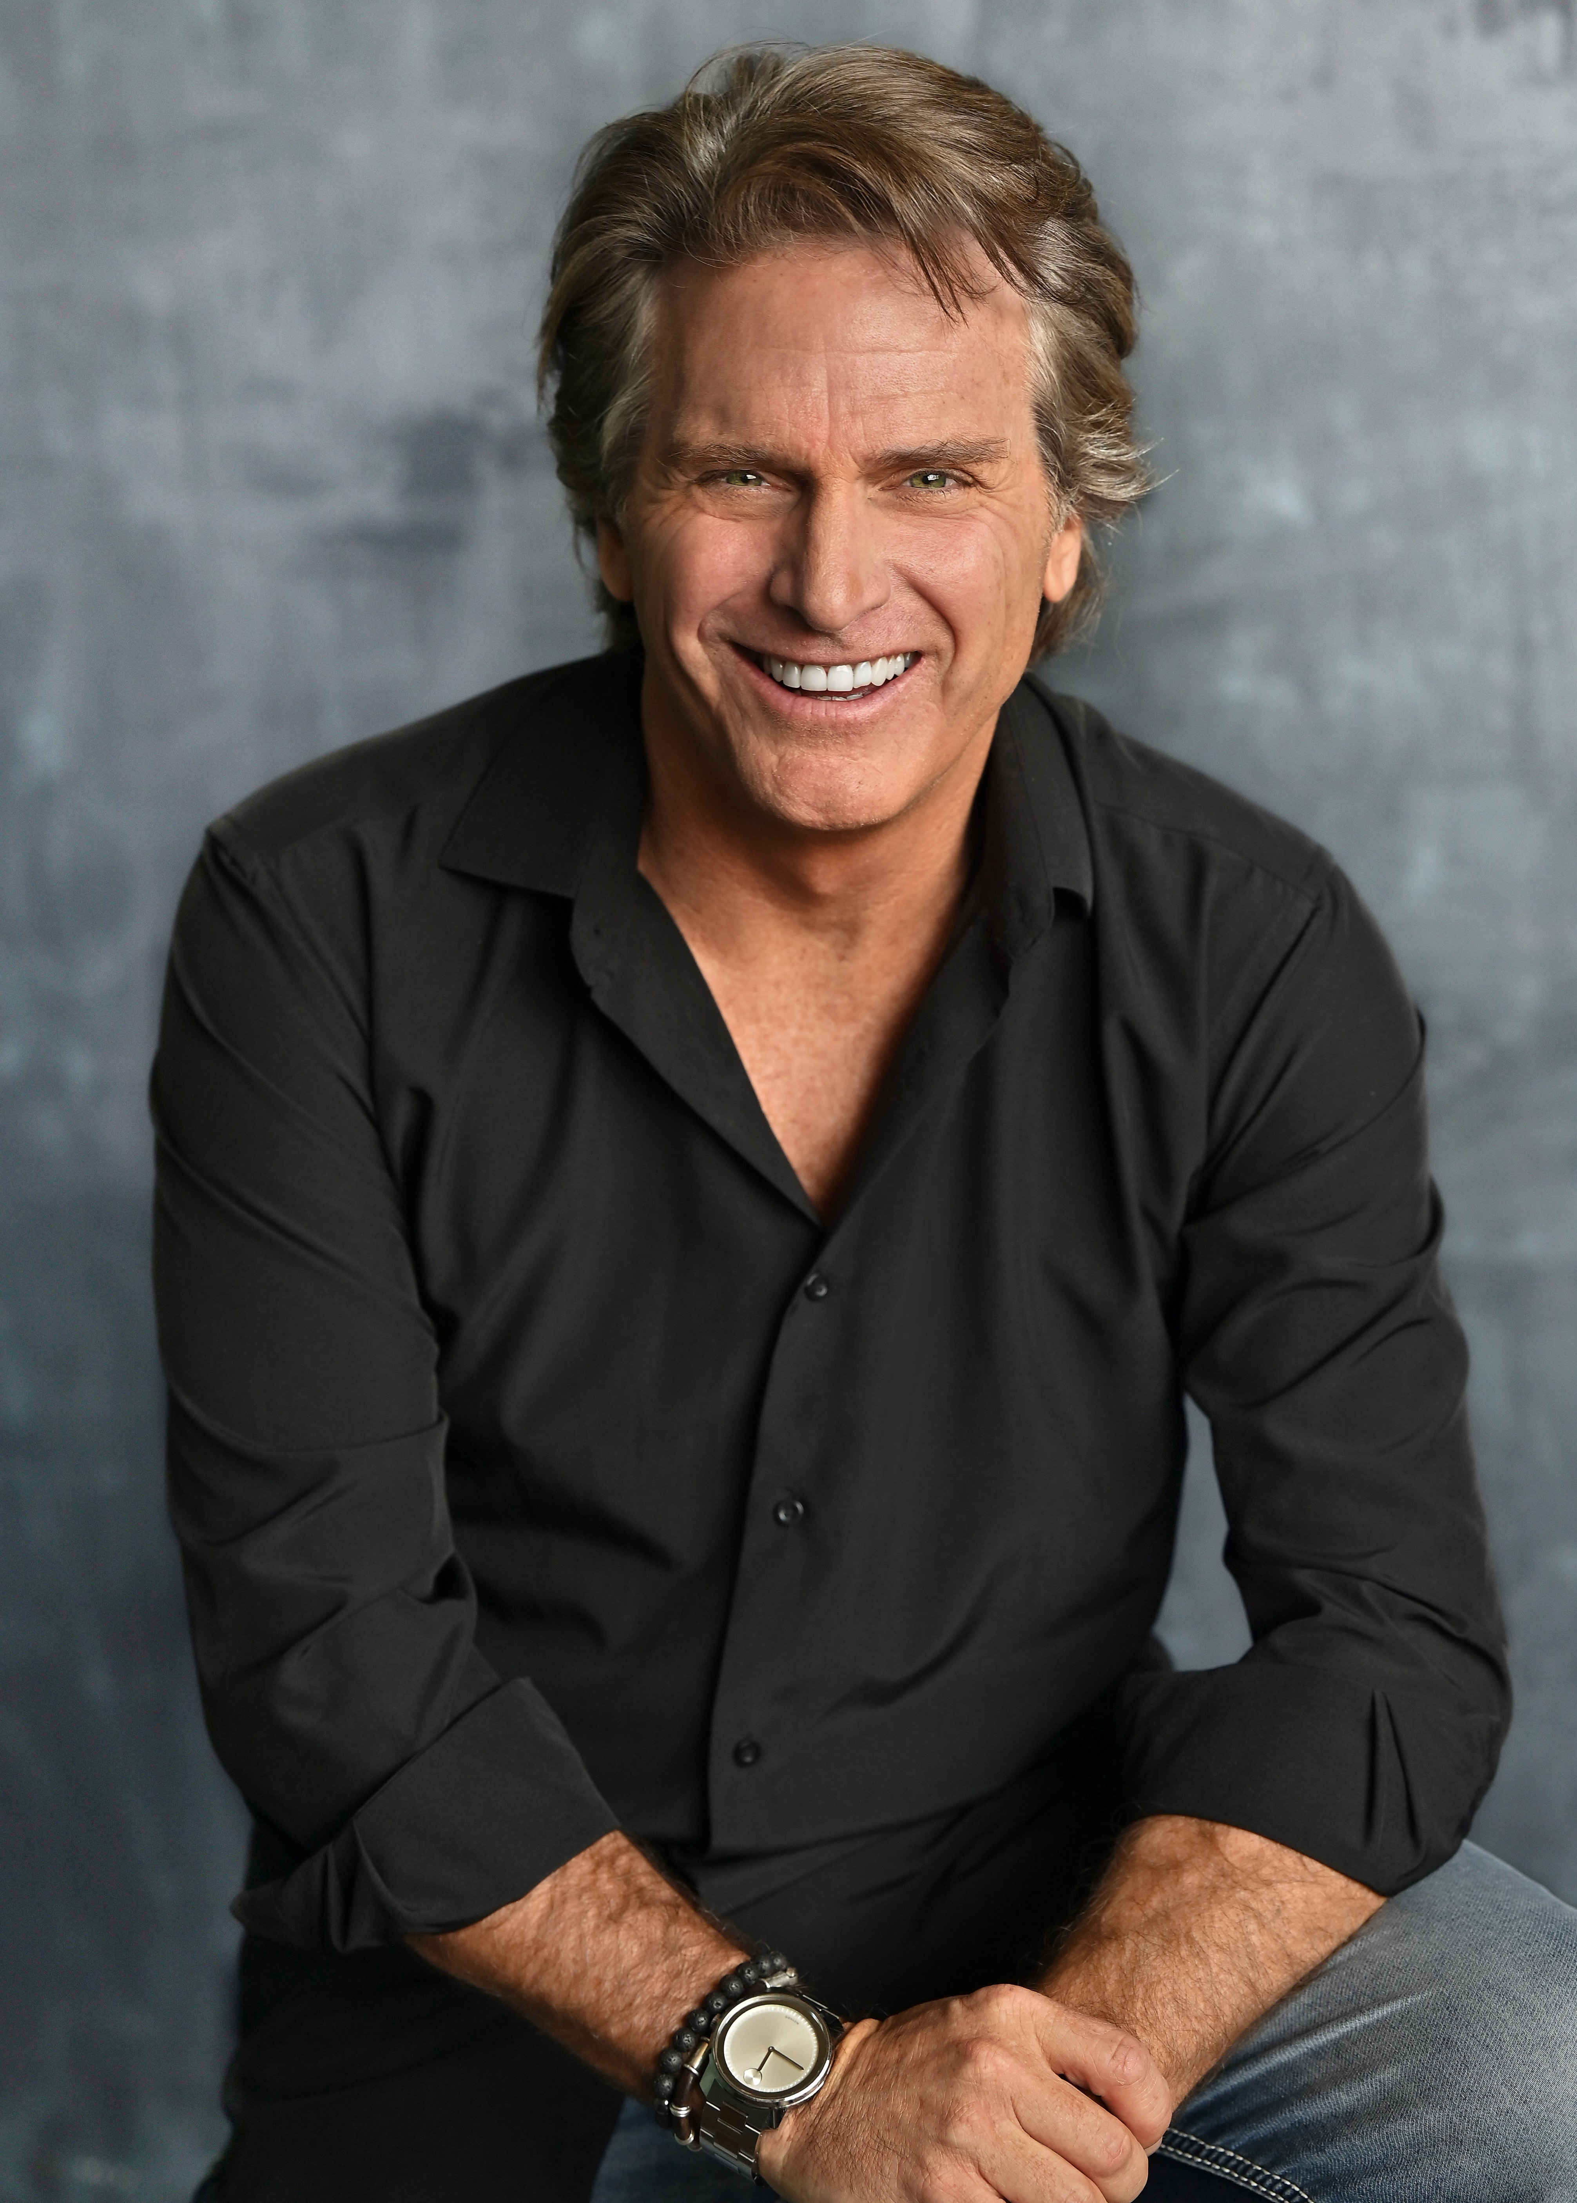
Jon began his professional acting career in 1989 performing in a Second City (Chicago) affiliated sketch comedy show. He trained in theater throughout the midwest prior to his arrival to Los Angeles in late 1994. His credits include over 40 feature films, constant television guest appearances, and numerous jobs in commercials, infomercials, and print campaigns. Jon is an avid Ohio State Football fan rarely missing a game on fall Saturdays.

Production Credits

Full Cast
Actors  RHIANNON FISH  CHRISTOPHER RUSSELL  BRITTANY CAREL  CJ HAMMOND  KOURTNEY GEORGE  MAUREEN KEDES  GREGORY M. MITCHELL  JON BRIDDELL  JODI BECK  PEDRO JOSE SANCHEZ ROVIRA  JULIANA WIMBLES  FERNANDO BOLANOS | Role  Emily  Ryan  Phoebe  Jamal  Tyesha  Sue  Harold  Bruce  Bonnie -  Esteban  Camille  Shane

Casting
JEFF HARDWICK CASTING, CSA

Composer
RUSS HOWARD III
MASSIMO SAMMI

Costume Designer
FLOR FONTELES

Editor
ROB PALLATINA

Production Designer
OLGA MADRIGAL

Director of Photography
ALEXANDER YELLEN

Written by
JULIANA WIMBLES

Directed by
COLIN THEYS

Full Crew
JEFF HARDWICK CASTING CSA | Casting
LIZ MILES | First Assistant Director
DAVID BOYLES | Producer
SERGIO MIRANDA | Line Producer
DAVID BOYLES | Line Producer
PETE HERNANDEZ | Unit Production Manager
LUKE DIEHL | Associate Producers
ELVIA MEGA
SERGIO MIRANDA JR | Production Assistants
DANIELA BOLAÑOS
KAROLINA PIEDRA
OLGA MADRIGAL | Production Designer
PAULA DEVITA | Props Master
PAULA DEVITA | Art Director Assist
FLOR FONTELES | Costume Designer
ESTEBAN MOSCOSO | Wardrobe Assistants
AGUSTIN LITTLE
JADEN DEVINE | Stylist for Rhiannon Fish
JULIA L. ROSS | Assistant Stylist for Rhiannon Fish
JADEN DEVINE | Stylist for Christopher Russell
JULIA L. ROSS | Assistant Stylist for Christopher Russell
ALEXANDER YELLEN | Director of Photography
ALEXANDER YELLEN | A Camera Operator
HANNAH SAM | 1st AC / Focus Puller
SEBASTIAN GARRO | 2nd AC / B CAMERA OPERATOR
ELVIA MEGA | DIT & Daily
ELVIA MEGA | Set Stills Photographer
EZEQUIEL BECERRA | Stills Photographer
JOSE PABLO GUEVARA | Gaffer
JUAN CARLOS VILLAREAL | Key Grip
ESTEBAN DIAZ | Swing Grip Truck Driver
AXEL MASTACHE | Sound Engineer
MAURICIO VINDAS | Boom Operator
SERGIO MIRANDA | Location Manager
JUAN GABRIEL QUESADA | On-set Medics
RICHARD VEUTHEY GARCIA
ALBERTO ALVARADO
POMPILIO CAMPOS | Snake Wrangler
PAULINE BARRY | Key Makeup
ERICA VILLANUEVA | Key Hair Stylist
MARIBEL MORALES | Hair/Makeup Assistant
JOSE PABLO ALVAREZ | Driver (Main Talent )
MILTON “MICHI” VEGA | Driver (Supporting Cast )
RICARDO CARMONA | Driver (Prod / Camera)
MANUEL | Driver
JOSE PABLO GUEVARA | Stunt Coordinator
NOAH ARCE | Stunt Double Cast #2
HOLLYWOOD SCRIPT RESEARCH | Script Clearances
GREGORY K. BOONE | Legal Services
HOLLYWARE LLC | Production Service Company
MOMENTOUS INSURANCE BROKERAGE | Insurance
BRIAN MCCAULEY | Post Production Supervisor
AARON M CHAMPION | Post Producer
RUSS HOWARD III | Music
MASSIMO SAMMI
ANDRES BOULTON | Re-Recording Mixer
ANDRES BOULTON | Supervising Sound Editor
JONATHAN MORGAN | Foley Editor
LA COLEMBA | VFX
LUIS MIGUEL HENAO | VFX Supervisor
CATALINA VIEIRA | VFX Artists
GUILLERMO RESTREPO C
EMANUEL PALACIOS
DIEGO A CAMELO P
TEFF RAMOS
KEVIN GOMEZ GONZALEZ
NATALIA LOPEZ LOPEZ
KYOTOCOLOR | Digital Intermediate Services
WENDY CELESTE | Online Editor
BRADLEY GREER | Colorist
POND5 | Stock Footage

Producer Biographies
TIMOTHY O. JOHNSON – Executive Producer
Timothy O. Johnson is among the most active and reliable producers in the business thanks to top rate productions and global distribution appeal. He is the managing partner of Johnson Production Group, a Canadian based operation that produces over 100 hours of dramatic television annually with hundreds of programs running internationally. The company is the leader supplier to Lifetime, Hallmark and other international outlets.
A graduate of the Marshall School of Business at the University of Southern California, he served as President of the USC Entertainment Management Association and a member of the Advisory Committee of the Center for Entrepreneurial Studies.
Johnson is also responsible for producing the international hit series, DR. QUINN, MEDICINE WOMAN for CBS for over 5 seasons. During his 100-episode tenure, he also developed and produced the original docu-drama COLD CASE for CBS network, which was the very first program to integrate television with the Internet.
Most recently, Johnson has produced the THE NOEL DIARY, being the #1 Film on Netflix’s Top 10 list in December of 2022. He was also at the helm of the successful GIRL IN THE SHED: THE KIDNAPPING OF ABBY HERNANDEZ, as well as the V.C. Andrews series of films, to date including TWILIGHT’S CHILD, MIDNIGHT WHISPERS, and DAWN, all produced for Lifetime..
Johnson has produced over 400 movies and 15 globally released series for every major US network - including Netflix, Lifetime, Hallmark, ABC, Disney, CBS, NBC, Netfly, FOX and Sony.
JOHNSON PRODUCTION GROUP
Johnson Production Group packages, finances, and distributes television content to networks, studios and streamers. The company specializes in various types of programming including romances, thrillers, holiday and true crime TV movies.
The company has been involved in the production of over 3000 hours of network television, with over $1 billion spent on production. JPG specializes in value, efficiency, protection of creative elements, and delivery of a quality finished product.

JOSEPH WILKA – Executive Producer
Joseph Wilka is the Head of Production for Johnson Production Group. Los Angeles-based, Joseph had already produced and directed several feature films before serving as the senior marketing executive for Gravitas Ventures. While at Gravitas, Wilka helped pioneer new distribution models for independent films including day-and-date theatrical releases. It was also at Gravitas where Joseph first worked with Johnson Production Group to facilitate the release of their films to the worldwide Video On Demand audience. After serving as the Director of Distribution and Production for Viva Pictures, where he produced English-language versions of foreign animated titles for DirecTV, Wilka officially joined Johnson Production Group. As Head of Production, he oversees the development, production, and distribution of films from multiple production units for release on broadcast and streaming platforms.

LISA ALFORD – Co-Executive Producer
Lisa Alford is a development executive at Johnson Production Group. A Massachusetts native, Lisa has lived and worked in Los Angeles for over a decade, always in support of excellent storytelling. Prior to joining Johnson Production Group, Lisa worked as an executive at TriStar television where she specialized in identifying IP that supported TriStar’s mission to feature diverse, authentic characters and champion underrepresented voices. Lisa came up at Sony Pictures Television where she worked as a production coordinator in the Television Movies and Miniseries department and in the writers room on the WGN hit series OUTSIDERS. In her current role, Lisa shepherds projects from the concept phase through story development, production, and post.

DAVID BOYLES – Producer
David is the primary producer for Hollyware LLC. He has over two decades of experience in developing, implementing and producing award winning projects in the entertainment industry. (Concept through Distribution) His extensive experience in international production of Film, Television, Commercials, Games, and mixed media enables him to deliver timely, on budget, and magical visuals mixed with compelling content.

COLIN THEYS – Director
Colin turned a love of movies, obsession with technical geekery, and acting hobby into a career making films. As a student, he made several award-winning CGI animations and VFX-driven short films. Since graduating from Wesleyan University in 2007, he has been working with Connecticut-based independent production company Synthetic Cinema International.
In 2011, Colin directed Steve Niles' Remains, the first original feature for NBCUniversal's Chiller Network. He has since directed two additional features for the network: Dead Souls and Deep in the Darkness, both based on novels by Michael Laimo. In 2014 he directed Wishin' and Hopin', a Christmas story about a 10 year old boy in 1964 based on the New York Times bestselling novel by Wally Lamb.
In addition to directing, Colin produces for SCI and also supervises post production and VFX, delivering films on time and on budget.
He believes that a good director should know what everyone on set does and how they do it, setting the tone for the cast & crew with his energy. You'll usually find Colin standing by camera, close to the performance.

Billing Block
Hallmark Media presents in association with Johnson Production Group
A COSTA RICAN WEDDING starring RHIANNON FISH CHRISTOPHER RUSSELL BRITTANY CAREL CJ HAMMOND KOURTNEY GEORGE MAUREEN KEDES GREGORY M. MITCHELL
JON BRIDDELL Casting JEFF HARDWICK CASTING csa Composer RUSS HOWARD III MASSIMO SAMMI Costume Designer FLOR FONTELES Editor ROB PALLATINA Production Designer OLGA MADRIGAL Director of Photography ALEXANDER YELLEN Co-Executive Producer LISA ALFORD Executive Producer JOSEPH WILKA Executive Producer TIMOTHY O. JOHNSON Producer DAVID BOYLES
Written by JULIANA WIMBLES Directed by COLIN THEYS
© MMXXIV Johnson Production Group Inc. All Rights Reserved


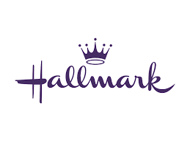

Meta Data
LONG (max 3000 characters) synopsis
Costa Rican surf swells and warm sand are just the distraction Emily needs from her ex boyfriend and his new, online relationship. Standing beside her best friend Phoebe as Maid of Honor is a dream come true, but it quickly turns into a nightmare when a group of rascally monkeys steal Emily’s bag— and the priceless, heirloom wedding rings she was holding onto! Desperate to forgo her klutzy reputation and not be responsible for ruining the wedding, Emily teams up with an unlikely aid; Ryan, the best man and her longtime rival. As a local tour guide, Ryan knows the incredible land of the tropical country; just not as well as he thought. Their hilarious misadventure takes them from stunning jungle volcanoes to surreal ancient archaeological sites and leads them somewhere neither of them saw coming; love. By helping each other, Emily and Ryan find a way to get past their old hangups and look forward to a future together— all the while saving the day, and the wedding.
(983)
MEDIUM (max 500) synopsis
As Maid of Honor, accident-prone EMILY wants to conquer her klutzy reputation and make sure everything is perfect for her best friend’s Costa Rican wedding. But when monkey’s steal her bag— and the custom wedding bands she’s been entrusted with, Emily will stop at nothing to get them back. Local tour guide and longtime foe, RYAN is the only person who can help her get the rings back and their hilarious, wondrous adventure takes them on an unexpected journey; the journey of love. (485)
SHORT (max 100 characters) synopsis
A klutzy Maid of Honor gets help from her handsome nemesis when things go awry in Costa Rica. (94)
5 KEY WORDS
Destination wedding, hilarious adventure, monkey

