Johnson Production Group

Press Kit

One-Liner
Ashley meets her seemingly perfect match while online dating, only to discover he’s a scammer after her money, escalating to a violent stalker when she attempts to bring him to justice.

Synopsis
Feeling let down by love after the ending of her marriage, Ashley decides to try online dating, meeting the mysterious Marco – a debonair businessman who seems like the perfect match – only to discover he’s a scammer after her money.
When she finds out she isn’t his only victim – that Marco’s a pro at this, his lies and false flattery breaking hundreds of hearts just like hers over the years, emptying countless bank accounts – Ashley refuses to let it stand.
Tracking Marco’s online movements, she creates a website dedicated to exposing him, informing every major dating site to be on the lookout for his many aliases, contacting Marco’s other victims to let them know they’re not alone and gather evidence, ending his reign of romantic terror.
When Marco suddenly finds all his hard work ruined, his careful lies made public, he sets out for revenge against Ashley, determined to ruin her life the way she has his – becoming her stalker, eventually progressing to kidnapper when he takes her best friend hostage in an effort to make Ashley recant her story and restore his reputation.
Only by banding together with a group of Marco’s previous victims is Ashley able to stop him – coming up with a dangerous plan to turn Marco’s lying ways against him and finally hold him to account, bringing him to justice and finding new love in the process.

Producers
Executive Producers
TIMOTHY O. JOHNSON
ANDREW C. ERIN
Co-Executive Producer
JOSEPH WILKA
Producer
TARALEE GERHARD
Supervising Producer
OLIVER DE CAIGNY

Key Cast
CHARACTER  Ashley Morrison  Marco  Grant Drysdale  Tess Parks  Roger Brampton  Jacqueline James |  | ACTOR  SHIVA NEGAR  DILLON CASEY  DREW NELSON  MIKAELA DYKE  DANNY MCLEOD  ALEXIS KOETTING

Key Cast Biographies

SHIVA NEGAR
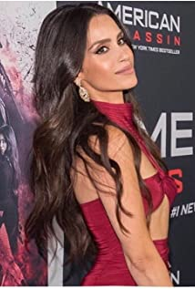
Shiva Negar is a Canadian Actress, Model, and Producer, who rose to prominence starring as Annika Ogden in CBS Films/Lionsgate Blockbuster Movie "American Assassin" and made the short list of Variety Magazine's "10 Canadians to watch".
Shiva can be seen on numerous Films and Network Television shows. Some of her latest credits include "The Cleaning Lady" on FOX and the CBS Military Drama "Seal Team".
Coming from a diverse background, born in Iran, raised in Turkey and Canada, Shiva began her career in music. She was a child performer in piano and guitar recitals and singing competitions, followed by theater and live performances throughout her adolescence. Performing Arts was always Shiva's passion and she had to overcome many obstacles and cultural traditions in order to follow her dreams and pursue her acting career. She also managed to graduate from York University with a Bachelor's degree in Psychology and a Postgraduate degree in Events Management & Marketing.
Dedicated to using her work in performing arts as a medium to tell impactful stories, to inspire, support and empower women all over the world, Shiva hopes to spread more awareness about pressing issues surrounding modern culture and society.
Shiva Negar is one of the faces of the EDA (Ethnically Diverse Artists). She is also one of the contributors and a child sponsor for the non-profit organization Mother Miracle, educating and feeding the impoverished children.

DILLON CASEY
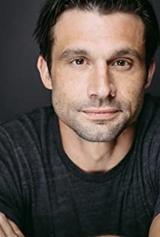
Dillon Casey was born on October 29, 1983 in Dallas, Texas, USA. He received his BSc. in Environmental Science from McGill University in 2005, and a Masters Degree in Economics from the University of Toronto in 2006.
Dillon, his two brothers Conor and Lyndon of "Films Dunproppa" teamed up with musician Jay McCarrol, Daniel Palermo and James Gallagher of Ryerson University, Annnie Bowker and MVP's Anastasia Phillips to win first place in the Fall 2006 24 Hour Toronto Film Challenge with their short film titled "A Rare Affair". Dillon was the lead in the film.
Dillon has had an extensive career with recurring roles in several high profile TV series such as Valemont, Being Erica, Skins, Nikita, Remedy, Backpackers and Designated Survivor. He has also starred in several TV Movies including A Nanny's Secret and A Perfect Christmas
He has been nominated for two Canadian Screen Awards.

DREW NELSON
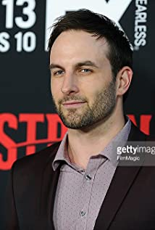
Drew, born and raised in Toronto, Canada started acting in his senior year of high school and hasn't looked back. He's best known to audiences for Guillermo del Toro's FX series, The Strain and the TBS comedy series, People Of Earth. He also recurred on two seasons of the Golden Globe nominated, The Girlfriend Experience starring Riley Keough and executive produced by Steven Soderbergh.
Aside from acting, Drew has a number of projects in development as a writer/producer, including the urban fantasy series Lost Ones.

MIKAELA DYKE
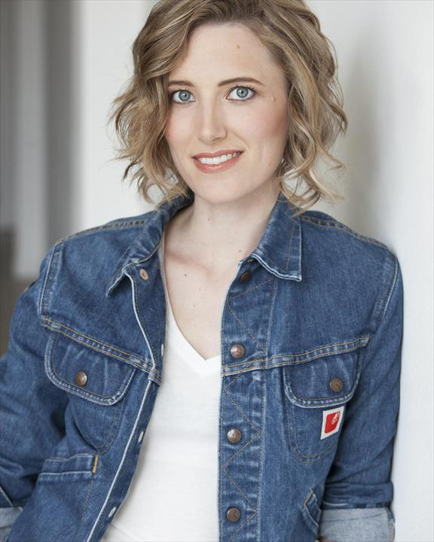
Originally from Newfoundland, Mikaela is a writer and performer who now makes her home in Toronto. An improviser for over a decade, Mikaela has training in solo improvisation, mask, Commedia dell’Arte, clown, storytelling and Alexander technique.
Having performed with companies all over Canada and the U.S., her recent theatre credits include: Arm’s Length (Summerworks festival); A Rustling (Playwrights of Spring Festival); Sky (Rabbittown Theatre Productions); Buried Child (Beothuck Street Players); Comedy of Errors (SBTS); My Name is Rachel Corrie (Forest Productions) and Reflections on Giving Birth to a Squid (Parent Productions).
Her dramatic work has brought her to stages across both the United States and Canada, and her acting has been called ‘intense’, ‘honest’, and ‘shattering’. Recently, she has been touring her solo shows, Dying Hard and Epic Pitch, which have won multiple critical and audience awards.
After obtaining her B.A. from Memorial University, she attended the University of Toronto where she completed her M.A. in Drama. She has appeared in short films at both the Edmonton and Queens, NY international film festivals and in the Toronto ScreamFest film festival. She appeared in the ensemble for the sketch comedy pilot 6 Billion Degrees and as the female lead opposite Canadian rockers Slim Twig and Gord Downie in Sight Unseen, a feature film.
Mikaela has an extensive comedy resume including a variety of sketch comedy, stand-up and improv. She has appeared at comedy cabarets in New York, Ottawa, Victoria, Winnipeg and Toronto. She was an original member of Bea Arthur (The Improv Group) and Rulers of the Universe. In 2013 she appeared with members of the Bad Dog Repertory Players and Tony Ho for Tony Ho’s Peak Falls, as well as with members of Sex T-Rex, Peter N’ Chris and Theatre Brouhaha for the Storefront Theatre’s Special Constables.

Production Credits

Full Cast
Actors  SHIVA NEGAR  DILLON CASEY  DREW NELSON  MIKAELA DYKE  DANNY MCLEOD  ALEXIS KOETTING  JILLIAN REES-BROWN | Role  Ashley Morrison  Marco  Grant Drysdale  Tess Parks  Roger Brampton  Jacqueline James  Dorothy

Casting
RON LEACH, c.d.c.

Composer
CHRISTOPHER GUGLICK

Costume Designer
MORGAN TODD

Editor
WADE TAVES

Production Designer
MARTIN BAPTISTE

Director of Photography
JUAN MONTALVO

Written by
SHAWN RIOPELLE

Directed by
MICHELLE OUELLET

Other Crew
GLENN REDMOND | Stunt Coordinator
BORYS SHAPOVALOV | First Assistant Director
JEFF LEWIS | Second Assistant Director
MALLORY HORSMAN | Third Assistant Director
ALISON DUFFY | Set PA
MALLORY HORSMAN | Extras Casting
JOSIE FITZGERALD | Line Producer
GILLIAN EGLESON | Production Coordinator
SHERRY HOUSE | Production Accountant
MARTIN BAPTISTE | Production Designer
TREVOR WHITE | Art Director
TIMOTHY MYLES | Art Assistant
HEIDI WAGNER | Art Daily
MICHAEL COLLIS | Graphic Artist / Set Dresser
LISA GHOULET | Props Prep
STEPHEN BUTLER | Assistant Props
WILL HAPGOOD | SFX Coordinators
MATT TEDFORD
MORGAN TODD | Costume Designer
KELSEY MAYE | Costume Set Supervisor
JUAN MONTALVO | Director of Photography
ADAM PENNEY | B Camera Operator
JAMES MACKINNON | A Cam - First Assistant Camera
SPENCER THOMPSON | A Cam - First Assistant Camera Daily
RILEY HARNETT | A Cam - Second Assistant Camera
JOSEF GERHARDS | B Cam - First Assistant Camera
NICHOLAS DUNNE | B Cam - Second Assistant Camera
LIAN MORRISON | DIT
SHANE KELLY | Stills Photographer
ROBERT PIKE | Gaffer
MARTIN TOBIN | Best Electric
MYLES BARNES | Key Grip
NICHOLAS MASTERS | Best Grip
DIEGO MEDINA | Sound Mixer
DAVE CONNOR | Boom Operator
JOANNE MCHUGH | Script Supervisor
DANIEL NOSEWORTHY | Location Manager
STEPHEN BUTLER | Location Production Assistants
DOUGAL MCDONALD
DAVID WHITTY
LAUREN SNOW | Key Makeup Artist
ZACK CLARKE | Key Hair Stylist
SAMANTHA GERHARDS | Hair / Makeup Swing
MICHAEL WEBBER | Transport Coordinator
MATHEW SMITH | Transport Captain
ARTHUR HAYNES | Driver
MICHAEL DODD | Transport Production Assistant
JOVER BASALO DOLLIMONT | Health & Safety
CODFATHER | Caterer
GRAHAM SNOW
DION EMBERLEY | Craft Service
LEON WHITE | Craft Assistant Daily
HOLLYWOOD SCRIPT RESEARCH | Script Clearances by
CURTIS DAWE LAWYERS | Legal Services by
TRAVIS PAYNE
ABOVE THE LINE MEDIA SERVICES | Business Affairs by
BRENDAN MCNEILL
ARTHUR J. GALLAGHER CANADA LTD. | Insurance by
ALEXANDRA WARING | Post Production Supervisor
URBAN POST PRODUCTION | Post Production Services provided by
 | Re-Recording Mixer
 | Re-Recording Assistant
 | ADR Editor
 | ADR Recordist
 | Dialogue Editors
 | Sound FX Editors
 | Foley Recordist
 | Foley Artist
 | VFX Artist
 | Colorist
 | Online Editors
PETER TOKARSKY | Project Manager
BRUCE REES | Picture Operations Manager
ROBERTA BRATTI | V.P. of Operations
POND5/JIAWANGKUN | Stock Footage
POND5/BLACKBOXGUILD
POND5/WILDMEDIA
POND5/ZENSTRATUSPREMIUM
POND5/JOHNRINEHART
ISTOCK/CHAMBERPG
ISTOCK/DENISTANGNEYJR
"We Can Have It All"
by Victoria Beaumont
courtesy of West One Music Limited

"Moving"
by Donald Ross Skinner, Nadeem A. Daya, Amit Thakkar, Amy J. Swift & Steve Hewitt
courtesy of Little Assembly

"Bad Luck Charm"
by Jez Miller
courtesy of West One Music Limited

"Rock Billy Rock"
by Levi Brown & Junior Mintz
courtesy of Extreme Production Music USA & Artfully Entertaining Music Library

"Blood Blister"
by Jonathan Lloyd & Nathan Coen
courtesy of Audio Network Limited

"Dinner For Two"
by Jason Nyberg
courtesy of Sounds Incredible Publishing
"Memory In The Mist"
by Edward Grenga & Douglas Stevens
courtesy of S.I. Publishing
Producer Biographies

TIM JOHNSON – Executive Producer
Tim Johnson is among the most active and reliable producers in the business thanks to top rate productions and global distribution appeal.
Johnson is also responsible for producing the international hit series, DR. QUINN, MEDICINE WOMAN for CBS for over 5 seasons. During his 100-episode tenure, he also developed and produced the original docu-drama COLD CASE for CBS network, which was the very first program to integrate television with the Internet.
Johnson has produced over 150 movies, 15 globally released series for every major US network - including ABC, Disney, CBS, NBC, Netfly, FOX and Sony.

JOHNSON PRODUCTION GROUP
The Johnson Production Group contracts globally to produce television content for international networks, studios and distributors. Based in Los Angeles and Vancouver, British Columbia, the company manages production, facilitates development and financing, procures distribution and guarantees quality and timely execution of its programs. While costs have gone up, so has the demand for quality. No longer is good enough, good enough. Johnson Production Group serves that segment when a show needs to be "A" quality, but produced efficiently enough to meet a locked budget. JPG specializes in value, protection of creative elements, and delivery of a quality finished product.
ANDREW C. ERIN – Executive Producer
Andrew Erin is a Canadian Writer/Director making a big splash in the US, and has produced, written and directed numerous commercially successful films. His directorial debut, SAM’S LAKE, was an official selection at the Tribeca Film Festival and did an excellent theatrical run in select theaters around the country; distributed by Lionsgate Films. Andrew also wrote the script for the film. Andrew’s directorial credits include, SIMPLE THINGS, produced for Screen Media Ventures and Universal Studios. Besides winning The Bob Clark Award for Best Director at the California Independent Film Festival, the film was commercially received. Andrew has worked continuously as a writer/director, building a strong library of films in the Thriller/Horror genres with: Embrace of The Vampire, The Clinic, Final Sale, Confined and Toxic Skies.

JOSEPH WILKA – Co-Executive Producer
Joseph Wilka is the Head of Production for Johnson Production Group. Los Angeles-based, Joseph had already produced and directed several feature films before serving as the senior marketing executive for Gravitas Ventures. While at Gravitas, Wilka helped pioneer new distribution models for independent films including day-and-date theatrical releases. It was also at Gravitas where Joseph first worked with Johnson Production Group to facilitate the release of their films to the worldwide Video On Demand audience. After serving as the Director of Distribution and Production for Viva Pictures, where he produced English-language versions of foreign animated titles for DirecTV, Wilka officially joined Johnson Production Group. As Head of Production, he oversees the development, production, and distribution of films from multiple production units for release on broadcast and streaming platforms.

TARALEE GERHARD– Producer
Taralee Gerhard committed to following her dream of making movies almost 20 years ago when the film industry was in its infancy in Ottawa. She spent several years with Fireside Pictures in Ottawa and truly cares about the family culture that Fireside has fostered amongst the crew, supporting each other's big sky dreams, making movies to be proud of. During the Covid-19 pandemic, the spirit of taking risks and following her heart lead Taralee to Newfoundland and she remains truly grateful to be able to continue working with Fireside Pictures as an in house Producer opening a new territory, expanding the Fireside Family and helping to foster the independent film industry in Newfoundland.
OLIVER DE CAIGNY – Supervising Producer
Oliver De Caigny is a Canadian producer originally from Belgium, his background in financing, production, and post production makes him a well-rounded producer for any type of production. His experience in financing and production agreements (film and TV series and movies-of-the week), distribution agreements (both domestic and foreign) as well as international co-productions, Canadian tax credit, Telefilm Canada and Canada Media Fund incentives provides him with a well-rounded background in development, production and distribution for motion pictures, television series and productions.

Billing Block

LIFETIME Presents In Association With JOHNSON PRODUCTION GROUP
“BURNED BY LOVE” starring SHIVA NEGAR DILLON CASEY DREW NELSON MIKAELA DYKE DANNY MCLEOD ALEXIS KOETTING Casting RON LEACH, c.d.c. Composer CHRISTOPHER GUGLICK Costume Designer MORGAN TODD Editor WADE TAVES Production Designer MARTIN BAPTISTE Director of Photography JUAN MONTALVO
Co-Executive Producer JOSEPH WILKA Supervising Producer OLIVER DE CAIGNY Executive Producers ANDREW C. ERIN TIMOTHY O. JOHNSON Produced by TARALEE GERHARD Written by SHAWN RIOPELLE Directed by MICHELLE OUELLET

The Canadian Film or Video Production Tax Credit
© MMXXII Dangerous Connection Ontario Films Inc. All Rights Reserved

Meta Data
LONG (max 3000 characters) synopsis
Feeling let down by love after the ending of her marriage, Ashley decides to try online dating, meeting the mysterious Marco – a debonair businessman who seems like the perfect match – only to discover he’s a scammer after her money.
When she finds out she isn’t his only victim – that Marco’s a pro at this, his lies and false flattery breaking hundreds of hearts just like hers over the years, emptying countless bank accounts – Ashley refuses to let it stand.
Tracking Marco’s online movements, she creates a website dedicated to exposing him, informing every major dating site to be on the lookout for his many aliases, contacting Marco’s other victims to let them know they’re not alone and gather evidence, ending his reign of romantic terror.
When Marco suddenly finds all his hard work ruined, his careful lies made public, he sets out for revenge against Ashley, determined to ruin her life the way she has his – becoming her stalker, eventually progressing to kidnapper when he takes her best friend hostage in an effort to make Ashley recant her story and restore his reputation.
Only by banding together with a group of Marco’s previous victims is Ashley able to stop him – coming up with a dangerous plan to turn Marco’s lying ways against him and finally hold him to account, bringing him to justice and finding new love in the process. (1350)
MEDIUM (max 500) synopsis
Ashley meets her seemingly perfect match while online dating, only to discover he’s a scammer after her money, escalating to a violent stalker when she attempts to bring him to justice. (186)
SHORT (max 100 characters) synopsis
A woman meets her perfect match while online dating, only to discover he’s a violent stalker (93)
5 KEY WORDS
Online dating, scammer, stalker, violent

