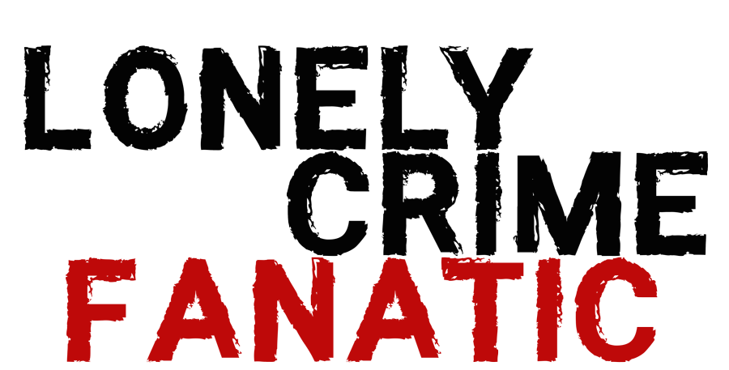

Inspired By Actual Events

Johnson Production Group

Press Kit

# One-Liner

# Romance sparks when a lonely true crime fan meets her favorite podcast host, but things soon turn strange as his fascination with her becomes obsession and his newest run of episodes appear to revolve around her eventual murder.

# Synopsis

# Recently separated from her violent husband, Ashley becomes obsessed with true crime podcasts. In an effort to get out of the house, she attends a book signing of a rather famous podcaster she’s been listening too, David Ryan. Ashley reminds David of a case he can’t forget and asks her out for coffee. A friendship blossoms between the two and grows into something more. At the same time, strange things are happening to Ashley; her house is broken into, threats are made, but it’s unclear if it’s her soon-to-be ex-husband or someone new in her life. Ashley must find out who it is, before it’s too late.

# Producers

Executive Producers

TIMOTHY O. JOHNSON

JOSEPH WILKA

Co-Executive Producer

LISA ALFORD

Producer

A.J. KELLY  
JACOB HORN

# Key Cast

|  |  |  |
| --- | --- | --- |
| CHARACTER  Ashley  David  Lily  Paul  Detective Wyler |  | ACTOR  BRENNA SKALSKI  IAN REIER MICHAELS  ALEXANDRIA PONCE  DAVID HURT  DOUG JEFFREY |

# Key Cast Biographies

# BRENNA SKALSKI

Brenna Skalski is an American actress known for Gates (2022) and a Puzzling Postmortem (2022). She was born and raised in Atlanta, Georgia where she attended Georgia State University on an athletic scholarship. Brenna was on track to become a practicing lawyer, but she swiftly shifted her energy to acting after unearthing a deep love for the art.

When she is not acting, Brenna is perfecting her Russian, working on writing her first television drama series, and spending time with her dogs.

# IAN REIER MICHAELS

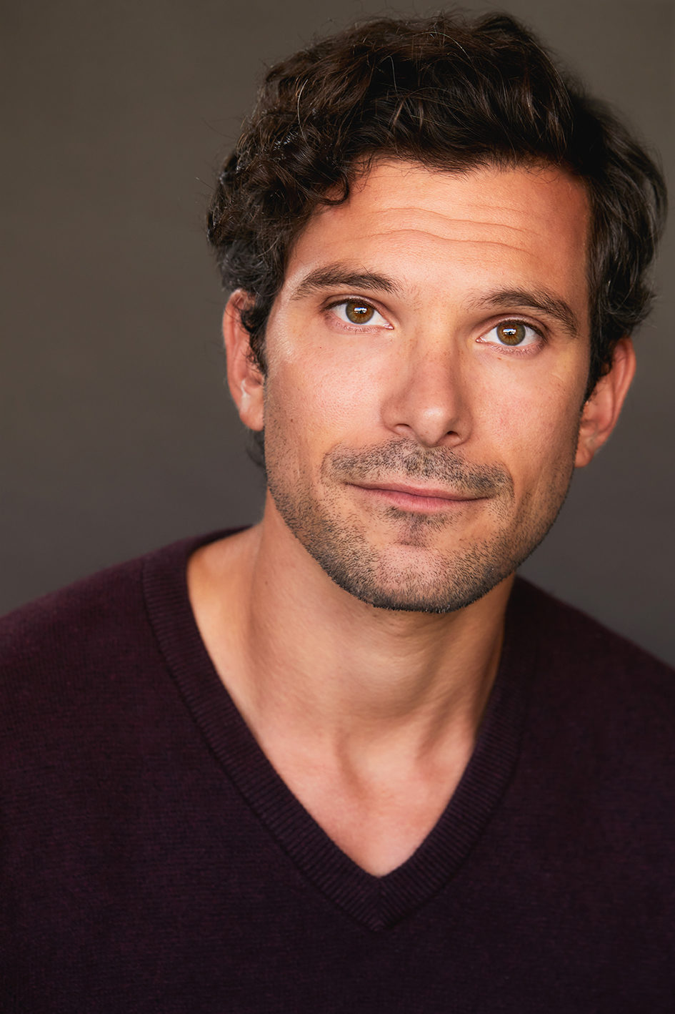Ian Reier Michaels is an actor and writer of musicals based in Los Angeles. Recent theater credits include Israel “Stucky” Stuckowitzenpuppetweiner in Max Zumstein’s The Hallway; Bindy Lipton in David Dickens’ Future Court; the title character in Mr. Ballviews Thanksgiving Relay. He recently appeared on Broadway in Cost of Living by Martyna Majok.

# ALEXANDRIA PONCE

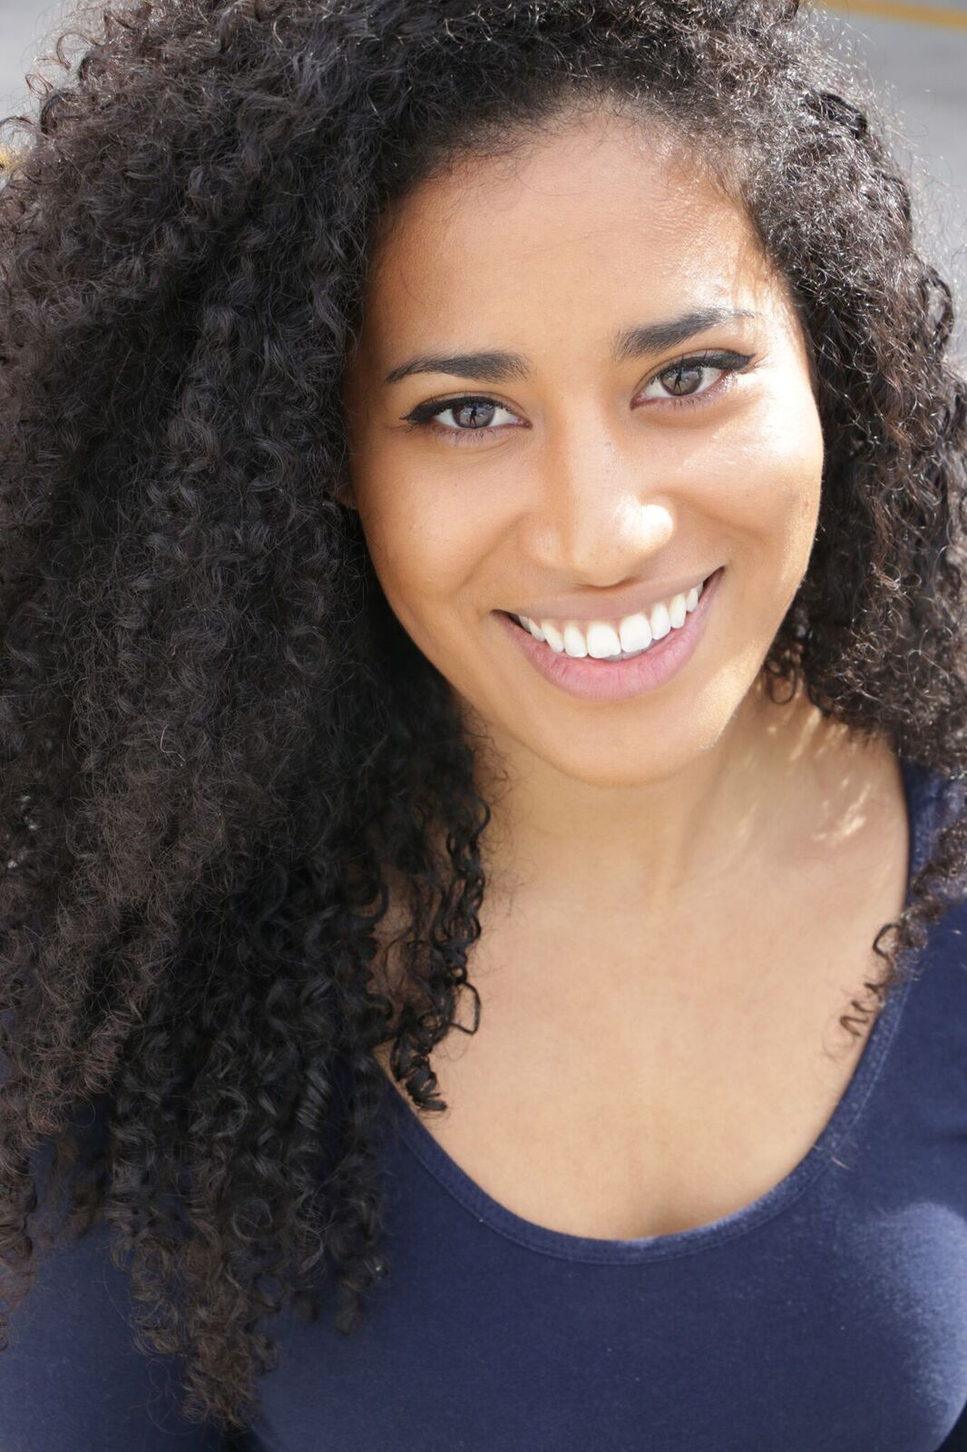American actress, writer & stuntwoman, Alexandria Ponce, is constantly working, auditioning, and perfecting her craft. She appeared in Spike Lee’s Tales from the Hood 2 and can be seen in the upcoming short, The Difference.

# DAVID HURT

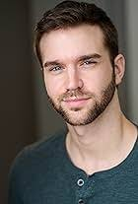David is a Cincinnati-born actor who has appeared in the short films Breaking Silence, and A Petal’s Edge. Lonely Crime Fanatic is David’s film debut.

# DOUG JEFFREY

## Doug Jeffery - IMDbDoug has had an extensive career as an actor and presenter while also having built a set design and construction company, 41 Sets. He presented History Channel’s ‘Where Did It Come From’ as its host and was a celebrity judge on ‘Beauty and the Geek.’ He can be seen acting in ‘The Baby Pact’ as Doug, ‘Secrets and Lies’ as John, ‘Born Champion’ as Bell Stewart, and ‘Confessions of a Lap Dancer’ as Ron. He also appears in the TV series, ‘Fit Over Fifty’ as himself.

# Production Credits

### Full Cast

|  |  |
| --- | --- |
| [Actors](http://www.imdb.com/name/nm7589451/?ref_=ttfc_fc_cl_t1)  BRENNA SKALSKI  IAN REIER MICHAELS  DAVID HURT  ALEXANDRIA PONCE  DOUG JEFFREY  JACOB HORN  ALEXANDRIA PILLOW  NAOMI PRENTICE  DIANA MARTIN | Role  Ashley  David  Paul  Lily  Detective Wyler  Podcast Host  Police Officer  Young Woman  Super Fan |

### Casting By

STELLA NOVA CSA

### Production Designer

ROBERT WISE

### Director of Photography

NICHOLAS ALBERT

### Edited By

QUINN ELSE

### Music By

FILIUS BLUE MUSIC

### Line Producer

LYNNETTE MYERS

### Written By

BRYAN LUCAS

### Directed By

KAILA YORK

### Full Crew

|  |  |
| --- | --- |
| ANDREW JUKES | First Assistant Director |
| NATE DE LORIMIER | Second Assistant Director |
| PETER BLICKENSDERFER | Additional Second Assistant Director |
| NATALIE BRADY | Second Second Assistant Director |
| TONY PAULLEY | Art Director |
| ADRIENNE REISHUS | Set Dresser |
| MICHAEL YORI | Graphic Designer |
| MICHELLE QUARANTA | Key Make-up Artist |
| ALAINA EGGER | Key Hair Stylist |
| LIZZY POLANCO | Additional Make-up Artist |
| MELISSA ROMERO |  |
| MIKE SPEZZANO |  |
| GEORGE ELLETT | 1st Assistant Camera |
| BRIAN CHOW | Additional 1st Assistant Camera |
| AMY FRYE | 2nd Assistant Camera |
| SELENA WEBB | Additional 2nd Assistant Camera |
| DAE HYUN KIM | Steadi Cam Op |
| AUSTIN ALBORG | Under Water Cam Op |
| GABRIEL ANTONUCCIO | Media Manager |
| MARIO OSEGUERA | Stills Photographer |
| JEFF MARLOWE | Gaffer |
| ANDREW CHO | Additional Gaffer |
| DAN PROSTEK | Best Boy Electric |
| JOHN MANNING | Additional Best Boy Electric |
| TREVOR MITCHEL |  |
| DEVIN CONNOR | Electric |
| PETE HOWELL | Key Grip |
| JOSH TOLON | Best Boy Grip |
| DAVID KINCHEN |  |
| CASEY DECOTIS |  |
| CHRISTOPHER GRAJALES |  |
| CHRIS WILLIAMS | Swing |
| JACQUELINE GARVEY | Costume Designer |
| JOHN MARK | Onset Costumer |
| TESSA MURPHY | Production Sound Mixer |
| JULIAN ANDREWS | Additional Production Sound Mixer |
| MARIA CAREY-WALTON | Script Supervisor |
| LANIE ALBIN | Production Manager |
| KARIM PHELPS | Safety Coordinator |
| LINDEN DEGURIAN | Production Assistants |
| SANDI MCBRIDE |  |
| MICHAEL LAWRENCE |  |
| DAVID VENABLE |  |
| CHRISTOPHER PENTECOST | Supervising Sound Editor, Re-Recording Mixer |
| PETER TREPKE | Dialogue Editor |
| PATRICK EVANS | Post Production Supervisor |
| UMAMI COLOR AND FINISHING | Post Production Services |
| DAN EDWARDS | Supervising Colorist |
| JENSEN VINCA | Colorist |
| JEFF SPOTT | Additional Colorist |
| ANTHONY CAMPAGNA | Finishing Artist |
| LUKE BUTLER | Digital Intermediate Producer |
| HOLLYWOOD SCRIPT CLEARANCE | Script Clearance |
| PRIVATE ISLAND AUDIO | ADR Facilities |
| MOONSHINE POST STUDIO |  |
| QUINN ELSE | Visual Effects |
| ABACUS INSURANCE BROKERS, INC | Insurance |
| DEL MAR CATERING | Catering |
| RARE BREEDS | Cameras |

# Producer Biographies

## TIMOTHY O. JOHNSON – Executive Producer

Timothy O. Johnson is among the most active and reliable producers in the business thanks to top rate productions and global distribution appeal. He is the managing partner of Johnson Production Group, a Canadian based operation that produces over 100 hours of dramatic television annually with hundreds of programs running internationally. The company is the leader supplier to Lifetime, Hallmark and other international outlets.

A graduate of the Marshall School of Business at the University of Southern California, he served as President of the USC Entertainment Management Association and a member of the Advisory Committee of the Center for Entrepreneurial Studies.

Johnson is also responsible for producing the international hit series, DR. QUINN, MEDICINE WOMAN for CBS for over 5 seasons. During his 100-episode tenure, he also developed and produced the original docu-drama COLD CASE for CBS network, which was the very first program to integrate television with the Internet.

Most recently, Johnson has produced the THE NOEL DIARY, being the #1 Film on Netflix’s Top 10 list in December of 2022. He was also at the helm of the successful GIRL IN THE SHED: THE KIDNAPPING OF ABBY HERNANDEZ, as well as the V.C. Andrews series of films, to date including TWILIGHT’S CHILD, MIDNIGHT WHISPERS, and DAWN, all produced for Lifetime..

Johnson has produced over 400 movies and 15 globally released series for every major US network - including Netflix, Lifetime, Hallmark, ABC, Disney, CBS, NBC, Netfly, FOX and Sony.

## JOHNSON PRODUCTION GROUP

The Johnson Production Group contracts globally to produce television content for international networks, studios and distributors. Based in Los Angeles and Vancouver, British Columbia, the company manages production, facilitates development and financing, procures distribution and guarantees quality and timely execution of its programs. While costs have gone up, so has the demand for quality. No longer is good enough, good enough. Johnson Production Group serves that segment when a show needs to be "A" quality, but produced efficiently enough to meet a locked budget. JPG specializes in value, protection of creative elements, and delivery of a quality finished product.

## JOSEPH WILKA – Executive Producer

Joseph Wilka is the Head of Production for Johnson Production Group. Los Angeles-based, Joseph had already produced and directed several feature films before serving as the senior marketing executive for Gravitas Ventures. While at Gravitas, Wilka helped pioneer new distribution models for independent films including day-and-date theatrical releases. It was also at Gravitas where Joseph first worked with Johnson Production Group to facilitate the release of their films to the worldwide Video On Demand audience. After serving as the Director of Distribution and Production for Viva Pictures, where he produced English-language versions of foreign animated titles for DirecTV, Wilka officially joined Johnson Production Group. As Head of Production, he oversees the development, production, and distribution of films from multiple production units for release on broadcast and streaming platforms.

## LISA ALFORD – Co-Executive Producer

Lisa Alford is a development executive at Johnson Production Group. A Massachusetts native, Lisa has lived and worked in Los Angeles for over a decade, always in support of excellent storytelling. Prior to joining Johnson Production Group, Lisa worked as an executive at TriStar television where she specialized in identifying IP that supported TriStar’s mission to feature diverse, authentic characters and champion underrepresented voices. Lisa came up at Sony Pictures Television where she worked as a production coordinator in the Television Movies and Miniseries department and in the writers room on the WGN hit series OUTSIDERS. In her current role, Lisa shepherds projects from the concept phase through story development, production, and post.

## A.J. KELLY – Producer

Producer and co-founder of the creative production company, Goodform, A.J. Kelly has spent the past decade creating film, television, documentary, experiential and branded content. His work has won awards at top festivals including Cannes & SXSW, aired on premium networks and received multi-cultural acclaim.

Based in Los Angeles, A.J. believes in elevating content from diverse creative voices and providing an outlet for filmmakers to bring their stories to life.

## JACOB HORN – Producer

Jacob Horn began his career in the entertainment industry by working his way up through Elijah Wood’s production company, Spectrevision. With them, he was able to gain producing experience with directors such as Nacho Vigalondo and Josh Waller. After leaving Spectrevision, Jacob went out on his own to produce and direct his own content including several short films, a Christmas feature for Hallmark , and also becoming the Stunt Dept Manager on Once Upon A Time In Hollywood. At present, Jacob is the Head of Production for GoodFlix, a feature film production company where he oversees an annual slate of films.

## Billing Block

LIFETIME Presents In Association with JOHNSON PRODUCTION GROUP **LONELY CRIME FANATIC** starring BRENNA SKALSKI IAN REIER MICHAELS ALEXANDRIA PONCE DAVID HURT DOUG JEFFREY Casting By STELLA NOVA CSA Production Designer ROBERT WISE Director of Photography NICHOLAS ALBERT Edited By QUINN ELSE Music By FILIUS BLUE MUSIC Line Producer LYNNETTE MYERS Co-Executive Producer LISA ALFORD Executive Producers JOSEPH WILKA TIMOTHY O. JOHNSON Produced By A.J. KELLY JACOB HORN Written By BRYAN LUCAS Directed By KAILA YORK

© MMXX Johnson Production Group Inc. All Rights Reserved

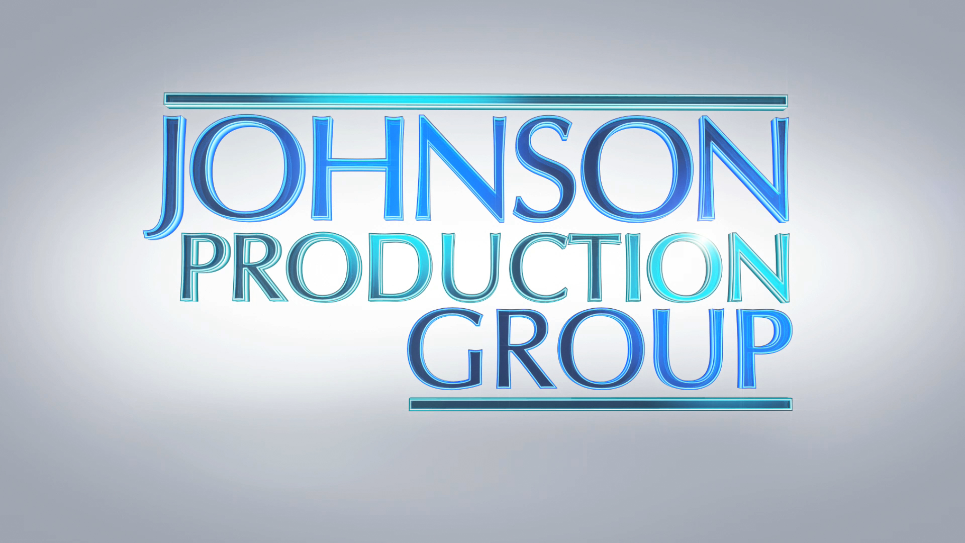



Meta Data

LONG (max 3000 characters) synopsis

Recently separated from her violent husband, Ashley becomes obsessed with true crime podcasts. In an effort to get out of the house, she attends a book signing of a rather famous podcaster she’s been listening too, David Ryan. Ashley reminds David of a case he can’t forget and asks her out for coffee. A friendship blossoms between the two and grows into something more. At the same time, strange things are happening to Ashley; her house is broken into, threats are made, but it’s unclear if it’s her soon-to-be ex-husband or someone new in her life. Ashley must find out who it is, before it’s too late.

(606)

MEDIUM (max 500) synopsis

Romance sparks when a lonely true crime fan meets her favorite podcast host, but things soon turn strange as his fascination with her becomes obsession and his newest run of episodes appear to revolve around her eventual murder.

(228)

SHORT (max 100 characters) synopsis

A true crime fan meets her favorite podcast host but his show appears to revolve around her murder.

(99)

5 KEY WORDS

Podcast, true crime, fan, murder