

Johnson Production Group

Press Kit

# One-Liner

# Sparks fly when an expert in avalanche forecasting brings her new technology to Glacier National Park and faces push back from the director of Mountain Rescue.

# Synopsis

# Dr. Heather Lawrence has her life and job down to a science. In fact, as a climatologist and avalanche expert, she’s dedicated her career to developing an avalanche forecasting technology to help keep danger at bay for those on the mountains. When word of her impressive system travels all the way to Glacier National Park, she’s invited to install her equipment and teach her program to their Mountain Rescue Team. Eager to share this life-saving technology, Heather sets off for Glacier National Park where she’s greeted by Chris Parker, director of Mountain Rescue. Chris is confident, rugged, handsome… and skeptical. Things are a bit frosty between them at first. The way he sees it, Heather might have her science and data, but he has real world experience. He doesn’t need an algorithm to tell him how to navigate the terrain. Chris begins to thaw, however, when he realizes that like him, Heather just wants to save lives. And soon enough they discover that it’s love - not an avalanche - sweeping them both off their feet, even if they still don’t see eye to eye on avalanche forecasting. One afternoon, Chris is called out on an emergency rescue mission to a location that Heather’s technology has flagged as a high-risk area. Heather worries an avalanche is coming and Chris is right in its path. With time running out, Heather must convince Chris to let science be his guide, as it’s sure to lead him not just back to safety but right into the romance of his life!

# Producers

Executive Producers

TIMOTHY O. JOHNSON

Christie Will

Producer

GREGORY MACKENZIE

# Key Cast

|  |  |  |
| --- | --- | --- |
| CHARACTER  Dr. Heather Lawrence  Chris Parker  Riley  Samantha Parker  Eric Johnson  Sonya |  | ACTOR  ASHLEY NEWBROUGH  STEPHEN HUSZAR  TEGAN MOSS  AMÉLIE WOLF  DEVON ALEXANDER  TEAGAN VINCZE |

# Key Cast Biographies

# ASHLEY NEWBROUGH

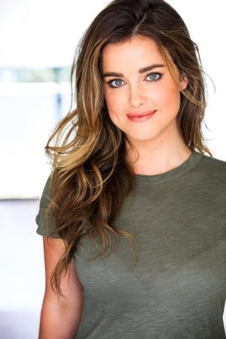Beloved American child actress, Ashley Newbrough, started her entertainment career at the tender age of 14. Newbrough began her career with roles in Get a Clue for Disney and Missing for Lifetime. She went on to act in Radio Free Roscoe. She is known for starring as Sage Baker in The CW drama series Privileged, as well as for the ABC series Mistresses, and for starring in a number of predominantly Christmas-themed television films since 2015, such as Small Town Christmas, A Merry Christmas Match, Flowers and Honey, Blue Moon Ball, Christmas for Keeps and Saving Christmas Spirit.

# STEPHEN HUSZAR

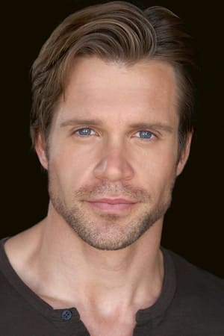Stephen Huszar is a Canadian film and television actor from Saskatoon, Saskatchewan. Huszar attended high school at Aden Bowman Collegiate and later studied at the University of Saskatchewan. Based in Toronto, Ontario, the 6' 1" Huszar began his screen career in 2004 with a role in The Cradle Will Fall. Quickly he built a list of supporting roles in made-for-television films during the mid-2000s. During the late 2000s, Huszar found recurring work on the series Paradise Falls and Corner Gas. He also had the good fortune to appear in one of CW's longest-running series Smallville. During the 2010s Huszar appeared in the direct-to-video horror sequel 30 Days of Night: Dark Days, followed by work in Time after Time, Faces in the Crowd, InSayshable and continued television work on series including Cashing In, Fringe, Continuum, and Supernatural. Huszar also brought one of DC Comics' supervillians to the screen with his performance as Plunder in the series The Flash. During 2016-2017, Huszar worked on the series Letterkenny. Since then he has been a series regular on such shows as Ruby Herring Mysteries, Tribal and Chesapeake Shores. Huszar has starred in several recent holiday movies such as Magical Christmas Ornaments, Christmas Wedding Planner, Christmas In The Rockies, Time For Us To Come Home for Christmas, The Sauce of Love, Undercover Holiday and Christmas In Rockwell.

# TEGAN MOSS

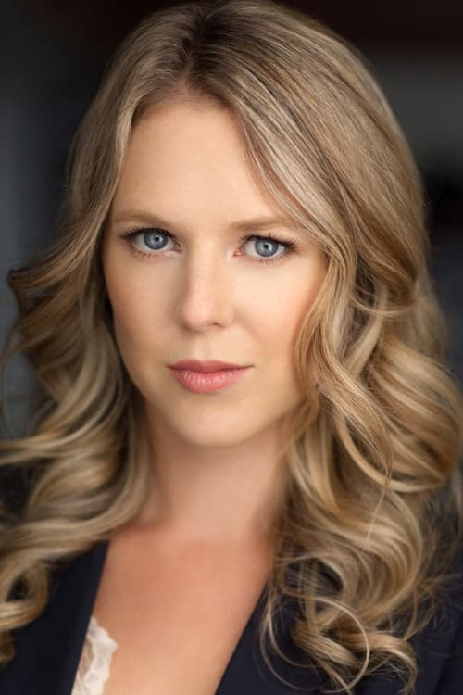Tegan Moss was born on February 7, 1985 in Vancouver, British Columbia, Canada into a family that includes a writer, a producer and an actor. In the year 1997, she was nominated for the Young Artist Award for Best Performance in a TV Movie – Actress for her role in The Angel of Pennsylvania Avenue and again in 2000 for Sea People. In 2007 she was nominated for a Gemini for Best Supporting Role in Eight Days to Live. She is known for her work on The Good Doctor (2017), Flashpoint (2008) and The X Files (1993). Tegan has also had roles in the Hallmark Movies Summer in the Vineyard and Valentine in the Vineyard.

She has been married to Joshua Franken since 2013. They have two children.

# AMÉLIE WOLF

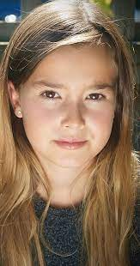Young Amélie Wolf has already amassed an extensive movie career playing key roles in such TV Movies as A Wish For Christmas, A Snowcapped Christmas, Eat,Play,Love, Today I Do, Poinsettias For Christmas, Chasing Waterfalls as well as High Flying Romance for which she garnered a Leo Award Nomination in 2022.

# DEVON ALEXANDER

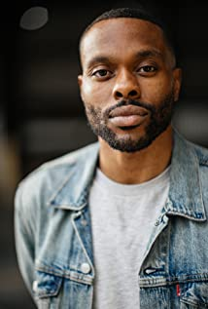Whether you know him from the stages of Canada's top stand up comedy venues or from a myriad of film, television and commercial appearances, one thing is certain for Devon Alexander: he is fast becoming a sought-after Canadian treasure.

Born and raised in Calgary, Alberta, Devon's interest in acting and comedy started at a very young age. After receiving a Diploma in Radio Broadcasting in Toronto, he moved to New York to focus on his acting career, hone his craft and star in independent films. Hollywood North came calling so Devon made Vancouver his home base and quickly amassed credits in productions like Fox's The X-Files and Lucifer, CW's iZombie, Arrow and No Tomorrow, ABC's Somewhere Between and multiple Hallmark and Lifetime movies.

With his easy charm, sharp wit and magnetic charisma, Devon is a unique and singular talent who is poised to take his film and television career to international heights.

# TEAGAN VINCZE

Teagan has split her life and career between Toronto and Vancouver where she has built film and television credits in roles that range from suspense and drama, to comedy and romance, in shows such as The CW's Life Sentence, Global's Rookie Blue, the CBC's Murdoch Mysteries, The Hallmark Channel's When Calls the Heart, and The Unauthorized Melrose Place Story, to name a few. Her feature film roles include The Cannon, earning her a Leo nomination for best supporting actress in a motion picture and Daughter where she co-starred alongside John Cassini, which premiered in the BC Spotlight Category at the 2019 Vancouver International Film Festival. When she's not acting, Teagan enjoys snapping pictures on her film camera, art and theatre.

# Production Credits

### Full Cast

|  |  |
| --- | --- |
| [**Actors**](http://www.imdb.com/name/nm7589451/?ref_=ttfc_fc_cl_t1)  ASHLEY NEWBROUGH  STEPHEN HUSZAR  TEGAN MOSS  AMÉLIE WOLF  DEVON ALEXANDER  TEAGAN VINCZE  MYKHILA DRUMMOND  MAIA ROSE MICHAELS  ROBIN SIGGERS  MELVIN  AJAY BHARTI  ANDY WILHELM  JANET MARTIN  LINDA HUNTER  PAMELA MAGEAU-BELL  GARY POULIN  NELS SHERMAN  KEVIN GIFFIN  LIAM MORGAN  ANNICA COLLOMBIN  MICHELLE MCDONALD  NELS SHERMAN  MEGAN KELLY  MOGUL  PHOENIX  BOSCO played by puppy OZZY  ANNICA COLLOMBIN  SCOUT (#1)  PEARL  SCOUT (#2)  KITZBUHEL “KITZ”  TAMIKA GREEN  KEVIN GIFFIN  MEGAN KELLY  OLIVIA JOHNSON  FREDRIKA ENGBLOM  FINDLAY THOMPSON  AIDEN FAUGHT  MARIA MILNER  SAMIR SOMJI  CALVIN LOVENUIK  JUSTINE COWITZ  RYAN BRYDEN  MORGAN COUCH  TYLER STEEN | **Role**  Dr. Heather Lawrence  Chris Parker  Riley  Samantha Parker  Eric Johnson  Sonya  Spa Attendant  Bridget Johnson  Bryce  Gala Singer  Restaurant Waiter  Gala Donors  Taxi Driver  Mountaineers  Driver  AST Course Instructor  Avi Dogs  Puppy Wrangler  Puppies  Fernie Ski Patrol  As themselves |

### Casting by

JUDY K. LEE

### Production Designer

STEVE SCOTT

### Director of Photography

STIRLING BANCROFT, CSC

### Edited by

DEVIN TAYLOR

### Composer

RUSS HOWARD III

### Written by

KEITH HEMSTREET

### Directed by

CHRISTIE WILL

### Other Crew

|  |  |
| --- | --- |
| GREGORY MACKENZIE | Production Manager |
| JEFF CROFT | First Assistant Director |
| LISA D’ALESSANDRO | Second Assistant Director |
| MYKHILA DRUMMOND | Set Decorator |
| HASSAN ELEWAD | On-Set Dresser |
| JEREMY NORDSTROM | Dressers |
| JAMIE MCCREARY |  |
| CHIS BUFFETT | Graphics |
| DWAYNE HIGGINS | Props Master |
| ERIC JENSEN | Props |
| SIMONE MAWSON | On-Set Props |
| DEVAN ADAMS | Key Hair Stylist |
| SHAUNA CARVETH | Key Make-Up Artist |
| KELSEY BARAN | Costume Designers |
| MICHELLE MCDONALD |  |
| SUE MCCREARY | Costume Assistants |
| SARA YUILL |  |
| STIRLING BANCROFT, CSC | “A” Camera/Steadicam Operator |
| NELSON WU | “A” Camera First Assistant |
| VILMA PETTERSSON | “A” Camera Second Assistant |
| ALEX TORRES | “B” Camera Operator |
| ZACHARY ZAZA | “B” Camera First Assistant |
| BARBARA COSTA | “B” Camera Second Assistant |
| ANDREW POVIL | Digital Image Technician |
| JUSTIN UITTO | Chief Lighting Technician |
| PAULA LARA | Best Electrician |
| NICHOLAS MACKENZIE | Electrician |
| BRODY THOMAS | Key Grip / Dolly |
| MITCHEL TAYLOR | Best Grip / B Dolly |
| JESSE WOODS | Grip |
| KEVIN POLLARD | Transport Coordinator |
| JAMIE MCCREARY | Drivers |
| KIM WALLACE |  |
| DOUG DAVIDSON |  |
| NELS SHERMAN |  |
| DAVE KEENAN |  |
| DEBRA THERRIEN |  |
| ROBERT GLEN |  |
| GEOFFREY ABBOT |  |
| KEEGAN LAITHWAITE |  |
| MAIA ROSE MICHAELS | Tutor / Casting Assistant |
| ALLY DAVIES | Craft Services |
| JENNIFER HEATH | Set Medics |
| JIM MACKINNON |  |
| KEVIN GIFFIN |  |
| TAMIKA GREEN |  |
| ROBIN SIGGERS | Alpine Resort Liason / Operations Manager |
| MEGAN KELLY | Ski Patrol Coordinator / Avi Dog Handler |
| ANNICA COLLOMBIN | Puppy Wrangler |
| TREEVOR MASON | Production Coordinator / Locations |
| JANET MARTIN | Assistant PC / Office |
| ANNICA COLLOMBIN | Assistant PC / Mountain |
| JACOB CHILD | 3rd Assistant Director |
| VASILI VASSOS | Key Locations PA |
| ROBERT O’BRIEN | Key Set PA |
| CONNOR P. LYONS | Production Sound Mixer |
| MASON J. HNATIW | Boom Operator |
| JULIE ZHU | Script Supervisor |
| PARALEE COOK | Production Accountant |
| AMANDA PORTER | Production Accountant Assistants |
| CHRISTOPHER LOGAN |  |
| THOMAS STANFORD | Business Affairs |
| JESSICA OLSEN |  |
| STEVE SCOTT | Production Designer |
| RON OSIOWY | Sound Mixer/Boom (mountain) |
| AYDEN COOK | Sound Mixer |
| DAMIAN GAMBLE | Boom Operator |
| SUE BOYD | Continuity |
| BOBBY MUNDH | Production Accountant |
| ANDREW | Best First Assistant Accountant |
| CIRQUE RESTAURANT & BAR | Catering |
| RESORTS OF THE CANADIAN ROCKIES | Ski Resort |
| FERNIE ALPINE RESORT | Ski Resort Operations |
| CAST AND CREW | Payroll Services |
| GRAY KRAUSS DES ROCHERS LLP | Production Counsel |
| WILLAM F. WHITE | Camera Equipment |
| WILLIAM F. WHITE | Lighting Equipment |
| LIZARD CREEK LODGE | Lodging |
| CIRQUE RESTAURANT & BAR | Catering by |
| ASCENT HELICOPTERS LTD. | Helicopter |
| WESTERN WIND EQUIPMENT RENTALS LTD, | Trucks |
| COASTAL CLEARANCES | Script Clearance |
| CHANDLER FOGDEN ALDOUS | Legal Services |
| LAW CORPORATION |  |
| FRONT ROW INSURANCE BROKERS | Insurance |
| TIM SPENCE | Post Production Supervisor |
| ANDREW POVIL | Post Production Coordinator |
| MEL CORRIGAN | First Assistant Editor |
| HRANT AHANISYAN | Second Assistant Editor |
| EMIR KAHN BAUTISTA | Visual Effects |
| DERMOT SHANE | Colorist |
| MAVERICK POST GROUP | Audio Post-Production |
| GREGOR PHILLIPS | Supervising Sound Editor |
| GREGOR PHILLIPS | Re-recording Mixer |
| MAKI MAROUKA | Dialogue Editor |
| CRAIG GEORGE | SFX Editor |
| ALEX MACIA | Foley Artists |
| DEVON QUELCH |  |
| MATIAS GIBBS | Foley Editor |
| JEFF GROUT | ADR Editor |
| DYLAN SIGGERS | Fernie Stock Footage |
| KOOTENAY REGIONAL FILM COMMISSIONER | Special Thanks |
| JOHN WITTMAYER |  |
| FERNIE ALPINE RESORT LIASON |  |
| ROBIN SIGGERS |  |
| MANAGER ANDY WILHELM |  |
| AND THE WONDERFUL STAFF OF LIZARD CREEK LODGE |  |
| RESORTS OF THE CANADIAN ROCKIES |  |
| ANDY COHEN |  |
| MARK ORMANDY |  |
| KAREN PEPPER |  |
| PHIL ADRIAN |  |
| AND ALL STAFF AT THE FERNIE ALPINE RESORT |  |
| THE CITY OF FERNIE |  |
| MAYOR NIC MILLIGAN |  |
| CITY STAFF |  |
| AND ALL RESIDENTS |  |

# Producer Biographies

TIM JOHNSON – Executive Producer

Tim Johnson is among the most active and reliable producers in the business thanks to top rate productions and global distribution appeal.

Johnson is also responsible for producing the international hit series, DR. QUINN, MEDICINE WOMAN for CBS for over 5 seasons. During his 100-episode tenure, he also developed and produced the original docu-drama COLD CASE for CBS network, which was the very first program to integrate television with the Internet.

Johnson has produced over 150 movies, 15 globally released series for every major US network - including ABC, Disney, CBS, NBC, Netfly, FOX and Sony.

## JOHNSON PRODUCTION GROUP

The Johnson Production Group contracts globally to produce television content for international networks, studios and distributors. Based in Los Angeles and Vancouver, British Columbia, the company manages production, facilitates development and financing, procures distribution and guarantees quality and timely execution of its programs. While costs have gone up, so has the demand for quality. No longer is good enough, good enough. Johnson Production Group serves that segment when a show needs to be "A" quality, but produced efficiently enough to meet a locked budget. JPG specializes in value, protection of creative elements, and delivery of a quality finished product.

## CHRISTIE WILL - Executive-Producer | Director

## Named Best Canadian Female Director, Best Director and winning Best Film and Best Sci-Fi Film in 2020 and 2021 [Her Coming], Christie Will brings an authentic and vulnerable perspective to her work being reviewed in “Integral Women in Film 2022” as having Directed more feature films that any other female in the director’s chair worldwide. In July 2022 Christie won a Canadian Leo Award for Best Screenwriting; Television Movie, in addition to garnering a Best Director nomination; Television Movie. In December of 2021, Christie received a Best Director nomination [Five Star Christmas], and in 2020 Will was awarded the Directors Guild of Canada’s Legacy Award, in addition to receiving a Best Screenwriting Leo Award 2019 [Killer Ending]. September 2022 Will was selected (one of 5 new content creators) for Royal Bank of Canada’s Series Fest “Best New Series Creator” at The Toronto International Film Festival [Fishing For Men]. Early in her career, Christie worked as Director/ Producer Peter Berg’s Assistant and later segued into producing and developing films starring Saturday Night Live comedians Chris Kattan, David Spade, Norm McDonald, The Farley Brothers, Patrick Swayze, Tim Curry and more. Christie’s first feature film Slightly Single in L.A. [Simon Rex, Lacey Chabert, Chris Kattan Jenna Dewan and more] was one of the first acquisitions for Netflix in their early days, and her second comedy “Boy Toy” [Dawn Oliveri, Mircea Monroe, Simon Rex, Morgan Fairchild] was bought by Lionsgate. Christie received the Terry Fox Humanitarian Award in 1995, and holds a Master Of Fine Arts in Creative Writing and Film from University of British Columbia as well as a BFA from Emerson College in Boston MA; and a BA College of Charleston, SC. Christie also studied Sanford Mesiner at Playhouse West in Los Angeles for seven years.

## GREGORY MACKENZIE - Producer

Gregory Mackenzie has an extensive background in directing and producing across North America and Europe. He started his career directing experimental films, music videos, and TV commercials across Canada, then was brought out to Europe to be the in-house director at Nova Imagem, at the time the largest production company in Lisbon. From there he moved to London, helming blue-chip commercials then producing independent features and dramatic series. Gregory’s works range widely, from directing comedy romance ‘Camille’ (Sienna Miller, James Franco), to dramatized documentary series, to producing horror movie ‘Barney Burman’s Wild Boar’. He is currently based out of Nelson, BC.

## Billing Block

HALLMARK CHANNEL presents in association with JOHNSON PRODUCTION GROUP “LOVE IN GLACIER NATIONAL: A NATIONAL PARK ROMANCE” starring ASHLEY NEWBROUGH STEPHEN HUSZAR TEGAN MOSS AMÉLIE WOLF DEVON ALEXANDER TEAGAN VINCZE Casting by JUDY K. LEE Production Designer STEVE SCOTT Director of Photography STIRLING BANCROFT Edited by DEVIN TAYLOR Composer RUSS HOWARD III Executive Producers TIMOTHY O. JOHNSON CHRISTIE WILL Produced by GREGORY MACKENZIE Written by KEITH HEMSTREET Directed by CHRISTIE WILL

  

With the participation of the Province of British Columbia   
Film Incentive BC



The Canadian Film or Video Production Tax Credit  


© MMXXII Snowfield Productions Inc.. All Rights Reserved





Meta Data

LONG (max 3000 characters) synopsis

Dr. Heather Lawrence has her life and job down to a science. In fact, as a climatologist and avalanche expert, she’s dedicated her career to developing an avalanche forecasting technology to help keep danger at bay for those on the mountains. When word of her impressive system travels all the way to Glacier National Park, she’s invited to install her equipment and teach her program to their Mountain Rescue Team. Eager to share this life-saving technology, Heather sets off for Glacier National Park where she’s greeted by Chris, director of Mountain Rescue. Chris is confident, rugged, handsome… and skeptical. Things are a bit frosty between them at first. The way he sees it, Heather might have her science and data, but he has real world experience. He doesn’t need an algorithm to tell him how to navigate the terrain. Chris begins to thaw, however, when he realizes that like him, Heather just wants to save lives. And soon enough they discover that it’s love - not an avalanche - sweeping them both off their feet, even if they still don’t see eye to eye on avalanche forecasting. One afternoon, Chris is called out on an emergency rescue mission to a location that Heather’s technology has flagged as a high-risk area. Heather worries an avalanche is coming and Chris is right in its path. With time running out, Heather must convince Chris to let science be his guide, as it’s sure to lead him not just back to safety but right into the romance of his life! (1470)

MEDIUM (max 500) synopsis

Sparks fly when Dr. Heather Lawrence, an expert in avalanche forecasting, brings her new technology to Glacier National Park and faces push-back from Chris Parker, the director of Mountain Rescue who is old-school trained in intuition and common sense. Their dual approaches bring more than forecasting to the forefront of their hearts. (337)

SHORT (max 100 characters) synopsis

Sparks fly between Heather, an expert in avalanches and Chris, the director of Mountain Rescue. (97)

5 KEY WORDS

Avalanche, search, rescue, mountain, danger