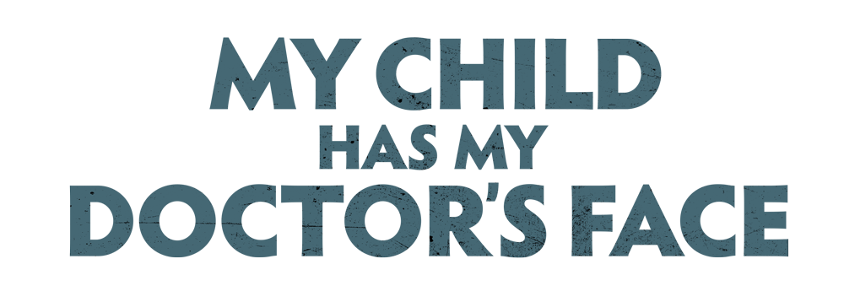

Johnson Production Group

Press Kit

# One-Liner

# When a woman discovers that her son’s biological father is actually their fertility doctor, she works to bring him to justice.

# Synopsis

# Young Henry is the light of Jessica and Dylan's life, but when Jessica discovers that his biological father is actually their fertility doctor, Dr. Bellamy, she teams up with another one of the doctor's clients to bring him to justice before he can destroy any more families.

# Producers

Executive Producers

TIMOTHY O. JOHNSON

JOSEPH WILKA

Co-Executive Producers

LISA ALFORD

Producer

ROBERT BALLO

Associate Producer

NIMA AZADI

Line Producer

NICOLE LAYSON

# Key Cast

|  |  |  |
| --- | --- | --- |
| CHARACTER  Jessica Graff  Dr. Preston Bellamy  Dylan Graff  Sarah Laughlin  Henry Graff |  | ACTOR  NATALIE POLISSON  DANIEL O’REILLY  JASON TOBIAS  KELSEY FORDHAM  VIRON SAGE WEAVER |

# Key Cast Biographies

## NATALIE POLISSON

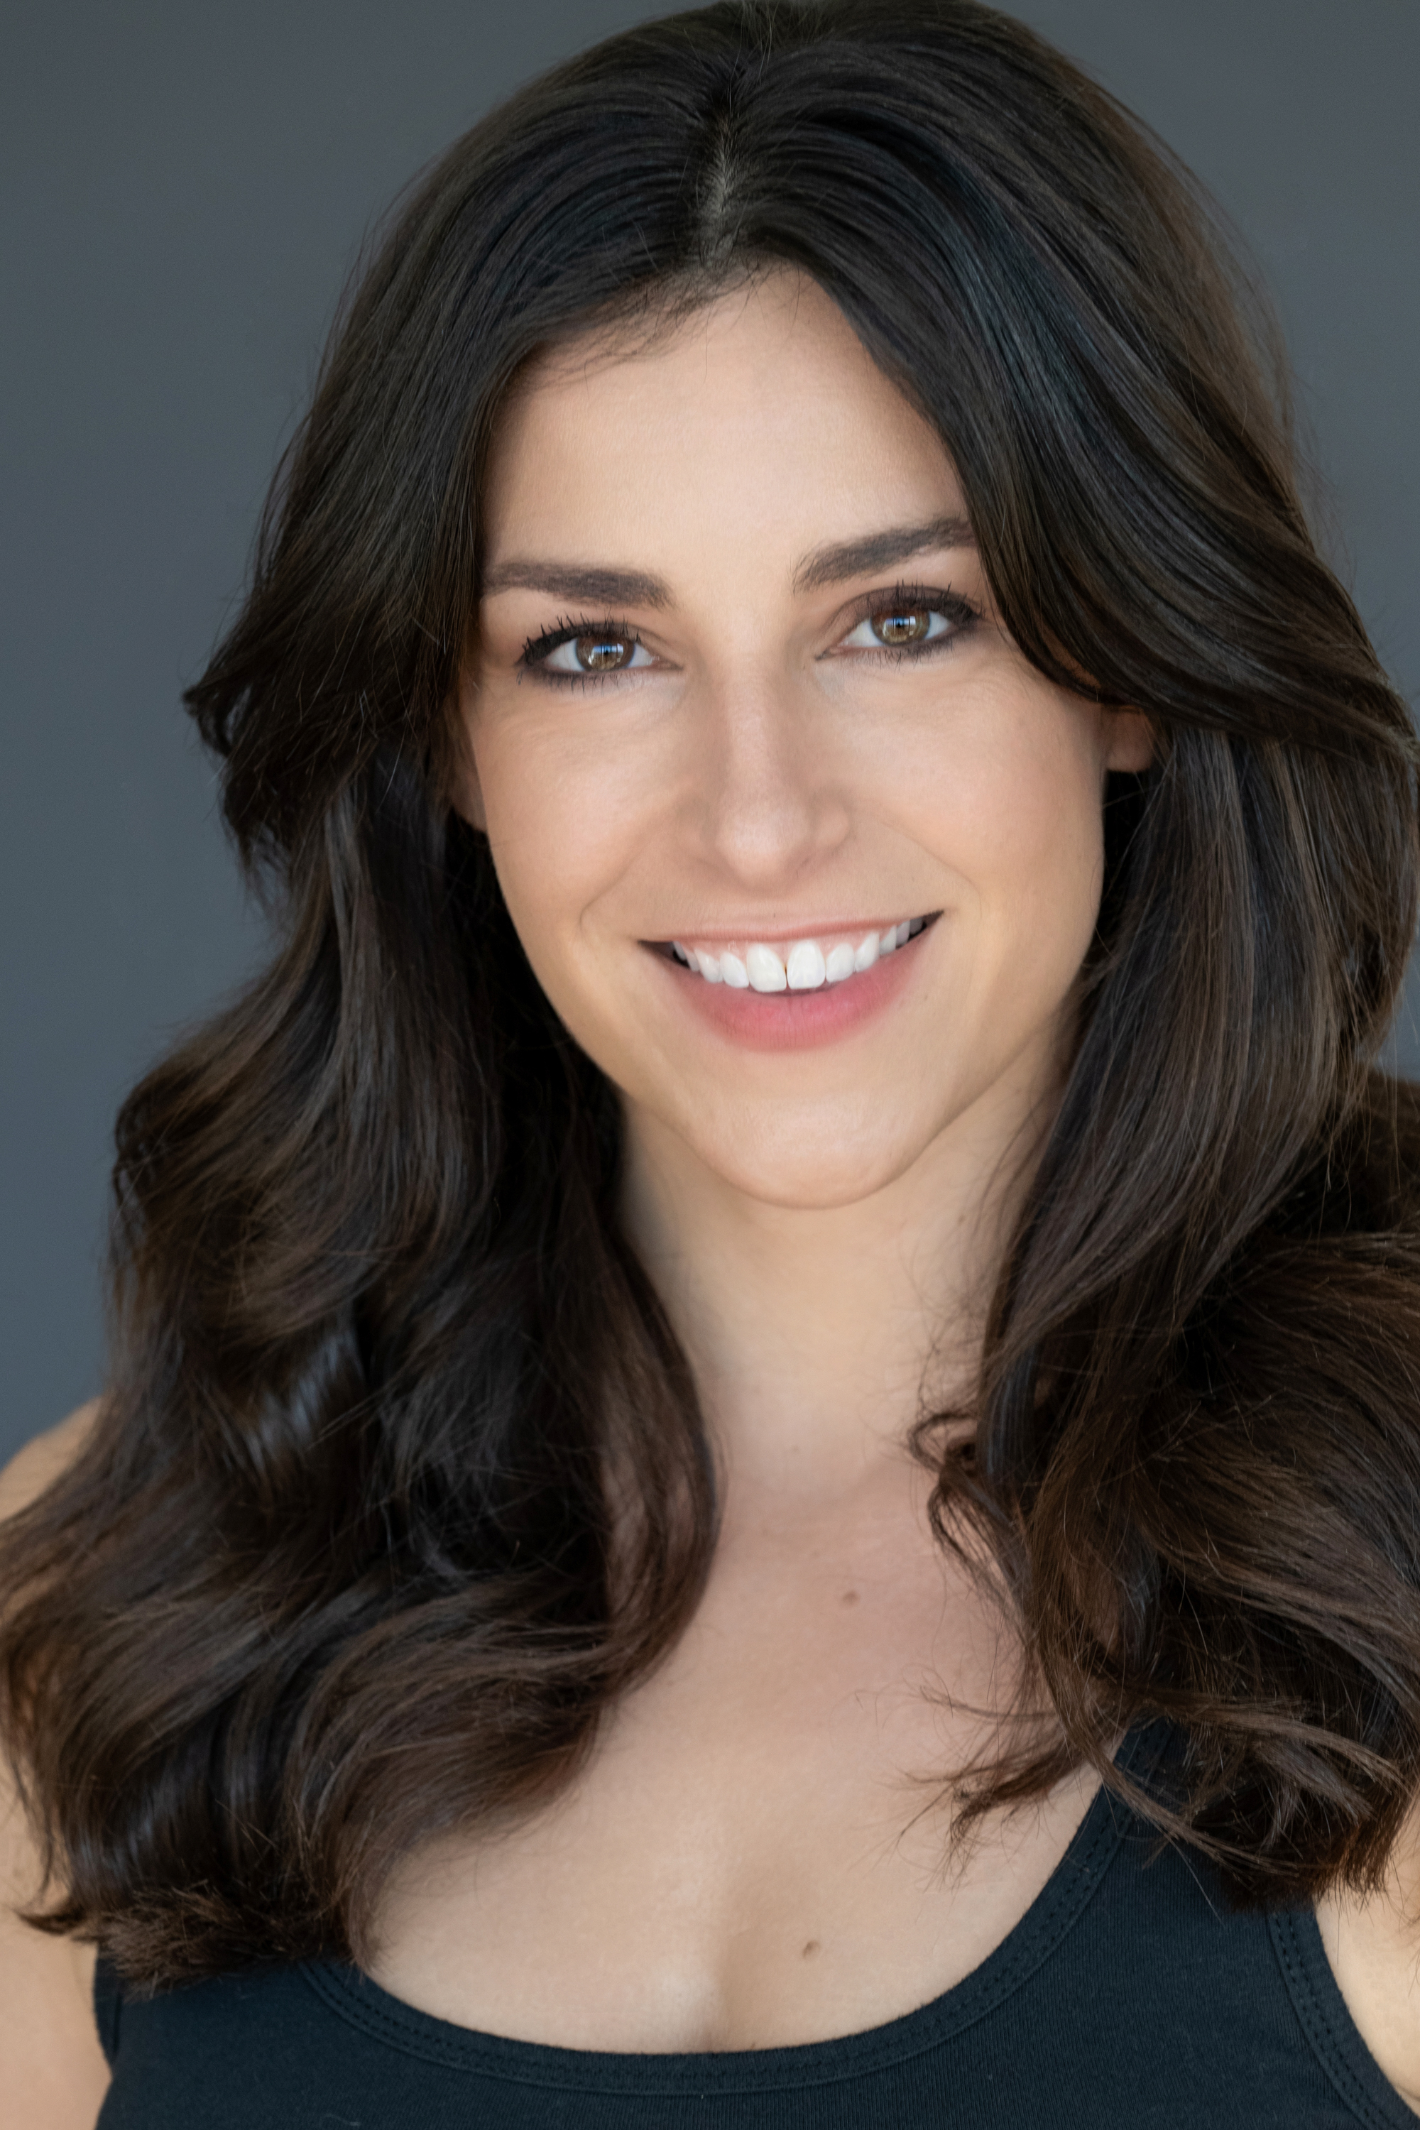Natalie Polisson, originally from northwest Indiana, has over 12 years of acting experience both in front of the camera and acting live on-stage. She has trained at John Rosenfeld Studios, UCB and with Annie Grindlay. Most recently she was a voice actor in Build-a-Bear's "Glisten and the Merry Misson" starring Chevy Chase, Freddie Prinz Jr, and Michael Rappaport, which received a wide national theatrical release in December of 2023. Natalie also appeared in "The Rise of Supermouth" by Stories International and recurs on "Chicken Girls" in addition to acting in 'Piercing Wounds', currently available on Amazon Prime. Finally, you have may have seen her as a vampire in Native's sunscreen commercial, airing nationally.

## DANIEL O’REILLY

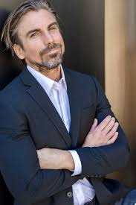Daniel O'Reilly is an American actor born in New Jersey. He has enjoyed some success as a semi-pro football player, a news anchor for CBS, print & promo modeling, commercial acting, followed by working on his first TV series "Bad Sides" in 2010 shot in Chicago, IL. Daniel made the permanent move to Los Angeles to pursue his passion for acting in December of 2011. Since then Daniel has forged a proactive creative path working alongside a wide variety of talented actors/filmmakers. He is a proud member of 'Truth Be Told' A Stanislavski/Meisner acting collective coached and directed by actor/filmmaker BoJesse Christopher. Daniel's natural ability to process material and make it his own allows him to live truthfully in the moment earning the respect of his creative peer group.

Daniel is most recently known for his work in The Girl on the Mountain (2022), Into the Wild Frontier (2022) and Christmas Angel (2023).

## JASON TOBIAS

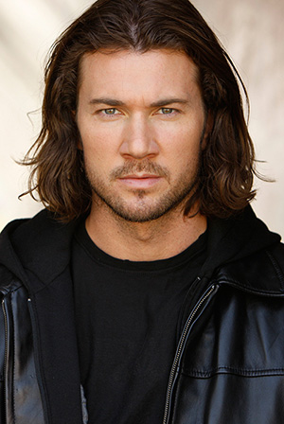Jason Tobias is an actor, writer, director, that grew up between the Bay Area and the east coast, throughout the late 80's and 90's.Since he was a child, he has loved storytelling. His strongest influences include; Classic Literature, Comics, Cartoons, Video Games, the Summer Blockbuster and Family.

He moved to Los Angeles in the spring of '09. In pursuing his acting career, he has built credits on popular shows like; "Better Things" (FX), "Dead To Me" (Netflix), "Justified" (FX), "The Fosters" (ABC Family), "Nashville" (CMT), and Independent feature films, "Downrange" (Ryuhei Kitamura), "Can't Have You" (Mark A. Altman).

In 2016, Jason wrote, produced and starred in, his first award winning short film: "Star Wars: Generations". It won with Disney/Lucasfilm at Star Wars Celebration, at London that year.

In 2017, Jason created the production company; 'Action Figure Entertainment' with long time friend and collaborator Lucas Solomon. Together partnered with Blair Pennington, they develop, produce and deliver, high concept, scripted series and feature films.

In 2021, Action Figure Entertainment released "F.E.A.R." (Geoff Reisner & Jason Tobias) their first feature film from their production banner. Jason co-directed, wrote, produced and stars in the picture.

## KELSEY FORDHAM

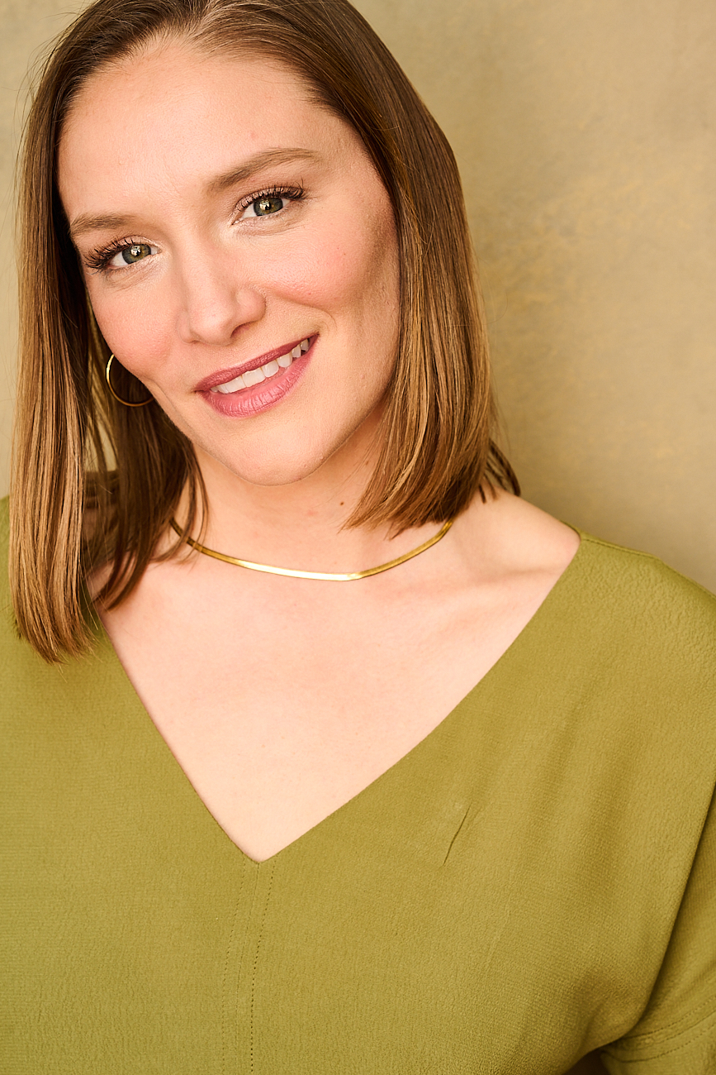Kelsey Fordham is an award-winning director, actress and producer committed to telling powerful and daring stories with a soul. Her art is influenced by over 6 years of work for a documentary-based NGO that partnered with local leaders to provide protection resources to vulnerable communities in some of the most dangerous areas of central Africa. There, Kelsey witnessed film at its best and fell head over heels for the power of storytelling.

As an actor Kelsey is known for her ability to tap into the depths of the human experience with raw honesty, vulnerability and strength. She is a winner of Leah Daniels Butler's 2020 Monologue Challenge and won Best Actress at the 2022 San Diego Film Awards for her leading role in Entitled. Last November she led a 9-show run as May in The Hudson Theatres production of Sam Shepard's iconic and mercurial play, Fool for Love, and will make her feature film debut as the lead in Blood Wine – which began production in fall 2023.

As a filmmaker, Kelsey has produced over a dozen projects including Harry Shum Jr's 2021 proof of concept, Milo, starring Shum Jr. and Kheng Hua Tan, the 2019 HBO APA Visionaries winning film, Halwa, and the 2020 Academy Sponsored Armed with a Camera film Thank You, Come Again.

In 2020 Kelsey directed her first film, Entitled - a story about a woman thrust into the spotlight when the details of her sexual assault go viral. Her directorial debut had its World Premiere at HollyShorts and won the Grand Jury Prize for Best U.S. Narrative Short at DC Shorts in 2021.

Kelsey's films have premiered at Austin Film Festival, HollyShorts, Outfest, San Diego International Film Festival, LAAPFF, LA Shorts, Dances With Films, among others and have aired and streamed on HBO and Disney+ Hotstar.

## VIRON SAGE WEAVER

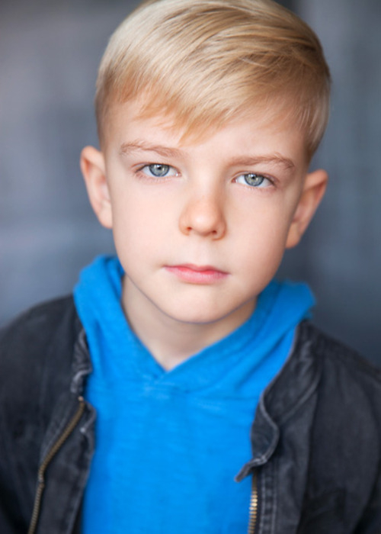At the age of 8, Viron Weaver is already a seasoned actor. His first performance was as an infant and he hasn’t slowed down since. Born in Los Angeles to an industry family (all 3 siblings and both parents are in show business), his precociousness and mature work ethic have served him well as a guest star in primetime network series as well as in his recurring role as Wiley Quartermaine-Corinthos on General Hospital (49 episodes and counting).

Viron has also had roles in Luba The Angel Of Bergen Belsen, My Best Friend Ruined My Life and Famish.

# Production Credits

### Full Cast

|  |  |
| --- | --- |
| [Actors](http://www.imdb.com/name/nm7589451/?ref_=ttfc_fc_cl_t1)  NATALIE POLISSON  DANIEL O'REILLY  JASON TOBIAS  KELSEY FORDHAM  VIRON SAGE WEAVER  JAX BINKERT  ARIEL POLANCO  JUSTIN POWELL  MICHAEL PROFUNATO  ALYX LEE  Background  DEVIN GIST  CHASE ROQUES  ADI SEGAL  ARIA WALTON  ARINA KHOJAYEVA  STEPHANIE NIELSEN  CHRISTIAN SAAD  MATTHEW VIG  AIDA BOUKENTER  FRANK INGLIS  ERICK NUNEZ  EMILIA FOKOVA  DERICK CLARK JR.  JET ECHEGOYEN  SET ECHEGOYEN  SELAH GARCIA  VALE WEAVER  MICHAEL DODD  RAMESH DURAIRAJ  STREAM GARDNER  RAYNOLD FABRE JEUNE  JOANNA PITTMAN  ERIC BERGNER  JERICK FUENTES  BRITTANI MEDINA  ZACHARY MICAL  DANI CHACE  LESLY FLORES  JAYSON GALLAGHER  ALEX KEEME  ELYSE LOPEZ  CELINE HOPE  SHOSHANAH MANASEE  REINA GUTIERREZ  LILLIAN COLUCCI  KAMILLA SHIMINA  BRIELLE DEGROOT  MADISON DESILVA  MILAN LYKOY  SHANE MANOR  ANDRIA KIPHIANI  JULIAN DOW  MAVERICK MANASEE | Role  Jessica Graff  Dr. Preston Bellamy  Dylan Graff  Sarah Laughlin  Henry Graff  Emmett  Bellamy's Driver  Connor  Michael Graff  Tammy  Bellamy's Son  Nurse  Pregnant Woman  Kids in the Waiting Room  Park Goers  Paramedics  Detectives  Police Officers  Book Reading Patrons |

### Casting By

ROBIN DE LANO  
NICOLE DIONNE

### Makeup By

ASHLEY ALDERIDGE

### Sound Design By

ANDRES BOULTON

### Music By

LUNA PAN

### Edited By

JOSHUA BUTLER

### Costume Designer

ZHEN ZHEN ZHONG

### Production Designer

CAMERON BARRETT

### Director of Photography

CHRISTOS BITSAKOS

### Associate Producer

NIMA AZADI

### Line Producer

NICOLE LAYSON

### Story By

DANE K. BRAUN

### Screenplay By

DANE K. BRAUN  
JOSHUA BUTLER

### Directed By

JOSHUA BUTLER

### Full Crew

|  |  |
| --- | --- |
| DENZEL JOHN | 1st Assistant Director |
| AIDA BOUKENTER | 2nd Assistant Director |
| CHARLIE REETZ | Steadi Cam / B Camera Operator |
| MOLLY WHITE | 1st Assistant Camera - A Cam |
| REID COLLINS | 1st Assistant Camera - B Cam |
| KATE BITSAKOS | 2nd Assistant Camera / DIT |
| STEVE CURLY | Still Photographer |
| JUSTIN THATCHER | Chief Lighting Technicians |
| AYDEN MARCUS |  |
| DAVID BARAHONA | Best Boy Electric |
| DANIEL CASTILLO | Key Grips |
| NICK GIGGANS-HILL |  |
| EDGAR NUNLEY | Best Boy Grips |
| ALEX TOBIAS |  |
| MARSHALL VICTORY |  |
| AMANDA TORRES | Grip & Electric Swings |
| AIDAN KOSTICH |  |
| JASON ROSE | Additional Editorial |
| CHANTAL MASSUH-FOX | Art Director |
| ZYEIR DANTE LASLEY SHABETE | Art Production Assistants |
| ANDREW MORRIS |  |
| JASON MORAN | Production Sound Mixer |
| STACY HILL |  |
| ALI YAMASHITA | Boom Operator |
| MAX ZAROU | Studio Teachers |
| TOM PORTER |  |
| CAROLINE LUND |  |
| FRANK INGLIS | Production Assistants |
| ERICK NUNEZ |  |
| JASON TATE |  |
| LINDSEY PRECIADO |  |
| JADEN JAVIER |  |
| SARA DAWIDIAN |  |
| ANDREW MORRIS |  |
| COLIN SIMJIAN |  |
| DOUGIE SMITH | Transportation Driver |
| BOOKED TALENT | Background Casting |
| STUDIO KIDS |  |
| KIDS! MANAGEMENT |  |
| TONY MONTANA | Catering |
| GALLAGHER RISK MANAGEMENT SERVICES LLC. | Production Insurance |
| WRAPBOOK | Payroll |
| DOERTE LINDNER | Accounting |
| NIMA AZADI | Post Production Supervisor |
| ANDRES BOULTON | Supervising Sound Editor |
| SCOTT CASILLAS | Foley Artist |
| NICK HURTADO | Foley Editor |
| JONATHAN MORGAN | Sound Editor |
| ANDRES BOULTON | Re-Recording Sound Mixer |
| BLUELINE FINISHING | Conform and Delivery |
| RANDY COONFIELD | Colorist |
| VICAPS | Captioning by |
| POND5 | Stock Footage |
| ALEX MUELLER | Musician (Viola) |
| ARZO YUSUF | Special Thanks |
| CITY OF LAVERNE |  |
| UNIVERSITY OF LAVERNE |  |
| LOOPER THE DOG |  |

# Producer Biographies

## TIMOTHY O. JOHNSON – Executive Producer

Timothy O. Johnson is among the most active and reliable producers in the business thanks to top rate productions and global distribution appeal. He is the managing partner of Johnson Production Group, a Canadian based operation that produces over 100 hours of dramatic television annually with hundreds of programs running internationally. The company is the leader supplier to Lifetime, Hallmark and other international outlets.

A graduate of the Marshall School of Business at the University of Southern California, he served as President of the USC Entertainment Management Association and a member of the Advisory Committee of the Center for Entrepreneurial Studies.

Johnson is also responsible for producing the international hit series, DR. QUINN, MEDICINE WOMAN for CBS for over 5 seasons. During his 100-episode tenure, he also developed and produced the original docu-drama COLD CASE for CBS network, which was the very first program to integrate television with the Internet.

Most recently, Johnson has produced the THE NOEL DIARY, being the #1 Film on Netflix’s Top 10 list in December of 2022. He was also at the helm of the successful GIRL IN THE SHED: THE KIDNAPPING OF ABBY HERNANDEZ, as well as the V.C. Andrews series of films, to date including TWILIGHT’S CHILD, MIDNIGHT WHISPERS, and DAWN, all produced for Lifetime..

Johnson has produced over 400 movies and 15 globally released series for every major US network - including Netflix, Lifetime, Hallmark, ABC, Disney, CBS, NBC, Netfly, FOX and Sony.

## JOHNSON PRODUCTION GROUP

The Johnson Production Group contracts globally to produce television content for international networks, studios and distributors. Based in Los Angeles and Vancouver, British Columbia, the company manages production, facilitates development and financing, procures distribution and guarantees quality and timely execution of its programs. While costs have gone up, so has the demand for quality. No longer is good enough, good enough. Johnson Production Group serves that segment when a show needs to be "A" quality, but produced efficiently enough to meet a locked budget. JPG specializes in value, protection of creative elements, and delivery of a quality finished product.

## JOSEPH WILKA – Executive Producer

Joseph Wilka is the Head of Production for Johnson Production Group. Los Angeles-based, Joseph had already produced and directed several feature films before serving as the senior marketing executive for Gravitas Ventures. While at Gravitas, Wilka helped pioneer new distribution models for independent films including day-and-date theatrical releases. It was also at Gravitas where Joseph first worked with Johnson Production Group to facilitate the release of their films to the worldwide Video On Demand audience. After serving as the Director of Distribution and Production for Viva Pictures, where he produced English-language versions of foreign animated titles for DirecTV, Wilka officially joined Johnson Production Group. As Head of Production, he oversees the development, production, and distribution of films from multiple production units for release on broadcast and streaming platforms.

## LISA ALFORD – Co-Executive Producer

Lisa Alford is a development executive at Johnson Production Group. A Massachusetts native, Lisa has lived and worked in Los Angeles for over a decade, always in support of excellent storytelling. Prior to joining Johnson Production Group, Lisa worked as an executive at TriStar television where she specialized in identifying IP that supported TriStar’s mission to feature diverse, authentic characters and champion underrepresented voices. Lisa came up at Sony Pictures Television where she worked as a production coordinator in the Television Movies and Miniseries department and in the writers room on the WGN hit series OUTSIDERS. In her current role, Lisa shepherds projects from the concept phase through story development, production, and post.

ROBERT BALLO – Producer  
With over 34 years of industry experience, Robert Ballo has created award-winning productions for clients that include ABC, TBS, PBS, Discovery Channel, and Lifetime, and that have aired on national network television, cable networks, and internationally in Asia and Europe. As Director of Photography and Producer at Shadowland, Ballo has created over a dozen feature films seen on the Lifetime Network and distributed internationally. As Director of Photography, his Shadowland films include MISSING AT 17, THE SURROGATE, STALKED AT 17, TEENAGE BANK HEIST, WALKING THE HALLS, BETRAYED AT 17, HOME INVASION, MATERNAL OBSESSION, ACCUSED AT 17 and SPECTRES. Other feature film credits include RUNNIN' AT MIDNITE, THE AFFAIRand STARVING ARTISTS. Ballo has also traveled the world on many documentary productions.

His television credits for national broadcast and cable networks include COLLEGE SPORTS IN AMERICA, GREAT EUROPEAN BALLOON ADVENTURE, DIRTY HARRY THE ORIGINAL, THE GREAT YEAR, and THE ROSE PARADE - PAGEANT FOR THE AGES. Through his other digital motion picture company, GOAL Productions, Ballo works with Fortune 500 companies, non-profit organizations and government agencies to produce sales and marketing videos as promotional communications. After a twenty-year tenure teaching film and video imaging, Ballo recently retired from his position as an Associate Professor of Practice at USC’s School of Cinematic Arts. A graduate of the USC film production program himself, Ballo is a member of the Academy of Television Arts and Sciences.

## Billing Block

LIFETIME Presents in association with JOHNSON PRODUCTION GROUP “MY CHILD HAS MY DOCTOR’S FACE” Starring NATALIE POLISSON DANIEL O’REILLY JASON TOBIAS KELSEY FORDHAM VIRON SAGE WEAVER Casting By ROBIN DE LANO NICOLE DIONNE Makeup By ASHLEY ALDERIDGE Sound Design By ANDRES BOULTON Music By LUNA PAN Edited By JOSHUA BUTLER Costume Designer ZHEN ZHEN ZHONG Production Designer CAMERON BARRETT Director Of Photography CHRISTOS BITSAKOS Associate Producer NIMA AZADI Line Producer NICOLE LAYSON Co-Executive Producer LISA ALFORD Executive Producers JOSEPH WILKA TIMOTHY O. JOHNSON Produced By ROBERT BALLO Story By DANE K. BRAUN Screenplay By DANE K. BRAUN JOSHUA BUTLER Directed By JOSHUA BUTLER

© MMXXIIIV Johnson Production Group Inc. All Rights Reserved





Meta Data

LONG (max 3000 characters) synopsis

Young Henry is the light of Jessica and Dylan's life, but when Jessica discovers that his biological father is actually their fertility doctor, Dr. Bellamy, she teams up with another one of the doctor's clients to bring him to justice before he can destroy any more families. (275)

MEDIUM (max 500) synopsis

Young Henry is the light of Jessica and Dylan's life, but when Jessica discovers that his biological father is actually their fertility doctor, Dr. Bellamy, she teams up with another one of the doctor's clients to bring him to justice before he can destroy any more families. (275)

SHORT (max 100 characters) synopsis

Jessica discovers her son’s biological father is actually their fertility doctor and vows justice. (98)

5 KEY WORDS

Sperm donor, family, justice, DNA