**POLAR OPPOSITES**

Johnson Production Group

Press Kit

# One-Liner

Emma Rivera sneaks onto a research cruise to Antarctica to rescue her father, Ian, a penguin researcher, and unexpectedly teams up with Andy Jackson, a charming but reluctant engineer. As they navigate icy challenges, comedic mishaps, and a growing romantic connection, a shocking twist about Ian’s fate threatens to derail both their mission and their budding romance.

# Synopsis

Emma Rivera, a courtroom illustrator, heads to Antarctica to rescue her father, Ian, a passionate penguin researcher after receiving a cryptic and worrying call from him. In a hurry to get to him, she sneaks aboard a research cruise headed to Antarctica disguised as a crew member where she crosses paths with Andy Jackson, a charming yet flustered mechanical engineer. Initially at odds, Emma's quick thinking and Andy's reluctant complicity bind them in a covert alliance. Amid narrow escapes from the sharp-eyed Chief Officer Ingrid and comedic mishaps, Emma and Andy’s banter turns from exasperation to undeniable chemistry, hinting at more than just a shared goal of survival.

As their journey plunges deeper into icy waters, their connection grows. Between shared laughs and heartfelt exchanges about love and loyalty, sparks fly in the most unexpected places. But just as things heat up, a heart-pounding revelation about Ian’s predicament throws a wrench in their budding romance. Will their journey leave them out in the cold before love has a chance to heat things up, or can their teamwork light the fire that will bring them together and melt their hearts along the way?

# Producers

Executive Producers

TIMOTHY O. JOHNSON

JOSEPH WILKA

Co-Executive Producer

LISA ALFORD

Producer

DAVID BOYLES

# Key Cast

|  |  |  |
| --- | --- | --- |
| CHARACTER  Emma  Andy  Ian  Peg |  | ACTOR  RHIANNON FISH  MARKIAN TARASIUK  DEAN McDERMOTT  MAEVE QUINLAN |

# Key Cast Biographies

# RHIANNON FISH

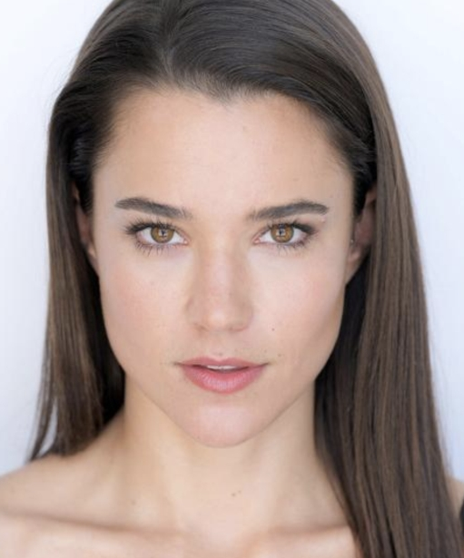From Australian soap star to Hallmark sweetheart, Rhiannon Fish has range. Getting started on the small screen at the age of 11, the 32-year-old Canada-born Australia-raised actress made her television debut on the hit series Neighbours.

Roles that followed were in series such as As the Bell Rings and Satisfaction before her role of April Scott in Home and Away, an Australian soap opera, brought her recognition on a much greater scale from 2010 to 2013.

Later, Fish had a recurring role in the popular science-fiction series The 100 and appeared in films such as Occupation, You’re Bacon Me Crazy and A Love to Remember before making her debut on the Hallmark Channel in Aurora Teagarden Mysteries: How To Con a Con. She has appeared in two of the Hallmark Mystery Signed, Sealed and Delivered films: The Vows We Have Made and A Tale of Three Letters.

It wasn’t until 2021’s Journey of My Heart that she shined on the Hallmark screen as a leading lady opposite Darien Martin, followed by A Splash of Love, A Picture of Her and A Costa Rican Wedding.

# MARKIAN TARASIUK

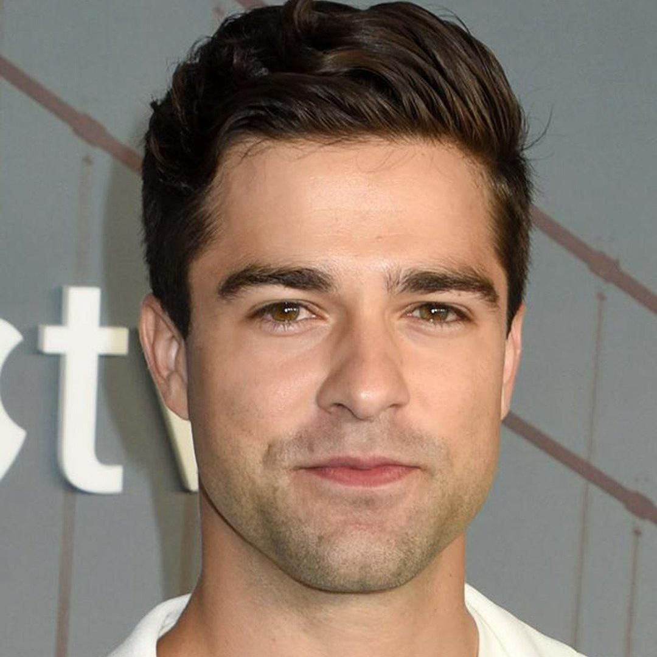Markian Tarasiuk started taking acting classes when he was six years old and performed in his first play at the age of 14 in Winnipeg and it was then he knew he wanted to be an actor. Since that time, his acting career has taken him all over Canada and he has starred in multiple films such as There’s Someone Inside Your House (UBCP/ACTRA Awards nomination, Best Supporting Actor) and Christmas Jars (Canadian Screen Awards nomination, Best Actor). His upcoming movie “Why Can't My Life be a Rom Com?” will be premiering in 2023 on E!. Tarasiuk has also appeared in many television series most recently, “Surface” for Apple TV+, “Family Law” on The CW, “The Night Agent,” “Virgin River” on Netflix, “Supernatural” on The CW, in addition to many roles in Hallmark Channel original movies. On stage he performed in the production of Sex With Strangers (Mitch and Murray Productions) and has acted in other noteworthy productions such as Billy Elliot, Over the Tavern (RMTC), Vincent River (Osimous) and Footloose (Rainbow Stage). Tarasiuk served as the General Manager and Artistic Producer of SpeakEasy Theatre in Vancouver from 2015-2021 and was nominated for five Jessie Awards for the critically acclaimed production of The Shipment by Young Jean Lee.

# DEAN McDERMOTT

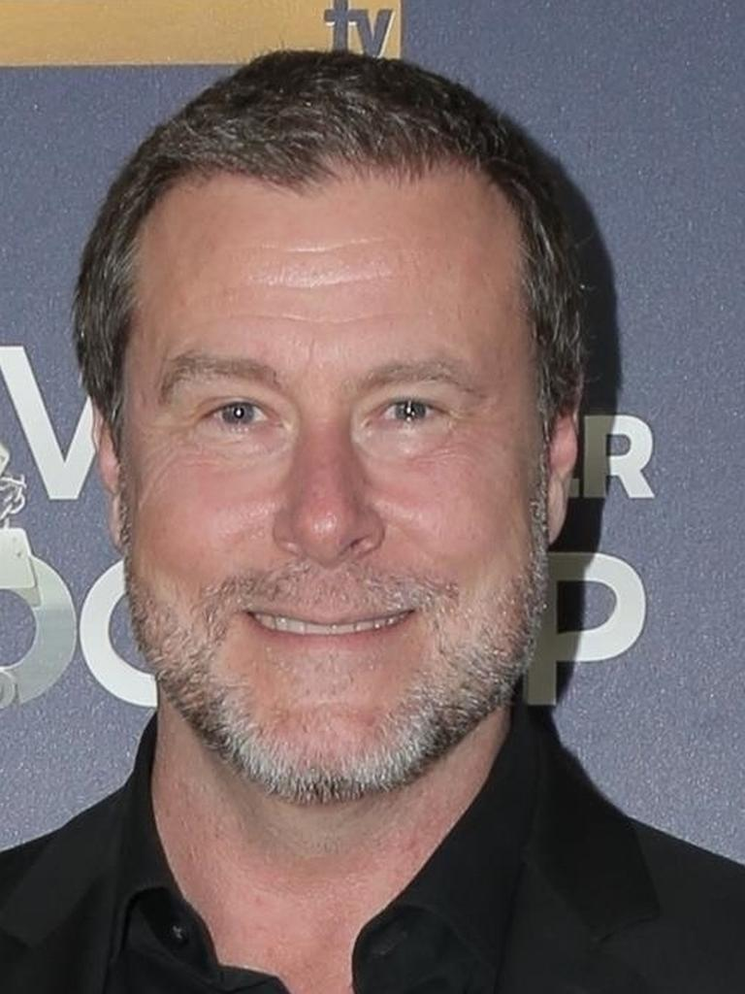Dean McDermott (born November 16, 1966) is a Canadian actor best known as a reality television personality with his former wife, actress Tori Spelling, and as the host of the cooking competition Chopped Canada. He played the role of Constable Renfield Turnbull on the TV series Due South.

McDermott was born in Toronto, Ontario, Canada, to David and Doreen McDermott. He has three sisters, Dale, Dawn, and Dana. He graduated from North Albion Collegiate Institute in Toronto's Rexdale neighbourhood.

McDermott has performed in films Open Range, Irvine Welsh's Ecstasy and Against the Ropes. He has appeared in several TV movies including Always and Forever, Santa Baby 2: Christmas Maybe and A Christmas Visitor.

McDermott has had a variety of guest and recurring roles on television series, such as Earth: Final Conflict, Tracker, 1-800-Missing, NCIS and CSI: Crime Scene Investigation. 2016 saw McDermott take on a starring role, portraying Iain Vaughn on Slasher.

McDermott is a professionally trained chef. In 2013, he became a member of "Team Guy" on the second season of Food Network's Rachael vs. Guy: Celebrity Cook-Off and was the winner, and in January 2014, McDermott began hosting Chopped Canada on Food Network Canada. McDermott hosted Chopped Canada for two seasons, announcing in March 2015 that he would leave the show.

McDermott released a cookbook The Gourmet Dad, in which he wanted to make intimidating plates more attractive to kids.

**MAEVE QUINLAN**

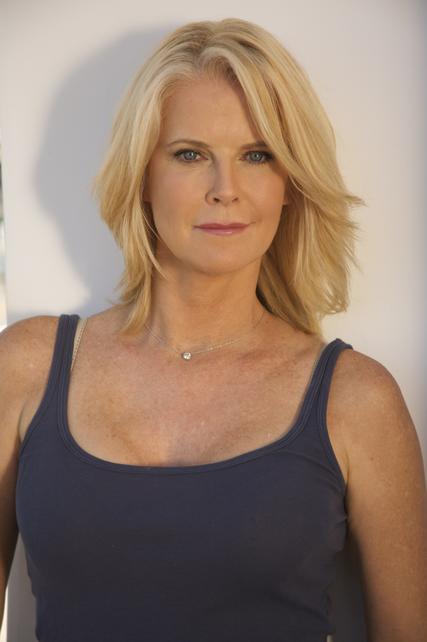Born in Chicago from Irish parent, blonde, tall and very beautiful, Maeve Quinlan entered in the professional tennis circuit at age 16, appearing in several major tournaments and eventually reaching seed position #95 in world rankings, before turning to acting; she has starred in many films in supporting roles such as The Florentine (1999) with Tom Sizemore, co-star in Totally Blonde (2001) with Krista Allen and also in controversial film Ken Park (2002) in Rhonda's role followed by a role in another film thriller Net Games (2003) with C. Thomas Howell; in 2004, is lead actress in film The Drone Virus (2004) and plays supporting role in film comedy Criminal (2004) with John C. Reilly, while in 2005 she plays another supporting role in The Nickel Children (2005), but Maeve Quinlan is best known for her role as secretary Megan Conley/Brenda in The Bold and the Beautiful (1987) series Tv; she then went on to work on many other TV series and films as South of Nowhere (2005) plays Paula Carlin, star and product series Tv 3Way (2008), co-star in Not Easily Broken (2009) with Taraji P. Henson, and is the lead actress star in film Tv Teenage Bank Heist (2012); co-star in films as Double Daddy (2015), the thriller The Stalker Club (2017) and in The Sinister Surrogate (2018). Recent appearances have been co-starring roles in My Father's Murder in Greece, Beware the Night Nurse (2023), The Paramedic Who Stalked Me (2023), A Job to Die For (2022), Our Almost Completely True Story (2021) and Riley Parra: Better Angels (2019).

# Production Credits

### Full Cast

|  |  |
| --- | --- |
| [**Actors**](http://www.imdb.com/name/nm7589451/?ref_=ttfc_fc_cl_t1)  RHIANNON FISH  MARKIAN TARASIUK  DEAN MC DERMOTT  RAISSA XAVIER  MICHEL HERSCH  MAEVE QUINLAN  ELENA GOWLAND  JOHN SILVERMAN  DAVID FRIEDLANDER  DARIA NEFODOVA | **Role**  Emma  Andy  Ian  Ingrid  Martin  Peg  Gloria  Boris  Boris  Doctor |

### Casting

BRIAN LEVY CASTING INC csa

### Composer

RUSS HOWARD III

### Costume Designer

FLOR FONTELES

### Editor

ROB PALLATINA

### Production Designer

OLGA MADRIGAL

### Director Of Photography

BRANDEN MAXHAM

### Written By

BARBARA KYMLICKA

### Directed By

COLIN THEYS

### Full Crew

|  |  |
| --- | --- |
| TRAVIS LASALLE | First Assistant Director |
| DAVID BOYLES | Producer |
| DAVID BOYLES | Line Producer |
| GABRIEL BICO | Brazilian Co-Producer |
| SERENO BICO | Brazilian Line Producer |
| TETE DEPETRIS | Argentina Co-Producer |
| EZEQUIEL LABORDA | Argentina Line Producer |
| MAYRA SANTOS | Peru Co-Producer |
| SANDRA DE UGARTE | Peru Production Manager |
| JOHN SILVERMAN | Unit Production Manager |
| ELVIA MEGA | Associate Producers |
| JOHN DILBECK III |  |
| MAURICIO "MAU MAU" FONTOURA | Brazilian Key PA |
| ICARO MEIRELLES DIAS | Brazilian PA |
| JAMILLE FORTUNAO SOUZA GÓIS | Brazilian Talent PA |
| ROBERTO CARLOS | Brazilian Driver |
| MATIAS TORINO | Argentina Key PA |
| ALEXANDRO RIVERA | Argentina PA |
| OLGA MADRIGAL | Production Designer |
| PAULA DEVITA | Art Director |
| FLOR FONTELES | Costume Designer |
| AGUSTIN LITTLE | Canadian Wardrobe assist |
| FLOR FONTELES | Stylist for Rhiannon Fish |
| FLOR FONTELES | Stylist for Markian Tarasiuk |
| KAMILLA AIRES | Brazilian Wardrobe Assist |
| EMA BOGDANICH | Argentina Wardrobe PA |
| BRANDEN MAXHAM | Director of Photography |
| BRANDEN MAXHAM | A Camera Operator |
| SAM LÜSTED | 1st AC / Focus Puller |
| POLLY CHESNOKOVA | 2nd AC / B Camera Operator |
| DANTE VINCENZO | Brazil Drone Operator |
| ELVIA MEGA | DIT & Daily |
| ELVIA MEGA | Set Stills Photographer |
| IVAN SPIRIDONOFF | Gallery Photographer |
| JOSE PABLO GUEVARA | Gaffer |
| DAVID FRIEDLANDER | Key Grip |
| VINICIUS LUIS LEITE | Brazilian Swing Grip |
| NICOLAS PETROLI | Argentina Swing Grip |
| AXEL MASTACHE | Sound Engineer |
| AXEL MASTACHE | Boom Operator |
| SEBASTIAN BELTRAME | Argentina co-Location Manager |
| MARINE ISRAEL | Argentina co-Location Manager |
| RODRIGO MENDOZA | Peru Mountain Guide |
| ENZO WALIGORA | Peru Mountain support |
| DANIEL MORALES | Peru Mountain support |
| DANIEL SERRANO | Peru Mountain support |
| ALFREDO ZUÑIGA | Peru On-set Medic |
| PAULA CARVAJAL | Key Makeup |
| MARIBEL MORALES | Key Hair Stylist |
| DONATA MAMANI | Peru Mountain Cook |
| NIDIO AUCACUSI | Peru Mountain Cook |
| CEFERINO QUISPE | Peru Mountain Cook |
| PAULINO QUISPE | Peru Mountain Cook |
| ALFREDO ZUÑIGA | Peru Safety Coordinator |
| KAYNE DIPILATO | Snowmobile double |
| ALEJANDRO RIVERO | Snowmobile double |
| SOL RODRIGUEZ | Body double |
| GONZALO GRANERO | Body double |
| COASTAL CLEARANCES INC | Script Clearances |
| GREGORY K. BOONE | Legal Services |
| CHANDLER FOGDEN LYMAN LAW CORPORATION | Legal Services |
| HOLLYWARE LLC | Production Service Company |
| MOMENTOUS INSURANCE BROKERAGE | Insurance |
| ROBIN CONLY | Post Production Supervisor |
| RUSS HOWARD III | Music |
| ANDRES BOULTON | Re-Recording Mixer |
| ANDRES BOULTON | Supervising Sound Editor |
| JONATHAN MORGAN | Sound Effects Editor |
| LA COLEMBA | VFX |
| LUIS MIGUEL HENAO | VFX Supervisor |
| CATALINA VIEIRA | VFX Artists |
| GUILLERMO RESTREPO C |  |
| EMANUEL PALACIOS |  |
| DIEGO A CAMELO P |  |
| FELIPE CONTRERAS |  |
| KEVIN GOMEZ |  |
| OMAR RODRIGUEZ CAICEDO |  |
| DANIEL DAVID LOZANO |  |
| KYOTOCOLOR | Digital Intermediate Services |
| WENDY CELESTE | Online Editor |
| BRADLEY GREER | Colorist |
| BLUELINE FINISHING | Digital Intermediate Services |
| BLUELINE FINISHING | Post Finishing |
| DR FREDERIQUE OLIVIER MEDIA PRODUCTIONS | Stock Footage |
| SWAN HELLENIC CRUISE LINE | Special Thanks |
| ANDRES ZITO |  |
| PATRIZIA ZITO |  |
| THE RESIDENTS OF THE VILLAGE OF PHINAYA , PERU |  |

# Producer Biographies

## TIMOTHY O. JOHNSON – Executive Producer

Timothy O. Johnson is among the most active and reliable producers in the business thanks to top rate productions and global distribution appeal. He is the managing partner of Johnson Production Group, a Canadian based operation that produces over 100 hours of dramatic television annually with hundreds of programs running internationally. The company is the leader supplier to Lifetime, Hallmark and other international outlets.

A graduate of the Marshall School of Business at the University of Southern California, he served as President of the USC Entertainment Management Association and a member of the Advisory Committee of the Center for Entrepreneurial Studies.

Johnson is also responsible for producing the international hit series, DR. QUINN, MEDICINE WOMAN for CBS for over 5 seasons. During his 100-episode tenure, he also developed and produced the original docu-drama COLD CASE for CBS network, which was the very first program to integrate television with the Internet.

Most recently, Johnson has produced the THE NOEL DIARY, being the #1 Film on Netflix’s Top 10 list in December of 2022. He was also at the helm of the successful GIRL IN THE SHED: THE KIDNAPPING OF ABBY HERNANDEZ, as well as the V.C. Andrews series of films, to date including TWILIGHT’S CHILD, MIDNIGHT WHISPERS, and DAWN, all produced for Lifetime..

Johnson has produced over 400 movies and 15 globally released series for every major US network - including Netflix, Lifetime, Hallmark, ABC, Disney, CBS, NBC, Netfly, FOX and Sony.

## JOHNSON PRODUCTION GROUP

Johnson Production Group packages, finances, and distributes television content to networks, studios and streamers. The company specializes in various types of programming including romances, thrillers, holiday and true crime TV movies.

The company has been involved in the production of over 3000 hours of network television, with over $1 billion spent on production. JPG specializes in value, efficiency, protection of creative elements, and delivery of a quality finished product.

## JOSEPH WILKA – Executive Producer

Joseph Wilka is the Head of Production for Johnson Production Group. Los Angeles-based, Joseph had already produced and directed several feature films before serving as the senior marketing executive for Gravitas Ventures. While at Gravitas, Wilka helped pioneer new distribution models for independent films including day-and-date theatrical releases. It was also at Gravitas where Joseph first worked with Johnson Production Group to facilitate the release of their films to the worldwide Video On Demand audience. After serving as the Director of Distribution and Production for Viva Pictures, where he produced English-language versions of foreign animated titles for DirecTV, Wilka officially joined Johnson Production Group. As Head of Production, he oversees the development, production, and distribution of films from multiple production units for release on broadcast and streaming platforms.

## LISA ALFORD – Co-Executive Producer

Lisa Alford is a development executive at Johnson Production Group. A Massachusetts native, Lisa has lived and worked in Los Angeles for over a decade, always in support of excellent storytelling. Prior to joining Johnson Production Group, Lisa worked as an executive at TriStar television where she specialized in identifying IP that supported TriStar’s mission to feature diverse, authentic characters and champion underrepresented voices. Lisa came up at Sony Pictures Television where she worked as a production coordinator in the Television Movies and Miniseries department and in the writers room on the WGN hit series OUTSIDERS. In her current role, Lisa shepherds projects from the concept phase through story development, production, and post.

## DAVID BOYLES – Producer

David is the primary producer for Hollyware LLC. He has over two decades of experience in developing, implementing and producing award winning projects in the entertainment industry. (Concept through Distribution) His extensive experience in international production of Film, Television, Commercials, Games, and mixed media enables him to deliver timely, on budget, and magical visuals mixed with compelling content.

## Billing Block

HALLMARK MEDIA Presents In Association With JOHNSON PRODUCTION GROUP   
**POLAR OPPOSITES** Starring RHIANNON FISH MARKIAN TARASIUK DEAN McDERMOTT RAISSA XAVIER MICHEL HERSCH With MAEVE QUINLAN Casting BRIAN LEVY CASTING INC CSA Composer RUSS HOWARD III Costume Designer FLOR FONTELES Editor ROB PALLATINA Production Designer OLGA MADRIGAL Director Of Photography BRANDEN MAXHAM Co-Executive Producer LISA ALFORD EXECUTIVE Producer JOSEPH WILKA Executive Producer TIMOTHY O. JOHNSON Producer DAVID BOYLES   
Written By BARBARA KYMLICKA Directed By COLIN THEYS

© MMXXIV Johnson Production Group Inc. All Rights Reserved





Meta Data

LONG (max 3000 characters) synopsis

Emma Rivera, a courtroom illustrator, heads to Antarctica to rescue her father, Ian, a passionate penguin researcher after receiving a cryptic and worrying call from him. In a hurry to get to him, she sneaks aboard a research cruise headed to Antarctica disguised as a crew member where she crosses paths with Andy Jackson, a charming yet flustered mechanical engineer. Initially at odds, Emma's quick thinking and Andy's reluctant complicity bind them in a covert alliance. Amid narrow escapes from the sharp-eyed Chief Officer Ingrid and comedic mishaps, Emma and Andy’s banter turns from exasperation to undeniable chemistry, hinting at more than just a shared goal of survival.

As their journey plunges deeper into icy waters, their connection grows. Between shared laughs and heartfelt exchanges about love and loyalty, sparks fly in the most unexpected places. But just as things heat up, a heart-pounding revelation about Ian’s predicament throws a wrench in their budding romance. Will their journey leave them out in the cold before love has a chance to heat things up, or can their teamwork light the fire that will bring them together and melt their hearts along the way? (1181)

MEDIUM (max 500) synopsis

Emma Rivera sneaks onto a research cruise to Antarctica to rescue her father, Ian, a penguin researcher, and unexpectedly teams up with Andy Jackson, a charming but reluctant engineer. As they navigate icy challenges, comedic mishaps, and a growing romantic connection, a shocking twist about Ian’s fate threatens to derail both their mission and their budding romance. (369)

SHORT (max 100 characters) synopsis

Emma sneaks onto a cruise to Antarctica to rescue her dad, teaming up with Andy, sparking romance. (97)

5 KEY WORDS

Cruise, Antartica, Penguins, Romance, Engineer