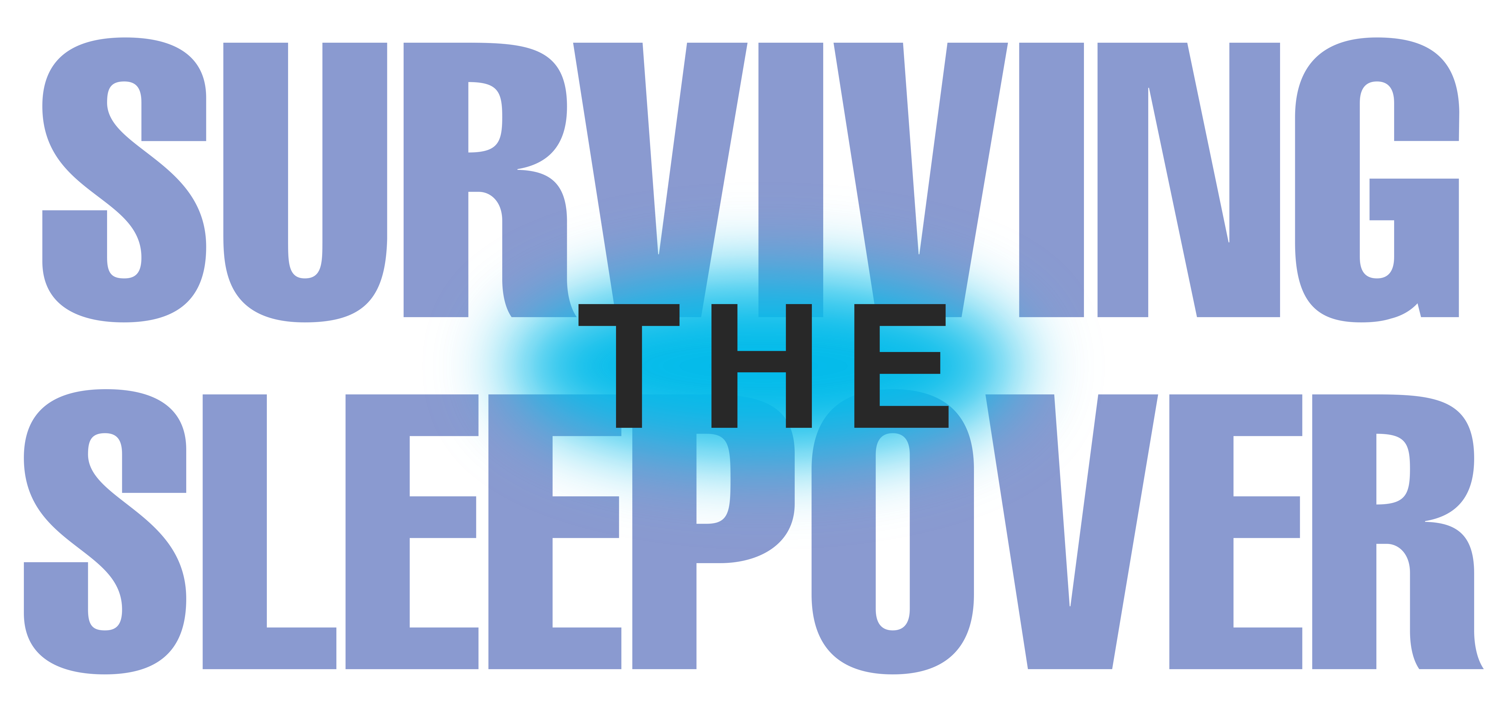
INSPIRED BY ACTUAL EVENTS

Johnson Production Group

Press Kit

One-Liner

Having trouble fitting in at her new high school, outspoken teen Hannah is invited to a sleepover, not realizing she was only invited to be the victim of a prank – but the night turns more sinister than she anticipated.

Synopsis

After the tragic death of her father, a young high school student named Hannah and her mother move to a new town. Three months into the school year, Hannah finally feels she’s making new friends. Hannah is invited to a sleepover at the popular Melissa's house, not realizing she was only invited to be the victim of a prank – but when the night turns more sinister than intended Hannah's mother will become her only chance of surviving the night.

Producers
Executive Producers
TIMOTHY O. JOHNSON
JOSEPH WILKA
Co-Executive Producer
LISA ALFORD
Producer
A.J. KELLY
JACOB HORN

Key Cast
CHARACTER  Hannah  Melissa  Abbie  Charlotte  Jessica  Cameron  Tracy |  | ACTOR  SLOAN MANNINO  JENNA HOGAN  SAGE MOORE  ABIGAIL VILLANUEVA  DAWN MARIE  JOSH BERTELL  JENNINGS RICE

Key Cast Biographies

SLOAN MANNINO

Sloan was born in New York and raised in a small town in Ohio. She now lives in Los Angeles. Growing up, Sloan was always involved in sports and broke many records for Track & Field as well as being a 2x Regional qualifier in personal events (300m hurdles and 100m hurdles). Though she spent most of her time in sports, she always had a love for TV and Film and knew it was her true passion. Some of her favorites growing up include The Wizard of Oz, Matilda, and Ferris Bueller's Day Off (her parents named her after the character Sloane Peterson, Ferris' girlfriend.
Sloan is known for her roles in Pi Day Die Day, Another Average Halloween, The Independents, and Skin in the Game. She will be playing the lead in the upcoming films Sabotaging the Squad and Sisterhood of Secrets as well as a recurring role in the upcoming series, The Ponds.

JENNA HOGAN

American actress and model, Jenna Hogan, earned her Associates Degree in Liberal Arts/Theatre at the Middlesex County College in New Jersey. Jenna grew up in New Jersey and now lives and works in LA as an actor and social media director. She made her directorial debut in 2023 with Echoes of a Gunman, on which she was also an Executive Producer.

SAGE MOORE

Sage Moore is known for the upcoming film Paper Crowns, Big Break (2023) and Blue Nights (2022).

ABIGAIL VILLANUEVA

Abigail Villanueva is a talented musician who has studied at the Actor Training Studio. She has modeled as well as appeared in several commercials. She is known for her work in Red and I Have A Boyfriend.

DAWN MARIE
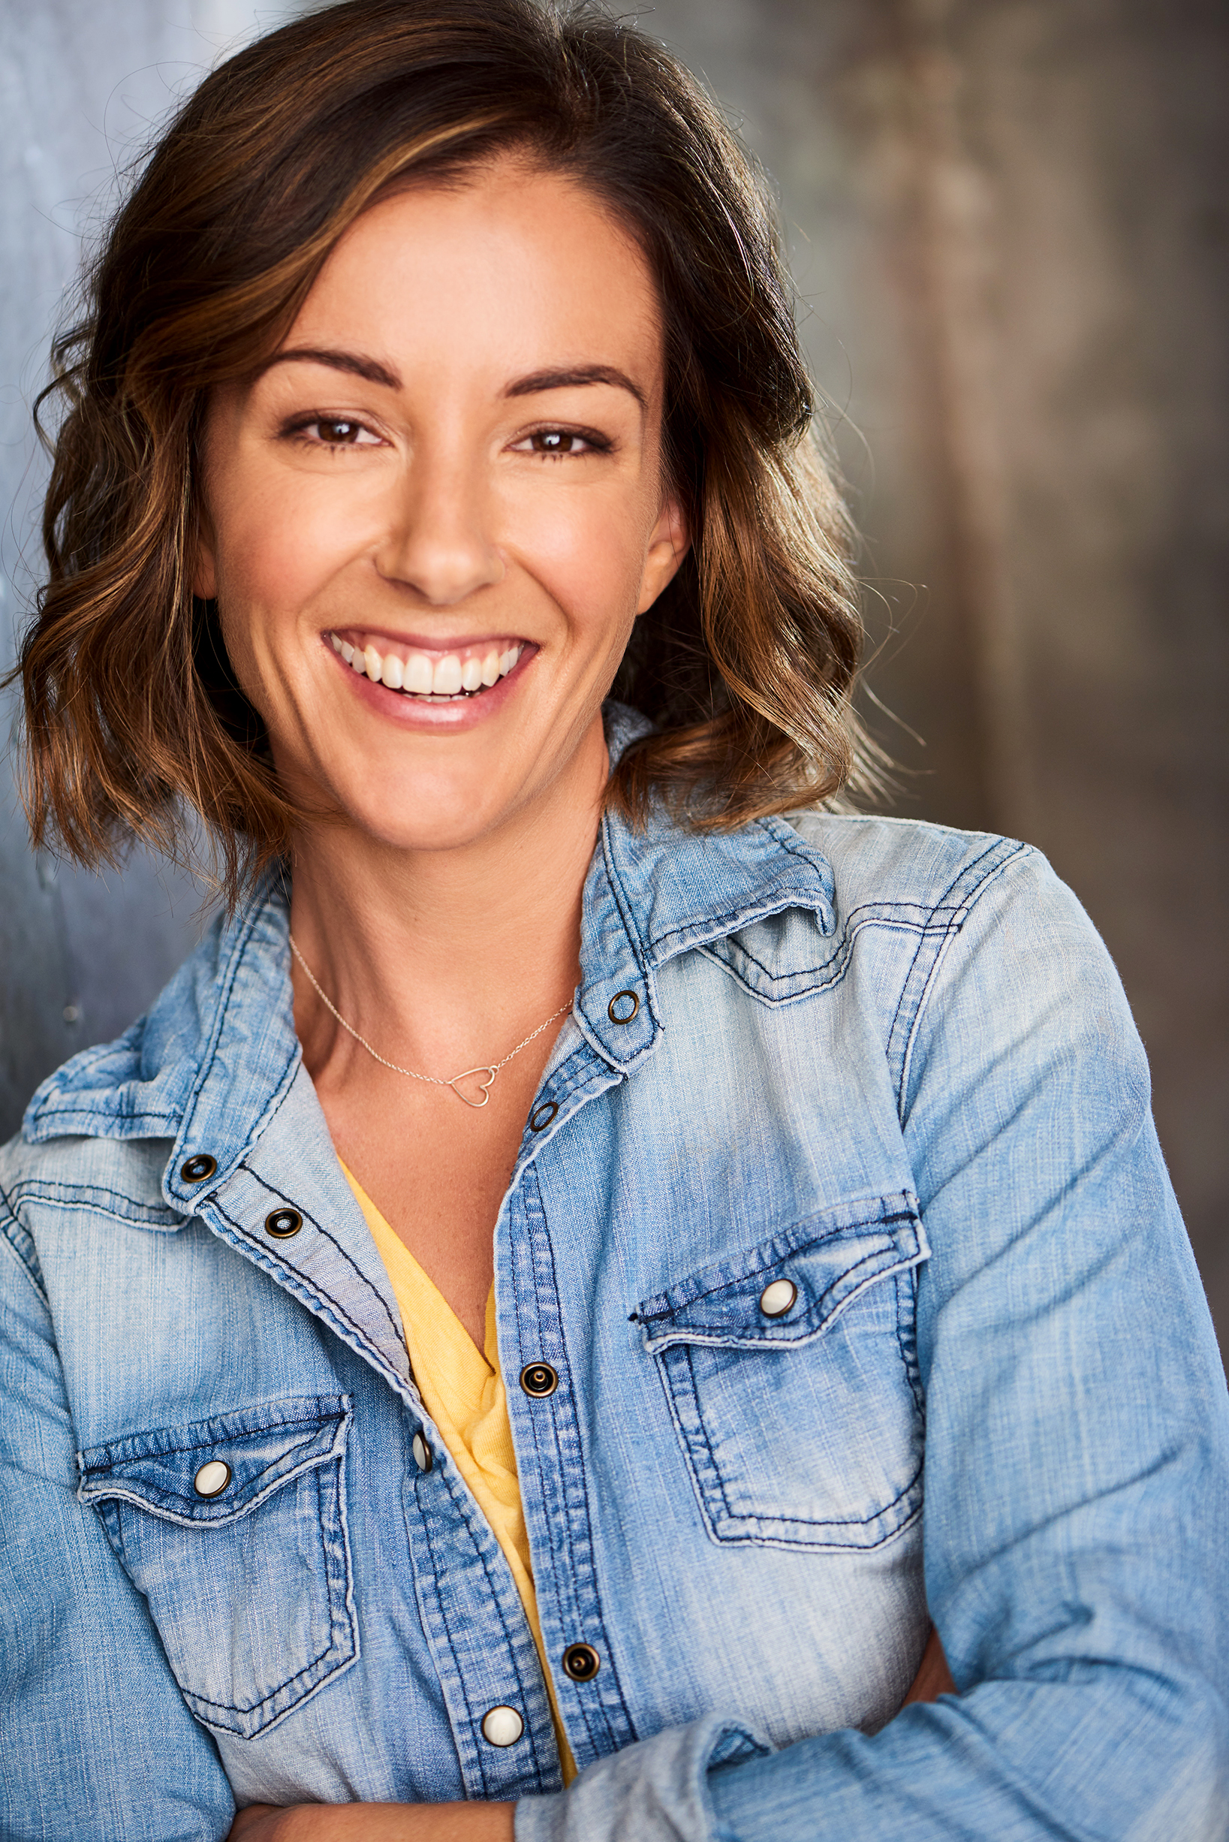
Dawn Marie is known for her work in the films The Measure of Your Faith, Dark Hours: Roxana, Nuclear Family (2021), Unwelcome (2021) and the upcoming Long Shadows.

JOSHUA BERTELL

Joshua Bertell is a trained actor and a professional model, and is an active learner with a keen interest in mathematics, physics, and science. He has appeared in the TV seris The Rookie: Feds as well as being a series regular Alpha of Aberdeen. He will also be starring in the upcoming film Adolescent Plush.

JENNINGS RICE
Up and coming actress and writer, Jennings Rice, lead the short film "Next" for which she won Best Actress at the Los Angeles Film Awards, New York Film Awards and the Actors Awards. It had its World Premiere at the Virginia Film Festival. You can also spot her in one of her National Commercials running all over the USA or in Saint Motel's Music Video "Everyone's a Guru Now".
Upcoming, she'll be spotted in the Lifetime Network's Pool Boy Seduction premiering in 2024

Production Credits

Full Cast
Actors  SLOAN MANNINO  JENNA HOGAN  SAGE MOORE  ABIGAIL VILLANUEVA  DAWN MARIE  JOSH BERTELL  JENNINGS RICE | Role  Hannah  Melissa  Abbie  Charlotte  Jessica  Cameron  Tracy

Casting By
STELLA NOVA csa

Production Designer
CAMERON BARRETT

Director of Photography
HANA KITASEI

Edited By
IAN HARBILAS

Music By
LINDSAY JONES

Written By
RICHARD PIERCE

Directed By
PATRICIA FRONTAIN

Full Crew
PHINEAS PALMER | First Assistant Director
ELIZABETH SOTO-LARA | Additional First Assistant Director
BROOKLYN BRUCE | Second Assistant Director
CHANTAL MASSUH-FOX | Art Director
NICOLAS HATTORFF | Art PA
KESHIA BILLINGSLEA-SMITH | Key Make-up Artist
CORTNEY WATSON | Key Hair Stylist
DANIELLE LOUISE | Additional Hair Stylist
EMMA FIRIULLI | 1st Assistant Camera
OMAR ROJAS | 2nd Assistant Camera
OLIVIA WHITNEY | Additional 2nd Assistant Camera
ANTHONY DINARDO | Media Manager
REID COLLINS | Stills Photographer
JOHN FISHER | Gaffer
CHASE DUBOSE | Best Boy Electric
NICK PERRY | Additional Best Boy Electric
KEVIN RAMIREZ | Key Grip
ZAN CULLEN | Best Boy Grip
BENJI PAYNE | Additional Best Boy Grip
EVAN PAPADAKIS | Swing
JAYNE STEWARD | Costume Designer
LORENA BARROS | Costume Assistant
DYLAN HENNING | Production Sound Mixer
AARON KESLER | Additional Production Sound Mixers
ANTHONY WONG
ETHAN RHANIELLE
HANNAH DIEDRICH | Script Supervisor
KATE COMPTON | Production Manager
KARIM PHELPS | Safety Coordinator
ANTONIO SANCHEZ | Production Assistants
ARIES LOUIZA
EVA PAPADAKOU
DUMITRU TRIF
CHRISTOPHER PENTECOST | Supervising Sound Editor, Re-Recording Mixer
PETER TREPKE | Dialogue Editor
PATRICK EVANS | Post Production Supervisor
UMAMI COLOR AND FINISHING | Post Production Services
DAN EDWARDS | Supervising Colorist
JEFF SPOTT | Colorist
ANTHONY CAMPAGNA | Finishing Artist
LUKE BUTLER | Digital Intermediate Producer
HOLLYWOOD SCRIPT RESEARCH | Script Clearance
PRIVATE ISLAND AUDIO | ADR Facilities
GOODFORM | Visual Effects
ABHIMANYU TANWAR
ABACUS INSURANCE BROKERS, INC | Insurance
MARBLED LA | Catering
RARE BREEDS | Cameras

Producer Biographies

TIMOTHY O. JOHNSON – Executive Producer
Timothy O. Johnson is among the most active and reliable producers in the business thanks to top rate productions and global distribution appeal. He is the managing partner of Johnson Production Group, a Canadian based operation that produces over 100 hours of dramatic television annually with hundreds of programs running internationally. The company is the leader supplier to Lifetime, Hallmark and other international outlets.
A graduate of the Marshall School of Business at the University of Southern California, he served as President of the USC Entertainment Management Association and a member of the Advisory Committee of the Center for Entrepreneurial Studies.
Johnson is also responsible for producing the international hit series, DR. QUINN, MEDICINE WOMAN for CBS for over 5 seasons. During his 100-episode tenure, he also developed and produced the original docu-drama COLD CASE for CBS network, which was the very first program to integrate television with the Internet.
Most recently, Johnson has produced the THE NOEL DIARY, being the #1 Film on Netflix’s Top 10 list in December of 2022. He was also at the helm of the successful GIRL IN THE SHED: THE KIDNAPPING OF ABBY HERNANDEZ, as well as the V.C. Andrews series of films, to date including TWILIGHT’S CHILD, MIDNIGHT WHISPERS, and DAWN, all produced for Lifetime..
Johnson has produced over 400 movies and 15 globally released series for every major US network - including Netflix, Lifetime, Hallmark, ABC, Disney, CBS, NBC, Netfly, FOX and Sony.

JOHNSON PRODUCTION GROUP
The Johnson Production Group contracts globally to produce television content for international networks, studios and distributors. Based in Los Angeles and Vancouver, British Columbia, the company manages production, facilitates development and financing, procures distribution and guarantees quality and timely execution of its programs. While costs have gone up, so has the demand for quality. No longer is good enough, good enough. Johnson Production Group serves that segment when a show needs to be "A" quality, but produced efficiently enough to meet a locked budget. JPG specializes in value, protection of creative elements, and delivery of a quality finished product.

JOSEPH WILKA – Executive Producer
Joseph Wilka is the Head of Production for Johnson Production Group. Los Angeles-based, Joseph had already produced and directed several feature films before serving as the senior marketing executive for Gravitas Ventures. While at Gravitas, Wilka helped pioneer new distribution models for independent films including day-and-date theatrical releases. It was also at Gravitas where Joseph first worked with Johnson Production Group to facilitate the release of their films to the worldwide Video On Demand audience. After serving as the Director of Distribution and Production for Viva Pictures, where he produced English-language versions of foreign animated titles for DirecTV, Wilka officially joined Johnson Production Group. As Head of Production, he oversees the development, production, and distribution of films from multiple production units for release on broadcast and streaming platforms.

LISA ALFORD – Co-Executive Producer
Lisa Alford is a development executive at Johnson Production Group. A Massachusetts native, Lisa has lived and worked in Los Angeles for over a decade, always in support of excellent storytelling. Prior to joining Johnson Production Group, Lisa worked as an executive at TriStar television where she specialized in identifying IP that supported TriStar’s mission to feature diverse, authentic characters and champion underrepresented voices. Lisa came up at Sony Pictures Television where she worked as a production coordinator in the Television Movies and Miniseries department and in the writers room on the WGN hit series OUTSIDERS. In her current role, Lisa shepherds projects from the concept phase through story development, production, and post.

A.J. KELLY – Producer
Producer and co-founder of the creative production company, Goodform, A.J. Kelly has spent the past decade creating film, television, documentary, experiential and branded content. His work has won awards at top festivals including Cannes & SXSW, aired on premium networks and received multi-cultural acclaim.
Based in Los Angeles, A.J. believes in elevating content from diverse creative voices and providing an outlet for filmmakers to bring their stories to life.

JACOB HORN - Producer
Jacob Horn began his career in the entertainment industry by working his way up through Elijah Wood’s production company, Spectrevision. With them, he was able to gain producing experience with directors such as Nacho Vigalondo and Josh Waller. After leaving Spectrevision, Jacob went out on his own to produce and direct his own content including several short films, a Christmas feature for Hallmark, and also becoming the Stunt Dept Manager on Once Upon A Time In Hollywood. At present, Jacob is the Head of Production for GoodFlix, a feature film production company where he oversees an annual slate of films.

Billing Block
Lifetime Presents In Association with Johnson Production Group SURVIVING THE SLEEPOVER starring SLOAN MANNINO JENNA HOGAN SAGE MOORE ABIGAIL VILLANUEVA DAWN MARIE JOSHUA BERTELL JENNINGS RICE Casting By STELLA NOVA csa Production Designer CAMERON BARRETT Director of Photography HANA KITASEI Edited By IAN HARBILAS Music By LINDSAY JONES Co-Executive Producer LISA ALFORD Executive Producers JOSEPH WILKA TIMOTHY O. JOHNSON Produced By A.J. KELLY JACOB HORN Written By RICHARD PIERCE Directed By PATRICIA FRONTAIN
© MMXXIV Johnson Production Group Inc. All Rights Reserved




Meta Data
LONG (max 3000 characters) synopsis
After the tragic death of her father, a young high school student named Hannah and her mother move to a new town. Three months into the school year, Hannah finally feels she’s making new friends. Hannah is invited to a sleepover at the popular Melissa's house, not realizing she was only invited to be the victim of a prank – but when the night turns more sinister than intended Hannah's mother will become her only chance of surviving the night. (446)
MEDIUM (max 500) synopsis
After the tragic death of her father, a young high school student named Hannah and her mother move to a new town. Three months into the school year, Hannah finally feels she’s making new friends. Hannah is invited to a sleepover at the popular Melissa's house, not realizing she was only invited to be the victim of a prank – but when the night turns more sinister than intended Hannah's mother will become her only chance of surviving the night. (446)
SHORT (max 100 characters) synopsis
Hannah attends a sleepover with her new friends but a prank takes a serious turn for the worst. (95)
5 KEY WORDS
Teens, prank, new school, mother

