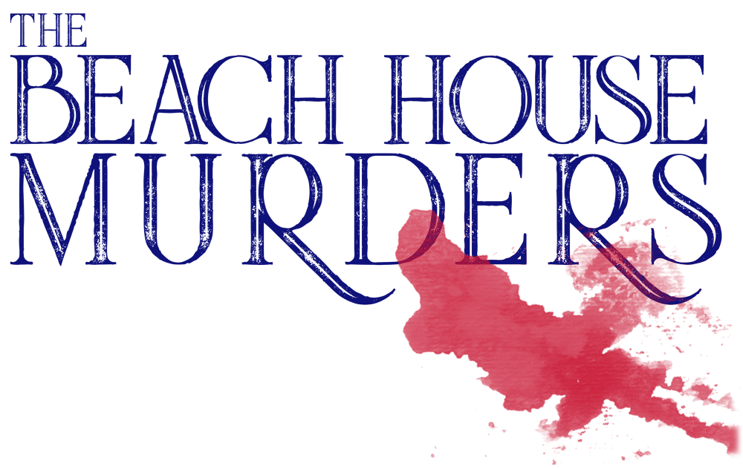

Johnson Production Group

Press Kit

One-Liner
Hoping to relieve her stress, mystery novelist Sarah Brewer goes on vacation to a lovely beach house. However, when a strange man begins stalking her, Sarah's happy vacation becomes a living nightmare, similar to her novel.

Synopsis
When mystery novelist Sarah Brewer is violently attacked, her husband Miles is accused and goes to prison. One year later, a traumatized Sarah battles a severe case of writer's block. Enter Sarah's agent, Alice, who suggests Sarah relieve her stress by taking a vacation at her beautiful summer house on the California coast. However, the moment Sarah arrives at the house, she is stalked and terrorized by a mysterious person, and she soon realizes her happy vacation is about to become a living nightmare by the sea.

Producers
Executive Producers
TIMOTHY O. JOHNSON
JOSEPH WILKA
Co-Executive Producer
LISA ALFORD
Producer
ROBERT BALLO
Line Producer
NICOLE LAYSON

Key Cast
CHARACTER  Sarah  Tony  Miles  Alice |  | ACTOR  BRITTNEY DOREY  CJ HAMMOND  DEVANTE WINFREY  ASHLI AUGUILLARD

Key Cast Biographies

BRITTNEY DOREY
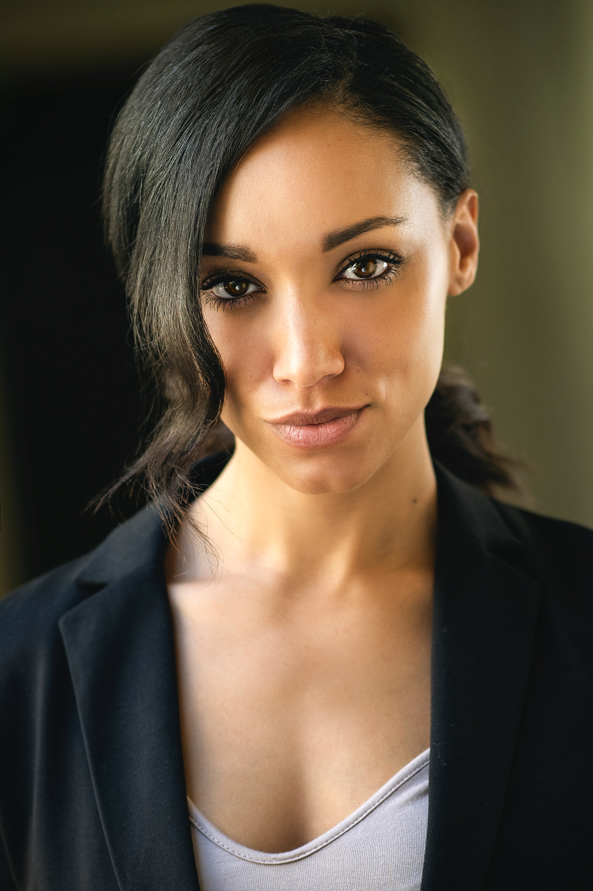
After moving to Los Angeles from Arkansas in order to attend nursing school, Brittney Dorey soon realized that her future lay in TV and film so she switched to Henderson State University to study Mass Media. Since then she has put together her own award nominated show that she wrote, directed and acted in called Almost Nowhere. She has also appeared in TMI Hollywood, The Preacher’s Son, The Choir Director as well as the TV Series Family Time and Dynasty.

CJ HAMMOND
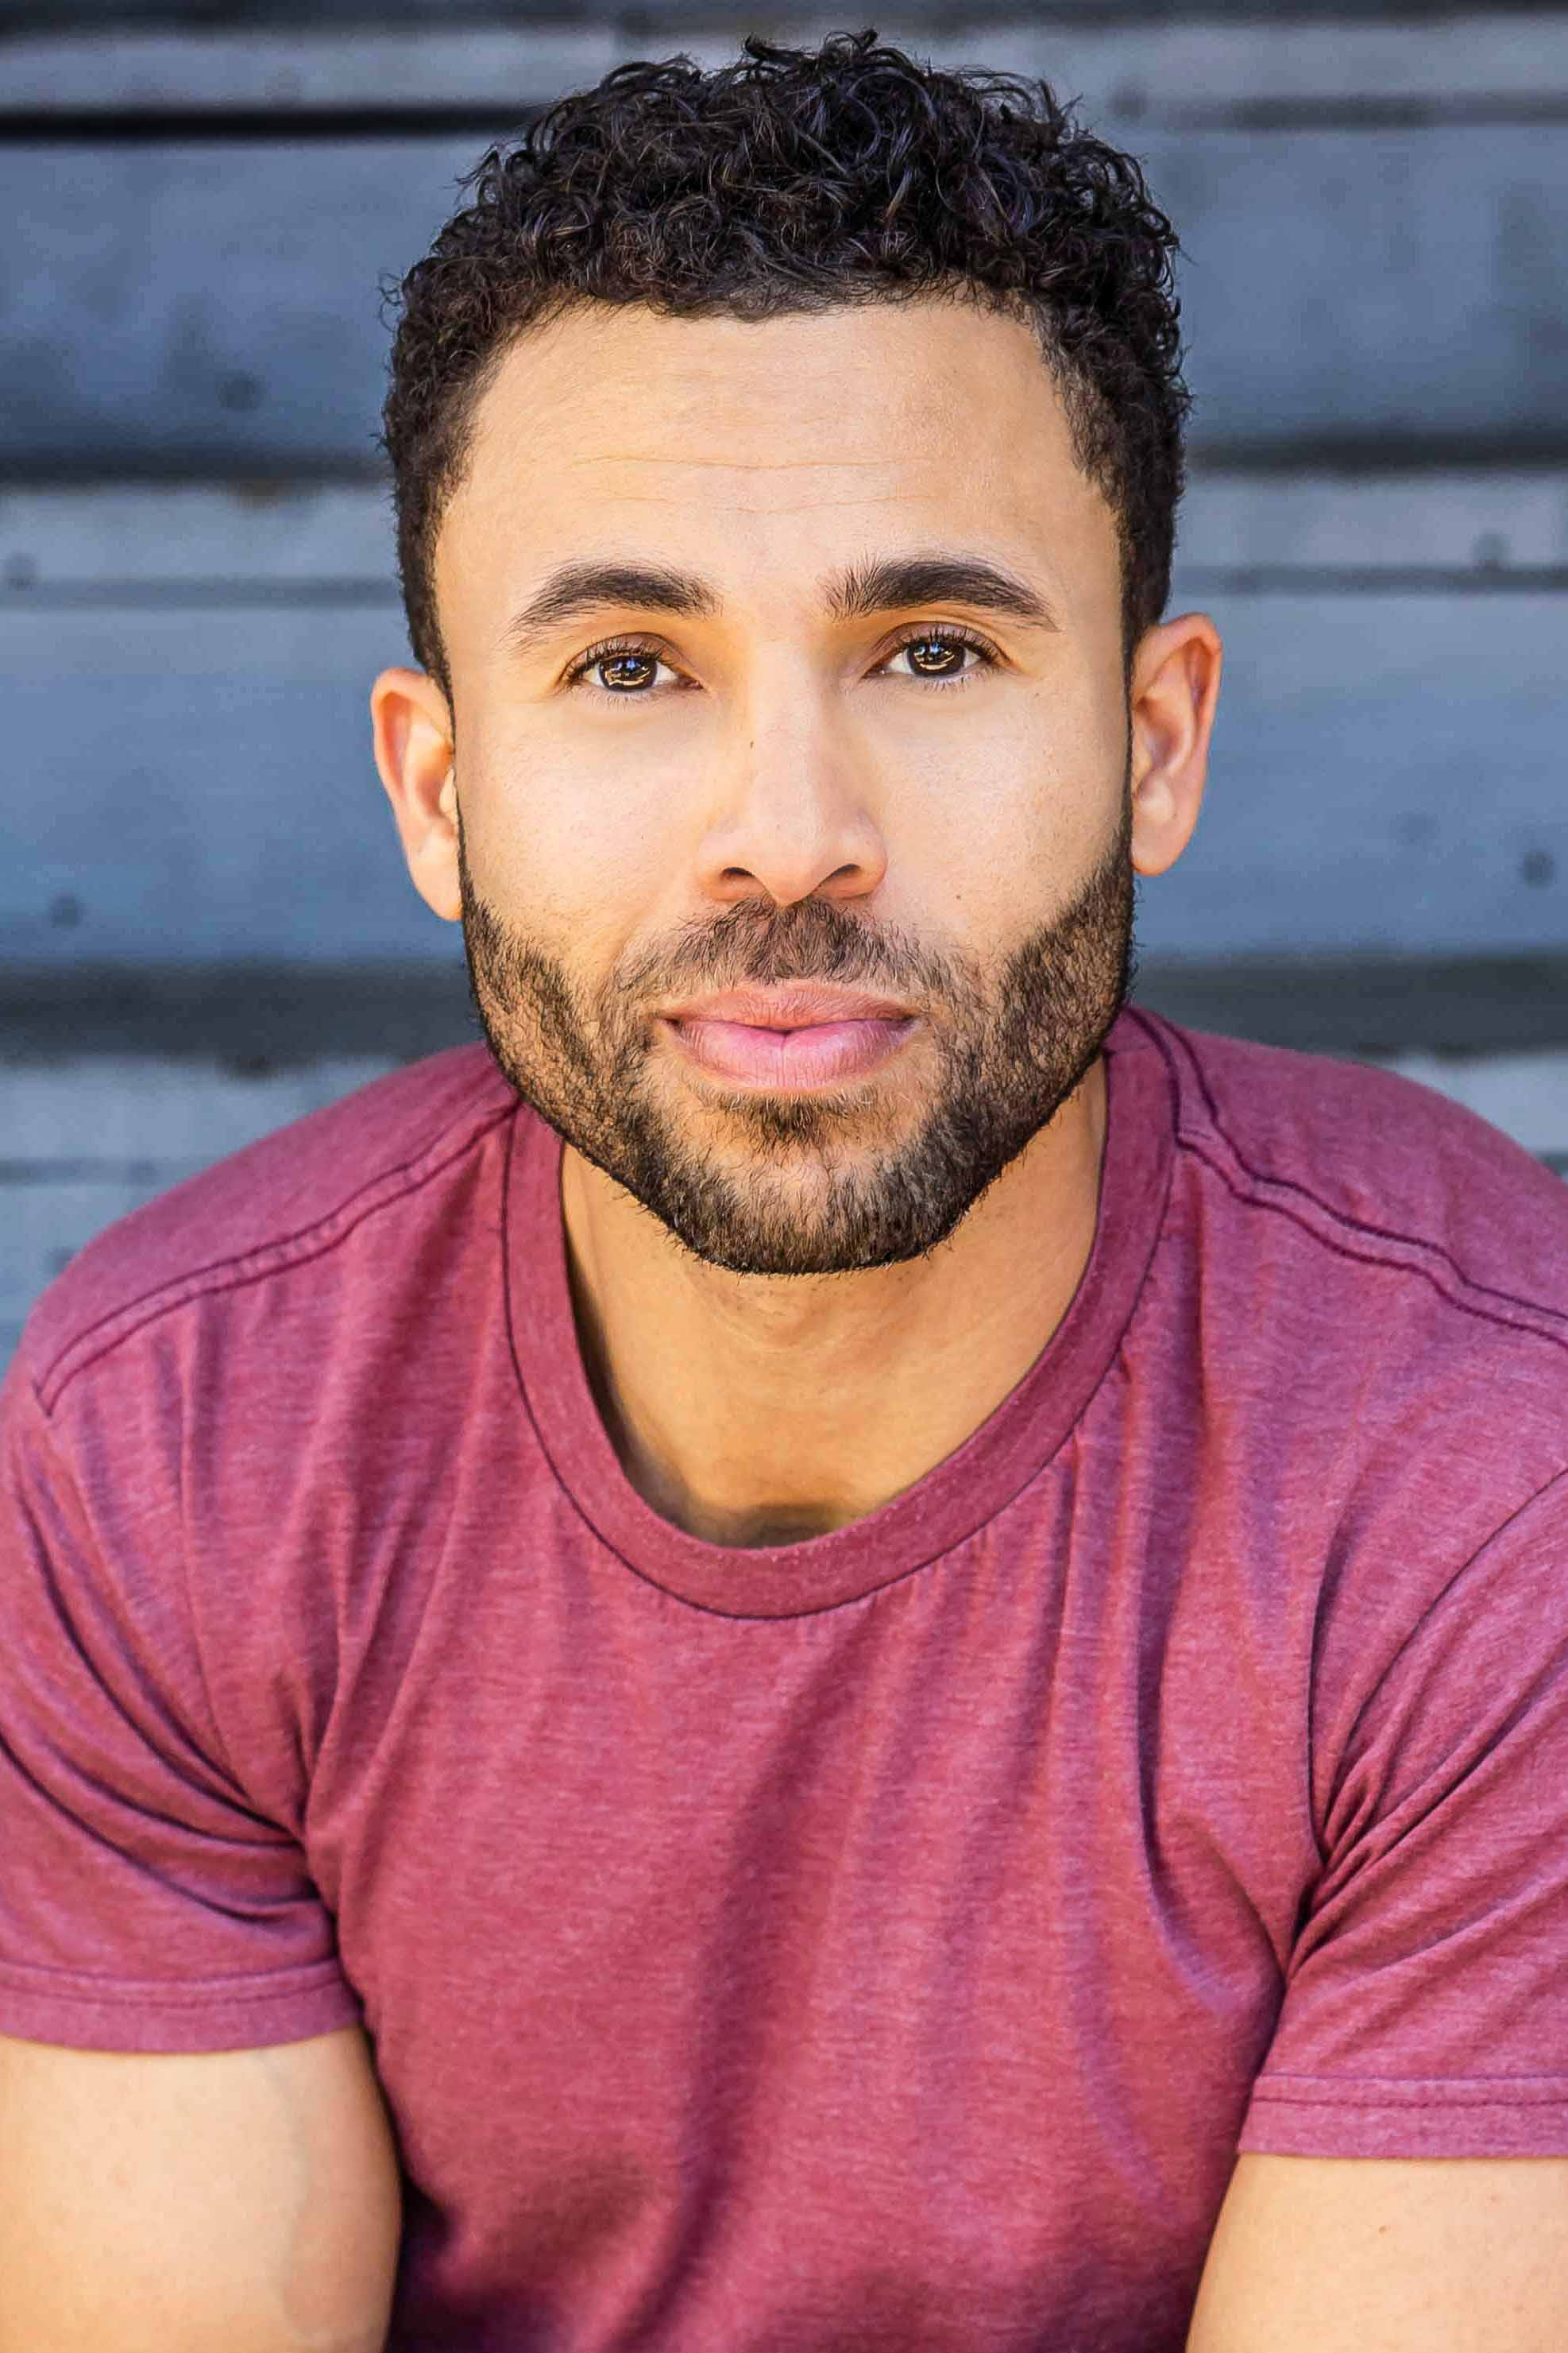
CJ Hammond is originally from Denver, CO and moved to Los Angeles to solidify his entertainment career. He began his career in modeling and has been in numerous print campaigns. Since then, CJ has expanded his talents into TV, film & music and has landed the role of Leading Man in several feature films.

DEVANTE WINFREY
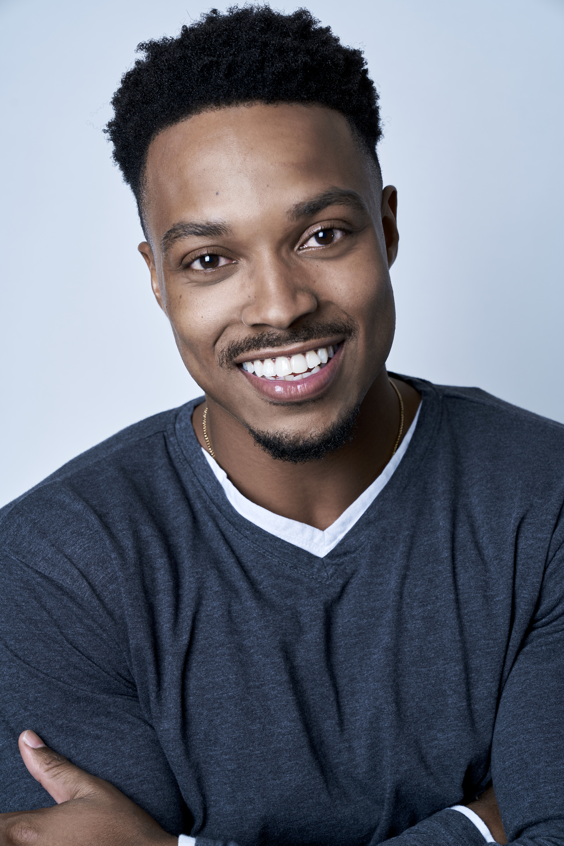
Born and raised from Mississippi Devante spent most of his youth/teen years playing sports: basketball, football and track. Now trained in both theater and film after attending the Academy of Art University, Devante has played a myriad of roles ranging from musicals to films and tv. He has appeared in several Lifetime Network movies including Stalked by My Mother, Designed For Death, Wheels of Beauty, Unfinished, Bound by Blackmail, Dying to Win and most recently, Vanished in Yosemite.

ASHLI AUGUILLARD
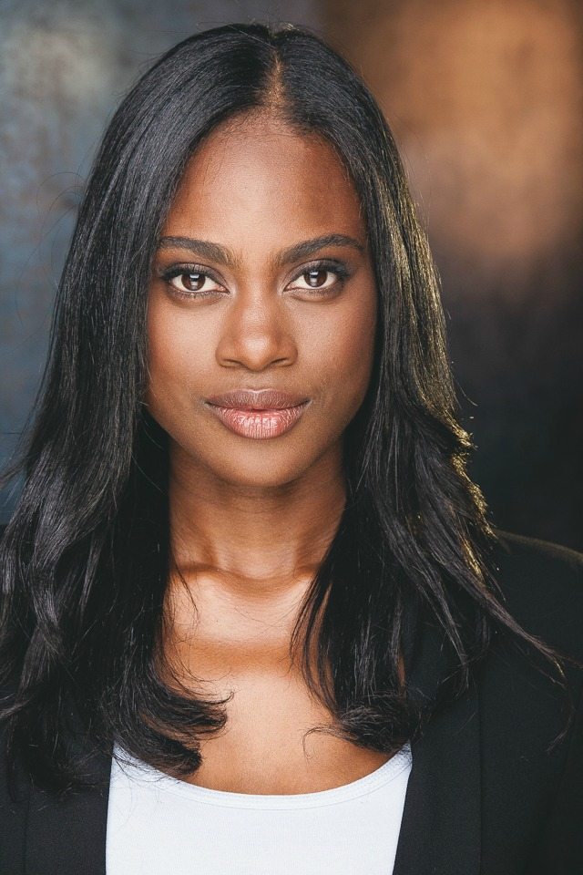
Ashli Auguillard (AKA Ashli with an "i") is an actor from the small town of Breaux Bridge, Louisiana. She's proudly the eldest of 6 siblings, raised by a strong mother (Kia Auguillard) who taught her integrity and resilience. Tall, athletic and vivacious, she's a force with Creole, West African and Native American heritage. She is adept at regional and international accents and dialects, giving life to a wide range of characters.
Ashli stands out as a new comedic face on HBO's Curb Your Enthusiasm (2021), holding her own across Larry David, Lucy Liu, and other heavy hitters. She also has guest-starring and recurring roles on USA Network, BET, Hallmark Channel, Facebook Watch, and Screambox TV. In addition to her acting skills, she is a certified tactical shooter and wire stunt pro, with special skills including stand-up comedy, improv, singing, rapping, dancing, and volleyball.
Growing up, Ashli lived in poverty, so her route to the arts was through academics. Her perfect grades earned her a seat in the state's gifted program (GPGC) at age 11, where she garnered her first theatrical role in the stage production of "The Miser." One year later, she would land the lead role in the production of "Here We Sit," also through GPGC. She completed the program after three years, then reignited her passion in high school, where she became a popular member of the drama club, winning tournaments for her racy monologues from "The Colored Museum" and "Live and in Color."
At 17, she moved to Nevada alone for college at UNLV, where she landed the role of "Juanita Sims" in the production of "For Colored Girls Who've Considered Suicide." She would soon return to Louisiana to attend LSU, double majoring in biology and theatre. Ashli finally made the bold move to California in late 2014 (with her beloved dog Oreo) to further her acting training, studying at the Baron Brown Studio in their intensive 2-year Meisner program. After her training, she was selected by an industry masterclass panel for her live portrayal of "Cleo" in "Set It Off," the performance that caught the attention of talent manager Michelle Zeitlin.

Production Credits

Full Cast
ACTORS  BRITTNEY DOREY  CJ HAMMOND  DEVANTE WINFREY  ASHLI AUGUILLARD  KYLE WILLIAMS  CAROLYN ZANELLI  JORDAN HUBBARD  ROBIN DE LANO  NICOLE DIONNE  Background  JOSHUA GUERRERO  APRIL JOHNSON  JAYSON LEE  RACHEL MOSES  MARCUS NOCERINO  RYAN BLACKMAN  DIANA KHALIKOVA  JULIA LIPKIN  ZACHARY MICAL  ANDREW OH  CAREY OSIMO  JACOB ROMERO  TYREEK SPAIDE  MELANIE ALVAREZ  ANTHONY VLASTAS  LUCIEN ELDRED  NICHOLAS LAMBERT  STEPHANIE NIELSEN  BRIAN WALKER  ASHLEY WAWERU  LUIS MENDOZA  HANA FREEMAN  CHRISTOPHER BOGUSH  BRENT BERNAL  ANNE MCDANIELS  MONIKA CHAN  JACOB BURAS  AMANDA JOY TOTPAL | Role  Sarah  Tony  Miles  Alice  Jack  Officer Evans  Detective Branton  Gina  Uma  Restaurant Patrons  Coffee Shop Patrons  Middle-Aged Woman  Middle-Age Man  Wedding Guests  CSI Investigators  Police Officers  Beachgoers

Casting by
ROBIN DE LANO
NICOLE DIONNE

Makeup by
ASHLEY ALDRIDGE

Sound Design by
ANDRES BOULTON

Music by
MARC JOVANI
NATHANIEL BLUME

Costume Designer
CLEY KIM

Production Designer
NICOLA WAKE

Edited by
JOSHUA BUTLER

Director of Photography
CHRISTOPHER JORDAN

Story by
JOSH RIDGWAY

Screenplay by
JOSH RIDGWAY
DOUG CAMPBELL

Directed by
DOUG CAMPBELL

Full Crew
DENZEL JOHN | First Assistant Director
AIDA BOUKENTER | Second Assistant Director
ALEX TETZNER | B Camera Operators
WARREN MCELROY
REID COLLINS | First Assistant Camera
EMMA DONAHUE | Second Assistant Camera/DIT
NATALI OLVERA
NEIL YANG
BILL MOLDT | Drone Operator
CHARLES WIBERT | Underwater Camera Operator
STEVE CURLY | Still Photographer
LAUREN VERHAGE | Art Directors
BRANDON TASKER
KEEGAN CRAWFORD | Prop Master
AYDEN MARCUS | Chief Lighting Technicians
JASPER HARRIS
DANIEL CASTILLO | Key Grip
EDGAR NUNLEY | Best Boy Grips
DAVID BARAHONA
MELANIE AKSAMIT | Key Makeup
EMERSON BUALAT | Key Set Costumers
LISA HOANG
AARON KESLER | Production Sound Mixer
FRANK INGLIS | Production Assistants
ERICK NUNEZ
DOERTE LINDNER | Accountant
WRAPBOOK | Payroll
NICK LORENZ CATERING | Catering
BOOKED TALENT | Background Casting
DOUGIE SMITH | Driver
POST PRODUCTION
ANDRES BOULTON | Supervising Sound Editor
JONATHAN MORGAN | Foley Editor
ANDRES BOULTON | Re-Recording Sound Mixer
BLUELINE FINISHING | Finishing Services
RANDY COONFIELD | Colorist
PETER LALIC | VFX Artist
POND5 | Stock Footage
BLACKSTONE ENTERTAINMENT | Grip and Lighting Equipment
GOAL PRODUCTIONS | Camera Equipment
“Falling Fences”
Performed by ill-esha
By Elysha Zaide
“Night Sophisticates”
By Robert John Foster & Clive Michael Oliver Carroll
“Lonely Night”
By Dave James & Keith Beauvais
“Deeper”
By Marc Jackson Burrows & Chris Bangs
“Midnight City”
By Keith Mansfield

Producer Biographies
TIMOTHY O. JOHNSON – Executive Producer
Timothy O. Johnson is among the most active and reliable producers in the business thanks to top rate productions and global distribution appeal. He is the managing partner of Johnson Production Group, a Canadian based operation that produces over 100 hours of dramatic television annually with hundreds of programs running internationally. The company is the leader supplier to Lifetime, Hallmark and other international outlets.
A graduate of the Marshall School of Business at the University of Southern California, he served as President of the USC Entertainment Management Association and a member of the Advisory Committee of the Center for Entrepreneurial Studies.
Johnson is also responsible for producing the international hit series, DR. QUINN, MEDICINE WOMAN for CBS for over 5 seasons. During his 100-episode tenure, he also developed and produced the original docu-drama COLD CASE for CBS network, which was the very first program to integrate television with the Internet.
Most recently, Johnson has produced the THE NOEL DIARY, being the #1 Film on Netflix’s Top 10 list in December of 2022. He was also at the helm of the successful GIRL IN THE SHED: THE KIDNAPPING OF ABBY HERNANDEZ, as well as the V.C. Andrews series of films, to date including TWILIGHT’S CHILD, MIDNIGHT WHISPERS, and DAWN, all produced for Lifetime.
Johnson has produced over 400 movies and 15 globally released series for every major US network - including Netflix, Lifetime, Hallmark, ABC, Disney, CBS, NBC, Netfly, FOX and Sony.

JOHNSON PRODUCTION GROUP
The Johnson Production Group contracts globally to produce television content for international networks, studios and distributors. Based in Los Angeles and Vancouver, British Columbia, the company manages production, facilitates development and financing, procures distribution and guarantees quality and timely execution of its programs. While costs have gone up, so has the demand for quality. No longer is good enough, good enough. Johnson Production Group serves that segment when a show needs to be "A" quality, but produced efficiently enough to meet a locked budget. JPG specializes in value, protection of creative elements, and delivery of a quality finished product.

JOSEPH WILKA – Executive Producer
Joseph Wilka is the Head of Production for Johnson Production Group. Los Angeles-based, Joseph had already produced and directed several feature films before serving as the senior marketing executive for Gravitas Ventures. While at Gravitas, Wilka helped pioneer new distribution models for independent films including day-and-date theatrical releases. It was also at Gravitas where Joseph first worked with Johnson Production Group to facilitate the release of their films to the worldwide Video On Demand audience. After serving as the Director of Distribution and Production for Viva Pictures, where he produced English-language versions of foreign animated titles for DirecTV, Wilka officially joined Johnson Production Group. As Head of Production, he oversees the development, production, and distribution of films from multiple production units for release on broadcast and streaming platforms.

LISA ALFORD – Co-Producer
Lisa Alford is a development executive at Johnson Production Group. A Massachusetts native, Lisa has lived and worked in Los Angeles for over a decade, always in support of excellent storytelling. Prior to joining Johnson Production Group, Lisa worked as an executive at TriStar television where she specialized in identifying IP that supported TriStar’s mission to feature diverse, authentic characters and champion underrepresented voices. Lisa came up at Sony Pictures Television where she worked as a production coordinator in the Television Movies and Miniseries department and in the writers room on the WGN hit series OUTSIDERS. In her current role, Lisa shepherds projects from the concept phase through story development, production, and post.
ROBERT BALLO – Producer
With over 34 years of industry experience, Robert Ballo has created award-winning productions for clients that include ABC, TBS, PBS, Discovery Channel, and Lifetime, and that have aired on national network television, cable networks, and internationally in Asia and Europe. As Director of Photography and Producer at Shadowland, Ballo has created over a dozen feature films seen on the Lifetime Network and distributed internationally. As Director of Photography, his Shadowland films include MISSING AT 17, THE SURROGATE, STALKED AT 17, TEENAGE BANK HEIST, WALKING THE HALLS, BETRAYED AT 17, HOME INVASION, MATERNAL OBSESSION, ACCUSED AT 17 and SPECTRES. Other feature film credits include RUNNIN' AT MIDNITE, THE AFFAIR and STARVING ARTISTS. Ballo has also traveled the world on many documentary productions.
His television credits for national broadcast and cable networks include COLLEGE SPORTS IN AMERICA, GREAT EUROPEAN BALLOON ADVENTURE, DIRTY HARRY THE ORIGINAL, THE GREAT YEAR, and THE ROSE PARADE - PAGEANT FOR THE AGES. Through his other digital motion picture company, GOAL Productions, Ballo works with Fortune 500 companies, non-profit organizations and government agencies to produce sales and marketing videos as promotional communications. After a twenty-year tenure teaching film and video imaging, Ballo recently retired from his position as an Associate Professor of Practice at USC’s School of Cinematic Arts. A graduate of the USC film production program himself, Ballo is a member of the Academy of Television Arts and Sciences.

NICOLE LAYSON – Line Producer
A West Virginia native, Nicole Layson, received her degree in Theatre from the University of Tennessee, Knoxville, where she acted in and directed countless plays. She continued her acting career in Los Angeles and became a member of SAG/AFTRA after playing supporting roles in independent feature films. While on set as an actor, Nicole fell in love with what happens behind the camera, which led her to pursue a Film Degree from the Los Angeles Film School. After graduating, she wrote, produced, and directed her own award-winning short films and began working in production. Within two years of finishing her degree in 2014, she has production managed and line produced multiple television series and feature films, including Hitting the Breaks, Reborn, and American Fighter. She has also produced numerous music videos, commercials, and shorts, many of which she developed.

DOUG CAMPBELL – Director
Doug has directed several feature films with his producers Ken Sanders and Robert Ballo. Since 2009 they have completed multiple features which have all been acquired by Lifetime. Doug has directed 21 feature films (twelve of which he wrote or co-wrote), 18 hours of network TV, four commercials and 20 short subjects. His projects have appeared in theaters and on TV across the world. Domestically, CBS, HBO, Lifetime, Showtime, Fox, PAX-TV, The Family Channel and other networks have broadcast my work. A film he financed, wrote and directed, THE TOMORROW MAN, was nominated for Best New Live Action Feature, Best Director and Best Screenplay in the 2001 DVD Premiere Awards sponsored by Daily Variety Magazine. Doug took home the Best Director Award.
Growing up in the San Fernando Valley north of Los Angeles, Doug made his first Super-8 when he was fourteen. After studying under Sandy Mackendrick at California Institute of the Arts, he directed his first feature film at age 24. Since then, shooting low budget films and TV has taught him to work fast, get the good performance and keep it fun. Having directed different genres (action, family adventure, children's television, documentary, sci-fi and teen comedy), his favorites are thriller and drama. In 2003 Jikei schools asked Doug to design the curriculum and launch a new film school, Tokyo Film Center School of Arts. Currently he teaches at Academy of Art University in San Francisco under Executive Director Diane Baker. “Filmmaking is something I knew I wanted to do as a kid, and I can't imagine doing anything else.”

Billing Block
LIFETIME Presents In Association with
JOHNSON PRODUCTION GROUP and SHADOWBOXER FILMS “THE BEACH HOUSE MURDERS“ starring BRITTNEY DOREY CJ HAMMOND DEVANTE WINFREY ASHLI AUGUILLARD KYLE WILLIAMS JORDAN HUBBARD CAROLYN ZANELLI Casting by ROBIN DE LANO NICOLE DIONNE Makeup by ASHLEY ALDRIDGE Sound Design by ANDRES BOULTON Music by MARC JOVANI NATHANIEL BLUME Costume Designer CLEY KIM Production Designer NICOLA WAKE Edited by JOSHUA BUTLER Director of Photography CHRISTOPHER JORDAN Line Producer NICOLE LAYSON Co-Executive Producer LISA ALFORD Executive Producers TIMOTHY O. JOHNSON JOSEPH WILKA Produced by ROBERT BALLO Story by JOSH RIDGWAY Screenplay by JOSH RIDGWAY DOUG CAMPBELL Directed by DOUG CAMPBELL
© MMXXIII Johnson Production Group Inc. All Rights Reserved



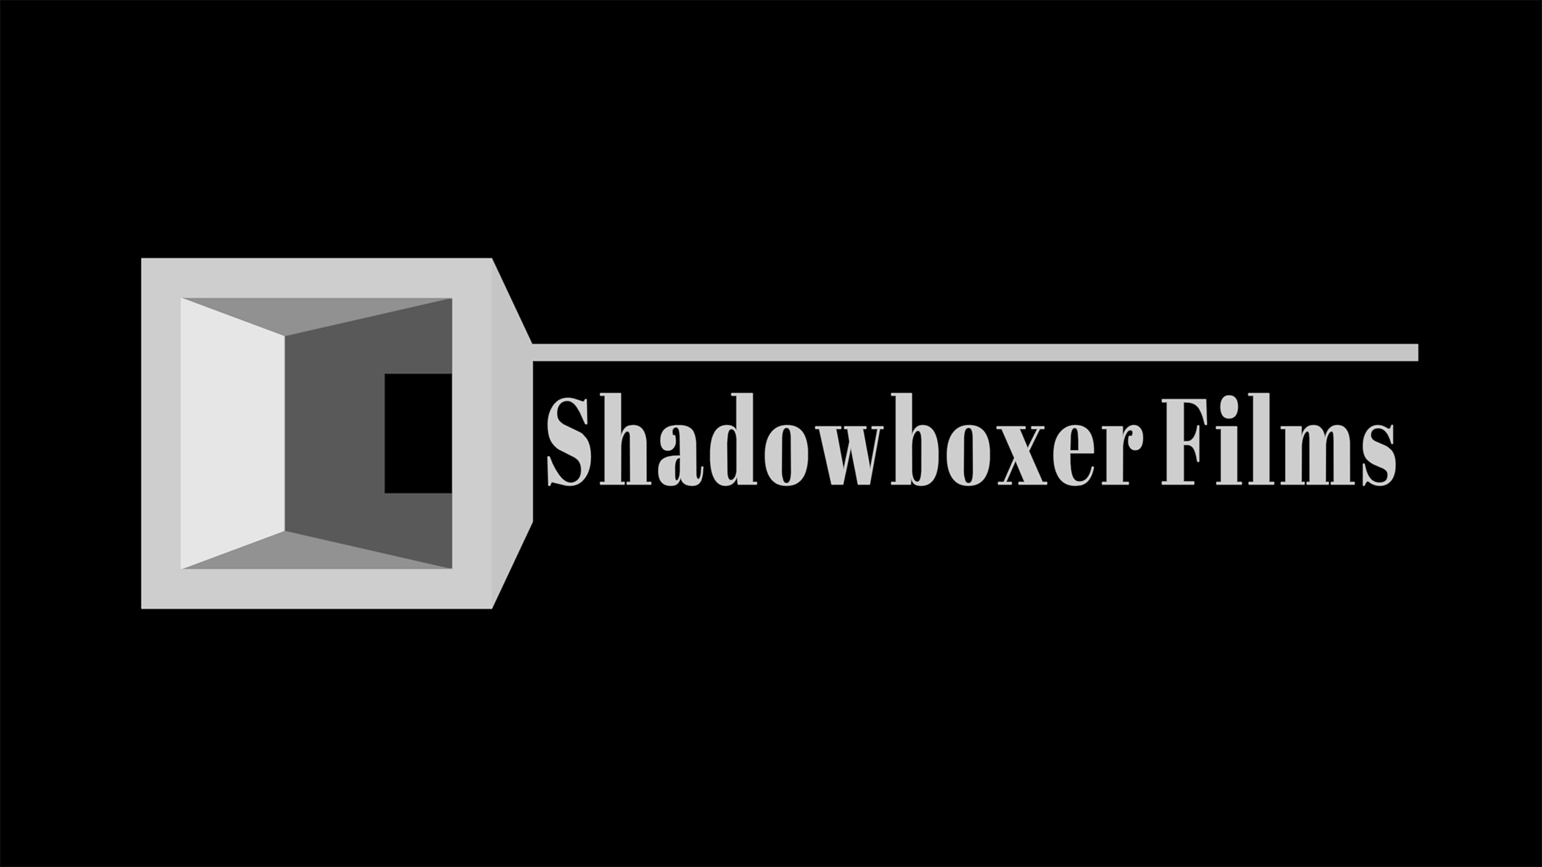



Meta Data
LONG (max 3000 characters) synopsis
When mystery novelist Sarah Brewer is violently attacked, her husband Miles is accused and goes to prison. One year later, a traumatized Sarah battles a severe case of writer's block. Enter Sarah's agent, Alice, who suggests Sarah relieve her stress by taking a vacation at her beautiful summer house on the California coast. However, the moment Sarah arrives at the house, she is stalked and terrorized by a mysterious person, and she soon realizes her happy vacation is about to become a living nightmare by the sea. (519)
MEDIUM (max 500) synopsis
Hoping to relieve her stress, mystery novelist Sarah Brewer goes on vacation to a lovely beach house. However, when a strange man begins stalking her, Sarah's happy vacation becomes a living nightmare, similar to her novel. (223)
SHORT (max 100 characters) synopsis
A mystery writer goes on stress-relieving beach house vacation but realizes she is being stalked. (98)
5 KEY WORDS
Stress, vacation, novelist, stalker, beach

