Johnson Production Group

Press Kit

# One-Liner

# Frankie gets a chance to leave her foster care home and attend an exclusive Swiss boarding school. But it turns out the opportunity of a lifetime comes at a deadly price.

# Synopsis

Francesca “Frankie” Logan, a bright, foster home teenager, receives a scholarship to attend the super exclusive Limoux Boarding School in the Swiss Alps. She thinks her life is finally turning around until she becomes embroiled in a murder and attempted murder where she’s the prime suspect due to her past.

Frankie, with the help of fellow student Jacqueline, attempts to solve the murder, pulling her deeper into the school’s secrets. But just as the dangerous secret is revealed there is one more for her to discover - that Jacqueline, her closest friend at the school, is actually the one setting her up for murder. And the reason couldn’t be more heartbreaking.

# Producers

Executive Producers

TIMOTHY O. JOHNSON

ANDREW C. ERIN

OLIVER DE CAIGNY

Co-Executive Producers

JOSEPH WILKA

LISA ALFORD

Producer

JOSIE FITZGERALD

# Key Cast

|  |  |  |
| --- | --- | --- |
| CHARACTER  Francesca "Frankie" Logan  Jacqueline  Miss Ainsworth |  | ACTOR  HANNAH GALWAY  NICOLE AMBER FARRUGIA  CHRISTINA COX |

# Key Cast Biographies

# HANNAH GALWAY

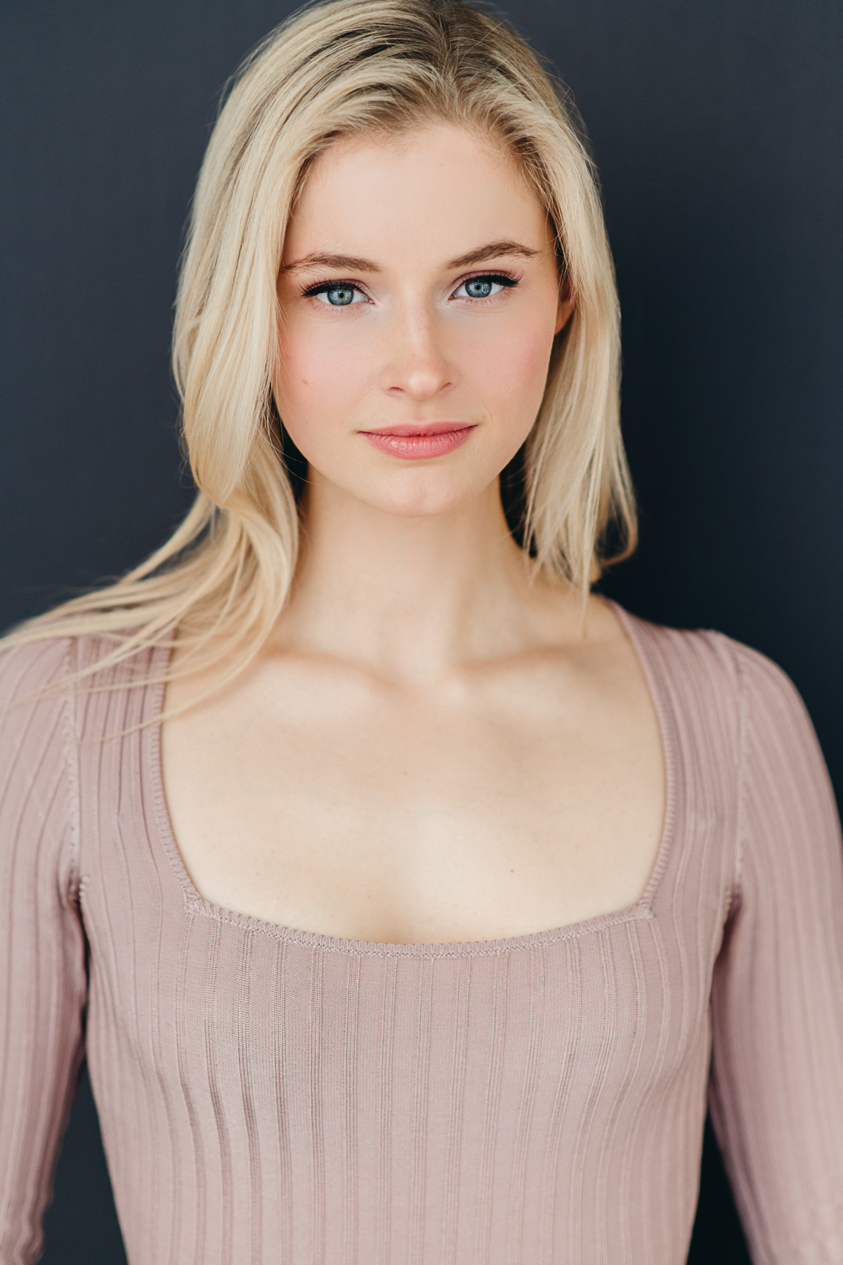Canadian actress, Hannah Galway, attended Ryerson School of Performance and since then has assembled an impressive list of acting credits included appearances in the TV series, Frankie Drake Mysteries, Murdoch Mysteries, Good Sam, Under the Banner of Heaven, Guillermo del Toro's Cabinet of Curiosities, and a recurring role in Sex/Life. She also has several film credits including Love Upstream, Webcam Cheerleaders, An Eclectic Christmas, Still: A Michael J. Fox Movie (as a young Tracy Pollan), and Secrets of a University.

# NICOLE AMBER FARRUGIA

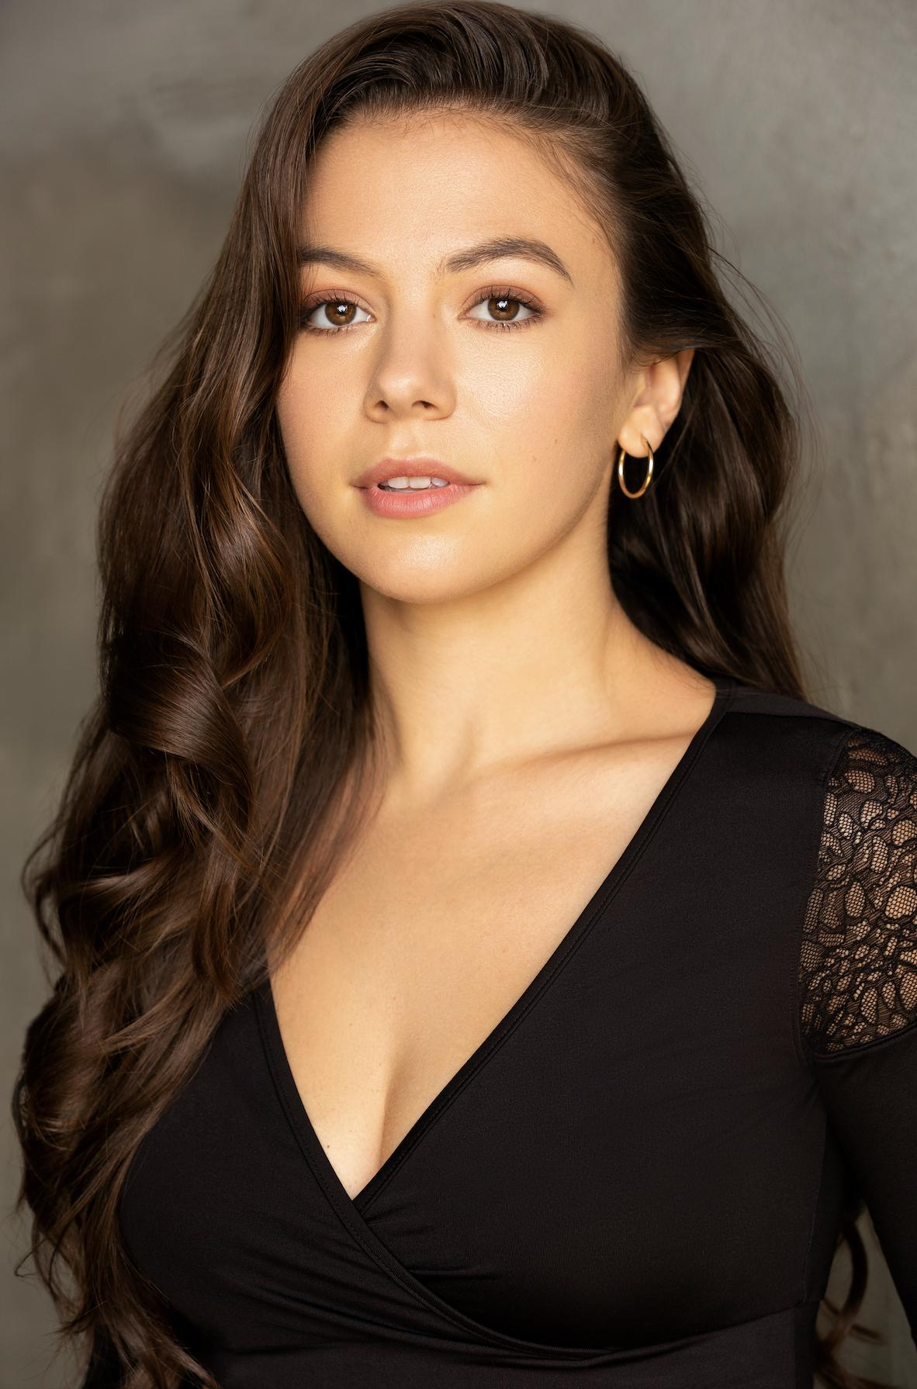Nicole Amber Farrugia is a Canadian-British actress, dancer & choreographer born in Port Perry, Ontario.

Her passion for performing began at the young age of three when her parents registered her for ballet classes. Nicole then went on to pursue dance in all styles at a competitive and recreational level before deciding to take her love of the arts to a university level. Nicole studied at both York University (Toronto, Canada) and Chichester University (U.K) where she had the opportunity to study acting as her electives. She has graduated with a Bachelor of Fine Arts Degree in Dance with Honours in the Choreography and Performance Stream. She also completed a summer intensive at the American Academy of Dramatic Arts in Hollywood.

Nicole began her acting career while on set for CW's Television series "Reign" where she instantly fell in love with the environment and acting for film and television. She has had the opportunity to both act and dance in a few music videos, commercials and independent films.

**CHRISTINA COX**

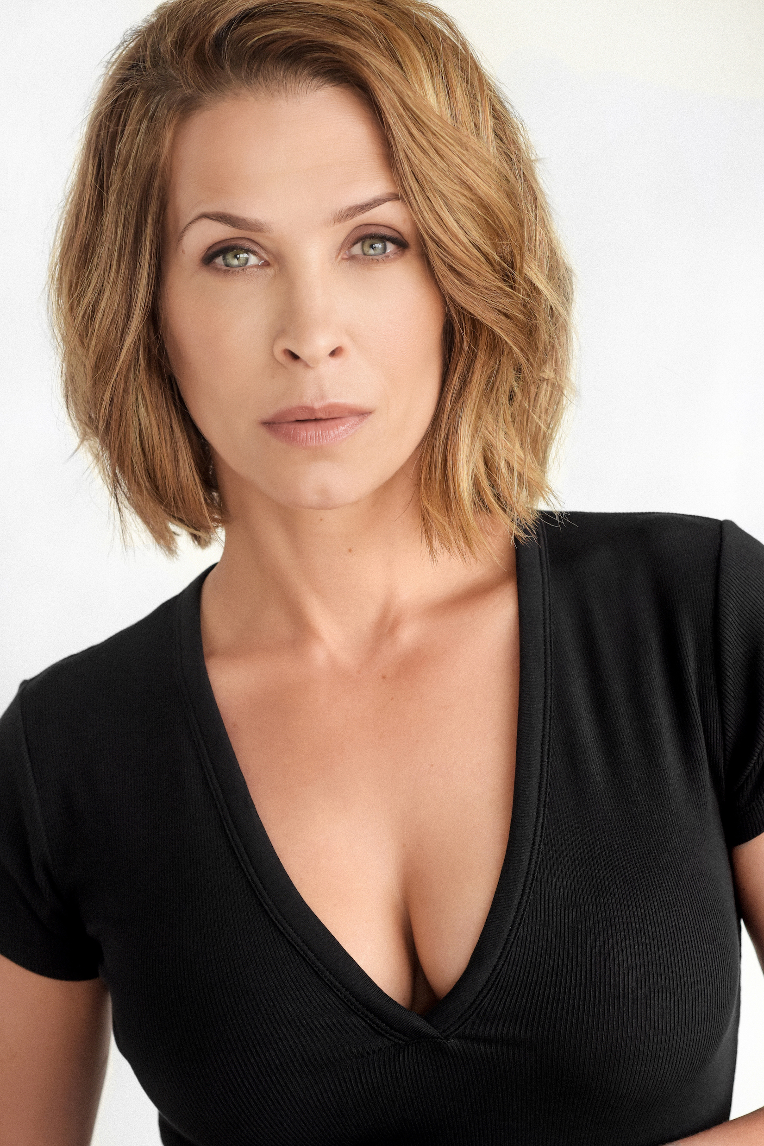The youngest of three girls, Christina was born just outside Toronto. She carried a double major of theater and dance at the prestigious Arts York at Unionville High School. She went on to further her training at the Ryerson Theatre School of Toronto, among such alumni as Eric McCormack and David James Elliott. In addition to her film and television credits, Christina has appeared in numerous national theater productions, ranging from classical productions of William Shakespeare's "Twelfth Night" to Jim Cartwright's raw and dirty "Road".

Christina completed the last of 13 episodes, as "astrobiologist Jen Crane", in the FTVS/ABC series, Defying Gravity (2009), a one-hour drama about a team of astronauts on a six-year mission in outer space.

On completion of Defying Gravity (2009), Christina guest-starred as "Zoey Kruger", a cop accused of killing her family on the 4th season of Showtime's Dexter (2006). After "Dexter", she joined the cast of the hit series, 24 (2001), as "Secret Service agent Molly O'Connor", as well as dropping by The Mentalist (2008) and filming The Stepson (2010), with Adam Beach.

Christina also guest-starred, as "Marine Gunnery Sergeant Georgia Wooten", in the NCIS (2003) episode, Freedom (2011).

Prior to Defying Gravity (2009), she starred as "Vicki Nelson", an ex-cop turned private investigator specializing in solving supernatural crimes in 22 episodes of the Lifetime series, Blood Ties (2007).

In addition to starring in several pilots, including the "most-watched-never-aired" pilot on You Tube; Nikki and Nora (2004), she co-created and developed an original script for Sony Television and Barry Sonnenfeld with her Nikki and Nora (2004) show runner Nancylee Myatt (South of Nowhere (2005), 3Way (2008)) and co-star Liz Vassey (CSI: Crime Scene Investigation (2000)

# Production Credits

### Full Cast

|  |  |
| --- | --- |
| [**Actors**](http://www.imdb.com/name/nm7589451/?ref_=ttfc_fc_cl_t1)  HANNAH GALWAY  NICOLE FARRUGIA  CHRISTINA COX  KSENIA DANIELA KHARLAMOVA  EVE EDWARDS  KATIA EDITH WOOD  GUY SPRUNG  DOUGLAS KIDD  VICTORIA LENHARDT  ISABELLE BOULTON  NORMAN MIKEAL BERKETA  AURY BARNETT  MALIK MCCALL  XAVIER SOTELO | **Role**  Francesca "Frankie" Logan  Jacqueline  Miss Ainsworth  Annabelle Volkov  Maria Lewis  Tinsley Wellington  Detective Krause  Mr. Limoux  Trina  Miss Galiani  Gardner  Friedrich  History Teacher  Dr. Garcia |

### Casting

BRIAN LEVY

### Composer

CHRISTOPHER GUGLICK

### Costume Designer

SAGINE CAVÉ

### Editor

RICHARD MANDIN

### Production Designer

GREGORY PHILIP WILSON

### Director of Photography

MICHAEL TIEN

### Written by

JASON BYERS  
RICHARD PIERCE

### Directed by

ALEXANDRE CARRIÈRE

### Full Crew

|  |  |
| --- | --- |
| ALEXANDRA WARING | Associate Producer |
| JOHNNY ROSS | First Assistant Director |
| CIMARRON LANGLOIS | Second Assistant Director |
| ANTHONY RANKIN | Third Assistant Director |
| DUSTIN DIGNARD | Fourth Assistant Directors |
| IAN FRASER |  |
| SMYTH CASTING | Extras Casting |
| ILONA SMYTH |  |
| GORAN POBRIĆ | Production Coordinator |
| CIMARRON LANGLOIS | Assistant Production Coordinator |
| LOGAN A. WAGNER | Production Accountant |
| JOSHUA LANGE | Assistant Accountant |
| MATTHEW CARVELL | Post Production Accountant |
| RYAN WHITEHURST | Accounting Clerk |
| ALEXANDRA WARING | Post Production Supervisor |
| GREGORY PHILIP WILSON | Production Designer |
| ELIZABETH FITZPATRICK | Art Director |
| TOMAS CHOVANEC | Set Decorator |
| MORGAN DUNBAR | Graphics |
| NATHALIE GREGOIRE | Property Master |
| MICHAEL DICKSON | Props Assistants |
| LYNN SPRACKLIN |  |
| SAGINE CAVÉ | Costume Designer |
| RÉNALD JEAN-PIERRE | Costume Truck Supervisor |
| JESSIE EDWARDS | Costume Set Supervisor |
| HANNAH LUNDRIGAN | Wardrobe Assistant |
| MICHAEL TIEN | Director of Photography |
| JOSH HENDERSON | B Camera Operator |
| ADAM TESTA | A Camera - First Assistant Camera |
| ABRAHAM ISSA |  |
| MUNG HATLANG | A Camera - Second Assistant Camera |
| MATT CROSSE | B Camera - First Assistant Camera |
| LINDSEY BELANGER | B Camera - Second Assistant Camera |
| ALEX FORGUES |  |
| NIKKI TUBONGBANUA |  |
| RAMZI ESTEPHAN | Drone Operator |
| RICHARD FRAZIER | Digital Imaging Technician |
| RICHARD FRAZIER | Camera Technicians |
| GEGHANI PANOSIAN |  |
| PETR MAUR | Stills Photographer |
| MARCUS LAUTENBACH | Stills Assistants |
| LILIANA DEL VEDOVA |  |
| STEVEN F. S. BRUNI | Gaffer |
| NICK LYNCH | Best Electrics |
| YAN SCHNELL |  |
| NICHOLAS HERMIER | Key Grip |
| RJ NADON | Best Grip |
| CONNOR DORZEK | Grip / Electric Swings |
| ALEX FORGUES |  |
| IAN FRASER |  |
| NICK LYNCH |  |
| RACHEL VRECIC |  |
| FRANCESCO FALSETTO | Sound Mixer |
| KARLYNE FÉLIX | Boom Operators |
| MICHAEL LORNE |  |
| MICHAEL SWATTON |  |
| NICK SMITH | Script Supervisor |
| KEENE IMBLEAU | Assistant Location Manager |
| NATALIE HONSHORST | Key Location Production Assistant |
| THOMAS DUNCAN | Location Production Assistants |
| EVAN POSNER |  |
| WILLIAM THIBODEAU |  |
| ALYSSA "ALY" MORDEN-HAYLEY | Key Makeup Artist |
| JANELLE CARDINAL | Assistant Makeup Artists |
| GISELE MATTE |  |
| CHANCELLE MULELA |  |
| NATASHA GABRIELA TREPANIER | Key Hairstylist |
| MARC-ANDRE LEVAC | Assistant Hairstylist |
| STEFANE GREGOIRE | Transport Coordinator |
| GREG LEWIS | Transport Captain |
| MICHAEL DICKSON | Drivers |
| BILAL MAHMOUD |  |
| KIM RODGER |  |
| CHRIS SURUJNARAIN |  |
| ALEXANDRE GREGOIRE | Transport Production Assistants |
| COOPER HUDSON |  |
| PERRY MCCONNELL |  |
| LYNN SPRACKLIN |  |
| JAY VISNESKIE |  |
| ERIC P. BEAUCHAMP | Move Crew |
| JARED KELLY |  |
| SHAWN NADEAU |  |
| KEITH STEFFENSEN |  |
| CHRIS SURUJNARAIN |  |
| CORNELIA VILLENEUVE |  |
| DAN VILLENEUVE |  |
| SEAN VILLENEUVE |  |
| TOM WARRELL | Head Chef |
| GERRY WHALEN | Chef |
| MATTHEW DUBUC | Caterer |
| RONDA MACKINNON | Craft Service |
| THE NO CONFLICT CLEARANCE COMPANY | Script Clearances |
| HALL WEBER LLP | Legal Services |
| DANNY WEBBER |  |
| ABOVE THE LINE MEDIA SERVICES | Business Affairs |
| BRENDAN MCNEILL |  |
| ARTHUR J. GALLAGHER CANADA LTD. | Insurance |
| URBAN POST PRODUCTION | Post Production Services |
| JOSEPH FACCIUOLO | Dialogue & ADR Editor |
| EHREN PFEIFER | ADR Recordist |
| KIRSTY SMITH | Sound FX Editors |
| LUKA TOMA |  |
| TESS MOIR | Foley Artists |
| JESSICA SEVIER |  |
| DAVE MERCEL | Foley Recordists |
| JESSICA SEVIER |  |
| COLIN MCCLELLAN | Re-Recording Mixer |
| KYLE BROCK | Colorist |
| URBAN PRAIRIE POST | VFX |
| KYLE BROCK | Online / Packaging Editor |
| PETER TOKARSKY | Project Manager |
| BRUCE REES | Picture Operations Manager |
| ROBERTA BRATTI | V.P. of Operations |
| POND5/TRAVEL_ASIA | Stock Footage |

# Producer Biographies

## TIMOTHY O. JOHNSON – Executive Producer

Timothy O. Johnson is among the most active and reliable producers in the business thanks to top rate productions and global distribution appeal. He is the managing partner of Johnson Production Group, a Canadian based operation that produces over 100 hours of dramatic television annually with hundreds of programs running internationally. The company is the leader supplier to Lifetime, Hallmark and other international outlets.

A graduate of the Marshall School of Business at the University of Southern California, he served as President of the USC Entertainment Management Association and a member of the Advisory Committee of the Center for Entrepreneurial Studies.

Johnson is also responsible for producing the international hit series, DR. QUINN, MEDICINE WOMAN for CBS for over 5 seasons. During his 100-episode tenure, he also developed and produced the original docu-drama COLD CASE for CBS network, which was the very first program to integrate television with the Internet.

Most recently, Johnson has produced the THE NOEL DIARY, being the #1 Film on Netflix’s Top 10 list in December of 2022. He was also at the helm of the successful GIRL IN THE SHED: THE KIDNAPPING OF ABBY HERNANDEZ, as well as the V.C. Andrews series of films, to date including TWILIGHT’S CHILD, MIDNIGHT WHISPERS, and DAWN, all produced for Lifetime..

Johnson has produced over 400 movies and 15 globally released series for every major US network - including Netflix, Lifetime, Hallmark, ABC, Disney, CBS, NBC, Netfly, FOX and Sony.

## JOHNSON PRODUCTION GROUP

The Johnson Production Group contracts globally to produce television content for international networks, studios and distributors. Based in Los Angeles and Vancouver, British Columbia, the company manages production, facilitates development and financing, procures distribution and guarantees quality and timely execution of its programs. While costs have gone up, so has the demand for quality. No longer is good enough, good enough. Johnson Production Group serves that segment when a show needs to be "A" quality, but produced efficiently enough to meet a locked budget. JPG specializes in value, protection of creative elements, and delivery of a quality finished product.

OLIVER DE CAIGNY – Executive Producer  
Oliver De Caigny is a Canadian producer originally from Belgium, his background in financing, production, and post production makes him a well-rounded producer for any type of production. His experience in financing and production agreements (film and TV series and movies-of-the week), distribution agreements (both domestic and foreign) as well as international co-productions, Canadian tax credit, Telefilm Canada and Canada Media Fund incentives provides him with a well-rounded background in development, production and distribution for motion pictures, television series and productions.

ANDREW C. ERIN – Executive Producer  
Andrew Erin is a Canadian Writer/Director making a big splash in the US, and has produced, written and directed numerous commercially successful films. His directorial debut, SAM’S LAKE, was an official selection at the Tribeca Film Festival and did an excellent theatrical run in select theaters around the country; distributed by Lionsgate Films.  Andrew also wrote the script for the film. Andrew’s directorial credits include, SIMPLE THINGS, produced for Screen Media Ventures and Universal Studios.  Besides winning The Bob Clark Award for Best Director at the California Independent Film Festival, the film was commercially received. Andrew has worked continuously as a writer/director, building a strong library of films in the Thriller/Horror genres with: Embrace of The Vampire, The Clinic, Final Sale, Confined and Toxic Skies.

## JOSEPH WILKA – Co-Executive Producer

Joseph Wilka is the Head of Production for Johnson Production Group. Los Angeles-based, Joseph had already produced and directed several feature films before serving as the senior marketing executive for Gravitas Ventures. While at Gravitas, Wilka helped pioneer new distribution models for independent films including day-and-date theatrical releases. It was also at Gravitas where Joseph first worked with Johnson Production Group to facilitate the release of their films to the worldwide Video On Demand audience. After serving as the Director of Distribution and Production for Viva Pictures, where he produced English-language versions of foreign animated titles for DirecTV, Wilka officially joined Johnson Production Group. As Head of Production, he oversees the development, production, and distribution of films from multiple production units for release on broadcast and streaming platforms.

## LISA ALFORD – Co-Executive Producer

Lisa Alford is a development executive at Johnson Production Group. A Massachusetts native, Lisa has lived and worked in Los Angeles for over a decade, always in support of excellent storytelling. Prior to joining Johnson Production Group, Lisa worked as an executive at TriStar television where she specialized in identifying IP that supported TriStar’s mission to feature diverse, authentic characters and champion underrepresented voices. Lisa came up at Sony Pictures Television where she worked as a production coordinator in the Television Movies and Miniseries department and in the writers room on the WGN hit series OUTSIDERS. In her current role, Lisa shepherds projects from the concept phase through story development, production, and post.

## JOSIE FITZGERALD - Producer

Josie Fitzgerald is a Canadian born Producer currently residing and working in Ottawa, Ontario. Josie is also a passionate photographer and writer, with an education in Justice Studies and a professional background in Human Resources and Project Management.

## Billing Block

INSPIRED BY ACTUAL EVENTS LIFETIME PRESENTS IN ASSOCIATION WITH   
JOHNSON PRODUCTION GROUP **THE BOARDING SCHOOL MURDERS**   
starring HANNAH GALWAY NICOLE AMBER FARRUGIA CHRISTINA COX KSENIA DANIELA KHARLAMOVA EVE EDWARDS KATIA EDITH WOOD GUY SPRUNG DOUGLAS KIDD VICTORIA LENHARDT ISABELLE BOULTON NORMAN MIKEAL BERKETA AURY BARNETT MALIK MCCALL XAVIER SOTELO Casting BRIAN LEVY Composer CHRISTOPHER GUGLICK Costume Designer SAGINE CAVÉ Editor RICHARD MANDIN Production Designer GREGORY PHILIP WILSON Director of Photography MICHAEL TIEN Co-Executive Producers JOSEPH WILKA LISA ALFORD Executive Producers TIMOTHY O. JOHNSON ANDREW C. ERIN OLIVER DE CAIGNY Producer JOSIE FITZGERALD   
Written by JASON BYERS RICHARD PIERCE Directed by ALEXANDRE CARRIÈRE

 

The Canadian Film or Video Production Tax Credit  


© MMXXIII Thriller One (FS) ON Films Inc. All Rights Reserved





Meta Data

LONG (max 3000 characters) synopsis

Francesca “Frankie” Logan, a bright, foster home teenager, receives a scholarship to attend the super exclusive Limoux Boarding School in the Swiss Alps. She thinks her life is finally turning around until she becomes embroiled in a murder and attempted murder where she’s the prime suspect due to her past.

Frankie, with the help of fellow student Jacqueline, attempts to solve the murder, pulling her deeper into the school’s secrets. But just as the dangerous secret is revealed there is one more for her to discover - that Jacqueline, her closest friend at the school, is actually the one setting her up for murder. And the reason couldn’t be more heartbreaking. (667)

MEDIUM (max 500) synopsis

Frankie Logan, a bright, foster home teenager, receives a scholarship to attend a super exclusive Boarding School in the Swiss Alps. She thinks her life is finally turning around until she becomes embroiled in a murder and attempted murder where she’s the prime suspect due to her past.

Frankie and fellow student Jacqueline, attempt to solve the murder, but just as the dangerous secret is revealed there is one more for her to discover – and the reason is heartbreaking. (474)

SHORT (max 100 characters) synopsis

Frankie gets to leave foster care for an exclusive Swiss boarding school but pays a deadly price. (97)

5 KEY WORDS

Murder, school friends, foster care