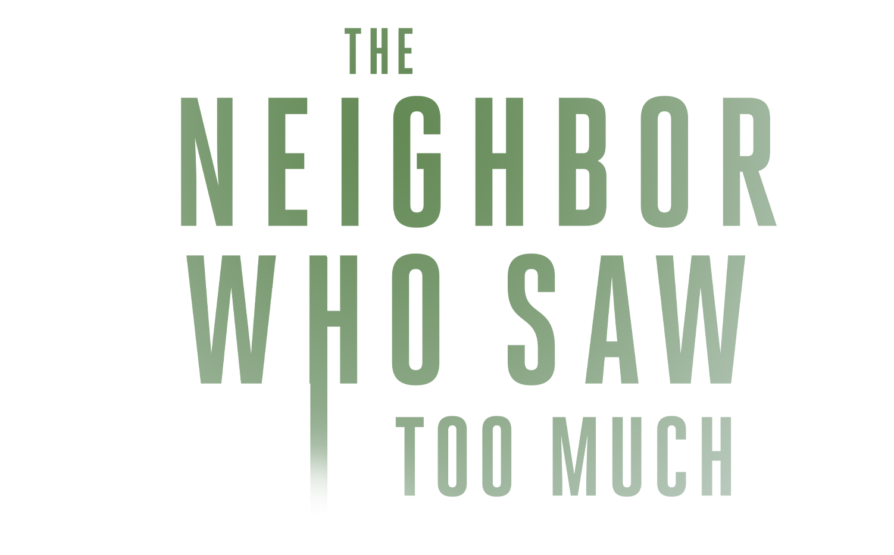
INSPIRED BY ACTUAL EVENTS

Johnson Production Group

Press Kit

One-Liner
A grounded teen becomes convinced that her hot new neighbor is actually a dangerous killer -- and when no one else believes her, she takes matters into her own hands.

Synopsis

After the devastating loss of her mother, Hayley Robinson moves in with her older sister, Diane. It’s a rocky start in a new house and new neighborhood. One night, Hayley is awoken by screams coming from next door. She starts to believe that their neighbor, Jason, is a serial killer. However, no one believes her and her erratic behavior isn’t helping. As Hayley becomes more suspicious, she and her friend Chrissy start to investigate, but Jason is on to her, and a dangerous cat and mouse games begins.

Producers
Executive Producers
TIMOTHY O. JOHNSON
JOSEPH WILKA
Co-Executive Producers
LISA ALFORD
Producer
A.J. KELLY
JACOB HORN
Line Producer
TERRENCE KIRIOKOS

Key Cast
CHARACTER  Hayley  Jason  Diane  Chrissy |  | ACTOR  SAGE MOORE  DEVANTE WINFREY  KIA DORSEY  KYLA NOVA

Key Cast Biographies

SAGE MOORE
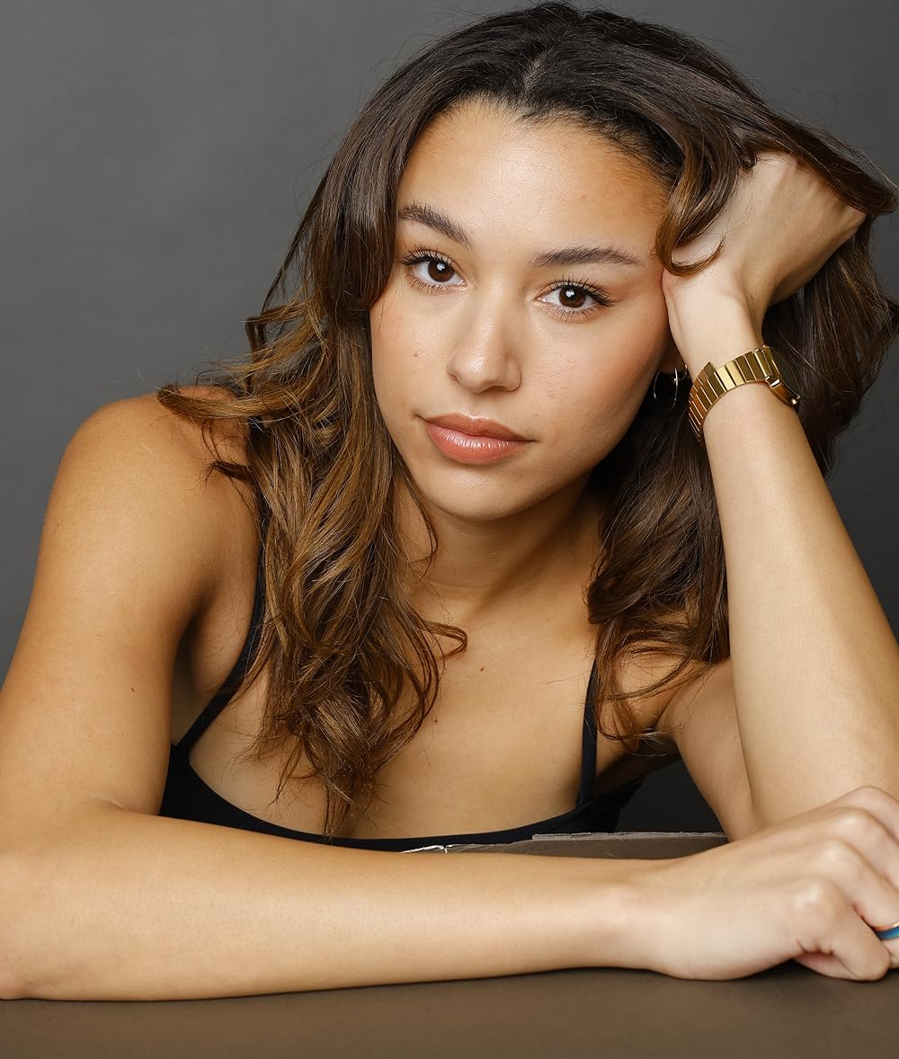
Trained for the screen and stage, Sage Moore is an accomplished actress, singer, and dancer. Sage is a USC graduate, a Lin Manuel Miranda Fellowship member, and a current student at Berg Studios. Other training includes UCB Improv and the National Theater Institute. As a queer person of color, Sage is passionate about identity-driven storytelling and inclusive projects. She's appeared in various independent films, music videos, and commercials including Tinder and Old Navy. Most recently, she worked as a lead in two Lifetime features!

DEVANTE WINFREY

Born and raised from Mississippi Devante spent most of his youth/teen years playing sports: basketball, football and track. Now trained in both theater and film after attending the Academy of Art University, Devante has played a myriad of roles ranging from musicals to films and tv. He has appeared in several Lifetime Network movies including Stalked by My Mother, Designed For Death, Wheels of Beauty, Unfinished, Bound by Blackmail, Dying to Win, Vanished in Yosemite, and most recently, The Beach House Murders.

KIA DORSEY

Kia Dorsey is an actress and director and has appeared in several film, television, and theatre productions. Kia studied Theatre at Oklahoma State University graduating with a Bachelor of Arts. After graduating, she became a high school theatre teacher and was also the Education Coordinator for Theatre Tulsa in Tulsa, Oklahoma. Kia later trained at The Identity School of Acting in Los Angeles, California. A native of Oklahoma, she now lives in Los Angeles.
Kia has appeared in W.W.J.R., Secrets in the Building, A Date with Deception, The Man in the Guest House and Ghost Game. She has also had a recurring role in Centuries Collide.

KYLA NOVA


Kyla's electric authenticity & edgy humor have captivated audiences. Her contagious energy, work ethic, & professionalism make her a joy to work with. She’s recently wrapped starring roles in Paris Santana’s Night Out (B47Films), Guilty Secrets (Lindsay Hartley), Influenced to Kill, LIFETIME & the sitcom pilot Residential which she also produces (178Blank). She spearheads every opportunity with immense passion & a unique point of view brought on by her richly diverse upbringing. Kyla is a rising star to watch.

Production Credits

Full Cast
Actors  SAGE MOORE  DEVANTE WINFREY  KIA DORSEY  KYLA NOVA  NIKO SOROKO  JOSHWA COPELAND  JACKIE MABRY  TRE MCBRIDE  ANASTACIA ROSE MCPHERSON  NANCY HARDING  TAYLOR MORAN  BRITTNEY DOIRON  MICHELLE BERNARD  MELVIN WARD | Role  Hayley  Jason  Diane  Chrissy  Max  Kevin  Officer Suarez  Officer Walker  Carol  News Anchor  Samantha  Layla  Detective #1  Detective #2

Casting By
STELLA NOVA csa

Production Designer
TYLER VOGEL

Director of Photography
ANDRESSA CORDEIRO

Edited By
QUINN ELSE

Music By
FB STUDIOS

Written By
BRANDI SPERRY

Directed By
KAILA YORK

Full Crew
ANDREW JUKES | First Assistant Director
NATALIE BRADY | Second Assistant Director
PETER BLICKENSDERFER | 2nd2nd Assistant Director
NATHAN DE LORIMIER
LEANDA HARLEY | Art Director
DAVID VENABLE | Art PA
KAITLYN CORWIN | Graphics
KESHIA BILLINGSLEA-SMITH | Key Make-up Artist
JENNIFER CORMACK | Key Hair Stylist
GEORGE ELLETT | 1st Assistant Camera
AMY FRYE | 2nd Assistant Camera
SELENA WEBB | Additional 2nd Assistant Camera
MIKE RADEFF
SATYA GOMEZ | Media Manager
JONATHON WARD | Stills Photographer
JEFF MARLOWE | Gaffer
DEVIN CONNOR | Best Boy Electric
JOHN MANNING | Additional Gaffer
PETE HOWELL | Key Grip
JOSH TOLON | Best Boy Grip
CHRIS GRAJALES | Additional Best Boy Grip
DAVID KINCHEN | Swing
DAVID HUGHES
ALEX HERNANDEZ | Jib Operator
JESSYCA BLUWAL | Costume Designer
DAVID DEAN CRUZ | Costumer Assistant
JASON AARON MORAN | Production Sound Mixer
MARIA CAREY-WALTON | Script Supervisor
SAMANTHA GRACE MILLER | Production Manager
BRIAN MCKEANEY | Locations Manager
KARIM PHELPS | Safety Coordinator
KARSTEN HALL | Production Assistants
JESSICA LEMON
DYLAN MYERS
SASHA KAMINSKY
BRIAN HURLEY
TIMMER PENNY
CHRISTOPHER PENTECOST | Supervising Sound Editor, Re-Recording Mixer
PETER TREPKE | Re-Recording Mixers, Dialogue Editor
PATRICK EVANS | Post Production Supervisor
UMAMI COLOR AND FINISHING | Post Production Services
JEFF SPOTT | Supervising Colorist
DAN EDWARDS | Colorist
ANTHONY CAMPAGNA | Finishing Artist
LUKE BUTLER | Digital Intermediate Producer / Conform Artist
HOLLYWOOD SCRIPT CLEARANCE | Script Clearance
PRIVATE ISLAND AUDIO | ADR Facilities
QUINN ELSE | Visual Effects
GOODFORM
ABACUS INSURANCE BROKERS, INC | Insurance
DEL MAR CATERING | Catering
RARE BREEDS | Cameras

Producer Biographies

TIMOTHY O. JOHNSON – Executive Producer
Timothy O. Johnson is among the most active and reliable producers in the business thanks to top rate productions and global distribution appeal. He is the managing partner of Johnson Production Group, a Canadian based operation that produces over 100 hours of dramatic television annually with hundreds of programs running internationally. The company is the leader supplier to Lifetime, Hallmark and other international outlets.
A graduate of the Marshall School of Business at the University of Southern California, he served as President of the USC Entertainment Management Association and a member of the Advisory Committee of the Center for Entrepreneurial Studies.
Johnson is also responsible for producing the international hit series, DR. QUINN, MEDICINE WOMAN for CBS for over 5 seasons. During his 100-episode tenure, he also developed and produced the original docu-drama COLD CASE for CBS network, which was the very first program to integrate television with the Internet.
Most recently, Johnson has produced the THE NOEL DIARY, being the #1 Film on Netflix’s Top 10 list in December of 2022. He was also at the helm of the successful GIRL IN THE SHED: THE KIDNAPPING OF ABBY HERNANDEZ, as well as the V.C. Andrews series of films, to date including TWILIGHT’S CHILD, MIDNIGHT WHISPERS, and DAWN, all produced for Lifetime..
Johnson has produced over 400 movies and 15 globally released series for every major US network - including Netflix, Lifetime, Hallmark, ABC, Disney, CBS, NBC, Netfly, FOX and Sony.

JOHNSON PRODUCTION GROUP
The Johnson Production Group contracts globally to produce television content for international networks, studios and distributors. Based in Los Angeles and Vancouver, British Columbia, the company manages production, facilitates development and financing, procures distribution and guarantees quality and timely execution of its programs. While costs have gone up, so has the demand for quality. No longer is good enough, good enough. Johnson Production Group serves that segment when a show needs to be "A" quality, but produced efficiently enough to meet a locked budget. JPG specializes in value, protection of creative elements, and delivery of a quality finished product.

JOSEPH WILKA – Co-Executive Producer
Joseph Wilka is the Head of Production for Johnson Production Group. Los Angeles-based, Joseph had already produced and directed several feature films before serving as the senior marketing executive for Gravitas Ventures. While at Gravitas, Wilka helped pioneer new distribution models for independent films including day-and-date theatrical releases. It was also at Gravitas where Joseph first worked with Johnson Production Group to facilitate the release of their films to the worldwide Video On Demand audience. After serving as the Director of Distribution and Production for Viva Pictures, where he produced English-language versions of foreign animated titles for DirecTV, Wilka officially joined Johnson Production Group. As Head of Production, he oversees the development, production, and distribution of films from multiple production units for release on broadcast and streaming platforms.

LISA ALFORD – Producer
Lisa Alford is a development executive at Johnson Production Group. A Massachusetts native, Lisa has lived and worked in Los Angeles for over a decade, always in support of excellent storytelling. Prior to joining Johnson Production Group, Lisa worked as an executive at TriStar television where she specialized in identifying IP that supported TriStar’s mission to feature diverse, authentic characters and champion underrepresented voices. Lisa came up at Sony Pictures Television where she worked as a production coordinator in the Television Movies and Miniseries department and in the writers room on the WGN hit series OUTSIDERS. In her current role, Lisa shepherds projects from the concept phase through story development, production, and post.

A.J. KELLY – Producer
Producer and co-founder of the creative production company, Goodform, A.J. Kelly has spent the past decade creating film, television, documentary, experiential and branded content. His work has won awards at top festivals including Cannes & SXSW, aired on premium networks and received multi-cultural acclaim.
Based in Los Angeles, A.J. believes in elevating content from diverse creative voices and providing an outlet for filmmakers to bring their stories to life.

JACOB HORN - Producer
Jacob Horn began his career in the entertainment industry by working his way up through Elijah Wood’s production company, Spectrevision. With them, he was able to gain producing experience with directors such as Nacho Vigalondo and Josh Waller. After leaving Spectrevision, Jacob went out on his own to produce and direct his own content including several short films, a Christmas feature for Hallmark , and also becoming the Stunt Dept Manager on Once Upon A Time In Hollywood. At present, Jacob is the Head of Production for GoodFlix, a feature film production company where he oversees an annual slate of films.

Billing Block
LIFETIME Presents In Association with JOHNSON PRODUCTION GROUP THE NEIGHBOR WHO SAW TOO MUCH Starring SAGE MOORE DEVANTE WINFREY KIA DORSEY KYLA NOVA NIKO SOROKO JOSHWA COPELAND JACKIE MABRY & TRE MCBRIDE Casting By STELLA NOVA csa Production Designer TYLER VOGEL Director of Photography ANDRESSA CORDEIRO Edited By QUINN ELSE Music By FB STUDIOS Line Producer TERRENCE KIRIOKOS Co-Executive Producer LISA ALFORD Executive Producers JOSEPH WILKA TIMOTHY O. JOHNSON Produced By A.J. KELLY JACOB HORN Written By BRANDI SPERRY Directed By KAILA YORK
© MMXXIV Johnson Production Group Inc. All Rights Reserved




Meta Data
LONG (max 3000 characters) synopsis
After the devastating loss of her mother, Hayley Robinson moves in with her older sister, Diane. It’s a rocky start in a new house and new neighborhood. One night, Hayley is awoken by screams coming from next door. She starts to believe that their neighbor, Jason, is a serial killer. However, no one believes her and her erratic behavior isn’t helping. As Hayley becomes more suspicious, she and her friend Chrissy start to investigate, but Jason is on to her, and a dangerous cat and mouse games begins. (505)
MEDIUM (max 500) synopsis
After the devastating loss of her mother, Hayley moves in with her older sister, Diane. It’s a rocky start in a new house and new neighborhood. One night, Hayley is awoken by screams coming from next door. She starts to believe that their neighbor, Jason, is a serial killer. However, no one believes her and her erratic behaviour isn’t helping. As Hayley becomes more suspicious, she and her friend Chrissy start to investigate, but Jason is on to her, and a dangerous cat and mouse games begins. (498)
SHORT (max 100 characters) synopsis
A teen thinks that her new neighbor is really a dangerous killer - takes matters into her own hands.
(100)
5 KEY WORDS
Murder, serial killer, neighbor, teenager

