

Johnson Production Group

Press Kit

# One-Liner

Largely inspired by the book My Mother’s Soldier written by Mary Elizabeth Kelso (Bailey), this film depicts the horrific real-life events that happened to this family where a young girl shoots her abusive stepfather, on the orders of her mother.

# Synopsis

# One night after her abusive stepfather got drunk and passed out, 11 year-old Mary Elizabeth Bailey’s mother put a gun in her hand and ordered her to kill him. Later, Mary’s mother told authorities that the child had acted on her own – but the truth came out and her mother went to prison. It would take more than three decades for Mary to make peace with what she was forced to do — and also to repair her relationship with her mother.

# It all started in early February 1987 when Wyers, then 29, returned from working as a truck driver to their West Virginia home and discovered his wife Priscilla had lent his Jeep to an acquaintance who'd run it off the road. Wyers was enraged and spent the next few days turning their lives into a living hell. Mary watched Wyers slap her grandmother so hard that he damaged her hearing. Finally, he grabbed a butcher knife, pressed it against her mother's throat and threatened to kill her before eventually passing out drunk in his chair. Priscilla then went to her bedroom and emerged with a .22-cal. rifle and put it in her daughter's hands. After police arrived, Priscilla initially told investigators she shot him. But then "she said it was all my idea," says Mary. Mother and daughter were both charged with murder. Mary was quickly placed in foster care and her attorney was told charges against her would be dropped if she testified against her mother.

# Producers

Executive Producer

TIMOTHY O. JOHNSON

PIERRE DAVID

ROXANNE BOISVERT

Producers

BRENDAN MCNEILL

STEVE BOISVERT

Associate Producer

KELLY SPINELLI

# Key Cast

|  |  |  |
| --- | --- | --- |
| CHARACTER  Ella  Veronica  Willard  Mary (11 Yr Old)  Sheriff Deere  Judge Bristol  Cordelia |  | ACTOR  MELISSA JOAN HART  OLIVIA SCRIVEN  CONNOR MCMAHON  PRESLEY ALLARD  ERIC ANTHONY DAVIS  JANAE ARMOGAN  LAURA ADAMO |

# Key Cast Biographies

# MELISSA JOAN HART

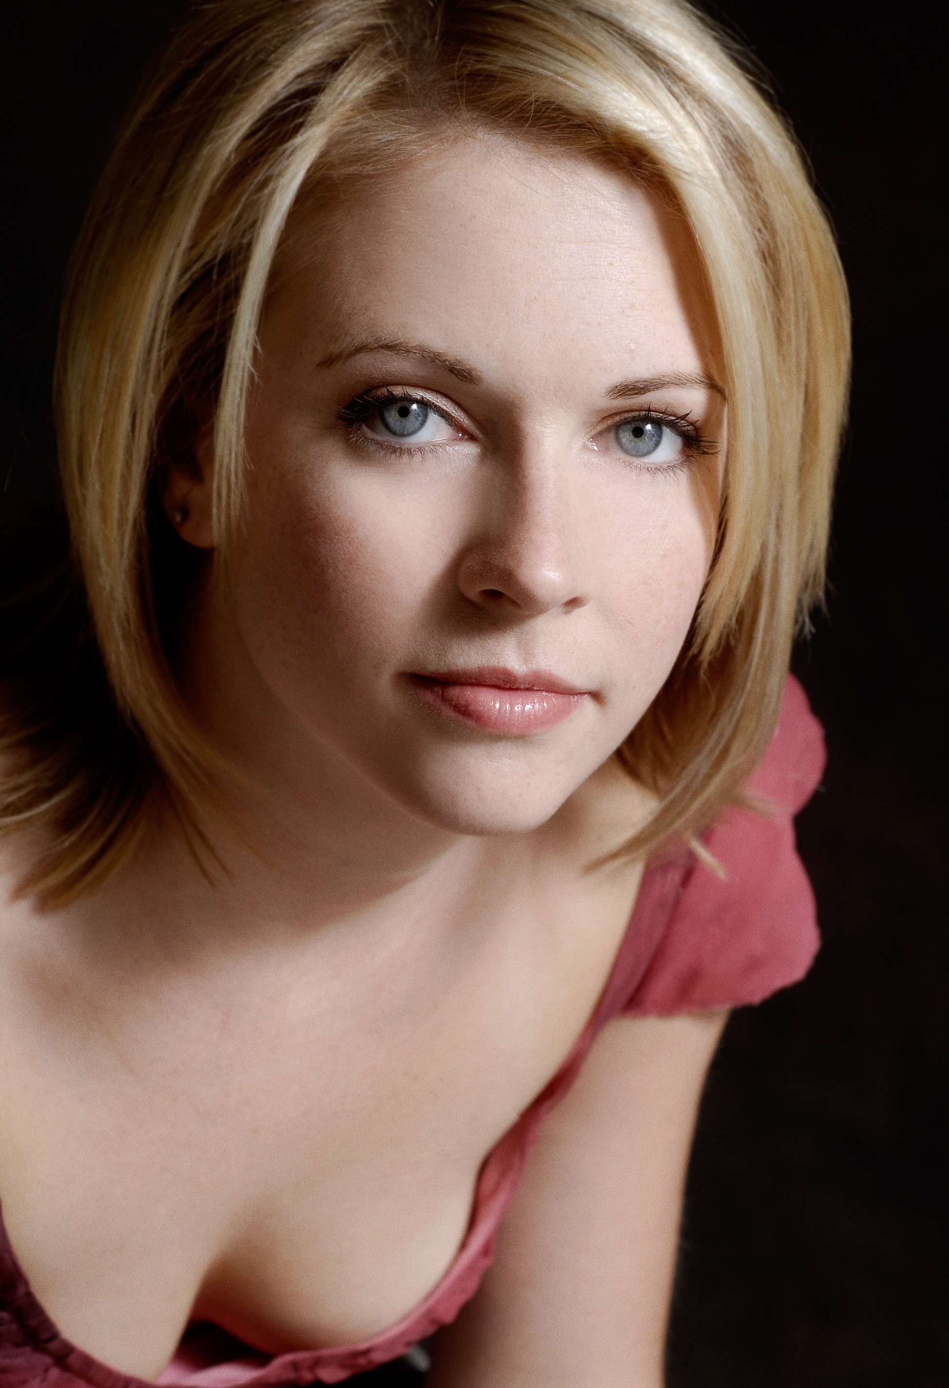Melissa Joan Hart has a list of credits far beyond her years. Having made her first national commercial at age 4, she is now a veteran of television, film and theater.

Recently, Hart directed a remake of the 1980s cult classic thriller, “The Watcher in the Woods,” starring Academy Award winning actress Anjelica Huston. The film premiered on Lifetime on October 21, 2017 to an impressive 332,000 (P 25-54, 1MM) in total viewers which was great opening for the network.

Hart appeared in “A Very Merry Toy Store” opposite Mario Lopez, which aired on Lifetime on November 26, 2017.

In 2016, she appeared in the sequel “God’s Not Dead 2,” alongside Jesse Metcalfe and Ernie Hudson. Melissa won the Grace Award for Most Inspiring Performance for Movies at the 2017 MovieGuide Awards on behalf of her performance in “God’s Not Dead 2.” The film also won the award for Best Movie for Mature Audiences at the 2017 MovieGuide Awards. “God’s Not Dead 2” earned $24,487,848 in the worldwide box office.

In the summer of 2015, Hart completed her 6th and final season on the ABC Family series. “Melissa & Joey”. She executive produced and directed the half-hour multi-camera comedy along with her co-star Joey Lawrence. The series premiered on ABC Family on August 17, 2010 and was ABC Family’s #1 series launch ever in Adults 18-49.

In 2014, Hart directed the holiday film titled “Santa Con” as well as appearing in the film. This was her feature-length directorial debut. The film premiered on Lifetime on December 13, 2014. That fall, Hart made her debut as an author her memoir, “Melissa Explains it All: Tales from My Abnormally Normal Life.” The memoir is published by St. Martin’s press and is currently available in bookstores and on Amazon.

Hart is best known internationally for her starring role in “Sabrina, the Teenage Witch,” which is produced by her company Hartbreak Films in association with Viacom and aired on ABC network from 1996-2000 and the WB Network from 2000-2003. She won a Nickelodeon’s Kids Choice Award for Favorite TV Actress for the title character. The show is also in syndication around the world and has inspired two “Wonderful World of Disney” movies, “Sabrina Goes To Rome” and “Sabrina Down Under,” both of which she produced and starred in after the success of the first TV movie “Sabrina the Teenage Witch” in 1995 alongside Ryan Reynolds for Showtime.

Hart first made her mark in television playing the title role in Nickelodeon’s “Clarissa Explains It All.” Winner of numerous Youth in Film awards for her work, Hart was nominated for a CableACE Award for Best Actress in a Comedy Series for “Clarissa Explains It All.” Hart has also appeared in numerous series such as “Just Shoot Me” and “That ’70s Show” and co-hosted the “American Music Awards” with Brandy. Hart’s episode of “Law and Order SVU,” which aired in Oct, 2007 had the highest ratings of the season, even outpacing the season premiere. Her ABC Family movie “Holiday in Handcuffs” premiered to record high ratings during the 2007 holiday season, making it ABC Family’s No. 1 telecast of all time.

On the big screen, Hart starred in the romantic comedy “Drive Me Crazy,” with newcomer Adrian Grenier for Fox Studio for which she won a Nickelodeon Kids Choice Award for Favorite Movie Actress. The filmed earned $22,593,409 in the worldwide box office. She made a memorable appearance as “yearbook girl” in the graduation night comedy “Can’t Hardly Wait” also had a cameo in “Not Another Teen Movie”. She also starred in and executive produced the thriller “Nine Dead” with Hartbreak Films producing.

Hart made her Broadway debut opposite Martin Sheen in “The Crucible.” She also starred opposite William Hurt and Calista Flockhart in the Circle Repertory production of “Beside Herself” in 1987. In the same company’s production of Peter Hedges’ “Imagining Brad” with Joe Mantello directing, Hart did a half hour monologue on stage at the impressive age of 12 to rave reviews which opened the door for her to audition for the role in “Clarissa Explains It All”. She has since returned to the stage to star in the acclaimed off-Broadway production of Eve Ensler’s “The Vagina Monologues” in 2000 and also appeared in the Los Angeles production of the show in May 2001.

In April 2010, Hart returned to the stage to star in Nora Efron’s Off-Broadway show “Love, Loss and What I Wore”. She led the star-studded ensemble of Lucy DeVito, Judy Gold, and Shirley Knight.

# OLIVIA SCRIVEN

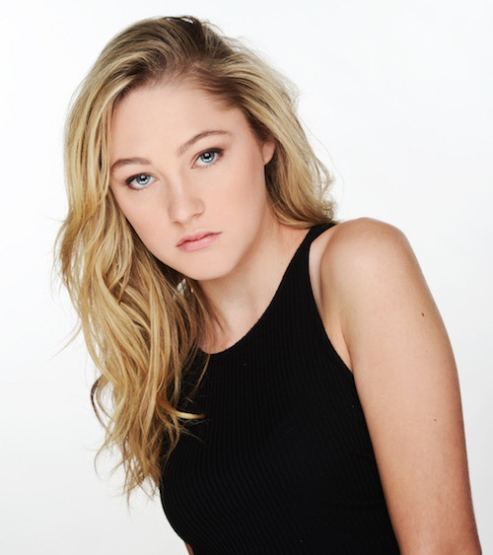Olivia Scriven was born in Wakefield,Quebec,Canada and at a young age moved to London,Ontario, Canada, with her parents and her two younger brothers. In London, she attended a unique public elementary school for the arts, and participated in many song, dance, and theatre productions in the city. She is a talented singer and musician. At age 13 she decided that she wanted to pursue acting as a career. She was cast in the highly successful Degrassi as Maya Matlin and has appeared as a continuing character in multiple Degrassi series, films and special projects. In addition, she has had recurring roles in the TV Series Skal and Mrs. America and has appeared in several films including Unless, Giant Little Ones, Blood Quantum and Black Conflux.

# CONNOR MCMAHON

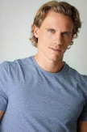Bilingual Canadian actor, Connor McMahon graduated from Carleton University with a Bachelor of Global and International Studies, receiving Honors with Distinction. He had a recurring role in the TV series Demain Des Hommes and has also made his mark in films such as Zombie at 17, Matthias & Maxime, The Fear in Their Eyes, Royally Wrapped for Christmas, Let’s Get Merried, Be Mine. Valentine, Stalked by a Prince, Ice Road Killer, Hotel for the Holidays, Record Breaking Christmas and Gwen Shamblin: Starving for Salvation.

# PRESLEY ALLARD

Young Presley Allard is known for her roles in the film Sorry About the Demon and UnPerfect Christmas Wish. She also appeard in the TV Series Good Sam as young Sam.

# ERIC ANTHONY DAVIS

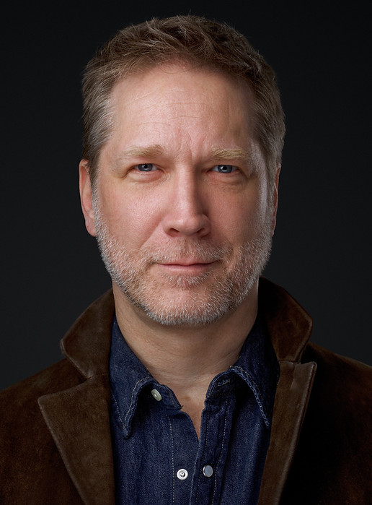Eric Davis has had an extensive career in film, including starring roles in Would You Kill For Me?, Wong And Winchester, Anna & Arnaud, Peace By Chocolate, Midway, Deadly , Broken Trust, Red Head, Canadian Detective, Psalm 53, 21 Thunder, The Art Of More Principal, Fatal Vows, 19-2, and A Stranger In My Home

# JANAE ARMOGAN

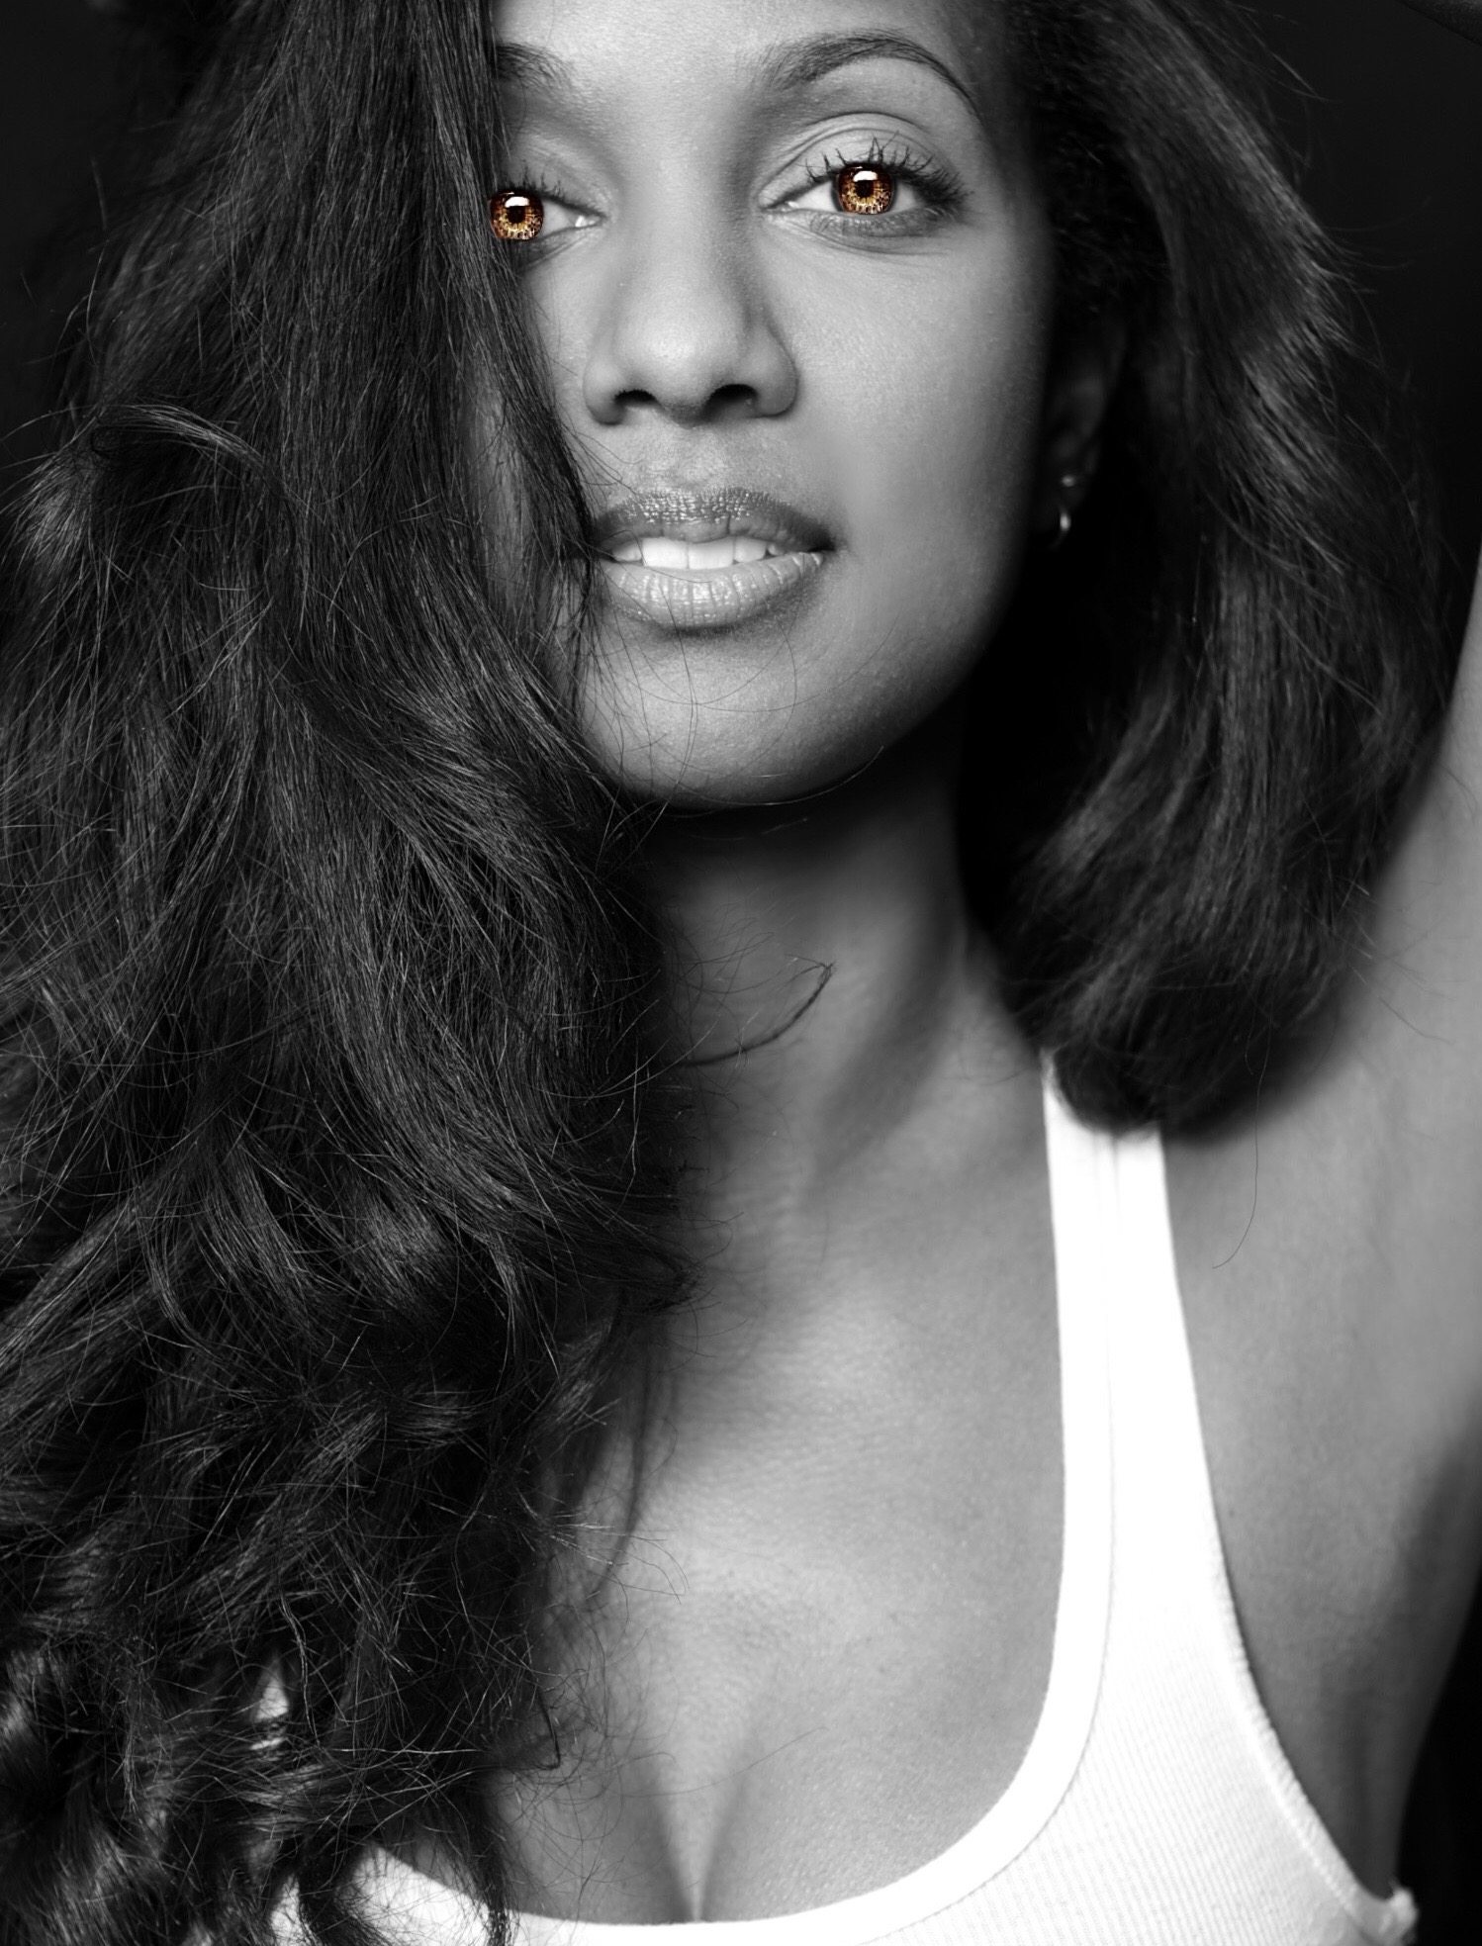JaNae was born in Toronto, Ontario on May 23, to an American mother and Guyanese/Canadian father, giving her dual citizenship. During high school, she joined the Improv team, as well as landing the lead role in the school production of "Cabaret". She entered the International Modeling and Talent Associations (IMTA) competition in L.A in 2004 and took home four awards, including "Actress of the year".

Her career started when wanting to be a track athlete, but after permanently hurting her leg, her life went a different direction, she always had a thing for the Arts but it did not really take effect until watching a film with Jada Pinkett Smith called "A Low Down Dirty Shame" It was the boldness and attitude of the female character that grabbed her interest in both her acting abilities and real life. From that point on she decided to focus in building her career, doing auditions for plays such as "The Kink in my Hair" and "The Lion King" winning call backs for both plays. She was discovered during a workshop by an agent while doing a monologue piece from the hit T.V. show "The Kink in my hair" This workshop discovery is now leading JaNae to becoming the strong bold female character that is launching her to stardom.

This busy actress has most recently been seen in a recurring role in Good Witch, as well as film roles in Galentine’s Day Nightmare, A Chestnut Family Christmas, Love Triangle Nightmare, Trapped with My Husband and Who Killed Our Father?

**LAURA ADAMO**

Laura Adamo is a Toronto based actor, and a graduate of the Neighborhood Playhouse School of Theatre in New York. Her first project was the short film "Drama Queen", which she created the concept for, produced, and stared in. The film screened at the Tribeca Film Festival and won the bronze medallion award at the Houston International Film Festival. She went on to produce and star in "Last Call", a feature film that screened at The Big Apple Film Festival and won the audience choice award at The San Diego Film Festival, which led to a distribution deal with Moving Pictures in the USA. Adamo then turned her attention to television. She created 5 scripted series and one lifestyle documentary food series. Her lifestyle show "Family Secrets" was in development with Paperny films and the pilot was shot by Douglas Arrowsmith. Her first scripted series "Cattle Call", a half hour comedy, went into development with City TV where she shot a pilot directed by Ron Murphy. Her second series, "Bait", went into development with Buck Productions and had a pilot script ordered by Much Music. Laura's most recent project is the feature film "The Wishing Tree", which she wrote, directed, and starred in. The film won the audience choice award at Filmocracy Fest.

# Production Credits

### Full Cast

|  |  |
| --- | --- |
| [**Actors**](http://www.imdb.com/name/nm7589451/?ref_=ttfc_fc_cl_t1)  MELISSA JOAN HART  OLIVIA SCRIVEN  CONNOR MCMAHON  PRESLEY ALLARD  ERIC ANTHONY DAVIS  JANAE ARMOGAN  MICHAEL GORDIN SHORE  BARBARA SAXBERG  LAURA ADAMO  PIERRE SIMPSON  CELINA MYERS  KYLE MEAGHER  ISABELLA ASTBURY  DANA FRADKIN  LUCA THUNBERG  LORENZO DAMIANO  PAULYNE WEI  MEGAN JONKER | **Role**  ELLA  VERONICA  WILLARD  MARY (11 YR OLD)  SHERIFF DEERE  POLICEWOMAN  ANGUS  JUDGE BRISTOL  CORDELIA  PASTOR  SUSAN  TODD  YOUNG MARY (5 YR OLD)  JENNIFER  SAMMY (6 YR OLD)  BO PERKINS  CELINE  MARY (21 YR OLD) |

### Casting By

LISA PARASYN  
ILONA SMYTH

### Production Designer

CODY JOHNSON

### Edited By

JORDAN JENSEN

### Music By

KEVIN CRONIN

### Wardrobe Designer

ROXANNE BOISVERT

### Director Of Photography

BILL ST. JOHN

### Associate Producer

KELLY SPINELLY

### Story By

MARY ELZABETH KELSO

### Screenplay By

GREGG MCBRIDE

### Directed By

SIMONE STOCK

**Full Crew**

|  |  |
| --- | --- |
| AINSLIE S. WIGGS | Production Manager |
| MICHEL POIRIER | First Assistant Directors |
| MICHELE E. DUTKA |  |
| SARAH PETKOV | Second Assistant Director |
| BRIANNA DE AVILA | Third Assistant Director |
| AJ BUFFMAN | Fourth Assistant Director |
| VINCENT CARDYN | Production Coordinator |
| GISELE MATTE | Assistant Production Coordinator |
| JESSICA FERGUSON |  |
| DANIEL SIMPSON | Production Accountant |
| ANDREW PECS | Comptroller |
| IAN PARSONS | Payroll Accountant |
| BILL ST JOHN | Director of Photography |
| NATHAN JONNA BOULIANE | Camera Operators |
| ANDRE DUFOUR |  |
| CARLA CLARKE | First Assistant Camera |
| TAYLOR RICE | Second Assistant Camera |
| ABRAHAM ISSA | Camera Trainees |
| JILLIAN SKIDMORE |  |
| MICHAEL MCCASEY |  |
| MATTHEW MCALLISTER |  |
| DANIEL COSTEA |  |
| ANTHONY SECK | B Cam Operator |
| CAELANN BENN |  |
| THIERRY FARGEAU | First Assistant B Camera |
| JUSTIN MCLOUGHLIN |  |
| JOHN PERKINS |  |
| TRISH YOUNG | Second Assistant B Camera |
| BRIAN TURPIN | Crane Technicians |
| RICHARD BOUCHER |  |
| ANDREW ANTHONY | Data Management Technician |
| DARCY RYAN | Stills Photographer |
| ASHLEY DAWN SZABADI | Script Supervisor |
| DAVID MOFFAT | Sound Mixer |
| DEVLIN JAMES | Boom Operator |
| PETER CHARTIER | Gaffer |
| CHRISTIAN GUERIN | Assistant Gaffer |
| NICK COUZELIS | Electric |
| SHAWN TONARY | Key Grip |
| CALLUM R.C. COOKE | Assistant Key Grip |
| SHAWN KAZDA |  |
| THOMAS JOHN ROLFE | Dolly Grip |
| MITCHELL HARTMANN | Daily Grip |
| CODY JOHNSON | Production Designer |
| TAMMIE “JAKE” WALKER | Art Director |
| DEVIN RUSHTON | Key Set Decorators |
| JONATHAN RAY GOODWIN | Assistant Set Decorators |
| MIKE MCGRATH | Lead Dresser |
| AICHA LASFAR | Set Dresser |
| JAMES SCHEMBRE | Daily Set Dresser |
| BRENDAN ROBERTSON |  |
| SAM HAQUE | Graphics |
| TIM WINCHESTER | Props Master |
| SHELBY TAYLOR | Props Assistants |
| CINTHIA BURKE | Head of Department Makeup |
| GISELLE MATTE | Key Makeup |
| TRACY PAGE | Head of Department Hair |
| DARCY RYAN | Key Hair |
| KAITLIN HUM | Wardrobe Assistants |
| HANNAH LUNDRIGAN |  |
| HOLLY WONG | Daily Wardrobe Assistants |
| STEVE BOISVERT | Location Manager |
| BRENDAN BUTT | Assistant Location Manager |
| CORGAND SVENDSEN | Location Scouts |
| MAUDE SCHOBLOCHER | Post Production Assistant |
| CORGAND SVENDSEN | Transportation Coordinator |
| ANDREW HAZELDEAN | Basecamp Coordinator |
| JOHN DAROUZE | Drivers |
| OLMES LEON |  |
| BRENDAN MCLOUGHLIN |  |
| ROGER E STEPHENS |  |
| LIAM HARPER | Daily Driver |
| ZACH BOISVERT | Genny Operator |
| ERIC “PIPEZ” BEAUCHAMP | Driver/Move Crew |
| CORY COVERT | Security |
| ROBERT LEE |  |
| JESSICA SOUANNHAPHANH |  |
| FRANK NICHOLS | Set Production Assistant |
| THOMAS DUNCAN | Location Production Assistants |
| SEAN MCNAMARA |  |
| KIPP HARPER |  |
| RAY BARKHOUSE | Key Craft |
| ED TANG | Craft Supervisor |
| MONIQUE MARCHAND | Tutor |
| LISA PARASYN | Toronto Casting |
| JAEDEI SANSOM |  |
| ILONA SMYTH | Extras Casting |
| MATTHEW GOUDIE |  |
| KELSIE WINSOR |  |
| SMYTH CASTING |  |
| **POST PRODUCTION** |  |
| VIRGINIE FOREST | Post Production Superviser |
| TBD | Post Production Coordinator |
| BEN USA | Post Production Accountant |
| SASSONIQUE PRODUCTIONS | Dialogue Transcription |
| AUDIO ZONE INC. | Audio Post Production Facility |
| MYRIAM THIBEAULT | Audio Post Production Coordinator |
| GUILLAUME BOURSIER | Sound Supervision |
| GUILLAUME BOURSIER | Sound Design |
| MICHEL GAUVIN | Re-Recording Mixer |
| BRIAN COSSETTE | Assisted by |
| FELIX DORAIS-TROTTIER |  |
| GENEVIÈVE SINCENNES |  |
| LUC BERNARD |  |
| MATHIEU PELLERIN |  |
| SÉBASTIEN BÉDARD | Sound Editor |
| JACQUES PLANTE | Dialogue Editor |
| MARIE-MIEL LACASSE HÉVEY | Assisted by |
| LEONARDO LAMELA | Foley Recordist |
| STÉPHANE CADOTTE | Foley Artists |
| FRANCIS REGIMBAL |  |
| LEONARDO LAMELA | ADR Recordist |
| JACQUES PLANTE | ADR Director and Editor |
| MONTREAL – AUDIO ZONE INC. | ADR Recording Facilities |
| TORONTO – URBAN POST INC. |  |
| OTTAWA – BARMART INC. |  |
| VANCOUVER – PINEWOOD |  |
| LOS ANGELES – AUDIO POST & PICTURE |  |
| FAKE DIGITAL ENTERTAINMENT | Video Post Production Service |
| ISABELLE DUBOIS | Video Post Production Coordinator |
| ERIC GAUDRY | Color Correction |
| GUILLAUME PICHÉ | Color Correction Assistant |
| LUIS MARTINO | Visual Effects & HD Editor |
| AUDIO ZONE INC. | Audio Post Production Facility |
| TECHNICOLOR CREATIVE SERVICES | Video Post Production Services |
| AFFINITY PRODUCTIONS INC. | Camera Equipment |
| HOLLYWOOD SCRIPT RESEARCH | Script Clearances |
| BREANNE HARTLEY | VP Business Affairs |
| SERVICES JURIDIQUES | Legal Services |
| CLAIRE BENOÎT |  |
| JOHANNE GAUTHIER | Financing Services |
| PHILIP SVOBODA | Business Affairs Manager |
| PARISE BOURGOIN | Business Affairs Associate |
| CHELSEA REYES-MORGAN | Business Affairs Coordinator |
| FRONT ROW INSURANCE BROKERS | Insurance Broker |
| HECHT HEFT LAMOUREUX | Accounting Services |
| ROBERT HECHT |  |
| ENTERTAINMENT PARTNERS CANADA | Payroll Services |
| CITY OF GATINEAU | Thanks to |
| CITY OF OTTAWA |  |
| OTTAWA DANCE DIRECTIVE/ CENTRE DE DANSE CONTEMPORAINE |  |

# Producer Biographies

## TIM JOHNSON – Executive Producer

Timothy O. Johnson is among the most active and reliable producers in the business thanks to top rate productions and global distribution appeal. He is the managing partner of Johnson Production Group, a Canadian based operation that produces over 100 hours of dramatic television annually with hundreds of programs running internationally. The company is the leader supplier to Lifetime, Hallmark and other international outlets.

A graduate of the Marshall School of Business at the University of Southern California, he served as President of the USC Entertainment Management Association and a member of the Advisory Committee of the Center for Entrepreneurial Studies.

Johnson is also responsible for producing the international hit series, DR. QUINN, MEDICINE WOMAN for CBS for over 5 seasons. During his 100-episode tenure, he also developed and produced the original docu-drama COLD CASE for CBS network, which was the very first program to integrate television with the Internet.

Most recently, Johnson has produced the THE NOEL DIARY, being the #1 Film on Netflix’s Top 10 list in December of 2022. He was also at the helm of the successful GIRL IN THE SHED: THE KIDNAPPING OF ABBY HERNANDEZ, as well as the V.C. Andrews series of films, to date including TWILIGHT’S CHILD, MIDNIGHT WHISPERS, and DAWN, all produced for Lifetime..

Johnson has produced over 400 movies and 15 globally released series for every major US network - including Netflix, Lifetime, Hallmark, ABC, Disney, CBS, NBC, Netfly, FOX and Sony.

## PIERRE DAVID – Executive Producer

David is best known for executive-producing iconic films directed by David Cronenberg, such as Scanners, Videodrome, and The Brood. He is also credited as "production executive" on the Academy Award-winning film Platoon, directed by Oliver Stone. He has since produced dozens of independent films, mainly in the thriller genre, and is still actively producing. He is the brother of former Quebec solidaire MNA Françoise David, as well as current Liberal MNA Hélène David.

In 1987, Pierre David Enterprises was the founding partners, along with home video distributor Malofilm, animation studio Nelvana and another home video distributor, New Star Entertainment, to form Los Angeles-based firm Image Organization, which was specialized in the thriller genre, and by 1996, represents 100 films in the international market, which by the beginning of the Image Organization combined group, represents foreign sales of the productions from the four companies each, and Pierre David hold a 20% interest, along with Nelvana and Malofilm, which also hold a 20% share, with a majority of 40% controlled by New Star Entertainment, which was led by partners Dmitri Villard and Robby Wald. Both Nelvana and New Star would later sell its shares in Image to David and Malofilm in 1989. Malo also formed in partnership with Pierre David, a company Lance Entertainment to develop films among the strongest French-indie track distributors in Canada.

## BRENDAN MCNEILL – Producer

Brendan McNeill spent 13 years working at the Canadian Audio-Visual Certification Office (CAVCO), co-administrator of federal film & television tax credits in Canada, where he gained extensive experience in analysing and adjudicating productions and assisted in the creation of key policies that continue to guide the office to this day.

In 2017, Brendan launched Above The Line Media Services Inc., a consultancy that has become a pre-eminent Canadian company for tax credit administration and processing. Brendan and the company have built up an extensive client base across the country and internationally, and regularly works with key industry stakeholders, such as lenders, and other professionals, including accounting and law firms.

He is a noted expert and a panel member at various industry events, including the Whistler International Film Festival.

## SIMONE STOCK – Director

Award-winning Writer-Director Simone Stock creates vivid performances from a distinctively emotional point of view.

Lifetime thriller The Girl Who Escaped - The Kara Robinson Story directed by Simone, starring Katie Douglas (Ginny & Georgia), Cara Buono (Stranger Things) & Kristian Bruun (Orphan Black) recently went to air netting over 2 million views and ranking #1 at Apple's Top TV Chart.

TIFF nominated Simone for comedy short Motown Morning (made at AFI) for Best Short. Sci-fi short Iris screened Cannes, was broadcast on TMN and won awards around the world.

Roger Spottiswoode, for whom Simone directed 2nd Unit on a number of features, partnered with Simone to produce Sci-Fi feature Starlight, for which Simone won the Telefilm New Voices Award.

## Billing Block

Produced by Pierre David in association with Johnson Production Group **“WOULD YOU KILL FOR ME? THE MARY BAILEY STORY”** starring MELISSA JOAN HART OLIVIA SCRIVEN CONNOR MCMAHON PRESLEY ALLARD ERIC ANTHONY DAVIS JANAE ARMOGAN LAURA ADAMO Casting By LISA PARASYN ILONA SMYTH Production DesignerCODY JOHNSON Edited By JORDAN JENSEN Music By KEVIN CRONIN Wardrobe Designer ROXANNE BOISVERT Director Of Photography BILL ST. JOHN Associate Producer KELLY SPINELLY Story By MARY ELZABETH KELSO Screenplay By GREGG MCBRIDE Produced By STEVE BOISVERT BRENDAN MCNEIL Executive Producers PIERRE DAVID TIMOTHY O. JOHNSON ROXANNE BOISVERT Directed By SIMONE STOCK

 

The Canadian Film or Video Production Tax Credit  


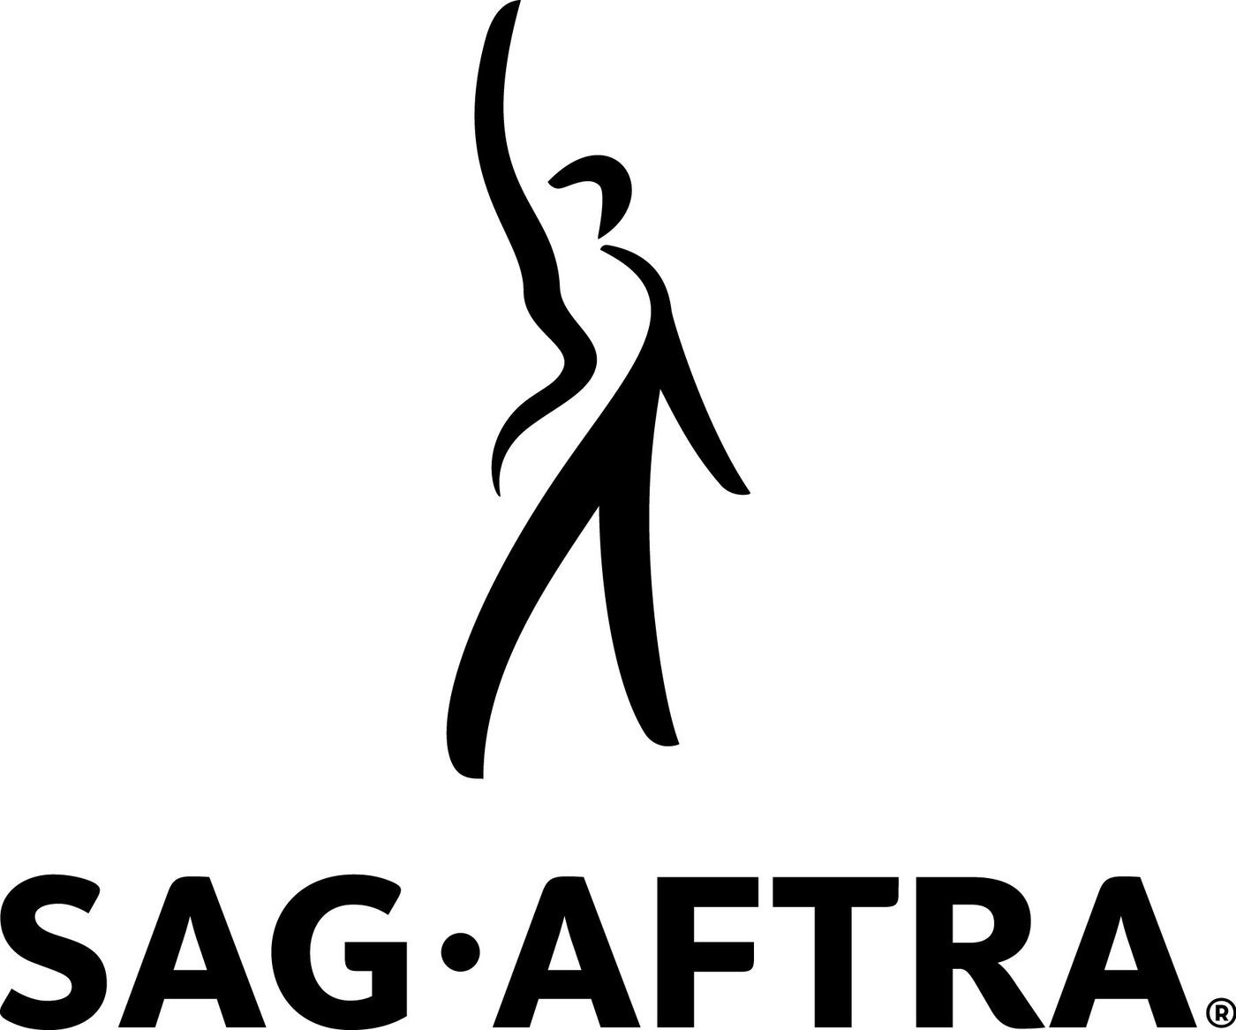







Interim financing by National Bank of Canada - TV and Motion Picture Group

A Quebec Ontario Coproduction

© MMXXIII – MB Ontarion Film Inc. and MB Quebec Film Inc. All Rights Reserved





Meta Data

LONG (max 3000 characters) synopsis

Largely inspired by the book My Mother’s Soldier written by Mary Elizabeth Kelso (Bailey), this film depicts the horrific real-life events that happened to this family where a young girl shoots her abusive stepfather, on the orders of her mother.

One night after her abusive stepfather got drunk and passed out, 11 year-old Mary Elizabeth Bailey’s mother put a gun in her hand and ordered her to kill him. Later, Mary’s mother told authorities that the child had acted on her own – but the truth came out and her mother went to prison. It would take more than three decades for Mary to make peace with what she was forced to do — and also to repair her relationship with her mother.

It all started in early February 1987 when Wyers, then 29, returned from working as a truck driver to their West Virginia home and discovered his wife Priscilla had lent his Jeep to an acquaintance who'd run it off the road. Wyers was enraged and spent the next few days turning their lives into a living hell. Mary watched Wyers slap her grandmother so hard that he damaged her hearing. Finally, he grabbed a butcher knife, pressed it against her mother's throat and threatened to kill her before eventually passing out drunk in his chair. Priscilla then went to her bedroom and emerged with a .22-cal. rifle and put it in her daughter's hands. After police arrived, Priscilla initially told investigators she shot him. But then "she said it was all my idea," says Mary. Mother and daughter were both charged with murder. Mary was quickly placed in foster care and her attorney was told charges against her would be dropped if she testified against her mother. (1643)

MEDIUM (max 500) synopsis

One night after her abusive stepfather got drunk and passed out, 11 year-old Mary Elizabeth Bailey’s mother put a gun in her hand and ordered her to kill him. Later, Mary’s mother told authorities that the child had acted on her own – but the truth came out and her mother went to prison. It would take more than three decades for Mary to make peace with what she was forced to do — and also to repair her relationship with her mother. (435)

SHORT (max 100 characters) synopsis

Horrific real-life event where a mother orders her young daughter to shoot her abusive stepfather (98)

5 KEY WORDS

Abusive stepfather, Mother, murder, daughter