A LIFEGUARD’S OBSESSION

Johnson Production Group

Press Kit

One-Liner

When Blake, a handsome and obsessed lifeguard, saves local surfer Maggie, from drowning, he believes he’s earned a place in her life... and her heart.

Synopsis

Beautiful surfer Maggie Temple seems to have everything: a cool job, a sexy boyfriend, and her beachy artwork. But her boss AJ is a lazy lothario who barely shows up, her boyfriend Cade is social media obsessed, and her art is so far getting her nowhere. Her one escape - the ocean - has been recommended against by her doctor because of a knee injury, but she pushes her limits and takes her board out into the rolling waves. Her bad knee quickly gives way and the ocean drags her under - until handsome lifeguard Blake Hopkins dives in to rescue her. Maggie is insanely grateful to Blake and after Cade lets his jealousy take over, she ends up spending more time with the thoughtful Blake instead. But the closer the two become, the more Maggie feels that something about the guy is just off. And the more she gives, the more he takes. Eventually, she discovers the painful truth: that she is Blake’s latest obsession and that he is more than willing to commit murder to get what he wants.

Producers
Executive Producers
TIMOTHY O. JOHNSON
JOSEPH WILKA
Producer
A.J. KELLY
Line Producer
JACOB HORN

Key Cast
CHARACTER  Maggie Temple  Blake Hopkins  Cade Kerrigan  Tina Jackson  AJ  Sam |  | ACTOR  AMANDA JONES  CHRISTIAN HOWARD  NOAH FEARNLEY  NAOMI BAKER  STEVEN OLSON  CHRISTINA GRAY

Key Cast Biographies

AMANDA JONES
Amanda Jones was born and raised in Fort Lauderdale, FL, and resides in Los Angeles, CA. Her passion for the performing arts began with her stage debut as Sharpay Evans in the iconic teen movie High School Musical. Immediately after graduating from The University of Southern California (fight on!) with a BAA in Communications and Cinematic Arts, Amanda began pursuing this career path full time. She has now worked on numerous projects for networks such as Amazon and Netflix. Amanda has since studied with some of the most prominent acting mentors in Los Angeles; working with Conchata Ferrell, Jeffrey Marcus, and Mary Lou Belli.

CHRISTIAN HOWARD
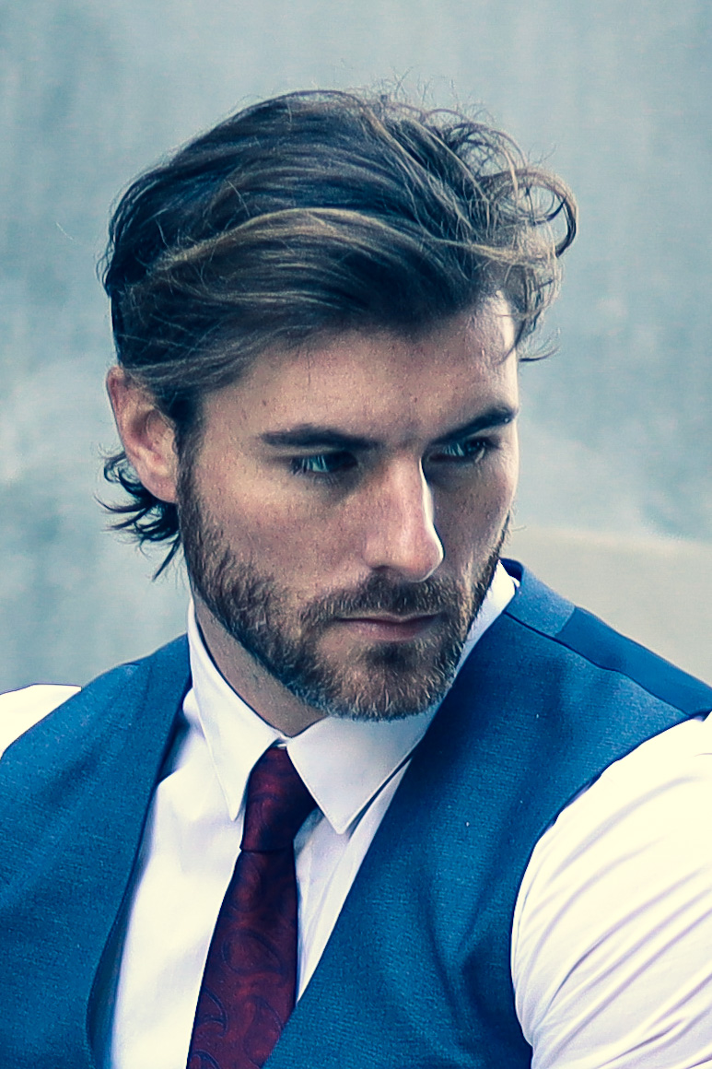
Christian Howard was born in Sunderland, near Newcastle, in the United Kingdom on 4 May 1984. At the age of 13, Howard began his training in martial arts in Essex. Howard began his training in Kung Fu, but later trained in Karate, Taekwondo and Capoeira. He notes Bruce Lee and Jean-Claude Van Damme as his influences for training in the martial arts.
Howard made his film debut in 2005 with the indie film Love Struck and worked primarily in television movies and short films. In 2010, he played the role of Ken Masters in the short film Street Fighter: Legacy opposite Jon Foo as Ryu. In addition to playing Ken, Howard also co-wrote the screenplay and assisted with fight choreography with director Joey Ansah. He earned his first male lead role in a feature film with Ross Boyask's sword and sorcery homage Warrioress opposite Cecily Fay, who met Howard while he worked as a stuntman. Howard worked as a fight choreographer on films such as Dragon Crusaders and the Bollywood film Force and doubled for lead actor John Abraham. Howard had worked as assistant fight choreographer and doubled for idol Jean-Claude Van Damme on U.F.O.
In 2013, Howard co-starred as Wedge and served as assistant fight choreographer on Green Street 3: Never Back Down.
The overwhelming success of the 2010 short film Street Fighter: Legacy led to Capcom and Machinima financing the web-series Street Fighter: Assassin's Fist. Howard was able to return to the role of Ken Masters, but since Jon Foo was unavailable, Mike Moh replaced Foo as Ryu. The series was also co-written by Howard and again, Howard assisted with the series' fight choreography alongside co-star and series director Joey Ansah.
In 2016, Howard returned to the role of Ken Masters in the sequel series Street Fighter: Resurrection alongside Mike Moh returning as Ryu and features Alain Moussi as Charlie Nash.

NOAH FEARNLEY
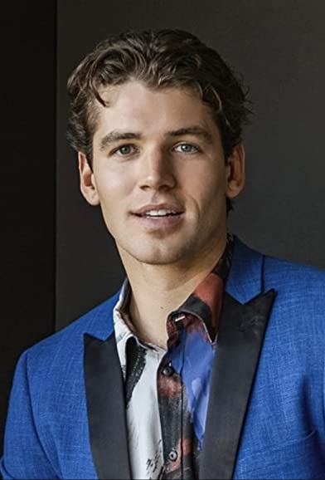
Noah Fearnley is an American actor raised in Orange, Connecticut. He made his debut into television appearing as Sam Hitchens in the mini-series, Morgan's Secret Admirer. He later starred as a lead in the 2021 Lifetime film, The Wrong Cheer Captain. In 2022, he premiered 4 films, staring in Mother's Deadly Son and Dognapped: Hound for the Holidays. Aside from his acting career, Fearnley has modeled for brands such as Giorgio Armani, Dolce & Gabbana and Givenchy.

NAOMI BAKER
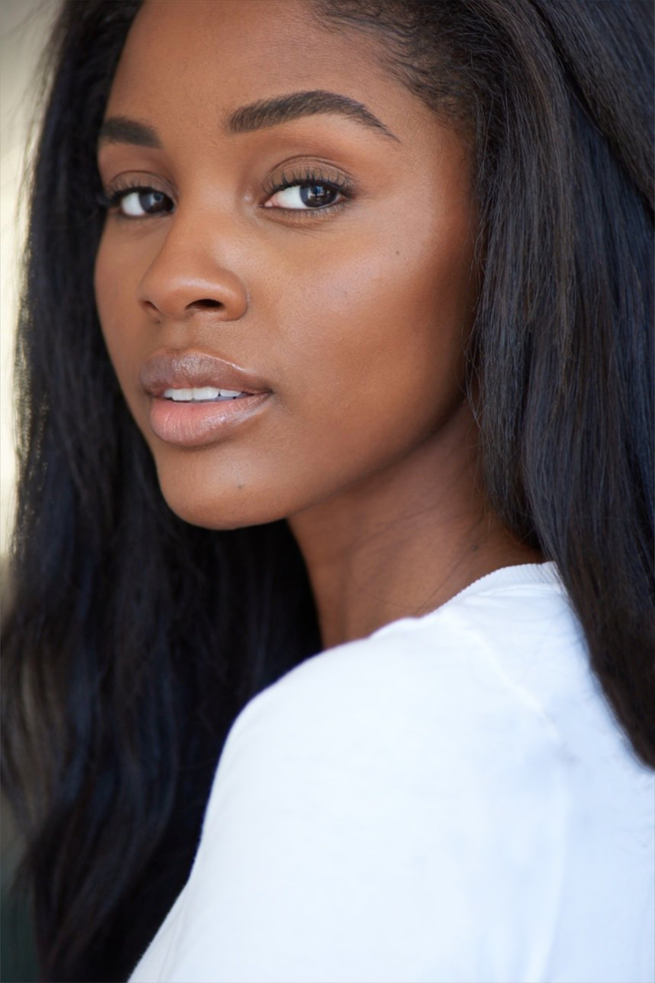
American actor, Naomi Baker was born on May 6, 1998 in Dayton, Ohio, USA. She is known for her work in All American: Homecoming (2022), Club Alli (2020) and We're F*cked, Lol! (2022).

STEVEN OLSON
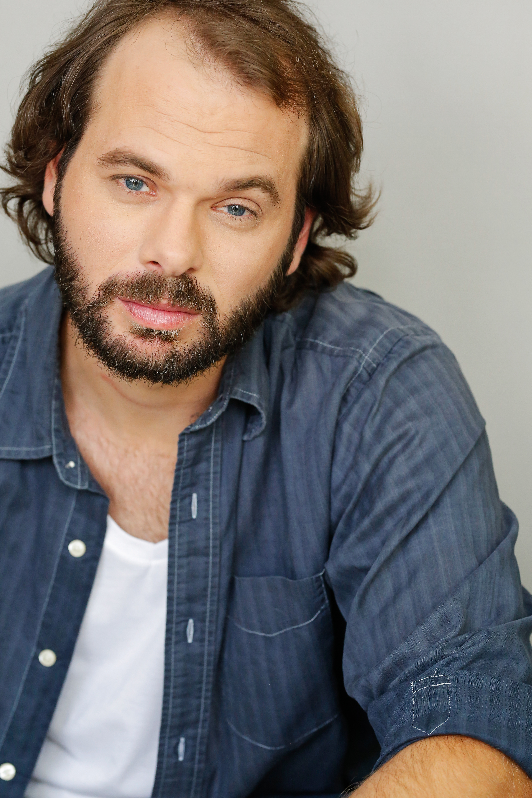
American actor, Steven James Olson, graduated from California State University of Fresno with a B.A. Theatre Arts and Mass Communication and Journalism. He continued his education with a two Year Professional Conservatory at the Art of Acting Studio in Los Angeles. His film work has included roles in Southbound Heist, The Recording, Hollywood Road Trip, Brick Madness and he will also appear in the upcoming Staycation.

CHRISTINA GRAY
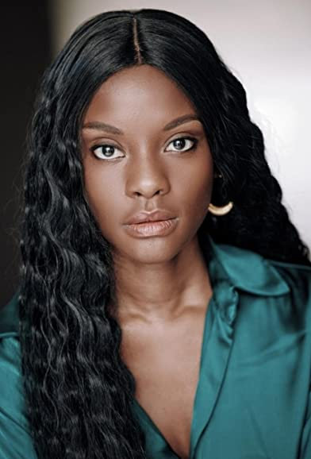
Christina Gray is an actress, model and filmmaker. Born and raised in Miami, Florida to Jamaican immigrant parents. She has always had an affinity for the arts since childhood. She began dancing at 3 years old and singing at age twelve. She later attended the Universiity of Florida and Florida Atlantic University where she earned her bachelors degree in Musical Theater and a minor in dance and Business Administration.
Christina then moved to Los Angeles to further her career. During her first couple of years she managed to start her own business called 'The Models Bootcamp" where she coached aspiring models in print and commercial acting. She also started her own production company called "ROOM Entertainment" where she produced, wrote, directed and starred in her first film "Tricks" that won Best first time filmmaker in Miami's Flow Film Festival. Christina also has a passion for activism and is a member of the Peace organization in Palm Beach Florida where she works on platforms for racial equality and prison reform.

Production Credits

Full Cast
Actors  AMANDA JONES  CHRISTIAN HOWARD  NOAH FEARNLEY  STEVEN OLSEN  NAOMI BAKER  CHRISTINA GRAY  CRAIG GEOGHAN  JENNIFER CASTILLO | Role  Maggie Temple  Blake Hopkins  Cade Kerrigan  AJ  Tina Jackson  Sam  Tyson  Alicia

Casting By
THOMAS SULLIVAN CSA

Production Designer
DAVID VENABLE

Director of Photography
ANDREW J. GIANNETTA

Edited By
ERIC MARSH

Music By
BEN COLLIER

Written By
JAMES ALAN ROSS
RICHARD PIERCE

Directed By
LANE SHEFTER BISHOP

Other Crew
ANDREW JUKES | First Assistant Director
NATHAN DE LORIMIER | Second Assistant Director
NATALIE BRADY | Second Second Assistant Director
LESLIE GLADNEY | Art Director
GRAHAM HART | Set Dresser
KESHIA SMITH | Key Make-up Artist
CORTNEY WATSON | Key Hair Stylist
CESYLEA DAVIS | Additional Stylist
AUSTIN AHLBORG | Underwater Camera Operator
DON DUFFIELD JR | 1st Assistant Camera
SOFIA GLEZZ | 2nd Assistant Camera
KEIRY VERA
PETE AGUIRRE | Media Manager
KEN SAX | Stills Photographer
JEFF MARLOWE | Gaffer
DANIEL MENDE MARTINS
MATHIAS MADSEN | Additional Gaffer
NATHAN ALEXANDER | Best Boy Electric
JESSE COLLETTE
JOHN CHIGAS
DAVID HUGHES | Electric
PETER G HOWELL | Key Grip
JOSHUA TOLON | Best Boy Grip
CHAD MARSHALL | Dolly Grip/Swing
JESSYCA BLUWEL | Costume Designer
DAVID DEAN CRUZ | Wardrobe Assistant
ERIC ENROTH | Production Sound Mixer
ADAM BROOKS | Boom Operator
ANGELA HERNANDEZ | Script Supervisor
TRAVIS PILAT | Production Manager
KARIM PHELPS | Safety Coordinator
ARIES LOUIZIA | Production Assistants
NATALIE BRADY
BROOKESHARLAND
BRANDON HILL
JACK RUDMAN | Sound Designer / Supervising Sound Editor/Dialogue Editor
JACK RUDMAN | Re-Recording Mixers
CADDY LEDOUCHE
CHANGING FRAMES | Post Production Services
DAN EDWARDS | Colorist
JEFF SPOTT
ANTHONY CAMPAGNA | Finishing Artist
HOLLYWOOD SCRIPT CLEARANCE | Script Clearance
PRIVATE ISLAND AUDIO | ADR Facilities
ANDREW LUPAN | Visual Effects
MATT GARDOCKI / GARDOCKI DIGITAL | Additional VFX
ABACUS INSURANCE BROKERS, INC | Insurance
TOO TASTY CATERING | Catering
RARE BREEDS | Cameras

Producer Biographies

TIM JOHNSON – Executive Producer
Tim Johnson is among the most active and reliable producers in the business thanks to top rate productions and global distribution appeal.
Johnson is also responsible for producing the international hit series, DR. QUINN, MEDICINE WOMAN for CBS for over 5 seasons. During his 100-episode tenure, he also developed and produced the original docu-drama COLD CASE for CBS network, which was the very first program to integrate television with the Internet.
Johnson has produced over 150 movies, 15 globally released series for every major US network - including ABC, Disney, CBS, NBC, Netfly, FOX and Sony.

JOHNSON PRODUCTION GROUP
The Johnson Production Group contracts globally to produce television content for international networks, studios and distributors. Based in Los Angeles and Vancouver, British Columbia, the company manages production, facilitates development and financing, procures distribution and guarantees quality and timely execution of its programs. While costs have gone up, so has the demand for quality. No longer is good enough, good enough. Johnson Production Group serves that segment when a show needs to be "A" quality, but produced efficiently enough to meet a locked budget. JPG specializes in value, protection of creative elements, and delivery of a quality finished product.

JOSEPH WILKA – Executive Producer
Joseph Wilka is the Head of Production for Johnson Production Group. Los Angeles-based, Joseph had already produced and directed several feature films before serving as the senior marketing executive for Gravitas Ventures. While at Gravitas, Wilka helped pioneer new distribution models for independent films including day-and-date theatrical releases. It was also at Gravitas where Joseph first worked with Johnson Production Group to facilitate the release of their films to the worldwide Video On Demand audience. After serving as the Director of Distribution and Production for Viva Pictures, where he produced English-language versions of foreign animated titles for DirecTV, Wilka officially joined Johnson Production Group. As Head of Production, he oversees the development, production, and distribution of films from multiple production units for release on broadcast and streaming platforms.

A.J. KELLY – Producer
Producer and co-founder of the creative production company, Goodform, A.J. Kelly has spent the past decade creating film, television, documentary, experiential and branded content. His work has won awards at top festivals including Cannes & SXSW, aired on premium networks and received multi-cultural acclaim.
Based in Los Angeles, A.J. believes in elevating content from diverse creative voices and providing an outlet for filmmakers to bring their stories to life.

JACOB HORN – Line Producer
Jacob Horn began his career in the entertainment industry by working his way up through Elijah Wood’s production company, Spectrevision. With them, he was able to gain producing experience with directors such as Nacho Vigalondo and Josh Waller. After leaving Spectrevision, Jacob went out on his own to produce and direct his own content including several short films, a Christmas feature for Hallmark , and also becoming the Stunt Dept Manager on Once Upon A Time In Hollywood. At present, Jacob is the Head of Production for GoodFlix, a feature film production company where he oversees an annual slate of films.

LANE SHEFTER BISHOP – Director
Lane Shefter Bishop is a multi-award-winning Producer and Director who has received numerous accolades for her work including an EMMY and the DGA Fellowship Award for Episodic Television. Currently Ms. Bishop is the CEO of Vast Entertainment, THE go to book-to-screen company since in an online interview, CNN dubbed her “The Book Whisperer” of Hollywood.
Ms. Bishop has numerous projects, both completed and in active development including: Producing Feature Films, THE DUFF for CBS Films & Lionsgate and ASSASSINATION GAMES for MPCA (both based on books) as well as Producing, Directing and Showrunning the Backdoor Pilot for TV Series, HOPETOWN for Hallmark Channel (based on the ‘Blessings’ books by Beverly Jenkins) as well as Producing and Directing THE DARK DESCENT OF ELIZABETH FRANKENSTEIN for Sony Pictures Television and Tristar (based on the Kiersten White novel).
Ms. Bishop has also been Executive Producing and Directing Christmas Movies for UPtv and Superchannel including MISTLETOE & MOLLY, SECRET SANTA, CHRISTMAS BENEATH THE STARS, THE HOLIDAY SWITCH, CHRISTMAS ON THE ROCKS, and A VINTAGE CHRISTMAS (all based on the Melissa Hill novels) as well as numerous Thriller Movies for Lifetime including TEMPTATION UNDER THE SUN, THE TRYST (in post), DESPERATE WIDOWS (also written by Ms. Bishop), HIS SECRET MARRIAGE (also written by Ms. Bishop), HE KNOWS YOUR EVERY MOVE, WICKED MOMS CLUB, BLOOD SWEAT AND LIES and THE CHOKING GAME – which was the third most viewed program on television the night it premiered. Ms. Bishop also directed the Streaming Movie A BROTHER’S HONOR, an African American romance for Passionflix (based on NY Times bestselling author Brenda Jackson’s uber-popular novel).
Additionally, Ms. Bishop is a published Author of the book SELL YOUR STORY IN A SINGLE SENTENCE, ADVICE FROM THE FRONT LINES OF HOLLYWOOD. She also holds a B.A. in Literature from UC Santa Barbara and an M.F.A. in Production from USC's School of Cinema/Television. She is a director-member of the Directors Guild of America and the Academy of Television Arts and Sciences.

Billing Block
LIFETIME Presents In Association with JOHNSON PRODUCTION GROUP “A LIFEGUARD’S OBSESSION” starring AMANDA JONES CHRISTIAN HOWARD NOAH FEARNLEY NAOMI BAKER STEVEN OLSON CHRISTINA GRAY Casting By THOMAS SULLIVAN CSA Production Designer DAVID VENABLE Director of Photography ANDREW J. GIANNETTA Edited By ERIC MARSH Music By BEN COLLIER Line Producer JACOB HORN Executive Producers TIMOTHY O. JOHNSON JOSEPH WILKA Produced By A.J. KELLY Written By JAMES ALAN ROSS RICHARD PIERCE Directed By LANE SHEFTER BISHOP
© MMXXIII Johnson Production Group Inc. All Rights Reserved

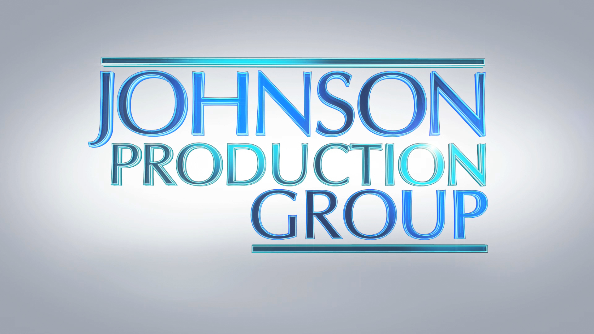

Meta Data
LONG (max 3000 characters) synopsis
Beautiful surfer Maggie Temple seems to have everything: a cool job, a sexy boyfriend, and her beachy artwork. But her boss AJ is a lazy lothario who barely shows up, her boyfriend Cade is social media obsessed, and her art is so far getting her nowhere. Her one escape - the ocean - has been recommended against by her doctor because of a knee injury, but she pushes her limits and takes her board out into the rolling waves. Her bad knee quickly gives way and the ocean drags her under - until handsome lifeguard Blake Hopkins dives in to rescue her. Maggie is insanely grateful to Blake and after Cade lets his jealousy take over, she ends up spending more time with the thoughtful Blake instead. But the closer the two become, the more Maggie feels that something about the guy is just off. And the more she gives, the more he takes. Eventually, she discovers the painful truth: that she is Blake’s latest obsession and that he is more than willing to commit murder to get what he wants. (991)
MEDIUM (max 500) synopsis
When Blake, a handsome and obsessed lifeguard, saves local surfer Maggie, from drowning he believes he’s earned a place in her life... and her heart. (150)
SHORT (max 100 characters) synopsis
A lifeguard saves a woman from drowning and believes he’s earned a place in her life and her heart. (99)
5 KEY WORDS
Drowning, thriller, artist, jealousy, surfer

