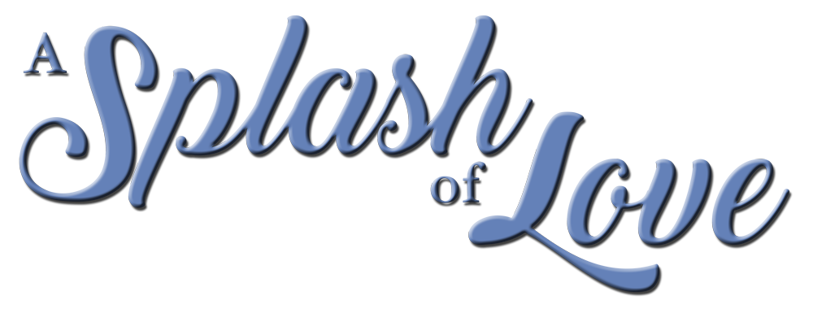

Johnson Production Group

Press Kit

One-Liner

A PhD student makes her way to the Pacific Northwest to study the resident whales and relies on the expertise of a local tour guide.

Synopsis
When PhD student Chloe makes the choice to expand her studies to include the whales of the Pacific Northwest, she leaves Miami and heads to the picturesque Cable Cove. There she relies on the local expertise of whale watching tour guide, Ben, and they soon find themselves bonding over more than just the J-Pod of orcas.

Producers
Executive Producer
TIMOTHY O. JOHNSON
Co-Executive Producer
JULIANA WIMBLES
Producer
NAVID SOOFI
Supervising Producer
OLIVER DE CAIGNY

Key Cast
CHARACTER  Chloe Turner  Ben Winters  Mary Martin  Marcus |  | ACTOR  RHIANNON FISH  BEN HOLLINGSWORTH  LAURA SOLTIS  SEAN YVES LESSARD

Key Cast Biographies

RHIANNON FISH
Rhiannon Fish is a Canadian/Australian actress. Rhiannon is known worldwide for her role as Ontari in The 100. Her first work came as a child actor when she had the series regular role of Lisa Jefferies on the Australian TV series, Neighbours. In her late teens, she then booked the series regular role of April Scott on Home and Away that made her a household name in Australia. Rhiannon has also had a successful career in feature films, booking lead roles in productions such as Playing for Charlie, Relentless, 2018’s Occupation and Hallmark’s 2020 films Remembering Love and You’re Bacon Me Crazy. She will next be seen leading the cast in the US feature film, Love and Chocolate and Hallmark’s Journey of My Heart.

BENJAMIN HOLLINGSWORTH
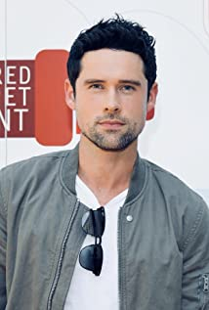
Benjamin Hollingsworth is a classically trained actor who was born September 7th, 1984 in Brockville, Ontario, Canada. In 2006, Hollingsworth graduated from the National Theatre School of Canada (NTS), a prestigious three year acting conservatory program in Montréal.
Soon after, in his first professional role under the direction of NTS alumni, Ted Dykstra, Benjamin was nominated for a Robert Merritt Award for his portrayal of Lance Corporal Dawson, in A Few Good Men, by Aaron Sorkin.
Hollingsworth shifted his focus from theater to film and television. He quickly found footing in the Toronto film industry and began guest starring on several popular Canadian TV series including Degrassi, Heartland and HBO Canada's The Line by George F. Walker.
Benjamin's breakout role came when he landed the lead in his feature film debut alongside Demi Moore, David Duchovny and Amber Heard in the highly acclaimed film feature The Joneses (2010).
Following The Joneses, Benjamin was cast in a new CW series called The Beautiful Life (2009) starring Misha Barton, Sara Paxton and Gal Gadot. The series, produced by Ashton Kutcher, cast Hollingsworth in the lead role of "Chris Andrews," a character that was loosely based on Kutcher's own experiences in the industry.
Shortly after, Hollingsworth went on to recur in several TV series including a memorable turn as "Kyle Durant" on the first season of USA's Suits; followed by multiple recurring roles on the CW's The Tomorrow People, Cult and a guest star on ABC's Once Upon a Time.
In 2014, Hollingsworth joined the cast of the Fox series Backstrom starring Rainn Wilson, as Assistant District Attorney "Steven Kines." Later that year he starred in several romantic comedies including Lucky in Love (2014) opposite Gossip Girl's Jessica Szohr, A Wish Come True (2014) starring Megan Park and Can't Buy My Love (2014) with Adelaide Kane. He balanced the year out with lead roles in two action thrillers; 20th Century Fox's Joy Ride 3 (2014) and the Lionsgate feature Vendetta (2014).
Benjamin made his return to network TV as a series regular in CBS' medical drama Code Black (2015) in which Hollingsworth played "Dr. Mario Savetti;" a performance that earned Benjamin a Golden Maple Award nomination for Best Actor in a TV series. Code Black featured an all-star cast made up of Oscar winner Marcia Gay Harden, Luis Guzman and Emmy and Golden Globe nominee Rob Lowe. Code Black concluded its third and final season in 2018. By 2021 he was appearing as a series regular in Joe Pickett, Nancy Drew and the immensely popular Virgin River.
In 2019 Benjamin made his return to the big screen with two feature films; Lionsgate's revenge thriller Hard Powder starring Liam Neeson, Laura Dern and Emmy Rossum and the David Cronenberg remake of the 1977 cult classic Rabid from the Soska Twins.

LAURA SOLTIS
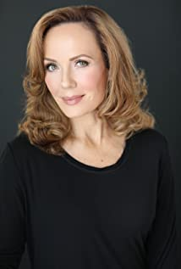
American actress Laura Soltis has had a busy career. She is known for Hiccups (2010), Step Up All In (2014) and Black Sash (2003) but most recently has appeared in several TV Movies including Framed for Murder: A Fixer Upper Mystery, Summer in the Vineyard, Love at First Dance, Yes, I Do, Valentine in the Vineyard, Five Star Christmas, Christmas Waltz, A Whirlwind Wedding and The J Team.

SEAN YVES LESSARD
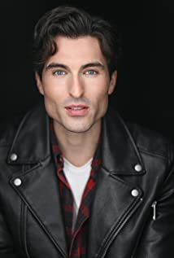
Sean was born in Syracuse, NY. He attended Chittenango High School, graduated with a BA in Music from SUNY Geneseo and later a MFA in Acting from Harvard University's A.R.T. Institute. After spending years in theatre he made the switch to television and film. He now lives and works, primarily, in Vancouver, B.C.. He has a recurring role on Heartland as Evan Garland, will appear in the upcoming film Wifelike as Ido and will recur on the new SyFy and NBC/Universal show Reginald the Vampire.

Production Credits

Full Cast
Actors  RHIANNON FISH  BEN HOLLINGSWORTH  LAURA SOLTIS  BRAD ABRAMENKO  JULIANA WIMBLES  SEAN YVES LESSARD  MADELEINE KELDERS  KAMANTHA NAIDOO | Role  Chloe Turner  Ben Winters  Mary Martin  Adrian  Shawna  Marcus  Dr. Andrea Ware  Shannon

Casting by
JUDY LEE

Production Designer
JORDAN NINKOVICH

Director of Photography
JAY KAMAL

Edited by
JASON NIELSEN

Music by
Mario VAIRA

Written by
JULIANA WIMBLES

Directed by
HEATHER HAWTHORN-DOYLE

Full Crew
THOMAS STANFORD | Associate Producer
CELESTE CROWE | Unit Production Manager
JEFF CROFT | First Assistant Director
AKRAM FAKHFAKH | Second Assistant Director
JADEN DEVINE | Costume Designer
MARIA ALEJANDRA MOLANO | Set Decorator
JUAN PABLO GONZALEZ AMAYA | Props Master
ASHLEY TAMBOUR | Make-Up Artist
ASHLEY DE SOUZA | Hair Stylist
ROBIN D. MACDONALD | Location Manager
SAMANTHA SUMINGUIT | Script Supervisor
JEFF DESMARAIS | Production Coordinator
BRETT SWORDER | Production Sound Mixer
LA HILTS | Extras Casting
NOVUS ORDO SECLORUM SHOOTING GROUP INC. | Picture Post Production
MAVERICK POST GROUP | Sound Facilities Provided By

Producer Biographies

TIM JOHNSON – Executive Producer
Tim Johnson is among the most active and reliable producers in the business thanks to top rate productions and global distribution appeal.
Johnson is also responsible for producing the international hit series, DR. QUINN, MEDICINE WOMAN for CBS for over 5 seasons. During his 100-episode tenure, he also developed and produced the original docu-drama COLD CASE for CBS network, which was the very first program to integrate television with the Internet.
Johnson has produced over 150 movies, 15 globally released series for every major US network - including ABC, Disney, CBS, NBC, Netfly, FOX and Sony.

JOHNSON PRODUCTION GROUP
The Johnson Production Group contracts globally to produce television content for international networks, studios and distributors. Based in Los Angeles and Vancouver, British Columbia, the company manages production, facilitates development and financing, procures distribution and guarantees quality and timely execution of its programs. While costs have gone up, so has the demand for quality. No longer is good enough, good enough. Johnson Production Group serves that segment when a show needs to be "A" quality, but produced efficiently enough to meet a locked budget. JPG specializes in value, protection of creative elements, and delivery of a quality finished product.
NAVID SOOFI – Producer
Navid is the primary producer for Novus Ordo Seclorum. Navid’s passion for filmmaking along with his business and engineering background plays an important role in creating a successful and transparent business model. Navid has been in the entertainment industry for more than 13 years and has produced over 50 feature films, TV shows and commercials that have been featured on national television, international theatres, and new media platforms. His credits include Over the Moon in Love, The Mistletoe Secret, Random Acts of Christmas, Love Unleashed, Identity Theft of a Cheerleader, and A Mother on the Edge.
OLIVER DE CAIGNY – Supervising Producer
Oliver De Caigny is a Canadian producer originally from Belgium, his background in financing, production, and post production makes him a well-rounded producer for any type of production. His experience in financing and production agreements (film and TV series and movies-of-the week), distribution agreements (both domestic and foreign) as well as international co-productions, Canadian tax credit, Telefilm Canada and Canada Media Fund incentives provides him with a well-rounded background in development, production and distribution for motion pictures, television series and productions.

Billing Block
Johnson Production Group with Hallmark Channel Presents “A SPLASH OF LOVE”
Starring RHIANNON FISH BEN HOLLINGSWORTH LAURA SOLTIS SEAN YVES LESSARD Casting by JUDY LEE Production Designer JORDAN NINKOVICH Director of Photography JAY KAMAL Edited by JASON NIELSEN Music by Mario VAIRA Executive Producer
TIMOTHY O. JOHNSON Co-Executive Producer JULIANA WIMBLES Produced by NAVID SOOFI Supervising Producer OLIVER DE CAIGNY Written by JULIANA WIMBLES
Directed by HEATHER HAWTHORN-DOYLE

With the participation of the Province of British Columbia
Film Incentive BC
The Canadian Film or Video Production Tax Credit
© MMXXII WhaleProductions Inc. All Rights Reserved

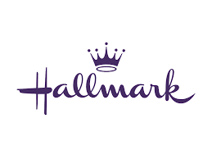
Meta Data
LONG (max 3000 characters) synopsis
Chloe Turner is halfway through her PhD program in marine mammalogy (the study of whales) at one of Miami’s top universities, and applies for a highly sought after scholarship that would fund the last two years of her doctorate. Her mentor Dr. Andrea encourages Chloe to go beyond their local waters and study a species less familiar to her and the board, specifically the J-Pod Orcas. But Chloe’s unconvinced, the timing isn’t right. She’s studying alongside her college boyfriend Marcus, also PhD applying for same scholarship) and while she had thought their relationship was about to reach the next level, it turns out that Marcus isn’t there yet so she decides take the leap that Andrea has suggested.
The cute cottages that line up along Cable Cove in the Pacific Northwest look right out of a story book. Deep green trees line the bays of even deeper blue waters, and multicoloured buildings stand on stilts, clinging to the rocky shores. It really does seem like the edge of the world, and Mary’s bed and breakfast makes Chloe feel welcome even as a proverbial ‘fish out of water’ in the small town. Down at the docks, Chloe meets handsome whale watching tour guide BEN who’s grown up in the area and knows it like the back of his hand. He offers some guidance, but Chloe insists she’s set herself up with everything she needs. After all, she’s here as a scientist, not a tourist. Soon, she realizes her independence has got the best of her and the mighty (much colder) Pacific has her in over her head. Needing some help, Chloe teams up with Ben and learns that he has the knowledge and passion for the whales that not only matches her own, but that she could even learn from. The Orcas turn out to be more shy than Chloe anticipated, and she has to rely on Ben’s knowledge of the waters to get her close.
Ben uses the opportunity to set a couple crab traps and teach Chloe how to fish. There’s an ease Chloe shares with Ben, and in an unexpected moment, a pod of Orca’s breech around them and Chloe has never felt more alive. And something truly exciting comes to light; the pod of whales is about to welcome a new addition! Ben guesses that the new Orca calf will be born any day now, and if she’s lucky, Chloe will be at Cable Cove for its arrival.
At Mary’s big “boil-up” dinner, when Ben asks Chloe to dance under the twinkle lights at the dinner, the closeness between them displays their undeniable chemistry. But she doesn’t have much time to get swept away before Marcus shows up at the end of the night! He reveals that Chloe has inspired him to come to Cable Cove to research his own scholarship application.
Marcus arranges to rent the biggest vessel in the marina to take off the next morning for the big migration with Chloe. When Ben gets word of Marcus’ intention, he realizes that his plans the next morning to take Chloe out on his whale watching boat are likely off. Heartbroken (and misinterpreting an embrace) Ben heads off expecting it’s the last of her he will see. (2996)
MEDIUM (max 500) synopsis
When PhD student Chloe makes the choice to expand her studies to include the whales of the Pacific Northwest, she leaves Miami and heads to the picturesque Cable Cove. There she relies on the local expertise of whale watching tour guide, Ben, and they soon find themselves bonding over more than just the J-Pod of orcas. (320)
SHORT (max 100 characters) synopsis
PhD student Chloe learns more about whales than she could have imagined from her attractive guide. (99)
5 KEY WORDS
Whales, orcas, marine biologist, romance

