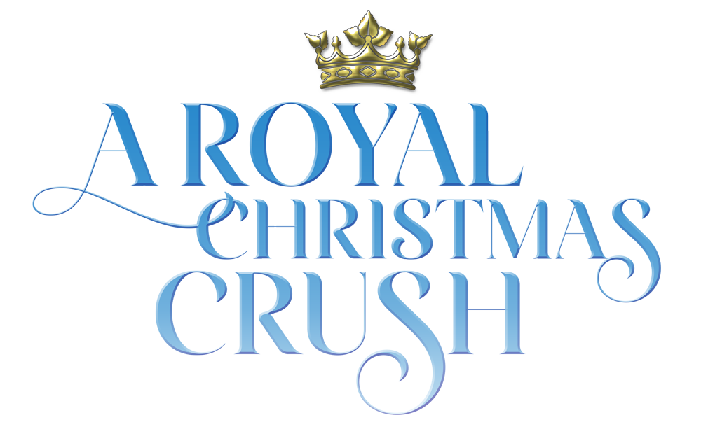

Johnson Production Group

Press Kit

One-Liner

Ava takes the opportunity of lifetime to work at the Royal Ice Hotel and falls into a whirlwind romance with the most important guest of all, the Royal Prince himself.

Synopsis

When Ava’s uncle Karl invites her to Scandinavia to work at the Ice Castle he’s just built to commemorate the Country’s Centennial Christmas Ceremony, she couldn’t be more thrilled. She leaves her boring 9-5 behind and sets off for a Guest Services job at the spectacular Ice Castle Hotel. The work is not glamorous but the hotel sure is. When the Royal Family arrives for their stay in the lead up to the Christmas Ball, Ava catches the eye of dashing Prince Henry. Both Ava and the prince are warned to stay away from each other, Ava is reminded that she should know her place as a member of the staff and Henry’s parents pressure him into asking out snobby, entitled Astrid, who they believe is a more suitable fit for a prince. As the week goes on, Ava and Henry sneak off to spend more time together, their connection undeniable. Will interference from the frigid Royal Family keep them apart, or will Ava and Henry prove that true love can melt even the iciest heart?

Producers
Executive Producers
TIMOTHY O. JOHNSON
ANDREW C. ERIN
OLIVER DE CAIGNY
Co-Executive Producers
JOSEPH WILKA
LISA ALFORD
Producers
JOSIE FITZGERALD
STEFANE GREGOIRE

Key Cast
CHARACTER  Ava  Prince Henry  Brigitta  Von Trier  Uncle Karl  Sigrid |  | ACTOR  KATIE CASSIDY  STEPHEN HUSZAR  ANGELA BESHARAH  GLENN EDWARD GYORFFY  CHARLIE EBBS  KATHRYN KOHUT

Key Cast Biographies

KATIE CASSIDY
Katie Cassidy was born Katherine Evelyn Anita Cassidy on November 25, 1986, in Los Angeles, California. Her father, David Cassidy, was a pop star in the 1970s. Her famous relatives include uncles Shaun Cassidy, Patrick Cassidy and Ryan Cassidy, the sons by her grandfather Jack Cassidy's marriage to Shirley Jones; Katie's grandmother was Evelyn Ward. As a child, Katie took gymnastics, studied piano, guitar and singing, then took dancing and acting lessons and eventually became a cheerleader for the California Flyers. She attended Calabasas High School in her neighborhood. For years prior to graduation in 2005, Katie was modeling and studying acting in community theater. Katie had just been accepted to 'Tisch' at NYU when she was offered her first role as "Dee Dee", which was one month before graduating. Katie has not stopped working since. Katie's early exposure to show business, the cosmopolitan culture of Los Angeles, her family upbringing, and her comprehensive education altogether produced a remarkable result. She grew up as a multifaceted person showing her many talents in a variety of professions such as recording her father's 1970s hit "I Think I Love You" and singing in VH1's TV special Bubblegum Babylon (2002), writing her own songs, modeling for Abercrombie and Fitch and Guess?'s Rock and Republic clothing lines in 2004, and acting. By 2006 she was busy working on five feature film productions going on almost simultaneously. Katie made several appearances in TV series, such as 7th Heaven (1996) and Sex, Love & Secrets (2005), among others. She appeared as Samantha, the grown-up daughter of Adam Sandler and Kate Beckinsale in the comedy Click (2006). After the release of a teen horror film, When a Stranger Calls (2006), in which she co-starred as Tiffany, Cassidy went to Vancouver to work on her second horror film, Black Christmas (2006), in which she stars as a sorority girl. Katie had the leading role opposite John Travolta as his daughter and the heir to the most powerful energy company in the world in Dallas, the big-screen remake of the cult TV series. She then went on to appear in 12 episodes of the very popular TV Series, Gossip Girl as Juliet Sharp.
Since then she has been busy in the superhero world with recurring roles in Vixen, The Flash and a whopping 152 episodes as Laurel Lance/Black Siren/Black Canary in Arrow. She also also found time for roles in several films including The Scribbler, Wolves at the Door, Cover Versions, Grace, I Love Us and Agent Game.

STEPHEN HUSZAR
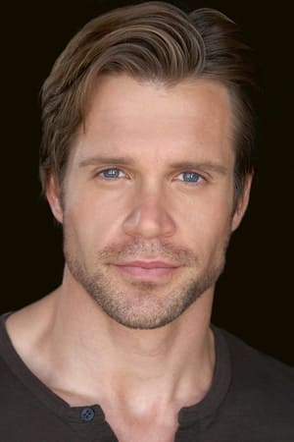
Stephen Huszar is a Canadian film and television actor from Saskatoon, Saskatchewan. Huszar attended high school at Aden Bowman Collegiate and later studied at the University of Saskatchewan. Based in Toronto, Ontario, the 6' 1" Huszar began his screen career in 2004 with a role in The Cradle Will Fall. Quickly he built a list of supporting roles in made-for-television films during the mid-2000s. During the late 2000s, Huszar found recurring work on the series Paradise Falls and Corner Gas. He also had the good fortune to appear in one of CW's longest-running series Smallville. During the 2010s Huszar appeared in the direct-to-video horror sequel 30 Days of Night: Dark Days, followed by work in Time after Time, Faces in the Crowd, InSayshable and continued television work on series including Cashing In, Fringe, Continuum, and Supernatural. Huszar also brought one of DC Comics' supervillians to the screen with his performance as Plunder in the series The Flash. During 2016-2017, Huszar worked on the series Letterkenny. Since then he has been a series regular on such shows as Ruby Herring Mysteries, Tribal and Chesapeake Shores. Huszar has starred in several recent holiday movies such as Magical Christmas Ornaments, Christmas Wedding Planner, Christmas In The Rockies, Time For Us To Come Home for Christmas, The Sauce of Love, Undercover Holiday and Christmas In Rockwell.

ANGELA BESHARAH
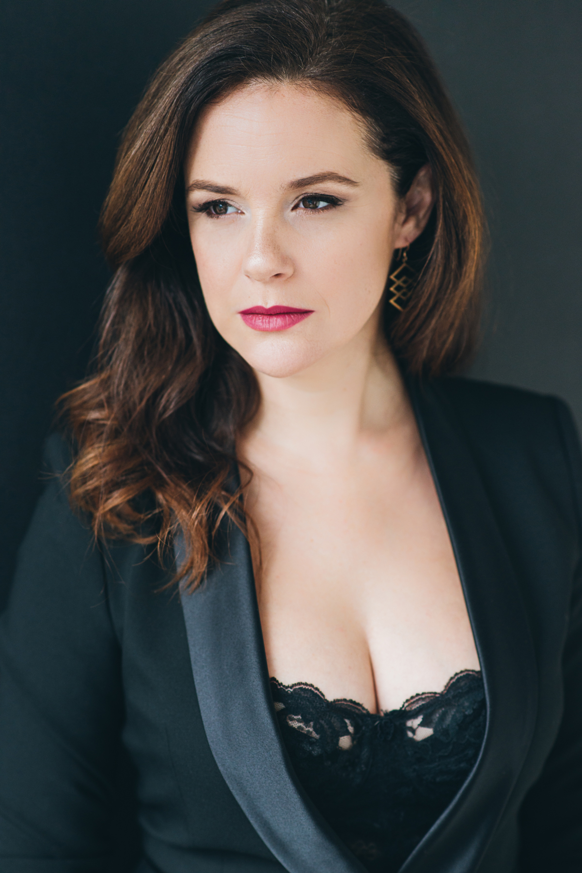
Angela Besharah is an award-winning director, actor and producer. Her acting credits include Accused (Fox/Sony), Star Trek: Strange New Worlds (CBS), Luckiest Girl Alive (Netflix) with upcoming supporting roles in: Fat Lady Srircha (Independent Film), Circuit Breakers (Apple TV+) and a new comedy for Amazon. She’s also worked on Mrs. America (FX), The Kennedys (History), Reign (CW), Lost Girl, Bitten (Syfy), Copper (BBC America) among others.
As a film director, With You Always, had its world premiere in Toronto, its US debut in California and has since been acquired by numerous online platforms. Rive, won Best Foreign Drama in Atlanta, premiered at the Art Gallery of Ontario is now playing on the NSI site. Her first film creation, Now & Then, was featured in The New York Times. She’s also directed documentary shorts for TVO’s Get Involved!
For theatre, Angela has directed 13 plays (7 original works) to rave reviews. The most recent: Evermore Theatre’s debut production of Sarah Burgess’ Dry Powder starring Rebecca Liddiard, Peter Keleghan & Chrisef Desir.
In 2018, she launched The Lighthouse Acting Studio, coaching On-Camera and Scene Study classes in Toronto. She has been coaching actors privately for over 10 years through her first studio - Inside Light.

GLENN EDWARD GYORFFY
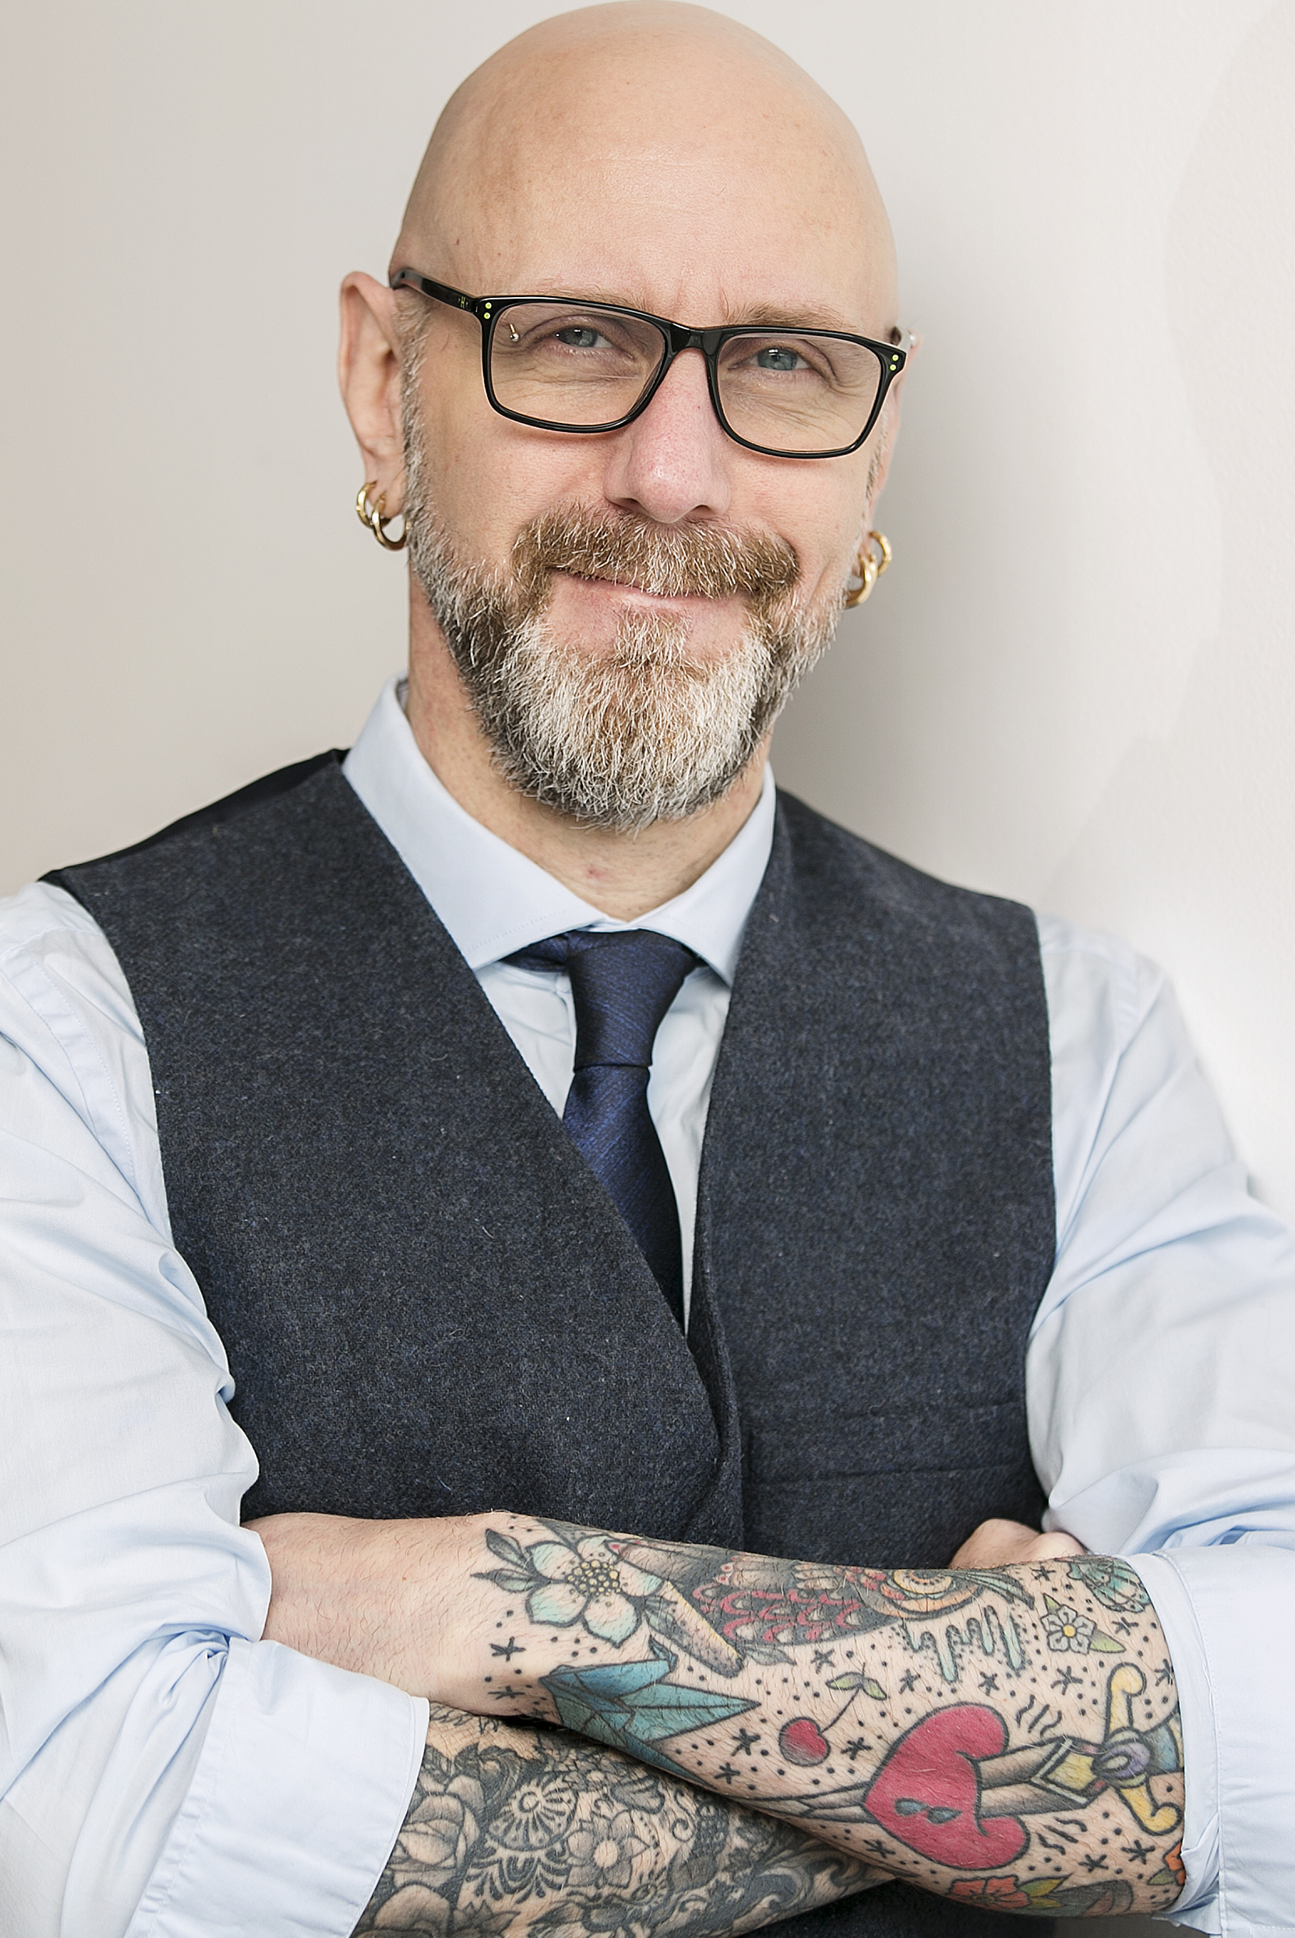
Glenn Edward Gyorffy was born August 10, 1970 in Toronto, Canada. A musician from a young age, he played in local bands and dreamed of becoming a professional performer. At the age of 25 (1995) he joined the classic Canadian metal band Anvil and was the bass player and back-up vocalist for 16 years. During his time in Anvil he co-wrote 7 albums and appeared in the critically acclaimed feature documentary 'Anvil, The Story Of Anvil'. The success of the documentary took the band around the world performing on some of the biggest stages including opening up for ACDC at Giants Stadium. Dream #1 accomplished!
Glenn left the band in late 2011 and after a few years - and a few day jobs - and some soul searching decided to pursue another life long dream of acting in 2018. His first role was in the episodic TV show Haunted Hospitals (2018). Since then he has continued to learn his craft in classes and workshops and has appeared in commercials and TV. In January 2020 he shot the 1st episode of season 3 of American Gods where he plays a Rock-Star Bass Player, a role which was obviously a natural fit. The episode is set to air early 2021. Dream #2 off to a good start!

CHARLIE EBBS
Born and raised on a farm near Perth, Ontario, Charlie is an actor/writer/photographer whose numerous film credits include Undercurrent (2011), Eddie: The Sleepwalking Cannibal (2013), Crook (2014), Tell the World (2015), ANON (2018), American Hangman (2019), and Dreamland (2021). His television appearances include Hard Rock Medical (TVO), 19-2 (BRAVO), Fatal Vows (Slice), Man Seeking Woman (Broadway Video), and Real Detective (Sony Crime).
Charlie's has also appeared on the professional stage with Grecian Formula (2010), Preshrunk (2011), Sparks (2014), and the lead role in Beneath (2017)-all with the New Ottawa Repertory Theatre; Death of a Salesman (2014) with the Hintonburg Chamber Theatre; and Follow the Tracks We Forgot to Finish (2013) by award-winning Toronto-born playwright Barry Germansky, which had its initial run at the Shetler Studio Theatre in New York City.
Charlie also wrote and co-produced two successful short films, The Hold Up (2012) which premiered in Los Angeles at the Hollyshorts Film Festival, and The Buckley Brothers (2014), which won "Best Comedy" at the 2014 Lady Filmmakers Fest, also in L.A. - the latter film going on to be one of three finalists for CBCs Cross Country Short Film Challenge. He was a founding member of the comedy group "Ottawa Sketch," collaborating on a variety of projects: stage shows, a web series (Locker Lives), and a sketch comedy show, Tripping in Orbit featured on Rogers TV (Ottawa).

KATHRYN KOHUT
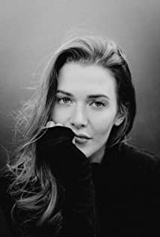
Kathryn Kohut is a Canadian actress, martial artist and model. She was born in Wetaskiwin, Alberta into a family of pipeline welders. Welding alongside her father in Fort McMurray, she was recruited by EllisDon and grew to have a successful career in the construction industry. Her career as an actress began only recently, as growing up she didn't have access to acting programs and didn't consider it a possibility until she decided to leave the construction industry and follow the pull she felt towards the arts.
Kohut began her training at the Lee Strasberg Theatre and Film Institute in New York, and has since continued her studies with a diverse number of teachers and coaches throughout Canada, USA and the UK. She hit the ground running, with her first role being a supporting lead in Spare Parts (RLJE Films, Amazon Prime) and has continued on an upward trajectory.
She has recently appeared in several TV Movies including Christmas Scavenger Hunt, A Merry Holiday, Love at Look Loge, Kitty Mammas, Baby It’s Cold Inside, Yellowstone Romance, Feeling Butterflies and Obsessed to Death.
Apart from acting, Kohut is an avid horseback rider, and extreme sports enthusiast with a passion for dirt biking, wake boarding, skiing and Muay Thai. In 2014, she won Miss International Canada and placed second runner up out of 85 contestants in Bangkok, Thailand. In 2015, she won Miss International Canada and placed second runner up at Miss Universe Canada in 2017.
Kohut is passionate about supporting causes that are close to her heart which include the Malala Fund, the Canadian Centre to End Human Trafficking and Black Lives Matter. She is also an animal rights advocate and volunteered for animal shelters and organizations growing up.

Production Credits

Full Cast
Actors  KATIE CASSIDY  STEPHEN HUSZAR  ANGELA BESHARAH  GLENN EDWARD GYORFFY  CHARLIE EBBS  KATHRYN KOHUT  SIMON PHILLIPS  PIP DWYER  ALICE HAMID  TOMAS CHOVANEC  IRIS OLIVIA BURT | Role  Ava  Prince Henry  Brigitta  Von Trier  Uncle Karl  Sigrid  King  Queen  Ingrid  Paparazzi Peter  Young Ava

Casting
RON LEACH, c.d.c.
LINDSAY CHAG

Composer
RUSS HOWARD III

Costume Designer
SARAH A. CARROLL

Editor
ALVIN CAMPANA

Production Designer
GREGORY PHILIP WILSON

Director of Photography
MICHAEL TIEN

Associate Producer
ALEXANDRA WARING

Written by
KEITH HEMSTREET
CATHERINE REAY
KATE SOMERVILLE

Directed by
MARITA JANE GRABIAK

Other Crew
JOHNNY ROSS | Production Manager
SARAH PETKOV | First Assistant Director
BEN HRKACH | Second Assistant Director
CIMARRON LANGLOIS | Third Assistant Director
AIDAN MAZEROLLE | Fourth Assistant Director
REGAL BACKGROUND CASTING | Background Casting, Ontario
MARY SAKS
ALDO LOPEZ | Background Casting, Quebec
GORAN POBRIĆ | Production Coordinator
LOGAN A. WAGNER | Production Accountant
JOSHUA LANGE | First Assistant Accountant
MATTHEW CARVELL | Post Production Accountant
RYAN WHITEHURST | Accountant Clerk
ALEXANDRA WARING | Post Production Supervisor
RICHARD FRAZIER | Post Production Coordinators
GEGHANI PANOSIAN
GREGORY PHILIP WILSON | Production Designer
ELIZABETH FITZPATRICK | Art Director
TOMAS CHOVANEC | Set Decorators
ANTHONY RANKIN
NATHALIE GREGOIRE | Property Master
SARAH A. CARROLL | Costume Designer
JULIANNE HJARTARSON | Costume Set Supervisor
ERIN MORRISON | Costume Truck Supervisors
PHYLLIS VERCH
MICHAEL TIEN | Director of Photography
JOSH HENDERSON | B Camera Operator
ADAM TESTA | A Camera - First Assistant Camera
NATHAN YEE | A Camera - Second Assistant Camera
MATT CROSSE | B Camera - First Assistant Camera
LINDSEY BELANGER | B Camera - Second Assistant Camera
ADAM SOURGES
RAMZI ESTEPHAN | Drone Operator
RICHARD FRAZIER | Camera Technician & Digital Imaging Technician
GEGHANI PANOSIAN | EPK Camera Assistant & Camera Utility
PETR MAUR | Stills Photographer
MARCUS LAUTENBACH | Stills Assistant
STEVEN F. S. BRUNI | Gaffer
YAN SCHNELL | Best Electric
NICHOLAS HERMIER | Key Grip
RJ NADON | Best Grip
CONNOR DORZEK | Grip / Electric Swings
IAN FRASER
NICK LYNCH
FRANCESCO FALSETTO | Sound Mixer
ANDREW SUTHERLAND | Boom Operator
NICK SMITH | Script Supervisor
JESSICA FERGUSON | Location Manager
SAGINE CAVÉ | Assistant Location Manager
KEENE IMBLEAU | Key Location Production Assistants
NATALIE HONSHORST
AEMON LOPER-GROSS | Location Production Assistants
GREGORY LOWE
CAMERON MATHESON
BRENDAN MCLOUGHLIN
TOM WARRELL
ALYSSA "ALY" MORDEN-HAYLEY | Key Makeup Artist
GISELE MATTE | Assistant Makeup Artists
KASSANDRA PEREIRA
NATASHA GABRIELA TREPANIER | Key Hairstylist
BETSY BEN-SMITH | Assistant Hairstylists
DARCY RYAN
STEFANE GREGOIRE | Transport Coordinator
GREG LEWIS | Transport Captain
MICHAEL DICKSON | Drivers
GREG LEWIS
BILAL MAHMOUD
KIM RODGER
ROBERT STRONACH
CHRIS SURUJNARIAN
LYNN SPRACKLIN | Transport Production Assistants
JAY VISNESKIE
JULIANN WRIGHT
KEITH STEFFENSEN | Move Crew
CORNELIA VILLENEUVE
DAN VILLENEUVE
ERIC VILLENEUVE
SEAN VILLENEUVE
TOM WARRELL | Chefs
GERRY WHALEN
MATTHEW DUBUC | Caterer
RONDA MACKINNON | Craft Service
MATTHEW DUBUC | Craft Labourer
THE NO CONFLICT CLEARANCE COMPANY | Script Clearances
HALL WEBER LLP | Legal Services
DANNY WEBBER
ABOVE THE LINE MEDIA SERVICES | Business Affairs
BRENDAN MCNEILL
ARTHUR J. GALLAGHER CANADA LTD. | Insurance by
URBAN POST PRODUCTION | Post Production Services
JOSEPH FACCIUOLO | Dialogue & ADR Editor
EHREN PFEIFER | ADR Recordist
KIRSTY SMITH | Sound FX Editors
LUKA TOMA | Foley Artists
JESSICA SEVIER
TESS MOIR
MATT THIBIDEAU
DAWN LEWIS
DAVE MERCEL | Foley Recordists
JESSICA SEVIER
MIKE POISSON
STEVE MOORE | Re-Recording Mixer
RUDY MICHAEL | Re-Recording Assistants
TYLER HALL
KENT MCCORMICK | Colorist
EVAN GRAVES | VFX Artist
GEORGE HAYWARD | Online/ Packaging Editor
PETER TOKARSKY | Project Manager
BRUCE REES | Picture Operations Manager
ROBERTA BRATTI | V.P. of Operations
POND5/DINGWANG | Stock Footage
POND5/ICEDALION
POND5/NORDICSTOCKS
POND5/QUADSIDEMEDIA
ISTOCK/ALEXPOTEMKIN
ISTOCK/EXCENTRIC_01
ISTOCK/WESTERSOE
ISTOCK/WIRESTOCK
ARTGRID/CHRISTIANJOHANNESKASK
ARTGRID/LUCAAMHOFER
ARTGRID/MATICOBLAK
ARTGRID/TANNERFOWLER
ARTGRID/TOPILEIKAS
ARTGRID/VITALYGARIEV
THE GRAND BALL
by David Tobin, Jeff Meegan and Julian Gallant
courtesy of Audio Network Rights Limited
WALTZ WINE WOMEN AND SONG
by Johann Strauss
courtesy of Extreme Music Library Ltd
MEMORIES OF CHRISTMAS
by Russell L. Howard III and Benjamin J. Bromfield
courtesy of Sweaty Avocado Music and Astral Avocado Music

Producer Biographies

TIM JOHNSON – Executive Producer
Timothy O. Johnson is among the most active and reliable producers in the business thanks to top rate productions and global distribution appeal. He is the managing partner of Johnson Production Group, a Canadian based operation that produces over 100 hours of dramatic television annually with hundreds of programs running internationally. The company is the leader supplier to Lifetime, Hallmark and other international outlets.
A graduate of the Marshall School of Business at the University of Southern California, he served as President of the USC Entertainment Management Association and a member of the Advisory Committee of the Center for Entrepreneurial Studies.
Johnson is also responsible for producing the international hit series, DR. QUINN, MEDICINE WOMAN for CBS for over 5 seasons. During his 100-episode tenure, he also developed and produced the original docu-drama COLD CASE for CBS network, which was the very first program to integrate television with the Internet.

Most recently, Johnson has produced the THE NOEL DIARY, being the #1 Film on Netflix’s Top 10 list in December of 2022. He was also at the helm of the successful GIRL IN THE SHED: THE KIDNAPPING OF ABBY HERNANDEZ, as well as the V.C. Andrews series of films, to date including TWILIGHT’S CHILD, MIDNIGHT WHISPERS, and DAWN, all produced for Lifetime..

Johnson has produced over 400 movies and 15 globally released series for every major US network - including Netflix, Lifetime, Hallmark, ABC, Disney, CBS, NBC, Netfly, FOX and Sony.

JOHNSON PRODUCTION GROUP
The Johnson Production Group contracts globally to produce television content for international networks, studios and distributors. Based in Los Angeles and Vancouver, British Columbia, the company manages production, facilitates development and financing, procures distribution and guarantees quality and timely execution of its programs. While costs have gone up, so has the demand for quality. No longer is good enough, good enough. Johnson Production Group serves that segment when a show needs to be "A" quality, but produced efficiently enough to meet a locked budget. JPG specializes in value, protection of creative elements, and delivery of a quality finished product.
ANDREW C. ERIN – Executive Producer
Andrew Erin is a Canadian Writer/Director making a big splash in the US, and has produced, written and directed numerous commercially successful films. His directorial debut, SAM’S LAKE, was an official selection at the Tribeca Film Festival and did an excellent theatrical run in select theaters around the country; distributed by Lionsgate Films. Andrew also wrote the script for the film. Andrew’s directorial credits include, SIMPLE THINGS, produced for Screen Media Ventures and Universal Studios. Besides winning The Bob Clark Award for Best Director at the California Independent Film Festival, the film was commercially received. Andrew has worked continuously as a writer/director, building a strong library of films in the Thriller/Horror genres with: Embrace of The Vampire, The Clinic, Final Sale, Confined and Toxic Skies.
OLIVER DE CAIGNY – Executive Producer
Oliver De Caigny is a Canadian producer originally from Belgium, his background in financing, production, and post production makes him a well-rounded producer for any type of production. His experience in financing and production agreements (film and TV series and movies-of-the week), distribution agreements (both domestic and foreign) as well as international co-productions, Canadian tax credit, Telefilm Canada and Canada Media Fund incentives provides him with a well-rounded background in development, production and distribution for motion pictures, television series and productions.

JOSEPH WILKA – Co-Executive Producer
Joseph Wilka is the Head of Production for Johnson Production Group. Los Angeles-based, Joseph had already produced and directed several feature films before serving as the senior marketing executive for Gravitas Ventures. While at Gravitas, Wilka helped pioneer new distribution models for independent films including day-and-date theatrical releases. It was also at Gravitas where Joseph first worked with Johnson Production Group to facilitate the release of their films to the worldwide Video On Demand audience. After serving as the Director of Distribution and Production for Viva Pictures, where he produced English-language versions of foreign animated titles for DirecTV, Wilka officially joined Johnson Production Group. As Head of Production, he oversees the development, production, and distribution of films from multiple production units for release on broadcast and streaming platforms.

LISA ALFORD – Co-Executive Producer
Lisa Alford is a development executive at Johnson Production Group. A Massachusetts native, Lisa has lived and worked in Los Angeles for over a decade, always in support of excellent storytelling. Prior to joining Johnson Production Group, Lisa worked as an executive at TriStar television where she specialized in identifying IP that supported TriStar’s mission to feature diverse, authentic characters and champion underrepresented voices. Lisa came up at Sony Pictures Television where she worked as a production coordinator in the Television Movies and Miniseries department and in the writers room on the WGN hit series OUTSIDERS. In her current role, Lisa shepherds projects from the concept phase through story development, production, and post.

JOSIE FITGERALD – Producer
Josie Fitzgerald is a Canadian born Producer currently residing and working in Ottawa, Ontario. Josie is also a passionate photographer and writer, with an education in Justice Studies and a professional background in Human Resources and Project Management.

MARITA JANE GRABIAK - Director
Marita is veteran Television Director/Writer, with 40 credits in episodic television in a wide range of genres, having directed repeatedly for the top producers in the USA; Joss Whedon, J.J. Abrams, and John Wells. She was hired by Ryan Murphy to be one of the first female directors on American Horror Story. Her TV Movies, both Thrillers and Romantic Comedies, have been highly rated on Lifetime and Hallmark Channels.
In addition to averaging at least 3 TV movies per year, in 2018, she directed V Wars for Netflix. A versatile director, as strong with obtaining great performances as she is technically with camera, she is very adept with the design of action and CGI sequences.
Marita had thousands of hours of film production experience, before she made the move into Television Directing on the long running series ER in 2001. She has worked successfully with acclaimed actors such as; Lady Gaga, Cuba Gooding Jr., Emma Stone, Kathy Bates, Sarah Paulson, George Clooney, Sally Fields, and is known for elevating performances of young and lesser experienced actors.
A talented global filmmaker, with cameras and drone in hand, she has explored some of the most remote places on earth. Her journeys provide her with rich and fascinating life experiences, which resonate profoundly in her work. In 2017, she undertook an expedition through the jungles and mountains of Papua New Guinea and the Solomon Islands, where she photographed tribal peoples, wildlife, and explored many WWII sites such as Guadalcanal. In 2018 she continued in the Lower Solomon Islands and the countries of Vanautu and New Caledonia, where she interviewed indigenous peoples on small islands, who have never encountered outsiders.
Past adventures include; filming Victoria Falls from every angle, (including White Water Rafting down the Zambezi River), covering Normandy during the 70th Anniversary of D Day, and Road Trips spanning from Europe, Central Asia, to Japan. Her poetical documentary "The Silk Road in Central Asia", (as a one person crew in Uzbekistan & Turkmenistan) is a one of her best writing examples.
Raised in a small town near Pittsburgh, Pennsylvania, she attended Carnegie Mellon University for theater, and graduated from UCLA with a B.A. Major in Motion Picture/Television, and a Minor in Art History. Her experiences include working in NYC Off Broadway Theater, and as a Story Analyst for Independent Feature companies. For a decade, she was one of Hollywood’s top Script Supervisors on high budget features, filmed everywhere in the USA, and as far away as Malaysia.
Marita's inspiration comes from the study of theater and film history, art, architecture, ancient civilizations, current cultural anthropology, and classic literature.

Billing Block
HALLMARK CHANNEL PRESENTS IN ASSOCIATION WITH JOHNSON PRODUCTION GROUP “A ROYAL CHRISTMAS CRUSH” starring KATIE CASSIDY STEPHEN HUSZAR ANGELA BESHARAH GLENN EDWARD GYORFFY CHARLIE EBBS KATHRYN KOHUT Casting RON LEACH, c.d.c. LINDSAY CHAG Composer RUSS HOWARD III Costume Designer SARAH A. CARROLL Editor ALVIN CAMPANA Production Designer GREGORY PHILIP WILSON Director of Photography MICHAEL TIEN Co-Executive Producers JOSEPH WILKA LISA ALFORD Executive Producers TIMOTHY O. JOHNSON ANDREW C. ERIN OLIVER DE CAIGNY Producers JOSIE FITZGERALD STEFANE GREGOIRE Written by KEITH HEMSTREET CATHERINE REAY KATE SOMERVILLE Directed by MARITA JANE GRABIAK

The Canadian Film or Video Production Tax Credit

© MMXXIII Fireside (IH3) Films Inc. & Fireside (CDG) Films Inc. All Rights Reserved

Meta Data
LONG (max 3000 characters) synopsis
When Ava’s uncle Karl, invites her to Scandinavia to work at the Ice Castle he’s just built to commemorate the Country’s Centennial Christmas Ceremony, she couldn’t be more thrilled. She leaves her boring 9-5 behind and sets off for a Guest Services job at the spectacular Ice Castle Hotel. The work is not glamorous but the hotel sure is. When the Royal Family arrives for their stay in the lead up to the Christmas Ball, Ava catches the eye of dashing Prince Henry. Both Ava and the prince are warned to stay away from each other, Ava is reminded that she should know her place as a member of the staff and Henry’s parents pressure him into asking out snobby, entitled Astrid, who they believe is a more suitable fit for a prince. As the week goes on, Ava and Henry sneak off to spend more time together, their connection undeniable. Will interference from the frigid Royal Family keep them apart, or will Ava and Henry prove that true love can melt even the iciest heart? (959)
MEDIUM (max 500) synopsis
Ava’s thrilled that her Uncle Karl has invited her to Scandinavia to work in Guest Services at his new Ice Castle Hotel. When the Royal Family arrives for the lead up to the Christmas Ball, Ava catches the eye of dashing Prince Henry, but his parents believe snobby, entitled Astrid is a more suitable fit for a prince. Ava and Henry’s connection is undeniable. Will interference from the frigid Royal Family keep them apart, or will Ava and Henry prove that true love can melt even the iciest heart? (500)
SHORT (max 100 characters) synopsis
Ava starts work at the Royal Ice Hotel and has a whirlwind romance with the Royal Prince himself.(97)
5 KEY WORDS
Romance, prince, Ice Castle Hotel

