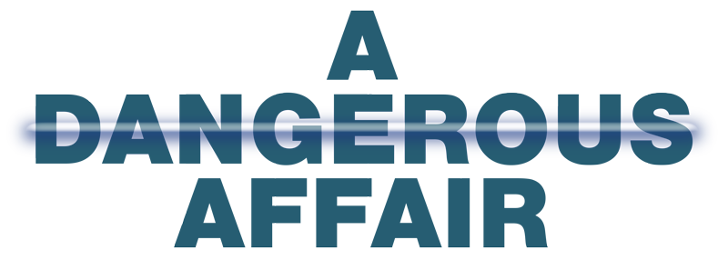

Johnson Production Group

Press Kit

One-Liner

A pilates instructor begins a steamy love affair with one of her handsome clients but following a murder she becomes a target in the middle of a deadly love triangle.

Synopsis

Pilates instructor Amélie Didot moves to a new city with hopes of starting fresh leaving her painful divorce behind. It's not long before her new studio begins to boom with business, as does a steamy love affair with successful British media mogul, journalist Pierce Dalton. Unbeknownst to Amélie, Pierce's last relationship was unrequited love; leaving his ex-girlfriend, Fran Gibbons, raging with hostility and jealously. Fran's obsessive behavior turns deadly in her quest to win Pierce back - putting Amélie, and anyone else in her path, at risk.

Producers
Executive Producers
CHRISTIE WILL WOLF
CHARLIE BEWLEY
TIMOTHY O. JOHNSON
JOSEPH WILKA
Producers
DANIEL IRIAS
NIMA SOOFI

Key Cast
CHARACTER  Amélie Didot  Pierce Dalton  Fran Gibson  Barbara  Kip |  | ACTOR  AUBREE BOUCHE  CHARLIE BEWLEY  KARLEE ELDRIDGE  TANYA CHRISTIANSES  JAVON WHITE

Key Cast Biographies

AUBREE BOUCHÉ
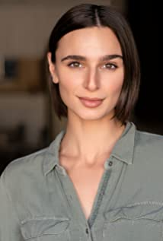
The multiple award winning Aubree Bouché has appeared in several films including The Diamond Ring, Beta and Best Girl Friend in addition to a selection of commercials. She also has extensive theatre experience.

CHARLIE BEWLEY
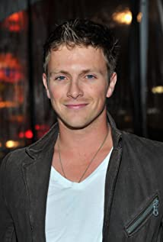
The eldest of four children, Charlie Bewley was born in London and raised on a farm in Leicester. After finishing his education he moved to Vancouver before relocating to Los Angeles, where he continues to reside.
His best known film role is that of vampire Demetri in the Twilight series, which he starred in from 2009 until the final film in 2012. He has also starred in the 2013 film Hammer of the Gods, and appeared in Slightly Single in LA, The Broken Ones, Renegades, The Foreigner, Burning Kentucky, Tellers and Sister of the Groom. He has had recurring roles in several TV series including Nashville, Extant, Colony and as vampire hunter Galen Vaughn in Season 4 of The Vampire Diaries.

KARLEE ELDRIDGE
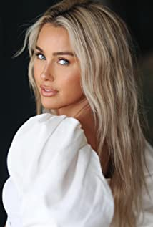
Karlee Eldridge went to arts middle school for theatre, studied performing arts in high school and then in College. She studied musical theatre at NYU for a summer and then moved to FSU’s film school and realized that was exactly what she want to do. After that, she headed up to Atlanta for a year working on shows like The Vampire Diaries, Nashville, Ballers and others. She quickly moved out to LA and since then has appeared in several TV series including Being Mary Jane, and This Is Us as well as movies Scare BNB, Moon Manor and the upcoming It Crawls Beneath.

TANYA CHRISTIANSES
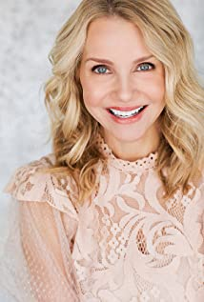
Tanya Christiansen is a Tennessee native and began her acting career on stage doing local theater. Her passion for acting continued after she graduated from The University Of Tennessee and continued in the industry first as a host for a shopping network and then moving into film and television. She divides her time between Georgia and California.

JAVON WHITE
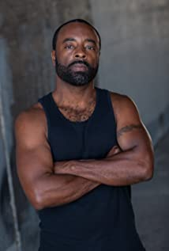
Jevon White is an actor writer and part-time director. As a young teen, he had his first experiences in the arts writing and performing plays in church and auditioning in L.A. He continued his love for creative writing and drama in school so much so that he returned after serving in our U.S Armed Forces.
He had an undeclared major in college albeit half of his classes were centered around the arts. Some may even call that fate. He had small parts in the movies Holy Man and There’s Something About Mary both of those experiences ignited a hunger and thirst for acting but he concluded that he did not want to serve acting career exclusively as a background. Years later, with more knowledge, guidance and ‘living life’, he decided to give acting a go once more and could better navigate the film industry.
Jevon can be seen as in Start Up as Gilles where he has a recurring role as well as Cake: The Series & Peanut Headz: Black History Toonz. His film roles include War-Angel: The Awakening, Uncivil Servants, The United States vs. The Private Sector, His Instrument and Thunder Force.

Production Credits

Full Cast
Actors  AUBREE BOUCHE  CHARLIE BEWLEY  KARLEE ELDRIDGE  TANYA CHRISTIANSES  JAVON WHITE  ROSETTA JOHNSON  SHIRA LEE ABERGEL  JIM BALLARD  YESNIA FULLER  GABRIEL RODRIGUEZ  JASON YEHUDA NEUMAN  CAROLINE LINNEA  THOR VALAZCO  HECTOR DANIEL CASTILLO  JUAN BOFILL  DANIELLE KWOKA  TRAVIS LOMBARDI  SHAYNA BOFILL | Role  Amélie Didot  Pierce Dalton  Fran Gibson  Barbara  Kip  Margaret  Dale  Frank  Dr. Ramos  Large Man  Jason  Caroline  Buster Dog  Pet store cashier  Stunt Coordinator  Amélie Didot Stunt Double  PierceDalton Stunt Double  Fran Gibson Stunt Double

Casting by
LORI WYMAN

Production Designer
JULIANA MESA

Director of Photography
ANGEL BARROETA

Edited by
PEPE PLAZA

Music by
EDUARDO JARAMILLO

Written and Directed by
CHRISTIE WILL WOLF

Other Crew
GABRIELA SALDAGO | Production Manager
PETER EBANKS | First Assistant Director
ROGER MENDOZA | Second Assistant Director
GLORIA R DE LOS REYES | Second Second Assistant Director
JULIANA MESA | Art Director
LEONARDO MOLINA | On Set Dresser
OSWALDO MACHADO | Set Buyer
GABRIEL BARRETO | Dressers
HUGO VÁZQUEZ | Dressers
MARCELO SHARRY | Props Master
MARCELA GOTERA | Props Master
MARTHA LOOCHKARTT | Key Hair Stylist
PRISCILLA LOOCHKARTT | Key Make-Up Artist
VANESSA VILLAESCUSA | Make-Up Assistant
LAURA SARNELLI | Costume Designer
DIANA ALVARADO | Assistant Costume Designer
SANTIAGO BALL | First Assistants Camera
EDUARDO LEGUIA | Second Assistants Camera
ANGEL BARROETA | Camera Operators
ALEXANDRA VIVAS | Underwater Camera Operator
DANIEL IRIAS | Drone Pilot
CAMERON JOHN BOISSEAU | Gaffer
MANUEL GONZALEZ | Best Boy Electric
HECTOR PEREZ | Lamp Operators
NIKKI PEÑALBA | Key Grip
REINIE ALVINO | Best Boy Grip
LILIBETH SANCHEZ | Location Managers
ALBERTO | Production Assistant
FRANK FLEITES | Production Assistant
ABEL QUICK SEND SERVICES | Picture Vehicle
GUILLERMO URSINI | Production Sound Mixer
RAYME CASAMAYOR | Boom Operator
EDUARDO PRUS | Boom Operator
ARIEL NOVO | Boom Operator
KARLA TEEVIN | Script Supervisor
ALEX ABRAMOVICH | Production Accountant
GABRIELA SALDAGO | Production Coordinator
HECK GROUP LLC | Craft Service/Catering
GINNETTE ARAVENA | COVID Specialist/ First AID
ELETTOS TALENT AGENCY | Extras Casting
COASTAL CLEARANCES | Script Clearances by
FILM EMPORIUM INC. | Insurance broker
DARREN HENSHAW | Insurance broker
FRONT ROW INSURANCE | Insurance by
MOVING FORWARD STUDIOS | Post Production
LEO LOVERA | Post Production Supervisor
PEPE PLAZA | Editor
TOMAS LOVERA | Assistant Editor
JORGE | Visual Effects
ÓSCAR MARTÍNEZ ASENCIO | Colourist
FINAL MIX AUDIO | Sound Facilities Provided by
RICARDO TINOCO | Supervising Sound Editor
RICARDO TINOCO | Dialogue Editor
RICARDO TINOCO | SFX Editor
DANIEL BETANCOURT | SFX Editor
DANIEL BETANCOURT | Foley Editor
DANIEL BETANCOURT | Foley Artists
RICARDO TINOCO | ADR Mixer
JACINTO GONZALEZ | ADR Mixer
EDUARDO JARAMILLO VERA | Music Composer

Producer Biographies
TIM JOHNSON – Executive Producer
Tim Johnson is among the most active and reliable producers in the business thanks to top rate productions and global distribution appeal.
Johnson is also responsible for producing the international hit series, DR. QUINN, MEDICINE WOMAN for CBS for over 5 seasons. During his 100-episode tenure, he also developed and produced the original docu-drama COLD CASE for CBS network, which was the very first program to integrate television with the Internet.
Johnson has produced over 150 movies, 15 globally released series for every major US network - including ABC, Disney, CBS, NBC, Netfly, FOX and Sony.

JOHNSON PRODUCTION GROUP
The Johnson Production Group contracts globally to produce television content for international networks, studios and distributors. Based in Los Angeles and Vancouver, British Columbia, the company manages production, facilitates development and financing, procures distribution and guarantees quality and timely execution of its programs. While costs have gone up, so has the demand for quality. No longer is good enough, good enough. Johnson Production Group serves that segment when a show needs to be "A" quality, but produced efficiently enough to meet a locked budget. JPG specializes in value, protection of creative elements, and delivery of a quality finished product.

JOSEPH WILKA – Executive Producer
Joseph Wilka is the Head of Production for Johnson Production Group. Los Angeles-based, Joseph had already produced and directed several feature films before serving as the senior marketing executive for Gravitas Ventures. While at Gravitas, Wilka helped pioneer new distribution models for independent films including day-and-date theatrical releases. It was also at Gravitas where Joseph first worked with Johnson Production Group to facilitate the release of their films to the worldwide Video On Demand audience. After serving as the Director of Distribution and Production for Viva Pictures, where he produced English-language versions of foreign animated titles for DirecTV, Wilka officially joined Johnson Production Group. As Head of Production, he oversees the development, production, and distribution of films from multiple production units for release on broadcast and streaming platforms.

DANIEL IRIAS – Producer
Daniel was born and raised in Honduras. At the age of 15 he moved to States with his family. Coming from a family rich in culture influenced him into pursuing a more deep interest into film. He turned his filming career into a passion that would help him express himself through story telling. He found interest not only in filming but also into travel allowing him to understand more about different culture. He brings a fresh inspiring perspective when creating films and is fully committed to deliver the best every chance he gets.

NIMA SOOFI – Producer
Known as a prodigy, Nima won the prestigious Zoom Film Festival Award in high school. Upon showing his talent, he received an admission with a scholarship into the Vancouver Film School. While finishing two degrees in Film Production and 3D Animations from the VFS and continuing studying for his BA majoring in Film from Simon Fraser University, he was also busy working on many independent documentaries and working as an editor at Bodog. Nima co-founded Qube Film, a boutique film company located in central downtown Vancouver, where he gathered a group of talented professionals. In 2012 Nima moved to the US and opened a branch of Qube Film in New York and Miami in order to expand his network beyond the borders of Canada. Since then, he has been actively involved as a director and the lead editor for many TV shows, feature films, documentaries and commercials.

CHRISTIE WILL WOLF – Executive Producer, Writer, Director
Christie Will studied at Emerson College in Boston MA, and the College of Charleston in SC. She earned a BA in Business Arts Management, in addition to a BA in Theatre Performance (concentrating in Music Theatre and Film). Christie also earned a BFA in Art History, along with receiving a 'Leadership in the Arts' Distinction Award, upon graduation.
Following University, Christie graced stages across North America, before moving to Los Angeles where she worked as an actress, model, and emerging director and writer. During this time, she split the year by living between Vancouver Canada and Los Angeles California. In Vancouver, Christie founded the first avant-garde black box theatre; The Beaumont Playhouse (based on the teachings of Sanford Meisner; Christie was a long time student of Robert Carnegie's 'Playhouse West' in Los Angeles). It was during her time back in the theatre that Christie honed in on her writing and directing for the stage. After finding success and audiences within the theatre scene, Christie soon transposed her efforts into film.
Career: Her first short film 'Dysfunction' was received with critical acclaim, encouraging Christie to focus her creative aspirations to further writing and directing for the big and small screen. She worked as Peter Berg's director's assistant (Smokin Aces, Friday Night Lights, Hancock, The Rundown), before moving into Senior Executive in Business Development for singer/ entertainer Paula Abdul (responsible for the development of Paula's first reality show 'Hey Paula'). From this position, Christie focused her sights on directing electronic press kits for feature films, and learning the business of movie production. Her sharp story telling, and creative approach to these electronic press kits, made for happy distributors and producers. She quickly moved into a producer’s seat, after earning the respect from her colleagues and peers.
After successfully producing (co-producing & associate producing) on various film and televised projects, Christie naturally segued into writing and directing feature films.
As a new female writer, director, producer on the Hollywood scene, Christie's work has been described as "fresh, often providing an uncontrived social commentary on Hollywood" (ref: TS 2006). Her writing and directing has also been described as "authentic, uncensored, and female centric; Christie Will Wolf is one of those emerging talents to keep your eye on" (The Sun)
Christie lives on the West Coast between Los Angeles, California, USA, and Vancouver, British Columbia, Canada.

Billing Block
Johnson Production Group presents A Lifetime Movie “A DANGEROUS AFFAIR”
starring AUBREE BOUCHE CHARLIE BEWLEY KARLEE ELDRIDGE TANYA CHRISTIANSES JAVON WHITE Casting by LORI WYMAN Production Designer JULIANA MESA
Director of Photography ANGEL BARROETA Edited by PEPE PLAZA Music by EDUARDO JARAMILLO Executive Producers CHRISTIE WILL WOLF CHARLIE BEWLEY JOSEPH WILKA TIMOTHY O. JOHNSON Produced by DANIEL IRIAS NIMA SOOFI
Written and Directed by CHRISTIE WILL WOLF
© Her Obsession LLC. All Rights Reserved
Special thanks to:
With the participation of
In Association With

Meta Data
LONG (max 3000 characters) synopsis
Amélie Didot, an athletic pilates instructor, has opened up a new pilates studio in the small city where she has just relocated. The class, all women, follow Amélie’s instruction with fervor. Pierce Dalton, tall, ripped, and reeking of sexiness joins the class late. Following the class, Amélie’s new clientele share their excitement about finally having a pilates studio in town. Brenda Gershwin, a visually aﬄuent women invites her to an Eyes Wide Shut theme costume party that she and her husband are hosting. As they discuss the party, they both watch as Pierce wipes sweat from his body and gets up to enter the change room. Brenda gives Amélie the short scoop on Pierce, a wealthy journalist with a crazy ex-girlfriend who didn’t take their breakup well. Pierce spots her watching- they lock eyes, before she steps away, embarrassed.
The following day, Amélie finishes getting internet hooked up at her house, and completes some decorating and heads to the pet store to get a new name tag engraved for her dog, but her dog escapes the store and takes oﬀ. Pierce, having recognized the dog from a photo on her pilates studio counter, finds him and walks him there. Chemistry brews, and he invites her to Brenda’s party as his date (since she’s new in town). Surprised by the invite, she gladly accepts.
When they arrive at the party with their ‘Eyes Wide Shut’ masks on, it’s in full swing. Amélie darts oﬀ to get a drink, and returns to give it to Pierce. To her surprise, the man she taps on the shoulder isn’t Pierce. He looks like Pierce; same mask, same strong build, and same tux. Amélie laughs oﬀ the mistaken identity, and finds Pierce across the room- a woman talking to him quickly leaves just as she approaches. Amélie and Pierce find themselves exploring the mansion, ending up in a grand ballroom. The two share a bit about themselves - back story on his previous relationship, as well as her marriage that didn’t work. As a journalist, Pierce digs for information, learning Amélie’s ex husband cheated on her just before their wedding day, but she followed through with the marriage, regardless. As a result, she never trusted her ex-husband sexually, or other- part him - a part of her diminished when she became married. Pierce digs some more, and learns that she hasn’t had an intimate partner since that time- it’s been years. He asks her to dance. Then a scream is heard — a murder has taken place; a man’s body discovered.
In the coming days, Amélie and Pierce’s relationship continues to progress as the chemistry between the two intensifies. They are wrapped up in their own sexually tense world, watching each other with desire but unbeknownst to them someone else is watching them too…. (2692)
MEDIUM (max 500) synopsis
Amélie Didot, a pilates instructor, meets handsome journalist Pierce Dalton. As a steamy love aﬀair blooms, Amélie comes face to face with a masked woman following a murder. The duo find themselves dangerously intertwined when it’s revealed the killer is obsessed with Pierce, just as Amélie is to their sex life. (308)
SHORT (max 100 characters) synopsis
A couple involved in a steamy love affair find themselves dangerously intertwined with a murder.
(97)
5 KEY WORDS
Murder, sex, romance, pilates, journalist

