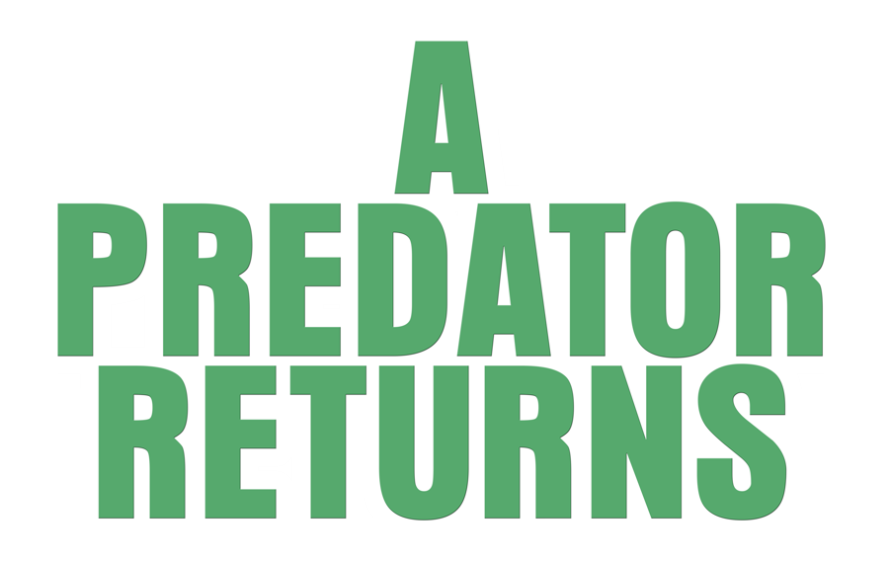

Johnson Production Group

Press Kit

One-Liner
Killer and shark-obsessive Bruce Kane is in hiding, masquerading as a shark researcher named David Burke in the isolated lighthouse where high school student Courtney and her friends have decided to go swimming. After a fling, Courtney can't shake Bruce from her life and has to take matters into her own hands when his obsession turns deadly.

Synopsis
High school senior Courtney lies to her divorced mother Erica to spend a night with her three best friends swimming at lighthouse island, where they find themselves surrounded by sharks. They barely escape with their lives, rescued by handsome, scarred young shark researcher David Burke, who's staying there. He's clearly hiding some secrets and a troubled past, but Courtney finds him charming and they start dating. David reveals himself to be a dangerous obsessive, tracking and recording her, threatening her family, and sneaking into her house at night. She breaks up with him and all seems well until she has a pregnancy scare and David returns with a vengeance, insinuating himself into her life as her mother's new boyfriend, blackmailing her, and attacking her friends and family. Courtney can't find any evidence that David ever existed and everyone who believes her is turning up dead. She then discovers that David is, in fact, infamous killer Bruce Kane. When she's framed for murder, she takes matters into her own hands and hunts down her tormentor once and for all.

Producers
Executive Producer
TIMOTHY O. JOHNSON
Co-Producer
JOSEPH WILKA
Producer
ANDREW GERNHARD
Associate Producer
JOHN DOOLAN
Key Cast
CHARACTER  Bruce/David  Courtney  Erica |  | ACTOR  HOUSTON STEVENSON  LEIGHA SINNOTT  HANNAH JANE McMURRAY

Key Cast Biographies

HOUSTON STEVENSON

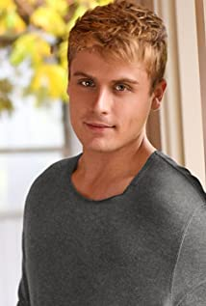
Young Hollywood actor on the rise, Houston Stevenson, can next be seen starring in the sequel to Lifetime's horror film "Stalker's Prey." The second installment, which is set on the beaches of the fictitious Hunter's Cove is directed by Colin Theys and debuted in 2019. Stevenson shines as Bruce, a charming well-mannered guy with a dark side. In addition to "Stalker's Prey" Stevenson recently wrapped filming a lead role in the upcoming thriller "FearPHarm," directed by Dante Yore. The feature follows four kids’ desperate attempt to escape a haunted maze. Stevenson stars as Brandon, a recent graduate and lovable jock who finds himself in troublesome situations. Born and raised in Vancouver, Stevenson first discovered his love for acting at the tender age of five and by ten was avidly filming and making family movies. He studied at Shawnigan Lake School on Vancouver Island, while landing roles in local theater productions. Upon graduating from high school, Stevenson found himself in the UK training with renowned acting coach Andy Johnson. He garnered a scholarship to the American Musical Dramatic Academy (AMDA) and went on to train with the acclaimed Ivana Chubbuck Studio in Los Angeles. Stevenson launched his career by garnering the attention of Kenny Ortega ("High School Musical") while working as a production assistant for the Disney Channel Original Movie "Descendants 2." Stevenson landed a cameo role in the film and went on to also appear in the third installment. He has been working steadily ever since. Houston currently divides his time between Vancouver and Los Angeles and is a dual citizen.

Leigha Sinnott
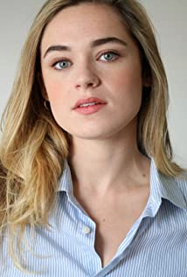
A recent graduated from the Juilliard School's Drama Division, Leigha is currently living in New York. Hailing originally from North Carolina, she graduated from the highly selective drama program at the University of North Carolina School of the Arts. She was a National Semi-Finalist at The English Speaking Union's National Shakespeare Competition held at Lincoln Center in New York City, and attended the North Carolina Governor's School Summer Conservatory studying Theater with a focus in Composition. Leigha is a proud founding member of Venture Theatre, based in Bermuda.
Most recently she played Witch in the virtual filmed play Salem: Post Mortem by Peter Gray, directed by Michael Alvarez. Past credits include Laura Wingfield in The Glass Menagerie with Venture Theatre, Viola in Twelfth Night with Dumb Theatre Co., Martin Eden, a feature film directed by Jay Craven.

Hannah Jane McMurray
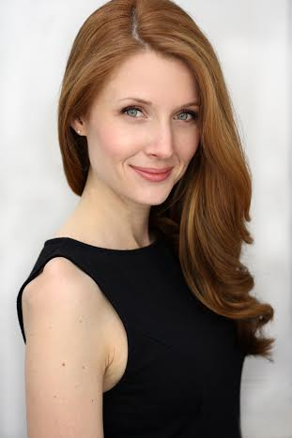
Hannah Jane McMurray has worked extensively on stage in New York and Regional theatre, as well as going on national tour with both Dirty Dancing and Peter Pan 360.
Her work in TV & film includes supporting roles in Misty Button and Roses on the Lawn, guest starring in Adventures of A Merch Girl and True Com with Aphrodite Jones, as well as the lead in Pronoia and Halina. She was winner of Best Supporting Actress at the Long Island International Film Festival for her work in Halina.

Production Credits

Full Cast
Actors  HOUSTON STEVENSON  LEIGHA SINNOTT  HANNAH JANE McMURRAY  AMBER JANAE  CHRIS JEHNERT  JONATHAN CRUZ  MATTHEW CRAWLEY  SEAN GALLIMORE  JEFF FRYER  AMY WARD  TYLER WHITE  BRYCE BREEN  VALERIE BROOKSHIRE  PERI RASMUSSEN | Role  Bruce  Courtney  Erica  Kat  Ryan  Peter  Branden  Harbor Master  Detective  Jasmine  Travis  Drama Teacher  Officer  Lily Kane

Casting by
LIZ LEWIS, CSA
ANGELA MICKEY, CSA
LIZ LEWIS CASTING PARTNERS, CSA

Original Music and Score by
RYAN GARRISON

Edited by
BRYAN CAPRI

Costume Designer
TAMMY GIBBENS

Production Designer
SHANE MEADOR

Director of Photography
ALEXANDER YELLEN

Line Producer
GREG WHITE

Written by
JOHN DOOLAN

Directed by
COLIN THEYS

Full Crew
GABRIEL GALVEZ | 1st. Assistant Director
JOE NARODE | 2nd. Assistant Director
BRIEN SLATE | 2nd. 2nd. Assistant Director
VICTORIA HERSEY | Production Coordinator
SPENCER SWINDON | 1st. Team Production Assistant
JEREMY PEISNER | Production Assistants
JON SHAW
MASON RICE
SAM GOVE | 1st. AC
MATT SULLIVAN | 2nd. AC
PAUL STENKO | DIT
KATE EISEMANN | Still Photographer
HUNTER GARCEAU | Photographer Assistant
 | Art Director
 | Set Decorators
 | Prop Master
SEAN DERMOND | Assistant Costume Designer
AVERI RASMUSSEN | Hair & Make Up Dept Head
PAIGE LYON | Additional HMU
KEN RASMUSSEN | FX Makeup Assistant
DAVE HALLAS | Gaffer
BRANDON MCGINNIS | Key Grip
HENRY TOMPKINS | Best Boy Grip
ROWAN LUPTON | Best Boy Electric
JOSE RAMIREZ | Production Sound Mixers
MAXWELL DI PAOLO
STEPHEN DONOVAN | Location Manager
TOM CONDON | Assistant Location Manager
CINE EVOLUTION | Equipment Rental
TALAMAS
AIRSEALAND
FASTLIGHTS
ANTHONY HOANG | Safety Coordinator
PAUL DRESCHLER MARTELL | Safety Assistant
ALEX RAYMOND | Water Safety
CHRIS ROSACKER
SUSAN PURCELL | Production Accountant
ANDREW WILCOX | Drivers
JAMES CALNAN
JOE HAGE | Boat Captains
MATT LYNCH
LORI’S DELI NORWICH CT | Catering
THE GROTON TOWNHOUSE
THE MYSTIC DINER
THE COURTYARD BY MARRIOTT NORWICH, CT | Hotel
PAUL KOCHANSKI
MERRILL MARSCHAT
PETER MISLUK | COVID Compliance Officer
RYAN GAY | Assistant Editor
BRYAN CAPRI | Post Production Supervisor
ANDREW GERNHARD | Post Production Manager
SYNTHETIC CINEMA INTERNATIONAL | Post Lab Facilities
JAMES HONAKER | Colorist
BRIAN QUILL, CAS | Re-Recording Mixer
BRIAN QUILL, CAS | Dialogue Editor
ERIC STERN | Sound Editor
ERIC STERN | ADR Mixer
JEN-CHUN CHAO | Sound Effects Editor
RUSTAM GIMADIYEV | Foley Mixers
KARINA REZHEVSKA
IGOR YASHIN | Foley Editor
BOGDAN ZAVARZIN | Foley Artists
NATALIA SERIAKOVA
FLAVORLAB | Post Sound Facility
COLIN THEYS | VFX Supervisor
GARY SCHULTZ | Compositors
PIOTR SMORAWSKI
PAUL MELLUZZO | Omnislash Visual - Compositor
KAYLA BEEHLER | Omnislash Visual - Digital Artist
LUIS MIGUEL HENAO | La Colemba - VFX Supervisor
KEVIN GOMEZ | La Colemba - 3D Artists
FELIPE CONTRERAS
DIANA SILVA | La Colemba - Compositing Artists
AITZA VARGAS
JOSH KEZZER | VFX Brain - VFX Producer / CG Lead
ABDUL FARZAD | VFX Brain - 3D Animation

Special Thanks to:
NICK DEDO JEWELRY
SAYBROOK BREAKWATER LIGHTHOUSE
FRANK SCIAME
NEW LONDON MARITIME SOCIETY
MATT LYNCH
JOE HAGE
SAYBROOK POINT MARINA
GALES FERRY MARINA
JOHN WESTMAN
ALEWIFE COVE CONSERVANCY
DAVE SEGRUE
LEDYARD HIGH SCHOOL
AMANDA FAGAN
BURR’S MARINA
VITALE AQUATIC & TENNIS
ANNE VITALE
GEORGE VEZINA
BRYCE BREEN
ANDREW GERNHARD
CASTLE AAAARRGGHHHHHHHHHHH
CITY OF NORWICH
TOWN OF LEDYARD
TOWN OF STONINGTON
CONNECTICUT OFFICE OF FILM, TELEVISION AND DIGITAL MEDIA

Producer Biographies
TIM JOHNSON – Executive Producer
Tim Johnson is among the most active and reliable producers in the business thanks to top rate productions and global distribution appeal.
Johnson is also responsible for producing the international hit series, DR. QUINN, MEDICINE WOMAN for CBS for over 5 seasons. During his 100-episode tenure, he also developed and produced the original docu-drama COLD CASE for CBS network, which was the very first program to integrate television with the Internet.
Johnson has produced over 150 movies, 15 globally released series for every major US network - including ABC, Disney, CBS, NBC, Netfly, FOX and Sony.

JOHNSON PRODUCTION GROUP
The Johnson Production Group contracts globally to produce television content for international networks, studios and distributors. Based in Los Angeles and Vancouver, British Columbia, the company manages production, facilitates development and financing, procures distribution and guarantees quality and timely execution of its programs. While costs have gone up, so has the demand for quality. No longer is good enough, good enough. Johnson Production Group serves that segment when a show needs to be "A" quality, but produced efficiently enough to meet a locked budget. JPG specializes in value, protection of creative elements, and delivery of a quality finished product.

JOSEPH WILKA – Co-Executive Producer
Joseph Wilka is the Head of Production for Johnson Production Group. Los Angeles-based, Joseph had already produced and directed several feature films before serving as the senior marketing executive for Gravitas Ventures. While at Gravitas, Wilka helped pioneer new distribution models for independent films including day-and-date theatrical releases. It was also at Gravitas where Joseph first worked with Johnson Production Group to facilitate the release of their films to the worldwide Video On Demand audience. After serving as the Director of Distribution and Production for Viva Pictures, where he produced English-language versions of foreign animated titles for DirecTV, Wilka officially joined Johnson Production Group. As Head of Production, he oversees the development, production, and distribution of films from multiple production units for release on broadcast and streaming platforms.
ANDREW GERNHARD – Producer
Upon graduating from Southern Connecticut State University with a Communication degree, Andrew immediately began working in the video production field, while also producing his first feature film, TREES. A tongue-in-cheek, loving homage to Steven Spielberg's seminal thriller, JAWS. TREES quickly gained a cult following for its irreverent humor among B-movie fans and was followed up by the sequel, THE ROOT OF ALL EVIL, which lead to him forming the production company, Synthetic Cinema International, the following year. Taking advantage of the then burgeoning straight-to-video DVD market, Synthetic Cinema produced a series of economical horror films. During a time when the horror genre was saturated with Eastern inspired ghost films, and bleak torture movies, Synthetic Cinema's brand of fast paced and fun creature features stood out in the crowd, and quickly gained the attention of NBC/Universal's then brand new horror network, Chiller Network.
Andrew has continued to work with the Lifetime Network, producing the modern-day Tell-Tale Heart inspired thriller, THE MURDER PACT, and working with Melissa Joan Hart on projects like THE SANTA CON and the highly anticipated remake of Disney's cult classic, THE WATCHER IN THE WOODS. Synthetic Cinema has continued to grow and thrive, producing numerous feature films a year in Andrew's home state of Connecticut, often employing local crew members and aiding in creating a close-knit film community. Every movie has gone on to secure distribution in numerous territories across the world, making Synthetic Cinema a go-to production house for high quality, universally enjoyable feature films.

Billing Block
JOHNSON PRODUCTION GROUP presents a SYNTHETIC CINEMA INTERNATIONAL Production “A PREDATOR RETURNS” Starring HOUSTON STEVENSON LEIGHA SINNOTT HANNAH JANE McMURRAY AMBER JANAE CHRIS JEHNERT JONATHAN CRUZ MATTHEW CRAWLEY Casting by LIZ LEWIS, CSA ANGELA MICKEY, CSA LIZ LEWIS CASTING PARTNERS, CSA Original Music and Score by RYAN GARRISON Edited by BRYAN CAPRI Costume Designer TAMMY GIBBENS Production Designer SHANE MEADOR Director of Photography ALEXANDER YELLEN Line Producer GREG WHITE Associate Producer JOHN DOOLAN Co-Producer JOSEPH WILKA Executive Producer TIMOTHY O. JOHNSON Produced by ANDREW GERNHARD Written by JOHN DOOLAN Directed by COLIN THEYS
© MMXX Johnson Production Group Inc. All Rights Reserved

Meta Data

LONG (max 3000 characters) synopsis
High school senior Courtney lies to her divorced mother Erica to spend a night with her three best friends swimming at lighthouse island, where they find themselves surrounded by sharks. They barely escape with their lives, rescued by handsome, scarred young shark researcher David Burke, who's staying there. He's clearly hiding some secrets and a troubled past, but Courtney finds him charming and they start dating. David reveals himself to be a dangerous obsessive, tracking and recording her, threatening her family, and sneaking into her house at night. She breaks up with him and all seems well until she has a pregnancy scare and David returns with a vengeance, insinuating himself into her life as her mother's new boyfriend, blackmailing her, and attacking her friends and family. Courtney can't find any evidence that David ever existed and everyone who believes her is turning up dead. She then discovers that David is, in fact, infamous killer Bruce Kane. When she's framed for murder, she takes matters into her own hands and hunts down her tormentor once and for all. (1083)

MEDIUM (max 500) synopsis
Killer and shark-obsessive Bruce Kane is in hiding, masquerading as a shark researcher named David Burke in the isolated lighthouse where high school student Courtney and her friends have decided to go swimming. After a fling, Courtney can't shake Bruce from her life and has to take matters into her own hands when his obsession turns deadly. (343)
SHORT (max 100 characters) synopsis
A high school student takes matters into her own hands when her rescuer’s obsession turns deadly. (97)

5 KEY WORDS
Shark, stalker, killer, lighthouse, mother

