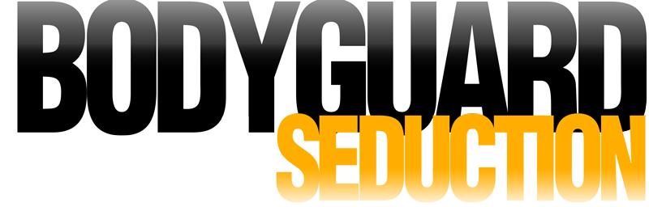

Johnson Production Group

Press Kit

# One-Liner

When threats force the hiring of a new bodyguard, a corporate CEO realize how much she will come to appreciate his many talents.

# Synopsis

# Wealthy businesswoman Charly must decide whom to trust when she falls for sexy bodyguard Jonathan who may be involved in a plot to assassinate her. When her life is threatened more than once by a mysterious killer she relies on seduction to find out the truth.

# Producers

Executive Producer

TIMOTHY O. JOHNSON

Co-Producers

JOSEPH WILKA

ROBIN CONLY

Producer

ROBERT BALLO

Line Producer

KATE LUGTU

Key Cast

|  |  |  |
| --- | --- | --- |
| CHARACTER  Charly Huxton  Jonathan Makepeace  Lark Embridge  Vargas |  | ACTOR  JESSICA MORRIS  ROSS JIRGL  ALICIA BLASINGAME  RYAN J FRANCIS |

# Key Cast Biographies

# JESSICA MORRIS

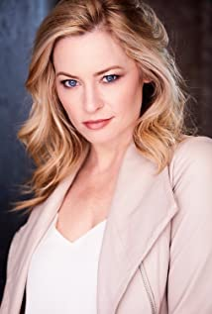Known for her portrayal of series regular Jennifer Rappaport on ABC's "One Life to Live", Jessica has cultivated her career as the leading lady in various television shows and independent films. Jessica starred in Lifetime TV's hit movie "The Wrong Teacher" and has also had strong guest starring roles on popular primetime shows, including Fox's "Rosewood" and TNT's "Perception". Jessica recently recurred in episodes of Freeform's "Party of Five" remake and appears in "The Upshaws" on Netflix. Jessica stands out as an actress who conveys honesty and depth through all of the characters she plays and has also discovered her passion for screenwriting.

# ROSS JIRGL

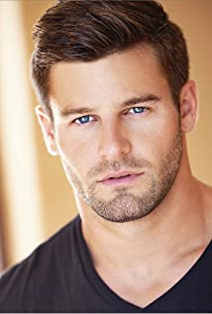American born Ross Alan Jirgl is of Norwegian, Finnish and Czech ancestry. Prior to becoming an actor, he spent the majority of his early professional years working in college athletics after having played football competitively in the NCAA for Minnesota State. His longtime interest in the art of acting grew when he audited a class while working for Stanford University.

After filming his television debut on Zoey's Extraordinary Playlist in San Francisco, CA, he decided to relocate to New York City to pursue more extensive formal training. He attended the conservatory at The William Esper Studio and then furthered his artistic development by studying with the long time acting coach Anthony Abeson.

Ross’ most recent film credits include starring in A Professor's Vengeance, Inexistent, Heart of the Manor as well as appearances in Love Map, Murderville and Hope Sinks as well as the TV Series Gossip Girl.

# ALICIA BLASINGAME

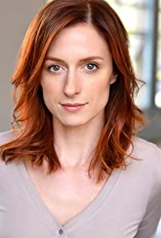Originally from the Northwest, Alicia is a Los Angeles based actor who has spent time on a variety of sets and stages in Seattle, New York, and San Francisco. She earned a B.A. in Theatre Arts at the University of Puget Sound and has studied at the The Imagined Life with Diana Castle and Faline England and John Rosenfeld of JRS Studio.

# RYAN J FRANCIS

## Ryan Francis PictureRyan has spent over 35 years in entertainment. He has worked with Academy Award Winners Steven Spielberg, Robin Williams, Gwyneth Paltrow, Maggie Smith and Dustin Hoffman in Hook, and Emmy Award Winners Sela Ward and George Clooney on NBC's Sisters, which he was a series regular for its entire six year run. He has also appeared in 100 national commercials, having the lead role in selling products like Subaru, Coors Lite and Twix. Ryan's voice can be heard on the radio and television for McDonalds, Chevrolet, Taco Bell, CiCi's Pizza as well as promo spots for the CW network and CBS. He was the Patriot and various other characters in the popular video game Hitman: Absolution. Having produced numerous short films and music videos, as well as the feature, The Helix Loaded... and Just Another Day in the Neighborhood a feature film shot entirely in one day for under $10,000, growing up on movie sets was a reality, one that continues today. He recently has turned his sights on writing and directing. His first short film Open 24 Hours, has received outstanding reviews and was selected to play at the 20th Arizona International Film Festival, 3rd San Jose Short Film Fest as well as the 14th Dances with Films. Ryan's recently wrote, directed and produced the feature film Do Over which was acquired by FreeStyle Media and received a world wide distribution deal available on all VOD platforms as well as iTunes, DishNetwork, Amazon Video, DirecTV, YouTube, PS4 and XBOX. Besides acting, he is an all around athlete who lettered in football as well as soccer, a team that knocked off the number two team in California on the way to the semi-final round of the California Southern Section Tournament. But it was on the baseball diamond where Ryan would set state and school records that still stand today. He was selected back to back years All-Westide, All-Outlook, and All-Ocean League. He also picked up a trophy in tennis, winning the Adidas Desert Challenge in Mixed Doubles as well as winning a belt buckle in team penning at a rodeo in North Carolina.

# Production Credits

### Full Cast

|  |  |
| --- | --- |
| [Actors](http://www.imdb.com/name/nm7589451/?ref_=ttfc_fc_cl_t1)  JESSICA MORRIS  ROSS JIRGL  ALICIA BLASINGAME  RYAN J FRANCIS  JARRID MASSE  LAUREN MAYO  JESSICA DEBONVILLE  MICHAEL MORANO  DAPHNE O’NEAL  CARRIE SCHROEDER  JESSE KLICK  MAURICE CARTER  ANDREW COLBURN  CRYSTAL REED  KATE LUGTU  ZAC COMPTON  MACKENZIE AUGUSTIN  WES HAMAD  PAIGE COMPTON  FRANK MULLER  DREW ABRAMOW  SARA PODWOL  TERRANCE MACKEY  OLIVIA PHILLIPS  ELIAS ZOUAK  CHRIS CARDOZA  CYDNEE BERRY  ZACHEREAH CHHAY  AMANDA JOY TOTPAL  AURELIA RUIZ  LEONARD CARTER  BRIEANA CAPONE  KENDRICK GIBSON  ROSITA RUVALCAVA  ANTHONY VLASTAS  ROBERT BALLO  EDGAR NUNLEY  ROBIN CONLY | Role  Charly Huxton  Jonathan Makepeace  Lark Embridge  Vargas  Baylor  Mindy  Reporter  Romero  Dr. Dankoff  Diane  Godfrey  Matt  Boy  Mom  Nurse  Actor  Female PA  Dylan Tanner  Actor Cop 1  Actor Cop 2  Police Officer 1  Police Officer 2  Police Officer 3  Police Officer 4  Bomb Tech  CSI Officer  Office Employee 1  Office Employee 2  Office Employee 3  Office Employee 4  Office Employee 5  Office Employee 6  Board of Director 1  Board of Director 2  Board of Director 3  Camera Man  Grip  Grip |

### Casting by

ROBIN DE   
NICOLE DIONNE

### Makeup by

SHANNON MARIE TRIGGER

### Sound Design by

ANDRES BOULTON

### Music by

EMIR ISILAY

### Edited by

WES SNEERINGER

### Costume Designer

JOYCE ONUORAH

### Production Designer

CHRISTELL HOLMES

### Director of Photography

JOSH MAAS

### Screenplay by

PAUL A BIRKETT  
DOUG CAMPBELL

### Directed by

LINDSAY HARTLEY

### Full Crew

|  |  |
| --- | --- |
| TEMPEST MONTGOMERY | First Assistant Director |
| JORDAN THOMA | 2nd Unit Director |
| NICOLE DIONNE | Casting Director |
| ROBIN DE LANO |  |
| GABRIELLE FERNANDEZ | Casting Assistant |
| JUSTIN CROWE | First Assistant Camera |
| COLIN MACK NAIR |  |
| JOHN VOGT | Second Assistant Camera |
| NICK SERABYN | Steadicam Operator |
| SCOTT BAKER |  |
| CHRISTELL HOLMES | Production Designer |
| VERONICA BOWEN | Art Director |
| PATRICK HUBBARD | Chief Lighting Technician |
| DANIEL CASTILLO | Key Grip |
| EDGAR NUNLEY | Grip & Electric Swing |
| SHANNON MARIE TRIGGER | Makeup Dept. Head |
| MEGAN LONGMEYER | Makeup Artist |
| MAIRA GOMEZ |  |
| BRENDA LOPEZ | Hair Stylist |
| HANNAH NORMAN | Set Costumer |
| JASON MORAN | Production Sound Mixer |
| FRANK MULLER | Key Production Assistant |
| CHRIS CARDOZA | Production Assistants |
| CYRUS RADCLIFF | Art Assistant |
| SERGEI DMITRIEV | Picture Vehicle Driver |
| DOERTE LINDER | Accountant |
| WRAPBOOK | Payroll |
| TJ CRAFTY | Catering |
| TOSHA WILLIAMS |  |
| B&G THAI CATERING |  |
| CHEF GROUPZEE |  |
| ALEISHA BROOKS | Covid Safety Supervisors |
| ARNOLD JUAREZ |  |
| GEE DEPRATT |  |
| BOOKED TALENT | Background Casting |
| ROBIN CONLY | Post Supervisor |
| SOUND AS ART | Post Sound |
| ANDRES BOULTON |  |
| JONATHAN MORGAN | Foley Editor |
| BLUELINE FINISHING | Conform and Delivery |
| RANDY COONFIELD | Color Grading |
| GOAL PRODUCTIONS, INC. | Stock Footage |
| CLEARANCE UNLIMITED | Script Clearance |
| SUZY VAUGHAN |  |
| BLACKSTONE ENTERTAINMENT | Grip and Lighting Equipment |
| GOAL PRODUCTIONS, INC. | Camera Equipment |
| PURSUIT SYSTEMS | Process Trailer |
| MICHAEL “MOOSE” MONTANTE | Process Trailer Driver |

# Producer Biographies

TIM JOHNSON – Executive Producer

Tim Johnson is among the most active and reliable producers in the business thanks to top rate productions and global distribution appeal.

Johnson is also responsible for producing the international hit series, DR. QUINN, MEDICINE WOMAN for CBS for over 5 seasons. During his 100-episode tenure, he also developed and produced the original docu-drama COLD CASE for CBS network, which was the very first program to integrate television with the Internet.

Johnson has produced over 150 movies, 15 globally released series for every major US network - including ABC, Disney, CBS, NBC, Netfly, FOX and Sony.

## JOHNSON PRODUCTION GROUP

The Johnson Production Group contracts globally to produce television content for international networks, studios and distributors. Based in Los Angeles and Vancouver, British Columbia, the company manages production, facilitates development and financing, procures distribution and guarantees quality and timely execution of its programs. While costs have gone up, so has the demand for quality. No longer is good enough, good enough. Johnson Production Group serves that segment when a show needs to be "A" quality, but produced efficiently enough to meet a locked budget. JPG specializes in value, protection of creative elements, and delivery of a quality finished product.

## JOSEPH WILKA – Co-Producer

Joseph Wilka is the Head of Production for Johnson Production Group. Los Angeles-based, Joseph had already produced and directed several feature films before serving as the senior marketing executive for Gravitas Ventures. While at Gravitas, Wilka helped pioneer new distribution models for independent films including day-and-date theatrical releases. It was also at Gravitas where Joseph first worked with Johnson Production Group to facilitate the release of their films to the worldwide Video On Demand audience. After serving as the Director of Distribution and Production for Viva Pictures, where he produced English-language versions of foreign animated titles for DirecTV, Wilka officially joined Johnson Production Group. As Head of Production, he oversees the development, production, and distribution of films from multiple production units for release on broadcast and streaming platforms.

## ROBIN CONLY – Co-Producer

Robin's career has spanned from Texas to Los Angeles, where she's produced several internationally distributed films that can be seen on networks including HBO, Hallmark, Showtime, Hulu, and Netflix. Recently, she worked with a former Disney Imagineer to produce multiple segments of a 4D IMAX attraction for the Mall of America; helmed research and development for a documentary production company; and produced an award-winning web-series.

ROBERT BALLO – Producer  
With over 34 years of industry experience, Robert Ballo has created award-winning productions for clients that include ABC, TBS, PBS, Discovery Channel, and Lifetime, and that have aired on national network television, cable networks, and internationally in Asia and Europe. As Director of Photography and Producer at Shadowland, Ballo has created over a dozen feature films seen on the Lifetime Network and distributed internationally. As Director of Photography, his Shadowland films include MISSING AT 17, THE SURROGATE, STALKED AT 17, TEENAGE BANK HEIST, WALKING THE HALLS, BETRAYED AT 17, HOME INVASION, MATERNAL OBSESSION, ACCUSED AT 17 and SPECTRES. Other feature film credits include RUNNIN' AT MIDNITE, THE AFFAIRand STARVING ARTISTS. Ballo has also traveled the world on many documentary productions.

His television credits for national broadcast and cable networks include COLLEGE SPORTS IN AMERICA, GREAT EUROPEAN BALLOON ADVENTURE, DIRTY HARRY THE ORIGINAL, THE GREAT YEAR, and THE ROSE PARADE - PAGEANT FOR THE AGES. Through his other digital motion picture company, GOAL Productions, Ballo works with Fortune 500 companies, non-profit organizations and government agencies to produce sales and marketing videos as promotional communications. After a twenty-year tenure teaching film and video imaging, Ballo recently retired from his position as an Associate Professor of Practice at USC’s School of Cinematic Arts. A graduate of the USC film production program himself, Ballo is a member of the Academy of Television Arts and Sciences.

## Billing Block

Johnson Production Group Presents A Lifetime Movie “BODYGUARD SEDUCTION”

starring JESSICA MORRIS ROSS JIRGL ALICIA BLASINGAME RYAN J FRANCIS Casting by ROBIN DE LANO NICOLE DIONNE Makeup by SHANNON MARIE TRIGGER Sound Design by ANDRES BOULTON Music by EMIR ISILAY Edited by WES SNEERINGER Costume Designer JOYCE ONUORAH Production Designer CHRISTELL HOLMES Director of Photography JOSH MAAS Line Producer KATE LUGTU Co-Producers JOSEPH WILKA ROBIN CONLY Executive Producer TIMOTHY O. JOHNSON Produced by ROBERT BALLO Screenplay by PAUL A BIRKETT DOUG CAMPBELL Directed by LINDSAY HARTLEY

© MMXXII Johnson Production Group Inc. All Rights Reserved

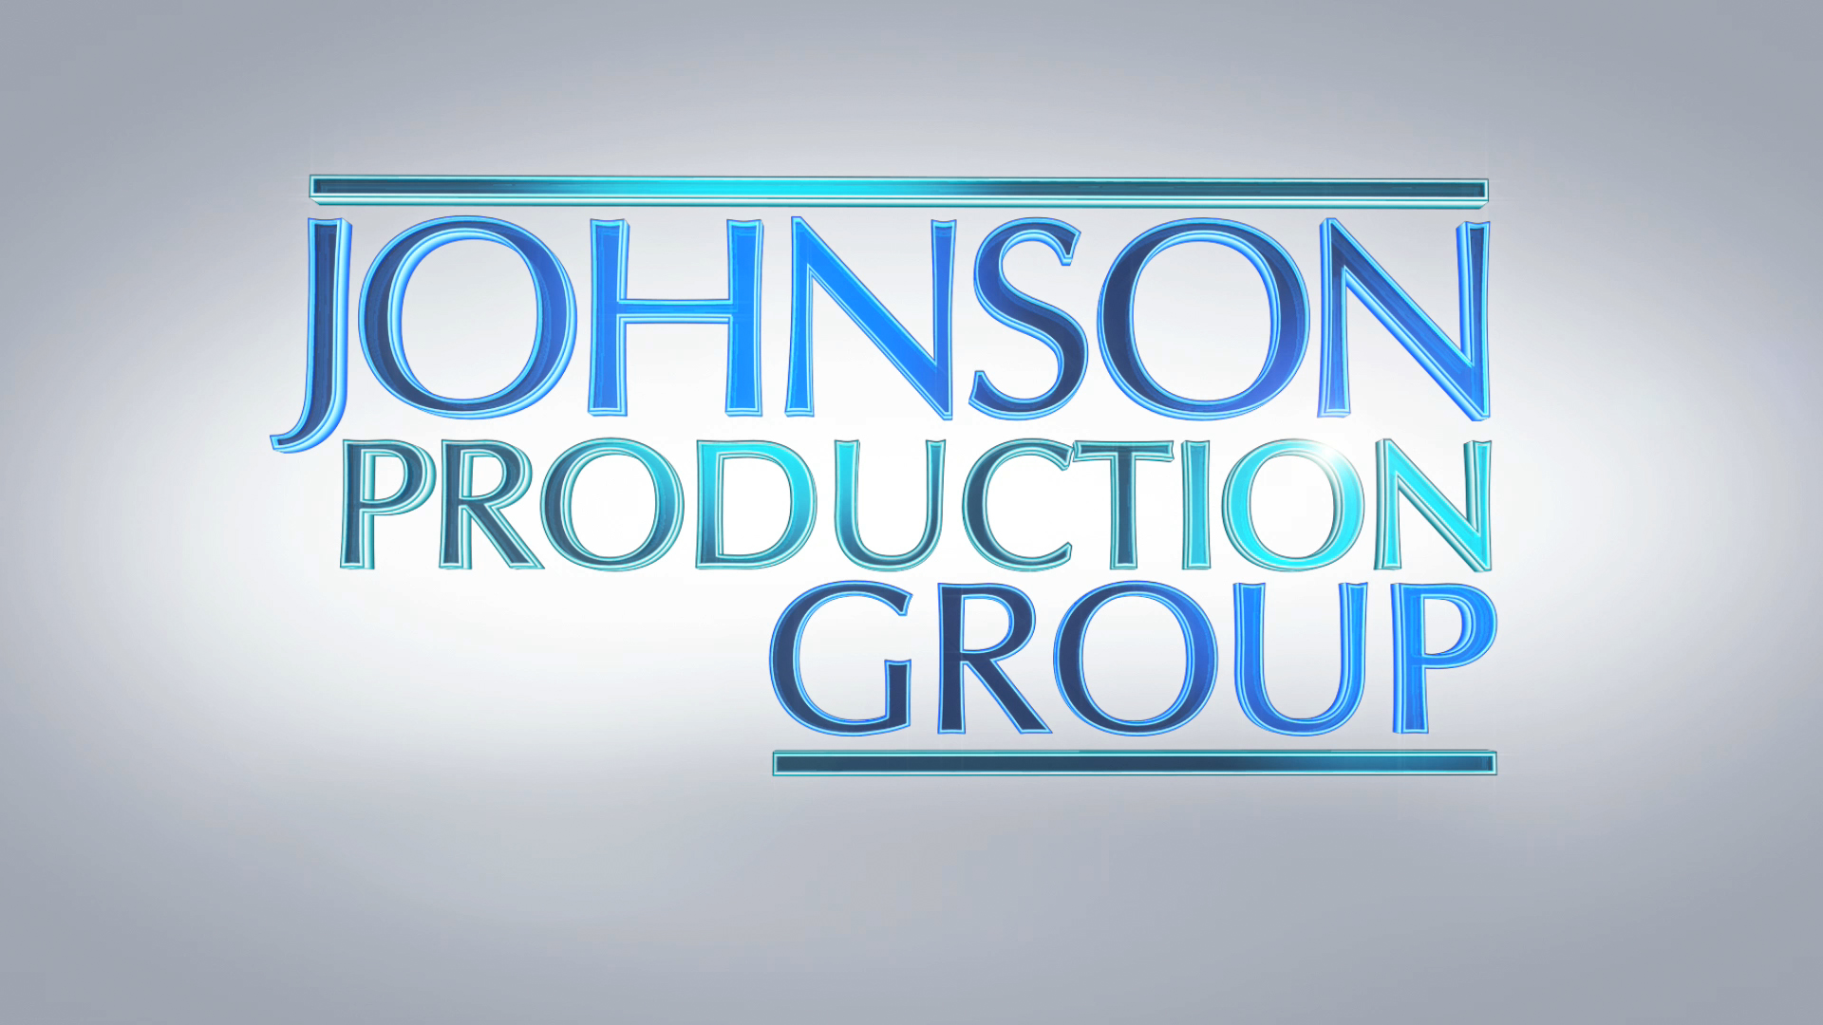



Meta Data

LONG (max 3000 characters) synopsis

# Her Bodyguard is a romantic thriller about a supermodel turned CEO, Charly, who receives death threats after terminating an employee. Without her knowledge or cooperation, Charly’s business partner hires a Bodyguard to protect her. But when the threats turn real and Charly is framed for crimes she didn’t commit, she’s glad she has Her Bodyguard there to protect her.

(374)

MEDIUM (max 500) synopsis

Wealthy businesswoman Charly must decide whom to trust when she falls for sexy bodyguard Jonathan who may be involved in a plot to assassinate her. When her life is threatened more than once by a mysterious killer she relies on seduction to find out the truth. (261)

SHORT (max 100 characters) synopsis

# When Charly receives death threats her business partner secretly hires a Bodyguard to protect her.

(99)

5 KEY WORDS

Romance, death threat, business, model