Johnson Production Group

Press Kit

One-Liner
Amy is assigned to photograph a fabled waterfall and ends up falling for her rugged guide.

Synopsis
Photographer Amy Atwater gets the break of her career when high profile magazine Explorer Worldwide puts her on an assignment to find North America’s most mythical Waterfalls. To her surprise, not only does she discover some of the world’s most pristine waterfalls, but she also catches herself falling for single dad, Mark North. When Amy’s slick and sneaky boss goes behind her back and discloses information on an image with without her knowledge, Amy’s integrity has been compromised, along with her chance at love

Producers
Executive Producers
TIMOTHY O. JOHNSON
CHRISTIE WILL
MICHAEL VICKERMAN
Producer
NAVID SOOFI
Supervising Producer
OLIVER DE CAIGNY
Line Producer
CHRIS IPPOLITO

Key Cast
CHARACTER  Amy Atwater  Mark North  Kyra North  Tara  Camilla |  | ACTOR  CINDY BUSBY  CHRISTOPHER RUSSELL  CASSIDY NUGENT  MIRANDA FRIGON  RHONDA DENT

Key Cast Biographies

CINDY BUSBY
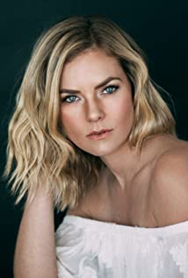
Cindy Busby has been making waves in the television and movie industry for almost 2 decades. Growing up in Montreal, Canada, Busby always dreamed of becoming an actress. To pursue these dreams, Busby attended the Professional Theater Program at Dawson College, a rigorous three-year training, allowing Busby to demonstrate her professionalism, hard work, and devotion to her craft.
After graduation, Busby hit the ground running and landed a leading role as Ashley Stanton in over 50 episodes of the hit series HEARTLAND. The series took off quickly becoming one of the most popular Canadian shows ever, as well as syndicated in 81 countries around the world and is a Netflix top pick. Busby continued having success booking roles as the antagonist in the film PICTURE THIS alongside Ashley Tisdale, and booking guest starring roles on the smash hit series THE VAMPIRE DIARIES, SUPERNATURAL, LA COMPLEX, RUSH, PROOF, THE TOMORROW PEOPLE, and THE SECRET CIRCLE. In 2010 and 2011, Busby appeared on the big screen in DIARY OF A WIMPY KID from 20th Century Fox, followed by the Fox 2000 film THE BIG YEAR, playing opposite Hollywood heavy hitter Steve Martin.
Cindy’s work ethic and reputation has earned her over a dozen lead roles in the last few years, making her a household name and fan favorite among the Hallmark Channel community. Starring in UNLEASHING MR DARCY and MARRYING MR DARCY, viewed by over 3 million viewers individually and breaking the network’s social media record. In 2017, Busby traveled to Romania when she booked the lead in ROYAL HEARTS, directed by James Brolin and most recently Busby starred in the audience acclaimed A GODWINK CHRISTMAS: MEANT FOR LOVE along side Kathie Lee Gifford.
Cindy also showed off her comedic chops as the leading lady in the series DATE MY DAD.
Time and time again, Cindy has won over audiences as a chameleon performer with her quick wit, comedic timing, and dramatic ability. With several movies slated to release in 2020, it’s safe to say that Cindy Busby is here to stay.

CHRISTOPHER RUSSELL
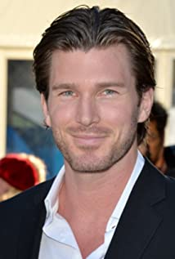
Christopher Russell is a first generation Canadian born to British parents. From a very young age, he was drawn to the arts and began performing. His first role as an actor was portraying Mary and Joseph's donkey in his pre-school production of “The Nativity Story,” for which he received rave reviews. In high school, Russell performed in many productions, most notably as Magnus Muldoon in a rendition of Tom Stoppard’s “The Real Inspector Hound,” which earned him the Sears Drama Festival Award of Excellence.
Russell recently filmed the lead role of Madison in ABC Family’s pilot “Gorgeous Morons.” His numerous television credits prior to that include guest star and recurring appearances on “Girlfriends’ Guide to Divorce,” “Men in Trees” with Anne Heche, “Flashpoint,” “The Listener,” “Murdoch Mysteries,” The CW’s “iZombie,” “Nikita,” “Supernatural” and “Beauty and the Beast,” as well as the TV movies “Love, Again,” “Midnight Masquerade,” “The Boy Next Door,” “Seduced By Lies” and “Catch A Christmas Star.”
Russell’s film credits include “Gone Tomorrow,” “Gangster Exchange,” George Romero’s “Land of the Dead,” “Center Stage: Turn It Up” and “The Right Kind Of Wrong,” which was an official selection for TIFF 2013, starring “True Blood’s” Ryan Kwanten and Catherine O'Hara.
Russell currently lives in Vancouver with his wife and his two children.

CASSIDY NUGENT
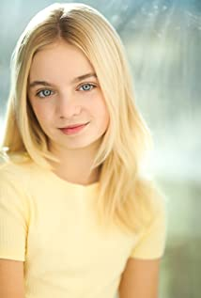
Cassidy Nugent was born in Vancouver, BC. She made her first appearance in commercials just before her first birthday and continued in a handful of national commercials over her early years. She booked a role in the CBS series "Zoo" followed by Lifetime's "I am Elizabeth Smart" biographic crime drama.
She is most known for Hallmark Channel's "Love Struck Cafe" and "When Calls the Heart; The Greatest Christmas Blessing," receiving recognition for both movies winning Canadian Youth Acting awards. This was followed by a recurring role on the SyFy series "Van Helsing" as Tabby.
She spends her time playing sports and loves soccer, skiing, horseback riding, wake boarding, volleyball, basketball and her dog.

MIRANDA FRIGON
Miranda Frigon is a Canadian Actress and Singer-Songwriter. Born in Edmonton, Alberta she began her acting career at the age of eight, appearing in numerous television commercials. Her childhood and adolescence revolved around competitive gymnastics, ballet and classical piano so performing was a huge part of her life from an early age. She traveled and competed across Canada with her gymnastics team all the while training professionally as a dancer. She then went on to dance in a ballet company for several years before joining and touring with a more diverse company that included more various styles of dance. She then attended the University of Alberta where she studied Theater and Psychology in addition to competing on the varsity gymnastics team. Shortly after, Miranda received a scholarship to the American Musical and Dramatic Academy in New York City where she trained in musical theater before landing her first recurring television role on the Disney series "Honey, I Shrunk The Kids." This brought her back to Canada to where she began working and building her film, television and music career. After moving and settling into Vancouver, B.C. she immediately began booking numerous guest stars on hit network U.S. shows such as "The 4400", "Higher Ground", "The Chris Isaak Show", "John Doe" "True Calling" and "The Dead Zone" to name a few. In her spare time she was writing music and playing live with her band in venues in and around Vancouver. She then landed a 13 episode run on UPN's "Jake 2.0" and the producers also placed 2 of her original songs in the series. This kicked off Miranda's music career of placing her songs in film and television.
In addition to her numerous feature and indie film credits, her most notable pasts TV roles include guest stars on hit shows such as "Bones", ,"Ugly Betty", "Dexter", "The New Adventures of Old Christine", "V", "Motive" "Supernatural" and "The Magicians".
Miranda was nominated for a Canadian Leo Award in 2013 for her leading role on Syfy's "Primeval: New World", was recurring for 5 seasons on the hit drama "Heartland" and is now most recognized for her leading role on Hallmark's "Aurora Teagarden Mysteries" alongside Candace Cameron and Marilu Henner which films in Vancouver, B.C. She was nominated for a Canadian Leo award again in 2015, for her role in this series.
Miranda's original song "Hiding Place" was used in episode 5 of Syfy's "Primeval New World" and it unleashed a worldwide fan base for her music. Since, her original songs have been placed in television series, Indie and feature films by Fox, Paramount, The CW, NBC, UPN, CBC, Space, Syfy, Hallmark & Lifetime. Her placements have gotten her worldwide exposure and attracted new fans from all over the globe. Miranda just released her new Kickstarter fan-funded album "First" in 2017 which can be found on iTunes, Amazon, Spotify and any additional online stores.
In addition to all of her creative and athletic talents, Miranda is also a skilled Mixed Martial Artist. She has been trained in Boxing and Thai Kickboxing for over 10 years.
RHONDA DENT
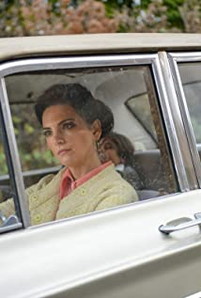
Canadian actress Rhonda Dent (born in 1978 in Langley, British Columbia) finished her theatrical studies in 1998 before starting her professional acting career in 1999 at the age of 20. Rhonda is the daughter of Anne(nurse) & Ronald (Lawyer). Rhonda's father Ron, was a World War Two veteran, and died of a brain tumor in 1996 when Rhonda was 17 she is the seventh of eight children from her father.
Rhonda's onscreen credits include an impressive range of sci-fi episodic and made for tv movies, short films and the re-occurring role of Lanie Snider in ABC's "That Was Then". Most recently the role of Judy Wood on "Almost Human" Rhonda is also known as an award winning photographer.

Production Credits

Full Cast
Actors  CINDY BUSBY  CHRISTOPHER RUSSELL  CASSIDY NUGENT  MIRANDA FRIGON  AKIZ AGUMA-BIRUNGI  HAMZA FOUAD  RHONDA DENT  JULIAN LEBLANC  SHERILYN ALLEN  FRANK CASSINI  AMÉLIE WILL WOLF  DEVON ALEXANDER | Role  Amy Atwater  Mark North  Kyra North  Tara  Hunter  Peter  Camilla  Ben  Penny  Shopkeeper  Pretty Girl  Leo/Desk Clerk

Produced by
TIMOTHY O. JOHNSON |  | executive producer
MICHAEL VICKERMAN |  | executive producer
CHRISTIE WILL |  | executive producer
NAVID SOOFI |  | producer
OLIVER DE CAIGNY |  | supervising producer
CHRIS IPPOLITO |  | Line producer

Directed by
CHRISTIE WILL

Written by

JASON BOURQUE
TAMARA JUNKIN
CHRISTIE WILL

Music by
FREDERIK WIEDMANN

Cinematography by
STIRLING BANCROFT

Film Editing by
DEVIN TAYLOR

Casting By
JUDY LEE

Production Design by
MAURICE CURTIN

Full Crew
CHAD SAYN | Stunt Coordinators
DAVE HOSPES
LISA CHANDLER | Amy Stunt Double
CHRIS WEBB | Mark Stunt Double
MATT PHILLIPS | Kyra Stunt Double
BECKY FERGUSON | Tara Stunt Double
BRENT LEE LISTER | Stunt Riggers
LUKE CORMIER
KAI HIRVONEN
RICHARD VAN LIEMPT | Water Safety
THOMAS STANFORD | Associate Producer
NAVID SOOFI | Production Manager
JEFF CROFT | First Assistant Director
CASSY HUNGERSON | Second Assistant Director
HELEN GRACE BURNETT | Set Decorator
TAMARA KVARNBERG | Assistant Set Decorator
ZOE CUVILLIER | On Set Dresser
LISA ANN GIDFREY | Dressers
ELLE ELLICKSON
ALYSSA-JANE MILETO
ERICA DJALOVIC
FRANCIS BELANGER | Props Master
ELLIOTT CARROLL | Props
SELENA TAYLOR | Make-Up Artist
KIERAN WANG | Hair Stylist
JADEN DEVINE | Costume Designer
NICOLE MOORE | Assistant Costume Designer
AMY SCHILBE | Set Supervisors
MEGAN BUZZARD
MARK MILLER | Drone Operator
ALEXANDER TORRES | First Assistant Camera
GIACOMO PASTORINO | Second Assistant Camera
GARETH JONES | Gaffer
JOSUE CARBALLO | Best BoyElectric
CORY TYMOSCHUK | Electrics
ZANE KLASSEN
CONNOR WELSH | Key Grip
CAMERON SCOTT-TRASK | Best BoyGrip
PETER GIBSON | Transport Coordinator
CHRIS WILD | Transport Captain
GORD MACKAY | Drivers
SCOTT REDBURN
SAEED SODEYF
PATRICK PARISIEN
BARRY HUNT | Security Coordinator
SHANE DIXON  PARRY PARSON | Security
CELESTE CROWE | Location Manager
JAMIE A. SKELTON | Location Manager Assistant
ROBIN LAWERENCE | Key Location Assistants
NATHANIEL HERRON
ANA NUNES
SOLVEIG ELESY
TAYLOR MILNE | Location Assistants
ALEX J. LEMMON
ERIC DOUBLEDAY
CAROLYN GAMACHE-VILLEMAGNE
CINDY SENAUD
TYLER WILKIE
RON P. OSIOWY | Production Sound Mixer
SHAUNA SUPEENE | Boom Operator
ROBIN LUDWIG | Script Supervisor
PARALEE COOK | Production Accountant
ROBERT J. DEACHMAN | Production Accountant Assistants
ALEX ZAHARA
THOMAS STANFORD | Business Affairs
JEFF DESMARAIS | Production Coordinator
CHRIS BILLION | Third Assistant Director
KATHLEEN STAFFORD | Craft Service/First Aid
CORY HORTON | Craft Service/First Aid Assistants
CORA HICKEN
MARLON SARAVIA | COVID Specialists
JESSICA JONGKIND
TASTEBUDS MOBILE CATERING | Catering
BILL SCHILDPATT | Chefs
SHARON TOUCHET
MAIA MICHAELS | Casting Assistant
LA HILTS | Extras Casting
STEPHANIE SARIN | Stand-In
COASTAL CLEARANCES | Script Clearances
CHANDLER FOGDEN ALDOUS LAW CORPORATION | Legal Services
FRONT ROW INSURANCE BROKERS | Insurance
LEAH MYERS | Post Production Supervisor
TIM SPENCE | Post Production Coordinator
RON PENCHALAIYA | Assistant Editor
RAYNE MUIR | Second Assistant Editor
 | Visual Effects
SEÁN TRAVERS | Colourist
MAVERICK POST GROUP | Sound Facilities
GREGOR PHILLIPS | Supervising Sound Editor
GREGOR PHILLIPS | Re-Recording Mixer

Producer Biographies

TIM JOHNSON – Executive Producer
Tim Johnson is among the most active and reliable producers in the business thanks to top rate productions and global distribution appeal.
Johnson is also responsible for producing the international hit series, DR. QUINN, MEDICINE WOMAN for CBS for over 5 seasons. During his 100-episode tenure, he also developed and produced the original docu-drama COLD CASE for CBS network, which was the very first program to integrate television with the Internet.
Johnson has produced over 150 movies, 15 globally released series for every major US network - including ABC, Disney, CBS, NBC, Netfly, FOX and Sony.

JOHNSON PRODUCTION GROUP
The Johnson Production Group contracts globally to produce television content for international networks, studios and distributors. Based in Los Angeles and Vancouver, British Columbia, the company manages production, facilitates development and financing, procures distribution and guarantees quality and timely execution of its programs. While costs have gone up, so has the demand for quality. No longer is good enough, good enough. Johnson Production Group serves that segment when a show needs to be "A" quality, but produced efficiently enough to meet a locked budget. JPG specializes in value, protection of creative elements, and delivery of a quality finished product.
NAVID SOOFI – Producer
Navid is the primary producer for Novus Ordo Seclorum. Navid’s passion for filmmaking along with his business and engineering background plays an important role in creating a successful and transparent business model. Navid has been in the entertainment industry for more than 13 years and has produced over 50 feature films, TV shows and commercials that have been featured on national television, international theatres, and new media platforms. His credits include Over the Moon in Love, The Mistletoe Secret, Random Acts of Christmas, Love Unleashed, Identity Theft of a Cheerleader, and A Mother on the Edge.

OLIVER DE CAIGNY – Supervising Producer
Oliver De Caigny is a Canadian producer originally from Belgium, his background in financing, production, and post production makes him a well-rounded producer for any type of production. His experience in financing and production agreements (film and TV series and movies-of-the week), distribution agreements (both domestic and foreign) as well as international co-productions, Canadian tax credit, Telefilm Canada and Canada Media Fund incentives provides him with a well-rounded background in development, production and distribution for motion pictures, television series and productions.

CHRISTIE WILL - Director
Christie Will studied at Emerson College in Boston MA, and the College of Charleston in SC. She earned a BA in Business Arts Management, in addition to a BA in Theatre Performance (concentrating in Music Theatre and Film). Christie also earned a BFA in Art History, along with receiving a 'Leadership in the Arts' Distinction Award, upon graduation.
Following University, Christie graced stages across North America, before moving to Los Angeles where she worked as an actress, model, and emerging director and writer. During this time, she split the year by living between Vancouver Canada and Los Angeles California. In Vancouver, Christie founded the first avant-garde black box theatre; The Beaumont Playhouse (based on the teachings of Sanford Meisner; Christie was a long time student of Robert Carnegie's 'Playhouse West' in Los Angeles). It was during her time back in the theatre that Christie honed in on her writing and directing for the stage. After finding success and audiences within the theatre scene, Christie soon transposed her efforts into film.
Career: Her first short film 'Dysfunction' was received with critical acclaim, encouraging Christie to focus her creative aspirations to further writing and directing for the big and small screen. She worked as Peter Berg's director's assistant (Smokin Aces, Friday Night Lights, Hancock, The Rundown), before moving into Senior Executive in Business Development for singer/ entertainer Paula Abdul (responsible for the development of Paula's first reality show 'Hey Paula'). From this position, Christie focused her sights on directing electronic press kits for feature films, and learning the business of movie production. Her sharp storytelling, and creative approach to these electronic press kits, made for happy distributors and producers. She quickly moved into a producer’s seat, after earning the respect from her colleagues and peers.
After successfully producing (co-producing & associate producing) on various film and televised projects, Christie naturally segued into writing and directing feature films.
As a new female writer, director, producer on the Hollywood scene, Christie's work has been described as "fresh, often providing an uncontrived social commentary on Hollywood" (ref: TS 2006). Her writing and directing has also been described as "authentic, uncensored, and female centric; Christie Will is one of those emerging talents to keep your eye on" (The Sun)
Christie lives on the West Coast between Los Angeles, California, USA, and Vancouver, British Columbia, Canada.

Billing Block
Johnson Production Group Presents “CHASING WATERFALLS”
starring CINDY BUSBY CHRISTOPHER RUSSELL CASSIDY NUGENT MIRANDA FRIGON RHONDA DENT Casting by JUDY LEE Production Designer MAURICE CURTIN
Director of Photography STIRLING BANCROFT Edited by DEVIN TAYLOR
Music by FREDERIK WIEDMANN Line Producer CHRIS IPPOLITO
Supervising Producer OLIVER DE CAIGNY Executive Producers CHRISTIE WILL
MICHAEL VICKERMAN TIMOTHY O. JOHNSON Produced By NAVID SOOFI
Written By JASON BOURQUE TAMARA JUNKIN CHRISTIE WILL
Directed by CHRISTIE WILL
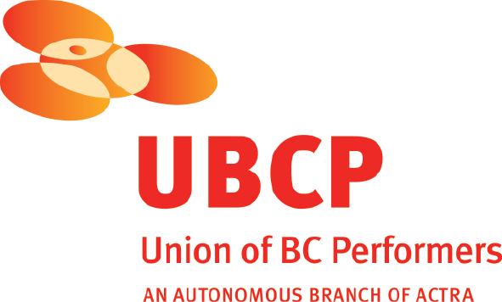
With the participation of the Province of British Columbia
Film Incentive BC
The Canadian Film or Video Production Tax Credit
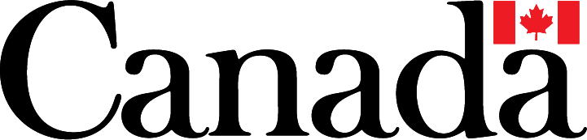
© MMXXI RefreshingProductions Inc. All Rights Reserved

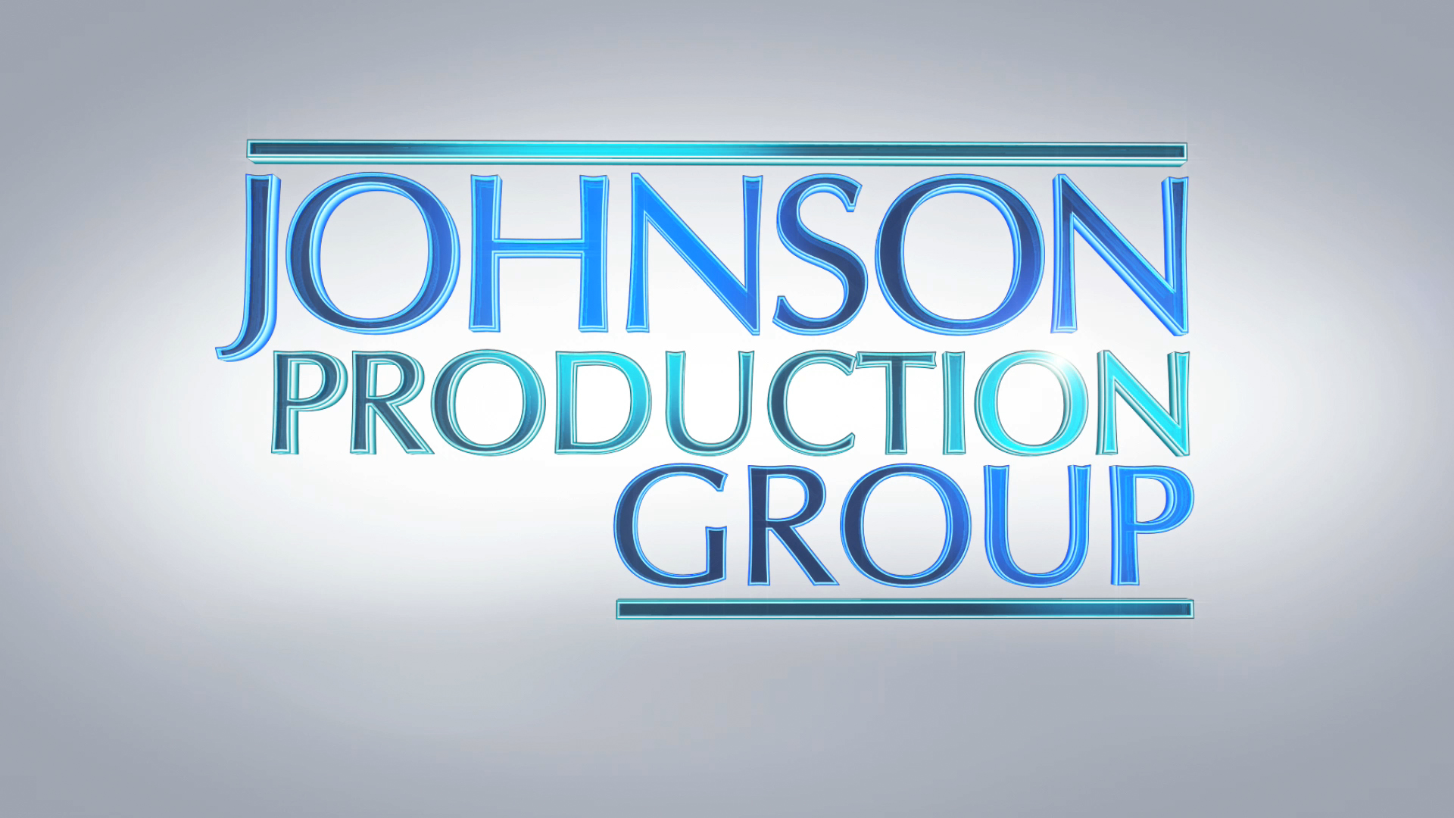

Meta Data
LONG (max 3000 characters) synopsis
Photographer Amy Atwater gets the break of her career when high profile magazine Explorer Worldwide puts her on an assignment to find North America’s most mythical Waterfalls. To her surprise, not only does she discover some of the world’s most pristine waterfalls, but she also catches herself falling for single dad, Mark North. When Amy’s slick and sneaky boss goes behind her back and discloses information on an image with without her knowledge, Amy’s integrity been compromised, along with her chance at love. (516)
MEDIUM (max 500) synopsis
Editorial photographer Amy Atwater travels to a remote lodge, nestled in the deep woods surrounded by waterfalls in order to find a fabled mystical waterfall for her next story. She unexpectedly falls for the ruggedly handsome tour guide, Mark North, and they start off on adventures in the wilderness to find the mystic waterfall and discover their true feelings for each other. (379)
SHORT (max 100 characters) synopsis
Amy is assigned to photograph a fabled waterfall and ends up falling for her rugged guide. (88)
5 KEY WORDS
Romance, photographer, adventure, betrayal, single

