CHRISTMAS BY DESIGN

Johnson Production Group

Press Kit

One-Liner

A New York City fashion designer gets accepted into a Christmas challenge to create a new holiday-themed collection and not only finds the inspiration for her next line but decides to redesign her approach to what's most important in life while she's at it.

Synopsis

Luxury fashion designer, Charlotte Charmichael, tirelessly works to make a name for herself from her New York City boutique, Alastair. So she's over the moon when she learns she's been selected to participate in a design competition for the renowned Warwick's department store. The assignment is to create a Christmas-themed collection for their Home & Family brand. There's just one problem, Charlotte is just not that into Christmas and she can't remember the last time she put down her work long enough to enjoy some quality time with her family. When a pipe bursts in her apartment, she decides to take it as an omen and return home for a family Christmas she hopes will quickly inspire her next design. She arrives just in time to be thrown into the town's annual 12-days-of-Elfcapades event where she meets a handsome mechanic who helps run the festivities. Despite a rocky first impression, he helps her reconnect with her family and ends up inspiring her new collection - holiday pajamas for the whole family. Throughout the week, the two bond and form a deep connection that soon blossoms into a love story they will never forget.

Producers
Executive Producers
TIMOTHY O. JOHNSON
ANDREW C. ERIN
OLIVER DE CAIGNY
Co-Executive Producer
JOSEPH WILKA
Producer
JOSIE FITZGERALD

Key Cast
CHARACTER  Charlotte  Spencer  Kristina  Olivia  DeeDee  Margo  Rick  Roger |  | ACTOR  REBECCA DALTON  JONATHAN KELTZ  JOANNA DOUGLAS  SUSAN HAMANN  DEBRA HALE  ADRIANA VASQUEZ  TIM PROGOSH  SCOTT GIBSON

Key Cast Biographies

REBECCA DALTON
In 2010, Rebecca Dalton made her on-screen appearance in an episode of the Canadian-American TV series Unnatural History in the role of Sally. In the same year she was also cast in the Canadian TV movie My Babysitter's a Vampire in the role of Della ('Popcorn Lady'). and she’s been busy ever since, both in television and film.
In 2013, Dalton was cast as Stephanie Lyons, one of the leading roles in the Canadian TV series Spun Out and then in 2015, she was cast to replace Ashley Leggat in the recurring role of Tara for season two of the Hallmark Channel's series Good Witch, a role she reprised in subsequent seasons. In the same year she was also cast in the role of Katie Littleton in the 2016 TV movie Total Frat Party.
Dalton has also appeared in a number of Canadian TV movies, including RockyRoad (2014), A Perfect Christmas (2016) and Christmas Wedding Planner (2017) and in 2020, The Santa Squad.

JONATHAN KELTZ
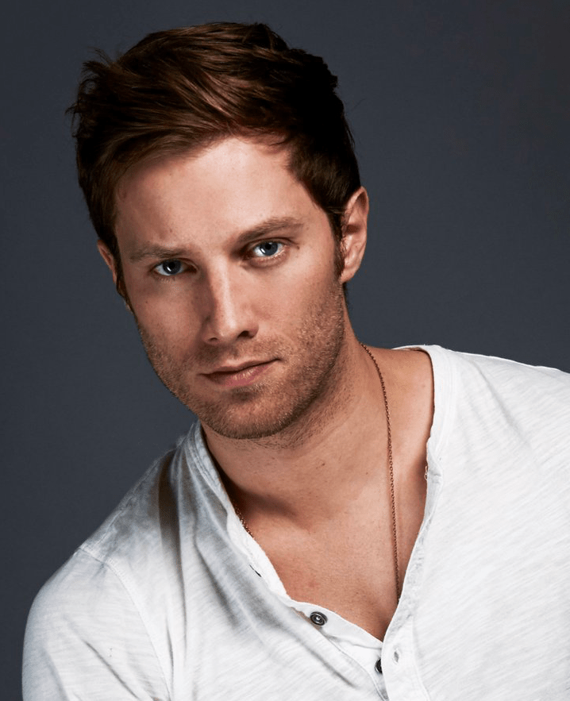
Jonathan Keltz starred on the CW’s Reign playing Leith, a kitchen boy turned war hero who is the loyal protector of Francis II, King of France. Keltz recently produced and starred in Acquainted, an independent film about the unpredictability of modern relationships. Additionally, Keltz recurred heavily on HBO’s Entourage, starred in Cardinal: Blackfly for CTV/Hulu, and starred in the popular Hallmark movies Fit For A Prince,Once Upon A Prince and Love at Look Lodge. Keltz also recently produced the limited series Nine Films About Technology for FX.

JOANNA DOUGLAS
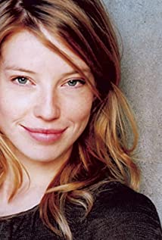
Canadian born actress, Joanna Douglas, is a graduate of the University of Toronto and Sheridan College's joint theatre and drama studies program. She is probably best known for portraying Samantha Strange on the TV series, Being Erica but has also appeared in Good Witch, Anne with an E, The Handmaid’s Tale, Murdoch Mysteries, Suits and Saving Hope, amongst others. Her film roles have included Saw 3D, New Year, Crimson Peak, Standoff and Christmas Inheritance.

SUSAN HAMANN
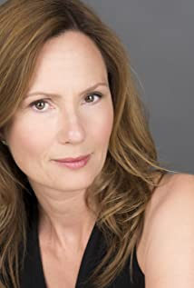
Susan is most recognized for her role as Mary-Kate Sinclair on Degrassi: The Next Generation. Her career in the film and television industry also includes several years of working behind the camera as an assistant director while a member of The Directors’s Guild of Canada (DGC). Susan holds an Honours Bachelor of Arts with High Distinction (Drama Specialist) degree from the University of Toronto and trained at the American Academy of Dramatic Arts in New York City, as well as various acting institutions in Toronto including Equity Showcase, Second City, and C.A.S.T.
Susan has dual citizenship Swiss & Canadian

DEBRA HALE
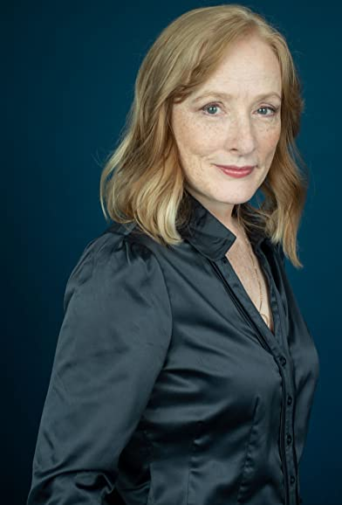
Toronto actor/writer/storyteller Debra Hale has performed in TV, in film, and onstage, across Canada and in the US. One of many theatrical successes is the two-woman, multi-character, comedy/drama "Freedom 85!" - which Debra wrote and performed in. Touring extensively, including NYC, "Freedom 85!" garnered great acclaim from audiences and critics alike.
When the pandemic hit, moving into editing and directing short videos was a natural evolution for Debra. In addition to these creative roles, she plays "Kitty" in "Colleen Curran's Kitty Calling" - winner of NOW Magazine's Best Web Series 2021.
Born and raised in Guelph, Ont., and a longtime advocate of dog rescue initiatives, this passionate dog lover has welcomed three wonderful rescue dogs into her family and home, vowing never to be without canine in her life.
Debra is also a self-described theatre-junkie, with hobbies including travelling, painting, cooking, cycling, playing euchre and visiting family and friends.

ADRIANA VASQUEZ
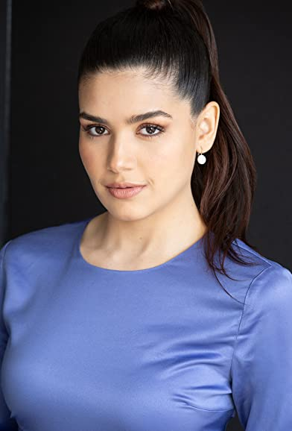
Adriana Vasquez is a Venezuelan-born Canadian actress based in Toronto. She started dancing and performing at the age of 5 in different art academies in her home country. Adriana attended the University of Arts of Venezuela (UNEARTE) within the Contemporary Dance program for 3 years, while also acting professionally with the National Youth Theatre Company. Adriana moved to Toronto in 2013. She enrolled in Toronto Film School and graduated with Honours in the Acting for Film and TV Program.

TIM PROGOSH
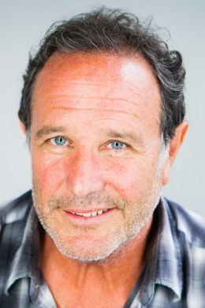
Tim Progosh is a Canadian actor and the creator and original producer of the Canadian Comedy Awards, an annual awards presentation that celebrates Canadian comedy in a variety of media (TV, radio, film, the Internet, etc.) inaugurated in 2000.
His most notable roles include Principal Bill Kremeza in the 2015 award-winning film Spotlight, which won the Academy Award for Best Picture with Best Original Screenplay at the 88th Academy Awards, and the ensemble cast character Firouz in the TV series The Adventures of Sinbad.
Since that time he has appeared as a regular in the TV series Crawford, as well as in many outher well loved series such as Ki’m Convenience, Schitt’s Creek, 1-800-Missing and American Gods. Recently he has had roles in TV movies such as Christmas Scavenger Hunt, Love at Look Lodge, A Christmas Village Romance, A Chance for Christmas and A Christmas Stray.
Tim graduated with a Double Honors degree in Political Science and Drama from the University of Western Ontario. His first job was as a lobbyist for the Canadian Federal Government, but switched permanently to acting and stand-up comedy in 1981. He studied screenwriting at Algonquin College in Ottawa and improvisational acting at The Second City in Toronto.
SCOTT GIBSON
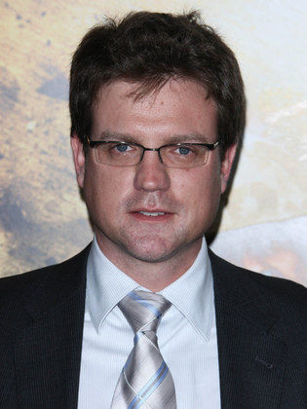
Born and raised in Ottawa, Canada, Scott Gibson obtained a classical acting diploma from London Academy of Music and Dramatic Arts as well as studying acting at the University of Western Ontario. He is an experienced actor with a demonstrated history of working in the international trade and development industry. His notable works include The Sentinel (2006), Lucky Number Slevin (2006), Breach (2007), and Diary of the Dead (2007).

Production Credits
Full Cast
Actors | Role
REBECCA DALTON | Charlotte
JONATHAN KELTZ | Spencer
JOANNA DOUGLAS | Kristina
SUSAN HAMANN | Olivia
DEBRA HALE | DeeDee
ADRIANA VASQUEZ | Margo
TIM PROGOSH | Rick
SCOTT GIBSON | Roger
DAVID PINARD | Evan
VIGGO HANVELT | Ben
TOMAS CHOVANEC | Peter
JINESEA LEWIS | Gwen
RODRIGUES WILLIAMS | Landlord
CATHERINE SAINDON | Jillian
MICHAEL DIXON | Husband
LINDA BALLANTYNE | Radio Host
JEFF TEREVAINAN | Announcer / Radio Host
TAYNIKUA CARMELLE JEAN-LOUIS PIERRE | Girl

Casting
RON LEACH, c.d.c.

Composer
RUSS HOWARD III

Costume Designer
AMANDA COLLIE

Editor
MITCH LACKIE

Production Designer
GREGORY PHILIP WILSON

Director of Photography
CHRISTIAN BIELZ

Written by
CARLEY SMALE

Directed by
MAXWELL MCGUIRE
Other Crew
JOHNNY ROSS | Production Manager
SARAH PETKOV | First Assistant Directors
BEN HRKACH
BEN HRKACH | Second Assistant Director
NICK GAUTHIER | Third Assistant Directors
CIMARRON LANGLOIS
NICK GAUTHIER | Fourth Assistant Directors
HOLLY WONG
AUDREY VIGOUROUX | Tutor
REGAL BACKGROUND CASTING | Extras Casting
MARY SAKS
GORAN Pobrić | Production Coordinator
LOGAN A. WAGNER | Production Accountant
JOSHUA LANGE | First Assistant Accountant
MATTHEW CARVELL | Assistant Accountant
MATTHEW CARVELL | Post Production Accountant
GREGORY PHILIP WILSON | Production Designer
ELIZABETH FITZPATRICK | Art Director
TOMAS CHOVANEC | Set Decorators
ANTHONY RANKIN
RACHAEL ZOE FENTON | Set Dresser
NATHALIE GREGOIRE | Property Master
GLITCH SPFX | SFX
AMANDA COLLIE | Costume Designer
JESSICA DYKINS | Costume Truck Supervisor
JULIANNE HJARTARSON | Costume Set Supervisor
SAGINE Cavé | Wardrobe Assistants
ALLISON PINEAULT
SERENA ROWSELL
ANDY TAIT
CHRISTIAN BIELZ | Director of Photography
JOSH HENDERSON | B Camera Operator
ADAM TESTA | A Camera - First Assistant Camera
TAYLOR RICE
LINDSEY BELANGER | A Camera - Second Assistant Camera
MUNG HATLANG
MATT CROSSE | B Camera - First Assistant Camera
MUNG HATLANG
LINDSEY BELANGER | B Camera - Second Assistant Camera
JILLIAN SKIDMORE
NIKKI TUBONGBANUA
GEGHANI PANOSIAN | EPK Camera Operator
RICHARD FRAZIER | Digital Imaging Technician
RICHARD FRAZIER | Camera Technician
GEGHANI PANOSIAN | Camera Utility
CAMERON MATHESON | Camera Trainee
PETR MAUR | Stills Photographer
STEVEN F. S. BRUNI | Gaffer
YAN SCHNELL | Best Electric
NICHOLAS HERMIER | Key Grip
RJ NADON | Best Grip
LIAM M. CASASOLA | Grip / Electric Swings
CONNOR DORZEK
DANIEL KAUNISVIITA
SONIC LIGHTNING ENTERTAINMENT INC. | Sound
NICK SMITH | Script Supervisor
SAGINE Cavé | Unit Manager
KIM RODGER | Location Coordinator
KEENE IMBLEAU | Key Location Production Assistant
ALLISON BOUSQUET | Location Production Assistants
NATALIE HONSHORST
JORDON PALAISY
KAYLA PIETARINEN
CHRYSTINE ST. LOUIS
ALYSSA "ALY" MORDEN-HAYLEY | Key Makeup Artist
KASSANDRA PEREIRA | Assistant Makeup Artist
CHRISTINA MCGUIRE | Makeup & Hair Assistant
NATASHA GABRIELA TREPANIER | Key Hair Stylist
ALYSSA "ALY" MORDEN-HAYLEY | Daily Key Hair Stylist
MARC-ANDRE LEVAC | Assistant Hair Stylist
STEFANE GREGOIRE | Transport Coordinator
GREG LEWIS | Transport Captain
MICHAEL DICKSON | Drivers
OLMES LEON
BILAL MAHMOUD
KIM RODGER
ROBERT STRONACH
CHRIS SURUJNARAIN
LYNN SPRACKLIN | Transport Production Assistants
TRACEY ST. LOUIS
JAY VISNESKIE
CRAIG WRIGHT
JULIANN WRIGHT
KEITH STEFFENSEN | Move Crew
CORNELIA VILLENEUVE
DAN VILLENEUVE
ERIC VILLENEUVE
SEAN VILLENEUVE
TOM WARRELL | Head Chef
MATTHEW DUBUC | Caterer
RONDA MACKINNON | Craft Service
GERRY WHALEN | Catering Vehicle Operator
THE NO CONFLICT CLEARANCE COMPANY | Script Clearances
HALL WEBER LLP | Legal Services
ABOVE THE LINE MEDIA SERVICES | Business Affairs
BRENDAN MCNEILL
ARTHUR J. GALLAGHER CANADA LTD. | Insurance
ALEXANDRA WARING | Post Production Supervisor
URBAN POST PRODUCTION | Post Production Services provided
JOSEPH FACCIUOLO | Dialogue Editor
JOSEPH FACCIUOLO | ADR Editor
EHREN PFEIFER | ADR Recordist
MATT MCKENZIE | Re-Recording Mixer
LUCAS CECCHETTI | Re-Recording Assistants
SOROOSH RAFIEI
OLIVIA KOLAKOWSKI | Sound FX Editor
MATT THIBIDEAU | Foley Artists
DAWN LEWIS
JESSICA SERVIER | Foley Recordists
MIKE POISSON
NIKA SHEVCHENKO | Colorist
EVAN GRAVES | VFX Artist
KALI RAIGH | Online Editor
PETER TOKARSKY | Project Manager
BRUCE REES | Picture Operations Manager
ROBERTA BRATTI | V.P. of Operations
 | Stock Footage

Producer Biographies

TIM JOHNSON – Executive Producer
Tim Johnson is among the most active and reliable producers in the business thanks to top rate productions and global distribution appeal.
Johnson is also responsible for producing the international hit series, DR. QUINN, MEDICINE WOMAN for CBS for over 5 seasons. During his 100-episode tenure, he also developed and produced the original docu-drama COLD CASE for CBS network, which was the very first program to integrate television with the Internet.
Johnson has produced over 150 movies, 15 globally released series for every major US network - including ABC, Disney, CBS, NBC, Netfly, FOX and Sony.

JOHNSON PRODUCTION GROUP
The Johnson Production Group contracts globally to produce television content for international networks, studios and distributors. Based in Los Angeles and Vancouver, British Columbia, the company manages production, facilitates development and financing, procures distribution and guarantees quality and timely execution of its programs. While costs have gone up, so has the demand for quality. No longer is good enough, good enough. Johnson Production Group serves that segment when a show needs to be "A" quality, but produced efficiently enough to meet a locked budget. JPG specializes in value, protection of creative elements, and delivery of a quality finished product.
OLIVER DE CAIGNY – Executive Producer
Oliver De Caigny is a Canadian producer originally from Belgium, his background in financing, production, and post production makes him a well-rounded producer for any type of production. His experience in financing and production agreements (film and TV series and movies-of-the week), distribution agreements (both domestic and foreign) as well as international co-productions, Canadian tax credit, Telefilm Canada and Canada Media Fund incentives provides him with a well-rounded background in development, production and distribution for motion pictures, television series and productions.
ANDREW C. ERIN – Executive Producer
Andrew Erin is a Canadian Writer/Director making a big splash in the US, and has produced, written and directed numerous commercially successful films. His directorial debut, SAM’S LAKE, was an official selection at the Tribeca Film Festival and did an excellent theatrical run in select theaters around the country; distributed by Lionsgate Films. Andrew also wrote the script for the film. Andrew’s directorial credits include, SIMPLE THINGS, produced for Screen Media Ventures and Universal Studios. Besides winning The Bob Clark Award for Best Director at the California Independent Film Festival, the film was commercially received. Andrew has worked continuously as a writer/director, building a strong library of films in the Thriller/Horror genres with: Embrace of The Vampire, The Clinic, Final Sale, Confined and Toxic Skies.

JOSEPH WILKA – Co-Executive Producer
Joseph Wilka is the Head of Production for Johnson Production Group. Los Angeles-based, Joseph had already produced and directed several feature films before serving as the senior marketing executive for Gravitas Ventures. While at Gravitas, Wilka helped pioneer new distribution models for independent films including day-and-date theatrical releases. It was also at Gravitas where Joseph first worked with Johnson Production Group to facilitate the release of their films to the worldwide Video On Demand audience. After serving as the Director of Distribution and Production for Viva Pictures, where he produced English-language versions of foreign animated titles for DirecTV, Wilka officially joined Johnson Production Group. As Head of Production, he oversees the development, production, and distribution of films from multiple production units for release on broadcast and streaming platforms.

JOSIE FITZGERALD – Producer
Josie Fitzgerald is a Canadian born Producer currently residing and working in Ottawa, Ontario. Josie is also a passionate photographer and writer, with an education in Justice Studies and a professional background in Human Resources and Project Management.

MAXWELL McGUIRE - Director
As a writer and director, Max's projects have been financed or distributed by; Netflix, Bron Studios, Telefilm Canada, Ontario Media Development Corp, Hallmark, Lifetime, CBC TV, UPtv, Canada Council for the Arts, the Harold Greenberg Fund and a number other private international distributors.
Foreverland, his most personal movie, was produced by Bron Studios and Screen Siren Media. It was distributed theatrically by Eone and sold internationally by Vision Films. It stars Max Thieriot (Seal Team/Bates Motel), Laurence Leboeuf (Transplant) and Oscar nominees Juliette Lewis (Cape Fear) and Demian Bichir (The Bridge) along with Sarah Wayne Callies, Matt Frewer and Thomas Dekker.
Max recently directed, Midnight at the Magnolia starring Natalie Hall and Evan Williams for Marvista Entertainment which can currently be seen on Netflix where it was TOP 5 worldwide most watched movie.
Love at Look Lodge, starring Clark Backo and Jonathan Keltz recently premiered on Hallmark to over 2 million viewers this past fall while Mistletoe and Menorahs starring Kelley Jakle and Jake Epstein continues to air on Lifetime TV and around the world.
He's directed numerous thrillers such as The Narcissist, starring Amber Goldfarb, Damon Runyon and Sam Ashe Arnold for Lifetime along with multiple movies for Johnson Production Group, Fireside Pictures, Reel World Management, Neshama Entertainment and Marvista Entertainment.

Billing Block
HALLMARK CHANNEL Presents In Association With JOHNSON PRODUCTION GROUP CHRISTMAS BY DESIGN starring REBECCA DALTON JONATHAN KELTZ
JOANNA DOUGLAS SUSAN HAMANN DEBRA HALE ADRIANA VASQUEZ TIM PROGOSH SCOTT GIBSON Casting RON LEACH, c.d.c. Composer RUSS HOWARD III
Costume Designer AMANDA COLLIE Editor MITCH LACKIE Production Designer GREGORY PHILIP WILSON Director of Photography CHRISTIAN BIELZ
Co-Executive Producer JOSEPH WILKA Executive Producers ANDREW C. ERIN
OLIVER DE CAIGNY TIMOTHY O. JOHNSON Producer JOSIE FITZGERALD
Written by CARLEY SMALE Directed by MAXWELL MCGUIRE
The Canadian Film or Video Production Tax Credit
© MMXXII Fireside (CD) Productions Inc. All Rights Reserved

Meta Data

LONG (max 3000 characters) synopsis
Luxury fashion designer, Charlotte Charmichael, tirelessly works to make a name for herself from her New York City boutique, Alastair. So she's over the moon when she learns she's been selected to participate in a design competition for the renowned Warwick's department store. The assignment is to create a Christmas-themed collection for their Home & Family brand. There's just one problem, Charlotte is just not that into Christmas and she can't remember the last time she put down her work long enough to enjoy some quality time with her family. When a pipe bursts in her apartment, she decides to take it as an omen and return home for a family Christmas she hopes will quickly inspire her next design. She arrives just in time to be thrown into the town's annual 12-days-of-Elfcapades event where she meets a handsome mechanic who helps run the festivities. Despite a rocky first impression, he helps her reconnect with her family and ends up inspiring her new collection - holiday pajamas for the whole family. Throughout the week, the two bond and form a deep connection that soon blossoms into a love story they will never forget. (1139)
MEDIUM (max 500) synopsis
A New York City fashion designer gets accepted into a Christmas challenge to create a new holiday-themed collection and not only finds the inspiration for her next line but decides to redesign her approach to what's most important in life while she's at it. (258)
SHORT (max 100 characters) synopsis
A fashion designer’s bid to create a new Christmas collection shows her what's important in life. (97)
5 KEY WORDS
Fashion designer, jammies, family, romance

