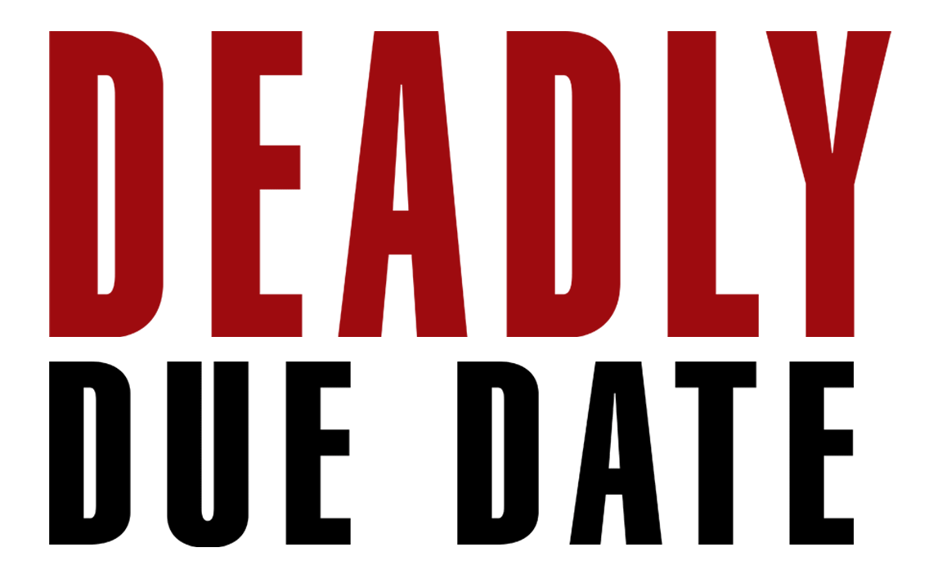

Johnson Production Group

Press Kit

One-Liner
A childless couple runs into a pregnant classmate at their high school reunion and agrees to adopt her baby, little realizing she has sinister plans for them.

Synopsis
When a childless couple attends their high reunion and reconnects with a now pregnant former classmate, their lives are suddenly injected with more chaos than they bargained for. When the woman promises to let the couple adopt her baby, they have no idea what she really has in mind.

Producers
Executive Producers
TIMOTHY O. JOHNSON
KEVIN GOETZ
Co-Executive Producers
NEIL GOETZ
STEPHEN HORNYAK
Co- Producers
SARA SOMETTI MICHAELS
SHERI REEVES
Producer
KEN SANDERS
Key Cast
CHARACTER  Rachel O’Donnell  Claire Mathers  Bill O’Donnell  Alice Odonnell  Lindsay |  | ACTOR  ASHLYN YENNIE  ELLA CANNON  PHILIP BOYD  DIANE ROBIN  BRIANNA BUTLER

Key Cast Biographies

ASHLYN YENNIE
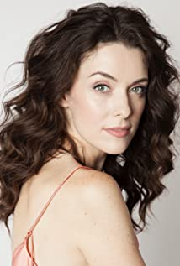
Ashlynn Yennie was born in the small town of Riverton, Wyoming. She studied acting at the New York Conservatory of Dramatic Arts. Her first feature film credit was when she was cast as Jenny in the cult horror film The Human Centipede and it’s 2011 sequel. Ashlynn starred in the TV Mini Series, Submission. She has appeared in numerous feature films and television shows including Heart of the Manor, Antidote, Burning Lies , Killer Cheerleader, Variant, Faith Based, The Wrong Mommy, Buried Secrets, The Wrong Neighbor and The Ghost and the Whale.

ELLA CANNON
Ella May Cannon is an Australian Actress best known for her roles of 'Peyton' in the 2021 Santa Barbara Film Festival winner, Trees of Peace and 'Rachel' in CW's fan-favorite series, iZombie.
Ella was born in East Melbourne, Australia, and grew up on a small farm with her parents and younger brother. Ella began acting professionally at 17 and initially began showcasing her talents through theatre. Her first leading role was that of Electra in the NIDA production The House of Atreus, shortly followed by Grace in the Wax Acts Theatre Company's original play The Innkeeper. After many years of studying her craft in numerous institutions, Ella has followed her career pursuits as a professional actress all over the world from Australia, Los Angeles, Mexico and Canada. Her credits include roles on the Australian all-star series 'Neighbours', 'Winners and Losers', and comedy spoof 'Footballer Wants a Wife', as well as Lifetime's 'The Lost Wife of Robert Durst' and CW's fan-favorites 'iZombie' and 'Supernatural'.

PHILIP BOYD
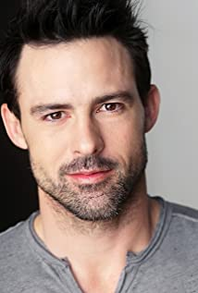
Philip Boyd was born in Conyers, Georgia. After to moving to Los Angeles, CA, Boyd made several TV appearances early in his career before becoming the well known character "Oscar" on Tyler Perry's "The Have and The Have Nots". Philip Keith Boyd grew up in Conyers, Georgia with his three brothers. He decided to take a chance and move to Los Angeles to pursue a career in acting at the age of 19. In 2018, he was a part of the Oscar winning film "First Man". In 2006, Boyd shared a "Best Ensemble Cast"m award for his role as "Matt" in "29 Reasons to Run" at the Bare Bones Film Festival. Philip also received a Best Supporting Actor Nominee for his work in "Clones Gone Wild" at the Action on Film Festival in 2009.

DIANE ROBIN
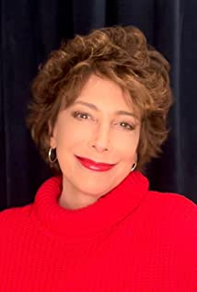
Although often cast as a New Yorker, Diane Robin was born in the Fairfax District of Los Angeles. Her training began in high school, with a scholarship to the Lee Strasberg Theater Institute, and she was the youngest person to have been accepted into the adult program.Diane got a manager who convinced her to sneak on to the Universal lot, and personally hand deliver her picture and resumé to a casting director. She did ,but was then thrown off the lot by a security guard. Telling the story of the fiasco to a complete stranger ,he replied "I'm an agent and don't have anyone like you." She signed with him the next day, and has gone on to appear in over 120 television and film productions. Diane has worked with Academy Award-winning actors including Holly Hunter, Robin Williams, and Jeff Bridges. Some of the legendary directors with whom she has worked include, Terry Gilliam , Peter Hyams,Chris Columbus , and Paul Verhoeven in Robocop, as Chandra in the infamous "bitches Leave " scene. She has guest starred on numerous TV shows including NCIS, Desperate Housewives, and MacGyver. She's also costarred in many Hallmark and Lifetime movies such as McBride, Mystery Woman and Annie's Point. She can be seen in Authors Anonymous with Kaley Cuoco, House of Deadly Secrets with Patty McCormack, and Lifetimes You Can't Take My Daughter with Lyndsy Fonseca. In the Indie Award-winning comedy Dating Daisy she plays one of her favorite roles, the pushy endearing mother Eleanor .She is very excited about her acclaimed comedy web series Strange Therapy, in which she stars , and wrote , on Amazon Prime. She recently completed costarring in the thriller Deadly Reunion, and has just been cast as of of the leads in The Sweepers. Always happy on a set, Diane got a license plate so there would be no ambiguity about who she is and what she loves to do. It simply reads CAST ME.

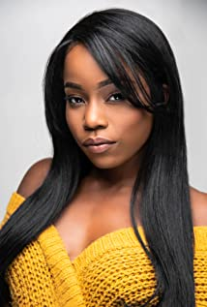
BRIANNA BUTLER
Brianna Butler was born November 12, 1989 in San Diego, California, USA. She is an actress most known for Christmas Dilemma (2020), American Soul (2019). and The Walking Dead (2021). Brianna is also a producer, singer/songwriter, dancer and screenwriter. Before her debut into acting in 2017, Brianna was a professional cheerleader for the Miami Heat (NBA) and Miami Dolphins (NFL)

Production Credits

Full Cast
Actors  ASHLYNN YENNIE  ELLA CANNON  PHILIP BOYD  DIANE ROBIN  BRIANNA BUTLER  RYAN LITTMANN  DAVE PILEGGI  RHETT BUCHANAN  CESAR CHANLATTE  DANA HANNA  ALEA HANSINGER  DREW LAMKINS  KYLE LARSEN  NICK RHAME  AMARA JA'NAI RUTLEDGE-RODRIGUEZ  CAROL STEPHANS  FRIEDMAN TWINKIES  PAUL VONASEK  JAKE ALEXANDER WILLIAMS | Role  Rachel O'Donnell  Claire Mathers  Bill O'Donnell  Alice O'Donnell  Lindsay  Justin Davis  Kurt  Baby Alex  Detective Sanchez  Detective Morton  Teen Claire  Bennie  Nurse  Teen Bill  Samantha  Harriet  One Year Old Alex  Daryl  Teen Kurt

Directed by
JEFF HARE

Story by
KEN SANDERS

Screenplay by
J. BRYAN DICK

Music by
STEVE GUREVITCH

Costume Design by
ELIZABETH KLINE BIBAL

Director of Photography
ROBERT VARDAROS

Edited by
GREG HOBSON

Casting By
JEFF HARDWICK

Production Designer
TONYA HASWELL

Full Crew
KELLY BARUCH | Conform Editor
CASEY BELLMAN | Assistant Editor
KYRA DUNN | Assistant Editor
NATHAN ROSS | Post-Production Coordinator
ROBERT VARDAROS | Colorist
ALTON LUTZ | Set Decoration
CHICA MORGAN | Set Decoration
KIMANI RICHARDSON | Set Decoration
MICHELLE ALDERMAN | Assistant Makeup Artist
REBECCA KUZMA | Makeup Department Head
NICHOLE MCAULEY | Hair Department Head
EMILIO GONZALEZ MORENO | First Assistant Director
CHRISTIAN ORTEGA | Second Unit Director
SCOTT MITCHELL | Property Master
ANDRES BOULTON | Re-Recording Mixer
JACOB BRIGGS | Sound Mixer
CURT BUSH | Re-Recording Mixer
DAVID ERWIN | Sound Effects Editor
DAVID KNIGHT | Sound Mixer
KYLE LARSEN | Additional Voices
MARK MCBRYDE | Foley Artist
PAUL RIECHMAN | Dialogue Editor
OLIVER PHIPPS | Visual Effects Supervisor
RYAN CARR | Stunt Double: Justin
KATIE KRAMER | Stunt Double: Alice
JASI COTTON LANIER | Stunt Coordinator
RACHEL HOFFPAUIR | Stunt Double: Claire
THERESA SUTERA | Stunt Double Rachel
ERIKA BOND | First Assistant Camera
MEGAN CLAXON | Second Assistant Camera
TONY M. COLLINS | B Camera Operator
JEREMY CROUCH | Grip
JAMES FICKLIN | Best Boy Electric
NATHAN FREEMAN | A Camera Operator
SEAN GARTLAND | Best Boy Grip
ANDRES GIRALDO | Grip
KANISHK GROVER | B Camera First Assistant Camera
KATIE HAWKINS | Second Assistant Camera
RICHARD HEMPTON | Key Grip
ANTHONY J. MACK | B Camera First Assistant Camera
ALLEN MEREDITH | Drone Operator / Gaffer
AARON ROSENE | B Camera First Assistant Camera
WILL STEWART | First Assistant Camera
EDI TINGLE | Grip
ROBERT VARDAROS | Steadicam Operator
SARAH WALKER | Second Assistant Camera
STEVEN WALLER | Dolly Grip
PETER SUTTON | Extras Casting
CHRISTINA BATTAGLIA | Key Costumer
CHRISTINA MCCARTHY | Location Manager
MICHAEL BURNS | Composer: Additional Music and Songs
JESSICA FARMER | Script Supervisor
COLLIN CLARKE | Production Assistant
ARIANNA JACKSON | Production Assistant
MARIANNJELY MARVAL | Production Assistant
RACHEL MCALISTER | Production Assistant
CHRISTINA MCCARTHY | Production Coordinator
FELICIA ORMAN | Production Accountant
JAZMINE RIVERA | Craft Service
ROBERTA SETZU | Assistant To Producer
JENNIFER TRESSLER | Production Assistant
AUSTIN WILLIFORD | Production Assistant
SETH MICHAELS | Special Thanks
EXTREME REACH | Payroll Services
GRAND LINE CREATIONS | Camera Equipment
HOLLYWOOD SCRIPT RESEARCH | Script Clearance
SAPELO INSURANCE | Insurance
WHITE DOG STUDIOS | Post-Production Sound Services

Producer Biographies

TIM JOHNSON – Executive Producer
Tim Johnson is among the most active and reliable producers in the business thanks to top rate productions and global distribution appeal.
Johnson is also responsible for producing the international hit series, DR. QUINN, MEDICINE WOMAN for CBS for over 5 seasons. During his 100-episode tenure, he also developed and produced the original docu-drama COLD CASE for CBS network, which was the very first program to integrate television with the Internet.
Johnson has produced over 150 movies, 15 globally released series for every major US network - including ABC, Disney, CBS, NBC, Netfly, FOX and Sony.

JOHNSON PRODUCTION GROUP
The Johnson Production Group contracts globally to produce television content for international networks, studios and distributors. Based in Los Angeles and Vancouver, British Columbia, the company manages production, facilitates development and financing, procures distribution and guarantees quality and timely execution of its programs. While costs have gone up, so has the demand for quality. No longer is good enough, good enough. Johnson Production Group serves that segment when a show needs to be "A" quality, but produced efficiently enough to meet a locked budget. JPG specializes in value, protection of creative elements, and delivery of a quality finished product.

KEVIN GOETZ – Executive Producer
In the span of fifteen years, 'Kevin Goetz' has carved out a name for himself in the world of market research of motion pictures. Goetz has extensive experience facilitating the gathering of audience responses, and has brought forward this illuminating information for over 1,500 motion pictures, in all genres, created by nearly every major studio and independent company in the film industry. Goetz' background and experience as a Focus Group Moderator, working directly with viewing audiences, has enabled him to become a barometer of audience trends and has given him a unique perspective in the understanding of what makes a movie work. The clients that he regularly interacts with include the film industry's most prominent filmmakers and top studio executives. Through the specific information that he is able to obtain from moviegoers, those same filmmakers and studio executives often acknowledge his contribution to a motion picture as an integral part of their film's success

NEIL GOETZ - Co-Executive Producer
Neil Goetz has an expansive career leading and producing advertising for domestic and international theatrical movies and television shows. He is a founder of The Engine Room, an innovative creative agency that offers entertainment clients both consumer research and creative advertising. Advance concept testing identifies the most marketable components of any property and informs the positioning, graphics and creative style of trailers, television spots and promo reels, resulting in reduced costs and a more targeted overall campaign. Team consists of top industry research analysts and award-winning writers, producers and editors.
Clients include Relativity Media, 20th Century Fox, Voltage Pictures, Phoenix Films, Blumhouse Pictures, Miramax Films, PBS and HBO

STEPHEN HORNYAK – Co-Producer
Stephen Hornyak was born in East Orange, New Jersey, USA. He is an actor and producer, known for The Killing Method, Flipper (1995) and Twisted Twin (2020).
KEN SANDERS – Producer
Over the past 15 years, Ken Sanders has written and/or produced over forty feature-length motion pictures. In 2009 he started the production company Shadowland, LLC with partner Robert Ballo. Together they produced THE CHEATING PACT, MISSING AT 17, THE PERFECT BOYFRIEND, DIRTY TEACHER, THE SURROGATE, STALKED AT 17, TEENAGE BANK HEIST, WALKING THE HALLS, BETRAYED AT 17, HOME INVASION, MATERNAL OBSESSION, and ACCUSED AT 17, all of which were ratings hits when they premiered on Lifetime Television. Sanders is now the primary producer for Stonecrest Entertainment where he continues to produce feature films for TV and streaming audiences. In addition to his film and television work, Sanders has served as an adjunct professor at Biola University, where he taught classes on producing and screenwriting. He is also a frequent guest lecturer at Los Angeles Valley College and the Los Angeles Film School, where he speaks on topics ranging from the business of film to post-production to pitching and script development. Sanders received his degree in Filmic Writing from the University of Southern California, School of Cinematic Arts.

Billing Block
Johnson Production Group Presents “DEADLY DUE DATE”
Starring ASHLYN YENNIE ELLA CANNON PHILIP BOYD DIANE ROBIN and BRIANNA BUTLER Music by STEVE GUREVITCH Costume Design by ELIZABETH KLINE BIBAL Director of Photography ROBERT VARDAROS Edited by GREG HOBSON Casting By JEFF HARDWICK Production Designer TONYA HASWELL Story by KEN SANDERS Screenplay by BRYAN DICK Executive Producers TIMOTHY O. JOHNSON KEVIN GOETZ Co-Executive Producers NEIL GOETZ STEPHEN HORNYAK Co- Producers SARA SOMETTI MICHAELS SHERI REEVES Produced by KEN SANDERS Directed by JEFF HARE

© MMXXI Johnson Production Group Inc. All Rights Reserved
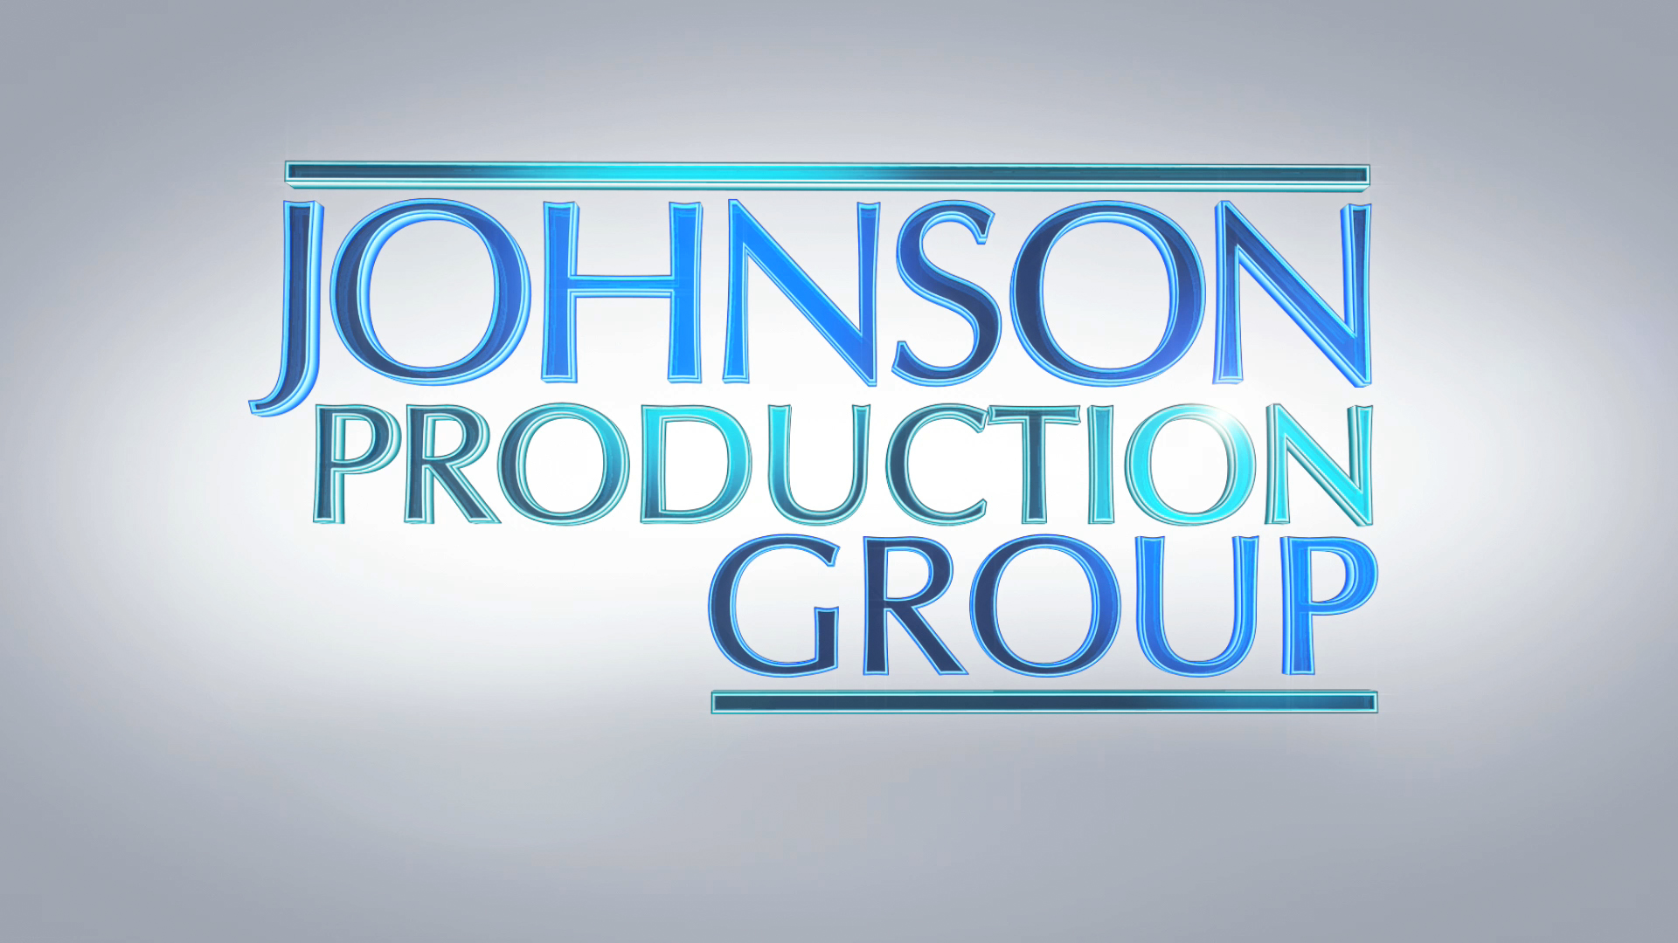
Meta Data

LONG (max 3000 characters) synopsis
When a childless couple attends their high reunion and reconnects with, a now pregnant former classmate, their lives are suddenly injected with more chaos than they bargained for. When the woman promises to let the couple adopt her baby, they have no idea what she really has in mind.
(284)

MEDIUM (max 500) synopsis
A childless couple runs into a pregnant classmate at their high school reunion and agrees to adopt her baby, little realizing she has sinister plans for them.
(158)
SHORT (max 100 characters) synopsis
A couple at their school reunion agrees to adopt a classmate’s baby, unaware of her sinister plans.
(99)

5 KEY WORDS
Pregnancy, class reunion, childless, parents

