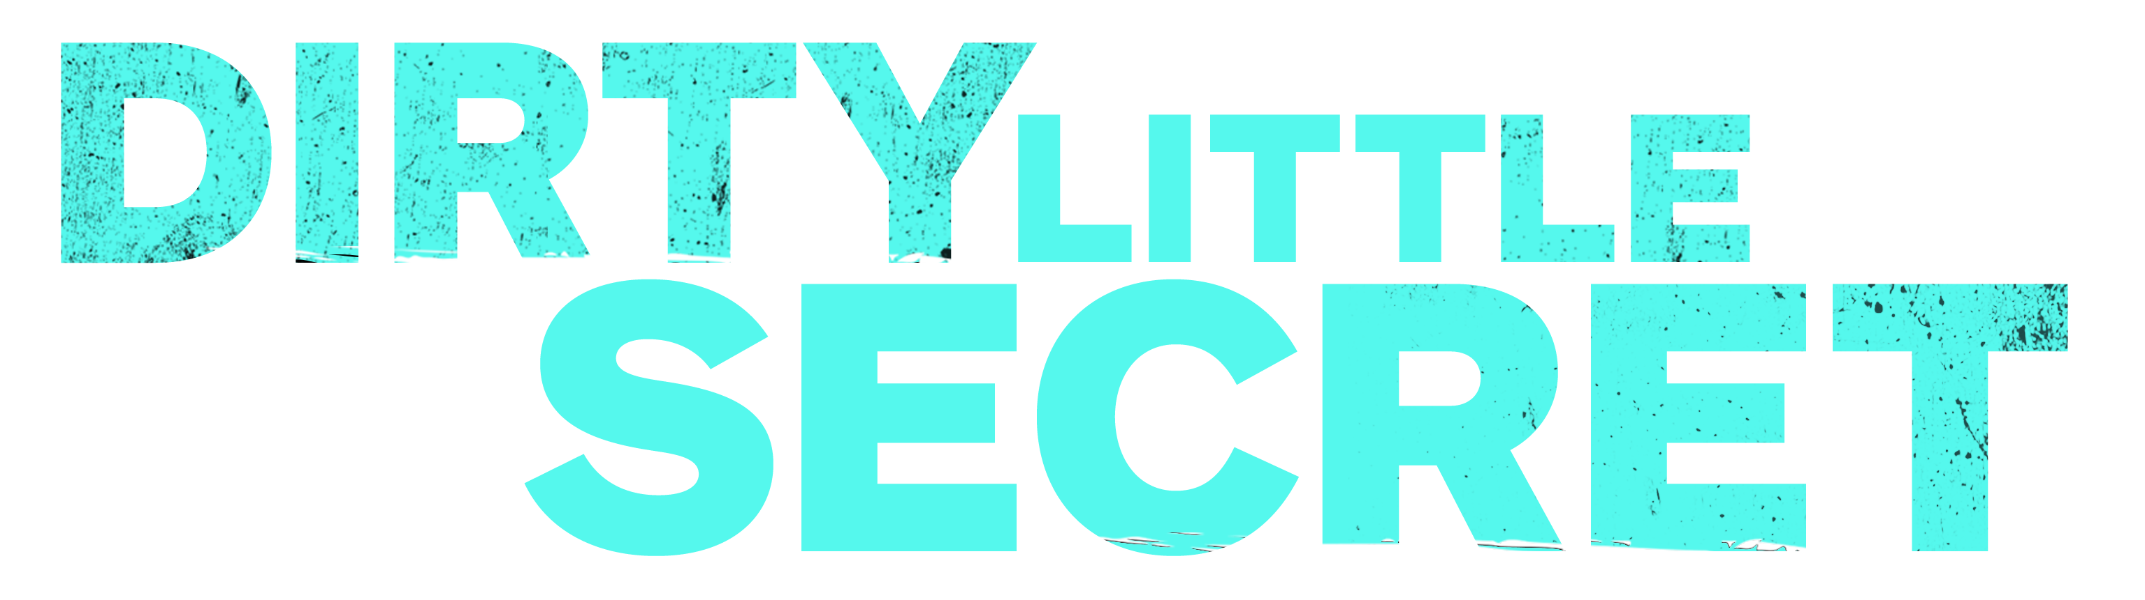

Johnson Production Group

Press Kit

INSPIRED BY TRUE EVENTS

One-Liner
A young woman has been hiding the painful family secret of her mom’s hoarding for years and when she finds her mother dead in the hallway, needs to find a way to keep the secret.

Synopsis
Lucy has been painfully isolated from her peers for years. She refuses to let anyone near her house to hide her family secret: her mom's out-of-control hoarding which has turned their lives into a world of garbage and shame. After finding her mother dead in the hallway, the story becomes an hour-by-hour account of Lucy's desperate attempt clean before reporting her mother’s death. These scenes are peppered with flashbacks of family confrontations and better times. In the end, realizing she can never clean the house by herself, Lucy sets the house on fire instead.

Producers
Executive Producer
TIMOTHY O. JOHNSON
STACY MANDELBERG
LINDA BERMAN
Co-Executive Producer
C.J. OMOLOLU
Producer
NAVID SOOFI
Supervising Producer
OLIVER DE CAIGNY
Key Cast
CHARACTER  Joanna  Lucy  Josh  Counsellor Miranda |  | ACTOR  MELISSA JOAN HART  LIZZIE BOYS  WERN LEE  CAITLYN STRYKER

Key Cast Biographies

MELISSA JOAN HART
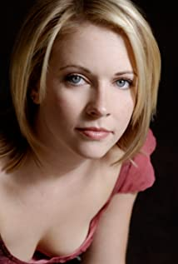
Melissa Joan Hart has a list of credits far beyond her years. Having made her first national commercial at age 4, she is now a veteran of television, film and theater.
Recently, Hart directed a remake of the 1980s cult classic thriller, “The Watcher in the Woods,” starring Academy Award winning actress Anjelica Huston. The film premiered on Lifetime on October 21, 2017 to an impressive 332,000 (P 25-54, 1MM) in total viewers which was great opening for the network.
Hart appeared in “A Very Merry Toy Store” opposite Mario Lopez, which aired on Lifetime on November 26, 2017.
In 2016, she appeared in the sequel “God’s Not Dead 2,” alongside Jesse Metcalfe and Ernie Hudson. Melissa won the Grace Award for Most Inspiring Performance for Movies at the 2017 MovieGuide Awards on behalf of her performance in “God’s Not Dead 2.” The film also won the award for Best Movie for Mature Audiences at the 2017 MovieGuide Awards. “God’s Not Dead 2” earned $24,487,848 in the worldwide box office.
In the summer of 2015, Hart completed her 6th and final season on the ABC Family series. “Melissa & Joey”. She executive produced and directed the half-hour multi-camera comedy along with her co-star Joey Lawrence. The series premiered on ABC Family on August 17, 2010 and was ABC Family’s #1 series launch ever in Adults 18-49.
In 2014, Hart directed the holiday film titled “Santa Con” as well as appearing in the film. This was her feature-length directorial debut. The film premiered on Lifetime on December 13, 2014. That fall, Hart made her debut as an author her memoir, “Melissa Explains it All: Tales from My Abnormally Normal Life.” The memoir is published by St. Martin’s press and is currently available in bookstores and on Amazon.
Hart is best known internationally for her starring role in “Sabrina, the Teenage Witch,” which is produced by her company Hartbreak Films in association with Viacom and aired on ABC network from 1996-2000 and the WB Network from 2000-2003. She won a Nickelodeon’s Kids Choice Award for Favorite TV Actress for the title character. The show is also in syndication around the world and has inspired two “Wonderful World of Disney” movies, “Sabrina Goes To Rome” and “Sabrina Down Under,” both of which she produced and starred in after the success of the first TV movie “Sabrina the Teenage Witch” in 1995 alongside Ryan Reynolds for Showtime.
Hart first made her mark in television playing the title role in Nickelodeon’s “Clarissa Explains It All.” Winner of numerous Youth in Film awards for her work, Hart was nominated for a CableACE Award for Best Actress in a Comedy Series for “Clarissa Explains It All.” Hart has also appeared in numerous series such as “Just Shoot Me” and “That ’70s Show” and co-hosted the “American Music Awards” with Brandy. Hart’s episode of “Law and Order SVU,” which aired in Oct, 2007 had the highest ratings of the season, even outpacing the season premiere. Her ABC Family movie “Holiday in Handcuffs” premiered to record high ratings during the 2007 holiday season, making it ABC Family’s No. 1 telecast of all time.
On the big screen, Hart starred in the romantic comedy “Drive Me Crazy,” with newcomer Adrian Grenier for Fox Studio for which she won a Nickelodeon Kids Choice Award for Favorite Movie Actress. The filmed earned $22,593,409 in the worldwide box office. She made a memorable appearance as “yearbook girl” in the graduation night comedy “Can’t Hardly Wait” also had a cameo in “Not Another Teen Movie”. She also starred in and executive produced the thriller “Nine Dead” with Hartbreak Films producing.
Hart made her Broadway debut opposite Martin Sheen in “The Crucible.” She also starred opposite William Hurt and Calista Flockhart in the Circle Repertory production of “Beside Herself” in 1987. In the same company’s production of Peter Hedges’ “Imagining Brad” with Joe Mantello directing, Hart did a half hour monologue on stage at the impressive age of 12 to rave reviews which opened the door for her to audition for the role in “Clarissa Explains It All”. She has since returned to the stage to star in the acclaimed off-Broadway production of Eve Ensler’s “The Vagina Monologues” in 2000 and also appeared in the Los Angeles production of the show in May 2001.
In April 2010, Hart returned to the stage to star in Nora Efron’s Off-Broadway show “Love, Loss and What I Wore”. She led the star-studded ensemble of Lucy DeVito, Judy Gold, and Shirley Knight.

LIZZIE BOYS
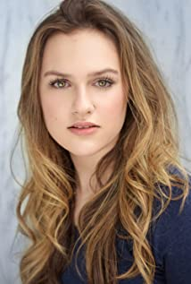
Lizzie Boys is a Canadian actress, Canadian actress who first became known to television audiences for her role as Cassandra Garner on the Hallmark Channel series When Calls the Heart. She has since appeared on series like The 100, iZombie, Motive, Angels in the Snow, A Wife's Suspicion, Firefly Lane, and Dead Shack as well as being a regular in the TV series Nancy Drew.
In 2015, she was nominated for a Young Artist Award for her performance on Best Performance in a TV Series.

WERN LEE
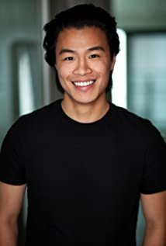
Wern Lee is an actor, known for Voyagers (2021), Superman & Lois (2021) and Motherland: Fort Salem (2020).

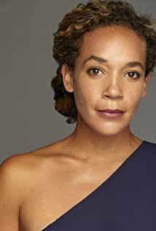
CAITLYN STRYKER
Caitlin Stryker grew up a railroad brat, never living in any city for longer than 2 years as her father's railroading career kept the family on the move. With her gypsy spirit firmly in place, she splits time between the three cities she calls home: NYC, LA, and Vancouver, BC. She started her career in the performing arts as a ballet dancer performing with the Royal Winnipeg Ballet's Young Performers Ensemble, where her love for emotional freedom was established. Caitlin was then scooped up by Elite modeling agency in Toronto, which fluidly led to her acting career in Film/TV. Her love of film has even put her behind the camera as she co-produced multiple shorts, and the 31x Award-Winning feature film, "Land of Smiles", with her husband Bradley Stryker.
Caitlyn’s recent work has included recurring roles in several TV series including American Tourist: Nightmare in Thailand, Clarice, Day of the Dead and A Million Little Things. She recently starred in the TV Movie Warming Up to You and has also appeared in Breakup Bootcamp , It Was Always You, A Valentine's Match, Time for You to Come Home for Christmas, Christmas Town Sealed with a Kiss: Wedding and many more.

Production Credits

Full Cast
Actors  MELISSA JOAN HART  LIZZIE BOYS  WERN LEE  PAVIA SIDHU  CAITLIN STRYKER  EDWARD FOY  LILY YAWSON  SAMANTHA HODHOD  HUDSYNN GRACE KENNEDY  BLAKE MCINTYRE  JOLIANA FRANCISCO  CHERYL MULLEN  MEGHAN GARDINER  MARC-ANTHONY MASSIAH  SAMUEL BRAUN  FORREST ANTHONY  ROXANNE DIMARUCOT  JIM EWENS  SEAN KULING  DEVINDER S. DILLON  ANGIE CHEN  MIKE MENEER  CHAD SAYN  RIKKI GAGNE  AMANDA VOLL | Role  Joanna  Lucy  Josh  Kaylie  Counsellor Miranda  Drew  Nurse Nadine  Sara  Young Sara  Young Phil  Young Lucy  Mrs. Ray  Aunt Jean  Mr. Duran  Phil  Ethan  Hazel  Dominic Hill  Michael  Man in White Apron  Virginia  Reporter  Stunt Coordinator  Joanna Stunt Double  Lucy Stunt Double

Casting by
JUDY LEE

Production Designer
HEATHER COUTTS

Director of Photography
PIETER STATHIS, CSC

Edited by
MAURI BERNSTEIN

Music by
RED JANES

Based upon the Book by
C.J. OMOLOLU

Story By
NANCEY SILVERS

Teleplay By
DORIS EGAN
ANNIE FRISBIE
NANCEY SILVERS

Directed by
LINDA-LISA HAYTER

Other Crew
THOMAS STANFORD  TIM SPENCE  GRANT O’KANE | Associate Producers
DARREN D. ROBSON | Production Manager
GRANT O’KANE  CHRIS A. KIT MARLATT | First Assistant Director
GABAR CHOLI | Second Assistant Director
RUSTY ROSS | Set Decorator
MADISON STENNER  JENNA SHORT | On Set Dresser  Buyer
BILLY RILEY | Dressers
AMY LYNCH
CAMERON CHEVELDAVE
RYAN BIEBERSTEIN
CHEYANNE REINELT
MARY-LOU EDDY
MOLLY CHRISTENSEN
JOHN ROBERTSON | Carpenter
KSENIIA LIEONTIEVA | Props Master
ANDREW SHOEMAKER  CLARA JOY SALAMEH | Assistant Props
SELENA TAYLOR | Key Hair Stylist
KATHLEEN FOWLSTONE  ASHLEY TAMBOUR | Key Make-Up Artist  Hair/Make-Up Swing
JADEN DEVINE | Costume Designer
SOPHIA NIEWERTH | Assistant Costume Designer
JODY SCHILBE | Costume Set Supervisor
CASSANDRA GUEVARA-CLARK  JARED LIM  JANE GRIFFITHS | Costume Assistants
SOLEN YAGIHARA  JESSICA LO | First Assistants Camera
PATRICK AGUILAR PAES | Second Assistants Camera
SUSANNE ROHAC
LAURENT PHILIP DANIS | Camera Operator
PETER VANDER GRIENT  DARCY JOHN DAVIS  TRAVIS JAMES OGILVIE  MORGAN C. BEECH  KAELAN GRELL  DEAN TOUTANT | Special Effects Coordinator  Special Effects Technicians
PIERRE CRUZ  EVAN MOYER | Gaffer  Best Boy Electric
KYLE THOMAS FOSTER  LENDL LEE QUIAPO  KEVIN SCHNEIDER  LISA OUABBACHE  TREVOR HATELT | Lamp Operators  Generator Operator
JEFF WOOD | Key Grip
CHOLO MEDINA | Best Boy Grip
JULIEN GORGUET  MALCOLM ALLARDYCE  JESSE JADE EVANS  OLIVER MCCREA | Grips
JAMES HEALEY  DECLAN MILLER | Dolly Grips
PETER GIBSON | Transport Coordinator
COSTAS PAPADOPOULOS | Transport Captain
EUGENE GILLIS | Drivers
RIDHA BENAMMAR
SEAN DICK
ROBIN LAWRENCE
GORDON MACKAY
STEVE MISKINIS
BARRY HUNT | Security Coordinator
MEGHAN RILEY | Security
CATHY STRANBERG
LINDA LARSON
RICHARD PLUHOWY
ROBERT GUDLJEK
JOSEPH BUCCI
BRUCE SPURRELL
BALWINDER KAUR SALL
CELESTE CROWE | Location Manager
ROBERT BRICKER | Assistant Location Managers
ANA NUNES  DANIEL LEVIN  JOSEPH FINNIE  CHRISTOPH BLASCHKE  KONSTANTINOS STAVRAKIS | Key Location Assistants
NATHAN HAMPTON  BEATRIZ JURREWIOZ FREIRE DA SILVA  KYLE GIROUX  JENNIFER ROBERTS  ELSY DAGDUG CHAMELIS | Location Assistants
EMILIA SAINZ SOLER | Production Sound Mixer
ELSY DAGDUG CHAMELIS  JEFFREY ZIPP | Boom Operators
JENNIFER LESLIE MACLEAN-ANGUS  SUSAN LYNN LAMBIE | Script Supervisors
PARALEE COOK | Production Accountant
AMANDA PORTER  ROBERT J. DEACHMAN | Production Accountant Assistants
THOMAS STANFORD  JESSICA OLSEN | Business Affairs
JEFF DESMARAIS | Production Coordinator
KARRY CROFT | Assistant Production Coordinators
VIOLET BARISOFF | Craft Service/First Aid
ROHMANN BARISOFF | Craft Service/First Aid Assistant
KAYLA BROWN  LETICIA LOUREIRO BRANDAO  VICTORIA WARD | COVID Assistant  COVID Specialists
CHRISTINA WILLIAMS  URIEL OMAR VELASQUEZ | Third Assistant Directors
JASON FRANK KING  CAMERON WINTERS | Chefs
RACHEL CHOO
LA HILTS | Extras Casting
ROBYN SIMONS  JENNIFER ROBERTS | Stand-Ins
COASTAL CLEARANCES | Script Clearances by
CHANDLER FOGDEN ALDOUS  LAW CORPORATION | Legal Services by
FRONT ROW INSURANCE  BROKERS | Insurance by
TIM SPENCE | Post Production Supervisor
JAMIE LAM | Post Production Coordinator
RON PENCHALAIYA | Online Editor
MEL CORRIGAN | First Assistant Editors
SO YOUNG PARK
MARCO ZODIO | Second Assistant Editor
MARCEL VANDERWEKKEN | Visual Effects
SEÁN TRAVERS | Colourist
MAVERICK POST GROUP | Sound Facilities Provided by
GREGOR PHILLIPS | Supervising Sound Editor
MATT DAWSON, MPSE | Dialogue Editors
COLIN WIND | SFX Editor
ALEX MACIA  DEVON QUELCH | Foley Artists
MATIAS GIBBS  JEFF GROUT | Foley Editor  ADR MXER
GREGOR PHILLIPS | Re-Recording Mixer

Producer Biographies

TIM JOHNSON – Executive Producer
Tim Johnson is among the most active and reliable producers in the business thanks to top rate productions and global distribution appeal.
Johnson is also responsible for producing the international hit series, DR. QUINN, MEDICINE WOMAN for CBS for over 5 seasons. During his 100-episode tenure, he also developed and produced the original docu-drama COLD CASE for CBS network, which was the very first program to integrate television with the Internet.
Johnson has produced over 150 movies, 15 globally released series for every major US network - including ABC, Disney, CBS, NBC, Netfly, FOX and Sony.

JOHNSON PRODUCTION GROUP
The Johnson Production Group contracts globally to produce television content for international networks, studios and distributors. Based in Los Angeles and Vancouver, British Columbia, the company manages production, facilitates development and financing, procures distribution and guarantees quality and timely execution of its programs. While costs have gone up, so has the demand for quality. No longer is good enough, good enough. Johnson Production Group serves that segment when a show needs to be "A" quality, but produced efficiently enough to meet a locked budget. JPG specializes in value, protection of creative elements, and delivery of a quality finished product.
STACY MANDELBERG – Executive Producer
Stacy Mandelberg attended Stanford University’s Mass Media Institute, Northwestern University School of Speech for a BS in Radio, Television and Film, and obtained her Masters of Fine Arts, Film at New York University School of the Arts. She is now the Head of Creative at Johnson Production Group and has had an extensive career in senior executive roles at New World Television, von Zerneck Sertner Films, Wilshire Court Productions, Atmosphere Entertainment, CBS and most recently, Sony/TriStar Television where she oversaw Showtime’s “On Becoming a God in Central Florida”. Stacy is known as a producer of TV movies including Switched Before Birth, Girl Positive, and Haunting Sarah (Lifetime), The Real World Movie (MTV), Sweetwater: A True Rock Story (VH1 Network), Bad to the Bone (ABC) and Crazy Horse (TNT). Additionally she produced several series including The Dovekeepers and The Doris Duke Story (CBS), as well as Robin Cook's Invasion (NBC).

LINDA BERMAN – Executive Producer
As a television producer and former network and studio executive, Linda has had extensive experience in the television world. She is the Head of Scripted Drama for Lincoln Square Productions, the in-house production entity for ABC News. Linda is currently producing MAHALIA, about the queen of gospel, Mahalia Jackson, starring Danielle Brooks and directed by Kenny Leon. Most recently, she developed and produced STOLEN BY MY MOTHER: THE KAMIYAH MOBLEY STORY, starring Niecy Nash, which is the first Lifetime MOW under the “Robin Roberts’ Presents” banner. She also produced YOU CAN’T TAKE MY DAUGHTER, starring Lyndsey Fonseca and Kirstie Alley, NEW YORK’S FINEST, an ABC one-hour pilot, directed by Regina King, Lifetime’s THE LOST WIFE OF ROBERT DURST, starring Daniel Gillies and Katharine McPhee, and FINAL VISION, Investigation Discovery’s first television movie, starring Scott Foley and Dave Annable. She also was the Executive Producer on the four-hour miniseries, MADOFF, starring Richard Dreyfuss and Blythe Danner, which aired on ABC in February, 2016. Previously, Linda produced the ABC eight-hour limited series, THE ASSETS.
In December of 2006, Linda started a production and management company, MEDIA NATION, with former A&E executive David Craig. The company produced the Stephen Gyllenhaal helmed movie-of-the-week, GIRL FIGHT, starring Anne Heche and James Tupper. Media Nation also developed a number of multiple format projects, including two Lifetime movies, PROTECT AND SERVE and DIRTY LITTLE SECRET; a one-hour pilot, JONES, written by Janna King and starring Dwight Yoakam; a mini-series AGAINST THEIR WILL, executive produced with Laurence Fishburne, and written by Paris Qualles; a half-hour pilot presentation, HELL ON EARTH, starring William Fichtner and Erin Cummings; a one-hour series LOS ALAMOS, written by Stephen Kronish; and a comedy feature, I DO, written and directed by director Dennis Dugan.
As Senior Vice President of COSGROVE/MEURER PRODUCTIONS from 2000-2005, Linda was responsible for developing and producing network and cable television movies as well as original series. Some of the projects she was involved with include: ROLLING STONE UNCOVERED, at Showtime Networks; KARROLL’S CHRISTMAS, at A&E; THE HEROES OF MOUNT HOOD, at USA; BUFFALO DREAMS, at Disney Channel, and many others.
As Senior Vice President at Turner Network Television, Linda started the Original Productions Division at the network, which launched in October 1988. She stayed in that position for five years, during which time she was responsible for developing and producing over 70 made-for-cable movies, including HEATWAVE which won Best Picture and Best Actress (Cicely Tyson) Cable Ace Awards; CONAGHER, the highest rated cable movie until 1996; and CRAZY IN LOVE, with Holly Hunter, Bill Pullman, and Frances McDormand.
Lastly, Linda started her career as a development executive at both Columbia Television and Paramount Network Television. Pilots produced while at Columbia included HOUSTON KNIGHTS, STARMAN, and while at Paramount, MACGYVER.
OLIVER DE CAIGNY – Supervising Producer
Oliver De Caigny is a Canadian producer originally from Belgium, his background in financing, production, and post production makes him a well-rounded producer for any type of production. His experience in financing and production agreements (film and TV series and movies-of-the week), distribution agreements (both domestic and foreign) as well as international co-productions, Canadian tax credit, Telefilm Canada and Canada Media Fund incentives provides him with a well-rounded background in development, production and distribution for motion pictures, television series and productions.
NAVID SOOFI – Producer
Navid is the primary producer for Novus Ordo Seclorum. Navid’s passion for filmmaking along with his business and engineering background plays an important role in creating a successful and transparent business model. Navid has been in the entertainment industry for more than 13 years and has produced over 50 feature films, TV shows and commercials that have been featured on national television, international theatres, and new media platforms. His credits include Over the Moon in Love, The Mistletoe Secret, Random Acts of Christmas, Love Unleashed, Identity Theft of a Cheerleader, and A Mother on the Edge.

Billing Block
Johnson Production Group Presents A Lifetime Original Movie “DIRTY LITTLE SECRET”
Starring MELISSA JOAN HART LIZZIE BOYS WERN LEE CAITLYN STRYKER Casting by Judy LEE Production Designer HEATHER COUTTS Director of Photography PIETER STATHIS, CSC Edited by MAURI BERNSTEIN Music by RED JANES Supervising Producer
OLIVER DE CAIGNY Co-Executive Producer C.J. OMOLOLU Executive Producers
STACY MANDELBERG TIMOTHY O. JOHNSON LINDA BERMAN Produced by NAVID SOOFI Based upon the Book by C.J. OMOLOLU
Story by NANCEY SILVERS Teleplay by DORIS EGAN ANNIE FRISBIE NANCEY SILVERS
Directed by LINDA-LISA HAYTER
With the participation of the Province of British Columbia
Film Incentive BC
The Canadian Film or Video Production Tax Credit
© MMXXII Tiny Secret Productions Inc. All Rights Reserved
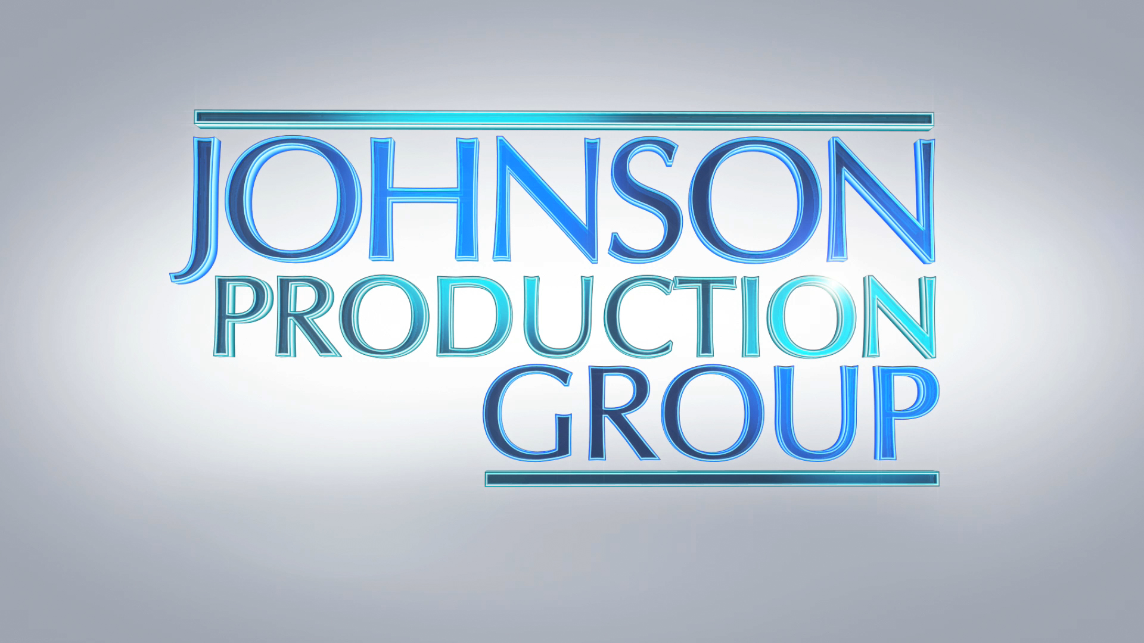
Meta Data
LONG (max 3000 characters) synopsis
Lucy has been painfully isolated from her peers for years. She refuses to let anyone near her house to hide her family secret: her mom's out-of-control hoarding which has turned their lives into a world of garbage and shame. After finding her mother dead in the hallway, the story becomes an hour-by-hour account of Lucy's desperate attempt clean before reporting her mother’s death. These scenes are peppered with flashbacks of family confrontations and better times. In the end, realizing she can never clean the house by herself, Lucy sets the house on fire instead. (570)
MEDIUM (max 500) synopsis
Lucy has been painfully isolated from her peers for years in order to hide her family secret: her mom's out-of-control hoarding which has turned their lives into a world of garbage and shame. After finding her mother dead in the hallway, she makes a desperate attempt clean before reporting the death. In the process she is peppered with flashbacks of family confrontations and better times. In the end, realizing she can never clean the house by herself, Lucy sets the house on fire instead. (493)
SHORT (max 100 characters) synopsis
When Lucy finds her hoarder mother dead, she is desperate to find a way to keep the family secret. (99)
5 KEY WORDS
Extreme hoarder, family, shame, cleaning

