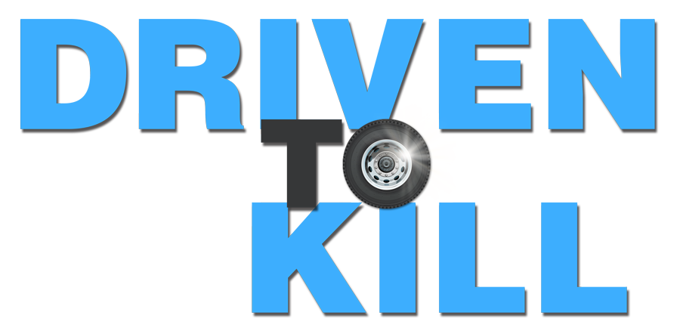

Johnson Production Group

Press Kit

One-Liner

When Brittany enrolls in an auto racing school, her mentally unstable instructor Andrew falls in love with her and tries to roll over everybody in her life.

Synopsis

Producers
Executive Producer
TIMOTHY O. JOHNSON
Co-Producer
JOSEPH WILKA
Line Producer
LIZ VACOVEC
Producer
ROBERT BALLO
Key Cast
CHARACTER  Brittany Green  Andrew James  Kevin Matthews |  | ACTOR  SHELBY YARDLEY  PHILIP BOYD  DEVANTE WINFREY

Key Cast Biographies

SHELBY YARDLEY
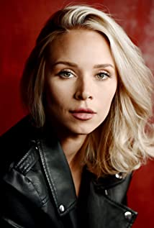
Shelby began her career in the entertainment industry as a television personality. Prior to starting a career in the entertainment industry, Shelby grew up as an athlete in Wichita, KS and attended Wichita State University. Although always having an interest in acting and modeling it wasn't until January of 2014 that she started taking acting lessons and found it was something she wanted to continue as a career. In May of 2015 she relocated to Los Angeles to pursue a career in acting.
Since that time she has appeared in several TV movies and stars as Bella in the animated children’s series Benny’s Bee Adventures.

PHILIP BOYD
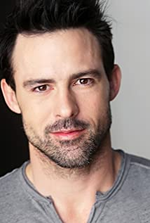
Philip Boyd is an American actor and writer who grew up in Conyers, Georgia with his three brothers. He decided to take a chance and move to Los Angeles to pursue a career in acting at the age of 19. Boyd made several TV appearances early in his career before becoming the well known character "Oscar" on Tyler Perry's "The Have and The Have Nots". In 2018, he was a part of the Oscar winning film "First Man". In 2006, Boyd shared a "Best Ensemble Cast" award for his role as "Matt" in "29 Reasons to Run" at the Bare Bones Film Festival. Philip also received a Best Supporting Actor Nominee for his work in "Clones Gone Wild" at the Action on Film Festival in 2009.

DEVANTE WINFREY
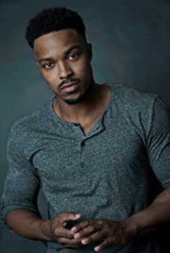
Devante Winfrey was born and raised in Mississippi. His acting background mostly comes out of San Francisco where he attended the Academy of Art and was also involved in two musicals: “Hair”, where he played the role of Hud and “Rocky Horror Picture Show”, cast as Rocky Horror. I was also a part of two productions called “Bus Stop”, where he played the character Will Masters and “Crimes of the Heart” as Doc Porter. His film history includes numerous of short films, and a role as Oliver in the Lifetime movie directed by Doug Campbell called “Stalked By My Mom” as well as the soon-to-be released movie “Unfinished”.

JUSTIN BERTI
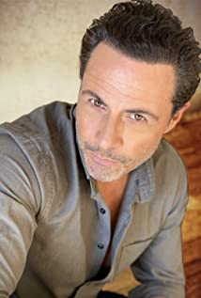
Justin Berti was born in Avon, Connecticut. Subsequently he has called many places home. These include Houston, Laguna Beach and New York City. However, for the last 12 years it was Tokyo that was his home. In the "Land of the Rising Sun" he acted, danced, and modeled in almost every facet of the entertainment industry. In Japan, he played semi-pro baseball and was a Major League Baseball announcer for all preseason and regular season games. Justin danced for Japan's most famous musical director, Amon Miyamoto and had a guest-star role in Ramen Girl starring Brittany Murphy. Since moving to L.A. he has performed on stage, film, and television. He stars in the independent film Brothers in Arms as well as having rolls in Frontera, Cindra and the TV series Kenan. He will also appear in the upcoming film Divorce Bait. His accomplishments include two theatrical appearances starring in Tats: The Experience and making an impact as a guest star in The Full Monty. Notably, the role of Elliot in the Showtime First Series Submission highlighted his first year back in the United States. Justin is a Columbia University graduate with a strong background in dance, baseball, and yoga. His energy, physicality, and passion find their roots in his athletic background. Offstage he teaches Yogic Arts, a worldly, powerful mixture of Ashtanga yoga, martial arts, and modern dance.

ANGELA NICHOLAS
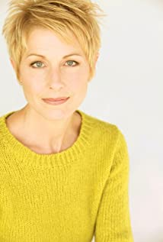
Angela Nicholas is known for her work on Deadwood, The Domicile (2017) and Washed (2014). She has recently appeared in several TV movies including Behemoth, A Royal Christmas Engagement, Pool Boy Nightmare and A Deceitful Mother: Lies That Kill, as well as the documentary Operation Varsity Blues: The College Admissions Scandal.

BRITTANY BUTLER
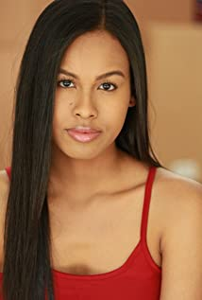
Brittany Jordan Butler was born on February 26th, 1997 in Honolulu, Hawaii to an African-American father and a Filipino mother. The youngest of two siblings, Brittany began developing her love for acting when she moved to Las Vegas, Nevada as a child and joined numerous school plays and musical theatre. She made the decision to attend acting, singing, and dancing lessons and began to discover her love for the arts. In 2019, Brittany decided to pursue her acting career full-time. Since then she has been able to book a national commercial for Lunchables as well as roles in TV shows such as Henry Danger, Tone-Def, and a co-starring role in the upcoming sitcom "Partners in Rhyme" starring MC Lyte which will premiere on AMC's new streaming service, Allblk. She was also lead in the short-film, "Krystal and Rae" which won her "Best Acting Duo" at the Independent Shorts Awards. Brittany is a student under Ivana Chubbuck in her Master Class at Ivana Chubbuck Studio.

ALESSANDRA MARANDOLA
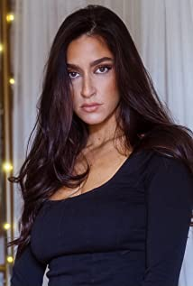
Alessandra Marandola is an actress, known for Soul Hunters (2019) and The Agency of International Affairs (2019). She has also had a recurring roll as Jessica Higgins in the TV Series Humor Me.

Production Credits

Full Cast
Actors  SHELBY YARDLEY  PHILIP BOYD  DEVANTE WINFREY  JUSTIN BERTI  ANGELA NICHOLAS  ALESSANDRA MARANDOLA  BRITTANY BUTLER  ANNA LI  MICHAEL HOUSTON  BENTLEIGH GLEAVE  TRAVIS BECK | Role  Brittany Green  Andrew James  Kevin Matthews  Mario Bargellini  Rhonda Matthews  Desiree  Shelley Montana  Dr. Aaronson  Officer Underhill  Young Brittany  Brittany's Father

Casting by
Robin De Lano
Nicole Dionne

Makeup by
Megan Longmeyer

Sound Design by
Andres Boulton

Music by
Marc Jovani

Edited by
Wes Sneeringer

Costume Designer
Lena Lollis

Production Designer
Cameron Barrett

Director of Photography
David Dolnik

Story by
Doug Campbell

Screenplay by
David Chester

Directed by
Doug Campbell

Full Crew
GUSTAVO PEÑA | First Assistant Director
ALEC CERUTTI | Production Coordinator
NAYIRI BEKIARIAN | Casting Assistant
MICHAEL SEMPEK | Key Production Assistant
RENE PERAZA | Production Assistants
JAILEN MOORE
NATHAN GROOTHUIS
DOERTE LINDER | Production Accountant
CHANTAL MASSUH-FOX | Art Director
GRIFF PARTINGTON | Drone Operator
CHRISTOPHER JORDAN | Camera Operators
LORETO DI CESARE
JUSTIN CROWE | A Camera 1st AC
REID COLLINS | 2nd AC
REID COLLINS | Media Managers
FERGUSON SAUVE-ROGAN
MIKE TAING | Still Photogrpaher
FOSTER CORDER | Chief Lighting Technician
STEWART HOLLINS | Key Grip
BEN DILSISIAN | Grips
KALEA CALLOWAY
CARLOS BEDOLLA
ALAN CONTRERAS
JOSE GALLO | Sound Mixer
MEGAN LONGMEYER | Make-Up Department Head
KWAME HEAD | Makeup Artist
KENNETH CALHOUN | Additional Make-Ups
SAMUEL WILDSTEIN | Covid Safety Officer
STARVING STUDENT CATERING | Caterer
BRUCE SCHAEFER | Chef
CLEARANCE UNLIMTED | Script Clearance
BRILLIANT SCREEN STUDIOS | Grip and Lighting Equipment
GOAL PRODUCITONS, INC | Camera Equipment
BOOKED TALENT | Background Casting
BREAKDOWN SERVICES | Cast Support Services
GRIFF PARTINGTON | Post Production SupervisorS
ROBIN CONLY
SOUNDASART | Post Production Sound Services
ANDRES BOULTON | Supervising Sound Editor
BLUELINE FINISHINF | Conform and Delivery
RANDY COONFIELD | Colour Grading
CLEARANCE UNLIMITED | Script Clearance
SUZY VAUGHAN
BRILLIANT SCREEN STUDIOS | Grip and Lighting Equipment
ACE UNDERHILL
GOAL PRODUCTIONS INC. | Camera Equipment
EMIR ISILAY | Score Composer and Producer
ECE MUNIROGLU | Additional Music
OGUZ OZCANLI
CAN CANEL
3D RETRO | Special thanks
IRWINDALE SPEEDWAY
WRAPBOOK
INTERNATIONAL PROMOTIONS
“Passeggiata Pomeridiana”
Written & Performed by Emir Isilay

Producer Biographies
TIM JOHNSON – Executive Producer
Tim Johnson is among the most active and reliable producers in the business thanks to top rate productions and global distribution appeal.
Johnson is also responsible for producing the international hit series, DR. QUINN, MEDICINE WOMAN for CBS for over 5 seasons. During his 100-episode tenure, he also developed and produced the original docu-drama COLD CASE for CBS network, which was the very first program to integrate television with the Internet.
Johnson has produced over 150 movies, 15 globally released series for every major US network - including ABC, Disney, CBS, NBC, Netfly, FOX and Sony.

JOHNSON PRODUCTION GROUP
The Johnson Production Group contracts globally to produce television content for international networks, studios and distributors. Based in Los Angeles and Vancouver, British Columbia, the company manages production, facilitates development and financing, procures distribution and guarantees quality and timely execution of its programs. While costs have gone up, so has the demand for quality. No longer is good enough, good enough. Johnson Production Group serves that segment when a show needs to be "A" quality, but produced efficiently enough to meet a locked budget. JPG specializes in value, protection of creative elements, and delivery of a quality finished product.
JOSEPH WILKA – Head of Production
Joseph Wilka is the Head of Production for Johnson Production Group. Los Angeles-based, Joseph had already produced and directed several feature films before serving as the senior marketing executive for Gravitas Ventures. While at Gravitas, Wilka helped pioneer new distribution models for independent films including day-and-date theatrical releases. It was also at Gravitas where Joseph first worked with Johnson Production Group to facilitate the release of their films to the worldwide Video On Demand audience. After serving as the Director of Distribution and Production for Viva Pictures, where he produced English-language versions of foreign animated titles for DirecTV, Wilka officially joined Johnson Production Group. As Head of Production, he oversees the development, production, and distribution of films from multiple production units for release on broadcast and streaming platforms.
ROBERT BALLO – Producer
With over 34 years of industry experience, Robert Ballo has created award-winning productions for clients that include ABC, TBS, PBS, Discovery Channel, and Lifetime, and that have aired on national network television, cable networks, and internationally in Asia and Europe. As Director of Photography and Producer at Shadowland, Ballo has created over a dozen feature films seen on the Lifetime Network and distributed internationally. As Director of Photography, his Shadowland films include MISSING AT 17, THE SURROGATE, STALKED AT 17, TEENAGE BANK HEIST, WALKING THE HALLS, BETRAYED AT 17, HOME INVASION, MATERNAL OBSESSION, ACCUSED AT 17 and SPECTRES. Other feature film credits include RUNNIN' AT MIDNITE, THE AFFAIR and STARVING ARTISTS. Ballo has also traveled the world on many documentary productions.
His television credits for national broadcast and cable networks include COLLEGE SPORTS IN AMERICA, GREAT EUROPEAN BALLOON ADVENTURE, DIRTY HARRY THE ORIGINAL, THE GREAT YEAR, and THE ROSE PARADE - PAGEANT FOR THE AGES. Through his other digital motion picture company, GOAL Productions, Ballo works with Fortune 500 companies, non-profit organizations and government agencies to produce sales and marketing videos as promotional communications. After a twenty-year tenure teaching film and video imaging, Ballo recently retired from his position as an Associate Professor of Practice at USC’s School of Cinematic Arts. A graduate of the USC film production program himself, Ballo is a member of the Academy of Television Arts and Sciences.

LIZ VACOVEC - Line Producer
Liz Vacovec is an accomplished producer who has experience in film, television, and digital production. She has produced over a dozen films and recently produced an original series for Snapchat, "Dead Girls Detective Agency." In the first 4 days the series received over 5 million unique views. A feature film Liz produced, "30 Nights of Sex to Save Your Marriage," was recently released on Amazon Prime and has sold internationally. Liz also has a slate of eight films and three television shows in various stages of financing and development. She is a member of the Producers Guild of America as well as the Television Academy. Liz received a Master's Degree from Emerson College in Visual and Media Arts. Prior to Graduate School she got her Bachelor's Degree at the University of Massachusetts, Amherst majoring in both communications and English.
DOUG CAMPBELL – Director
Doug has directed several feature films with his producers Ken Sanders and Robert Ballo. Since 2009 they have completed multiple features which have all been acquired by Lifetime. Doug has directed 21 feature films (twelve of which he wrote or co-wrote), 18 hours of network TV, four commercials and 20 short subjects. His projects have appeared in theaters and on TV across the world. Domestically, CBS, HBO, Lifetime, Showtime, Fox, PAX-TV, The Family Channel and other networks have broadcast my work. A film he financed, wrote and directed, THE TOMORROW MAN, was nominated for Best New Live Action Feature, Best Director and Best Screenplay in the 2001 DVD Premiere Awards sponsored by Daily Variety Magazine. Doug took home the Best Director Award.
Growing up in the San Fernando Valley north of Los Angeles, Doug made his first Super-8 when he was fourteen. After studying under Sandy Mackendrick at California Institute of the Arts, he directed his first feature film at age 24. Since then, shooting low budget films and TV has taught him to work fast, get the good performance and keep it fun. Having directed different genres (action, family adventure, children's television, documentary, sci-fi and teen comedy), his favorites are thriller and drama. In 2003 Jikei schools asked Doug to design the curriculum and launch a new film school, Tokyo Film Center School of Arts. Currently he teaches at Academy of Art University in San Francisco under Executive Director Diane Baker. “Filmmaking is something I knew I wanted to do as a kid, and I can't imagine doing anything else.”

Billing Block
Johnson Production Group in association with Shadowboxer Films Presents “DRIVEN TO KILL” starring SHELBY YARDLEY PHILIP BOYD DEVANTE WINFREY JUSTIN BERTI ANGELA NICHOLAS BRITTANY BUTLER and ALESSANDRA MARANDOLA Casting by ROBIN DE LANO NICOLE DIONNE Makeup by MEGAN LONGMEYER Sound Design by ANDRES BOULTON Music by MARC JOVANI Edited by WES SNEERINGER Costume Designer LENA LOLLIS Production Designer CAMERON BARRETT Director of Photography DAVID DOLNIK Line Producer LIZ VACOVEC Co-Producer JOSEPH WILKA Executive Producer TIMOTHY O. JOHNSON Produced by ROBERT BALLO Story by DOUG CAMPBELL Screenplay by DAVID CHESTER Directed by DOUG CAMPBELL

© MMXXI Johnson Production Group Inc. All Rights Reserved
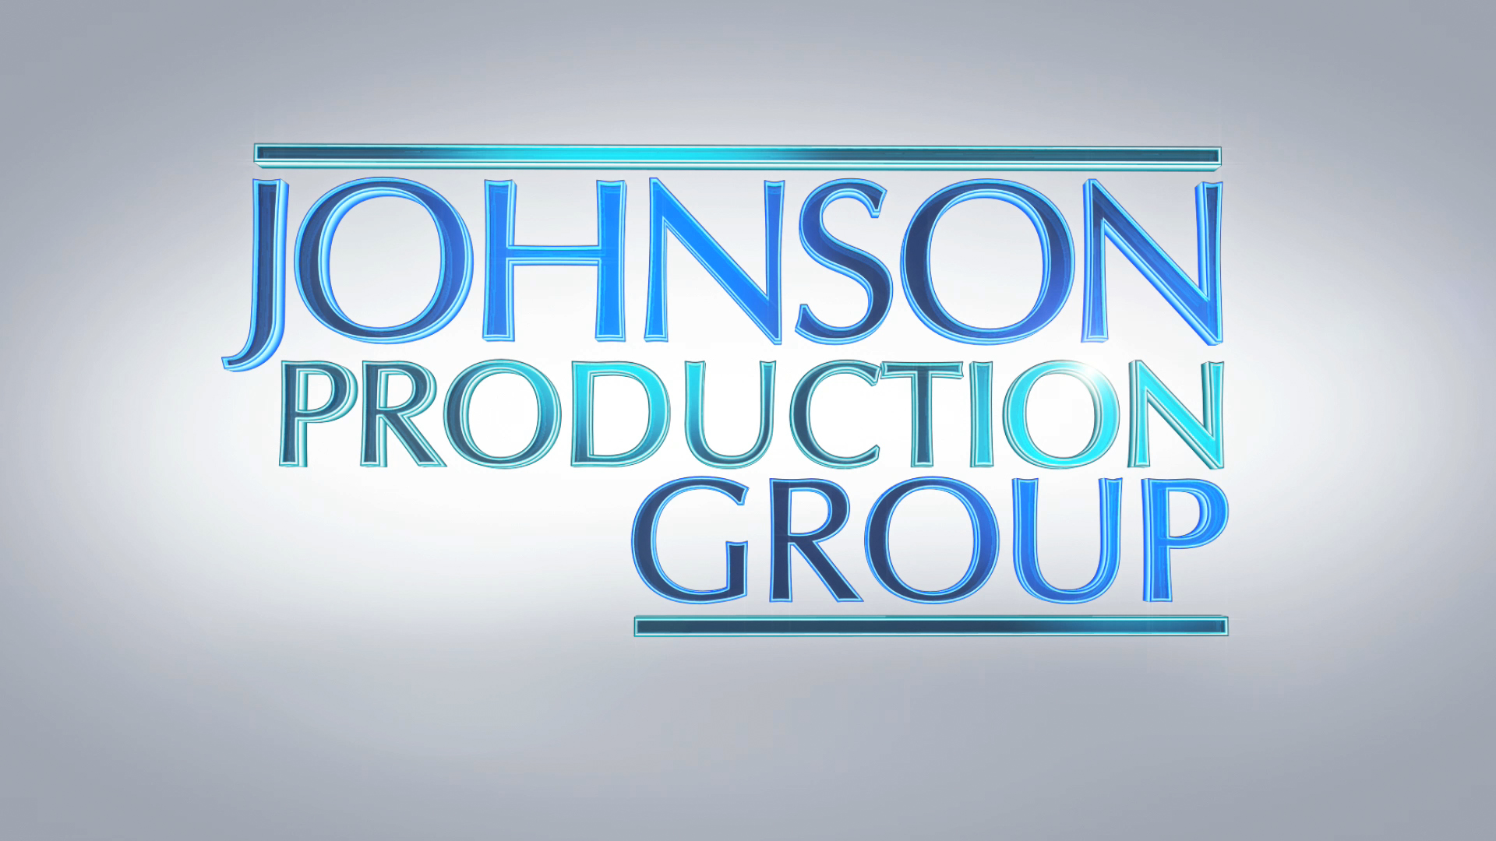

Meta Data

LONG (max 3000 characters) synopsis
Text (533)

MEDIUM (max 500) synopsis

When Brittany enrolls in an auto racing school, her mentally unstable instructor Andrew falls in love with her and tries to roll over everybody in her life.
(156)
SHORT (max 100 characters) synopsis

A beautiful auto racing student is wooed by her disturbing and mentally unstable instructor.(92)

5 KEY WORDS
Auto racing, instructor, romance, track

