Everything Christmas
All the Time

Johnson Production Group

Press Kit

One-Liner
A Christmas obsessed woman and her friend take a road trip to Yuletide Springs, where Christmas is celebrated year round, and they connect in serendipitous ways with various travelers on the way. But when things start to fall apart and she worries that Christmas might actually be ruined until a magical twist of fate shows her it just might be better than she could have imagined.

Synopsis

Lori Jo, “LJ”, has been obsessed with Christmas all her life. She and her grandmother had always planned to visit Yuletide Springs, where Christmas is celebrated year round, to take part in a longstanding tradition of hanging an ornament on the town tree and making a wish. But her grandmother passed away before they could go. This year LJ is determined to make the trip, hang her grandmother’s special homemade ornament in her honor. And she convinces her workaholic roommate Tori to join her. Along the way they have a fateful run in with a jolly magician with a white beard who goes by the name Kris Kringle. This chance encounter creates a ripple effect of… coincidences or small Christmas miracles that take them both on a journey full of serendipity and surprise. LJ meets Carl, a handsome tow truck driver who helps them out of a pinch and Tori meets Jason, a fellow traveler on his way to reunite with his aunt. The two become four as they continue to make stops, enjoying more small town Christmas attractions, while each couples’ connection grows more and more. But when Carl reveals that he intends to return home and her grandmother’s homemade ornament breaks, LJ is devastated. But Tori, who has finally learned to unplug from her job, is quick to remind LJ that the journey that got them here is what matters. All the little things they experienced (whether by coincidence or magic) have made this their best Christmas ever. LJ finds one last gift from Kris, and is amazed to find that Christmas magic might be real after all when she finds the perfect replacement ornament and reunites with Carl on Christmas Eve. When LJ finally hangs the ornament, she is certain of two things: her grandmother will always be with her, and everywhere she turns the spirit of Christmas is there, all the time!

Producers
Executive Producer
TIMOTHY O. JOHNSON
MICHAEL VICKERMAN
OLIVER DE CAIGNY
ANDREW C. ERIN
Co-Executive Producers
JOSEPH WILKA
LISA ALFORD
Producers
TARALEE GERHARD
JOHNNY ROSS

Key Cast
CHARACTER  Lori-Jo "LJ"  Viktoria "Tory"  Zach  Jason |  | ACTOR  CINDY BUSBY  KATHERINE BARRELL  COREY SEVIER  MATT WELLS

Key Cast Biographies

CINDY BUSBY
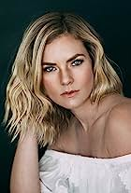
Cindy Busby has been making waves in the television and movie industry for almost two decades. Growing up in Montreal, Canada, Busby always dreamed of becoming an actress. To pursue these dreams, she attended the Professional Theater Program at Dawson College, a rigorous three-year training, allowing Busby to demonstrate her professionalism, hard work and devotion to her craft.
After graduation, Busby hit the ground running and landed a leading role as Ashley Stanton in more than 50 episodes of the hit series “Heartland.” The series took off quickly and became one of the most popular Canadian shows ever, was syndicated in 81 countries around the world and is a Netflix top pick. Busby continued having success booking roles as the antagonist in the television movie “Picture This” alongside Ashley Tisdale and appeared in guest star roles on the smash hit series “The Vampire Diaries,” “Supernatural,” “The L.A. Complex,” “Rush,” “Proof,” “The Tomorrow People” and “The Secret Circle.” In 2010 and 2011, Busby appeared on the big screen in Diary of a Wimpy Kid from 20th Century Fox, followed by the Fox 2000 film The Big Year, opposite Hollywood heavy hitter, Steve Martin.
Busby’s work ethic and reputation has earned her more than a dozen lead roles in the last few years, making her a household name and fan favorite among Hallmark Channel viewers. Some of her many credits for the network include starring roles in “Unleashing Mr. Darcy” and its sequel, “Marrying Mr. Darcy,” “Royal Hearts” directed by James Brolin, “Love in the Forecast,” “Romance on the Menu,” “Follow Me to Daisy Hills,” “Chasing Waterfalls, “Warming Up to You” and, most recently, “Marry Me in Yosemite.” For Hallmark Movies & Mysteries, Busby starred in “A Godwink Christmas: Meant For Love” alongside Kathie Lee Gifford. A versatile actress who can shine in a variety of roles, she showcased her comedic skills in the series “Date My Dad.”

KATHERINE BARRELL
Katherine (Kat) Barrell is best known for her work as Officer Nicole Haught on Wynonna Earp (45 episodes) (Syfy) and Alicia Rutherford on Workin' Moms (27 episodes) (Netflix/CBC). Most recently she joined the series cast of Good Witch (20 episodes) (Hallmark) and played the notorious Stella Grimes on Star Trek: Discovery (CBS).
Her most recent film work includes A Godwink Christmas: Miracle of Love, Cabin Connection, A Tale of Two Christmases and Making Scents of Love.
Katherine has worked as both a director and producer on 7 short films of which Issues (2013), Cannonball (2016), Dissecting Gwen (2017), and Mature Young Adults (2015) have screened at film festivals across North America.
She is a graduate of George Brown Classical Theatre School and trained at the Groundlings School of Comedy in Los Angeles. When not on set, Kat can be found picking fruit on her family farm and cuddling a notorious pooch named Bernie.
Awards and Notable Nominations: 2020 Canadian Screen Award Winner- Audience Choice, Katherine Barrell; 2018 People's Choice Award Winner- Wynonna Earp; TV Line Performer of the Week - Katherine Barrell; Spoiler TV Performer of the Month - Katherine Barrell; 2018 International Emmy Nominee - Workin Moms

COREY SEVIER
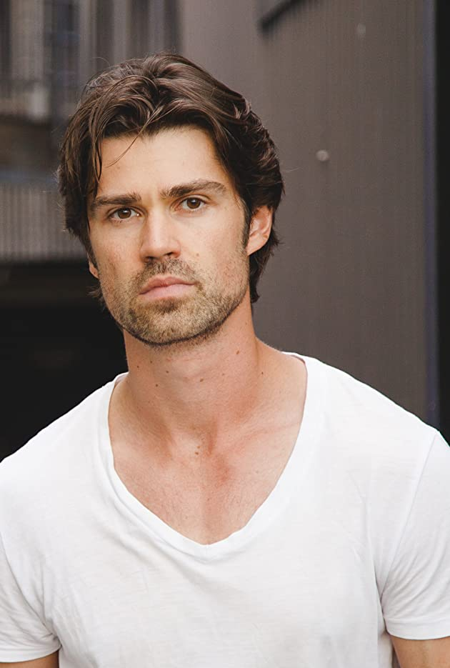
Corey Sevier is a Canadian actor whose career began at the age of seven. He landed the role of Timmy in the ’90s version of the prolific series “Lassie” then starred in the period drama “Little Men,” The WB's martial art series “Black Sash” and FOX's steamy drama “North Shore.”
Sevier has also guest-starred in numerous well-known series, among them “Psych,” “CSI: Miami,” “Smallville,” “Supernatural” and “Murdoch Mysteries.” He had recurring roles as Seth Gunderson in the Hallmark Channel original series “Debbie Macomber’s Cedar Cove” and as David Hudson in ABC’s “Mistresses.”
Sevier has also become a fixture in television movies through his work on Hallmark Movies & Mysteries’ “Northern Lights of Christmas,” Lifetime’s “Grounded for Christmas,” “Love in Translation,” “Love in Whitbrooke,” “Meet Me in New York,” “It Takes a Christmas Village” (which he also directed) and “The Secret Sauce” and, most recently for Hallmark Chanel, “Road Trip Romance.” Feature film work includes his role as Apollo in Tarsem Singh’s epic Immortals, The Northlander, Decoys and The Corruption of Divine Providence.

MATT WELLS
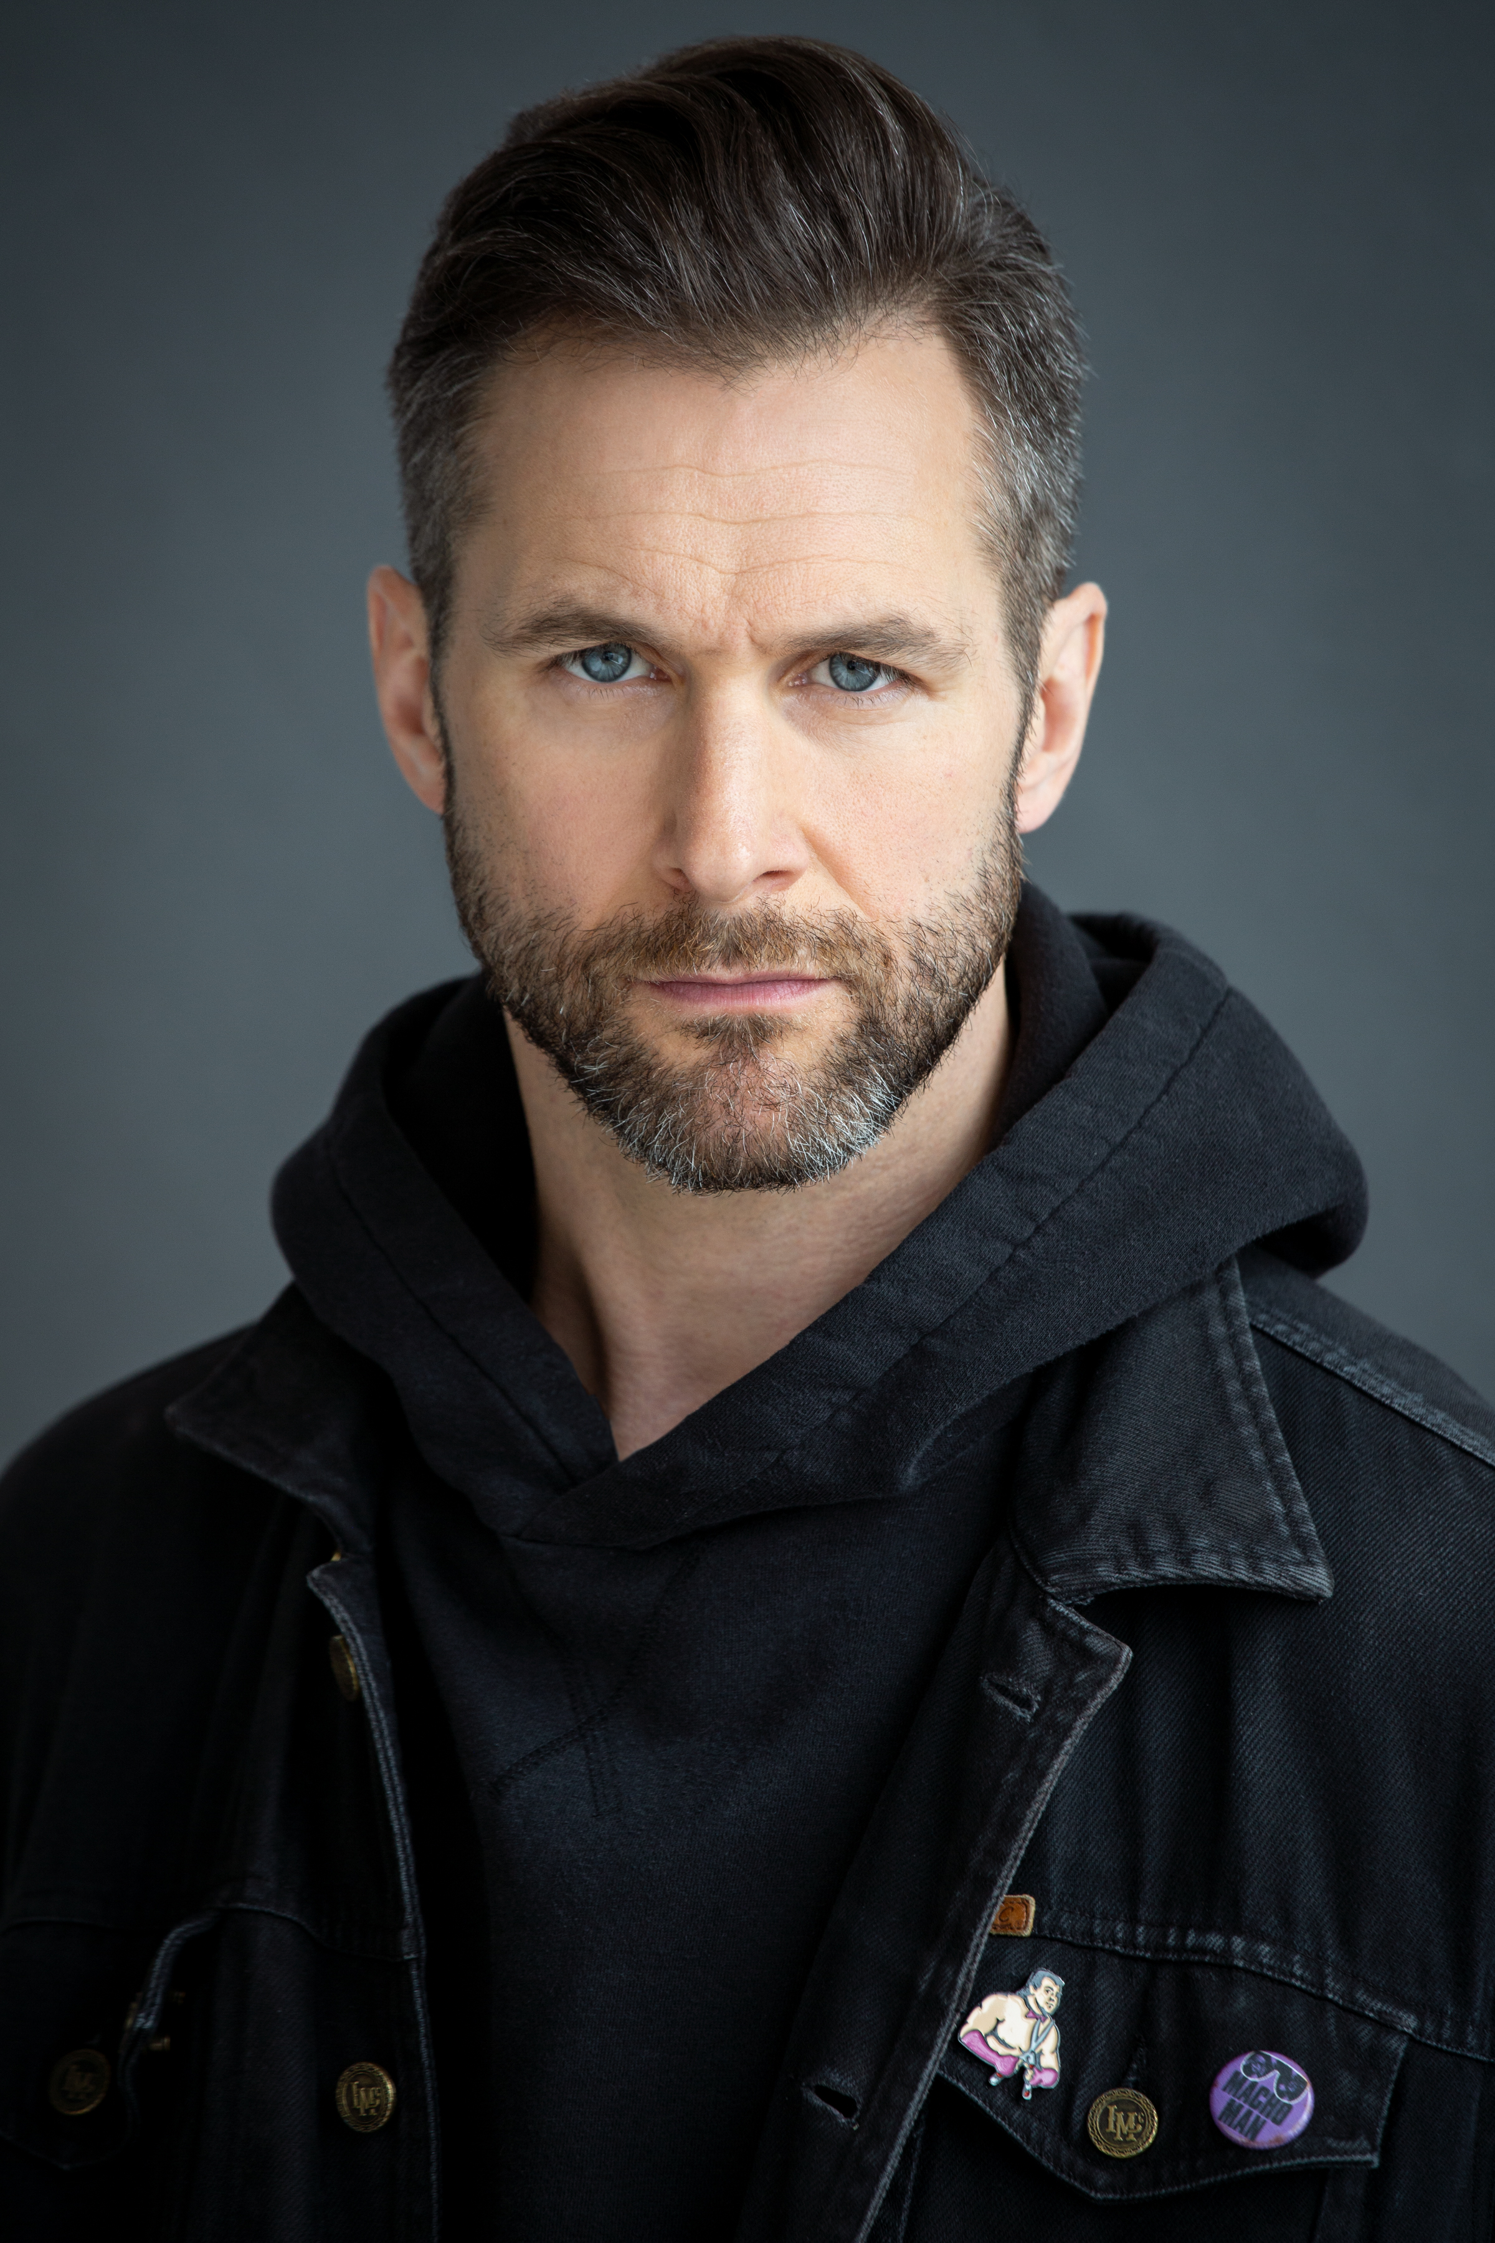
Matt Wells is a Canadian actor, writer, and musician born in St. John's, Newfoundland best known for his work in the award winning and critically acclaimed independent film "Crown and Anchor" which he created, produced and co-starred.
His path began writing songs and fronting the notorious Newfoundland punk/hardcore band Bucket Truck; releasing 4 albums, 10 self-produced music videos, and traveling the world while sharing stages with Slayer, Damage Plan, Fishbone, and Lagwagon. This journey directly led to him embarking on a career as an acclaimed music/film journalist for Much Music, The New Music, Bravo and MTV where Matt has interviewed everyone from The Police, Quentin Tarantino, Lee Daniels, and John Lydon to Lou Reed, Mariah Carey, Ben Kingsley, Zack Snyder and Lady Gaga.
As a solo musician Matt has released 2 albums and shared the stage with Sammy Hagar, Levon Helm, and Great Big Sea; as an actor he has appeared in Designated Survivor, Schitt's Creek, Murdoch Mysteries, and the multiple award winning short film "Poison in the Water" which he co-wrote with his daughter. Matt's most recent short film "The New Normal" won Best International Comedy at the 2021 Venice Film Awards and is an official selection at both The London International Film Festival and Berlin Flash Film Festival.

Production Credits

Full Cast
Actors  CINDY BUSBY  KATHERINE BARRELL  COREY SEVIER  MATT WELLS  GEORGE MASSWOHL  RUTH LAWRENCE  CHUCK HERRIOTT  AVA KANE  JANA GILLIS  ANDREW RYAN HALLIDAY  CLINT CHIMA KALU  HARVEY HEATH  JIM LESTER | Role  Lori-Jo "LJ"  Viktoria "Tory"  Zach  Jason  Kris Kringle  Pastor Olivia  Mayor Bennett  Cindy  Julia  Randy  Postal Clerk  Store Owner  Carriage Driver

Casting
BRIAN LEVY
JASON STROUD
MALLORY HORSMAN

Composer
RUSS HOWARD III

Costume Designer
MORGAN LEIGH TODD

Editors
ANN FOO
MITCH LACKIE

Production Designer
ANTHONY RANKIN

Director of Photography
MILJAN MILOVANOVIC

Written by
T. BOOKER JAMES

Directed by
MARNI BANACK

Full Crew
SHARA DÉSIRÉE KING |  |  | First Assistant Director
BORYS SHAPOVALOV |  |  | Second Assistant Directors
DANNY MCLEOD
DAVE WHITTY |  |  | Third Assistant Director
BRIANNA RUSSELL |  |  | Assistant BG Coordinator
MALLORY HORSMAN |  |  | Assistant Unit Manager
MELANIE GIBBONS |  |  | Production Coordinator
LOU MARTIN |  |  | Office Manager
DEBORAH HORSMAN |  |  | Production Secretary
LOGAN A. WAGNER |  |  | Production Accountant
JOSHUA LANGE |  |  | Assistant Accountant
MATTHEW CARVELL |  |  | Post Production Accountant
RYAN WHITEHURST |  |  | Accounting Clerk
ALEXANDRA WARING |  |  | Post Production Supervisor
RICHARD FRAZIER |  |  | Post Production Coordinator
ANTHONY RANKIN |  |  | Production Designer
AMANDA BULMAN |  |  | Art Director
VERONICA DYMOND |  |  | Set Dressers
DJANGO MALONE
ANDREW SHEARS
KEVIN MCGRATH |  |  | Art Department Swing
STEPHEN BUTLER |  |  | Props Masters
MICHAEL LAWLOR
KYLENE BARRETT |  |  | Key SFX
JAMES DROVER |  |  | First Assistant SFX
MORGAN LEIGH TODD |  |  | Costume Designer
BAILEY REID-CULLETON |  |  | Costume Set Supervisor
GRACE COX |  |  | Wardrobe Assistants
EZRA DOYLE
MILJAN MILOVANOVIC |  |  | Director of Photography
RODRIGO IÑIGUEZ BECERRIL |  |  | B Camera Operator
NATHAN "JONNA" BOULIANE |  |  | A Cam - First Assistant Camera
NICK EDGAR DUNNE |  |  | A Cam - Second Assistant Camera
NICK JACKSON
EVAN WILLIAMS |  |  | B Cam - First Assistant Camera
RILEY HARNETT |  |  | B Cam - Second Assistant Camera
MATTHEW FITZGERALD
ALEXANDRA LEWIS
GRAHAM GODDEN |  |  | Lab Technician
SARAH HOWSE |  |  | Stills Photographer
GRANT COURTNEY |  |  | Gaffer
PAUL MERLO |  |  | Best Electric
KYLENE BARRETT |  |  | Third Electric
CHRIS ADAMS |  |  | Key Grips
JAMES HARRIS
SAM LUDWIG |  |  | Best Grip
NICK EDGAR DUNNE |  |  | Grips
JOSEF GERHARDS
RUSSELL O'BRIEN
STEVE PIERCEY
TIM SULLIVAN
SEAN MURPHY |  |  | Grip / Electric Swings
ADAM THISTLE
OTTO QUINTON |  |  | Sound Mixer
SIMON MACHIN |  |  | Boom Operator
MILAN ANDRIJASEVIC |  |  | Continuity Coordinator
DONNA CORCORAN |  |  | Location Manager
ALEXANDER PIERCE |  |  | First Assistant Location Manager
DAVID FLEMING |  |  | Assistant Location Manager
BLAKE CLEARY |  |  | Location Production Assistants
CAMERON COURTNEY
DAN GILL
MEGAN GREGORY |  |  | Key Makeup Artist
LORRAINE POWER |  |  | Key Hairstylist
SAMANTHA KOSUB |  |  | Makeup & Hair Assistant
PAUL ELLIOTT |  |  | Transport Coordinator
JAMES WALL |  |  | Transport Captain
JAMES MICHAEL WOOLRIDGE |  |  | Driver Captain
MATT BUTT |  |  | Drivers
KELSEY MAYE
RHODA PENDER
JEN NORMAN |  |  | Food & Beverage Manager
JOHN MACKINNON |  |  | Caterer
ERICA BUSSEY |  |  | Craft Service
DANICA SANTUCCIONE
ROD BRACE |  |  | Assistant Craft Service
THE NO CONFLICT CLEARANCE COMPANY |  |  | Script Clearance
HALL WEBBER LLP |  |  | Legal Services
DANNY WEBBER
ABOVE THE LINE MEDIA SERVICES |  |  | Business Affairs
BRENDAN MCNEILL
ARTHUR J. GALLAGHER CANADA LTD. |  |  | Insurance
URBAN POST PRODUCTION |  |  | Post Production Services
CHRIS MATHESON |  |  | Dialogue / ADR Editors
LAUREN RICE
EHREN PFEIFER |  |  | ADR Recordist
OLIVIA KOLAKOWSKI |  |  | Sound FX Editor
TESS MOIR |  |  | Foley Artists
RYAN MACNEILL
DAWN LEWIS
DAVE MERCEL |  |  | Foley Recordists
TESS MOIR
MIKE POISSON
RENAN DEODATO |  |  | Re-Recording Mixer
BRAD TIGWELL |  |  | Re-Recording Assistant
URBAN PRAIRIE |  |  | VFX
KYLE BROCK |  |  | Colorist
KYLE BROCK |  |  | Online / Packaging Editor
PETER TOKARSKY |  |  | Project Manager
BRUCE REES |  |  | Picture Operations Manager
ROBERTA BRATTI |  |  | V.P. of Operations
THE TOWN OF BRIGUS, NEWFOUNDLAND |  |  | Special Thanks To
POND5/ARINAHABICH |  |  | Stock Footage
POND5/BLACKBOXGUILD
POND5/EBLISGALEA
POND5/EDGEOFREASON
POND5/FILMMASTER
POND5/FILMO
POND5/JMPROCREATIVE
POND5/KARAMYSH
POND5/ODESIGNS
POND5/PAULOPICCA
POND5/PRO_STUDIO
POND5/QUADSIDEMEDIA
POND5/ROBVIDEO74958
POND5/RSTOCK
POND5/THIRDBORNENTERTAINMENT
POND5/UAV
POND5/WPDR524149
ARTGRID/CREATIVELIGHT
ARTGRID/FORVISION
ARTGRID/THOMAS_GELLERT
 | "Jingle Bells"
 | by Dario Forzato and Kilian Alos
 | courtesy of Radical Sabbatical and Think Next Music Publishing
 | "You, Me and Mistletoe"
 | by Tim Garland
 | courtesy of Audio Network Rights Limited
 | "Santa's Got Something For You"
 | by Russell L. Howard III and Todd Herfindal
 | courtesy of Sweaty Avocado Music and Valley Vista Music
 | "Christmas All Year"
 | by Russell L. Howard III and Benjamin Bromfield
 | courtesy of Sweaty Avocado Music and Astral Avocados Music
 | "Christmas Smile"
 | by Russell L. Howard III, Todd Herfindal and Richard McCulley
 | courtesy of Sweaty Avocado Music, Valley Vista Music and Rich McCulley Music
 | "Home For Christmas"
 | by Willy Rodriguez, Natalis Ruby Rubero and Nestor Villar
 | courtesy of Just Call Me Angel Music and Angel Breath Music
 | "You For Me"
 | by Greg Borowsky and Jamarice Daughtry
 | courtesy of Just Call Me Angel Music
 | "Mine For Christmas"
 | by Jay Price
 | courtesy of West One Music Limited
 | "Bright Star"
 | by Dan Skinner and Adam Skinner
 | courtesy of Audio Network Rights Limited
 | "Christmas Bells Are Ringing"
 | by Patrick T. Hawes
 | courtesy of West One Music Limited
 | "Holiday Candlelight"
 | by Mark Weinstock
 | courtesy of Kind Records

Producer Biographies

TIMOTHY O. JOHNSON – Executive Producer
Timothy O. Johnson is among the most active and reliable producers in the business thanks to top rate productions and global distribution appeal. He is the managing partner of Johnson Production Group, a Canadian based operation that produces over 100 hours of dramatic television annually with hundreds of programs running internationally. The company is the leader supplier to Lifetime, Hallmark and other international outlets.
A graduate of the Marshall School of Business at the University of Southern California, he served as President of the USC Entertainment Management Association and a member of the Advisory Committee of the Center for Entrepreneurial Studies.
Johnson is also responsible for producing the international hit series, DR. QUINN, MEDICINE WOMAN for CBS for over 5 seasons. During his 100-episode tenure, he also developed and produced the original docu-drama COLD CASE for CBS network, which was the very first program to integrate television with the Internet.
Most recently, Johnson has produced the THE NOEL DIARY, being the #1 Film on Netflix’s Top 10 list in December of 2022. He was also at the helm of the successful GIRL IN THE SHED: THE KIDNAPPING OF ABBY HERNANDEZ, as well as the V.C. Andrews series of films, to date including TWILIGHT’S CHILD, MIDNIGHT WHISPERS, and DAWN, all produced for Lifetime..
Johnson has produced over 400 movies and 15 globally released series for every major US network - including Netflix, Lifetime, Hallmark, ABC, Disney, CBS, NBC, Netfly, FOX and Sony.

JOHNSON PRODUCTION GROUP
The Johnson Production Group contracts globally to produce television content for international networks, studios and distributors. Based in Los Angeles and Vancouver, British Columbia, the company manages production, facilitates development and financing, procures distribution and guarantees quality and timely execution of its programs. While costs have gone up, so has the demand for quality. No longer is good enough, good enough. Johnson Production Group serves that segment when a show needs to be "A" quality, but produced efficiently enough to meet a locked budget. JPG specializes in value, protection of creative elements, and delivery of a quality finished product.

MICHAEL VICKERMAN – Executive Producer
Michael Vickerman is a native of Minneapolis, Minnesota and attended film school at the University of Wisconsin – Milwaukee before transferring to Columbia Film School. Michael began his career writing scenes with Sylvester Stallone for the feature film “Cliffhanger” while still attending film school and working as Mr. Stallone’s assistant. Over the next twenty-five years, Michael went on to write, direct and/or produce over forty feature and television films, including the event limited series “Tut” for Spike TV starring Sir Ben Kingsley. He is currently developing the historical drama “Taj Mahal” for Warner Brothers Television and the historical WWII series “The Doolittle Raiders.”
ANDREW C. ERIN – Executive Producer
Andrew Erin is a Canadian Writer/Director making a big splash in the US, and has produced, written and directed numerous commercially successful films. His directorial debut, SAM’S LAKE, was an official selection at the Tribeca Film Festival and did an excellent theatrical run in select theaters around the country; distributed by Lionsgate Films. Andrew also wrote the script for the film. Andrew’s directorial credits include, SIMPLE THINGS, produced for Screen Media Ventures and Universal Studios. Besides winning The Bob Clark Award for Best Director at the California Independent Film Festival, the film was commercially received. Andrew has worked continuously as a writer/director, building a strong library of films in the Thriller/Horror genres with: Embrace of The Vampire, The Clinic, Final Sale, Confined and Toxic Skies.
OLIVER DE CAIGNY – Executive Producer
Oliver De Caigny is a Canadian producer originally from Belgium, his background in financing, production, and post production makes him a well-rounded producer for any type of production. His experience in financing and production agreements (film and TV series and movies-of-the week), distribution agreements (both domestic and foreign) as well as international co-productions, Canadian tax credit, Telefilm Canada and Canada Media Fund incentives provides him with a well-rounded background in development, production and distribution for motion pictures, television series and productions.

JOSEPH WILKA – Co-Executive Producer
Joseph Wilka is the Head of Production for Johnson Production Group. Los Angeles-based, Joseph had already produced and directed several feature films before serving as the senior marketing executive for Gravitas Ventures. While at Gravitas, Wilka helped pioneer new distribution models for independent films including day-and-date theatrical releases. It was also at Gravitas where Joseph first worked with Johnson Production Group to facilitate the release of their films to the worldwide Video On Demand audience. After serving as the Director of Distribution and Production for Viva Pictures, where he produced English-language versions of foreign animated titles for DirecTV, Wilka officially joined Johnson Production Group. As Head of Production, he oversees the development, production, and distribution of films from multiple production units for release on broadcast and streaming platforms.

LISA ALFORD – Co-Executive Producer
Lisa Alford is a development executive at Johnson Production Group. A Massachusetts native, Lisa has lived and worked in Los Angeles for over a decade, always in support of excellent storytelling. Prior to joining Johnson Production Group, Lisa worked as an executive at TriStar television where she specialized in identifying IP that supported TriStar’s mission to feature diverse, authentic characters and champion underrepresented voices. Lisa came up at Sony Pictures Television where she worked as a production coordinator in the Television Movies and Miniseries department and in the writers room on the WGN hit series OUTSIDERS. In her current role, Lisa shepherds projects from the concept phase through story development, production, and post.

TARALEE GERHARD – Producer
Taralee Gerhard committed to following her dream of making movies almost 20 years ago when the film industry was in its infancy in Ottawa. She spent several years with Fireside Pictures in Ottawa and truly cares about the family culture that Fireside has fostered amongst the crew, supporting each other's big sky dreams, making movies to be proud of. During the Covid-19 pandemic, the spirit of taking risks and following her heart lead Taralee to Newfoundland and she remains truly grateful to be able to continue working with Fireside Pictures as an in house Producer opening a new territory, expanding the Fireside Family and helping to foster the independent film industry in Newfoundland.

Billing Block
JOHNSON PRODUCTION GROUP Presents EVERYTHING CHRISTMAS
Starring CINDY BUSBY KATHERINE BARRELL COREY SEVIER MATT WELLS Casting BRIAN LEVY JASON STROUD MALLORY HORSMAN Composer RUSS HOWARD III Costume Designer MORGAN LEIGH TODD Editors ANN FOO MITCH LACKIE Production Designer ANTHONY RANKIN Director of Photography MILJAN MILOVANOVIC Co-Executive Producers JOSEPH WILKA LISA ALFORD Executive Producers OLIVER DE CAIGNY ANDREW C. ERIN TIMOTHY O. JOHNSON MICHAEL VICKERMAN Producers TARALEE GERHARD JOHNNY ROSS Written by T. BOOKER JAMES Directed by MARNI BANACK
The Canadian Film or Video Production Tax Credit
© MMXXIII F.S. (XMAS) NL Films Inc. & F.S. (XMAS) ON Films Inc. All Rights Reserved
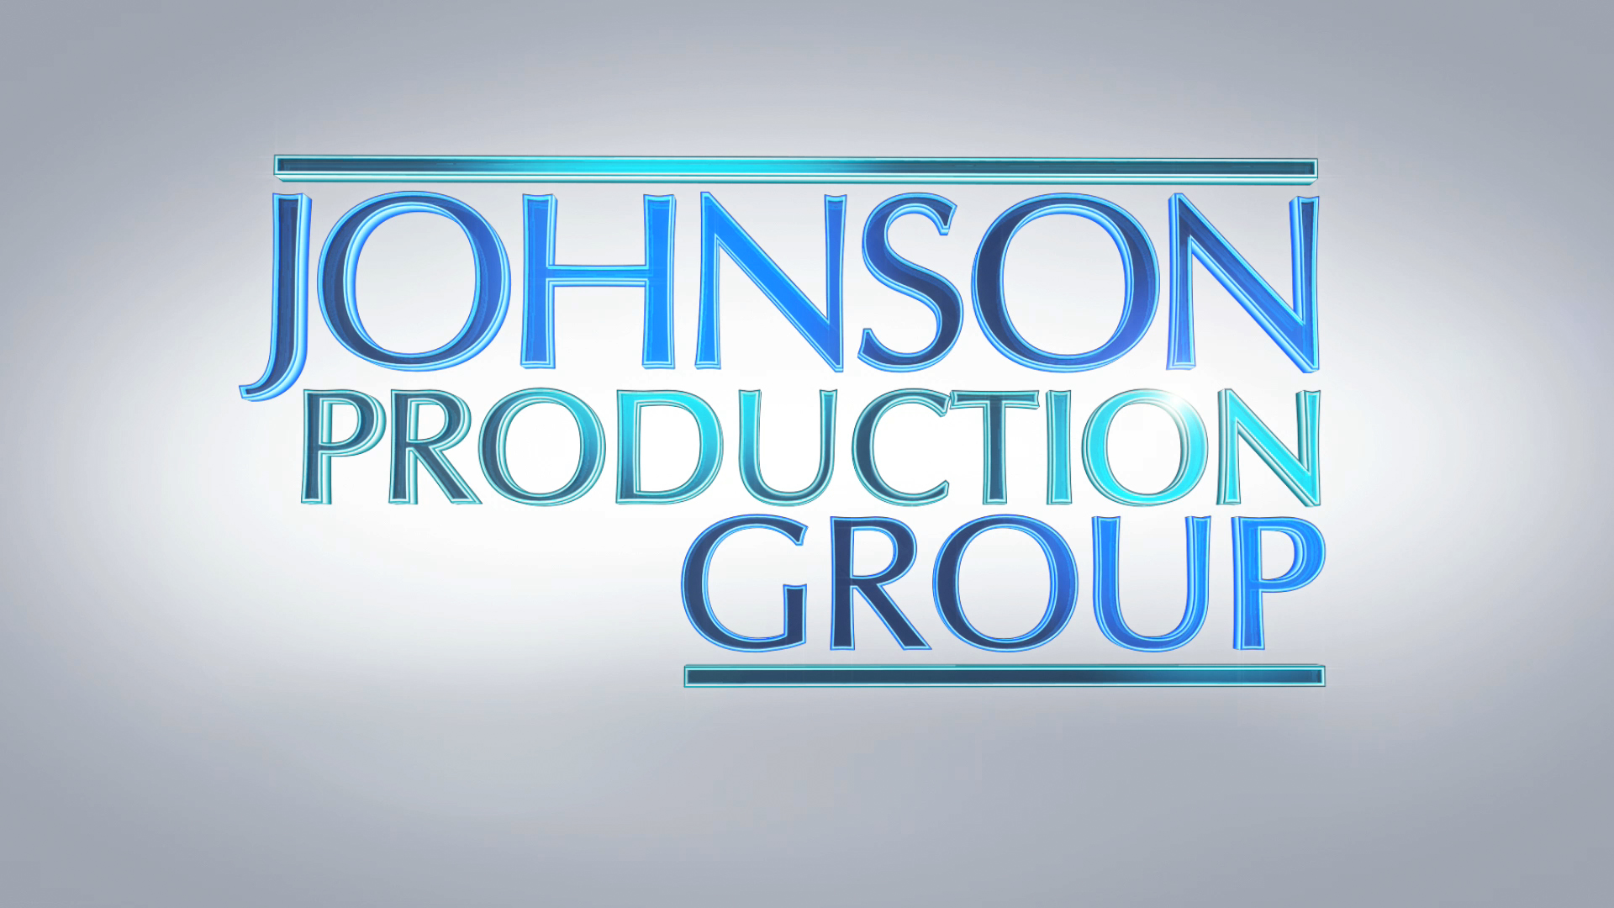
Meta Data
LONG (max 3000 characters) synopsis
Lori Jo, “LJ”, has been obsessed with Christmas all her life. She and her grandmother had always planned to visit Yuletide Springs, where Christmas is celebrated year round, to take part in a longstanding tradition of hanging an ornament on the town tree and making a wish. But her grandmother passed away before they could go. This year LJ is determined to make the trip, hang her grandmother’s special homemade ornament in her honor. And she convinces her workaholic roommate Tori to join her. Along the way they have a fateful run in with a jolly magician with a white beard who goes by the name Kris Kringle. This chance encounter creates a ripple effect of… coincidences or small Christmas miracles that take them both on a journey full of serendipity and surprise. LJ meets Carl, a handsome tow truck driver who helps them out of a pinch and Tori meets Jason, a fellow traveler on his way to reunite with his aunt. The two become four as they continue to make stops, enjoying more small town Christmas attractions, while each couples’ connection grows more and more. But when Carl reveals that he intends to return home and her grandmother’s homemade ornament breaks, LJ is devastated. But Tori, who has finally learned to unplug from her job, is quick to remind LJ that the journey that got them here is what matters. All the little things they experienced (whether by coincidence or magic) have made this their best Christmas ever. LJ finds one last gift from Kris, and is amazed to find that Christmas magic might be real after all when she finds the perfect replacement ornament and reunites with Carl on Christmas Eve. When LJ finally hangs the ornament, she is certain of two things: her grandmother will always be with her, and everywhere she turns the spirit of Christmas is there, all the time! (1809)
MEDIUM (max 500) synopsis
A Christmas obsessed woman takes a road trip to Yuletide Springs, where Christmas is celebrated year round, to participate in a longstanding town-wide tradition to honor her late grandmother. She connects in serendipitous ways with various travelers on her journey. Once she arrives, things start to fall apart and she worries that Christmas might actually be ruined until a magical twist of fate shows her it just might be better than she could have imagined. (461)
SHORT (max 100 characters) synopsis
A woman takes a very serendipitous trip to a town where Christmas is celebrated year round. (92)
5 KEY WORDS
Christmas magic, romance, family ties

