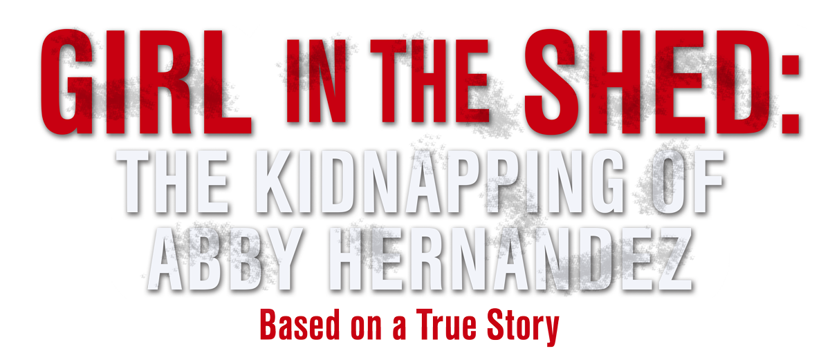

EXECUTIVE PRODUCER ELIZABETH SMART

For Lifetime and Star

One-Liner
The real life story of a teenage who was kidnapped while walking home from school and survived 9 months of rape and abuse.

Synopsis
A week before her 15th birthday, Abby Hernandez was kidnapped while walking home from school. Imprisoned in a shipping container, Abby survived 9 months of rape and abuse while her mother never gave up trying to find her.

Producers
Executive Producers
ELIZABETH SMART, MICHAEL VICKERMAN, STACY MANDELBERG
Producer
NAVID SOOFI
Supervising Producer
OLIVER DE CAIGNY

Key Cast
CHARACTER  Felix/Nate Kibby  Zenya Hernandez  Abby Hernandez  Det. Emily Sadler |  | ACTOR  BEN SAVAGE  ERICA DURANCE  LINDSAY NAVARRO  BETHANY BROWN

Key Cast Biographies

BEN SAVAGE
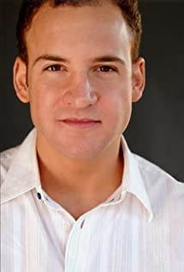
Bennett "Ben" Joseph Savage was born on September 13th, 1980, in Chicago, Illinois. Ben got his start in acting when he appeared in his first commercial at the tender age of 5. From there, his first major speaking role was in the comedy series, Dear John (1988), opposite Judd Hirsch and fellow Chicago-native, Isabella Hofmann. He starred in a handful of made-for-TV movies and other films, most significantly Wild Palms (1993), until being cast in the lead role in the series Boy Meets World (1993), which catapulted him into stardom. Ben didn't put aside his studies in the course of his acting career, graduating in 2004 from the famed Stanford University with a degree in Political Science. In the summer of 2003, he got an internship with the office of US Senator Arlen Specter (R-PA).
Ben has continued to appear as a regular in several series including Homeland, Criminal Minds, Speechless, Still the King, The Leftovers and starring in Girl Meets World as well as multiple film roles.

ERICA DURANCE
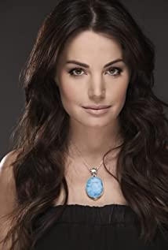
Durance began her career with background work, graduating to commercials and guest-starring roles. Durance made her feature film debut in the movie The Untold (2002). She guest-starred on the comedy series The Chris Isaak Show and the supernatural series The Collector. In Tru Calling, her character was a contender in a beauty pageant opposite Eliza Dushku. On the SyFy Channel, she played an intergalactic librarian in Andromeda and a love interest for Teal'c on Stargate SG-1.
While acting part-time, Durance worked as an agent for background actors and booked photo doubles for the television series Smallville. Durance was considering quit acting when she was cast as Lois Lane on Smallville in 2004. She played a sassy, street-smart teenage Lois in season four. Executive producer Kelly Souders recalled hiring Durance, stating: "There were a lot of wonderful actresses who came in for the role, but I remember sitting and watching her tape and everybody was like, 'That’s her. There's no question." Fellow producer Brian Peterson added that from the moment Durance was hired they knew she would be Lois for the series. Durance was promoted to series regular in season five and became part of the regular cast for the remainder of the series run. On playing Lois Lane, Durance said: "Everyone has their specific idea of who Lois Lane is for them, and you have your overall blueprint, but then you have to try to make it your own. That's the only way to try to stay truthful to what you're doing. It's an experience I will cherish always and never forget. Lois is a beloved character. I took that seriously and put my heart and soul into her for seven years. I enjoyed every minute and am forever changed by it."
Durance appeared in the films The Butterfly Effect 2 (2006) and Island Heat: Stranded (2006). She was nominated for a Gemini Awards for the Lifetime movie I Me Wed (2007). She starred as Maid Marian in Beyond Sherwood Forest (2009) and appeared in the film Sophie and Sheba (2010) as an Aerial silk performer in the circus. In 2011, she guest starred in the television series Charlie's Angels as CIA operative Samantha Masters. She played twin sisters Angela and Christine in the Italian TV mini-series 6 passinelgiallo and appeared in the NBC series Harry's Law in 2012.
In June 2012, Durance began starring in the lead role in the CTV medical drama television series Saving Hope, as Chief Surgical Dr. Alex Reid. She was also a producer on the series and directed the season four episode "Torn and Frayed". In season 3, Durance's real-life pregnancy was worked into her character Alex Reid and the series. Saving Hope ended its run in 2017.
Durance starred in the Hallmark Movies & Mysteries channel movie Wedding Planner Mystery (2014). The movie is based on Deborah Donnelly's novel Veiled Threats and was supposed to be the first film in the channel's Mystery Wheel series adaptation. In 2015, she appeared in the thriller film Painkillers with Tahmoh Penikett.
Durance appeared in The CW television series Supergirl in a recurring role as Kara's Kryptonian mother, Alura Zor-El, and as Agent Noel Neill in the episode "Midvale". Durance and her Smallville co-star Tom Welling reprised their roles as Lois and Clark in the Batwoman episode of the 2019 Arrowverse crossover event "Crisis on Infinite Earths".

LINDSAY NAVARRO
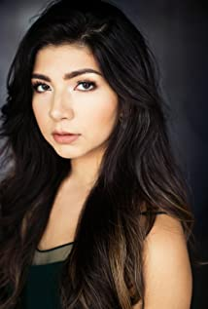
A Canadian actor of Hispanic and Caucasian descent,Lindsay was raised in Kelowna, B.C, where she joined a local actors' studio and performed in musical theatre productions, like Mamma Mia and West Side Story. Shortly after, Lindsay moved to Vancouver and completed her high school studies online while she juggled auditioning in film. She attended Vancouver Acting School and continues to train and work in Vancouver.
Lindsay is best known for her work in several TV series such as Kleigh in Haters Back Off (2016), as Steph in the 2019 series Life XP, and in iZombie (2016). She has also appeared in the films Brain on Fire (2016) and Ghosting: The Spirit of Christmas(2019).

BETHANY BROWN
Born in Burnaby BC, Bethany grew up in the Okanagan on a 100 acre farm milking cows, collecting eggs, riding horses, husking corn, and churning butter. She attended Classical Musical School from the age of 3 becoming a multi-award winning professional violinist by the age of 9. She moved to Vancouver at the age of 17 to play collegiate soccer in the NAIA (Simon Fraser University). When a foot injury ended her soccer career Bethany returned to her passion for the arts focusing her efforts on acting.
In 2021 Bethany was nominated for a Leo Award for Best Supporting Performance by a Female in a Dramatic Series for her work in the Imagine/Nickelodeon production of The Astronauts (2020-2021). She was also nominated for a Jessie Award in 2020 for Outstanding Performance by an Actress in a Supporting Role for her work in the stage production of 'Disgraced' by Ayad Akhtar.

Production Credits

Full Cast
Actors  LINDSAY NAVARRO  BEN SAVAGE  ERICA DURANCE  CARMELA SISON  BETHANY BROWN  CLAUDIA KAI  JASON DELINE  LEO CHIANG  MILES MERRY  MATTHEW KEVIN ANDERSON  MADDY HILLIS  BYRON LAWSON  MIRELLA GIBEAU  JULIAN KATO  LISA CHANDLER  TREVOR HINTON  KAREN KHUNKHUN  STEVE MAKAJ  CLAUDIA CHEN  KAMANTHA NAIDOO  DUMISILE OWANE  LESLIE SCHWETZ  DAVID BEAIRSTO | Role  Abby Hernandez  Felix/Nate Kibby  Zenya Hernandez  Tess Marrin  Det. Emily Sadler  Liz  Officer Daniels  Officer Babcock  Zach  Det. Jacob Dunlap  Miranda  Agent Carrera  Mary  Co-Worker  Dotty Brown  Ed  Field Reporter  Boss  Patricia  Reporter #1  Postal Clerk  Imelda  Rabbi

Casting by
JUDY LEE

Production Designer
HEATHER COUTTS

Director of Photography
MIKE CAM

Edited by
DEVIN TAYLOR

Music by
KEVIN BLUMENFELD

Written by
MICHAEL VICKERMAN

Directed by
JESSICA HARMON

Full Crew
BRUCE CRAWFORD | Stunt Coordinator
THOMAS STANFORD | Associate Producer
NAVID SOOFI | Production Managers
DARREN ROBSON
GRANT O’KANE | First Assistant Directors
TROY SCOTT
MARC GENEROSO | Second Assistant Director
RUSTY ROSS | Set Decorator
CIMRAN JASSAL | Assistant Set Decorator
CLARA SALAMEH | On Set Dresser
AARON WILSON | Dressers
MITCHELL RAUSCH
AMY LYNCH
RYAN BEIBERSTEIN
RAINE LEMAY
GELLERT HORVATH
MORGAN GREENWELL
KSENIIA LIEONTIEVA | Props Master
LETICIA LOUREIRO BRANDAO | Assistant Props Master
CARTER VILLEMAGNE-GAMACHE | Additional Props
SELENA TAYLOR | Hair Stylist
KATHLEEN FOWLSTONE | Make-up
BRYANA KOENNING | Swings
KRISTINA KITSUL
JADEN DEVINE | Costume Designer
SOPHIA NIEWERTH | Assistant Costume Designer
MATTHEW PASSARELLI | Set Supervisor
JODY SCHILBE | Truck Costumer
BERNICE WADDELL | Background Wardrobe
SEAN COX | Camera Operators
PETER PARK
BAURZHAN DOSMAGAMBETOV | First Assistants Camera
TITOUAN FOURNIER
CHARLES HADRIAN | Second Assistants Camera
TYLER OLCHOWY
BENJAMIN STENNER
PIERRE CRUZ | Gaffer
SEPEHR MAHBOB | Best Boy Electric
CHRISTOPHER HALL | Electrics
ERIK MORTENSEN
MATTHEW OLMSTEAD | Generator Operator
CORY TYMOSCHUK | Key Grip
DENNIS CHAPPELL | Best BoyGrip
JOSEPH HUNT | Dolly Grip
NILS KIMMEL | Grips
SAMUEL WANGAI
PETER GIBSON | Transport Coordinator
COSTAS PAPADOPOULOS | Transport Captain
GEORGIOS ANTONIADIS | Drivers
GORDON MACKAY
FRANCIS ROSS
TANYA STIPICA
ROBIN LAWRENCE
RIDHA BENAMMAR
ONOUFRIS ANTONIADIS
BARRY HUNT | Security Coordinator
MEGHAN RILEY | Security
JASON HUNT
HARPREET KAULDHAR
KATHY STRANBERG
LINDA LARSON
ANTHONY LIVELY
BRANDON RYAN
CELESTE CROWE | Location Manager
ANA NUNES | Assistant Location Manager
JAMIE SAMBELL | Key Location Assistants
JANA QUADRELLI
ANDREW MOORE
ANDREW FORDERER
LIANA BABIN | Location Assistants
ZACH SCOTT
CAMERON CHEVELDAVE
SEAN REA
ELSY DAGDUG CHAMELIS
SARAH EMMONS
BAILEE MILLER
ERIKKA GRIFFITHS-KEAM
BEN GREENWOOD
ALISON WOLD
TAYLOR VICKERMAN
EMILIA SAINZ SOLER | Production Sound Mixer
ELSY DAGDUG CHAMELIS | Boom Operator
CHRISTOPHER DOERKSEN | Script Supervisor
PARALEE COOK | Production Accountant
ROBERT JAY DEACHMAN | Production Accountant Assistant
THOMAS STANFORD | Business Affairs
JEFF DESMARAIS | Production Coordinator
KARRY CROFT | Production Assistant
MICHAEL HOLSTEIN | Craft Service/First Aid
JESSICA CLAYBO | Craft Service/First Aid Assistant
JENNIFER ROBERTS | COVID Specialists
KAYLA BROWN
CHRIS BILLON | Third Assistant Director
WAY LEE CHOO | Catering
CAMERON WINTERS
MAIA MICHAELS | Casting Assistant
LA HILTS | Extras Casting
CLAUDIA MOON | Extras Casting Assistant
CHRISTINE KELSEY | Stand-Ins
SHANE BRISCOE
COASTAL CLEARANCES | Script Clearances
CHANDLER FOGDEN ALDOUS  LAW CORPORATION | Legal Services
FRONT ROW INSURANCE BROKERS | Insurance
W. PETER VANDER GRIENT | Special Effects Coordinator
MORGAN BEECH | Special Effects Assistants
TRAVIS OGILVIE
KAELAN GRELL
PAUL URSULAK
LEAH MYERS | Post Production Supervisor
TIM SPENCE | Post Production Coordinator
RON PENCHALAIYA | Assistant Editors
EVELYN STARKS
SO YOUNG PARK | Second Assistant Editor
MARCEL VANDERWEKKEN | Visual Effects
SEÁN TRAVERS | Colourist
MAVERICK POST GROUP | Sound Facilities
GREGOR PHILLIPS | Supervising Sound Editor
GREGOR PHILLIPS | Re-Recording Mixer
ELAN GABRIEL | Dialogue Editor
RYAN THOMPSON | SFX Editor
COLIN WIND | Backgrounds Editor
MATIAS GIBBS | Foley Editor
ALEX MACIA | Foley Artists
DEVON QUELCH
JEFF GROUT | ADR Mixer

Producer Biographies

JOHNSON PRODUCTION GROUP
The Johnson Production Group contracts globally to produce television content for international networks, studios and distributors. Based in Los Angeles and Vancouver, British Columbia, the company manages production, facilitates development and financing, procures distribution and guarantees quality and timely execution of its programs. While costs have gone up, so has the demand for quality. No longer is good enough, good enough. Johnson Production Group serves that segment when a show needs to be "A" quality, but produced efficiently enough to meet a locked budget. JPG specializes in value, protection of creative elements, and delivery of a quality finished product.
MICHAEL VICKERMAN – Executive Producer
Michael Vickerman is a native of Minneapolis, Minnesota and attended film school at the University of Wisconsin – Milwaukee before transferring to Columbia Film School. Michael began his career writing scenes with Sylvester Stallone for the feature film “Cliffhanger” while still attending film school and working as Mr. Stallone’s assistant. Over the next twenty-five years, Michael went on to write, direct and/or produce over forty feature and television films, including the event limited series “Tut” for Spike TV starring Sir Ben Kingsley. He is currently developing the historical drama “Taj Mahal” for Warner Brothers Television and the historical WWII series “The Doolittle Raiders.”

STACY MANDELBERG – Executive Producer
Stacy Mandelberg attended Stanford University’s Mass Media Institute, Northwestern University School of Speech for a BS in Radio, Television and Film, and obtained her Masters of Fine Arts, Film at New York University School of the Arts. She is now the Head of Creative at Johnson Production Group and has had an extensive career in senior executive roles at New World Television, von Zerneck Sertner Films, Wilshire Court Productions, Atmosphere Entertainment, CBS and most recently, Sony/TriStar Television where she oversaw Showtime’s “On Becoming a God in Central Florida”. Stacy is known as a producer of TV movies including Switched Before Birth, Girl Positive, and Haunting Sarah (Lifetime), The Real World Movie (MTV), Sweetwater: A True Rock Story (VH1 Network), Bad to the Bone (ABC) and Crazy Horse (TNT). Additionally she produced several series including The Dovekeepers and The Doris Duke Story (CBS), as well as Robin Cook's Invasion (NBC).

OLIVER DE CAIGNY– Supervising Producer
Oliver De Caigny is a Canadian producer originally from Belgium, his background in financing, production, and post production makes him a well-rounded producer for any type of production. His experience in financing and production agreements (film and TV series and movies-of-the week), distribution agreements (both domestic and foreign) as well as international co-productions, Canadian tax credit, Telefilm Canada and Canada Media Fund incentives provides him with a well-rounded background in development, production and distribution for motion pictures, television series and productions.
NAVID SOOFI– Producer
Navid is the primary producer for Novus Ordo Seclorum. Navid’s passion for filmmaking along with his business and engineering background plays an important role in creating a successful and transparent business model. Navid has been in the entertainment industry for more than 13 years and has produced over 50 feature films, TV shows and commercials that have been featured on national television, international theatres, and new media platforms. His credits include Over the Moon in Love, The Mistletoe Secret, Random Acts of Christmas, Love Unleashed, Identity Theft of a Cheerleader, and A Mother on the Edge.

JESSICA HARMON- Director
While well known as an actor in many film and television roles, it is not surprising that Jessica has evolved into a director. Her parents are director Allan Harmon and producer Cynde Harmon. Her directing credits to date include the television movies A Christmas to Savour, Falling for Christmas, The Vows We Keep, The Angel Tree and My Best Friend's Bouquet.

Billing Block
Johnson Production Group Presents
“GIRL IN THE SHED: THE KIDNAPPING OF ABBY HERNANDEZ”
starring BEN SAVAGE ERICA DURANCE LINDSAY NAVARRO BETHANY BROWN
Casting by JUDY LEE Production Designer HEATHER COUTTS Director of Photography MIKE CAM Edited by DEVIN TAYLOR Music by KEVIN BLUMENFELD
Supervising Producer OLIVER DE CAIGNY Executive Producers ELIZABETH SMART MICHAEL VICKERMAN STACY MANDELBERG Produced by NAVID SOOFI Written by MICHAEL VICKERMAN Directed by JESSICA HARMON
With the participation of the Province of British Columbia
Film Incentive BC
The Canadian Film or Video Production Tax Credit
© MMXXI Sprott Productions Inc. All Rights Reserved
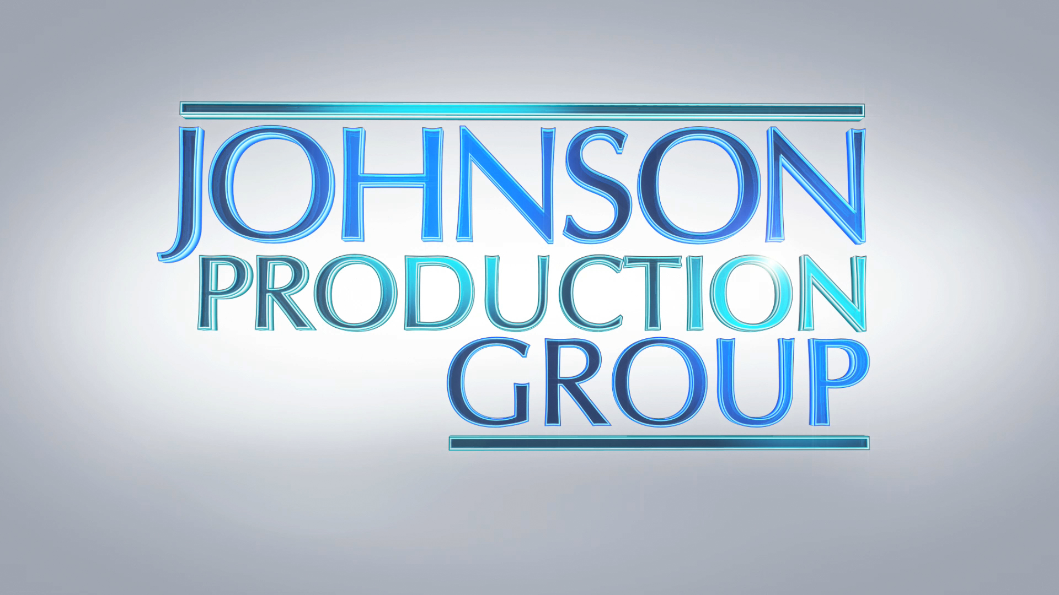
Meta Data

LONG (max 3000 characters) synopsis
A week before her 15th birthday, Abby Hernandez was kidnapped while walking home from school. Imprisoned in a shipping container, Abby survived 9 moths of rape and abuse for 9 months while her mother never gave up trying to find her. (234)
MEDIUM (max 500) synopsis
A week before her 15th birthday, Abby Hernandez was kidnapped while walking home from school. Imprisoned in a shipping container, Abby survived 9 moths of rape and abuse for 9 months while her mother never gave up trying to find her.(234)
SHORT (max 100 characters) synopsis
The real life story of teenager Abby Hernandez who was kidnapped and survived 9 months of captivity.
(100)
5 KEY WORDS
teenager, rape, captivity, mother, faith

