Based on a true story

Johnson Production Group

Press Kit

One-Liner
In 2016 Sherri Papini went for a run and didn't come home. This Northern California missing-person case quickly became a national story--especially after she returned and her story about being abducted wasn't adding up.

Synopsis
Beautiful mother of three, Sherri Papini, goes out for a jog and disappears for 8 weeks. Her husband and family are distraught. Police initially suspected her husband, Keith. She reappeared three weeks later at 4:30 in the morning on Thanksgiving Day, having been reportedly freed by her captors still wearing restraints, bruised, and branded. Everyone is happy for her return. That is until the police charge her with fraud and falsifying her own kidnapping.

Producers
Executive Producers
TIMOTHY O. JOHNSON
STACY MANDELBERG
JOCELYN FREID
Supervising Producer
NAVID SOOFI
Producer
OLIVER DE CAIGNY

Key Cast
CHARACTER  Sherri Papini  Keith Papini  Chris  Detective Molly Rowlands  Loretta Graeff |  | ACTOR  JAIME KING  MATT HAMILTON  JOSH COLLINS  LOSSEN CHAMBERS  JILL TEED

Key Cast Biographies

JAIME KING
Jaime King is an American actress and model from Omaha, Nebraska. She is known for acting in Hart of Dixie, the Sin City film series, White Chicks, Barely Lethal, Bulletproof Monk, Star Wars: The Clone Wars and Pearl Harbor. She was married to Kyle Newman and had two children with him. Jessica Alba and Taylor Swift are her children's godmothers.

MATT HAMILTON
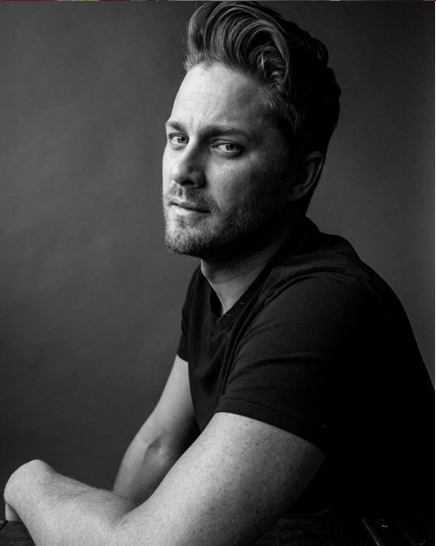
Matt Hamilton graduated from Vancouver Film School for Writing for Film and Television and has his B.F.A in Writing from the University of Victoria.
He was a 2019 Leo Award Winner for Best Male performance in The Actress Diaries, a 2018 Best Male Performance nominee at the International Academy of Web Television and a 2015 Leo Award Best Actor nominee, also for The Actress Diaries. He won Best Performance for The Fence at the Sunscreen Film Festival.
His screen writing has placed in numerous contests and festivals including Praxis Fellowship, LA International Screenplay contest, StoryPros feature contest, Storyline feature contest, CS Creative Screenwriting Open, Scriptoid Television Top 3 Winner, 13 Horror feature contest, the Leo Awards among many others.
He was born and raised in Victoria, BC and resides in Vancouver, BC.

JOSH COLLINS

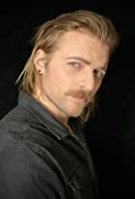
Josh was born in Gander, Newfoundland, August 5, 1993 as the first child to his mother, an author and a social worker. Moving to rural Alberta when he was 6, Josh and his younger sisters were raised in small farm towns after his mother remarried. After graduation, Josh left for Vancouver, BC to pursue a film career. Graduating from Vancouver Film School's Acting Program in 2013, he began working in the film industry in Vancouver and still lives locally.

LOSSEN CHAMBERS
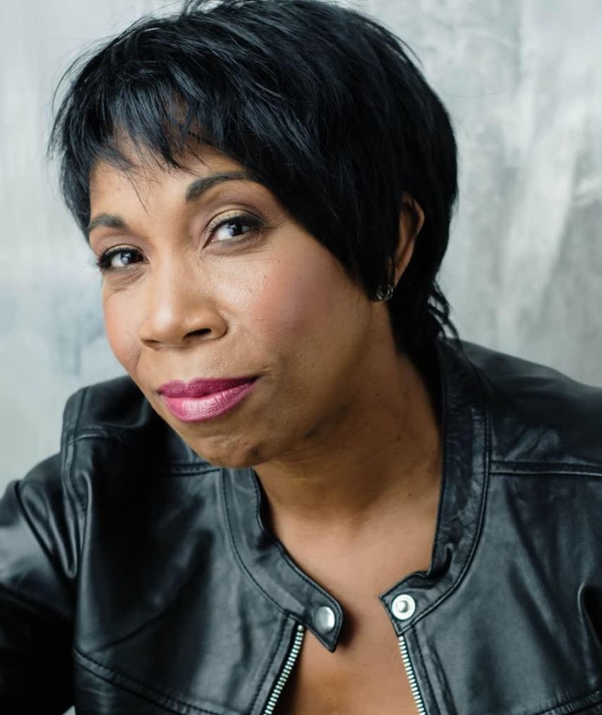
Toronto born actress, Lossen Chambers, is known for her extensive body of work in both TV and Film. Her film work includes Bird on a Wire, Snow Dogs, Signed, Sealed, Delivered: The Road Less Traveled, A Twist of Chistmas, A Winter Princess, Matching Hearts, Merry Liddle Christmas Wedding and The Long Island Serial Killer: A Mother’s Hunt for Justice. She has had recurring roles in several TV Series including Unspeakable, The Flash, Myster 101, Family Law, Superman & Lois and So Help Me Todd.
JILL TEED
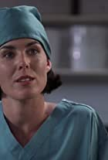
Canadian actress, Jill Teed, has appeared in many sci-fi roles. She has appeared in a number of television guest roles such as Street Justice, The X-Files, Stargate SG-1, Sliders, and The Outer Limits. Teed has also appeared in such feature films as X2 as Bobby Drake's mother, Mission to Mars and Godzilla. She played the role of FBI Agent Kaayla Brooks in "Reluctant Heroes", a Season Four episode of Highlander: The Series. She played Maggie Sawyer, a Metropolis police chief, on Smallville. She portrayed Sergeant Hadrian, the Galactica's Master-at-Arms, in the first season of Battlestar Galactica. She played Colonel Lasky in the web series Halo 4: Forward Unto Dawn. She had a prominent supporting role in the television film Seasons of the Heart (1994).[

Production Credits

Full Cast
Actors  JAIME KING  MATT HAMILTON  JOSH COLLINS  LOSSEN CHAMBERS  JILL TEED  CHRISTINA SICOLI  KAYLA DOERKSEN  DAVID PEARSON  DAVID LENNON  ARPAD BALOGH  WILLIAM CARSON  EVA BAKER  ROBERT EGGER  LISA MACFADDEN  ALIYA BOULANGER  KELLY ANN WOODS  CHRISTOPHER WARDROP  ANDREW LISSETT  ZAHRA ALANI  MAEGAN EASTWOOD  ANNI RAMSAY  KIERA WALLACE  EVERICK GOLDING  ROWAN O’CALLAGHAN  JAY HINDLE | Role  Sherri Papini  Keith Papini  Chris  Detective Molly Rowlands  Loretta Graeff  Laura Anderson  Caitlin Vernon  Detective Anthony Bertain  Andrew  David Dreyfus  Cameron  Hannah  Interviewer  Emma  Amy  Jennifer  Greg  News Reporter #1  News Reporter #2  Undercover Agent  Tina  Karen  Judge  Harper  Richard

U.S Casting by
DEBORAH GEORGE, CSA
ALEXIS BOOTH, CSA

Canadian Casting by
BIM NARINE
CATHERINE FALCON

Production Designer
JORDAN NINKOVICH

Director of Photography
JUSTIN SEBASTIAN

Edited by
SAEED VAHIDI

Composer
BRITTNEY RAND

Written By
KATIE BOLAND

Directed by
MARTA BOROWSKI

Other Crew
CHAD SAYN | Stunt Coordinator
EVELYN GONDA | Sherri Stunt Double
LISA CHANDLER | Stunt Woman
THOMAS STANFORD | Associate Producers
PARALEE COOK
CELESTE CROWE | Production Manager
JOSEPH GOLD | First Assistant Director
BENJAMIN GALLOWAY | Second Assistant Director
ROXANNE WONG | Set Decorator
LANA TUROK | Set Dec Assistant
HAYLEY MACPHAIL | On Set Dresser
JACOB KOLODZIEJ | Buyer
GUILLERMO CAICEDO | Dressers
MICHAEL JOY
GREGORY BLACK
SHANELLE WESTMACOTT
CHARLES IRUOBE
MANUEL JOSE TORRES MARTINEZ
NESTA CHAPMAN
JENNIFER STENNER
MELISSA HORRELL
NATASHA FINN
RONALD CAMPBELL
ALANA COOK
CARMEN BEST
MILES WILKINSON
CHAD GRANDBOIS
BRIANNA ROTTLUFF
WENLIANG WU
ELLA BIRKLAND
DIMA FOUER
DAVID BAIN
JOHN SHORT
KSENIIA LIEONTIEVA | Props Master
JOSEPHINE DAWSON-WHISKER | Assistant Props
SELENA TAYLOR | Key Hair Stylist
BRYANA KOENNING | Hair Assistant
KATHLEEN FOWLSTONE | Key Make-Up Artist
KAYLA LAURIE | Make-Up Assistants
PAOLA ORTEGA
KELSEY BARAN | Costume Designer
CHARU GUPTA | Assistant Costume Designer
EMILY STRINGER | Costume Set Supervisors
ROBIN LYONS | Costume Dressers
LOUISE SARAN
ANDREA MCDONALD
CHARLES HADRIAN | First Assistants Camera
STEVEN SINGH
BENJAMIN STENNER | Second Assistants Camera
SHINGO SUZUKI | Operators
TITOUAN FOURNIER
BAURZHAN DOSMAGAMBETOV
ANTONIN STURLESE | Trainee
PETER VAN DER GRIENT | Special Effects Coordinator
CLARA JOY SALAMEH | Special Effects Technician
PIERRE CRUZ | Gaffer
LENDL LEE QUIAPO | Best Boy Electric
BOBBY SKAPER | Lamp Operators
XAVIER SOH
MITCHELL ROWLAND | Key Grip
WILL BENNETT | Best Boy Grip
DYLAN CAMPBELL | Grips
DYLAN MORIN
KYLE MCKEACHIE | Dolly Grip
BENJAMIN VANDERKWAAK | Head Carpenter
SHAUN JOHNSON | Construction Labour
PETER GIBSON | Transport Coordinator
COSTAS PAPADOPOULOS | Transport Captain
ROBIN LAWRENCE | Drivers
GORDON MACKAY
EUGENE GILLIS
SAEED SODEYF
RIDHA BENAMMAR
STEVE MISKINIS
PETER WONG
RENATA FRANCISTY
GARY WATSON
BARRY HUNT | Security Coordinator
RICHARD PLUHOWY | Security
JEANNINE CLIFFE
JEREMY HUNT
WAYNE ROBINSON
CARRIE DRAUDE
JASON HUNT
PERRY PARSONS
MEGHAN RILEY
SANDRA SIGVARDSEN
CATHY STRANBERG
NIGEL WILLIAMS | Location Manager
CAROLINE BICKLE | Assistant Location Manager
RYAN PATERSON | TAL
CARLA FUGARD | Location Scout
DENIS LONG | Key Production Assistants
MATTHEW GIBSON | Production Assistants
MARCUS ZANE CARVALHO
MATTHEW CAMPBELL
TAYLOR MORRISON MILNE
OLEKSANDR PETROV
ANDREW CASSIDY
FISTON IRAKOZE
BYRON STANLEY
HANNA VORLICEK
CONNOR LYONS | Production Sound Mixer
MASON HNATIW | Boom Operator
JOANNE DAVIS | Script Supervisor
PARALEE COOK | Production Accountant
AMANDA PORTER | Production Accountant Assistants
CHRISTOPHER LOGAN
THOMAS STANFORD | Business Affairs
JESSICA OLSEN
JEFF DESMARAIS | Production Coordinator
KARRY CROFT | Assistant Production Coordinator
JESSICA CLAYBO | Craft Service/First Aid
CARLY SKINNER | Craft Service/First Aid Assistants
CHLOE LECLERC
KAYLA BROWN | COVID Coordinator
KATHLEEN LEE | Third Assistant Director
SHELBY LEOPOLD | TAD
CAMERON WINTERS | Chef
JORDAN GALVIN | Chef Assistants
FOOK LOON CHOO
LA HILTS | Extras Casting
RYAN MINAKER | Stand-Ins
EMILY COCKS
COASTAL CLEARANCES | Script Clearances
CHANDLER FOGDEN ALDOUS | Legal Services
LAW CORPORATION
FRONT ROW INSURANCE | Insurance
BROKERS
TIM SPENCE | Post Production Supervisor
JAMIE LAM | Post Production Coordinator
RON PENCHALAIYA | Online Editor
MEL CORRIGAN | First Assistant Editors
HRANT AHANISYAN
AMIR SALEHI | Second Assistant Editor
MARCEL VANDERWEKKEN | Visual Effects
SEÁN TRAVERS | Colourist
MAVERICK POST GROUP | Sound Facilities
GREGOR PHILLIPS | Supervising Sound Editor
ERIC MOUAWAD | Dialogue Editor
CRAIG GEORGE | SFX Editor
ALEX MACIA | Foley Artists
DEVON QUELCH
MATIAS GIBBS | Foley Editor
JEFF GROUT | ADR Mixer
MAY GUIMARÃES | Re-Recording Mixer

Producer Biographies
TIMOTHY O. JOHNSON – Executive Producer
Timothy O. Johnson is among the most active and reliable producers in the business thanks to top rate productions and global distribution appeal. He is the managing partner of Johnson Production Group, a Canadian based operation that produces over 100 hours of dramatic television annually with hundreds of programs running internationally. The company is the leader supplier to Lifetime, Hallmark and other international outlets.
A graduate of the Marshall School of Business at the University of Southern California, he served as President of the USC Entertainment Management Association and a member of the Advisory Committee of the Center for Entrepreneurial Studies.
Johnson is also responsible for producing the international hit series, DR. QUINN, MEDICINE WOMAN for CBS for over 5 seasons. During his 100-episode tenure, he also developed and produced the original docu-drama COLD CASE for CBS network, which was the very first program to integrate television with the Internet.
Most recently, Johnson has produced the THE NOEL DIARY, being the #1 Film on Netflix’s Top 10 list in December of 2022. He was also at the helm of the successful GIRL IN THE SHED: THE KIDNAPPING OF ABBY HERNANDEZ, as well as the V.C. Andrews series of films, to date including TWILIGHT’S CHILD, MIDNIGHT WHISPERS, and DAWN, all produced for Lifetime..
Johnson has produced over 400 movies and 15 globally released series for every major US network - including Netflix, Lifetime, Hallmark, ABC, Disney, CBS, NBC, Netfly, FOX and Sony.
JOHNSON PRODUCTION GROUP
The Johnson Production Group contracts globally to produce television content for international networks, studios and distributors. Based in Los Angeles and Vancouver, British Columbia, the company manages production, facilitates development and financing, procures distribution and guarantees quality and timely execution of its programs. While costs have gone up, so has the demand for quality. No longer is good enough, good enough. Johnson Production Group serves that segment when a show needs to be "A" quality, but produced efficiently enough to meet a locked budget. JPG specializes in value, protection of creative elements, and delivery of a quality finished product.

STACY MANDELBERG – Executive Producer
Stacy Mandelberg attended Stanford University’s Mass Media Institute, Northwestern University School of Speech for a BS in Radio, Television and Film, and obtained her Masters of Fine Arts, Film at New York University School of the Arts. She is now the Head of Creative at Johnson Production Group and has had an extensive career in senior executive roles at New World Television, von Zerneck Sertner Films, Wilshire Court Productions, Atmosphere Entertainment, CBS and most recently, Sony/TriStar Television where she oversaw Showtime’s “On Becoming a God in Central Florida”. Stacy is known as a producer of TV movies including Switched Before Birth, Girl Positive, and Haunting Sarah (Lifetime), The Real World Movie (MTV), Sweetwater: A True Rock Story (VH1 Network), Bad to the Bone (ABC) and Crazy Horse (TNT). Additionally she produced several series including The Dovekeepers and The Doris Duke Story (CBS), as well as Robin Cook's Invasion (NBC).

JOCELYN FREID – Executive Producer
Jocelyn Fried is the executive producer of the highly successful TV Series, Virgin River, now in its 4th season. Previously she was a producer on The Quad and Firefly Lane. She has also been the EP on TV Movies Tempting Fate, To Have and to Hold and Family Pictures.
NAVID SOOFI – Producer
Navid is the primary producer for Novus Ordo Seclorum. Navid’s passion for filmmaking along with his business and engineering background plays an important role in creating a successful and transparent business model. Navid has been in the entertainment industry for more than 13 years and has produced over 50 feature films, TV shows and commercials that have been featured on national television, international theatres, and new media platforms. His credits include Over the Moon in Love, The Mistletoe Secret, Random Acts of Christmas, Love Unleashed, Identity Theft of a Cheerleader, and A Mother on the Edge.
OLIVER DE CAIGNY – Supervising Producer
Oliver De Caigny is a Canadian producer originally from Belgium, his background in financing, production, and post production makes him a well-rounded producer for any type of production. His experience in financing and production agreements (film and TV series and movies-of-the week), distribution agreements (both domestic and foreign) as well as international co-productions, Canadian tax credit, Telefilm Canada and Canada Media Fund incentives provides him with a well-rounded background in development, production and distribution for motion pictures, television series and productions.

Billing Block
JOHNSON PRODUCTION GROUP presents a LIFETIME ORIGINAL MOVIE
HOAX: THE KIDNAPPING OF SHERRI PAPINI starring JAIME KING MATT HAMILTON JOSH COLLINS LOSSEN CHAMBERS JILL TEED U.S Casting by DEBORAH GEORGE, CSA ALEXIS BOOTH, CSA Canadian Casting by BIM NARINE CATHERINE FALCON Production Designer JORDAN NINKOVICH Director of Photography JUSTIN SEBASTIAN Edited by SAEED VAHIDI Composer BRITTNEY RAND Supervising Producer OLIVER DE CAIGNY Executive Producers STACY MANDELBERG TIMOTHY O. JOHNSON JOCELYN FREID Produced by NAVID SOOFI Written By KATIE BOLAND Directed by MARTA BOROWSKI
With the participation of the Province of British Columbia
Film Incentive BC
The Canadian Film or Video Production Tax Credit
© MMXXIII Hoax Productions Inc. All Rights Reserved
Meta Data
LONG (max 3000 characters) synopsis
Beautiful mother of three, Sherri Papini, goes out for a jog and disappears for 3 weeks. Her husband and family are distraught. Police initially suspected her husband, Keith. She reappeared three weeks later at 4:30 in the morning on Thanksgiving Day, having been reportedly freed by her captors still wearing restraints, bruised, and branded. Everyone is happy for her return. That is until the police charge her with fraud and falsifying her own kidnapping. (461)
MEDIUM (max 500) synopsis
Beautiful mother of three, Sherri Papini, goes out for a jog and disappears for 8 weeks. Her husband and family are distraught. Police initially suspected her husband, Keith. She reappeared three weeks later at 4:30 in the morning on Thanksgiving Day, having been reportedly freed by her captors still wearing restraints, bruised, and branded. Everyone is happy for her return. That is until the police charge her with fraud and falsifying her own kidnapping. (461)
SHORT (max 100 characters) synopsis
A woman goes out for a run and disappears only to turn up 3 weeks later, bruised and battered (94)
5 KEY WORDS
Kidnapping, branding, scam, lying, mother

