Johnson Production Group

Press Kit

One-Liner
Music teacher Hannah Adams finds unexpected love with Gavin after he and his daughter move back to town and participate in the town's annual Kite Festival.

Synopsis
Hannah Adams falls for more than teaching music when wood-worker Gavin McQueen (and his nine-year old daughter) move back to town after his wife’s passing. With a shared interest in the upcoming Kite Festival, Hannah becomes smitten with her new neighbour Gavin. But with an ex-girlfriend who makes it clear that she no longer wants to be an ex, Hannah finds difficulty in if knowing if Gavin is into her, as much as she is into him.

Producers
Executive Producer
TIMOTHY O. JOHNSON
JESSICA LOWNDES
CHRISTIE WILL
Co-Executive Producer
JOSEPH WILKA
Producer
NAVID SOOFI
Supervising Producer
OLIVER DE CAIGNY
Key Cast
CHARACTER  Hannah Adams  Gavin McQueen  Parker McQueen  Katie Longhorn  Shirley  John McQueen |  | ACTOR  JESSICA LOWNDES  CHRISTOPHER RUSSELL  AMÉLIE WILL WOLF  DONNA BENEDICTO  LISA ANN DURUPT  FRED KEATING

Key Cast Biographies

JESSICA LOWNDES
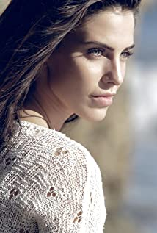
After captivating audiences and critics alike with her powerfully dynamic portrayal of drug-addicted, pregnant teen actress and singer Adrianna on The CW’s hit series “90210,” Jessica Lowndes (pronounced Lounds) quickly turned heads.
In 2014, Lowndes played Bruce Willis’s love interest opposite John Cusack in the action thriller The Prince. The following year she starred alongside Will Ferrell and Kristen Wiig in Lifetime’s “A Deadly Adoption” as well as the summer feature film Eden. Additionally, her horror film Abattoir premiered in June 2016 at the Los Angeles Film Festival and was released in December of that year.
Lowndes starred in the Hallmark Channel Original Movies “Merry Matrimony” and “A December Bride” and the Hallmark Movies & Mysteries Original Movie “Magical Christmas Ornaments.” Recently, she appeared in BBC America’s critically acclaimed series “Dirk Gently’s Holistic Detective Agency” and TNT’s “Major Crimes.”
In 2016, Lowndes broke the Internet when she punked her fans into believing she was engaged to comedian Jon Lovitz.
More recently, Lowndes starred in the 2018 Hallmark Channel holiday movie “Christmas at Pemberley Manor” as well as in “Yes, I Do,” part of Hallmark Channel’s “June Weddings” lineup.

CHRISTOPHER RUSSELL
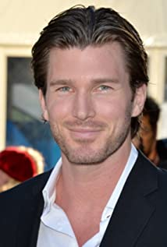
Christopher Russell is a first generation Canadian born to British parents. From a very young age, he was drawn to the arts and began performing. His first role as an actor was portraying Mary and Joseph's donkey in his pre-school production of “The Nativity Story,” for which he received rave reviews. In high school, Russell performed in many productions, most notably as Magnus Muldoon in a rendition of Tom Stoppard’s “The Real Inspector Hound,” which earned him the Sears Drama Festival Award of Excellence.
Russell recently filmed the lead role of Madison in ABC Family’s pilot “Gorgeous Morons.” His numerous television credits prior to that include guest star and recurring appearances on “Girlfriends’ Guide to Divorce,” “Men in Trees” with Anne Heche, “Flashpoint,” “The Listener,” “Murdoch Mysteries,” The CW’s “iZombie,” “Nikita,” “Supernatural” and “Beauty and the Beast,” as well as the TV movies “Love, Again,” “Midnight Masquerade,” “The Boy Next Door,” “Seduced By Lies” and “Catch A Christmas Star.”
Russell’s film credits include “Gone Tomorrow,” “Gangster Exchange,” George Romero’s “Land of the Dead,” “Center Stage: Turn It Up” and “The Right Kind Of Wrong,” which was an official selection for TIFF 2013, starring “True Blood’s” Ryan Kwanten and Catherine O'Hara.
Russell currently lives in Vancouver with his wife and his two children.

AMÉLIE WILL WOLF
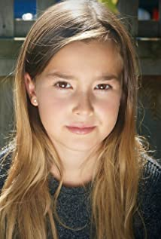
Amélie Will Wolf is best known for her role as “Avery Palmer” in “Poinsettias for Christmas” starring opposite Bethany Joy Lenz and Sharon Lawrence. Amélie also played Amy in the holiday favourite “A Wish for Christmas” starring Lacey Chabert & Paul Greene. In 2020, Amélie starred in the award winning short movie “Her Coming”.

DONNA BENEDICTO
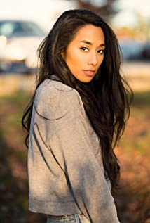
Donna Benedicto is a well known Canadian actress and producer based in Vancouver, British Columbia, Canada. She touted to stardom for her acting appearances in movies and television series like Supergirl, Almost Human, and The Main Event.

LISA ANN DURUPT
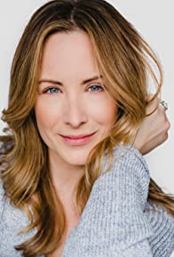
Originally from Winnipeg, Manitoba, Lisa Durupt has established herself as fierce, funny, and fearless talent in film and television. While she did study theatre at the University of Winnipeg and the Canadian College of Performing Arts, it was her natural athleticism that gave her an entry into the film industry as a dancer and stunt performer. Following early appearances in films like Shall We Dance and The Lazarus Project, Lisa was cast by Canadian comedy veteran Mark McKinney on the series, Less Than Kind, as the temperamental Shandra. Lisa's unfiltered energy and gift for ad-libbing over four seasons of the show was highlighted by a Gemini Award nomination in 2010 for Best Individual Performance in a Comedy Program or Series and a Leo Award nomination for Best Performance in a Music, Comedy, or Variety Program or Series in 2013.
After a string of appearances across film and television projects such as The Pastor's Wife, The Color of Rain, Run for Your Life, and Supernatural, Lisa Durupt won her most substantial cinematic role thus far as the overly competitive sister of Sonja Bennett in Preggoland, a performance that earned Lisa her second Leo Award nomination in 2015 for Best Supporting Performance by a Female in a Motion Picture.
While she continues to work steadily on film, Lisa is presently enjoying another steady run on television as Andrea Todd - sister to Alison Sweeney's Hannah Swensen - on Murder She Baked, the Hallmark Channel screen adaptations of the best-selling mystery novel series of the same name.
FRED KEATING
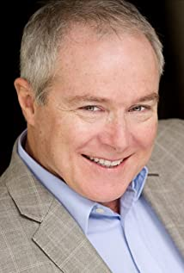
Fred Keating has a long and multi-faceted career in theatre, radio, TV and film in character roles and as a writer, actor, producer, director, host, motivational speaker and podcast producer/host.He is skilled and fearless, an award-winning filmmaker with many accomplishments. Since 1984 Fred’s been telling stories, both in front of and behind the camera, for the motion picture industry, private companies, and provincial and federal government departments. He’s racked up more than 78 movie credits on IMDB. He’s a voting member of the Academy of Canadian Cinema and Television and the Writer’s Guild of Canada. In 2003 Fred received the David Billington Award in recognition of his many contributions to Alberta’s production community, and in 2005 was honoured with The Centennial Medal for his work in Alberta-based media projects.

Production Credits

Full Cast
Actors  JESSICA LOWNDES  CHRISTOPHER RUSSELL  AMÉLIE WILL WOLF  DONNA BENEDICTO  LISA ANN DURUPT  KAREN KRUPER  FRED KEATING  HAMZA FOUAD  PETER GRAHAM-GAUDREAU  BEVERLEY ELLIOT  BIANCA LAWRENCE  MATTHEW KEVIN ANDERSON  ROBIN T. ROSE | Role  Hannah Adams  Gavin McQueen  Parker McQueen  Katie Longhorn  Shirley  Margaret McQueen  John McQueen  Brian  Henry Adams  Betty Anne  Isabelle  Jim  Announcer

Produced by
TIMOTHY O. JOHNSON |  | Executive producer
CHRISTIE WILL |  | Executive producer
JESSICA LOWNDES |  | Executive producer
JOSEPH WILKA |  | Co-executive producer
NAVID SOOFI |  | Producer
OLIVER DE CAIGNY |  | Supervising producer

Written & Directed by
CHRISTIE WILL

Music by
FREDERIK WIEDMANN

Cinematography by
MIKE KAM

Film Editing by
DEVIN TAYLOR

Casting By
JUDY LEE

Production Design by
HEATHER COUTTS

Full Crew
NAVID SOOFI | Production Managers
DARREN ROBSON
GARRETT VANDUSEN | Unit Manager
TROY SCOTT | First Assistant Director
JEFF CROFT | Second Assistant Director
KATIE GOOLD | Set Decorator
RUSTY ROSS | Assistant Set Decorator
MEGAN TAYLOR | Lead Dresser
SKYE DYKEN | Dressers
ANDRE ORIGUELA
ERIKA KELEHER | On Set Dresser
KSENIIA LIEONTIEVA | Props Master
LETICIA LOUREIRO | Props
LAIS ARAUJO
JOELY OSIKA
KATIE HILLIER | Graphic Designer
KATHLEEN FOWLSTONE | Make-Up Artist
SELENA TAYLOR | Hair Stylist
JADEN DEVINE | Costume Designers
HANNAH TAGGART
NICOLE MOORE | Truck Costumer
ERICA STERRY | Set Supervisor
BAURZHAN DOSMAGAMBETOV | First Assistants Camera
TITOUAN FOURNIER
TYLER OLCHOWY | Second Assistant Camera
MIKE JOHNSTON | Gaffer
SEPEHR MAHBOB | Best BoyElectric
MITCHELL ROWLAND | Key Grip
ERIK MORTENSEN | Best BoyGrip
ANDRIJ LYSKOV | Dolly Grip
PETER GIBSON | Transport Coordinator
DOUG HALVORSON | Transport Captains
CHRISTOPHER WILD
SAEED SODEYF | Drivers
JEFF CHARLTON
GORDON MACKAY
GARY WATSON
BARRY HUNT | Security Coordinator
ONKAR NAGRA | Security
JASON HUNT
SHANE DIXON
PERRY PARSONS
RICHARD PLUHOWY
BALWINDER SALL
CELESTE CROWE | Location Manager
STUART BROWNE | Assistant Location Managers
JAMIE SKELTON
ANA NUNES | Key Location Assistants
ERIC DOUBLEDAY
JAIME SAMBELL
JOHN MCINTYRE
LYNDSEY MILLIGAN
ROBIN LAWRENCE | Location Assistants
CARTER VILLEMAGNE-GAMACHE
EMILIA SAINZ SOLER | Production Sound Mixer
ELSY DAGDUG CHAMELIS | Boom Operator
SAMANTHA DUNBAR | Script Supervisor
PARALEE COOK | Production Accountant
THOMAS STANFORD | Business Affairs
JEFF DESMARAIS | Production Coordinator
CASSY HUNGERSON | Third Assistant Director
QUINN LEWIS-BRESCH | Craft Service/First Aid
CHRISSY SANDHU
ERIKKA GRIFFITHS-KEAM | Craft Service/First Aid Assistant
TASTEBUDS MOBILE CATERING | Catering
BILL SCHILDPATT | Chefs
SHARON TOUCHET
CIARRA COOK | Casting Assistant
LA HILTS | Extras Casting
CHRISTINE KNIGHT | Stand-In
COASTAL CLEARANCES | Script Clearances
CHANDLER FOGDEN ALDOUS LAW CORPORATION | Legal Services
FRONT ROW INSURANCE BROKERS | Insurance
LEAH MYERS | Post Production Supervisor
TIM SPENCE | Post Production Coordinator
RON PENCHALAIYA | Assistant Editor
RAYNE MUIR | Second Assistant Editor
RICHARD MINTAK | Visual Effects
SEÁN TRAVERS | Colourist
MAVERICK POST GROUP | Sound Facilities
Gregor Phillips | Supervising Sound Editor
Gregor Phillips | Re-Recording Mixer
AARON OLSON | Dialogue Editor
CRAIG GEORGE | SFX Editor
ALEX MACIA | Foley Artists
DEVON QUELCH

Producer Biographies
TIM JOHNSON – Executive Producer
Tim Johnson is among the most active and reliable producers in the business thanks to top rate productions and global distribution appeal.
Johnson is also responsible for producing the international hit series, DR. QUINN, MEDICINE WOMAN for CBS for over 5 seasons. During his 100-episode tenure, he also developed and produced the original docu-drama COLD CASE for CBS network, which was the very first program to integrate television with the Internet.
Johnson has produced over 150 movies, 15 globally released series for every major US network - including ABC, Disney, CBS, NBC, Netfly, FOX and Sony.

JOHNSON PRODUCTION GROUP
The Johnson Production Group contracts globally to produce television content for international networks, studios and distributors. Based in Los Angeles and Vancouver, British Columbia, the company manages production, facilitates development and financing, procures distribution and guarantees quality and timely execution of its programs. While costs have gone up, so has the demand for quality. No longer is good enough, good enough. Johnson Production Group serves that segment when a show needs to be "A" quality, but produced efficiently enough to meet a locked budget. JPG specializes in value, protection of creative elements, and delivery of a quality finished product.

JOSEPH WILKA – Head of Production
Joseph Wilka is the Head of Production for Johnson Production Group. Los Angeles-based, Joseph had already produced and directed several feature films before serving as the senior marketing executive for Gravitas Ventures. While at Gravitas, Wilka helped pioneer new distribution models for independent films including day-and-date theatrical releases. It was also at Gravitas where Joseph first worked with Johnson Production Group to facilitate the release of their films to the worldwide Video On Demand audience. After serving as the Director of Distribution and Production for Viva Pictures, where he produced English-language versions of foreign animated titles for DirecTV, Wilka officially joined Johnson Production Group. As Head of Production, he oversees the development, production, and distribution of films from multiple production units for release on broadcast and streaming platforms.

OLIVER DE CAIGNY – Supervising Producer
Oliver De Caigny is a Canadian producer originally from Belgium, his background in financing, production, and post production makes him a well-rounded producer for any type of production. His experience in financing and production agreements (film and TV series and movies-of-the week), distribution agreements (both domestic and foreign) as well as international co-productions, Canadian tax credit, Telefilm Canada and Canada Media Fund incentives provides him with a well-rounded background in development, production and distribution for motion pictures, television series and productions.

NAVID SOOFI – Producer

Navid is the primary producer for Novus Ordo Seclorum. Navid’s passion for filmmaking along with his business and engineering background plays an important role in creating a successful and transparent business model. Navid has been in the entertainment industry for more than 13 years and has produced over 50 feature films, TV shows and commercials that have been featured on national television, international theatres, and new media platforms. His credits include Over the Moon in Love, The Mistletoe Secret, Random Acts of Christmas, Love Unleashed, Identity Theft of a Cheerleader, and A Mother on the Edge.

CHRISTIE WILL - Director
Christie Will studied at Emerson College in Boston MA, and the College of Charleston in SC. She earned a BA in Business Arts Management, in addition to a BA in Theatre Performance (concentrating in Music Theatre and Film). Christie also earned a BFA in Art History, along with receiving a 'Leadership in the Arts' Distinction Award, upon graduation.
Following University, Christie graced stages across North America, before moving to Los Angeles where she worked as an actress, model, and emerging director and writer. During this time, she split the year by living between Vancouver Canada and Los Angeles California. In Vancouver, Christie founded the first avant-garde black box theatre; The Beaumont Playhouse (based on the teachings of Sanford Meisner; Christie was a long time student of Robert Carnegie's 'Playhouse West' in Los Angeles). It was during her time back in the theatre that Christie honed in on her writing and directing for the stage. After finding success and audiences within the theatre scene, Christie soon transposed her efforts into film.
Career: Her first short film 'Dysfunction' was received with critical acclaim, encouraging Christie to focus her creative aspirations to further writing and directing for the big and small screen. She worked as Peter Berg's director's assistant (Smokin Aces, Friday Night Lights, Hancock, The Rundown), before moving into Senior Executive in Business Development for singer/ entertainer Paula Abdul (responsible for the development of Paula's first reality show 'Hey Paula'). From this position, Christie focused her sights on directing electronic press kits for feature films, and learning the business of movie production. Her sharp storytelling, and creative approach to these electronic press kits, made for happy distributors and producers. She quickly moved into a producer’s seat, after earning the respect from her colleagues and peers.
After successfully producing (co-producing & associate producing) on various film and televised projects, Christie naturally segued into writing and directing feature films.
As a new female writer, director, producer on the Hollywood scene, Christie's work has been described as "fresh, often providing an uncontrived social commentary on Hollywood" (ref: TS 2006). Her writing and directing has also been described as "authentic, uncensored, and female centric; Christie Will is one of those emerging talents to keep your eye on" (The Sun)
Christie lives on the West Coast between Los Angeles, California, USA, and Vancouver, British Columbia, Canada.

Billing Block
Johnson Production Group Presents “HIGH FLYING ROMANCE”
Starring JESSICA LOWNDES CHRISTOPHER RUSSELL AMÉLIEWILL WOLF
DONNA BENEDICTO LISA ANN DURUPT FRED KEATING Casting by JUDY LEE
Production Designer HEATHER COUTTS Director of Photography MIKE KAM
Edited by DEVIN TAYLOR Music by FREDERIK WIEDMANN Supervising Producer
OLIVER DE CAIGNY Co-Executive Producer JOSEPH WILKA Executive Producers
TIMOTHY O. JOHNSON JESSICA LOWNDES CHRISTIE WILL
Produced by NAVID SOOFI Written and Directed by CHRISTIE WILL

In Loving Memory of PAUL EDWARDS

“My Heart is Waiting”
Performed by: JESSICA LOWNDES (Also performed by PETER GRAHAM-GAUDREAU)
Written by: SEBASTIAN HANSONN
Produced and Arranged by: AARON EDWARDS and COREY WALLES
Vocal Engineering by: CONAN JAREK KARPINSKI and ANDREW DIXON

“My Heart is Waiting” – Instrumental
Performed, Produced and Arranged by: COREY WALLES and AARON EDWARDS
Written by: SEBASTIAN HANSONN

“Best Friends”
Vocals: JESSICA LOWNDES and AMÉLIE WOLF
Written by: AMÉLIE WOLF and JACK ROSS

“Pride”
Written by: Miranda Frigon & Rob Vallier
Performed by: Miranda Frigon “Shine”
Written & Performed by: Miranda Frigon

“Brand New Day”
Written by: Miranda Frigon & Rob Vallier
Performed by: Miranda Frigon
“Heartbreak”
Written by: Miranda Frigon & Rob Vallier
Performed by: Miranda Frigon

“Any Kind of Love”
Written & Performed by: Miranda Frigon

“Like Vineyards”
Written by: Andrew Dixon, Conan Karpinski, Dallyn Hunt, Tim John Morrison
Performed by: Soul Push
Published by: Riptide Vinyl
“Hour Glass”
Written by: Andrew Dixon, Conan Karpinski, Dallyn Hunt, Tim John Morrison
Performed by: Soul Push
Published by: Riptide Vinyl

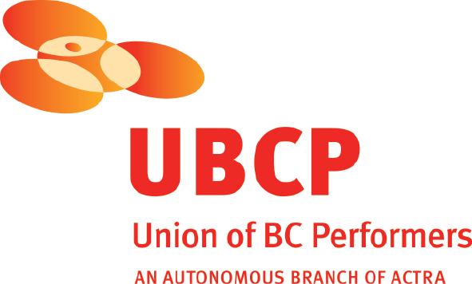
With the participation of the Province of British Columbia
Film Incentive BC
The Canadian Film or Video Production Tax Credit
© MMXX Charming Productions Inc. All Rights Reserved

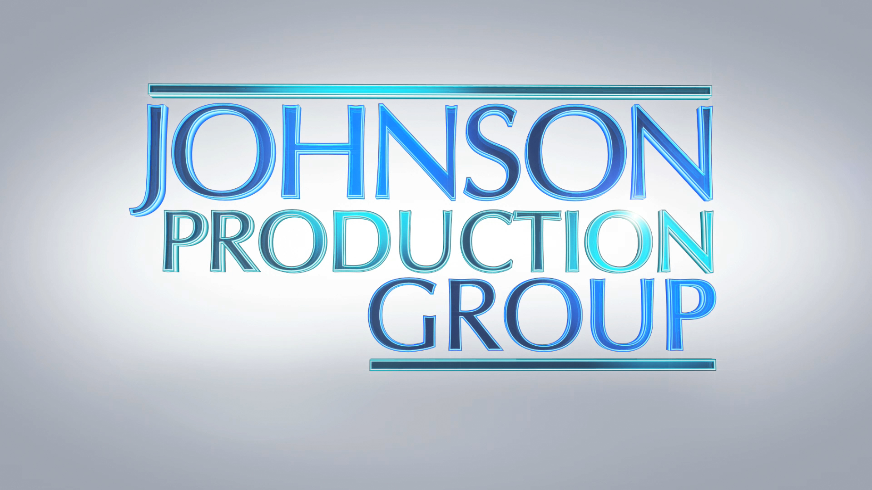

Meta Data

LONG (max 3000 characters) synopsis
Hannah Adams falls for more than teaching music when wood-worker Gavin McQueen (and his nine-year old daughter) move back to town after his wife’s passing. With a shared interest in the upcoming Kite Festival, Hannah becomes smitten with her new neighbour Gavin. But with an ex-girlfriend who makes it clear that she no longer wants to be an ex, Hannah finds difficulty in if knowing if Gavin is into her, as much as she is into him. (435)
MEDIUM (max 500) synopsis
Hannah Adams falls for more than teaching music when wood-worker Gavin McQueen (and his nine-year old daughter) move back to town after his wife’s passing. With a shared interest in the upcoming Kite Festival, Hannah becomes smitten with her new neighbour Gavin. But with an ex-girlfriend who makes it clear that she no longer wants to be an ex, Hannah finds difficulty in if knowing if Gavin is into her, as much as she is into him. (435)
SHORT (max 100 characters) synopsis
A music teacher finds unexpected love at the town's annual Kite Festival. (73)

5 KEY WORDS
Kite festival, windsurfing, widower, father

