Johnson Production Group

Press Kit

One-Liner
A stay-at-home mom takes in her struggling best friend to help her through a tough time but soon secrets are revealed that could tear her family apart and put everyone in danger.

Synopsis
Despite her husband's protests, a woman invites her pregnant best friend to stay with her until she can get on her feet. Soon secrets are uncovered and it turns out the husband is not who he says he is, and both women are endangered so they hatch a plan to flee with both of their children.
Paige and Michael have the picture-perfect life raising their young son Tanner together, who is the pride and joy of Michael's life. When Paige's closest friend Joslyn finds herself pregnant with nowhere to go, Paige doesn't hesitate to welcome her friend into her loving home. However, tensions begin to flair when Joslyn finally gives birth to her son, Sean, and it suddenly becomes urgent for Michael to get Joslyn and the baby out of the house. As he grows more impatient, Paige questions his motives and the blame of his financial concerns over having another pair of mouths to feed under his roof. Paige tries to keep the peace at home hoping she can find a solution for everyone and a safe place for Joslyn to stay.
One day, Paige discovers a birthmark on Joslyn's newborn, one that matches the same genetic birthmark that Michael and Tanner share. Rattled by this discovery, Paige confronts Joslyn accusing her of having an affair with her husband, but Joslyn insists Michael took advantage of her. Unsure what or who to believe, Paige begins to unravel the truth about her husband. She soon realizes Michael is not at all the man she thought he was. Searching for answers, she finds out he's involved in dangerous criminal activity that endangers both women and their young children. They know they need to stick together if they are going to survive. Will they be able to escape their house of deadly lies before it's too late?

Producers
Executive Producers
TIMOTHY O. JOHNSON
ANDREW C. ERIN
OLIVER DE CAIGNY
Co-Executive Producer
JOSEPH WILKA
Producer
TARALEE GERHARD

Key Cast
CHARACTER  Paige Johnson  Michael Johnson  Dolly  Joslyn  Det. Anderson  Tanner Johnson |  | ACTOR  KATY BREIER  JONATHAN MCLAREN  MARY WALSH  LEAH MCKENNEY  JUSTIN GERARD NURSE  LINCOLN MACNEIL

Key Cast Biographies

KATY BREIER
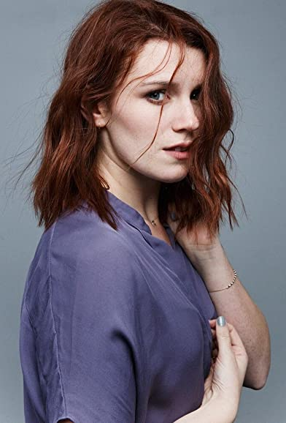
Katy Breier’s passion for acting began at an early age, but it was in 2010 that Katy had her big break when she landed a recurring role on the Syfy series Being Human.
Since then, her unique charm, quirk and emotional depth have caught the attention of casting directors and directors throughout the country and her career continues to grow and flourish.
Katy has landed recurring roles on show like FX’s The Strain and the award winning Canadian series Murdoch Mysteries. In 2018, Katy’s chilling portrayal of Nikki Meyers in the Lifetime MOW FANatic earned her a Canadian Screen Award nomination and an ACTRA award WIN for Best Supporting Role in a Drama. Most recently she can be seen in recurring roles on Amazon Prime Video's The Boys and Crave's Pillow Talk and will soon appear along side Jessie Buckley and Luke Wilson in Christos Nikou’s feature film Fingernails.
Feature film credits include Rebecca Addelman’s directorial debut Paper Year, the independent film The Calling opposite Susan Sarandon, Run This Town starring Nina Dobrev, Ben Platt, and Damian Lewis, and the action sci-fi film Moonfall starring Halle Berry.
Born and raised in Montreal Katy currently resides in Toronto. She is a graduate of the Dawson College Professional Theatre Program (DOME). her

JONATHAN MCLAREN
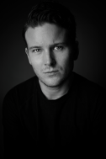
Jonathan McLaren is a BAFTA & ACTRA nominated actor with over 20 years of industry experience. He is best known for playing Star-Lord in Marvel’s Guardians of the Galaxy (Square Enix/Eidos), his recurring role as Jesse Stanton on the hit TV show Heartland (CBC/ Netflix), Jacob Reece in Blood & Treasure (CBS), and the voice of various characters in Ubisoft's smash video game, Far Cry 5.
Other Credits include: Titans S3 (Warner Bros/HBO Max), House at the End of the Street (Relativity Media), Private Eyes (eOne/Global), Picture Perfect Romance (Amazon/Super Channel), Good Witch (Hallmark/Netflix), and Cyberbully (ABC). Fans can see Jon next with upcoming performances in UpTV’s “Christmas on the Rocks” and “Sappy Holiday”. He is currently working in an Untitled Börje Salming’S drama from Warner Bros.
Off-screen, Jon loves spending down-time with family, friends, his two dogs (Argo & Jack) & playing a multitude of sports. He’s also founded what he calls the Ruffcut Collective; a passion project with an initiative towards charitable giving through community and various creative outlets.

MARY WALSH
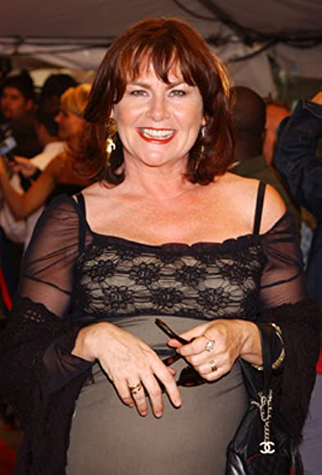
Mary Walsh is a Newfoundland actor, writer, comedian, activist and mother. Among her many awards and doctorates, Mary is also the recipient of The Order of Canada and the Governor General’s Lifetime Achievement Award in the Performing Arts.

No stranger to television audiences, Mary Walsh may be best known for her work on This Hour Has 22 Minutes, CBC’s wildly popular take on current affairs. The series, which she also created, earned her many of her numerous Gemini awards and showcased her dynamic range of characters, including the flagrantly outspoken ‘Marg Delahunty’.

Mary enjoyed 22 years as one of the hosts of This Hour Has 22 Minutes on CBC, a show she also created. The original This Hour Has 22 Minutes cast included Cathy Jones, Rick Mercer, Mary Walsh and Greg Thomey when it debuted in 1993. Hatching Matching and Dispatching aired for two seasons in 2005 and 2006. Mary played Mamie Lou Furey, the matriarch of a family in Cats Gut Cove, Newfoundland and Labrador who owned a combination ambulance, wedding and funeral business Mary had a great time as a recent guest on Chopped Canada on the Food Network.

Walsh wrote, produced and starred in the Gemini award winning Hatching, Matching and Dispatching, and more recent television credits include CBC’s Republic of Doyle, Global's Rookie Blue, and HBO Canada’s Sensitive Skin, for which she was nominated for a 2017 Canadian Screen Award.
Mary Walsh has enjoyed an exciting film career and has played roles in more than 15 films to date. She was nominated for two Genies for her performances in feature films Crackie (Official selection at TIFF) and New Waterford Girl.

LEAH MCKENNEY
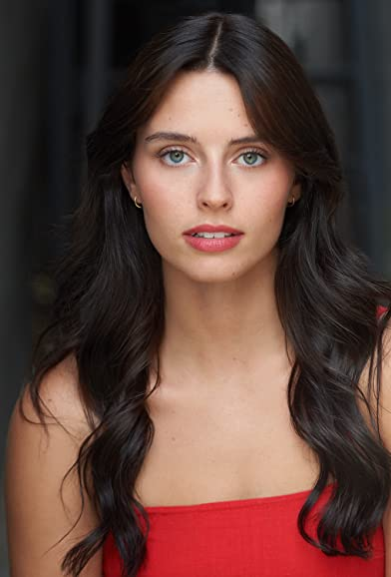
Leah McKenney is an actor, dancer, singer and model based in St. John’s, Newfoundland. She was the recipient of the 2019 Canada’s Walk of Fame Emerging Musician/Metalworks Institute Scholarship. Leah McKenney and received tuition scholarships at Metalworks Institute of Sound & Music Production.

JUSTIN GERARD NURSE
Justin Nurse is a multifaceted performer with a wide range of talents and professionally honed skills. As an actor he is capable of taking on both comedy and drama with remarkable skill. Justin is reliable and versatile. As both a exceptioanl singer and gifted actor Justin can deliver topnotch performances every time. Currently Justin is recording a number of Radio and Tv Commercials in his home province of NFLD and performing with his cover band Stixx N Stones and his big Band 709. His recent TV appearances include Behind Closed Doors, The Death of Winter, Hudson and Rex, Spin and Republic of Doyle.

LINCOLN MACNEIL
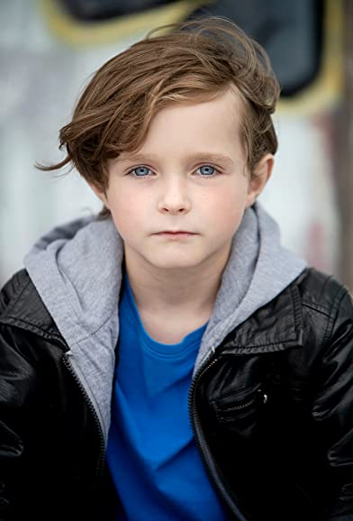
Lincoln MacNeil started acting this past year at age 7. His first supporting role was playing a scout in a whimsical short film called Scouter Joe. To further explore his interest in acting Lincoln worked as a photo double for 5 months for the hit tv show FROM and then accepted an offer to play young Justin in the feature film Bystanders shortly thereafter. He had a blast on set further cementing his interest in continuing to explore the arts with the support of his parents.
Since turning 8 years old Lincoln has held actor, principal, and supporting roles in both film and television.
Additional credits include a national commercial, a supporting principal role in a feature film followed by a second principal casting in another feature film; both which will air in 2023 and you can also catch him on episode 12 of season 30 of the iconic CBC show This Hour Has 22 Minutes.
Lincoln continues to be passionate about the TV & film industry and loves every moment on set with current aspirations to be a actor, scientist or a Director and make movies. In addition to his love of film, Lincoln enjoys traveling with his family, playing video games, lego, building, soccer, swimming, skiing, and biking. You can also find Lincoln playing with his dog Lando or his friends.
Lincoln MacNeil is based in Halifax, Nova Scotia, Canada.

Production Credits

Full Cast
Actors  KATY BREIER  JONATHAN MCLAREN  LEAH MCKENNEY  MARY WALSH  JUSTIN GERARD NURSE  MARY LEWIS  LINCOLN MACNEIL  GEOFF ADAMS  CHRIS ADAMS  MICHELLE LAMBERT  BRUCE BRENTON  RODNEY SQUIRES  ALEXIS KOETTING  JOSEPH MCGRATH  JOSEPH MCGRATH | Role  Paige Johnson  Michael Johnson  Joslyn  Dolly  Det. Anderson  Maeve  Tanner Johnson  Raymond  Brett  Ms. Bailey  Pawnshop Owner  Jeff  Doctor  Dad at BBQ  Motel Clerk

Casting
RON LEACH, c.d.c.

Composer
CATALIN MARIN

Costume Designer
MORGAN TODD

Editor
ALVIN CAMPANA

Production Designer
DAVE WHITTY

Director of Photography
MICHAEL TIEN

Written by
MATTHEW KEVIN ANDERSON

Directed by
PENELOPE BUITENHUIS

Other Crew
GLENN REDMOND | Stunt Coordinators
TOM DUNNE
BORYS SHAPOVALOV | First Assistant Director
JANA GILLIS | Second Assistant Director
MALLORY HORSMAN | Third Assistant Director
ALLIE DUFF | Set Production Assistant
MALLORY HORSMAN | Background Casting Director
ANDREW HAMMOND | Gun Wrangler
JUSTIN NURSE | Tutor
ZOË BALSOM | Production Coordinator
RANDY HUTCHINGS | Assistant Production Coordinator
MORGEN TAYLOR | Production Office Assistant
JOSHUA LANGE | Production Accountant
VICTORIA PICKETT | First Assistant Accountant (Payroll)
DAVE WHITTY | Production Designer
STEPHEN BUTLER | Art Director
MICHAEL LAWLOR | Art Swing
KOBE DILLON | Set Decorator
MICHAEL COLLIS | Props Master
MORGAN TODD | Costume Designer
KELSEY MAYE | Wardrobe Assistant
MICHAEL TIEN | Director of Photography
ADAM PENNEY | B Camera Operator
JOSEF GERHARDS | A Cam - First Assistant Camera
NICK EDGAR DUNNE | A Cam - Second Assistant Camera
MATTHEW FITZGERALD
GRAHAM GODDEN
STUART SIMPSON
SPENCER THOMPSON | B Cam - First Assistant Camera
RILEY HARNETT | B Cam - Second Assistant Camera
AARON ELLIOTT | Lab Technician
SARAH HOWSE | Stills Photographer
MARTIN TOBIN | Gaffer
ROBERT ALEXANDER PIKE | Best Electric
TIM SULLIVAN | Swing
MILES BARNES | Key Grips
JAMES HARRIS
JEREMY JESTICAN | Best Grip
ALEX TUCKER | Grip
DIEGO MEDINA | Sound Mixers
STEPHEN POND
MATTHEW FITZGERALD | Boom Operators
STEPHEN POND
ALEX TOPOLNISKI
DAVE CONNORS | Script Supervisors
NATHAN DAY
NATALIA HENNELLY | Continuity Coordinator
DANNY NOSEWORTHY | Location Manager
DION EMBERLEY | Assistant Location Manager
DAVE CONNORS | Location Scout
TYLO DUNNE | Location Production Assistants
DOUGAL MCDONALD
TRAVIS NOTFALL
ALEXANDER PIERCE
LAUREN SNOW | Key Makeup Artist
SAMANTHA KOSUB | Assistant Key Makeup Artist
MEGAN GREGORY | Makeup Assistant
ZACK CLARKE | Key Hair Stylist
MIKE WEBBER | Transport Coordinator
MATT SMITH | Transport Captain
DONNA CORCORAN | Drivers
PAUL ELLIOTT
DAVID FLEMING
SHANE NEWELL
ROD TAAFFE
JOVER DOLLIMONT | Safety Officer
JULIA MORRISSEY | Set Medic
DARREN COOPER | Caterer
MITCH "HUNGRY" HOBBS | Sous Chef
JEN NORMAN | Catering Assistants
CHERYL RYALL
DONNA CORCORAN | Key Craft Service
JANET CULL | Craft Service
PAUL ELLIOTT
HOLLYWOOD SCRIPT RESEARCH | Script Clearances
THE NO CONFLICT CLEARANCE COMPANY
HALL WEBBER LLP | Legal Services
DANNY WEBBER
ABOVE THE LINE MEDIA SERVICES | Business Affairs
BRENDAN MCNEILL
ARTHUR J. GALLAGHER CANADA LTD. | Insurance
ALEXANDRA WARING | Post Production Supervisor
URBAN POST PRODUCTION | Post Production Services
JOSEPH FACCIUOLO | Dialogue & ADR Editor
EHREN PFEIFER | ADR Recordist
OLIVIA KOLAKOWSKI | Sound FX Editor
TESS MOIR | Foley Artists
MATT THIBIDEAU
JESSICA SEVIER
DAVE MERCEL | Foley Recordists
JESSICA SEVIER
TESS MOIR
BRAD TIGWELL | Re-Recording Mixer
LUCAS CECCHETTI | Re-Recording Assistants
SOROOSH RAFIEI
EVAN GRAVES | VFX Artist
NIKA SHEVCHENKO | Colorist
KALI RAIGH | Online Editor
PETER TOKARSKY | Project Manager
BRUCE REES | Picture Operations Manager
ROBERTA BRATTI | V.P. of Operations
ISTOCK/JAMIEBYRD | Stock Footage
"ROAD RHYTHM"
BY BRUCE MAGINNIS
COURTESY OF AUDIO NETWORK LIMITED

"FITTING FANTASIA"
BY DOUG BOSSI AND TONY PHILLIPS
COURTESY OF NO TIME LIKE THE PRESENT MUSIC

"ROAD RHYTHM"
BY BRUCE MAGINNIS
COURTESY OF AUDIO NETWORK LIMITED

"GET ON TOP"
BY KEVIN BROWNE
COURTESY OF AUDIO NETWORK LIMITED

"LIKE A HIT AND RUN"
BY LEE RICHARDSON, JONATHAN MURRILL, TOM FORD AND JAMES CARLO COCOZZA
COURTESY OF EXTREME PRODUCTION MUSIC USA AND ARTFULLY ENTERTAINING MUSIC LIBRARY

Producer Biographies

TIM JOHNSON – Executive Producer
Tim Johnson is among the most active and reliable producers in the business thanks to top rate productions and global distribution appeal.
Johnson is also responsible for producing the international hit series, DR. QUINN, MEDICINE WOMAN for CBS for over 5 seasons. During his 100-episode tenure, he also developed and produced the original docu-drama COLD CASE for CBS network, which was the very first program to integrate television with the Internet.
Johnson has produced over 150 movies, 15 globally released series for every major US network - including ABC, Disney, CBS, NBC, Netfly, FOX and Sony.

JOHNSON PRODUCTION GROUP
The Johnson Production Group contracts globally to produce television content for international networks, studios and distributors. Based in Los Angeles and Vancouver, British Columbia, the company manages production, facilitates development and financing, procures distribution and guarantees quality and timely execution of its programs. While costs have gone up, so has the demand for quality. No longer is good enough, good enough. Johnson Production Group serves that segment when a show needs to be "A" quality, but produced efficiently enough to meet a locked budget. JPG specializes in value, protection of creative elements, and delivery of a quality finished product.

ANDREW C. ERIN – Producer
Andrew Erin is a Canadian Writer/Director making a big splash in the US, and has produced, written and directed numerous commercially successful films.
His directorial debut, SAM’S LAKE, was an official selection at the Tribeca Film Festival and did an excellent theatrical run in select theaters around the country; distributed by Lionsgate Films. Andrew also wrote the script for the film.
Andrew’s directorial credits include, SIMPLE THINGS, produced for Screen Media Ventures and Universal Studios. Besides winning The Bob Clark Award for Best Director at the California Independent Film Festival, the film was commercially received.
Andrew has worked continuously as a writer/director, building a strong library of films in the Thriller/Horror genres with: Embrace of The Vampire, The Clinic, Final Sale, Confined and Toxic Skies.
OLIVER DE CAIGNY – Supervising Producer
Oliver De Caigny is a Canadian producer originally from Belgium, his background in financing, production, and post production makes him a well-rounded producer for any type of production. His experience in financing and production agreements (film and TV series and movies-of-the week), distribution agreements (both domestic and foreign) as well as international co-productions, Canadian tax credit, Telefilm Canada and Canada Media Fund incentives provides him with a well-rounded background in development, production and distribution for motion pictures, television series and productions.

JOSEPH WILKA – Co-Executive Producer
Joseph Wilka is the Head of Production for Johnson Production Group. Los Angeles-based, Joseph had already produced and directed several feature films before serving as the senior marketing executive for Gravitas Ventures. While at Gravitas, Wilka helped pioneer new distribution models for independent films including day-and-date theatrical releases. It was also at Gravitas where Joseph first worked with Johnson Production Group to facilitate the release of their films to the worldwide Video On Demand audience. After serving as the Director of Distribution and Production for Viva Pictures, where he produced English-language versions of foreign animated titles for DirecTV, Wilka officially joined Johnson Production Group. As Head of Production, he oversees the development, production, and distribution of films from multiple production units for release on broadcast and streaming platforms.

TARALEE GERHARD– Producer
Taralee Gerhard committed to following her dream of making movies almost 20 years ago when the film industry was in its infancy in Ottawa. She spent several years with Fireside Pictures in Ottawa and truly cares about the family culture that Fireside has fostered amongst the crew, supporting each other's big sky dreams, making movies to be proud of. During the Covid-19 pandemic, the spirit of taking risks and following her heart lead Taralee to Newfoundland and she remains truly grateful to be able to continue working with Fireside Pictures as an in house Producer opening a new territory, expanding the Fireside Family and helping to foster the independent film industry in Newfoundland.

Billing Block
LIFETIME Presents In Association With JOHNSON PRODUCTION GROUP
HOUSE OF DEADLY LIES Starring KATY BREIER JONATHAN MCLAREN MARY WALSH LEAH MCKENNEY JUSTIN GERARD NURSE LINCOLN MACNEIL Casting RON LEACH, c.d.c. Composer CATALIN MARIN Costume Designer MORGAN TODD Editor ALVIN CAMPANA Production Designer DAVE WHITTY Director of Photography MICHAEL TIEN Co-Executive Producer JOSEPH WILKA Executive Producers ANDREW C. ERIN OLIVER DE CAIGNY TIMOTHY O. JOHNSON Producer TARALEE GERHARD Written by MATTHEW KEVIN ANDERSON Directed by PENELOPE BUITENHUIS
The Canadian Film or Video Production Tax Credit
© MMXXII BCD Productions Inc. & BCD Ontario Films Inc. All Rights Reserved

Meta Data
LONG (max 3000 characters) synopsis
Despite her husband's protests, a woman invites her pregnant best friend to stay with her until she can get on her feet. Soon secrets are uncovered and it turns out the husband is not who he says he is, and both women are endangered so they hatch a plan to flee with both of their children.
Paige and Michael have the picture-perfect life raising their young son Tanner together, who is the pride and joy of Michael's life. When Paige's closest friend Joslyn finds herself pregnant with nowhere to go, Paige doesn't hesitate to welcome her friend into her loving home. However, tensions begin to flair when Joslyn finally gives birth to her son, Sean, and it suddenly becomes urgent for Michael to get Joslyn and the baby out of the house. As he grows more impatient, Paige questions his motives and the blame of his financial concerns over having another pair of mouths to feed under his roof. Paige tries to keep the peace at home hoping she can find a solution for everyone and a safe place for Joslyn to stay.
One day, Paige discovers a birthmark on Joslyn's newborn, one that matches the same genetic birthmark that Michael and Tanner share. Rattled by this discovery, Paige confronts Joslyn accusing her of having an affair with her husband, but Joslyn insists Michael took advantage of her. Unsure what or who to believe, Paige begins to unravel the truth about her husband. She soon realizes Michael is not at all the man she thought he was. Searching for answers, she finds out he's involved in dangerous criminal activity that endangers both women and their young children. They know they need to stick together if they are going to survive. Will they be able to escape their house of deadly lies before it's too late? (1727)
MEDIUM (max 500) synopsis
A stay-at-home mom takes in her struggling best friend to help her through a tough time but soon secrets are revealed that could tear her family apart and put everyone in danger.
(178)
SHORT (max 100 characters) synopsis
A mom takes in her struggling friend but soon secrets are revealed that could tear her family apart.
(100)

5 KEY WORDS
Friends, birthmark, betrayal, baby, danger

