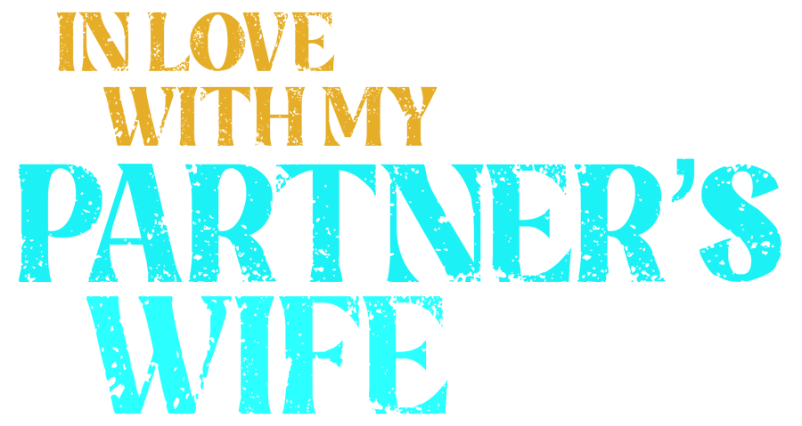

Johnson Production Group

Press Kit

# One-Liner

A police detective defends his abusive partner’s wife and gets framed for murder.

# Synopsis

# When detective Paul Ford discovers his partner, Frank, is abusing his wife Eve, Paul steps in to rescue her, but a vengeful Frank frames him for a murder. With Paul on the run from his fellow officers and Eve on the run from her husband, the two find themselves escaping into a heated love affair.

# Producers

Executive Producers

TIMOTHY O. JOHNSON

JOSEPH WILKA

Producer

A.J. KELLY

Key Cast

|  |  |  |
| --- | --- | --- |
| CHARACTER  Eve Miller  Paul Ford  Frank Miller  Andrea Billings  Captain Anderson |  | ACTOR  GINA VITORI  ANDREW SPACH  JONATHAN STODDARD  ISABELLA OLIVEIRA  NICOLE PULLIAM |

# Key Cast Biographies

# GINA VITORI

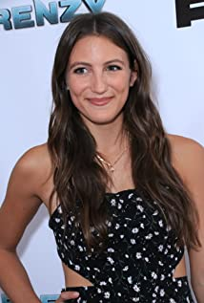Originating from the Island that is Long in NY, Gina officially moved to Manhattan to pursue her dream at New York University's Tisch School of the Arts. After training with incredible teachers and fellow actors at the Atlantic Acting School and Stonestreet Studios, she received her BFA in Acting. (Then Lesly Kahn told her to forget everything she knows about acting, and UCB taught her to 'yes and'). She now lives in sunny Los Angeles, where she spends her days on screen battling sharks and stalkers, and off screen surfing and training Martial Arts.

Gina is known for her starring roles in the original SyFy movie, 'Frenzy', as well as becoming a bit of a 'Lifetime' leading lady - most recently in 'Deadly Girls Night Out'. She can also be seen co-starring on '9-1-1' on FOX, and 'The Affair' on Showtime. Other fun roles include a Lara Croft knockoff, alcoholic farmer, and a singing mermaid for a live 2000 seat audience in Alaska.

# ANDREW SPACH

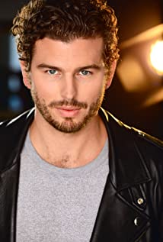Andrew Spach is an American actor. He is a graduate of the Meisner Technique Studio in San Francisco where he studied with Jim Jarrett (Sanford Meisner's last teaching protégé) along with Melissa Thompson Esaia. He also studied more recently with Steve Eastin in Los Angeles.

Andrew is known for his work in An Organized Killer, General Hospital and the upcoming Angels of Mercy. He now resides in Los Angeles, CA.

# JONATHAN STODDARD

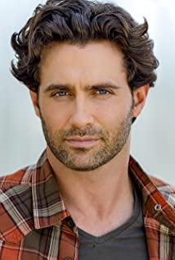Jonathan Stoddard started his acting career on the stage performing dramatic and musical theater portraying such roles as the Emcee in Cabaret and Tony in West Side Story. He has starred in over 30 feature films such as SOMEWHERE IN MONTANA, FURRY LITTLE CHRISTMAS and Hallmark’s ROME IN LOVE, and television shows, including Showtime's "Black Monday Season 2" and CBS’s Daytime Drama "The Young and the Restless” for 3 years.

Jonathan has an additional 10+ feature films releasing in 2022 and 2023 from Rom-Coms to Suspense to Supernatural Horror to Classic Comedies, so get ready to see him everywhere!

Jonathan is a also an accomplished singer/songwriter with multiple industry cuts and hit songs.

# ISABELLA OLIVEIRA

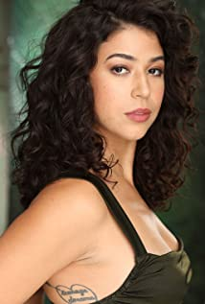Isabella Oliveira was born in Brasil and raised in LA with Jazz legend, Wayne Shorter, as an uncle, and a family of larger than life producers of the first Los Angeles Brasilian Carnival. Her first performance was at age 8, dancing the Samba at the Hollywood Palladium.

She began her professional career at 11, after being discovered by an agent a showcase, and auditioned for film and television through her formative years. She eventually attended the Los Angeles County High School for the Arts. There, she was able to fully delve into her love of the art of acting; training in Shakespeare, Suzuki/Viewpoints, Physical Theatre, and Directing.

Upon graduating high school, she trained with renowned theatre director Jon Jory before moving to New York to attend the New School for Drama. There she honed her craft, writing, directing and performing with Manhattan Theatre Repertory, Bank Street Theatre, and theatre director Sherri Eden Barber. She has performed at the largest theatre festival in the world at Edinburgh Fringe Festival in Scotland, as well as Shakespeare Theatre LA.

She now lives in Los Angeles, where she continues to dance to Brasilian music, hone her craft, and is committed to the representation of POC in film and television behind and in front of the camera.

**NICOLE PULLIAM**

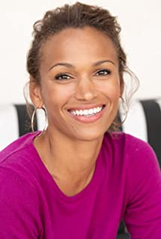Born and raised in Columbus, Ohio, Nicole knew from a very young age that she wanted to pursue a career as a performer. To that end, she participated in several school productions while growing up, and completed numerous acting classes throughout her life. She started out slowly by taking on modeling and commercial gigs in her native Ohio, and eventually worked up the courage to move out to Hollywood. Living bi-coastal between NYC and LA, Nicole began the tedious process of auditioning. She quickly landed small roles in films and television and has been a working actress ever since.

# Production Credits

### Full Cast

|  |  |
| --- | --- |
| [Actors](http://www.imdb.com/name/nm7589451/?ref_=ttfc_fc_cl_t1)  GINA VITORI  ANDREW SPACH  JONATHAN STODDARD  ISABELLA OLIVEIRA  NICOLE PULLIAM  CORBIN TIMBROOK  JOHNNY DINAN  ROBERT MILLER  JACOB HORN | Role  Eve Miller  Paul Ford  Frank Miller  Andrea Billings  Captain Anderson  Callaghan  Jeffrey  Brian  Pizza Guy |

### Casting By

JEFF HARDWICK CSA

### Production Designer

ROBERT WISE

### Director of Photography

NICK ALBERT

### Edited By

THIJS BAZELMANS

### Music By

ANDREW SKRABUTENAS

### Line Producer

JACOB HORN

### Written By

PAULA RAHN

### Directed By

LINDSAY HARTLEY

### Other Crew

|  |  |
| --- | --- |
| AMANDA SEARS | Production Coordinator |
| MARIIETTA VOLYNSKA | Location Manager |
| TEMPEST MONTGOMERY | 1st Assistant Director |
| MELODI TUNA | 2nd Assistant Director |
| TYLER DUVAL | Additional 2nd Assistant Director |
| MIKE ESCAMILLA | Stunt Coordinator |
| KARIM PHELPS | Stunt Co-Coordinator |
| ERIC ENROTH | Sound Mixer |
| CHRISTOPHER ADAM HRUBY | Additional Sound Mixer |
| DREW FRANZBLAU | Boom Operator |
| ROBERT WISE | Production Designer |
| NOEL MAGNUSSON | Prop Master |
| TONY PAULLEY | Prop Master |
| ASHLEY BAKER | Art Director |
| FRED MANCHENTO | Graphics |
| NATHAN MEADE | Steadicam Operator |
| JONATHAN WANG | Second Camera Operator |
| GEORGE ELLETT | 1st Assistant Camera |
| NATE JONES | Additional 1st Assistant Cameras |
| HARRISON WAYNE |  |
| JACOB LALLAS | BCAM 1st Assistant Camera |
| LENA LEE | Additional BCAM 1st Assistant Camera |
| AMY FRYE | 2nd Assistant Camera |
| JUSTIN HARTSAW | Additional 2nd Assistant Cameras |
| AUSTIN WEBSTER |  |
| MAURICE SALLAVE | Drone Operators |
| AUSTIN AHLBORG |  |
| PETE AGUIRRE | Media Manager |
| KEN SAX | Stills Photographer |
| JEFF MARLOWE | Gaffer |
| ANDREW CHOE | Best Boy Electric |
| SCOTT SUMMERS | Additional Best Boy Electrics |
| DEVIN CONNER |  |
| WADE PATTERSON | Electrics |
| XAVIER DUBOSE |  |
| PETER G HOWELL | Key Grip |
| SERGIO NAVA | Best Boy Grip |
| JOSHUA TOLON | Dolly Grip |
| KINGSLEY COSTIN | Additional Dolly Grips |
| JACKSON RICHARDSON |  |
| KESHIA SMITH | Key Make-Up Artist |
| DANIELLE LOUISE | Make-up Artist |
| CORTNEY WATSON | Key Hair Stylist |
| JAYNE SEWARD | Costume Designer |
| ADRIENNE REISHUS | Wardrobe Assistant |
| MARILYN MILLER | Script Supervisor |
| GREG SABA | Production Assistants |
| KAT NOLTE |  |
| BROOKE SHARLAND |  |
| ARIES LOUIZIA |  |
| STEVE RODGERS |  |
| CHIJIOKEAKUJUOBI |  |
| RICHMOND KEELING |  |
| TRAVIS LOWE |  |
| ERIK TROY |  |

# Producer Biographies

TIM JOHNSON – Executive Producer

Tim Johnson is among the most active and reliable producers in the business thanks to top rate productions and global distribution appeal.

Johnson is also responsible for producing the international hit series, DR. QUINN, MEDICINE WOMAN for CBS for over 5 seasons. During his 100-episode tenure, he also developed and produced the original docu-drama COLD CASE for CBS network, which was the very first program to integrate television with the Internet.

Johnson has produced over 150 movies, 15 globally released series for every major US network - including ABC, Disney, CBS, NBC, Netfly, FOX and Sony.

## JOHNSON PRODUCTION GROUP

The Johnson Production Group contracts globally to produce television content for international networks, studios and distributors. Based in Los Angeles and Vancouver, British Columbia, the company manages production, facilitates development and financing, procures distribution and guarantees quality and timely execution of its programs. While costs have gone up, so has the demand for quality. No longer is good enough, good enough. Johnson Production Group serves that segment when a show needs to be "A" quality, but produced efficiently enough to meet a locked budget. JPG specializes in value, protection of creative elements, and delivery of a quality finished product.

## JOSEPH WILKA – Co-Executive Producer

Joseph Wilka is the Head of Production for Johnson Production Group. Los Angeles-based, Joseph had already produced and directed several feature films before serving as the senior marketing executive for Gravitas Ventures. While at Gravitas, Wilka helped pioneer new distribution models for independent films including day-and-date theatrical releases. It was also at Gravitas where Joseph first worked with Johnson Production Group to facilitate the release of their films to the worldwide Video On Demand audience. After serving as the Director of Distribution and Production for Viva Pictures, where he produced English-language versions of foreign animated titles for DirecTV, Wilka officially joined Johnson Production Group. As Head of Production, he oversees the development, production, and distribution of films from multiple production units for release on broadcast and streaming platforms.

## A.J. KELLY – Producer

Producer and co-founder of the creative production company, Goodform, A.J. Kelly has spent the past decade creating film, television, documentary, experiential and branded content. His work has won awards at top festivals including Cannes & SXSW, aired on premium networks and received multi-cultural acclaim.

Based in Los Angeles, A.J. believes in elevating content from diverse creative voices and providing an outlet for filmmakers to bring their stories to life.

## Billing Block

Johnson Production Group Presents with Lifetime “IN LOVE WITH MY PARTNER’S WIFE”  
starring GINA VITORI ANDREW SPACH JONATHAN STODDARD ISABELLA OLIVEIRA NICOLE PULLIAM Casting By JEFF HARDWICK CSA Production Designer ROBERT WISE Director of Photography NICK ALBERT Edited By THIJS BAZELMANS Music By ANDREW SKRABUTENAS Executive Producers TIMOTHY O. JOHNSON JOSEPH WILKA   
Produced by A.J. KELLY Line Producer JACOB HORN Written By PAULA RAHN   
Directed By LINDSAY HARTLEY

© MMXX Johnson Production Group Inc. All Rights Reserved





Meta Data

LONG (max 3000 characters) synopsis

When detective Paul Ford discovers his partner, Frank, is abusing his wife Eve, Paul steps in to rescue her, but a vengeful Frank frames him for a murder. With Paul on the run from his fellow officers and Eve on the run from her husband, the two find themselves escaping into a heated love affair. (298)

MEDIUM (max 500) synopsis

When detective Paul Ford discovers his partner, Frank, is abusing his wife Eve, Paul steps in to rescue her, but a vengeful Frank frames him for a murder. With Paul on the run from his fellow officers and Eve on the run from her husband, the two find themselves escaping into a heated love affair. (298)

SHORT (max 100 characters) synopsis

A police detective defends his abusive partner’s wife and gets framed for murder. (81)

5 KEY WORDS

Police, detective, abusive, romance, murder