Johnson Production Group

Press Kit

One-Liner
Gina, a struggling fashion photographer, is forced to rent out her guest house as a means of paying the mortgage. But when her new tenant, a hunky pilot, is revealed to be a dangerous and womanizing con-man, Gina finds herself in the shoot of her life.

Synopsis
When Gina, a struggling fashion photographer, agreed to take over the mortgage to her childhood family home, she didn’t consider what a financial burden it would have on her artistic career. One missed payment away from defaulting on her mortgage, she is desperate. So desperate that she still takes photos for her ex- boyfriend Levon Starret, who still has a thing for Gina. Knowing that these tiny gigs can’t cover her mortgage, she is cajoled by her best friend, Rachel, into using her skills to take amazing photos of her property and rent out her guest house on a short-term rental site. With some more playful encouragement from Rachel, Gina does an impressive photo shoot of her gorgeous family estate. She then creates her online profile for the site while sitting in her studio. The space is cinematic and impressive: lots of art, camera lenses, large printers – and a computer display that projects onto the wall (that actually lets her walk into the picture). In a moment of distraction, Gina finds and clicks on her portfolio, which also projects onto the large wall. The images are beautiful and clearly show her talent. Gina sighs, looks back to her computer – and confirms her profile on the rental site.
The next morning, she wakes to many online notifications about the guest house. After declining numerous candidates/creeps, Gina finds the profile for Mark James. Not only is he drop-dead gorgeous (so says Rachel), but he’s an accomplished airplane pilot, with an impeccable rating (and 6-pack). Yes, there’s a picture of Mark playing tennis shirtless. Rachel teases Gina about her intentions with “Fabio McEnroe”, but agrees that the handsome pilot who can pay rent is just what the doctor ordered. With Rachel texting for constant updates, Gina meets Mark James, who shows up dressed in his pilot’s uniform, fresh off of a flight, and who is even more impressive in person. Smitten, but playing it cool, she shows Mark around the property. He takes notice of her photography studio and confesses to be a budding amateur videographer. She’s impressed. Mark also learns about Gina’s true goal of making it really big as a full-time photographer, and he encourages her to apply to the big agencies, which she does!
Gina confides in Rachel that Mark is a dream tenant. He cooks (BBQs in the backyard), cleans, works out - and still finds time to tend to her gardening. Rachel can tell that the heat is on and warns Gina not to jump in too quickly. It’s at that time, that Gina gets a call from Robert Simms, a suave man and an icon in the photo/fashion industry. Simms loved Gina’s submission and would like her to come work for him. Gina is thrilled. She tells Mark about the good news – and they celebrate. But this celebration is cut short when Levon shows up at Gina’s house, demanding to see the pictures she took as his client. Gina won’t hand the pictures over until Levon pays in full, which Levon won’t do. Levon and Mark have a run-in, and Mark promises to protect Gina from her ex.
Quickly Mark and Gina develop a passionate routine together, going on day trips, taking photos of Mark, Mark taking photos of Gina. Gina tells Mark that he is the first guy to really listen to her and embrace her for who she really is. They are actually falling for each other.
Gina then begins her first day with Robert Simms, taking photos at his agency. Things get off to an excellent start, but when Robert Simms is found dead by suicide at his own annual gala, a pair of police detectives show up and start to ask Gina questions. They let her know that they also have evidence that Levon Starret is missing and likely dead as well. Gina is consoled by Mark, who is brilliant at deflecting and coming up with alibis right in front of the detectives. Mark suggests that Gina need to be careful who she lets into her studio. Consoled by Rachel, who spends the night, Gina is encouraged to not give up on her dreams.
As things escalate, Gina starts to suspect that something is off with Mark. She begins to clean up her most recent project, a time-lapse photography recording, and sees something odd. A few of her time-lapse shots have a distinct shape blocking a few frames. Gina zooms in and is startled to see that the images are of a very bloodied up Mark, walking across the frame, the very night of Levon’s disappearance!
Feeling brave and desperate, she breaks her own house rules and enters Mark’s suite. She finds video evidence that Mark killed Levon. He is crawling away from camera, being relentlessly pursued by a sadistic Mark, who taunts him, telling him to leave Gina alone. As she watches the computer… boom – Mark is suddenly in the room. Gina confronts Mark about who he really is. She can’t believe she trusted him. A terrifying cat and mouse chase ensues through Gina’s studio, with the projector running and causing all sorts of visual trickery – aiding to distract Mark. Eventually, with a final confrontation in front of the time-lapse cameras, Mark tries to strangle Gina. With hope all but lost, Gina manages to use a short-circuiting wire to electrocute Mark – and stop him once and for all.
As a new day dawns, we find Gina in a picturesque location, taking photos of Rachel and her fiancé Tom. Gina never wants to let a man get in the way of her art again. She also mentions the good news: she sold her series of time-lapse pictures (of her kissing Mark) to a magazine publication. With Mark locked up in prison and Gina take pictures – life is good. But as we fade away, we sense someone is watching Gina from an obscured angle.

Producers
Executive Producer
TIMOTHY O. JOHNSON
Producer
NAVID SOOFI
Supervising Producer
OLIVER DE CAIGNY

Key Cast
CHARACTER  Gina Larson  Mark James  Levon Staret  Rachel Vine  Deputy Michaels  Detective Sheila Brown  Robert Simms |  | ACTOR  CHELSEA HOBBS  MARCUS ROSNER  MATTHEW KEVIN ANDERSON  CORINA BIZIM  AIDAN KAHN  SHARON TAYLOR  MARK HUMPHREY

Key Cast Biographies
CHELSEA HOBBS

Chelsea was born in Vancouver, Canada and entered the world of film and television at just 8 years old. As a child, Chelsea filmed over 80 commercials. Her first big break came when she starred alongside Bridget Fonda in Hallmark's timeless mini-series Snow Queen, earning her a best actress Leo award nomination. It wasn't long after that she booked her own pilot, starring in FOX's Save the Last Dance. Chelsea then graduated high school early through home schooling and moved to Los Angeles alone at the tender age of 17.

Over the next several years she made a name for herself in Hollywood starring in various TV films and guest starring on hit shows such as CSI, The L Word, CSI: Miami, Cold Case and HBO's Transporter. Chelsea was also fortunate to work alongside the late Heath Ledger in Sony picture's feature film Lords of Dogtown, which has since become a cult classic.

It was her lead role as underdog Emily Kmetko in Freeforms hit gymnastics drama, Make It Or Break It that solidified Chelsea's presence on the small screen. Following this success Chelsea had her second child, and moved back to Vancouver to raise her two children as a single mother.

Most recently Chelsea has heavily recurred on season 3 of the Emmy nominated Lifetime/Hulu series UnReal, guest starred on Girlfriends Guide to Divorce, Rogue, Lucifer, Motive, Supernatural, and Take Two, as well as several upcoming films including Tosca Musk's adaptation of Ruth Clampett's best selling novel Mr. 365. Chelsea is continuing to have a solid career excelling as an actress, and is excited to bring her own material to big and small screens with Jovanna in 2019.

MARCUS ROSNER
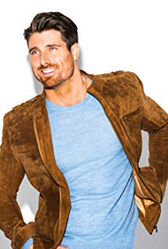
Marcus Rosner is a Canadian actor born on the west coast of British Columbia but raised on the prairies of Sherwood Park, Alberta. He started acting in 2012 and some of his more notable roles include appearances in the TV Shows UnREAL, Arrow, Supernatural, and Once Upon a Time to name just a few.

MATTHEW KEVIN ANDERSON

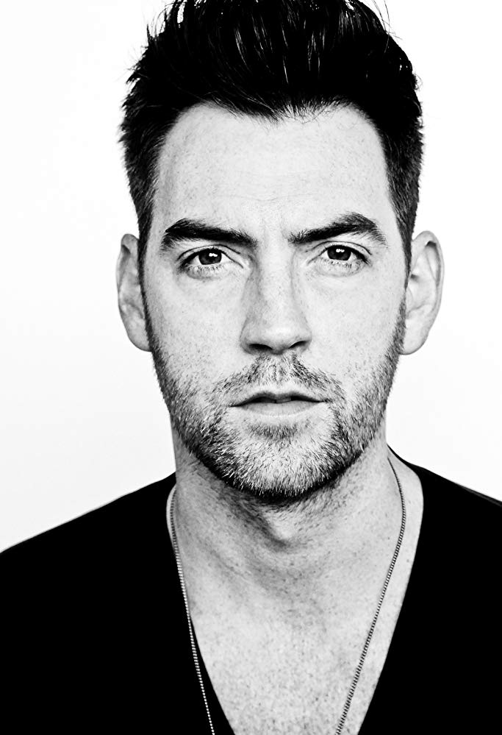
As of 2016 Matthew Kevin Anderson is currently recurring on 3 series including the much anticipated show from Mad Men writer Jonathan Abrahams “The Arrangement” on E! Network, Season 2 of TV Lands quirky comedy “Impastor” and “The Gourmet Detective” series on Hallmark.

After years of working and training in Los Angeles Matthew moved back to Vancouver where he continues to grow his career with great roles and share his experiences as a teacher and coach to local actors.

With his busy acting schedule Matthew has proven he knows how to get into ‘the booking zone’ and stay there. He is passionate about helping other actors do the same.

CORINA BIZIM
Ana Corina Bizim, best known for being a TV Actress, was born in Toronto in 1994. First known for playing Talia in the popular series Degrassi: The Next Generation, she has since starred in films like Pregnant at 17 and Beeba Boys.

AIDAN KAHN
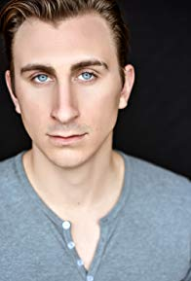
Aidan Kahn is an American/Canadian actor and filmmaker. He was born in California and moved to Canada at the age of 10. His brother is actor Rowen Kahn and his father is producer Harvey Kahn. In addition to acting, he was a music consultant and composed songs for HBO's "Lewis & Clark". Kahn studied abroad in Paris at Sciences Po and speaks French. He is an alumnus of Vassar College (class of 2014).

SHARON TAYLOR
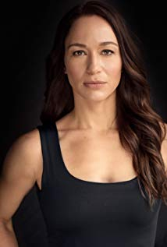
Sharon Taylor was born and raised in Vancouver, British Columbia. She received her Bachelor of Fine Arts degree in theatre from Simon Fraser University, and worked extensively in theatre for many years before making the leap to TV and Film. She has been seen most recently in the TV movie Surveillance and TV Series Altered Carbon, Blood & Treasure, Jann, Bad Blood and The X Files.
Sharon has trained in martial arts for over 15 years and has her 2nd degree black belt in karate kickboxing.

MARK HUMPHREY
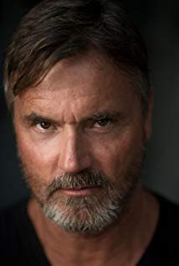
Mark Humphrey is a Canadian actor who has appeared in a variety of television series throughout his career. Mark is probably best known for his role as Jake Antonelli in the Canadian TV series E.N.G. Mark's acting talents have also been featured in several movies. He made his film debut starring in the feature film Iron Eagle II (1988) as Captain Matt Cooper. Mark's recent work includes the TV movie, Christmas Bells Are Ringing and as a series regular in When Calls the Heart.
Mark was born in Vancouver, British Columbia to radio and television producer Jack Humphrey and his wife Sidney. After graduating from high school in Toronto, Ontario, Mark moved to New York to pursue his acting career and study at the Lee Strasberg Theatre Institute. Mark resides in Los Angeles, but his work frequently brings him to Vancouver and Toronto.

Production Credits

Full Cast
Actors  CHELSEA HOBBS  MARCUS ROSNER  MATTHEW KEVIN ANDERSON  CORINA BIZIM  MARK HUMPHREY  SANGEETA WYLIE  NATALIE GIBSON  IAN COLLINS  AIDAN KAHN  JUNE B. WILDE  SHARON TAYLOR  ALEXANDRE DUONG  CHAD SAYN  LEIF HAVDALE  LEANNE BUCHANAN  DOUGLAS ARMSTRONG | Role  Gina Larson  Mark James  Levon Staret  Rachel Vine  Robert Simms  Bank Manager  Receptionist  Patrick Wilcox  Deputy Michaels  Phyllis  Detective Sheila Brown  Tom  Stunt Coordinator  Levon Stunt Double  Gina Stunt Double  Mark Stunt Double

Produced by
TIMOTHY O. JOHNSON |  | executive producer
NAVID SOOFI |  | producer
OLIVER DE CAIGNY |  | supervising producer

Written and Directed by
TONY DEAN SMITH

Casting by
JUDY LEE

Production Designer
ERIC CARBERY

Director of Photography
GABRIEL MEDINA

Edited By
DEVIN TAYLOR

Music by
ANDY FORSBERG

Full Crew
NAVID SOOFI | production manager
MICHAEL BISHOP | first assistant director
CLAUDE PAVEL | second assistant directors
ERIC CARBERY | set decorators
JOHN CASTREJON | assistant set decorator
TINA MULARCZYK | set dressers
NICHOLAS BERRNS
WALDEN CAMERON
GORD BECHLER
EVAN JONES
TERRY NELSON | on set dresser
MELODY WILSON | property master
ISABELLE FALLU | make-upartist
KATE ELLIS | hair stylist
SAMANTHA DEMPSEY | make-up and hair swing
STACEY BRADDER | costume designer
JOSH HOYLES | assistant costume designer
MANDY KOZIE | truck costumer
ROBIN METCALFE | set supervisor
CINDY HILLICKE | costume assistant
JUSTIN SEBASTIAN | first assistant camera
RANDY MEEHAN | second assistant camera
MIGUEL ANGEL HELU | key grip / gaffer
PATRICK SUTHERLAND | best boys
WARREN TIPLADY
JARED CHEER | electric
TOBIAS SOLEY
BARRY HUNT | security
CELESTE CROWE | location manager
ANA ADLER | assistant location managers
ALLY LYDYNUIK
MICHELE TOLOSA | location scouts
RICHARD TICKNER
NATHAN ADLER | key locations
RISSA GUTHRIE
PHILIP LICHTI
RICHARD BELL
KIM SVENNINGSEN
NOAH MEYERS | production sound mixer
 | & boom operator
BRIA WILK | script supervisor
PARALEE COOK | production accountant
LAURA GELUCH | accounting assistants
JUDY COOK
HADRIAN RAJOTTE | business affairs
JANE GOLDSMITH-JONES | production coordinator
CALSEY DIGGENS | third assistant director
MICHELE TOLOSA | background coordinator
CHRISTINA MORAN | craft service/first aid
ROOTS TO SHOOTS | catering
CIARRA COOK | casting assistant
LA HILTS | extras casting
PAULA LOEWEN | stand-in
COASTAL CLEARANCES | script clearances
CHANDLER FOGDEN ALDOUS  LAW CORPORATION | legal services
FRONT ROW INSURANCE  BROKERS | insurance
LEAH MYERS | post production supervisor
DAVID BALISTA | assistant editor
EVAN GRAVES | visual effects
SEVÉ SCHELENZ | colourist
CINESCOPE SOUND | audio post production
GREGOR PHILLIPS | supervising sound editor
GREGOR PHILLIPS | re-recording mixers
AARON OLSON | dialogue editorS
ELAN GABRIEL
CRAIG GEORGE | sfx editor
ALEX MACIA  DEVON QULCH | foley artists
FINALÉ POST | additional post services

Producer Biographies

TIM JOHNSON – Executive Producer

Tim Johnson is among the most active and reliable producers in the business thanks to top rate productions and global distribution appeal. Johnson is also responsible for producing the international hit series, DR. QUINN, MEDICINE WOMAN for CBS for over 5 seasons. During his 100-episode tenure, he also developed and produced the original docu-drama COLD CASE for CBS network, which was the very first program to integrate television with the Internet. Johnson has produced over 150 movies, 15 globally released series for every major US network - including ABC, Disney, CBS, NBC, Netfly, FOX and Sony.

JOHNSON PRODUCTION GROUP
The Johnson Production Group contracts globally to produce television content for international networks, studios and distributors. Based in Los Angeles and Vancouver, British Columbia, the company manages production, facilitates development and financing, procures distribution and guarantees quality and timely execution of its programs. While costs have gone up, so has the demand for quality. No longer is good enough, good enough. Johnson Production Group serves that segment when a show needs to be "A" quality, but produced efficiently enough to meet a locked budget. JPG specializes in value, protection of creative elements, and delivery of a quality finished product.
OLIVER DE CAIGNY - Producer
Oliver De Caigny is a Canadian producer originally from Belgium, his background in financing, production, and post production makes his a well-rounded producer for any type of production. His experience in financing and production agreements (film and TV series and movies-of-the week), distribution agreements (both domestic and foreign) as well as international co-productions, Canadian tax credit, Telefilm Canada and Canada Media Fund incentives provides him with a well-rounded background in development, production and distribution for motion pictures, television series and productions.
NAVID SOOFI – Supervising Producer
Navid is the primary producer for Novus Ordo Seclorum. Navid’s passion for filmmaking along with his business and engineering background plays an important role in creating a successful and transparent business model. Navid has been in the entertainment industry for more than 13 years and has produced over 50 feature films, TV shows and commercials that have been featured on national television, international theatres, and new media platforms. His credits include Over the Moon in Love, The Mistletoe Secret, Random Acts of Christmas, Love Unleashed, Identity Theft of a Cheerleader, and A Mother on the Edge.

Billing Block

Johnson Production Group Presents “KILLER IN THE GUESTHOUSE”
CHELSEA HOBBS MARCUS ROSNER MATTHEW KEVIN ANDERSON CORINA BIZIM AIDAN KAHN SHARON TAYLOR and MARK HUMPHREY Casting by JUDY LEE Production Designer ERIC CARBERY Director of Photography GABRIEL MEDINA Edited By DEVIN TAYLOR Music by ANDY FORSBERG Executive Producer TIMOTHY O. JOHNSON Produced by NAVID SOOFI Supervising Producer OLIVER DE CAIGNY Written and Directed by TONY DEAN SMITH

With the participation of the Province of British Columbia
Film Incentive BC
The Canadian Film or Video Production Tax Credit
© MMXX Thriller Productions Inc. All Rights Reserved

Johnson Production Group

Meta Data
LONG (max 3000 characters) synopsis
When Gina, a struggling fashion photographer, agreed to take over the mortgage to her childhood family home, she didn’t consider what a financial burden it would have on her artistic career. One missed payment away from defaulting on her mortgage, she is desperate. So desperate that she still takes photos for her ex- boyfriend Levon Starret, who still has a thing for Gina. Knowing that these tiny gigs can’t cover her mortgage, she is cajoled by her best friend, Rachel, into using her skills to take amazing photos of her property and rent out her guest house on a short-term rental site. With some more playful encouragement from Rachel, Gina does an impressive photo shoot of her gorgeous family estate. She then creates her online profile for the site while sitting in her studio. The space is cinematic and impressive: lots of art, camera lenses, large printers – and a computer display that projects onto the wall (that actually lets her walk into the picture). In a moment of distraction, Gina finds and clicks on her portfolio, which also projects onto the large wall. The images are beautiful and clearly show her talent. Gina sighs, looks back to her computer – and confirms her profile on the rental site.
The next morning, she wakes to many online notifications about the guest house. After declining numerous candidates/creeps, Gina finds the profile for Mark James. Not only is he drop-dead gorgeous (so says Rachel), but he’s an accomplished airplane pilot, with an impeccable rating (and 6-pack). Yes, there’s a picture of Mark playing tennis shirtless. Rachel teases Gina about her intentions with “Fabio McEnroe”, but agrees that the handsome pilot who can pay rent is just what the doctor ordered. With Rachel texting for constant updates, Gina meets Mark James, who shows up dressed in his pilot’s uniform, fresh off of a flight, and who is even more impressive in person. Smitten, but playing it cool, she shows Mark around the property. He takes notice of her photography studio and confesses to be a budding amateur videographer. She’s impressed. Mark also learns about Gina’s true goal of making it really big as a full-time photographer, and he encourages her to apply to the big agencies, which she does!
Gina confides in Rachel that Mark is a dream tenant. He cooks (BBQs in the backyard), cleans, works out - and still finds time to tend to her gardening. Rachel can tell that the heat is on and warns Gina not to jump in too quickly. It’s at that time, that Gina gets a call from Robert Simms, a suave man and an icon in the photo/fashion industry. Simms loved Gina’s submission and would like her to come work for him. Gina is thrilled. She tells Mark about the good news – and they celebrate. But this celebration is cut short when Levon shows up at Gina’s house, demanding to see the pictures she took as his client. Gina won’t hand the pictures over until Levon pays in full, which Levon won’t do. Levon and Mark have a run-in, and Mark promises to protect Gina from her ex.
Quickly Mark and Gina develop a passionate routine together, going on day trips, taking photos of Mark, Mark taking photos of Gina. Gina tells Mark that he is the first guy to really listen to her and embrace her for who she really is. They are actually falling for each other.
Gina then begins her first day with Robert Simms, taking photos at his agency. Things get off to an excellent start, but when Robert Simms is found dead by suicide at his own annual gala, a pair of police detectives show up and start to ask Gina questions. They let her know that they also have evidence that Levon Starret is missing and likely dead as well. Gina is consoled by Mark, who is brilliant at deflecting and coming up with alibis right in front of the detectives. Mark suggests that Gina need to be careful who she lets into her studio. Consoled by Rachel, who spends the night, Gina is encouraged to not give up on her dreams.
As the story escalates, Gina starts to suspect that something is off with Mark. She begins to clean up her most recent project, a time-lapse photography recording, and sees something odd. A few of her time-lapse shots have a distinct shape blocking a few frames. Gina zooms in and is startled to see that the images are of a very bloodied up Mark, walking across the frame, the very night of Levon’s disappearance!
Feeling brave and desperate, she breaks her own house rules and enters Mark’s suite. She finds video evidence that Mark killed Levon. He is crawling away from camera, being relentlessly pursued by a sadistic Mark, who taunts him, telling him to leave Gina alone. As she watches the computer… boom – Mark is suddenly in the room. Gina confronts Mark about who he really is. She can’t believe she trusted him. A terrifying cat and mouse chase ensues through Gina’s studio, with the projector running and causing all sorts of visual trickery – aiding to distract Mark. Eventually, with a final confrontation in front of the time-lapse cameras, Mark tries to strangle Gina. With hope all but lost, Gina manages to use a short-circuiting wire to electrocute Mark – and stop him once and for all.
As a new day dawns, we find Gina in a picturesque location, taking photos of Rachel and her fiancé Tom. Gina never wants to let a man get in the way of her art again. She also mentions the good news: she sold her series of time-lapse pictures (of her kissing Mark) to a magazine publication. With Mark locked up in prison and Gina take pictures – life is good. But as we fade away, we sense someone is watching Gina from an obscured angle.
MEDIUM (max 500) synopsis
Gina, a struggling fashion photographer, is forced to rent out her guest house as a means of paying the mortgage. But when her new tenant, a hunky pilot, is revealed to be a dangerous and womanizing con-man, Gina finds herself in the shoot of her life. (253)
SHORT (max 100 characters) synopsis
Gina, a struggling photographer, rents out her guesthouse to a hunky pilot with a mysterious past. (99)
5 KEY WORDS
photographer, thriller, pilot, guesthouse, friends

