Johnson Production Group

Press Kit

One-Liner
When a young woman moves into her Aunt’s secluded ranch house, she’s soon terrorized by someone with a mysterious past and nefarious motives.

Synopsis

When Madeline flunks out of college and loses her job, she turns to her Aunt Grace for help. A secluded ranch house with a cute neighbor and beautiful scenery seems too good to be true until a series of strange and terrifying events begin to occur.

With nowhere else to go, Madeline launches an investigation in an attempt to protect her Aunt Grace, not knowing that her own life is at stake.

Producers
Executive Producer
TIMOTHY O. JOHNSON
Co-Producers
JOSEPH WILKA
ROBIN CONLY
Producer
ROBERT BALLO
Line Producer
KATE LUGTU

Key Cast
CHARACTER  Maddie  Paul  Kevin  Layla  Aunt Grace  Kaycee |  | ACTOR  EMILY ROSLYN VILLARREAL  ROY ABRAMSOHN  JOEY HEYWORTH  LAUREN VAZ  ANZU LAWSON  CLARA CARLO

Key Cast Biographies

EMILY ROSLYN VILLARREAL
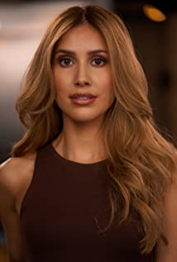
Emily Roslyn Villarreal is a Latina actress born and raised in Dallas, Texas. At an early age Emily's dream of becoming a singer, actor and dancer was realized. She started her professional career as an NBA dancer for the Dallas Mavericks. Not long after making the big move to Los Angeles she has gained momentum in Hollywood at an accelerated rate. She is best known for her roles on Euphoria on HBO Max and the film Bromates co-starring alongside Josh Brener. Emily has always been considered the underdog but that doesn't stop her from going after her dreams.

ROY ABRAMSOHN
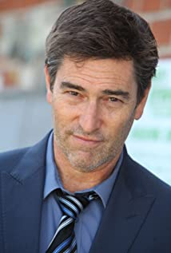
Roy originated one of the leads in the two-man, Pulizer-monimated drama Old Wicked Songs at the historic Walnut StreetTheater, where he also played the dual role of Chico and Harpo Marx in Groucho: A Life in Revue with the original Broadway cast. Groucho was taped live at the Westport Country Playhouse in Connecticut and has aired on PBS.
Other stage credits include two years at the Oregon Shakespearean Festival in Ashland, Dirty Blonde at Portland Center Stage, the west coast premiere of Israel Horovitz’s Lebensraum (Fountain Theatre), Gunmetal Blues and Who’s Afraid of Virginia Woolf? (San Jose Stage), Trumbo (with Joe Mantegna at the Falcon Theatre), Taking Sides and A Chorus of Disapproval (Odyssey Theatre), The Last Schwartz (Zephyr Theatre), and Leaving Iowa at The Laguna Playhouse. Last year he originated a role in the world premiere of Hijacking the Northern Star, with an international cast at the Shouson Theater in Hong Kong, China.
Originally from Pennsylvania, Roy attended Oberlin College and Conservatory of Music. He also hosted a Young People’s Concert on Romantic Music with the New York Philharmonic in Avery Fisher Hall at Lincoln Center, New York City, and played piano with the orchestra. He has appeared in over 100 television commercials and guest-starring roles including Without A Trace, American Dreams, The Parkers, and Medium. He has had recurring roles in the TV Series Picket Fences, Weeds, Here’s the Thing and General Hospital. Feature films include The Dukes with Chazz Palminteri and starring roles in Creepshow 3, Escape From Tomorrow, Dying to Marry Him and Unidentifed Objects, just to name a few.
Roy lives in Los Angeles with his wife, actress/singer Betsy Gardner, and his two children, Benjamin and Madeline.

JOEY HEYWORTH
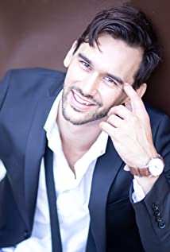
Known for his goofy humor and elastically expressive face, Joey Heyworth is a British American stage and screen actor. Beginning his career onstage, his work has been seen by audiences in New York, London, Chicago and Raleigh, working with acclaimed theaters such as Stoneham Theatre and Burning Coal Theatre playing title roles in Romeo and Juliet, and Simon Stephens' one-man-show Sea Wall.
Since expanding to the screen, Joey has had the great fortune of acting alongside immense talents such as Stella Maeve in Hulu's Original Old Maid (2020) and Theo Germaine in the indie film Holy Trinity (2019). When productions can't seem to get enough Joey, he has relished in the challenge of exploring different characters within the same series as he did for INSP's TV Series Wild West Chronicles (2020) and the Jay Shetty (2020) Mini-series.
Although his goofy comedic style is in full force with his recurring character in TV Series Sexpectations (2021), Rhian Williams's short Fetish (2022), and the outlandish comedy The Other Side of Infinity (2022), Joey's dramatic abilities were showcased in Critics' Choice nominated Betrayed (2016) and the short Audition, which awarded Joey an honorary mention for Best Actor from the Independent Shorts Awards. Joey's face might also be recognizable from Buzzfeed sketches, his commercial work for brands giants such as KMart, State Farm and Wayfair, or even in print for companies like Manscaped, Retrospec, Busch Beer and Rubios Grill.
Throughout the years Joey has continued to hone his craft and expand his skill set through revered training programs at The Groundlings, The Actor's Gymnasium, Spin Circus Academy and Cirque Du Vol. He recently discovered a new love for all things green and is proudly settling into his new series regular role of plant daddy.

LAUREN VAZ
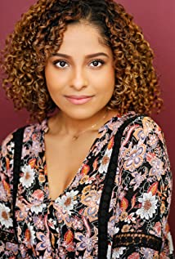
Lauren Vaz was born on February 4th, 1999 in Aurora, CO. She is the middle child, with entrepreneurial parents who own an award-winning curly hair salon business. She loves to dance, play piano, sing, and draw/paint in her free time.
She always dreamed of leaving her town in Colorado and making it to the West Coast to study acting, and she is now completing her BFA in Acting for Stage and Screen from the nationally ranked Azusa Pacific University in 2021. After receiving training from industry professionals such as Alex Wright, Andi Chapman, and David Barrera, Lauren has a passion for continuing to tell stories and make a lasting impact through her craft.
Lauren can be seen in the TV Series Darling Comedy as well as staring in the Mini Series The Clash Pad.

ANZU LAWSON
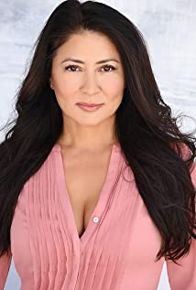
Anzu Lawson is a force of nature in many disciplines; acting, music, stand-up comedy, screenwriting & directing. A true warrior when it comes to following her passions, which have led her on many creative adventures, each one adding another layer to the multi-dimensional artist that is Anzu Lawson. Beginning at age 7, Anzu's first taste for acting was opposite Academy Award-nominated actor, Mako in her first screen test playing his granddaughter, in an independent film. Then at 14, She was scouted to model in Tokyo, thus beginning her International career path. While modeling one summer, the stars conspired for her to meet YES's singer Jon Anderson, backstage at an INXS concert in Tokyo. It was a pivotal moment in her career when Jon discovered Anzu's musical talent. He prompted the beginnings of her first album, and two albums later, Anzu topped the Japanese Billboard charts with a number one hit on AVEX records as a teen J-Pop star in Japan. Her creative career as a singer-songwriter had begun. Her bold and unique vocal styling can be heard on many of Hans Zimmer's & Harry Gregson-Williams movie soundtracks; The Chronicles of Narnia, Spygame, The DaVinci Code and Sinbad. As a young adult, back in Los Angeles, her acting career ignited when she landed the lead role in "American Yakuza", starring opposite Viggo Mortensen by casting director Don Phillips. Don Phillips is known for giving such talents as Forest Whitaker, Sean Penn, Viggo Mortensen & Matthew McConaughey their first film role. That film's director, Frank Cappello, commissioned her to write a song for his next movie "No Way Back" starring Russell Crowe and then cast her again, opposite Christian Slater in the indie Showtime movie, "He Was A Quiet Man", years later. To date, Anzu has played many diverse roles from Japanese, Korean, Filipino, Latin, Native American & Chinese.
After befriending comedian Brad Garrett, Anzu was inspired to explore the stand-up comedy world, and has now performed on such famous stages as The Comedy Store, Laugh Factory, Westside Comedy Theatre and The Improv Hollywood/Brea.
Frustrated with the lack of diverse leading female roles in Hollywood at the time, The seed for writing her own material had been planted, and Anzu received her certificate in screenwriting at UCLA in '09, where she optioned her first script, "The Seed Between the Stones." A coming of age story inspired by her time spent with Mick Jagger, Richard Perry & Steve Bing. Then in April 2018, Anzu collaborated with Cal State University Los Angeles to launch the second live workshop of her all original rock movie musical she penned called "Dear John, Why Yoko?" (formerly known as "Rock and Roll's Greatest Lovers.") Anzu Lawson had previously received her first "Best Actress nomination" in her portrayal as "Yoko Ono" in the 2014 Hollywood Fringe Festival.
One month later in May 2018, following her mother's death, Anzu wrote an homage to the "two Asian women that shaped her life and fueled her creativity" by debuting her 1st One Woman Show called "Dear Yoko." Anzu's One Woman Show "Dear Yoko" sold out every Los Angeles performance and was an official selection at the 2019 Santa Monica Playhouse "Binge Fringe Festival", Crazy Woke Asian Festival and Solofest 2020 Festival. While prepping for the 2020 summer festival tour of "Dear Yoko", Anzu was starring opposite Al Pacino in a revival workshop reading of Pacino's 1977 Tony Award winning performance in "The Basic Training of Pavlo Hummel" at the Wallis Annenberg/Beverly Hills, benefiting war veterans. On March 6, 2020 they had their only performance, with Los Angeles going into lock down the next day, due to the pandemic.
Anzu's production company Happy Hapa Films is focused on edgy screenplays that focus on challenging the stereotypes and bringing to light the untold stories of Asian American & diverse women throughout history.
No one says it better than Nicole Force of The Examiner when she wrote: "Anzu Lawson is a consummate and multi-talented performer who represents the new triple threat in Hollywood-singer, actress and stand-up comedian. Anzu Lawson is an entertainment force who consistently delivers, regardless of the genre."

CLARA CARLO
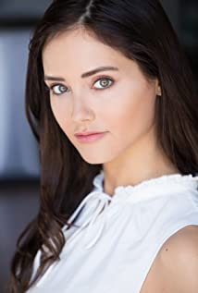
Clara Carlo is a New York based actress and model. She is a student of acting at the Stella Adler Studio and of Improv at the Upright Citizen’s Brigade. She enjoys nature, running, yoga, and supporting organizations dedicated to social justice.
She is known for her work on several TV Series including I Met My Murderer Online, Accident, Suicide or Murder and Pacific Breeze. For her leading role as Virginia in the series From Charlie, with Love, Clara received no less than 6 nominations and 3 wins as Best Actress.

Production Credits

Full Cast
Actors  EMILY ROSLYN VILLARREAL  ROY ABRAMSOHN  JOEY HEYWORTH  LAUREN VAZ  ANZU LAWSON  CLARA CARLO  KENT MCGUIRE  BRUCE VAN PATTEN  KATE LUGTU  FRANK MULLER  MEANOP TAN  DANA GALLER  VERONICA BOWEN  LAURI RUSSELL  PAIGE COMPTON  SAN-SAN ONGLATCO  JESSICA GRAHAM  ARIK AVRAMOVICH  MANTHA BARLOURDOU  ANDREW PETTKE  JYLLINA PEREZ  SAVANNAH DOSS  NEIL FIERRO | Role  Maddie  Paul  Kevin  Layla  Aunt Grace  Kaycee  Sherriff 1  Sherriff 2  Police Officer 1  Police Officer 2  EMT  CSI 1  CSI 2  Server  Art Gallery Patron 1  Art Gallery Patron 2  Art Gallery Patron 3  Art Gallery Patron 4  Art Gallery Patron 5  Art Gallery Patron 6  Art Gallery Patron 7  Art Gallery Patron 8  Art Gallery Patron 9

Casting by
ROBIN DE LANO
NICOLE DIONNE

Makeup by
SHANNON MARIE TRIGGER

Sound Design by
ANDRES BOULTON

Music by
ANDY FORSBERG

Edited by
CODY MILLER

Costume Designer
REMI NATIONS

Production Designer
CHRISTELL HOLMES

Director of Photography
FERGUSON SAUVÉ-ROGAN

Screenplay by
RICHARD DANE SCOTT

Directed by
FARAH WHITE

Other Crew
DOUG BARDEN | First Assistant Director
AMY SEACH | Second Assistant Director
COLIN MACK NAIR | First Assistant Camera
DAMIAN SOTOLONGO BONILLA | Second Assistant Camera
JAY RUGGIERI | Steadicam Operator
CORY HART | Drone Operator
STEVE CURLEY | Still Photographer
VERONICA BOWEN | Art Director
ZAC COMPTON | Art PA
ALEX ZAUNER
AYDEN MARCUS | Chief Lighting Technician
EDGAR NUNLEY | Key Grip
BRIAN HAYNES | Grip & Electric Swing
NABOR CABANILLAS
MEGAN LONGMEYER | Makeup Artists
KAITLYN MITHELL
ASHLEY ALDRIDGE
RAMONA COLLAZO | Hair Stylist
MIGUEL ANGEL RODRIGUEZ | Production Sound Mixers
JOHN RICHARD
DANE GALLER | Set Costumer
PAIGE COMPTON | Second Unit Director
ALEX WITT | Second Unit 2nd Assistant Camera
OLIVIA PHILLIPS | Production Office Coordinator
FRANK MULLER | Key Production Assistant
DOERTE LINDER | Accountant
WRAPBOOK | Payroll
TJ CRAFTY | Catering
TOSHA WILLIAMS
ALEISHA BROOKS | Covid Safety Supervisors
LAURI RUSSELL
BREAKDOWN SERVICES | Casting Support Services
ROBIN CONLY | Post Supervisor
SOUND AS ART | Post Sound
ANDRES BOULTON
JONATHAN MORGAN | Foley Editor
BLUELINE FINISHING | Conform and Delivery
RANDY COONFIELD | Color Grading
GOAL PRODUCTIONS, INC. | Stock Footage
CLEARANCE UNLIMITED | Script Clearance
SUZY VAUGHAN
BLACKSTONE ENTERTAINMENT | Grip and Lighting Equipment
F22 STUDIOS | Camera Equipment
WALK & TALK PRODUCTION RENTALS | Production Equipment
CINEREP INTERNATIONAL INC. | Generator
CHAPMAN/LEONARD STUDIO EQUIPMENT | Cobra VT
BRILLIANT STUDIOS | Police Cars and Ambulance
ACE UNDERHILL
SILVERSTRAND RANCH | Location
CARLOS RODRIGUEZ

Producer Biographies
TIM JOHNSON – Executive Producer
Tim Johnson is among the most active and reliable producers in the business thanks to top rate productions and global distribution appeal.
Johnson is also responsible for producing the international hit series, DR. QUINN, MEDICINE WOMAN for CBS for over 5 seasons. During his 100-episode tenure, he also developed and produced the original docu-drama COLD CASE for CBS network, which was the very first program to integrate television with the Internet.
Johnson has produced over 150 movies, 15 globally released series for every major US network - including ABC, Disney, CBS, NBC, Netfly, FOX and Sony.

JOHNSON PRODUCTION GROUP
The Johnson Production Group contracts globally to produce television content for international networks, studios and distributors. Based in Los Angeles and Vancouver, British Columbia, the company manages production, facilitates development and financing, procures distribution and guarantees quality and timely execution of its programs. While costs have gone up, so has the demand for quality. No longer is good enough, good enough. Johnson Production Group serves that segment when a show needs to be "A" quality, but produced efficiently enough to meet a locked budget. JPG specializes in value, protection of creative elements, and delivery of a quality finished product.

JOSEPH WILKA – Co-Producer
Joseph Wilka is the Head of Production for Johnson Production Group. Los Angeles-based, Joseph had already produced and directed several feature films before serving as the senior marketing executive for Gravitas Ventures. While at Gravitas, Wilka helped pioneer new distribution models for independent films including day-and-date theatrical releases. It was also at Gravitas where Joseph first worked with Johnson Production Group to facilitate the release of their films to the worldwide Video On Demand audience. After serving as the Director of Distribution and Production for Viva Pictures, where he produced English-language versions of foreign animated titles for DirecTV, Wilka officially joined Johnson Production Group. As Head of Production, he oversees the development, production, and distribution of films from multiple production units for release on broadcast and streaming platforms.

ROBIN CONLY – Co-Producer
Robin's career has spanned from Texas to Los Angeles, where she's produced several internationally distributed films that can be seen on networks including HBO, Hallmark, Showtime, Hulu, and Netflix. Recently, she worked with a former Disney Imagineer to produce multiple segments of a 4D IMAX attraction for the Mall of America; helmed research and development for a documentary production company; and produced an award-winning web-series.
ROBERT BALLO – Producer
With over 34 years of industry experience, Robert Ballo has created award-winning productions for clients that include ABC, TBS, PBS, Discovery Channel, and Lifetime, and that have aired on national network television, cable networks, and internationally in Asia and Europe. As Director of Photography and Producer at Shadowland, Ballo has created over a dozen feature films seen on the Lifetime Network and distributed internationally. As Director of Photography, his Shadowland films include MISSING AT 17, THE SURROGATE, STALKED AT 17, TEENAGE BANK HEIST, WALKING THE HALLS, BETRAYED AT 17, HOME INVASION, MATERNAL OBSESSION, ACCUSED AT 17 and SPECTRES. Other feature film credits include RUNNIN' AT MIDNITE, THE AFFAIR and STARVING ARTISTS. Ballo has also traveled the world on many documentary productions.
His television credits for national broadcast and cable networks include COLLEGE SPORTS IN AMERICA, GREAT EUROPEAN BALLOON ADVENTURE, DIRTY HARRY THE ORIGINAL, THE GREAT YEAR, and THE ROSE PARADE - PAGEANT FOR THE AGES. Through his other digital motion picture company, GOAL Productions, Ballo works with Fortune 500 companies, non-profit organizations and government agencies to produce sales and marketing videos as promotional communications. After a twenty-year tenure teaching film and video imaging, Ballo recently retired from his position as an Associate Professor of Practice at USC’s School of Cinematic Arts. A graduate of the USC film production program himself, Ballo is a member of the Academy of Television Arts and Sciences.

KATE LUGTU – Line Producer
Kate Lugtu is a Los Angeles based Director. Her career began in in the Philippines where she produced TV shows, commercials, industrials, and live events. You can find her mentoring up & coming filmmakers in the craft of being a 1AD at the American Film Institute.

Billing Block
Johnson Production Group Presents A Lifetime Movie “LANDLORD FROM HELL”
starring EMILY ROSLYN VILLARREAL ROY ABRAMSOHN JOEY HEYWORTH LAUREN VAZ with ANZU LAWSON and CLARA CARLO Casting by ROBIN DE LANO NICOLE DIONNE Makeup by SHANNON MARIE TRIGGER Sound Design by ANDRES BOULTON Music by ANDY FORSBERG Edited by CODY MILLER Costume Designer REMI NATIONS Production Designer CHRISTELL HOLMES Director of Photography FERGUSON SAUVÉ-ROGAN
Line Producer KATE LUGTU Co-Producers JOSEPH WILKA ROBIN CONLY
Executive Producer TIMOTHY O. JOHNSON Produced by ROBERT BALLO
Screenplay by RICHARD DANE SCOTT Directed by FARAH WHITE
© MMXXII Johnson Production Group Inc. All Rights Reserved
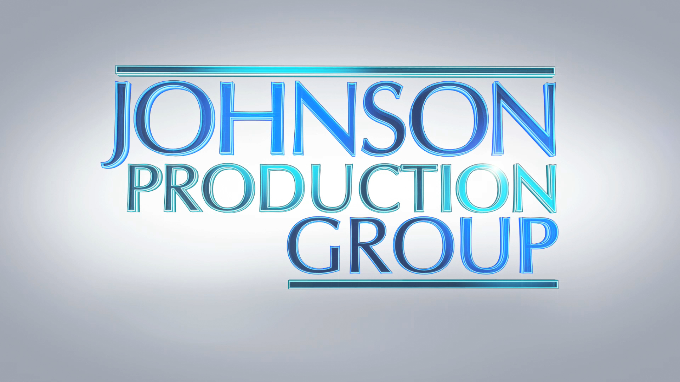

Meta Data
LONG (max 3000 characters) synopsis
When Madeline flunks out of college and loses her job, she turns to her Aunt Grace for help. A secluded ranch house with a cute neighbor and beautiful scenery seems too good to be true until a series of strange and terrifying events begin to occur.
With nowhere else to go, Madeline launches an investigation in an attempt to protect her Aunt Grace, not knowing that her own life is at stake. (394)
MEDIUM (max 500) synopsis
When Madeline flunks out of college and loses her job, she turns to her Aunt Grace for help. A secluded ranch house with a cute neighbor and beautiful scenery seems too good to be true until a series of strange and terrifying events begin to occur.
With nowhere else to go, Madeline launches an investigation in an attempt to protect her Aunt Grace, not knowing that her own life is at stake. (394)
SHORT (max 100 characters) synopsis
Needing a change, Madeline rents a house from a secretive man who brings terror too close to home. (99)
5 KEY WORDS
Renter, murder, terror, family, romance

