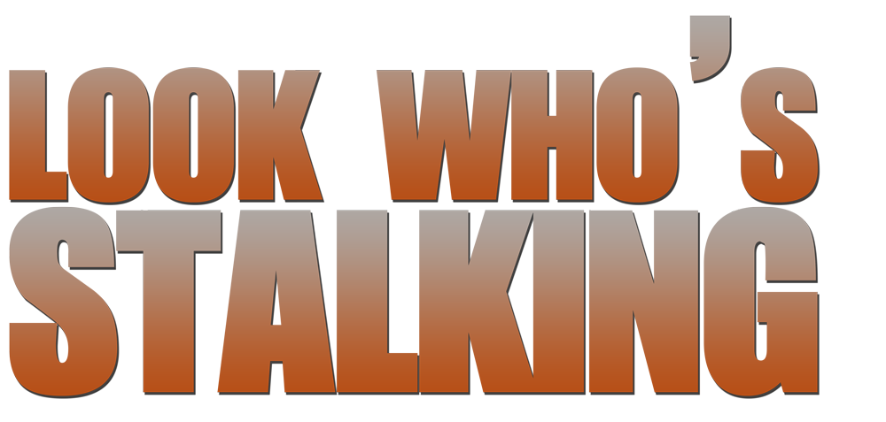

Johnson Production Group

Press Kit

# One-Liner

# After the death of her stalker, a mother pieces her life back together with the help of her new personal assistant. But when she realizes she’s being targeted again she’s forced to uncover whether she’s being stalked from the grave.

# Synopsis

# As a big city doctor, Hope saves lives every day. However, she's powerless to protect herself from Toby, her stalker who has been making her life hell for years. When Toby suffers a heart attack in front of Hope, she finds herself frozen, unable to do anything as he falls to the ground and breathes his last in front of her.

# Hope, along with her family and friends celebrate her chance at a fresh start. She gets a new job at a small medical practice where she can finally live free from fear. But the celebration is short-lived as Hope soon finds herself being stalked once again. Each phone call, gift, and break-in reminds her of Toby's torments. Her new stalker clearly knows Hope and her history well. Everyone in Hope's life becomes a suspect as she tries to determine the identity of her new stalker or if Toby is somehow stalking her from the grave.

# Producers

Executive Producer

TIMOTHY O. JOHNSON

Co-Producers

JOSEPH WILKA  
ROBIN CONLY

Producer

ROBERT BALLO

Line Producer

NICOLE LAYSON

# Key Cast

|  |  |  |
| --- | --- | --- |
| CHARACTER  Hope  Mary  Danielle  Evan  Nadine  Dr. Fitzgerald  Det. Adler |  | ACTOR  ALISSA FILORAMO  JULIANA DESTEFANO  KIANA NICOLE WASHINGTON  HARLEY JAY  ROBIN DE LANO  HOWARD M. LOCKIE  JON BRIDDELL |

# Key Cast Biographies

# ALISSA FILORAMO

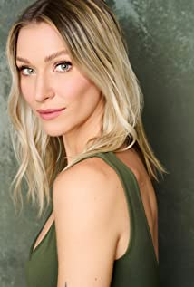Alissa Filoramo is an actress, designer, and athlete originally from the suburbs of Detroit; Birmingham, MI. She has helped produce and star in many award winning films since the beginning of her career including the short film Young Liars, which won Best Short Film at HP Lovecraft Film Festival & CthuluCon as well as Best Short Film at Thriller! Chiller! Fest in 2018. In 2019, her lead role in the film On The Mountain won her Best Acting Duo at Indie Shorts Awards, as well as Independent Shorts Awards, and just recently won another Best Acting Duo for the year at Independent Shorts Awards. Alissa can be seen starring in the TV Movie DOA at the PTA as well as How to Live Your Best Death, Devil's Triangle, Jurassic Domination, Cockpit, The Transcenders. She has also had a recurring role in the TV Series The Family Business.

# JULIANA DESTEFANO

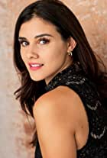Juliana DeStefano is an American actress who is known for her work in What Remains, Triple Threat, Deadly Garage Sale, My True Fairytale, Small Things, and Acid Test. She came into limelight for appearing in the TV series 13 Reasons Why. She made her appearance in the fourth season of the series and she played in the role of Bree. Juliana collected love from her fans by her role in the movie Psycho BFF. She also has her own upcoming comedy special.

# KIANA NICOLE WASHINGTON

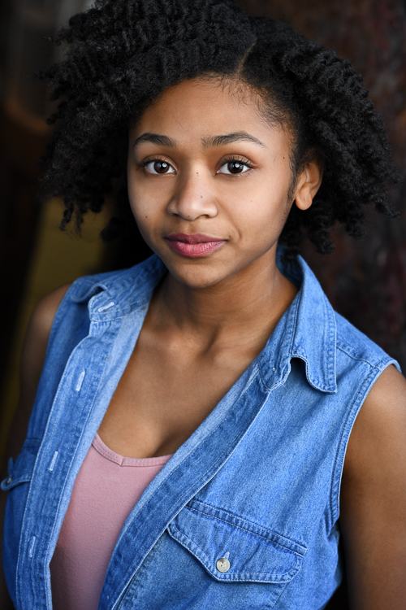Kiana Nicole Washington, was born on March 30 in a small town called Watkinsville, GA. As a musician himself, Tony Washington, her father pulled her into the arts at a young age. She has been performing on stage since the age of four as a singer, dancer, and actress. She launched her film acting career in 2017 and has been working since then and perfecting her craft at the Company Acting Studio. Kiana Nicole is a recent graduate from the University of Georgia where she obtained two B.A. degrees in Theatre and Entertainment and Media Studies. She loves pursuing projects that promote equality and development, while inspiring a sense of community. Rather than for applause and individual accomplishment, performing is important to Kiana because of the sense of community achieved and the effect a performance has on the audience. Therefore, she wants to be involved in films that address social, racial, and familial issues among other topics. Creating works that prompt audience members to think is most important to her as an entertainer.

This busy actress has had recurring roles in Totally Studios, Linked by Love and Dhar Mann. She has also appeared in Through Her Eys, Playing Through and Blossom.

# HARLEY JAY

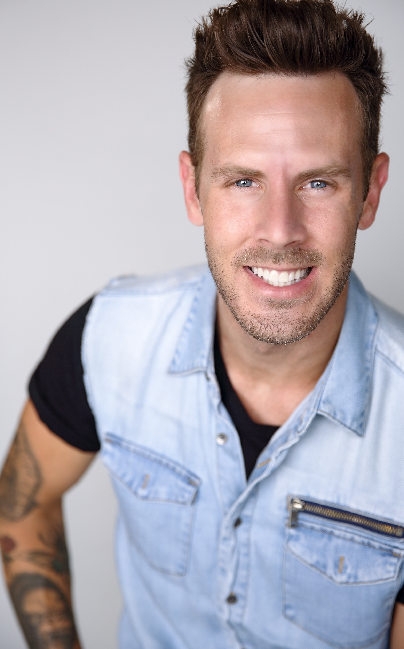Harley Jay was born in Salt Lake City, Utah. He appeared on Broadway playing the lead role of "Mark" in the historic play "Rent". He also did a national tour of the same production, along with the touring production of Miss Saigon. Harley has an original album out called "Without Wax". He performed his own music and opened for Grammy nominee James Otto on February 14, 2009.

# ROBIN DE LANO

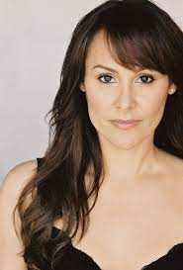Robin De Lano and casting partner Nicole Dionne work under their casting company Stella Nova Casting. Robin and Nicole have worked with producers in Poland, England, Canada and all across the United States providing talent for commercials, print, TV, streaming, and Award Winning films. They have had films at TIFF, Sundance Labs, and most recently the Oscars.

Robin has appeared in several films including First Comes Like, Your Family or Your Life and A Dangerous Defense.

# HOWARD M. LOCKIE

# Howard M. Lockie - IMDbHoward M. Lockie is an actor, known for Netflix's Screwball Baseball(2023),Jackie Robinson Bio (2022),Family Time with Omar Gooding and 2019's The Trouble with William McNamara Howard can be seen in Millennials on AMC's #allblknetwork playing Mr. O'Dell alongside Kyle Massey and others as well as Coach Parker in Netflix's Colin in Black & White for Ava DuVernay

.

# JON BRIDDELL

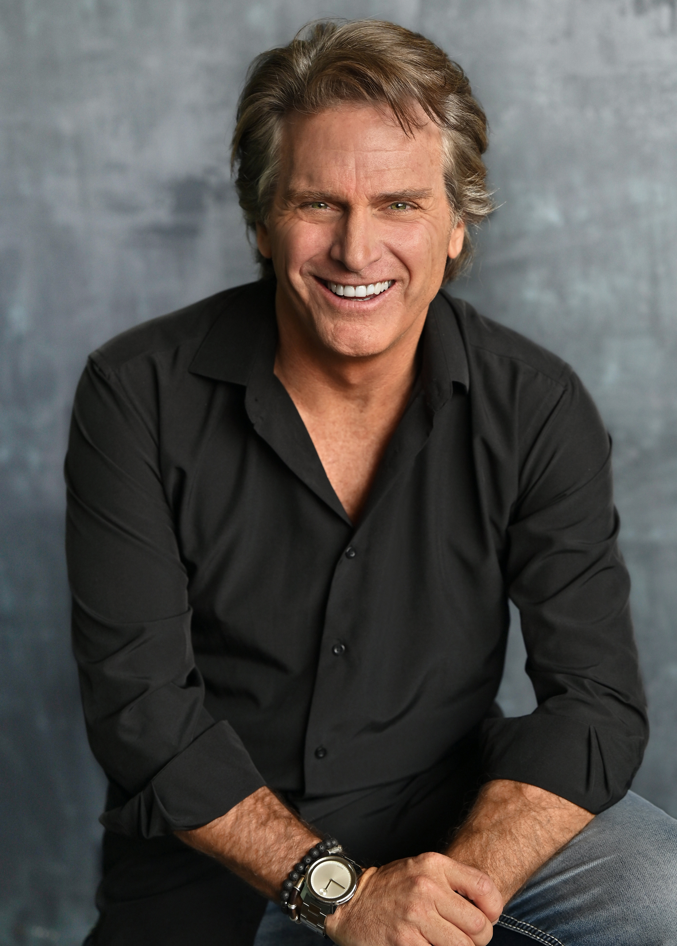Jon began his professional acting career in 1989 performing in a Second City (Chicago) affiliated sketch comedy show. He trained in theater throughout the midwest prior to his arrival to Los Angeles in late 1994. His credits include over 40 feature films, constant television guest appearances , and numerous work in commercials, infomercials, and print campaigns. Jon is an avid Ohio State Football fan rarely missing a game on fall Saturdays.

# Production Credits

### Full Cast

|  |  |
| --- | --- |
| [**Actors**](http://www.imdb.com/name/nm7589451/?ref_=ttfc_fc_cl_t1)  ALISSA FILORAMO  JULIANA DESTEFANO  KIANA NICOLE WASHINGTON  HARLEY JAY  HOWARD LOCKIE  ROBIN DE LANO  ANDREW SIMON  JON BRIDDELL  ISAAC STACKONIS  PHILLIP ANDRE BOTELLO  GABRIELLE FERNANDES  ANDREW SIMON  ISAAC STACKONIS  CENA BEAN  JACK DAVIDSON  COLIN MCCANN  TYREEK SPAIDE  CHRIS BOGUSH  CALVIN MCKAY  TERRY GREENE  SEROP OHANNESIAN  JEFF LAY  HANNAH RIESS  MARISA DESA  JOWELLE C. SALCEDO  ANGELA WATSON  HEIDI MCCLANE  STEPHEN AKANBI  STEPHEN AKHTEROV  BOLOR SARUUL  JACOB ROMERO  JACQUELINE REYES  IVORY RAMIREZ  BOB PEACE  HANA FREEMAN  KAYLA DACOSTA  MARCELIUS WILLIAMS  SALVADOR CARRIEDO  JENNY PURANEN  MATTHEW MASIERO  JOCELYN SHARPE | **Role**  Hope  Mary  Danielle  Evan  Dr. Fitzgerald  Nadine  Jesse  Det. Adler  Toby  Officer Wilson  Nurse Mackey  Hooded Figure  Hooded Figure  Crime Techs  Hospital Personnel  Hospital Patients  Civil Servant/Doctor  Hospital Workers  Elderly Woman  Party Goers  Paramedics  Police Officers |

### Casting by

ROBIN DE LANO  
NICOLE DIONNE

### Makeup by

KATHLEEN RODRIGUEZ

### Sound Design by

ANDRES BOULTON

### Music by

EMIR ISILAY

### Edited by

MARK SULT

### Costume Designer

CLEY KIM

### Production Designer

NICOLA WAKE

### Director of Photography

ERIC ANDERSON

### Screenplay by

STEPHEN CZERWINSKI

### Directed by

DOUG CAMPBELL

### Other Crew

|  |  |
| --- | --- |
| DENZEL JOHN | First Assistant Director |
| CHRISTOPHER JORDAN | Second Unit Director |
| NICOLE DIONNE | Casting Director |
| ROBIN DE LANO |  |
| GABRIELLE FERNANDES | Casting Assistant |
| ALEX TETZNER | First Assistant Camera |
| REID COLLINS | Second Assistant Camera/DIT |
| EMMA DONAHUE |  |
| CHRISTOPHER JORDAN | B Camera Op |
| JUSTIN JACH | Steadicam |
| MARK PECAR | Art Director |
| ROBBY CHE | Art Assistant |
| JUSTIN KNODEL | Chief Lighting Technician |
| ALEXANDER TOBIAS | Best Boy Electric |
| NICHOLAS MULLEN | Key Grip |
| BENJI PAYNE | Best Boy Grip |
| NURIA TORRENTE | Key Makeup Artist |
| MEGAN LONGMEYER | Megan Longmeyer |
| JASON MORAN | Production Sound Mixer |
| OLIVIA MARSTON PHILLIPS | Production Office Coordinator |
| JOAQUIN PARADA | Assistant Office Coordinator |
| FRANK INGLIS | Production Assistants |
| ERICK NUNEZ |  |
| DANNY WAGNER |  |
| ALEISHA BROOKS | Script Supervisor |
| DOERTE LINDNER | Accountant |
| WRAPBOOK | Payroll |
| TONY MONTANA CATERING | Catering |
| ALEISHA BROOKS | Covid Safety Supervisor |
| BOOKED TALENT | Background Casting |
| ROBIN CONLY | Post Supervisor |
| SOUNDASART | Post Sound |
| ANDRES BOULTON | Supervising Sound Editor |
| AOBO HUANG | Sound Effects Editor |
| YIWEN MA |  |
| JONATHAN MORGAN | Foley Editor |
| SCOTT CASILLAS | Foley Artist |
| NICK HURTADO | Foley Mixer |
| ANDRES BOULTON | Re-Recording Mixer |
| BLUELINE FINISHING | Conform and Delivery |
| RANDY COONFIELD | Color Grading |
| PETER LALIC | VFX Artist |
| CLEARANCE UNLIMITED | Script Clearance |
| SUZY VAUGHAN |  |
| BLACKSTONE ENTERTAINMENT | Grip and Lighting Equipment |
| GOAL PRODUCTIONS | Camera Equipment |
| EMIR ISILAY | Score Composer and Producer |
| ECE MUNIROGLU | Additional Music |
| CAN CANEL |  |
| OGUS OZCANLI |  |
| Songs | |
| ROSE | |
| Written by HARLEY JAY | |
|  | |
| TAKE ME OVER | |
| Written by HARLEY JAY | |
| Performed by KIANA NICOLE | |

# Producer Biographies

## TIM JOHNSON – Executive Producer

Tim Johnson is among the most active and reliable producers in the business thanks to top rate productions and global distribution appeal.

Johnson is also responsible for producing the international hit series, DR. QUINN, MEDICINE WOMAN for CBS for over 5 seasons. During his 100-episode tenure, he also developed and produced the original docu-drama COLD CASE for CBS network, which was the very first program to integrate television with the Internet.

Johnson has produced over 150 movies, 15 globally released series for every major US network - including ABC, Disney, CBS, NBC, Netfly, FOX and Sony.

## JOHNSON PRODUCTION GROUP

The Johnson Production Group contracts globally to produce television content for international networks, studios and distributors. Based in Los Angeles and Vancouver, British Columbia, the company manages production, facilitates development and financing, procures distribution and guarantees quality and timely execution of its programs. While costs have gone up, so has the demand for quality. No longer is good enough, good enough. Johnson Production Group serves that segment when a show needs to be "A" quality, but produced efficiently enough to meet a locked budget. JPG specializes in value, protection of creative elements, and delivery of a quality finished product.

## JOSEPH WILKA – Co-Producer

Joseph Wilka is the Head of Production for Johnson Production Group. Los Angeles-based, Joseph had already produced and directed several feature films before serving as the senior marketing executive for Gravitas Ventures. While at Gravitas, Wilka helped pioneer new distribution models for independent films including day-and-date theatrical releases. It was also at Gravitas where Joseph first worked with Johnson Production Group to facilitate the release of their films to the worldwide Video On Demand audience. After serving as the Director of Distribution and Production for Viva Pictures, where he produced English-language versions of foreign animated titles for DirecTV, Wilka officially joined Johnson Production Group. As Head of Production, he oversees the development, production, and distribution of films from multiple production units for release on broadcast and streaming platforms.

## ROBIN CONLY – Co-Producer

Robin is a boots-on-the-ground producer who can take any project from development thru deliverables; always aware of the artistic vision of the movies she makes. She is a PGA and DGA member who produced and directed a variety of successful, award-winning projects before joining Shadowboxer. Films. Most notable are her family films that can be seen on networks including HBO, Hallmark, Showtime, Hulu, Tubi and Netflix. At Shadowboxer Films, she has produced and overseen post-production on over a dozen features since 2021.

Her BA is in Radio / TV and Film production from the University of Louisiana.

ROBERT BALLO – Producer  
With over 34 years of industry experience, Robert Ballo has created award-winning productions for clients that include ABC, TBS, PBS, Discovery Channel, and Lifetime, and that have aired on national network television, cable networks, and internationally in Asia and Europe. As Director of Photography and Producer at Shadowland, Ballo has created over a dozen feature films seen on the Lifetime Network and distributed internationally. As Director of Photography, his Shadowland films include MISSING AT 17, THE SURROGATE, STALKED AT 17, TEENAGE BANK HEIST, WALKING THE HALLS, BETRAYED AT 17, HOME INVASION, MATERNAL OBSESSION, ACCUSED AT 17 and SPECTRES. Other feature film credits include RUNNIN' AT MIDNITE, THE AFFAIRand STARVING ARTISTS. Ballo has also traveled the world on many documentary productions.

His television credits for national broadcast and cable networks include COLLEGE SPORTS IN AMERICA, GREAT EUROPEAN BALLOON ADVENTURE, DIRTY HARRY THE ORIGINAL, THE GREAT YEAR, and THE ROSE PARADE - PAGEANT FOR THE AGES. Through his other digital motion picture company, GOAL Productions, Ballo works with Fortune 500 companies, non-profit organizations and government agencies to produce sales and marketing videos as promotional communications. After a twenty-year tenure teaching film and video imaging, Ballo recently retired from his position as an Associate Professor of Practice at USC’s School of Cinematic Arts. A graduate of the USC film production program himself, Ballo is a member of the Academy of Television Arts and Sciences.

## NICOLE LAYSON – Line Producer

A West Virginia native, Nicole Layson, received her degree in Theatre from the University of Tennessee, Knoxville, where she acted in and directed countless plays. She continued her acting career in Los Angeles and became a member of SAG/AFTRA after playing supporting roles in independent feature films. While on set as an actor, Nicole fell in love with what happens behind the camera, which led her to pursue a Film Degree from the Los Angeles Film School. After graduating, she wrote, produced, and directed her own award-winning short films and began working in production. Within two years of finishing her degree in 2014, she has production managed and line produced multiple television series and feature films, including Hitting the Breaks, Reborn, and American Fighter. She has also produced numerous music videos, commercials, and shorts, many of which she developed.

## Billing Block

JOHNSON PRODUCTION GROUP Presents In Association With SHADOWBOXER FILMS "LOOK WHO’S STALKING” starring ALISSA FILORAMO JULIANA DESTEFANO HARLEY JAY KIANA NICOLE WASHINGTON AND JON BRIDDELL CASTING BY NICOLE DIONNE AND ROBIN DE LANO Makeup by KATHLEEN RODRIGUEZ SOUND DESIGN BY ANDRES BOULTON MUSIC BY RANDY MILLER EDITED BY MARK SULT COSTUME DESIGNER   
CLEY KIM PRODUCTION DESIGNER NICOLA WAKE DIRECTOR OF PHOTOGRAPHY   
ERIC ANDERSON LINE PRODUCER NICOLE LAYSON CO-PRODUCED BY JOSEPH WILKA ROBIN CONLY EXECUTIVE PRODUCER TIMOTHY O. JOHNSON PRODUCED BY   
ROBERT BALLO STORY BY DOUG CAMPBELL   
WRITTEN BY STEPHEN CZERWINSKI DIRECTED BY DOUG CAMPBELL

© MMXXIII Johnson Production Group Inc. All Rights Reserved

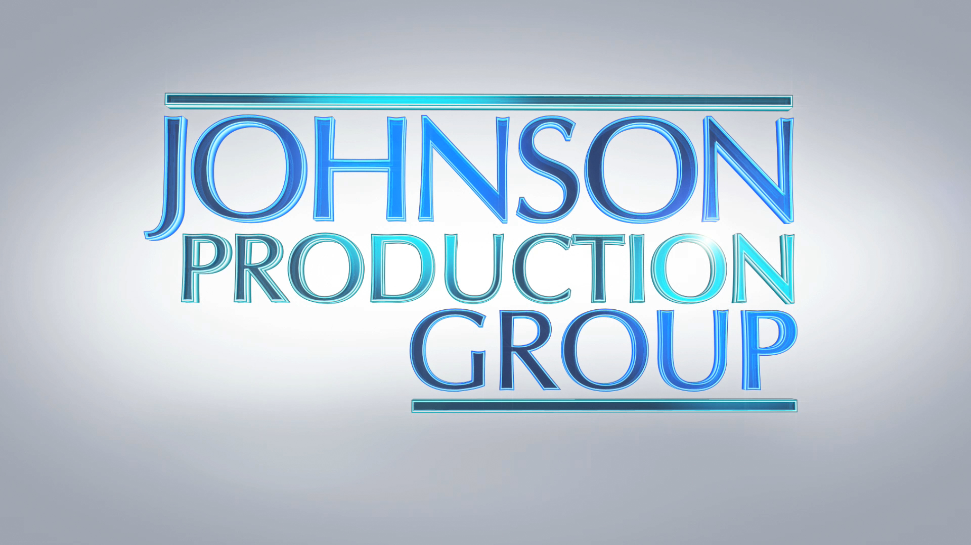



Meta Data

LONG (max 3000 characters) synopsis

As a big city doctor, Hope saves lives every day. However, she's powerless to protect herself from Toby, her stalker who has been making her life hell for years. When Toby suffers a heart attack in front of Hope, she finds herself frozen, unable to do anything as he falls to the ground and breathes his last in front of her.

Hope, along with her family and friends celebrate her chance at a fresh start. She gets a new job at a small medical practice where she can finally live free from fear. But the celebration is short-lived as Hope soon finds herself being stalked once again. Each phone call, gift, and break-in reminds her of Toby's torments. Her new stalker clearly knows Hope and her history well. Everyone in Hope's life becomes a suspect as she tries to determine the identity of her new stalker or if Toby is somehow stalking her from the grave. Text (859)

MEDIUM (max 500) synopsis

After the death of her stalker, a mother pieces her life back together with the help of her new personal assistant. But when she realizes she’s being targeted again she’s forced to uncover whether she’s being stalked from the grave. (232)

SHORT (max 100 characters) synopsis

Recovering after the death of her stalker, Hope now feels she’s being stalked from the grave. (94)

5 KEY WORDS

Stalker, mother, doctor, grave, suspicious