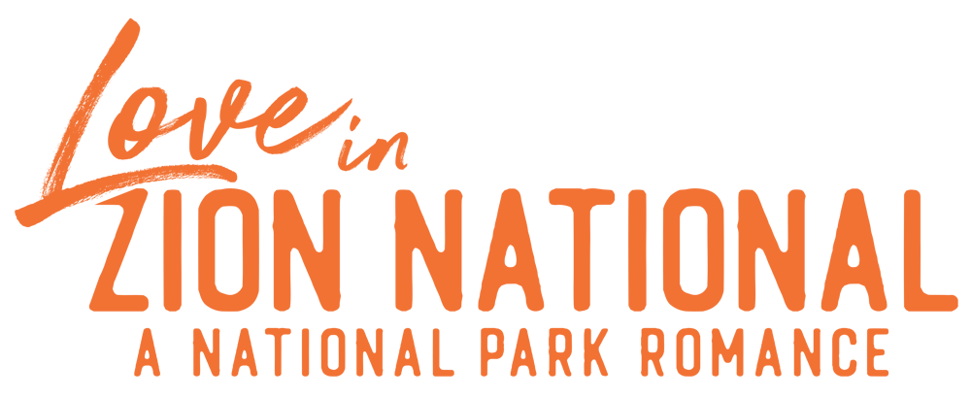

Johnson Production Group

Press Kit

One-Liner

An assistant museum curator is out to prove a set of ancient vases belong with the Pueblo Nation and enlists the reluctant help of a native Puebloan park ranger.

Synopsis

Lauren, (Busby) assistant curator at the Denver Museum of Natural History, has just received an exciting donation to the museum’s Native American Collections – a set of Anasazi wedding vases. But not everyone is as excited about the donation as Lauren. The benefactor’s grandnephew, Grady Hollingston (Bourke Floyd, “The Locksmith”), plans to contest the donation, claiming his great aunt had no right to give away such valuable family heirlooms. Lauren believes that based on the design of the vases there is a fourth vase that is missing from the set and if she can find it in Zion National Park herself, she can make the case that the vases should be returned to the Pueblo Nation. She heads to the park where she meets a local ranger and native Puebloan, Adam Proudstar (Gridley). Adam is at first skeptical of Lauren’s motives, but reluctantly agrees to accompany her search for the missing vase. When they arrive at their destination, they discover that Hollingston has also started a search of his own. Believing that they failed and have run out of time a disappointed Lauren and Adam prepare to part, despite growing feelings for each other, but perhaps not all is lost when a family secret is revealed.

Producers
Executive Producer
TIMOTHY O. JOHNSON
JOSEPH WILKA
DAVID GOLDEN
Producers
ROBERT BALLO
ROBIN CONLY

Key Cast
CHARACTER  Lauren  Adam  Margot  Milly  Tate |  | ACTOR  CINDY BUSBY  DAVID GRIDLEY  RAQUEL GARDNER  MICHELLE MURPHY  LIAM RILEY WOODRUM

Key Cast Biographies

CINDY BUSBY
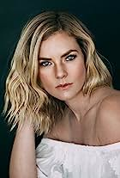
Cindy Busby has been making waves in the television and movie industry for almost two decades. Growing up in Montreal, Canada, Busby always dreamed of becoming an actress. To pursue these dreams, she attended the Professional Theater Program at Dawson College, a rigorous three-year training, allowing Busby to demonstrate her professionalism, hard work and devotion to her craft.
After graduation, Busby hit the ground running and landed a leading role as Ashley Stanton in more than 50 episodes of the hit series “Heartland.” The series took off quickly and became one of the most popular Canadian shows ever, was syndicated in 81 countries around the world and is a Netflix top pick. Busby continued having success booking roles as the antagonist in the television movie “Picture This” alongside Ashley Tisdale and appeared in guest star roles on the smash hit series “The Vampire Diaries,” “Supernatural,” “The L.A. Complex,” “Rush,” “Proof,” “The Tomorrow People” and “The Secret Circle.” In 2010 and 2011, Busby appeared on the big screen in Diary of a Wimpy Kid from 20th Century Fox, followed by the Fox 2000 film The Big Year, opposite Hollywood heavy hitter, Steve Martin.
Busby’s work ethic and reputation has earned her more than a dozen lead roles in the last few years, making her a household name and fan favorite among Hallmark Channel viewers. Some of her many credits for the network include starring roles in “Unleashing Mr. Darcy” and its sequel, “Marrying Mr. Darcy,” “Royal Hearts” directed by James Brolin, “Love in the Forecast,” “Romance on the Menu,” “Follow Me to Daisy Hills,” “Chasing Waterfalls, “Warming Up to You” and, most recently, “Marry Me in Yosemite.” For Hallmark Movies & Mysteries, Busby starred in “A Godwink Christmas: Meant For Love” alongside Kathie Lee Gifford. A versatile actress who can shine in a variety of roles, she showcased her comedic skills in the series “Date My Dad.”

DAVID GRIDLEY
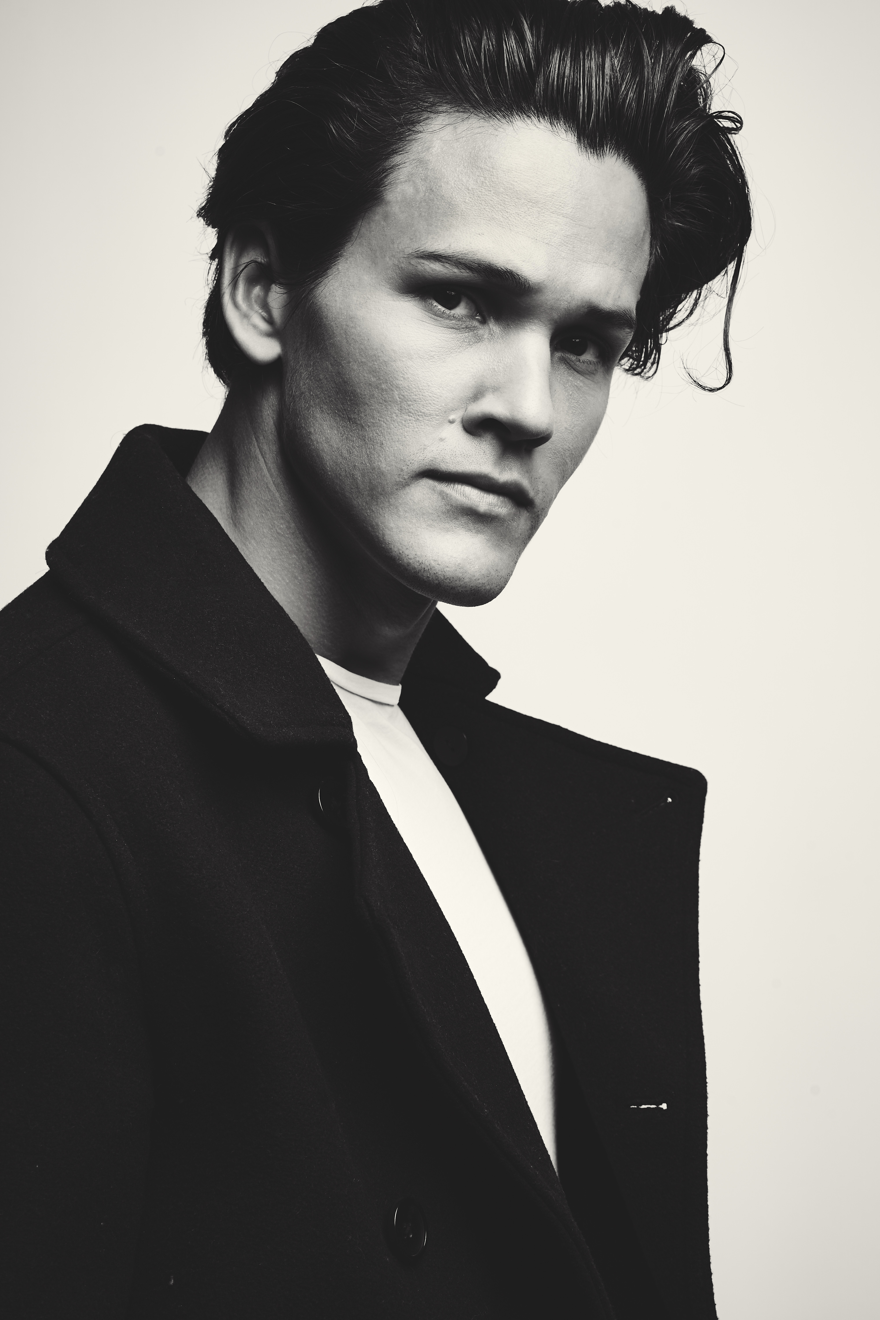
Originally from Atlanta, David Gridley received his bachelors in fine arts from the University of Georgia. He moved his way onto the big screen shortly after graduating and has appeared on a variety of network shows including Netflix’s “Pretty Smart,” “Army Wives” (ABC) “The Last Ship” (TNT), and “Team Kaylie” (Netflix).

RAQUEL GARDNER
Raquel resides in Los Angeles, California and through the years, she has built a reputation for being a professional and committed actor. Raquel has worked in many areas of the business. She starred in 60 episodes of Fox’s Acapulco Bay which aired in 22 countries around the world and is still running with millions of fans around the World!! She has a 6 episode recurring role on ABC’s Marvel Agents of Shield playing Adrian Pasdar’s wife. She’s also guest starred on many shows like Grey’s Anatomy, 90210, Eleventh Hour, Wings, Silk Stalkings, High Tide etc. One of Raquel’s most challenging roles to date was her recurring role on ABC’s daytime drama Port Charles where she played a nurse that contracted HIV. “Playing that character was a real learning experience for me both professionally and personally”. You have seen Raquel many times on the big screen as well. A few of her feature film credits include, A Night at the Roxbury, the Sci-Fi thriller Species II, Coldwater directed by Vincent Grashaw, Mother Ghost with Gary Marshall, Cutback directed by Johnny Remo. And a cameo role in the thriller The Boy Next Door starring Jennifer Lopez.

MICHELLE MURPHY
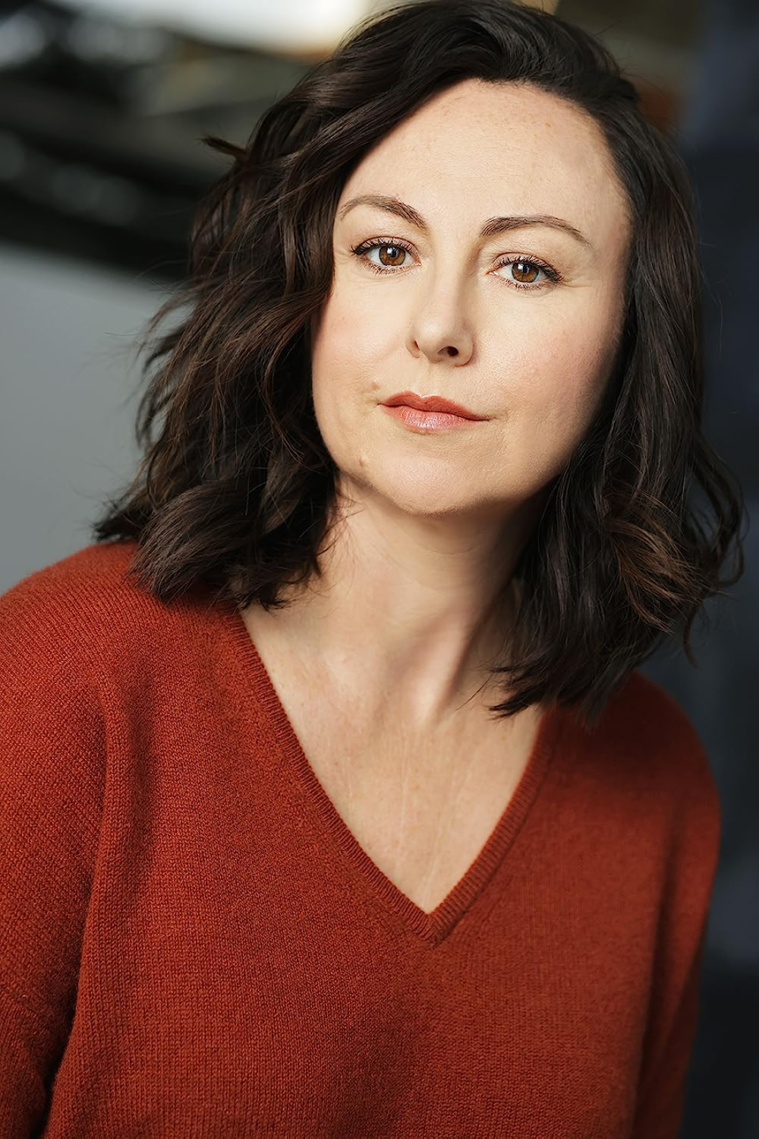
Michelle Murphy grew up in Dearborn & Detroit, MI. She graduated with her BFA in Liberal Arts from The University of Detroit Mercy. She was part of a thriving Metro-Detroit theatre scene, where she earned both her AEA and SAG cards with Jeff Daniels' The Purple Rose Theatre Company. She was named Artistic Director of the Planet Ant Theatre in 2000, a small black box theatre in Metro-Detroit, which she helped found in 1997, along with many talented Detroiters, including Keegan Michael Key.
Michelle is most proud of her work involving theatre for young audiences. She co-wrote and performed in Grandma Says for the critically acclaimed Mosaic Youth Theatre of Detroit and produced and performed in Little Bear, which toured Detroit public schools for over 10 years, providing outreach, awareness and assistance for minors involving sexual misconduct. Before she relocated to Chicago in 2002, she earned both Best Season Over All for her efforts at the Ant, as well as nabbing a Best Supporting Actress Award for her role in Stop, Kiss at The Performance Network in Ann Arbor, MI.
Regional credits include co-producing, co-writing and co-starring in Side of Ranch at Chicago's Donny's Skybox Theatre and a year performing and touring with Stage One; Louisville, KY's premiere theatre for young audiences. Michelle has performed at numerous Equity houses in the Midwest market before relocating permanently to Los Angeles in 2006 and pursuing a career in film and television.
She returned from Tokyo in the spring of 2022, where she filmed her recurring series role in Lost Man Found, a limited series on Hulu. She's had recurring roles on Sincerely, Camille, OWN networks first animated series, co-starring roles on Grey's Anatomy and Scandal, and is part of Beachbody's cast for their VOD workout program, #MBF and #MBFA. Michelle is a member of Loft Ensemble theatre company. She wrote and performed her first solo show, Keeper, in the fall of 2022.

LIAM RILEY WOODRUM
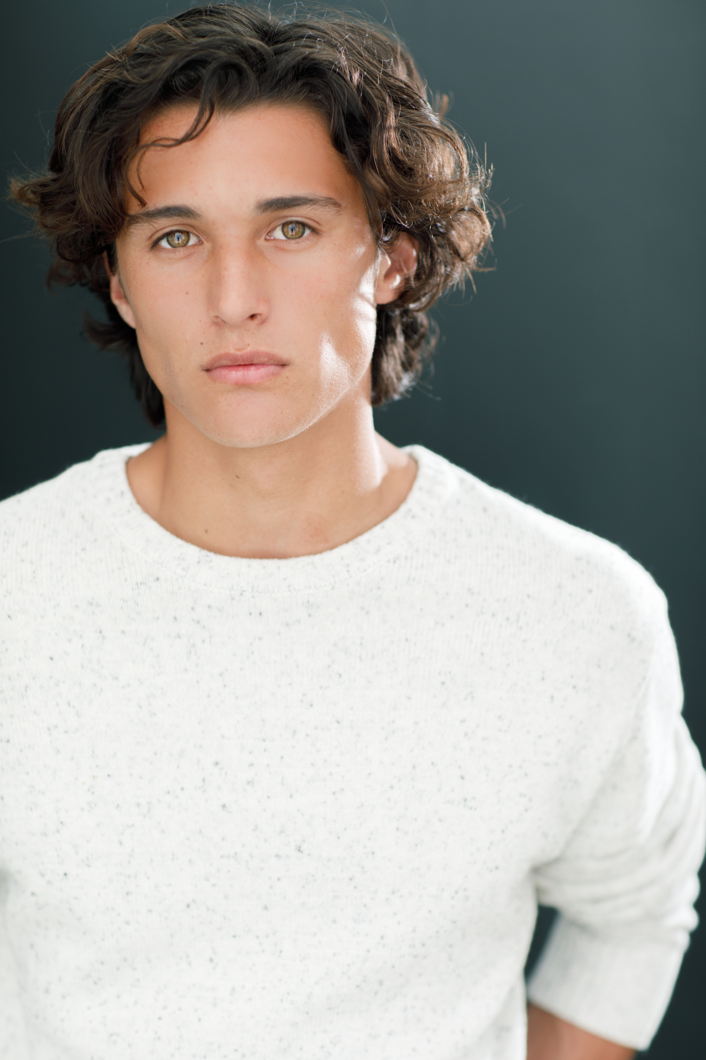
While still a newcomer to the acting world, California based Liam Woodrum has already been cast in the upcoming Geek Girl and Married Alive.

Production Credits

Full Cast
Actors  CINDY BUSBY  DAVID GRIDLEY  RAQUEL GARDNER  MICHELLE MURPHY  LIAM RILEY WOODRUM  BOURKE FLOYD  CRISPIAN BELFRAGE  MONIQUE FILIPS  DORIS “KATE” CHEN  TRAVIS DUBRIDGE  JOHN WYATT  ARIAL MESSERLI  AMANDA JOY TOTPAL  JESSE FELIX  HANNAH BRENNAN  LORI CAULFIELD  JULIA SMUSHKOVA  TAYLOR MONK  LANETTA EBERLY-YORBA  BRITTANY SHERIDYN  JAYLLEE McKOY  TAVIN HOYT  MADISON PATTON  JOSEPH SORENSEN  SHALISSE SORENSEN  CARLOS ROLEDO  WILLIAM MADET  RAYE SCHMALSTIG  ERIKA MCLAWS  JERIKA MCLAWS  TEMET EBERLY-YORBA  ERYKA KNUTSON  EMILIE HODGES  MATTHEW ANDREWS  STEPHANIE JANTZ  RACHEL JANTZ  MANILYN N. HEAD  BARBARA MAXWELL  MARYANN BLOCK  ELLIE MAE CLOUGH  RON THOMAS  CLAUDIA BALATA THOMAS  CLAUDIA BALATA THOMAS  RON THOMAS  LANETTA EBERLY-YORBA | Role  Lauren  Adam  Margot  Milly  Tate  Grady  Dr. George  Kaya  Museum Goers  Gala Guests  Zion Visitor Center Patrons

Casting Directors
ROBIN DE LANO
NICOLE DIONNE

Music by
RUSS HOWARD III

Editor
ANDREW HARWOOD

Costume Designer
ERICKA FERGELEC

Production Designer
CAMERON BARRETT

Director of Photography
DAVID DOLNIK

Written by
BRYAR FREED

Based on a Screenplay by
JACOB COONEY

Story by
ROBIN CONLY

Directed by
SAM IRVIN

Full Crew
OLIVIA MARSTON PHILLIPS | Unit Production Manager
LIAM FINN | Additional Production Manager
ELIZABETH SOTO-LARA | First Assistant Directors
JUSTIN CROWE | First Assistant Camera
REID COLLINS | Second Assistant Camera
REID COLLINS | Still Photographers
CLEY KIM | Set Costumer
ASHLEY ALDRIDGE | Make-Up Artist
BRITT CHRISTENSEN | Additional Makeup Artist
CHANTAL MASSUH-FOX | Art Director
DANA ST. AMAND | Chief Lighting Technician
BENJI PAYNE | Key Grip
ARIA BRICE
AYDEN MARCUS | Grip & Electric Swing
AARON KESLER | Production Sound Mixer
MELISSA PARSONS | Key Production Assistant
JOSEPH CASALE | Production Assistant
RAECHELE ALLDRIDGE
ROBIN CONLY | Post Supervisor
SOUND AS ART | Post Sound
ANDRES BOULTON | Supervising Sound Editor
NICK HURTADO | Foley Editor
SCOTT CASILLAS | Foley Artist
ANDRES BOULTON | Re-Recording Mixer
NICK JOHNSON | Additional Editor
BLUELINE FINISHING | Conform and Delivery
ALEX ROTHAUSER | Color Grading
YONAH NIMMER | VFX Artists
PETER LALIC
DOERTE LINDER | Accountant
WRAPBOOK | Payroll
BREAKDOWN SERVICES | Casting Support Services
CAMILLE’S | Catering
STORYBLOCKS | Stock Footage
POND5 | POND5
CLEARANCE UNLIMITED | Script Clearance
SUZY VAUGHAN
BLACKSTONE ENTERTAINMENT | Grip and Lighting Equipment
CHAD MCCLELLAN
ALTERNATIVE CAMERA RENTALS | Camera Equipment
CLIFF HSUI
BUNKR 21 | Production Equipment
BEST FRIENDS ANIMAL SANCTUARY | Special Thanks

Producer Biographies

TIMOTHY O. JOHNSON – Executive Producer
Timothy O. Johnson is among the most active and reliable producers in the business thanks to top rate productions and global distribution appeal. He is the managing partner of Johnson Production Group, a Canadian based operation that produces over 100 hours of dramatic television annually with hundreds of programs running internationally. The company is the leader supplier to Lifetime, Hallmark and other international outlets.
A graduate of the Marshall School of Business at the University of Southern California, he served as President of the USC Entertainment Management Association and a member of the Advisory Committee of the Center for Entrepreneurial Studies.
Johnson is also responsible for producing the international hit series, DR. QUINN, MEDICINE WOMAN for CBS for over 5 seasons. During his 100-episode tenure, he also developed and produced the original docu-drama COLD CASE for CBS network, which was the very first program to integrate television with the Internet.
Most recently, Johnson has produced the THE NOEL DIARY, being the #1 Film on Netflix’s Top 10 list in December of 2022. He was also at the helm of the successful GIRL IN THE SHED: THE KIDNAPPING OF ABBY HERNANDEZ, as well as the V.C. Andrews series of films, to date including TWILIGHT’S CHILD, MIDNIGHT WHISPERS, and DAWN, all produced for Lifetime..
Johnson has produced over 400 movies and 15 globally released series for every major US network - including Netflix, Lifetime, Hallmark, ABC, Disney, CBS, NBC, Netfly, FOX and Sony.

JOHNSON PRODUCTION GROUP
The Johnson Production Group contracts globally to produce television content for international networks, studios and distributors. Based in Los Angeles and Vancouver, British Columbia, the company manages production, facilitates development and financing, procures distribution and guarantees quality and timely execution of its programs. While costs have gone up, so has the demand for quality. No longer is good enough, good enough. Johnson Production Group serves that segment when a show needs to be "A" quality, but produced efficiently enough to meet a locked budget. JPG specializes in value, protection of creative elements, and delivery of a quality finished product.

JOSEPH WILKA – Executive Producer
Joseph Wilka is the Head of Production for Johnson Production Group. Los Angeles-based, Joseph had already produced and directed several feature films before serving as the senior marketing executive for Gravitas Ventures. While at Gravitas, Wilka helped pioneer new distribution models for independent films including day-and-date theatrical releases. It was also at Gravitas where Joseph first worked with Johnson Production Group to facilitate the release of their films to the worldwide Video On Demand audience. After serving as the Director of Distribution and Production for Viva Pictures, where he produced English-language versions of foreign animated titles for DirecTV, Wilka officially joined Johnson Production Group. As Head of Production, he oversees the development, production, and distribution of films from multiple production units for release on broadcast and streaming platforms.

DAVID GOLDEN – Executive Producer
As a writer and producer, David Golden has worked on more than two dozen television movies. His producing credits include the award winning Love Finds You in Sugarcreek for UPTV, with Tom Everett Scott and Kelly McGillis, as well as the other films made from the series of books, Love Finds You in Charm, and the upcoming Love Finds You in Valentine. Other producing credits include The Music in Me with Debbie Gibson, and Paper Angels, with Josie Bissett. Most recently, he was Executive Producer for the Hallmark movie Family For Christmas, with Lacey Chabert. Golden’s writing credits for Hallmark include Debbie Macomber’s Mrs. Miracle, with Doris Roberts and James Van Der Beek, Oliver’s Ghost, with Martin Mull and Rhea Perlman, and Kiss at Pine Lake, with Barry Watson. Other writing credits include Personal Effects, with Penelope Ann Miller and Casper Van Dien, Nightmare, with Haylie Duff, and Time and Again, with Brooke Burns.
ROBERT BALLO – Producer
With over 34 years of industry experience, Robert Ballo has created award-winning productions for clients that include ABC, TBS, PBS, Discovery Channel, and Lifetime, and that have aired on national network television, cable networks, and internationally in Asia and Europe. As Director of Photography and Producer at Shadowland, Ballo has created over a dozen feature films seen on the Lifetime Network and distributed internationally. As Director of Photography, his Shadowland films include MISSING AT 17, THE SURROGATE, STALKED AT 17, TEENAGE BANK HEIST, WALKING THE HALLS, BETRAYED AT 17, HOME INVASION, MATERNAL OBSESSION, ACCUSED AT 17 and SPECTRES. Other feature film credits include RUNNIN' AT MIDNITE, THE AFFAIR and STARVING ARTISTS. Ballo has also traveled the world on many documentary productions.
His television credits for national broadcast and cable networks include COLLEGE SPORTS IN AMERICA, GREAT EUROPEAN BALLOON ADVENTURE, DIRTY HARRY THE ORIGINAL, THE GREAT YEAR, and THE ROSE PARADE - PAGEANT FOR THE AGES. Through his other digital motion picture company, GOAL Productions, Ballo works with Fortune 500 companies, non-profit organizations and government agencies to produce sales and marketing videos as promotional communications. After a twenty-year tenure teaching film and video imaging, Ballo recently retired from his position as an Associate Professor of Practice at USC’s School of Cinematic Arts. A graduate of the USC film production program himself, Ballo is a member of the Academy of Television Arts and Sciences.

ROBIN CONLY – Producer
Robin is a boots-on-the-ground producer who can take any project from development thru deliverables; always aware of the artistic vision of the movies she makes. She is a PGA and DGA member who produced and directed a variety of successful, award-winning projects before joining Shadowboxer. Films. Most notable are her family films that can be seen on networks including HBO, Hallmark, Showtime, Hulu, Tubi and Netflix. At Shadowboxer Films, she has produced and overseen post-production on over a dozen features since 2021.
Her BA is in Radio / TV and Film production from the University of Louisiana.

Billing Block
Johnson Production Group Presents “LOVE IN ZION NATIONAL: A NATIONAL PARK ROMANCE” starring CINDY BUSBY DAVID GRIDLEY RAQUEL GARDNER MICHELLE MURPHY LIAM RILEY WOODRUM Casting Directors ROBIN DE LANO NICOLE DIONNE Music by RUSS HOWARD III Editor ANDREW HARWOOD Costume Designer ERICKA FERGELEC Production Designer CAMERON BARRETT Director of Photography DAVID DOLNIK Executive Producers TIMOTHY O.JOHNSON JOESPH WILKA DAVID GOLDEN Producers ROBERT BALLO ROBIN CONLY Written by BRYAR FREED Based on a Screenplay by JACOB COONEY Story by ROBIN CONLY Directed by SAM IRVIN
© MMXX Johnson Production Group Inc. All Rights Reserved

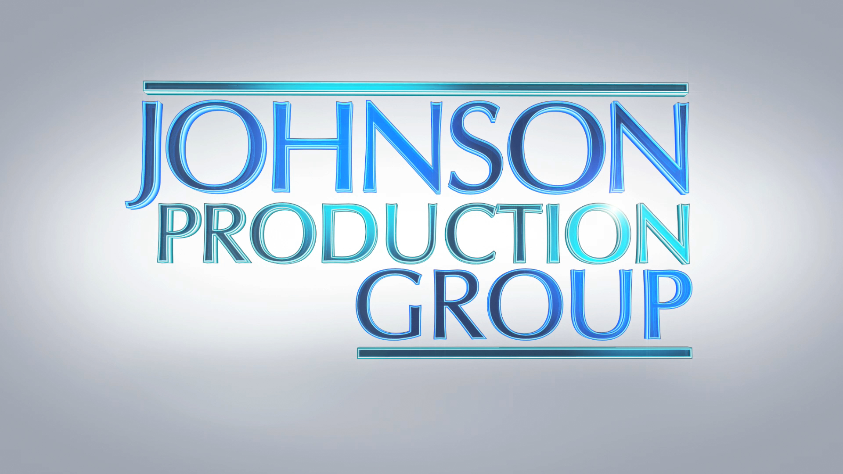
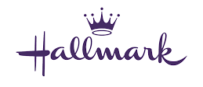

Meta Data
LONG (max 3000 characters) synopsis
Lauren, assistant curator at the Denver Museum of Natural History, has just received an exciting donation to the museum’s Native American Collections – a set of Anasazi wedding vases. But not everyone is as excited about the donation as Lauren. The benefactor’s grandnephew, Grady Hollingston, plans to contest the donation, claiming his great aunt had no right to give away such valuable family heirlooms. Lauren believes that based on the design of the vases there is a fourth vase that is missing from the set and if she can find it in Zion National Park herself, she can make the case that the vases should be returned to the Pueblo Nation. She heads to the park where she meets a local ranger and native Puebloan, Adam Proudstar. Adam is at first skeptical of Lauren’s motives, but reluctantly agrees to accompany her search for the missing vase. When they arrive at their destination, they discover that Hollingston has also started a search of his own. Believing that they failed and have run out of time, a disappointed Lauren and Adam prepare to part despite growing feelings for each other, but perhaps not all is lost when a family secret is revealed. (533)
MEDIUM (max 500) synopsis
Lauren is an assistant curator out to prove a set of ancient vases belong with the Pueblo Nation. While in Zion she meets Adam, a native Puebloan park ranger, who is sceptical of her motives initially but reluctantly agrees to help her on her mission. (251)
SHORT (max 100 characters) synopsis
With the help of a Puebloan ranger, a museum curator searches for a lost Anasazi wedding vase. (95)
5 KEY WORDS
Estate, wedding vase, Pueblo Nation

